**OUTPUT :🡪**

**01].** When we Run this Project First then Following Screen (**welcome screen**) is Shown :🡪

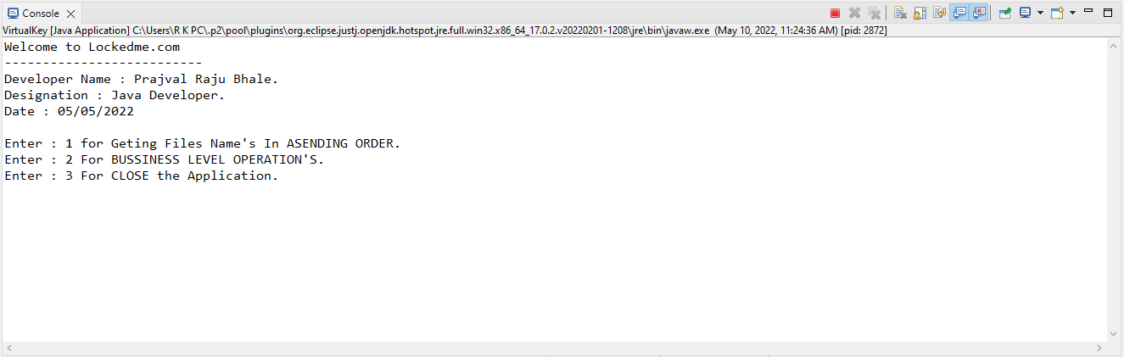

In this output screen Contains “Application Name, Developer Detail’s, Details of User Interface or Options are selected by User, etc. ”

**02].** In first Option, First Option Return the File Names in Ascending order.

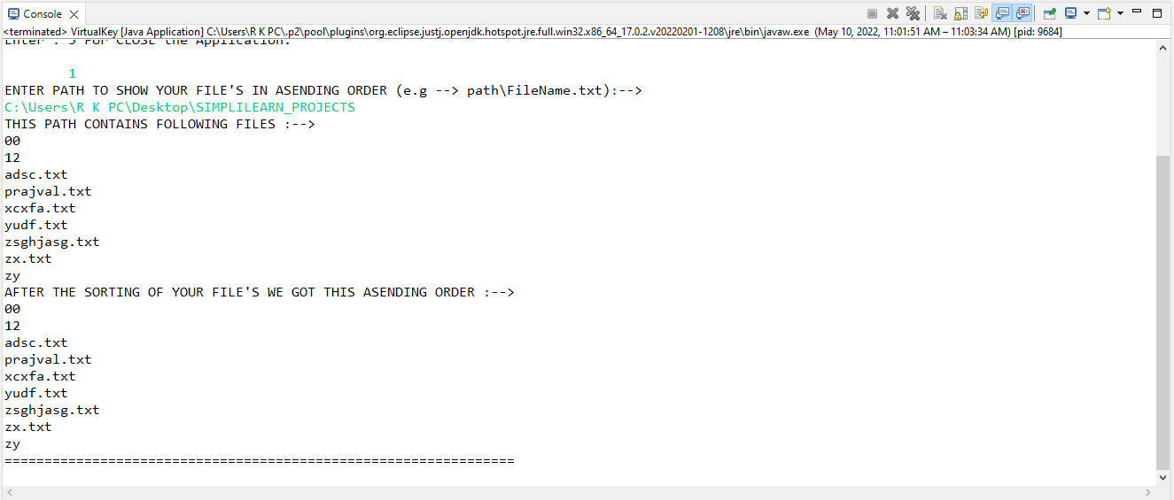

**03].** After we Gives input ‘2’ then some option are Shown Like following Screen :

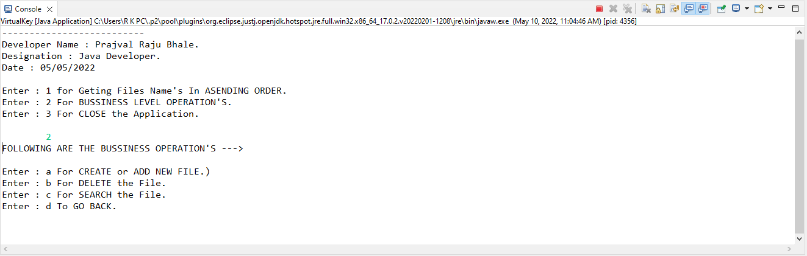

**04].** When we want to create file then we Give’s input ‘a’, then System will automatically create a file.

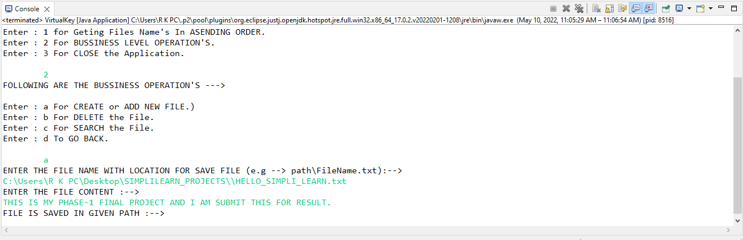

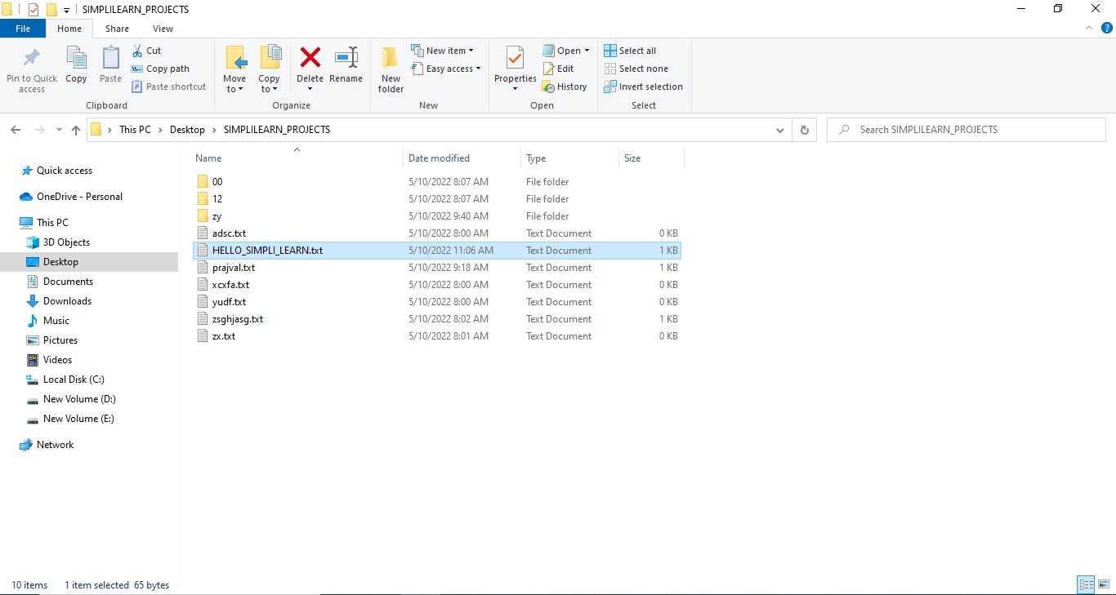

**05].** When we want to Delete file then we Gives input ‘b’, then system will Delete this file provided by user.

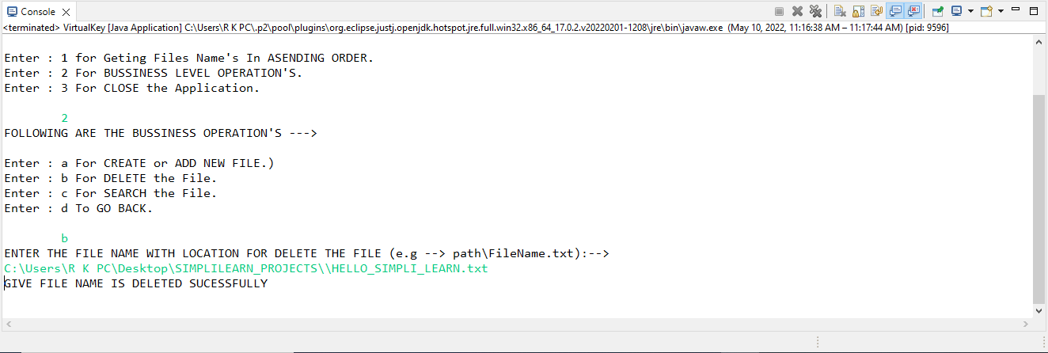



***Before the Delete Operation Perform***

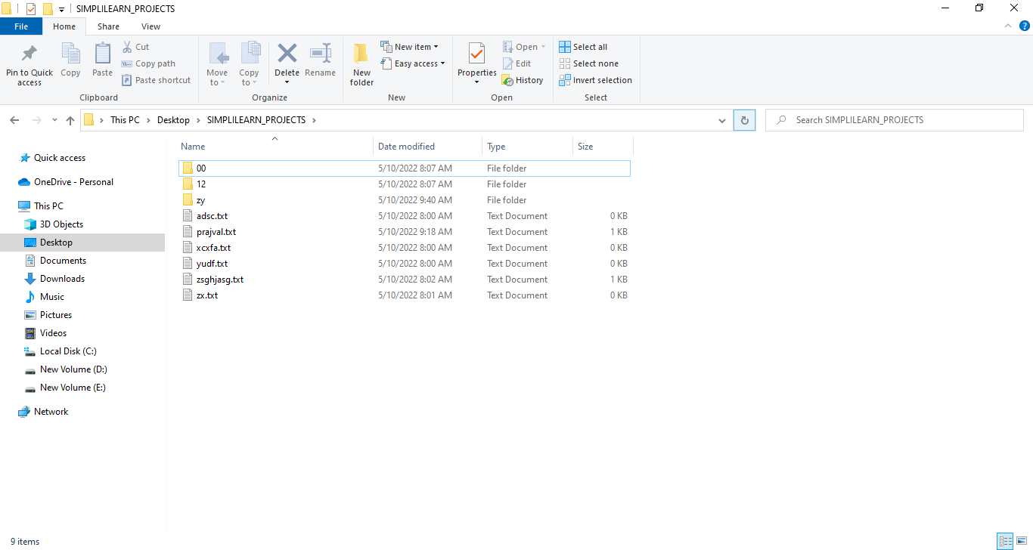

***After Delete The File “HELLO_SIMPLI_LEARN.txt”***

**06].** When we want to search some file then we give input ‘c’, then system will search this file on given Path.

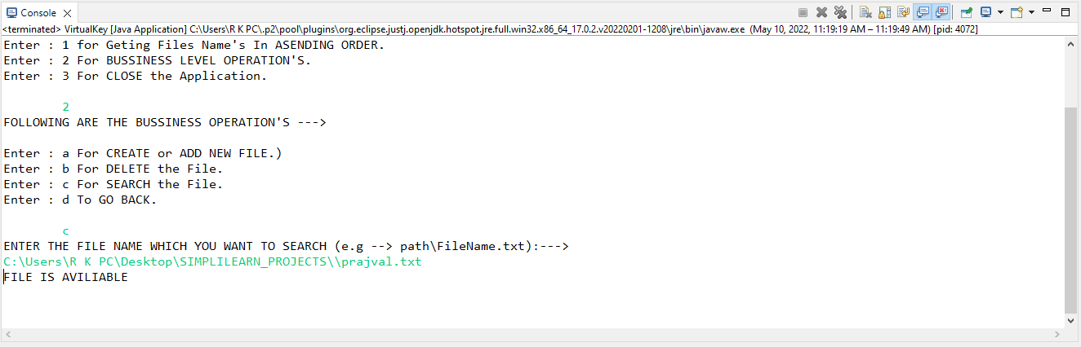

What happen when we search some file but not present in given path then system will show *“THIS FILE IS NOT HERE!!!! SORRY”*

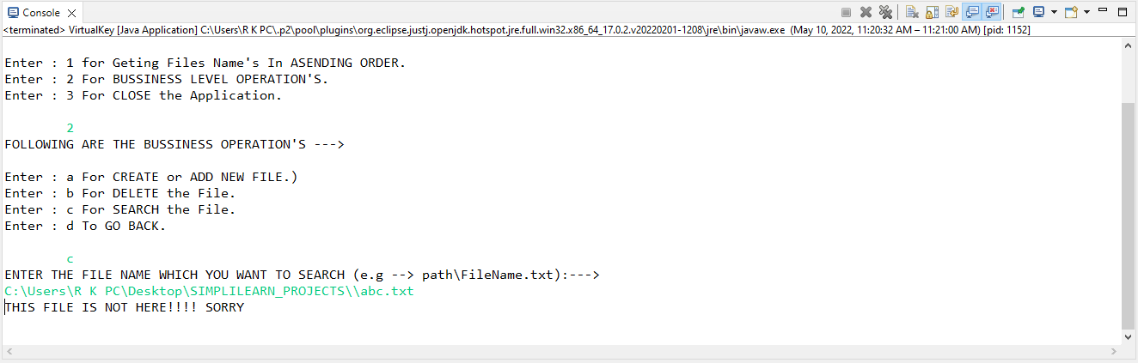

**07].** When we want to go back then we gives an input ‘d’, then we will Back from this Switch and Goes in Home Screen. Then we can do from home Screen.

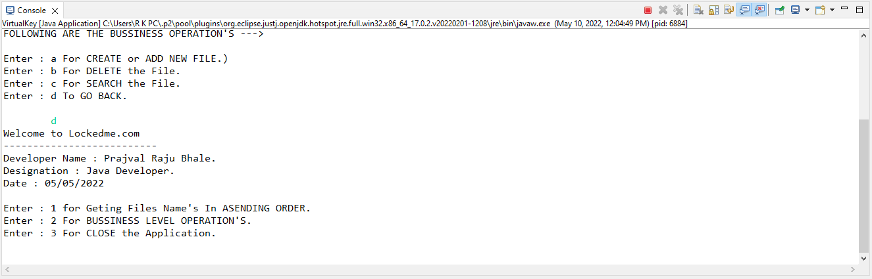

**08].** When we want to close this application then we gives input ‘3’, then we goes Out From Application.

