**package** com.Prajval.VertualKey;

**import** java.io.File;

**import** java.io.FileOutputStream;

**import** java.util.Arrays;

**import** java.util.Comparator;

**import** java.util.Scanner;

**public** **class** VirtualKey

{

/*ADDING OR CREATE NEW FILE METHOD STARTS*/

**public** **static** **void** add() /*<---- CREATE NEW FILE HERE*/

{

**try**

{

**try** (Scanner sc = **new** Scanner(System.***in***))

{

System.***out***.println("ENTER THE FILE NAME WITH LOCATION FOR SAVE FILE (e.g --> path\\FileName.txt):-->");

String filename = sc.nextLine();

FileOutputStream fos = **new** FileOutputStream(filename, **true**);

System.***out***.println("ENTER THE FILE CONTENT :-->");

String contain = sc.nextLine();

**byte** b[] = contain.getBytes();

fos.write(b);

fos.close();

}

System.***out***.println("FILE IS SAVED IN GIVEN PATH :-->");

}

**catch** (Exception e)

{

System.***out***.println("EXCEPTION COMING...........");

e.printStackTrace();

}

}

/*ADDING OR CREATE NEW FILE METHOD END*/

/*THIS METHOD FOR ASENDING ORDER*/

**public** **static** **void** accendingorder()

{

**try** (Scanner sc = **new** Scanner(System.***in***))

{

System.***out***.println("ENTER PATH TO SHOW YOUR FILE'S IN ASENDING ORDER (e.g --> path\\FileName.txt):-->");

String filename = sc.nextLine();

File dir = **new** File(filename);

**if**(dir.isDirectory())

{

File[] files = dir.listFiles();

System.***out***.println("THIS PATH CONTAINS FOLLOWING FILES :--> ");

*extracted*(files); /*SORT BY NAME ONLY*/

**for**(File file:files) /*ASENDING ORDER*/

{

System.***out***.println(file.getName());

}

System.***out***.println("AFTER THE SORTING OF YOUR FILE'S WE GOT THIS ASENDING ORDER :-->");

**for**(File file:files)

{

System.***out***.println(file.getName());

}

System.***out***.println("=============================================================");

}

}

}

**private** **static** **void** extracted(File[] files) {

Arrays.*sort*(files, **new** Comparator<Object>()

{

**public** **int** compare(Object f1, Object f2)

{

**return** ((File) f1).getName().compareTo(((File) f2).getName());

}

});

}

/*ASENDING METHOD IS END*/

/*DELETETION METHOD START*/

**public** **static** **void** delete()

{

**try** (Scanner sc = **new** Scanner(System.***in***))

{

System.***out***.println("ENTER THE FILE NAME WITH LOCATION FOR DELETE THE FILE (e.g --> path\\FileName.txt):-->");

String filename = sc.nextLine();

File file= **new** File(filename);

**if** (file.delete()) {

System.***out***.println("GIVE FILE NAME IS DELETED SUCESSFULLY");

}

**else** {

System.***out***.println("FAILED TO DELETE THE FILE");

}

}

}

/*DELETETION METHOD END*/

/*SEARCHING METHOD IS START*/

**public** **static** **void** search()

{

**try** (Scanner sc = **new** Scanner(System.***in***))

{

System.***out***.println("ENTER THE FILE NAME WHICH YOU WANT TO SEARCH (e.g --> path\\FileName.txt):---> ");

String filename = sc.nextLine();

File fff = **new** File(filename);

**if**( fff.exists())

{

System.***out***.println("FILE IS AVILIABLE \n");

}

**else**

System.***out***.println("THIS FILE IS NOT HERE!!!! SORRY");

}

}

/*SEARCHING METHOD IS END*/

/*MAIN METHOD IS START*/

**public** **static** **void** main(String[] args)

{

String ab = "Welcome to Lockedme.com";

System.***out***.println(ab);

System.***out***.println("--------------------------");

String DN = "Developer Name : Prajval Raju Bhale.\nDesignation : Java Developer.\nDate : 05/05/2022";

System.***out***.println(DN);

**try** (Scanner console = **new** Scanner(System.***in***))

{

**int** ch;

System.***out***.print(" \nEnter : 1 for Geting Files Name's In ASENDING ORDER. "

+ "\nEnter : 2 For BUSSINESS LEVEL OPERATION'S. "

+ "\nEnter : 3 For CLOSE the Application.\n\n\t");

ch = console.nextInt();

**switch**(ch)

{

**case** 1 :

*accendingorder*(); **break**;

**case** 2 :

**int** ch2;

System.***out***.println("FOLLOWING ARE THE BUSSINESS OPERATION'S --->");

System.***out***.print("\nEnter : a For CREATE or ADD NEW FILE.)"

+"\nEnter : b For DELETE the File."

+"\nEnter : c For SEARCH the File."

+"\nEnter : d To GO BACK.\n\n\t");

ch2 = console.next().charAt(0);

**switch**(ch2)

{

**case** 'a' :

*add*();

**break**;

**case** 'b' :

*delete*();

**break**;

**case** 'c' :

*search*();

**break**;

**case** 'd' :

System.*exit*(ch2);

**break**;

}

**break**;

**case** 3 :

System.***out***.println("SYSTEM GONNA CLOSE\nVISIT AGAIN THANK YOU..");

System.*exit*(ch);

**default** :

System.***out***.println("SOMETHING GOES WRONG(EXCEPTION)....");

**break**;

}

}

}

}

**OUTPUT :🡪**

**01].** When we Run this Project First then Following Screen (**welcome screen**) is Shown :🡪

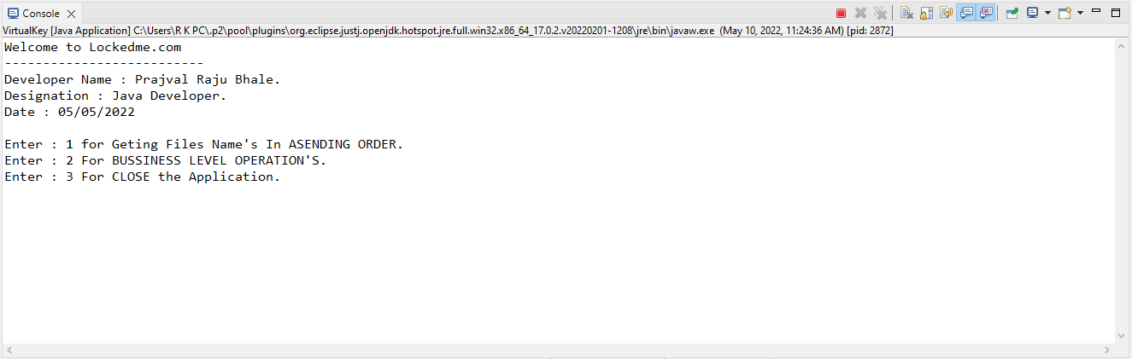

In this output screen Contains “Application Name, Developer Detail’s, Details of User Interface or Options are selected by User, etc. ”

**02].** In first Option, First Option Return the File Names in Ascending order.

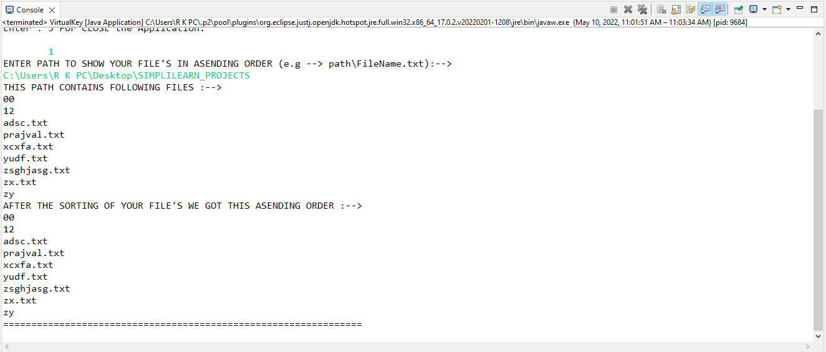

**03].** After we Gives input ‘2’ then some option are Shown Like following Screen :

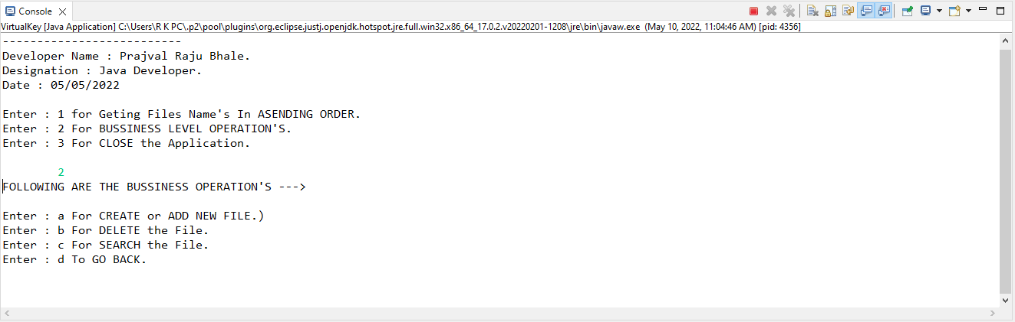

**04].** When we want to create file then we Give’s input ‘a’, then System will automatically create a file.

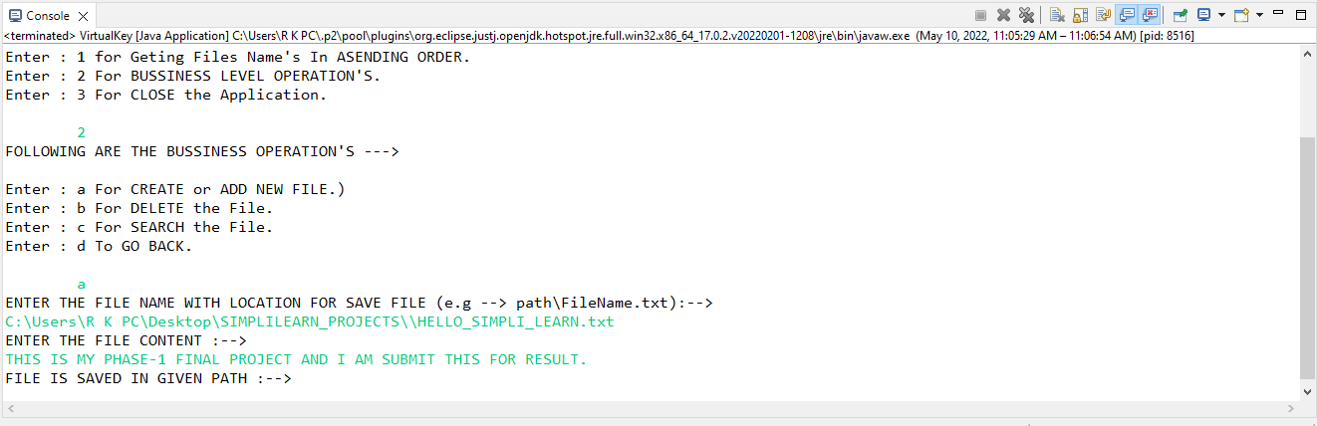

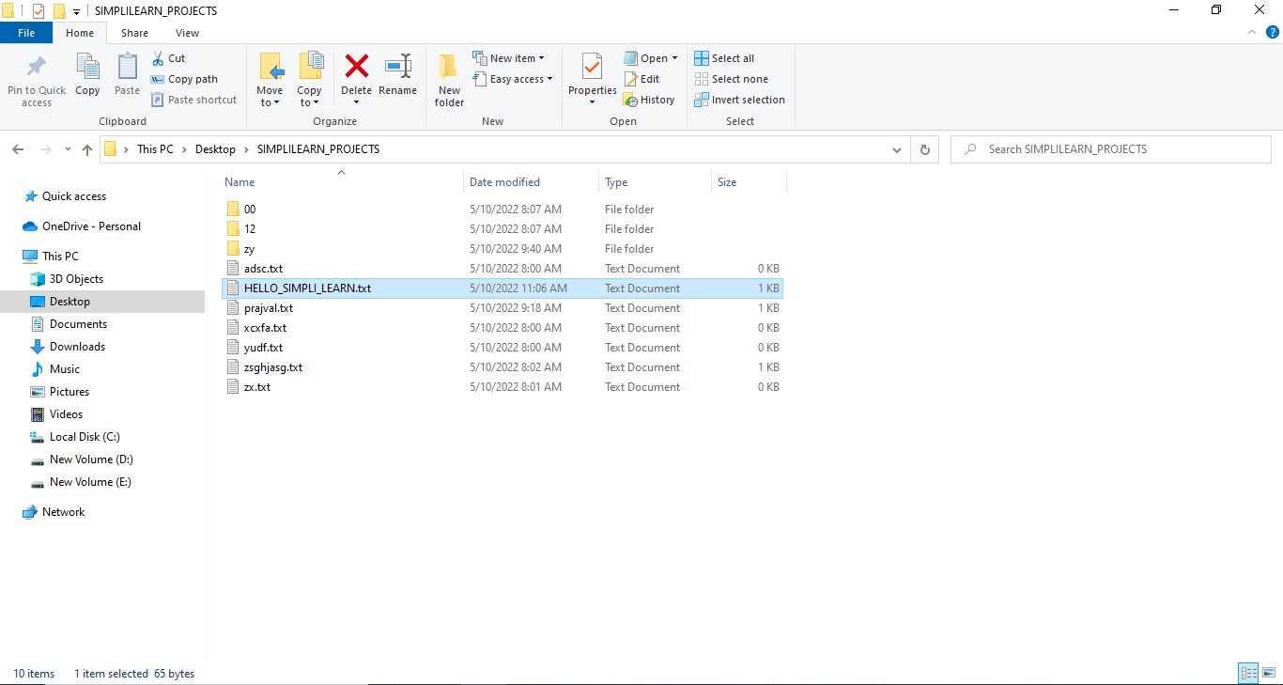

**05].** When we want to Delete file then we Gives input ‘b’, then system will Delete this file provided by user.

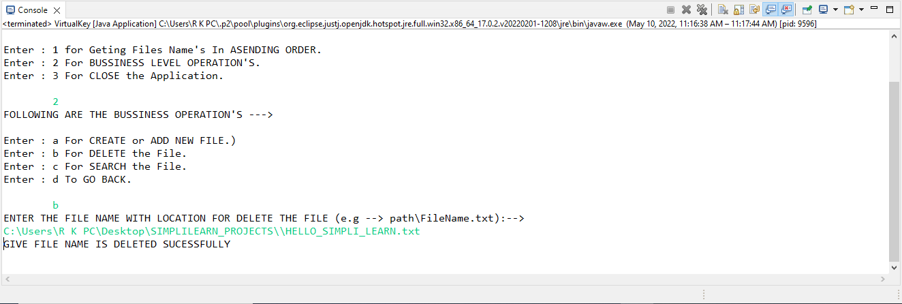



***Before the Delete Operation Perform***

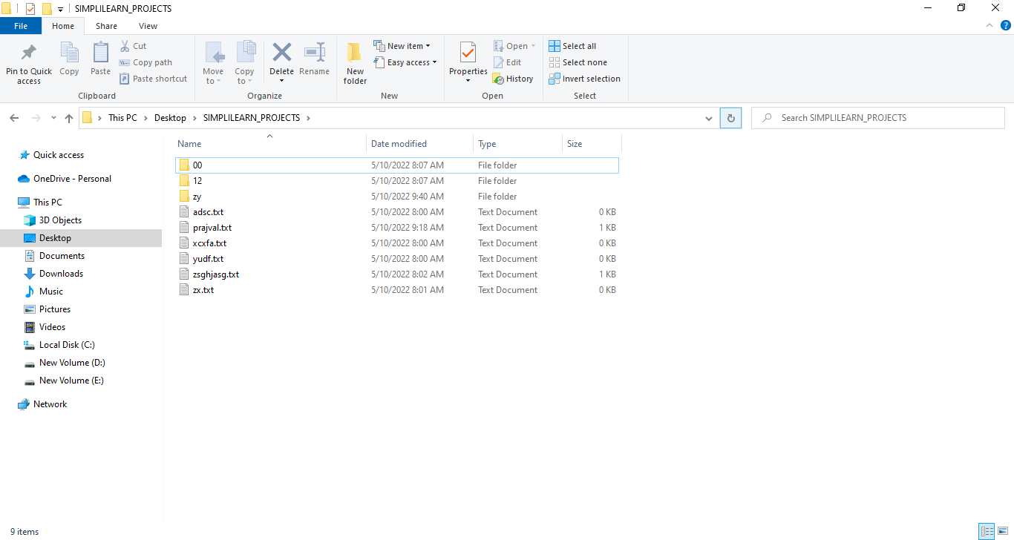

***After Delete The File “HELLO_SIMPLI_LEARN.txt”***

**06].** When we want to search some file then we give input ‘c’, then system will search this file on given Path.

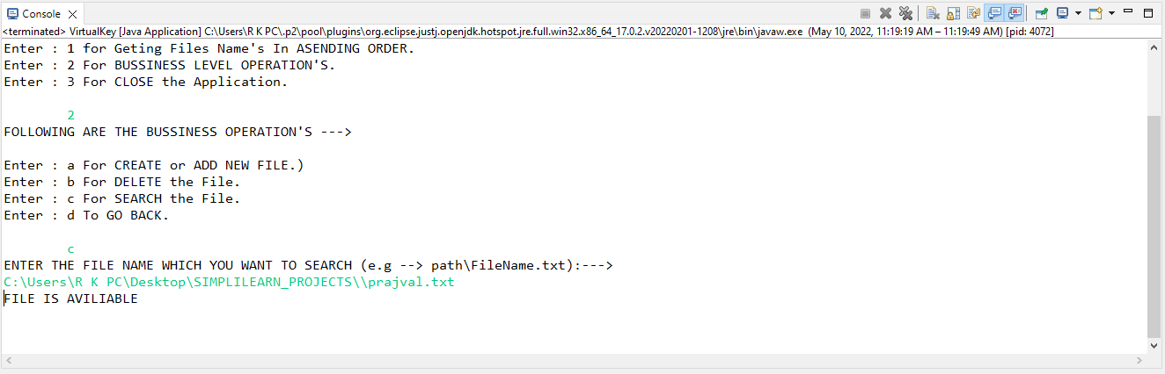

What happen when we search some file but not present in given path then system will show *“THIS FILE IS NOT HERE!!!! SORRY”*

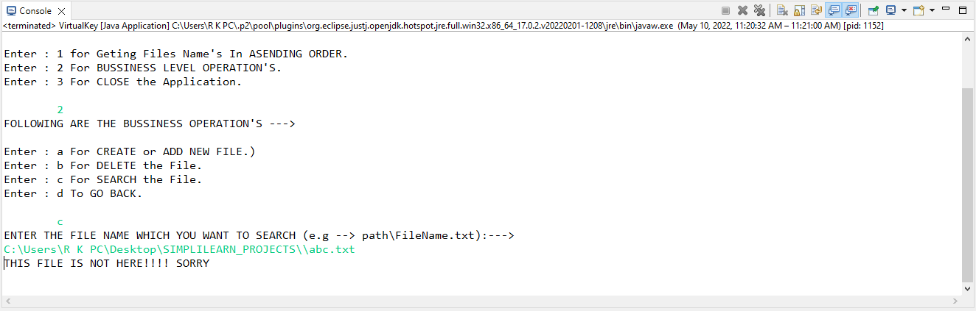

**07].** When we want to go back then we gives an input ‘d’, then we will Back from this Switch and Goes in Home Screen. Then we can do from home Screen.

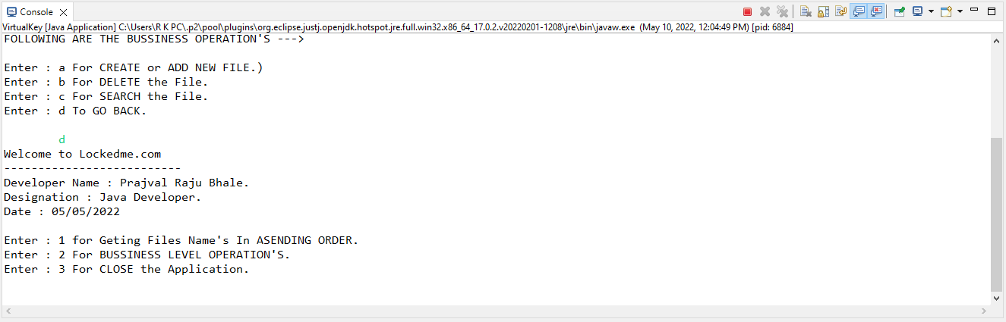

**08].** When we want to close this application then we gives input ‘3’, then we goes Out From Application.

