DevOps Task Documentation
Task 1: Trigger Pipeline from Repository
- Build and test the application
- Create a Docker image
- Deploy the application to EC2
Step 1: Create EC2 Instance
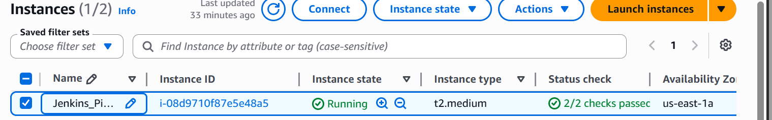
Step2- Enable inbound rules to allow public access
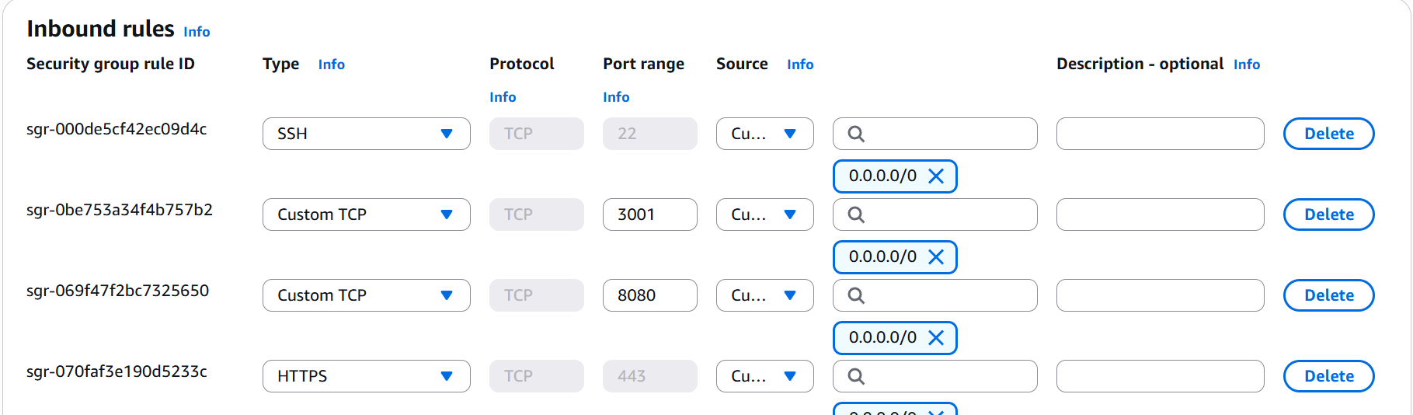
Step3 - SSH into the instance
Step4 - Update the instance
Step5 - Install Jenkins and Docker
Step6 - Clone repository and configure project files
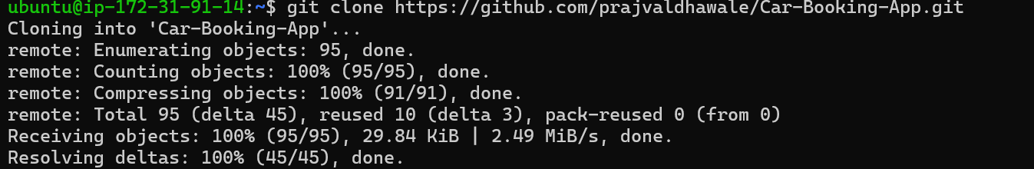
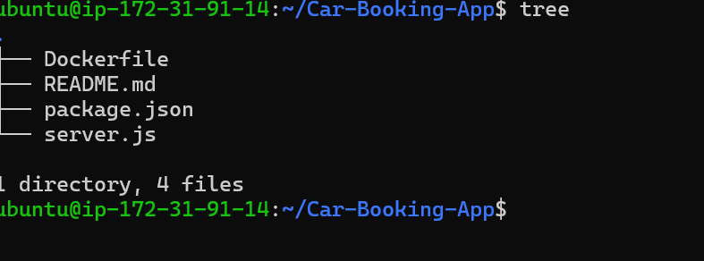
Step7 - Create Docker file
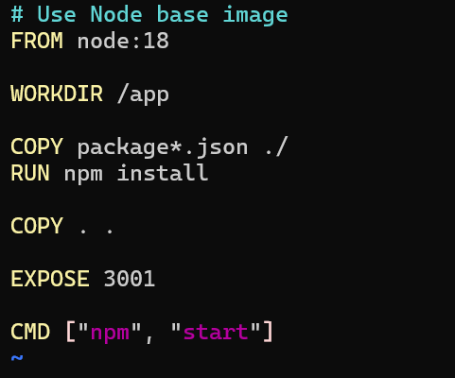
Step8 - Build and test Docker image locally
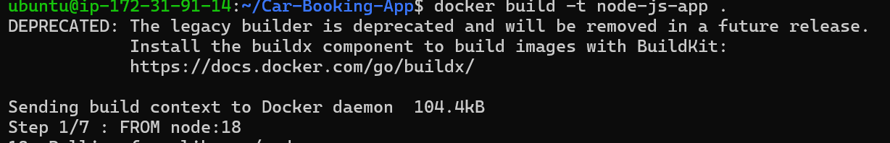
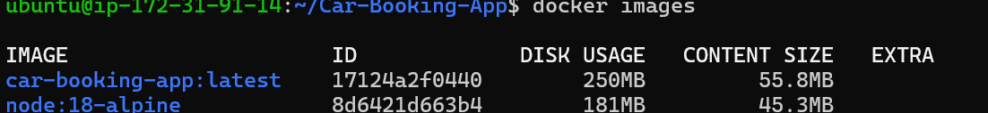
Step9 - Run the container successfully
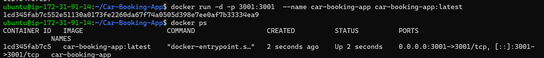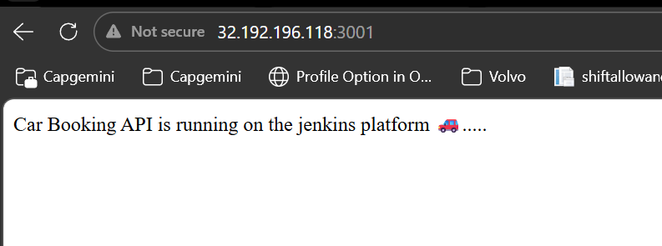

Step1 – Now we are Deploying the Application Using Jenkins Pipeline (Auto Trigger)
Step2 – Installed the Jenkins on Ubuntu server
Step3 - Use declarative pipeline
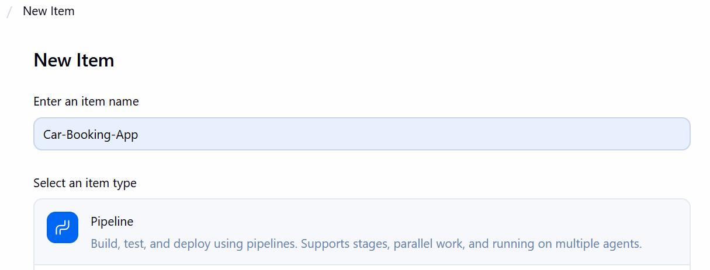
Step4 – Created Pipeline for Automate build, test, Docker image creation, and deployment stages
- pipeline {
- agent any

- environment {
- IMAGE_NAME = "node-app"
- TAG = "${BUILD_NUMBER}"
- }

- tools {
- nodejs 'NodeJS'
- }

- stages {
- stage("Clone Code") {
- steps {
- git url: "https://github.com/prajvaldhawale/Car-Booking-App.git", branch: "main"
- }
- }

- stage("Build Application") {
- steps {
- sh 'npm install'
- }
- }

- stage("Test") {
- steps {
- sh 'npm test || echo "No tests found, skipping..."'
- }
- }

- stage("Build Docker Image") {
- steps {
- sh 'docker build -t $IMAGE_NAME:$TAG .'
- }
- }

- stage("Deploy Container") {
- steps {
- sh '''
- docker stop jenk-node-app || true
- docker rm jenk-node-app || true
- docker run -d -p 3000:3000 --name jenk-node-app $IMAGE_NAME:$TAG
- '''
- }
- }
- }
- }
Step5 - Configure GitHub webhook for auto-triggering the pipeline
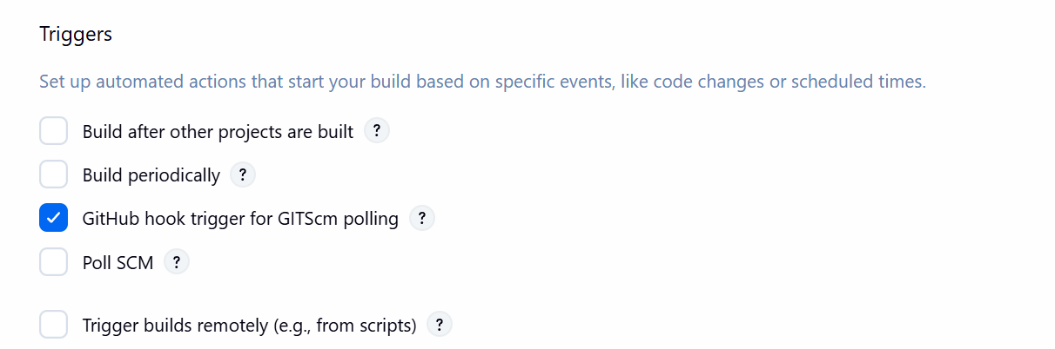

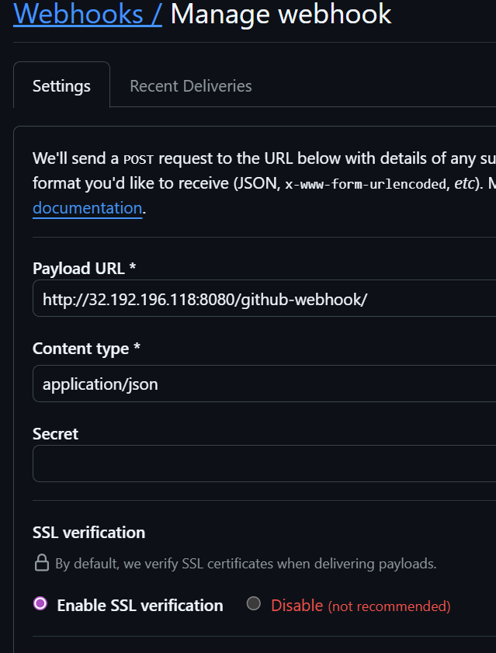
Step6 - Once I made in changes in the repository it will automatically trigger the pipeline
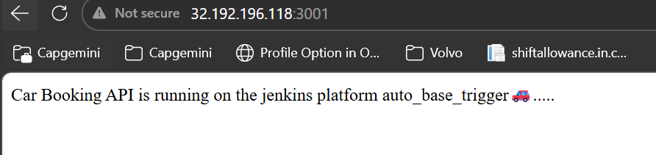
Task 2: Creating Terraform Infrastructure for Dev, QA, and Production Environments
- Install Terraform from the official website
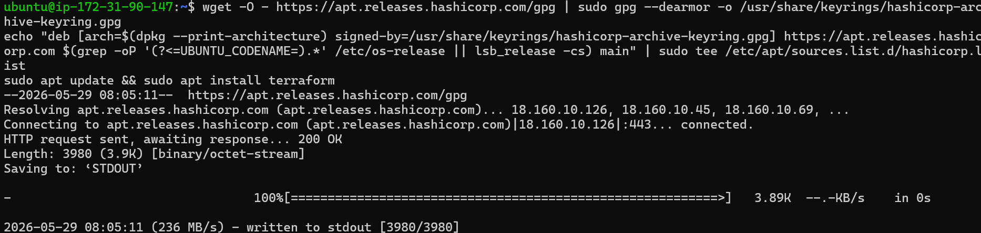
Step1 - Configure aws provider.
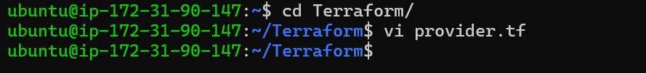
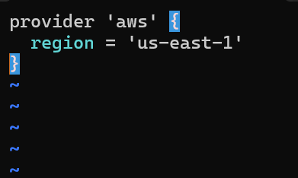
Step2 - Install AWS CLI and configure it to connect with AWS services using Terraform
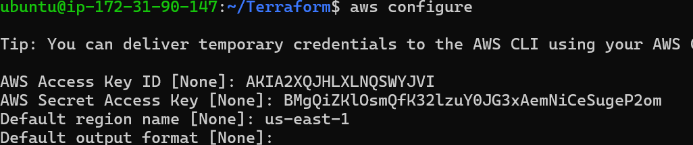
Step3 - Initialize the Terraform provider
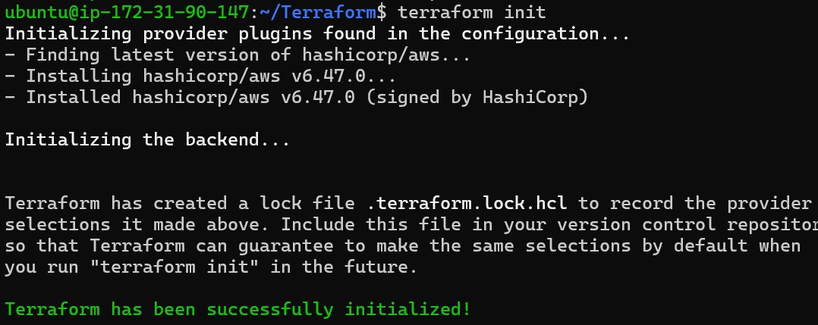
Step4 - Create main.tf and Configure AWS EC2 infrastructure and networking
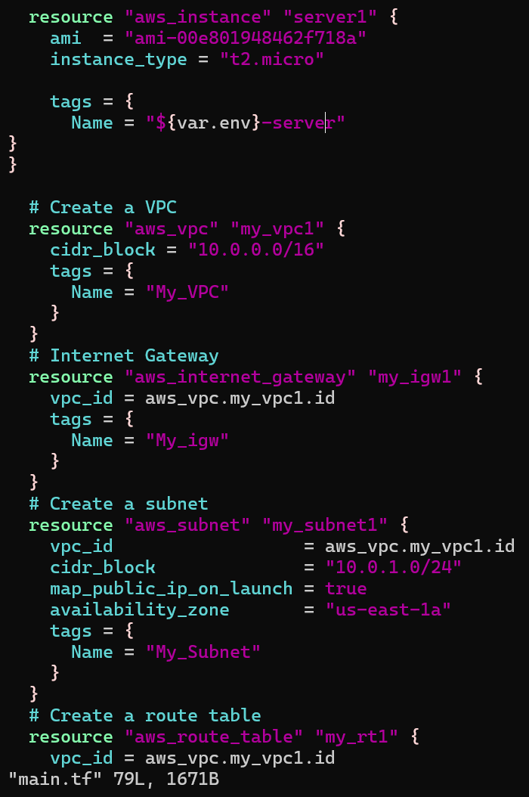

Step5 - Run plan and apply
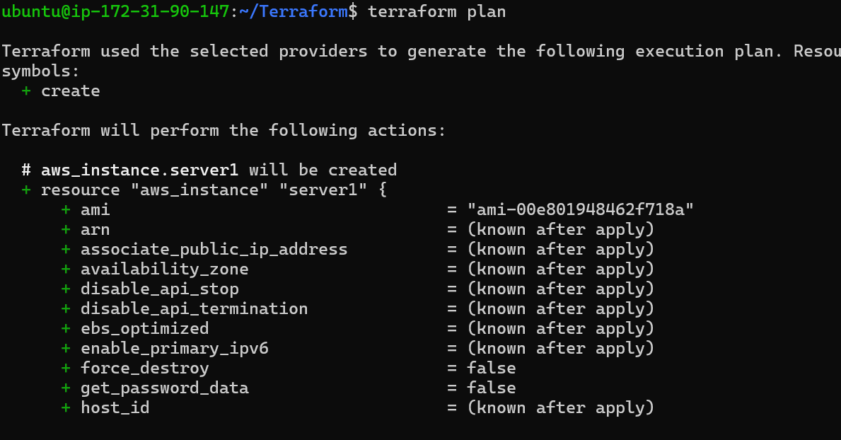
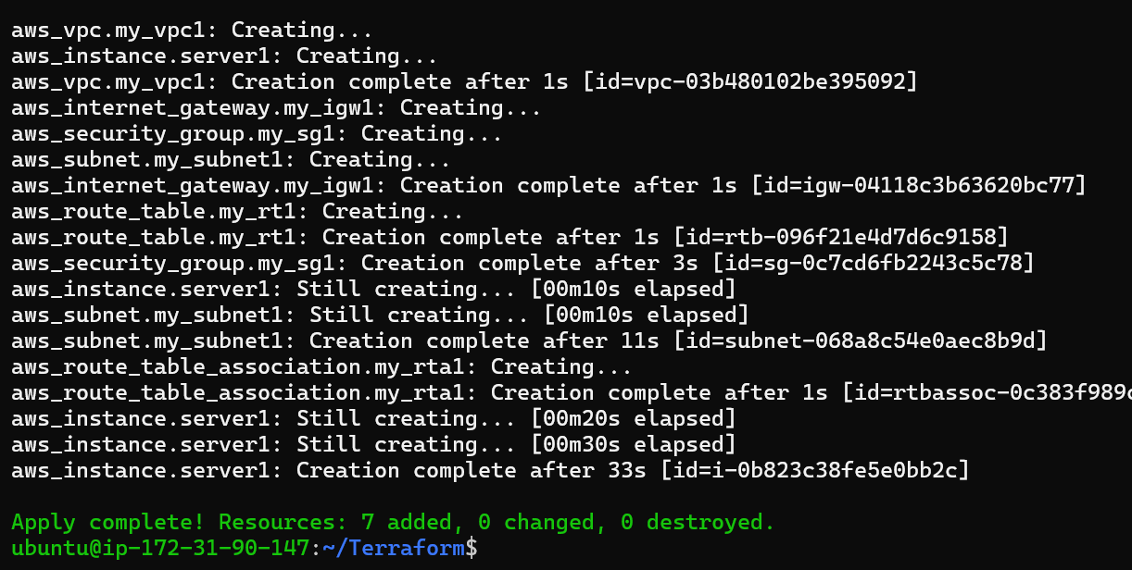

Step6 - Create multiple Terraform infrastructures for Development, QA, and Production environments
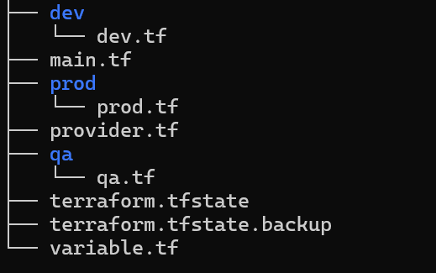
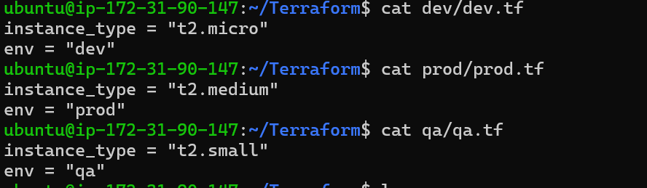
Step7 - Create variables.tf
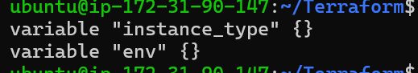
Step8- Update environment configurations in main.tf
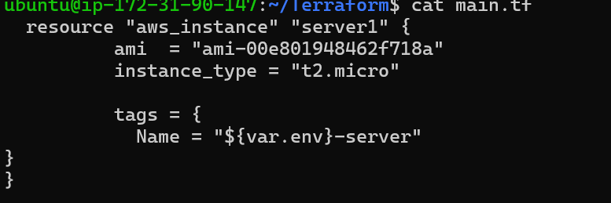

Step9 - Deploy individual environments
- Run the Development environment
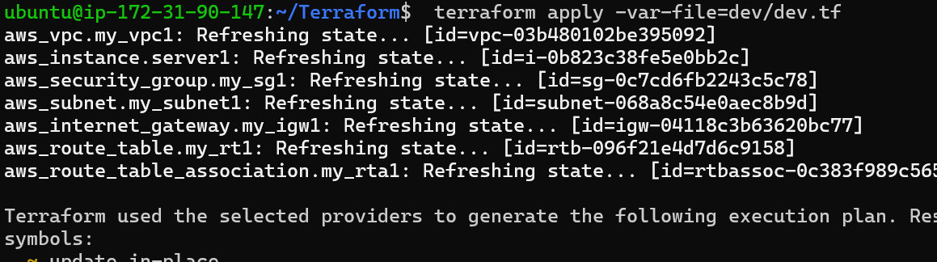
- Run the QA environment
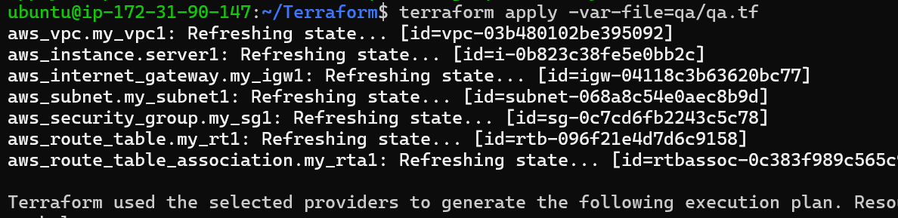
- Run the Production environment
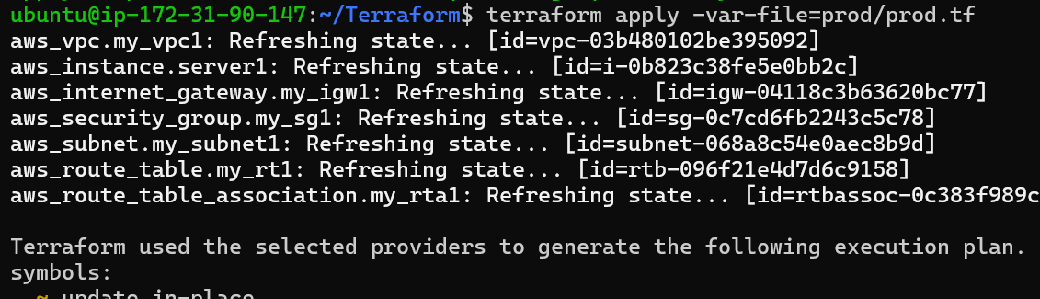
Thank You!.

