AICTE | IBM SkillsBuild
Academic Internship — Data Analytics with AI
INTERNSHIP PROJECT REPORT
Agricultural Financial & Seasonal Performance Analytics
A Data-Driven Study of Seasonal Crop Yield, Cost, Revenue and Profitability

Submitted by: Prajval Anandrao Kadam
AICTE Student ID: STU6a0c89cd24a8e1779206605
Submitted as part of the AICTE | IBM SkillsBuild Internship Program
Domain: Data Analytics with Artificial Intelligence
Dataset: seasonal_agriculture_performance_dataset.csv
Tools Used: Python, Pandas, Matplotlib, Seaborn (Jupyter/Colab Notebook)
September 2026

1. Executive Summary
This report presents the findings of a data analytics project undertaken as part of the AICTE | IBM SkillsBuild Academic Internship in Data Analytics with AI. The project analyses a seasonal agricultural performance dataset covering 4,000 farm-level records across 8 Indian states, 10 districts, 8 major crops and 3 cropping seasons (Kharif, Rabi and Zaid). The objective was to apply the end-to-end data analytics workflow — data loading, cleaning, exploratory analysis and visualization — using Python to uncover patterns in crop yield, input usage, and farm profitability.
The dataset combines agronomic variables (rainfall, temperature, humidity, soil moisture, soil pH, fertilizer and pesticide use, irrigation method) with financial variables (total cost, revenue and profit in INR) for each farm record, enabling a joint agro-economic analysis rather than a purely agronomic one.
Key results show that the Kharif season delivers the highest average yield (5.63 t/ha) and by far the highest average profit (₹1,78,915 per farm), while the Zaid season is, on average, loss-making (–₹24,805 per farm) and carries the highest share of loss-making farms (64.5%). Correlation analysis confirms that profitability is driven overwhelmingly by revenue (r = 0.89) and, in turn, by yield (r = 0.43 with revenue), while weather variables such as rainfall and temperature show only weak direct correlation with yield in this dataset — pointing to input management, crop choice and market price as stronger levers than climate alone within the sampled range. Sugarcane and Chilli emerge as the most profitable crops on average, whereas Wheat, Rice and Maize post negative average profits, largely on account of high cultivation costs relative to revenue realised.
Overall, the project demonstrates a complete, reproducible analytics pipeline — from missing-value treatment to multi-variable visual and statistical analysis — and translates the results into actionable insights for season- and crop-level agricultural planning.

2. Objectives
The specific objectives of this internship project were:
- To load, inspect and understand the structure of the seasonal agriculture performance dataset (4,000 records, 28 attributes).
- To identify and treat missing/null values in key agronomic fields (Rainfall, Soil Moisture, Yield) using appropriate statistical imputation (median).
- To perform exploratory data analysis (EDA) to understand the distribution of records across seasons and the distribution of crop yield.
- To compare average crop yield and average financial profit across the three cropping seasons — Kharif, Rabi and Zaid.
- To examine the correlation between key environmental variables (rainfall, temperature, humidity, soil moisture) and key outcome variables (yield, cost, revenue, profit).
- To visualize all findings using clear, labeled, publication-quality charts (bar charts, histogram, heatmap) built with Matplotlib and Seaborn.
- To translate the statistical findings into practical, actionable insights for agricultural planning and financial decision-making.

3. Methodology / Data Analysis

3.1 Tools and Technologies
- Programming Language: Python 3
- Environment: Jupyter / Google Colab Notebook
- Libraries: Pandas (data handling), Matplotlib & Seaborn (visualization)
- Data Format: CSV / Excel (seasonal_agriculture_performance_dataset)

3.2 Dataset Overview
The dataset consists of 4,000 rows and 28 columns capturing farm-level agronomic inputs, environmental conditions and financial outcomes for a single growing cycle per record. A summary of its structure is given below:
Attribute | Detail
Total Records | 4,000 farm entries
Total Columns | 28 (agronomic, environmental, operational & financial)
States Covered | 8 (Andhra Pradesh, Maharashtra, Telangana, Karnataka, Gujarat, Tamil Nadu, Punjab, Madhya Pradesh)
Districts Covered | 10
Crops Covered | 8 (Rice, Wheat, Maize, Cotton, Pulses, Groundnut, Chilli, Sugarcane)
Seasons | 3 (Kharif, Rabi, Zaid)
Irrigation Methods | 4 (Flood, Rainfed, Drip, Sprinkler)
Key Financial Fields | Total_Cost_INR, Revenue_INR, Profit_INR
Key Agronomic Fields | Rainfall_mm, Avg_Temperature_C, Humidity_pct, Soil_Moisture_pct, Soil_pH, Fertilizer_kg_ha, Yield_Tonnes_Ha

3.3 Data Cleaning
An initial null-value check revealed missing entries in three critical numeric fields. These were treated using median imputation, which is robust to outliers and preserves the central tendency of each variable:
Column | Missing Values (Before) | Treatment Applied
Rainfall_mm | 48 | Filled with column median
Soil_Moisture_pct | 40 | Filled with column median
Yield_Tonnes_Ha | 32 | Filled with column median
After imputation, the dataset contained zero missing values across all treated columns, confirming successful cleaning prior to analysis.

3.4 Analytical Approach
With a clean dataset in place, the analysis proceeded through five stages, each producing a dedicated visualization:
- Distributional check of records across the three seasons (Plot 1).
- Distributional check of the target outcome variable, crop yield (Plot 2).
- Season-wise aggregation of average yield to compare agronomic performance (Plot 3).
- Season-wise aggregation of average profit to compare financial performance (Plot 4).
- Pairwise Pearson correlation of eight key numeric variables to identify the strongest drivers of yield, revenue and profit (Plot 5).

4. Key Findings and Visualizations

4.1 Distribution of Records by Season
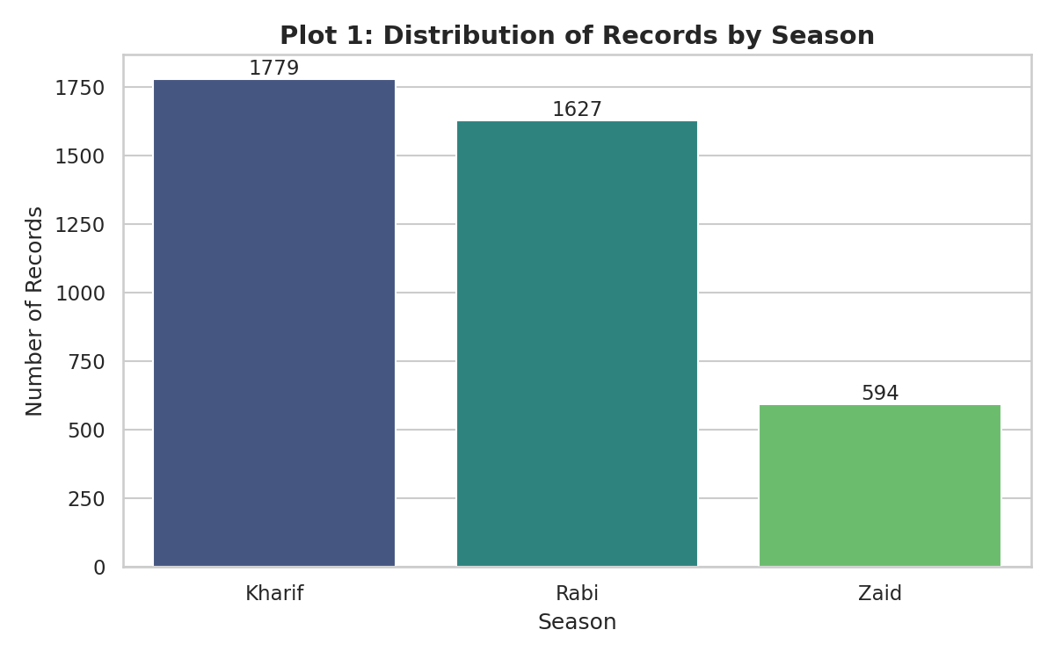
Figure 1: Distribution of Records by Season
The dataset is not evenly split across seasons. Kharif accounts for the largest share of records (1,779, ~44.5%), followed by Rabi (1,627, ~40.7%) and Zaid (594, ~14.9%). This imbalance is representative of real cropping patterns in India, where the Kharif (monsoon) and Rabi (winter) seasons together dominate cultivated area, while Zaid (short summer season) is used for a narrower set of crops.

4.2 Distribution of Crop Yield
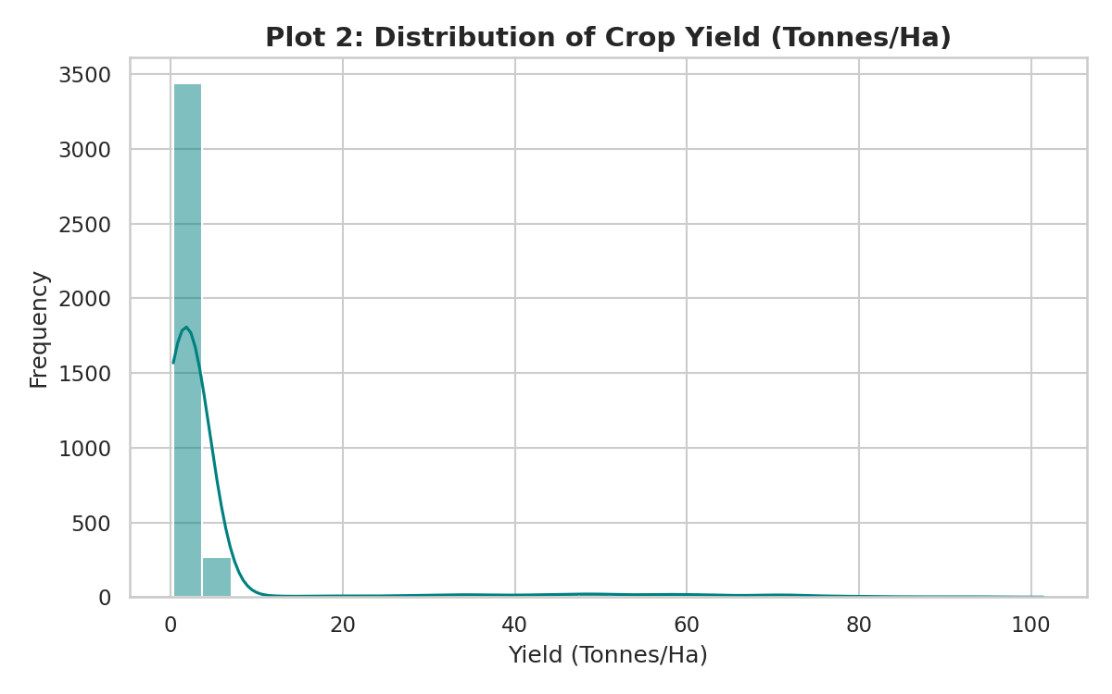
Figure 2: Distribution of Crop Yield (Tonnes/Ha)
Crop yield is strongly right-skewed: the median yield is 1.74 t/ha and the 75th percentile is 2.83 t/ha, but a long tail of high-yield records (driven mainly by Sugarcane, which is measured in much higher tonnage per hectare) pulls the mean up to 5.24 t/ha with a maximum of 101.44 t/ha. This confirms that yield should be interpreted crop-by-crop rather than as a single pooled metric, and that season/crop-level averages (Section 4.3) are more informative than the overall mean.

4.3 Average Crop Yield by Season
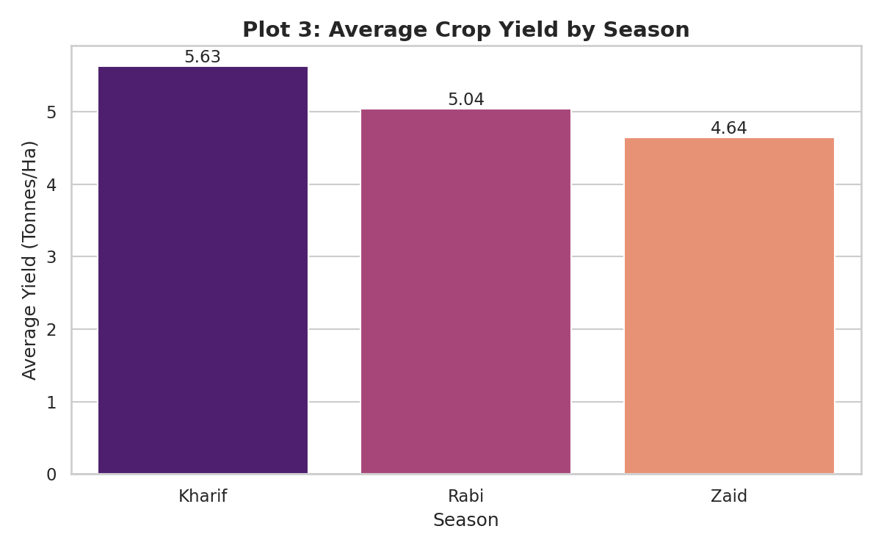
Figure 3: Average Crop Yield by Season
Season | Average Yield (t/ha) | Average Profit (₹) | Share of Loss-Making Farms
Kharif | 5.63 | 1,78,915 | 42.1%
Rabi | 5.04 | 87,689 | 51.1%
Zaid | 4.64 | -24,805 | 64.5%
Kharif recorded the highest average yield (5.63 t/ha), followed by Rabi (5.04 t/ha) and Zaid (4.64 t/ha). This ordering aligns with Kharif's dependence on the main monsoon, which supplies the bulk of India's annual rainfall and supports higher-yielding crops such as Rice, Cotton and Sugarcane.

4.4 Average Financial Profit by Season
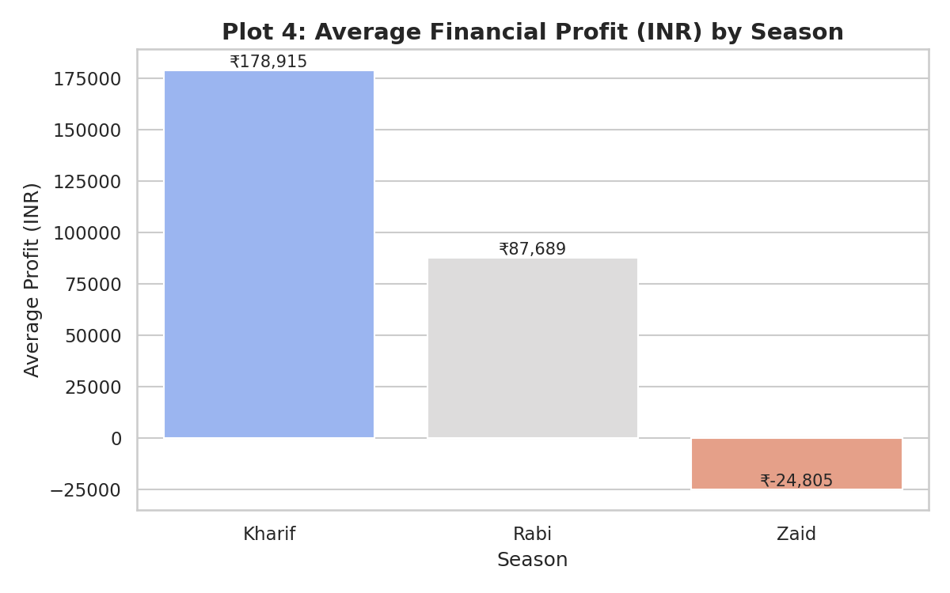
Figure 4: Average Financial Profit (INR) by Season
The financial picture reinforces the yield findings, and amplifies them: Kharif farms earned an average profit of ₹1,78,915, more than double the Rabi average of ₹87,689, while the average Zaid farm posted a loss of ₹24,805. Notably, even Kharif and Rabi carry a substantial share of loss-making individual farms (42.1% and 51.1% respectively), and nearly two-thirds of all Zaid farms (64.5%) were unprofitable — indicating that season alone does not guarantee profitability, but it strongly shifts the odds.

4.5 Correlation Analysis of Key Variables
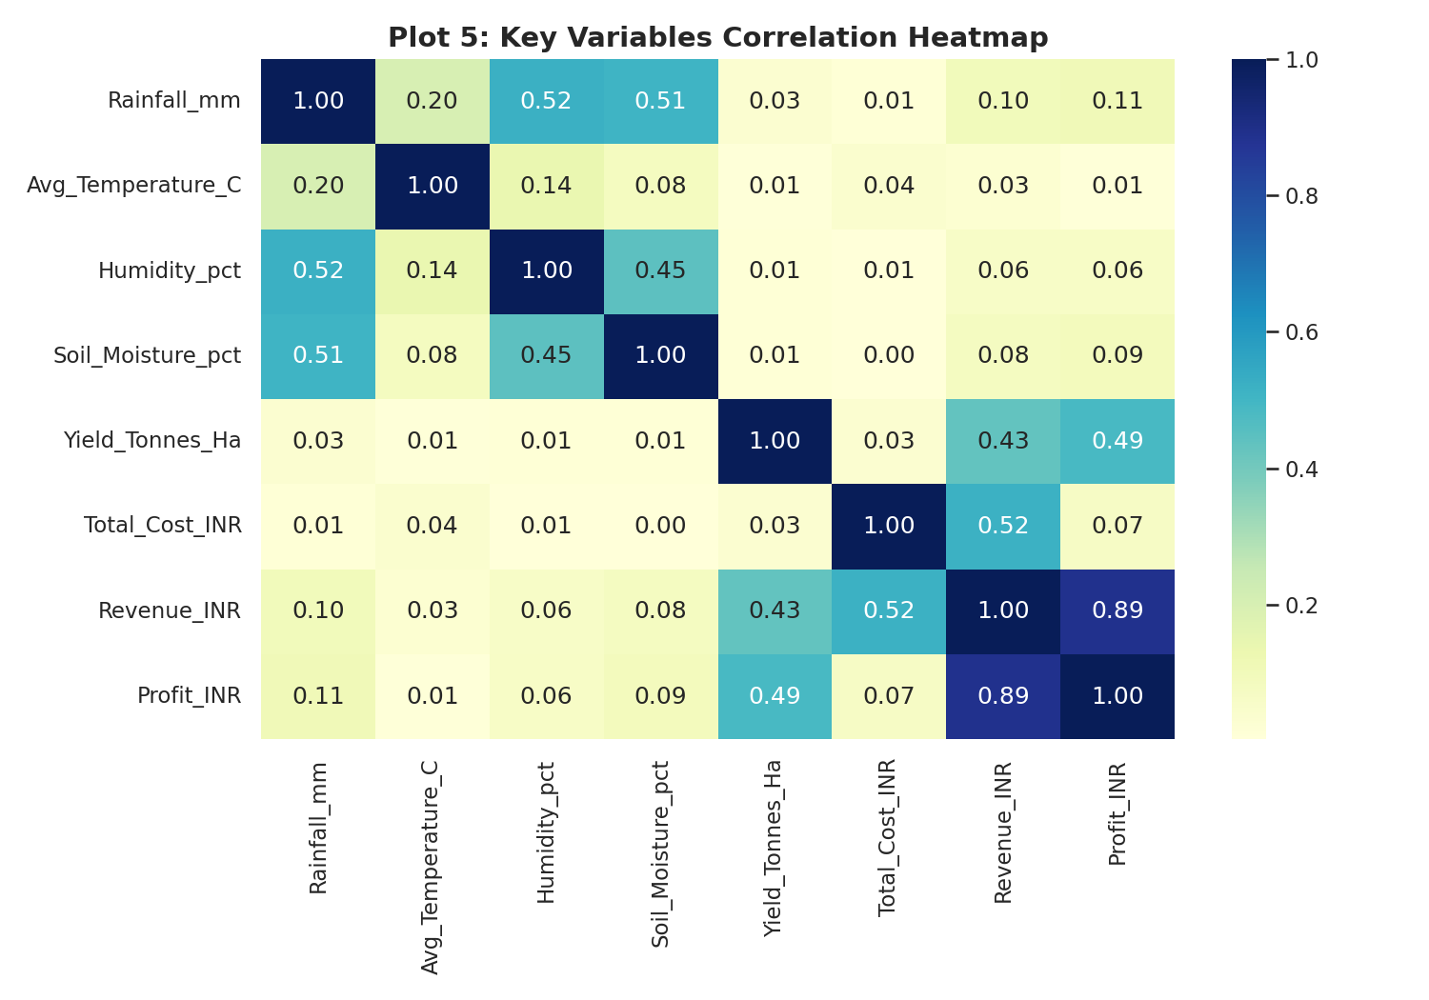
Figure 5: Key Variables Correlation Heatmap
The correlation heatmap highlights which variables move together most strongly:
- Profit is very strongly correlated with Revenue (r = 0.89) — confirming that revenue generation, not cost control, is the dominant driver of profit in this dataset.
- Revenue is moderately correlated with Yield (r = 0.43) and with Total Cost (r = 0.52), reflecting that higher input spend and higher output both contribute to revenue.
- Yield shows a weak direct correlation with Profit (r = 0.49) once revenue and cost are also accounted for, but only a very weak correlation with weather variables — Rainfall (r = 0.03), Temperature (r = 0.01), Humidity (r = 0.01) and Soil Moisture (r = 0.01) — within the ranges observed in this dataset.
- Rainfall correlates moderately with Humidity (r = 0.52) and Soil Moisture (r = 0.51), as expected physically, but this relationship does not propagate strongly into yield or profit outcomes.
The practical implication is that, in this dataset, financial outcomes are explained far more by market/revenue factors (price realisation, quantity sold) and cost management than by the specific weather conditions recorded — suggesting that post-harvest and market-access factors deserve as much analytical attention as agronomic inputs.

4.6 Additional Observations (Crop-Level)
Extending the season-level analysis to the crop level (from the underlying cleaned dataset) shows a wide profitability spread across crops:
Crop | Average Profit (₹ per farm)
Sugarcane | 8,17,188
Chilli | 7,50,878
Cotton | 1,24,547
Groundnut | 44,858
Pulses | -4,238
Maize | -83,978
Rice | -1,02,214
Wheat | -1,23,398
Sugarcane and Chilli are, on average, highly profitable, while staple cereals — Wheat, Rice and Maize — show negative average profit in this dataset, most likely due to high per-hectare cultivation costs relative to market price realised. This crop-wise view complements the season-wise view and suggests that crop selection is at least as important a lever as season for farm profitability.

5. Conclusion
This project successfully applied a complete data analytics workflow — data ingestion, cleaning, exploratory analysis and multi-chart visualization — to a real-world-style agricultural dataset of 4,000 farm records. The analysis confirms that Kharif is both the highest-yielding and most profitable season in the dataset, while Zaid is, on average, financially loss-making despite still producing a respectable average yield. Correlation analysis reveals that profit is driven primarily by revenue rather than by weather conditions directly, and that crop choice (e.g., Sugarcane and Chilli versus Wheat, Rice and Maize) creates a wider profitability spread than season alone.
From a practical standpoint, these findings suggest that agricultural planning and advisory efforts should combine season-appropriate crop selection with closer attention to cost control and market/price realisation, since the data shows profit tracks revenue far more closely than it tracks input costs or weather variables. The project also demonstrates the value of median imputation for handling missing agronomic sensor data without discarding valid records, and of pairing distributional (histogram), categorical (bar chart) and relational (correlation heatmap) visualizations to build a rounded understanding of a multi-dimensional dataset.
As a next step, this analysis could be extended with predictive modelling (e.g., regression or tree-based models to forecast yield or profit from agronomic and cost inputs), state/district-level geographic analysis, and irrigation-method-wise cost-efficiency comparisons to further sharpen the actionable recommendations for farmers and policymakers.
This work was carried out as part of the AICTE | IBM SkillsBuild Academic Internship in Data Analytics with AI, and reflects the practical application of Python-based data analytics skills — pandas for data wrangling and matplotlib/seaborn for visualization — to a domain-relevant, socially meaningful problem in agricultural finance.

