**ASSIGNMENT 1 : Web and Social Computing [ IT752]**

**By**

**Prajwal M P**

**192508IT015**

**Purpose**

To analyse a given graph dataset and find its properties.

**Procedure**

Download the “General Relativity and Quantum Cosmology collaboration network” from <https://snap.stanford.edu/data/ca-GrQc.html>

Use networkx in python to analyse the dataset

**Findings**

The following are the properties of the CA-Grq dataset

Nodes : 5242

Edges : 14496

Average degree : 5.5307

Density : 0.00105

Average clustering : 0.5296

Number of connected components : 355

Diameter : 17

Graph Degree Distribution

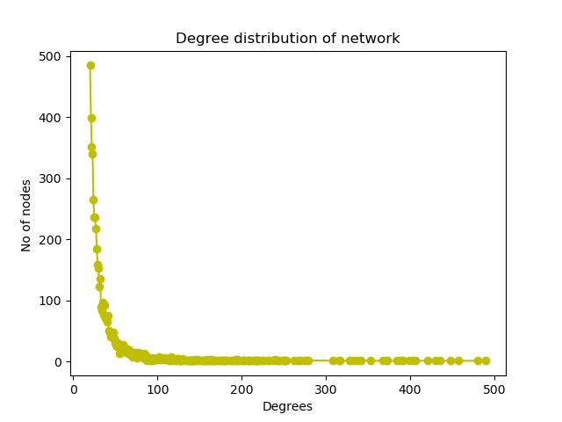

Graph plot

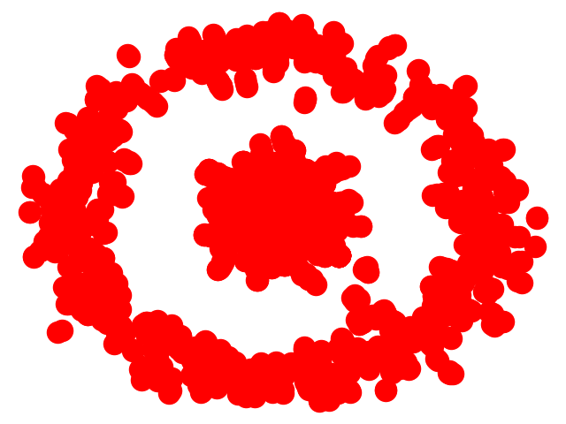

If ER model with same parameters were created then

Average Shortest path : 3.82068247881

Average Clustering Co-efficient : 0.00217847756537

If WS model with same parameters were created then

Average Shortest path : 4.07752997617

Average Clustering Co-efficient : 0.0431872224837

If AB model with same parameters were created then

Average Shortest path : 2.62709409514

Average Clustering Co-efficient : 0.0285012164725