Backend – 4 ( REST )

* What is REST
* A black background with white text

  AI-generated content may be incorrect.
* REST is a simple way for your app and server to talk to each other over the internet using links and rules like GET or POST.

In a REST system:

* You have a **client** (like your browser or app) and a **server** (like your backend Node.js app).
* The client makes **requests** (like GET, POST, PUT, DELETE) to the server to either **create**, **update**, read or **delete** data ( CRUD ) .
* The server responds with data (often in JSON format) or a message.
* REST follows a **stateless** rule — the server doesn’t remember the client’s previous request.
* Link : https://stackoverflow.blog/2020/03/02/best-practices-for-rest-api-design/
* CRUD Operations
* 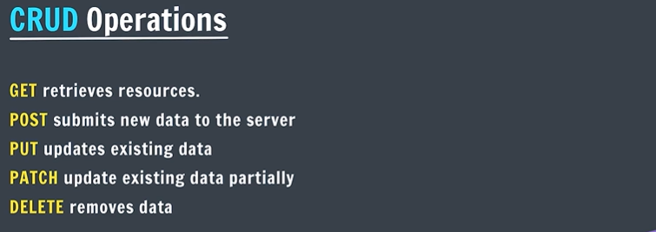
* Creating RESTful APIs
* A screenshot of a computer

  AI-generated content may be incorrect.
* app.set("view engine" , "ejs");
* 👉 This line tells Express to use EJS to convert (or "render") dynamic template files into real HTML pages to show to the user.
* Implement : GET / posts
* A blue and white text

  AI-generated content may be incorrect.
* A screenshot of a post

  AI-generated content may be incorrect.
* A route defines a specific URL path and the server’s response when that path is requested.
* Redirect
* res.redirect( URL )
* Implement : Get / posts / : id
* 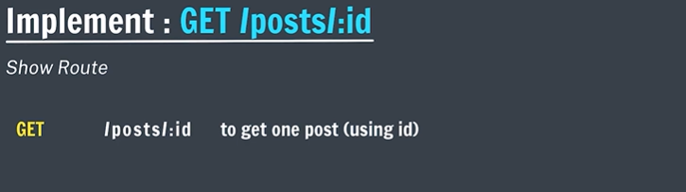
* Creating Id for Posts
* A screenshot of a computer

  AI-generated content may be incorrect.
* uuid package is used to create unique “id” .
* Implement : PATCH / posts / : id
* 
* A PATCH request is used to update or modify a part of existing data on the server without replacing the whole data.
* Create Form for Update
* A screen shot of a computer

  AI-generated content may be incorrect.
* Since you can't directly use <form method="PATCH">  
  — developers use a trick called **method override**.
* **📌 What’s Method Override in simple words?**
* **In one line layman explanation:**  
  👉 "We send a hidden field or query param inside a POST request to **pretend it's a PATCH or DELETE**, and the server reads that and treats the POST as a PATCH."
* Delete Operation
* 