**DEPARTMENT OF COLLEGIATE & TECHNICAL EDUCATION**

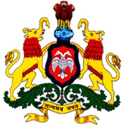 **GOVERNMENT POLYTECHNIC **

**CHAMRAJANAGARA – 571313**

**DEPARTMENT OF COMPUTER SCIENCE AND ENGINEERING**

**FAREWELL PARTY**

**Batch of 20__ - 20__**