Assignment –1

1. Creating and Renaming Files/Directories

Create a directory named test_dir using mkdir.

Inside test_dir, create an empty file called example.txt.

Rename example.txt to renamed_example.txt using mv

Steps followed :

* Enter to the linux terminal enter to the root directory
* Create a directory named test_dir using the command mkdir.
* Enter the ls command to check the list of the directories
* Change the directory to test_dir using cd test_dir command.
* Check the current working directoy is test_dir using the ls command.
* Enter touch example.txt to create a file inside the test_dir directory.
* Use mv example.txt renamed_example.txt to rename the file name.

Below is the snap of the practical performed.

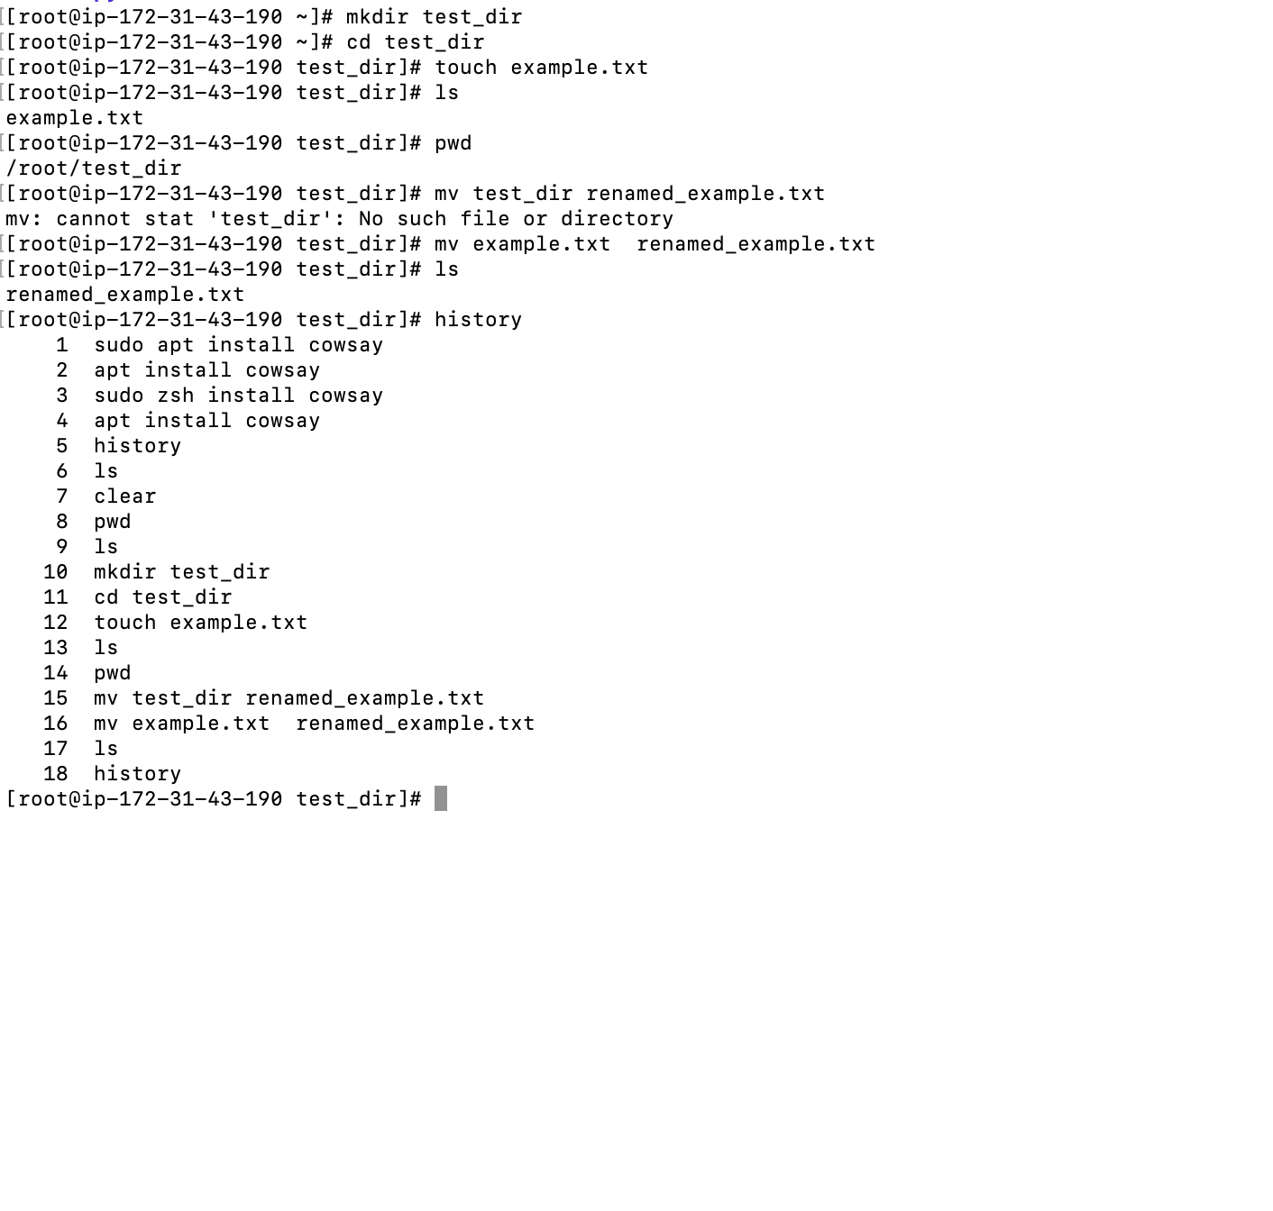

2. Viewing File Contents

Use cat to display the contents of /etc/passwd.

Display only the first 5 lines of /etc/passwd using head.

Display only the last 5 lines of /etc/passwd using tail.

Steps followed:

* Created the directory etc with mkdir etc command
* Checked with ls later cd etc to change the working directory
* In the directory etc creted the directory passwd
* Checked with ls : -- /etc/passwd
* In the directory passwd created a file passwd
* Using command touch passwd.txt
* To enter the text inside the file passwd used the vi editor / nano command.
* Checked the content with cat passwd.txt
* To display first 5 lines used the command
* Head –5 passwd.txt
* To display the last 5 lines used the command
* Tail –5 passwd.txt

Attached is the screenshot for reference.

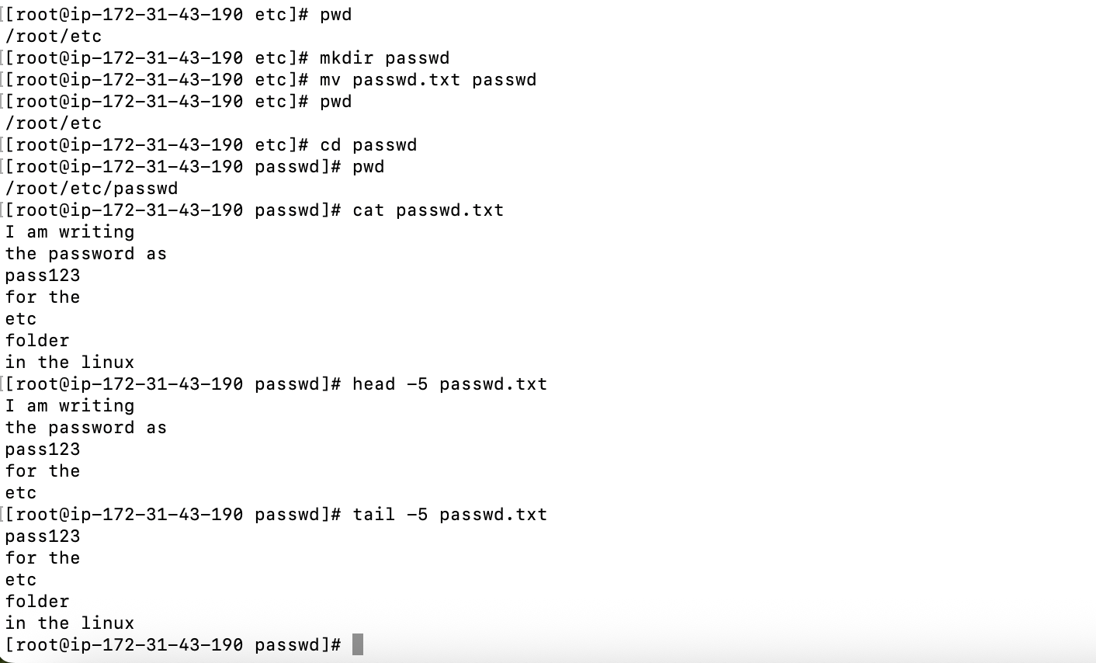

3.Searching for Patterns

Use grep to find all lines containing the word "root" in /etc/passwd.

Steps followed:

* Created the directory etc with mkdir etc command
* Checked with ls later cd etc to change the working directory
* In the directory etc creted the directory passwd
* Checked with ls : -- /etc/passwd
* In directory passwd used the command cat passwd.txt | grep root –n

To check the number of times the word “root” has occured in the passwd

Attached is the screenshot for the reference

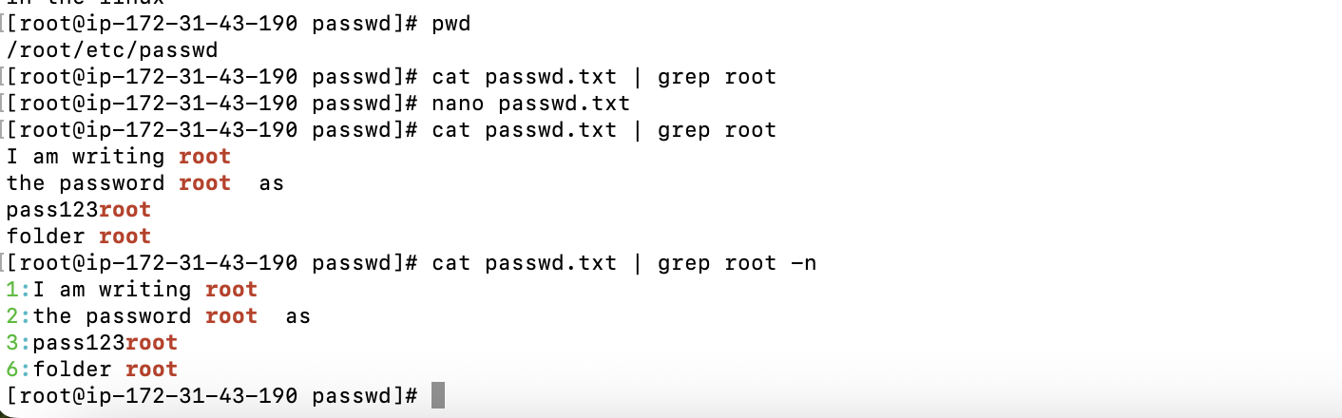

4. Zipping and Unzipping

Compress the test_dir directory into a file named test_dir.zip using zip.

Unzip test_dir.zip into a new directory named unzipped_dir.

Steps followed :

Added the two files in the passwd directory in the file test_dir using the command

Zip test_dir.zip

After checked with ls

Only one file was present in the folder named test_dir.zip

Later used the command

Unzip test_dir.zip to unzip the files

Checked with ls for the existing files, files were unzipped.

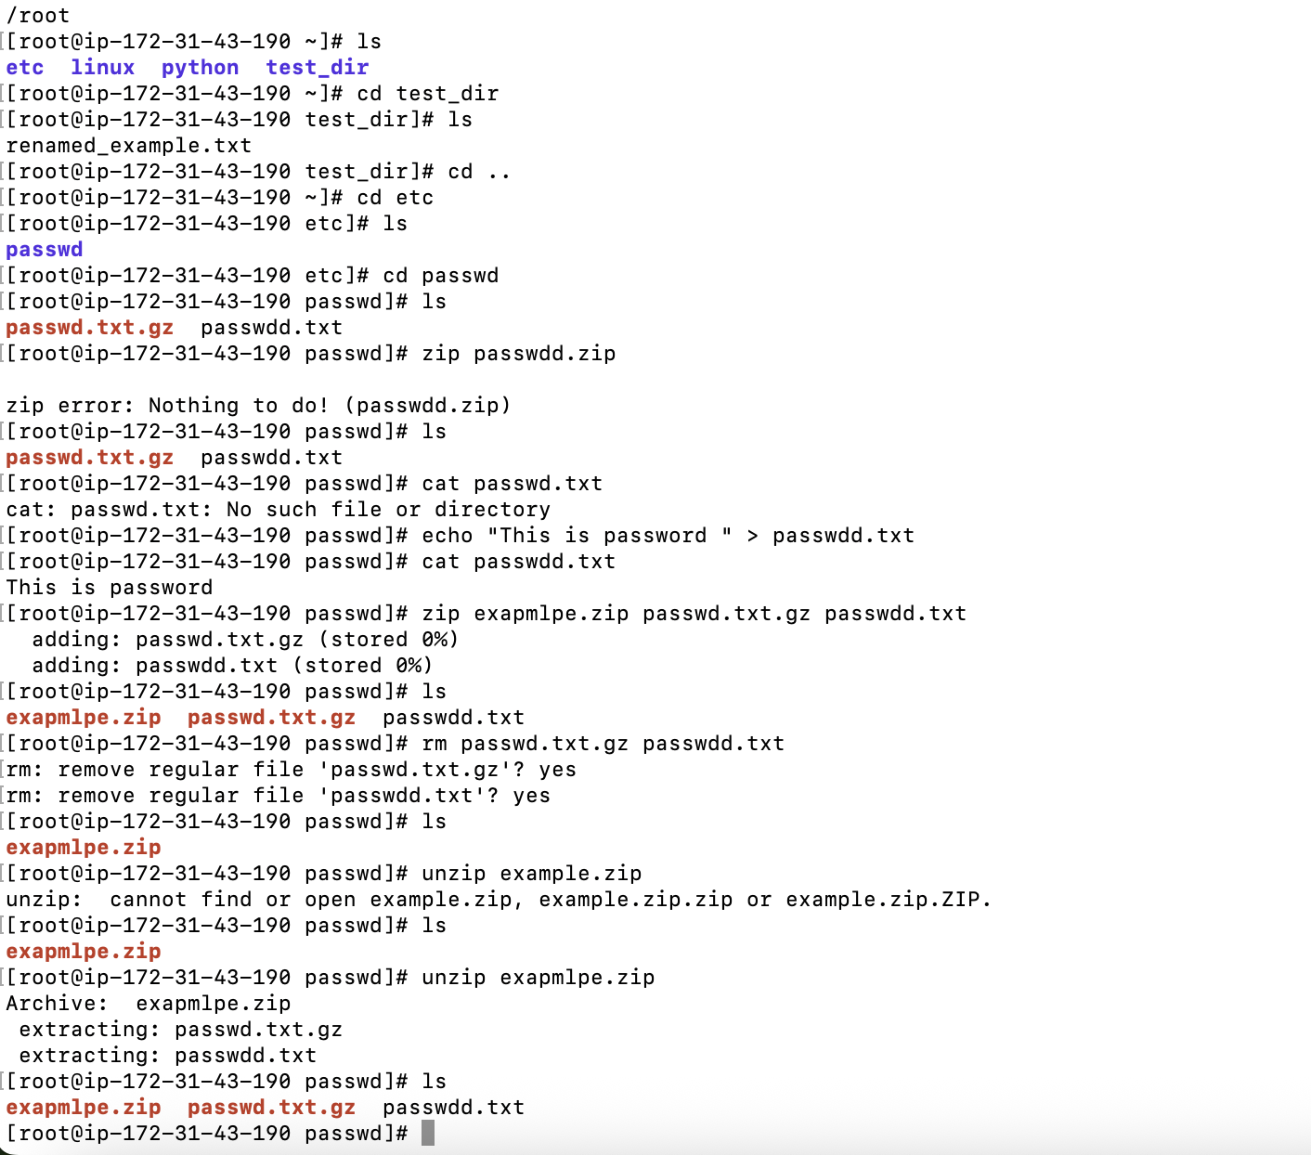

5. Downloading Files

Use wget to download a file from a URL (e.g., <https://example.com/sample.txt>).

Steps followed:

* Tried to connect to the example using the wget command
* Connection timeout as no root for the host.
* Later provided the domain of one image from the internet and
* Using the command wget and url
* The image was downloaded in the destination directory
* Later checked with the ls command one extra file named index.html was present

Attached is the screenshot for reference.

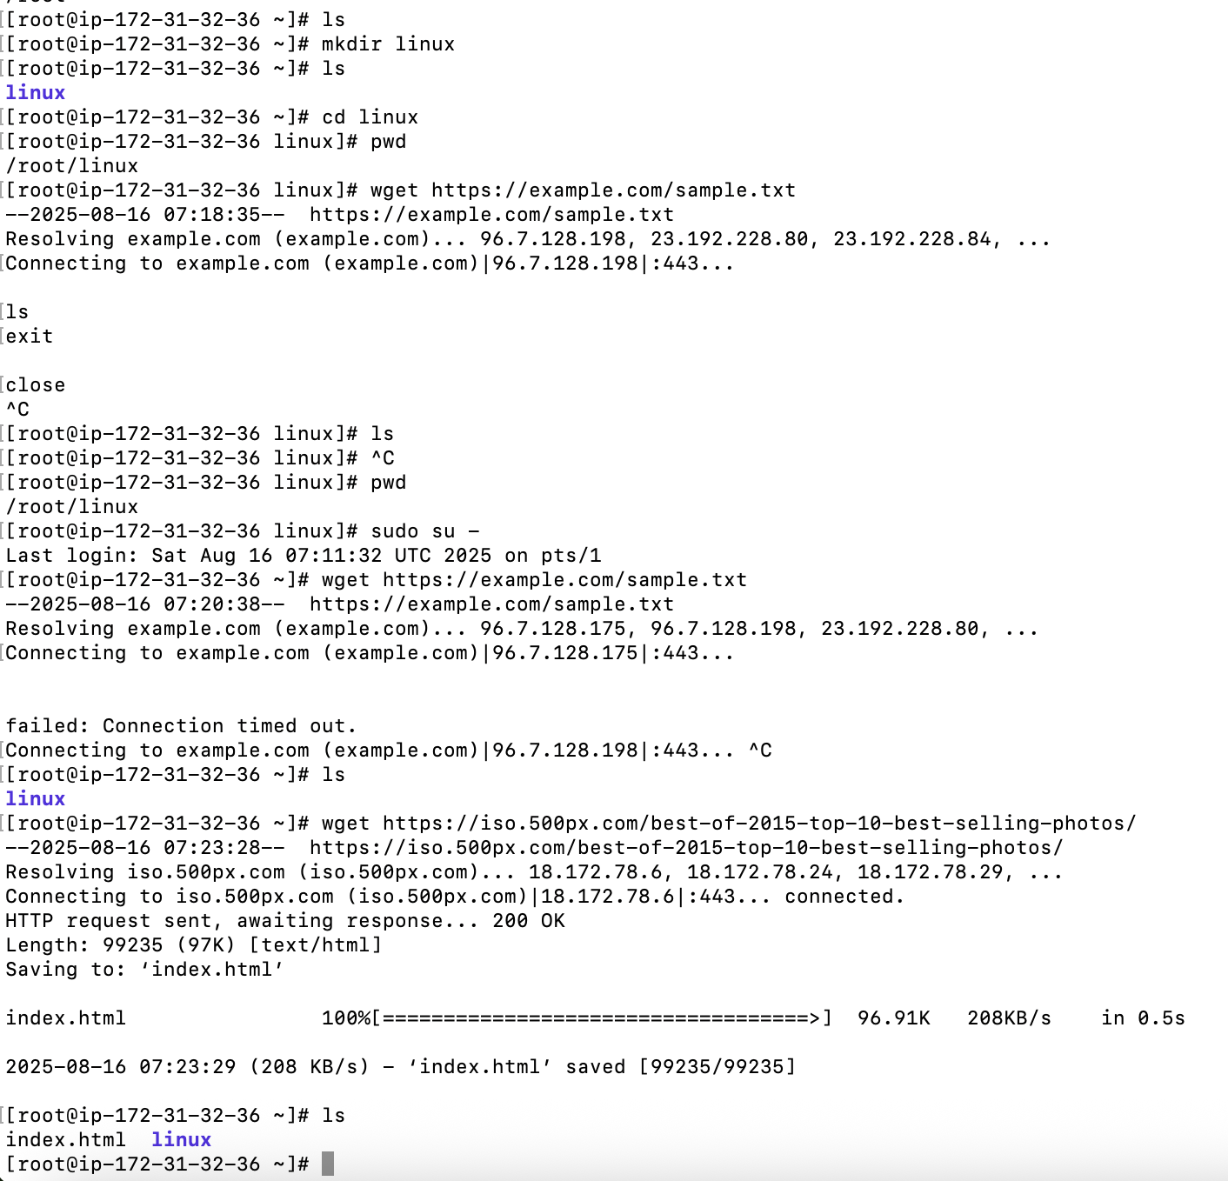

6. Changing Permissions

Create a file named secure.txt and change its permissions to read-only for everyone using chmod.

Steps followed :

Created the file secure.txt using the command mkdir secure.txt

Later checked the file permission using the command ls –la

For the secure.txt

As the current permissions were read , write , executable.

Changed the permissions to read only using the command

Chmod 444 secure.txt

Later checked with the command ls –la

Permissions were changed to read only .

Attached is the screenshot for reference.

7. Working with Environment Variables

Use export to set a new environment variable called MY_VAR with the value "Hello, Linux!".

Steps followed:

Used the command export MY_VAR = “ Hello , Linux! “

Later used the command echo $MY_VAR to check the value which was set to the MY_VAR

The printed output was Hello,Linux!

Attached is the screenshot of the practical along with the history of all the command performed.

