TY B.Tech. (CSE) – II [ 2021-22 ]

Software Engineering Tools Lab

PRN/ Roll No: 2018BTECS00103 & 2019BTECS00003

Batch: T6

Assignment No. 2

***Module 2- Software Development Frameworks***

1. For Eclipse IDE provide the answers for below questions:
2. Original author – IBM(International Business Machines Corporation)
3. Developers – Eclipse Foundation
4. Initial release – 1.0 / 7 November 2001
5. Stable release – 4.22.0 / 8 December 2021
6. Preview release – 4.21 (2021-09 release)
7. Repository (with cloud support) –

<https://download.eclipse.org/releases/latest/>

1. Written in (Languages) – Java, C
2. Operating System support – macOS, Windows and Linux
3. Platform, portability – Java Platform, Standard Edition & Portable
4. Available in (Total languages) – Available in 44 languages
5. List of languages supported – C, C++, C#, JavaScript, Perl, PHP, Python, R, Ruby, etc
6. Type – Integrated Development Environment
7. Website – <https://www.eclipse.org/ide/>
8. Features – Provides code insight, provides workspace, provides editors and views, etc
9. Size (in MB, GB etc.) – 182 MB
10. Privacy and Security – Any personally identifiable information collected by virtue of contributions will be publicly available on the Internet in unencrypted form and without access restriction.
11. Type of software (Open source/License) – Open Source
12. Latest version – 4.22.0
13. Cloud support (Yes/No) – Yes
14. Applicability – Eclipse is especially designed to handle large development projects
15. Drawbacks (if any) – Eclipse has a tendency to run slower than other IDEs. There are many reasons for this, such as insufficient memory allocation
16. **Implement linear regression problem using Google Colab (Perform pre-processing, training and testing)**

Dataset – <https://www.kaggle.com/spittman1248/cdc-data-nutrition-physical-activity-obesity>

Pre-processing

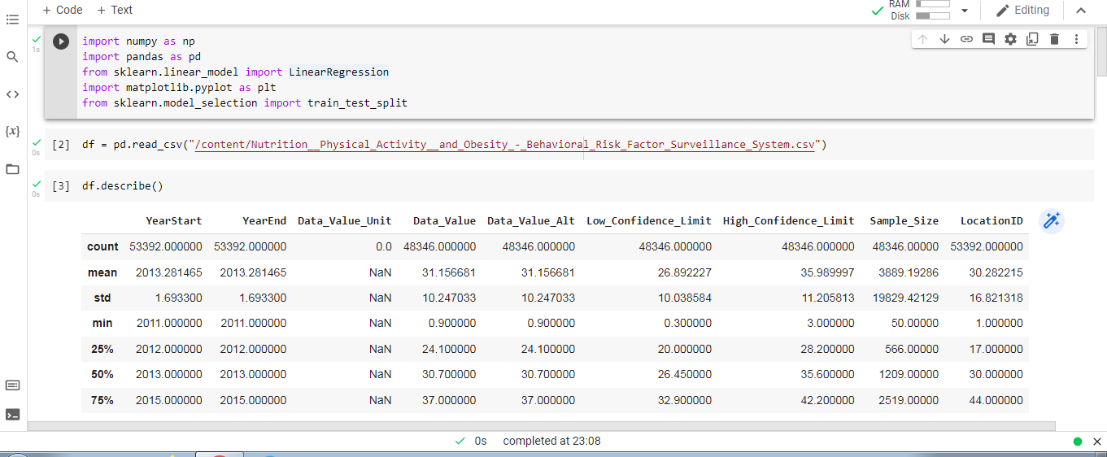

Training

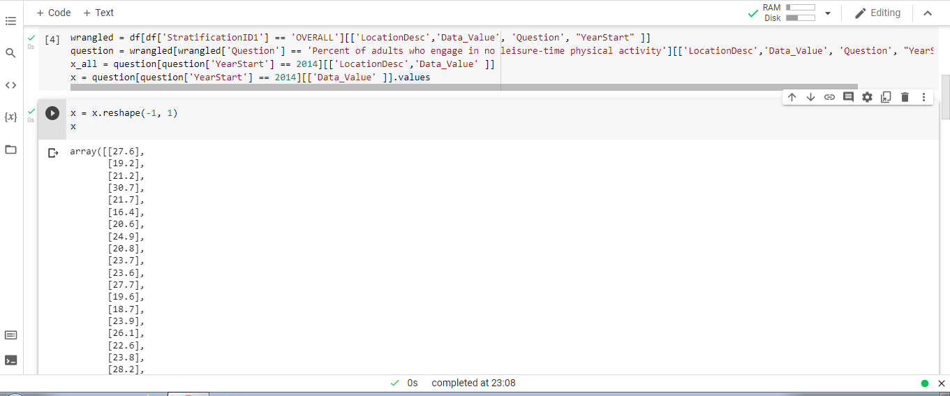

Testing

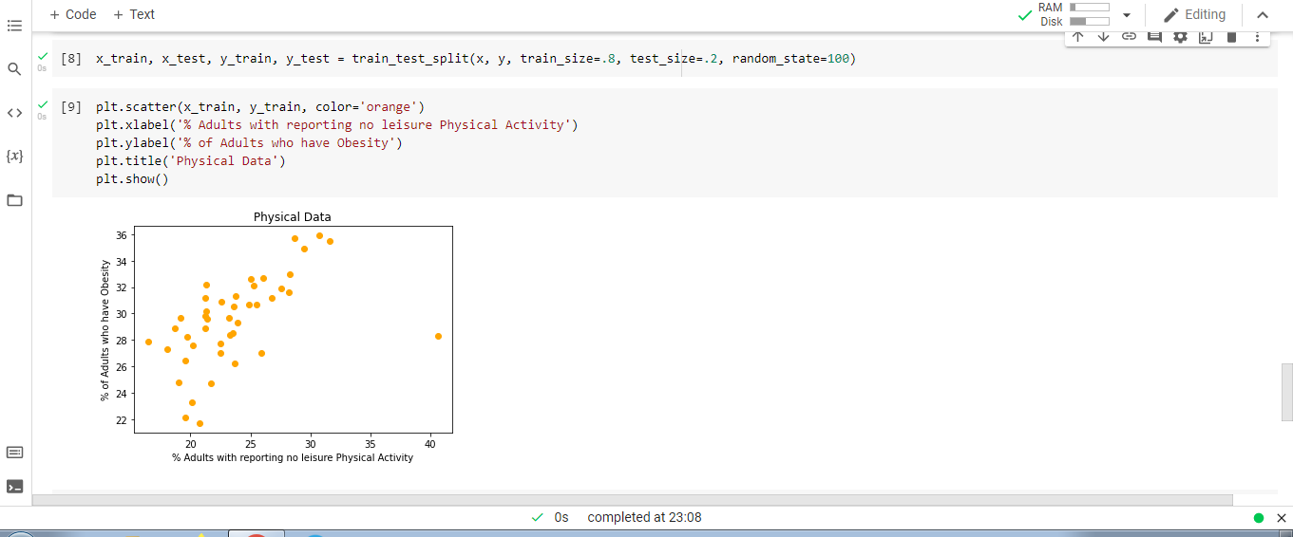

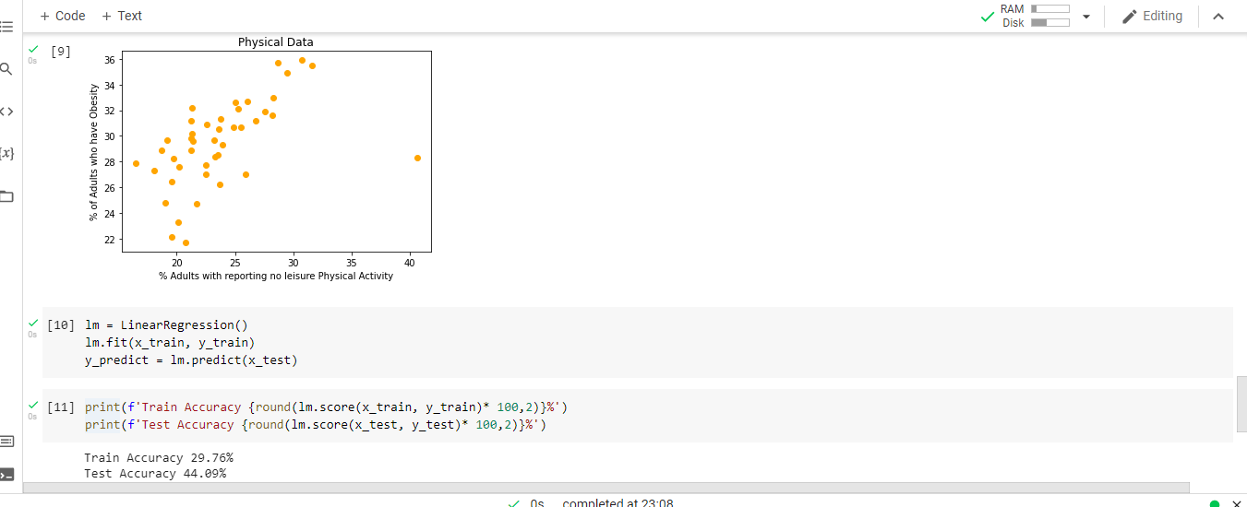

Linear Regression

