----------------Instruction to Run Code----------------

1. First unzip the file.

2. Follow are requried software and some liberaries for project.

Software:-

a) Python Language

Liberaries:-

a) tkinter

b) cv2

c) imutils

d) time

e) numpy

d) PIL

f) imageio

g) pathlib

h) shutil

i) argparse

j) pyttsx3

3. In Main Folder(Project), executable file name is gui.py file.

4. Run gui.py file on command prompt by typing the command as follow:

"python gui.py --prototxt MobileNetSSD_deploy.prototxt.txt --model MobileNetSSD_deploy.caffemodel"

5. GUI of project will shown.

OUTPUT:

First page:

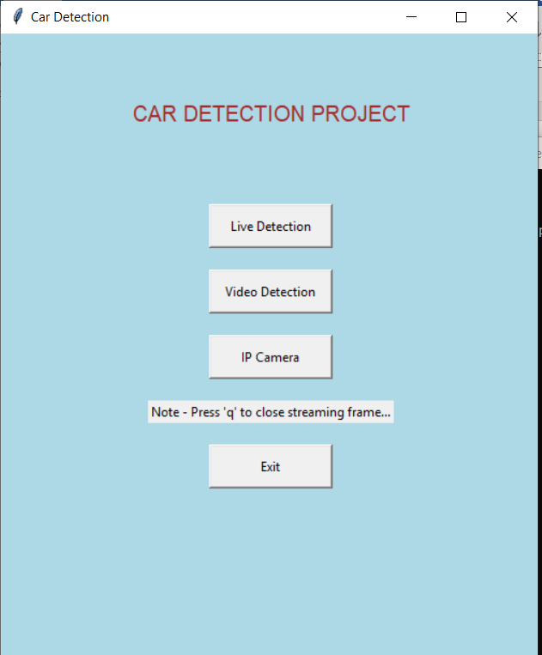

Live Detection:

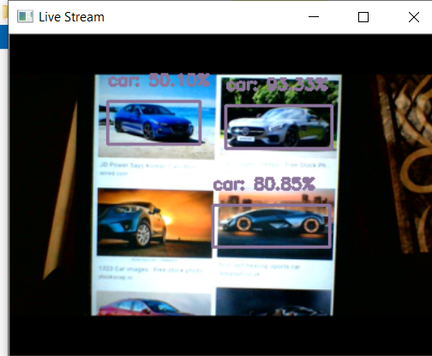

Video Stream Detection:

