LEARNER EDITION
Core Build Starter Guide
From written requirements to a running application, in ten stages
The core build is the sequence an experienced developer follows to take an application from written requirements to a deployed system that keeps running. This guide teaches that sequence in ten stages, the reasoning behind each decision, and one worked example carried through every stage.
Audience | Developers building and running a full application, from those doing it for the first time to experienced developers who want the reasoning, the comparisons and the checklists. Two reading paths are given below
Prerequisites | Python and basic SQL. Git and the command line help; Working in Git covers what a team needs. Installed: Python, Node.js, PostgreSQL, Docker (for the integration tests), Git, and an editor with a debugger
Reading time | About 4 hours for the full guide, and about 2 hours on the experienced path. Allow one working session per stage when building alongside the guide
Version | 3.1, learner edition, October 16, 2026
Companion | Core Build Facilitator Notes: session plans, the validation record and the review history

Contents
How to use this guide 3
At a glance 5
Why this order 6
Quick reference 8
The example application 9
The ten stages
Stage 1. Gather the requirements 10
Stage 2. Pick the stack 13
Stage 3. Settle the versions 19
Stage 4. Structure the backend 23
Stage 5. Build the skeleton 30
Stage 6. Connect the front end 36
Stage 7. Build the database 40
Stage 8. Prepare for load 50
Stage 9. Test and deploy 58
Stage 10. Operate after launch 76
Adding a module later 87
Working in Git 89
Documentation and working rhythm 97
Checklist 98
Glossary 101
Answers to the self-checks 106
Sources 110

How to use this guide
Read the stages in order. Each stage uses the output of the one before it, and the guide teaches that order as much as the content of each stage.

What you will be able to do
After working through the guide and its example, you can:
- Write requirements that give each later stage what it needs, including the two load numbers and the operating requirements: audit, retention, recovery and acceptable downtime.
- Choose a stack one layer at a time, including the API style, and record the reason for each choice.
- Set version rules for the tools you depend on and for the API you publish.
- Lay out a backend and its repository, write its skeleton, use an AI assistant to fill function bodies, and review them for correctness and security.
- Connect a front end, design the database in detail from the fields the application uses, and decide from measurements which load layers to add.
- Plan the tests for each layer, choose a deployment strategy, and deploy the application as separate services through a sandbox.
- Operate the application after launch: logs, errors, rollbacks, backups, patches and secret rotation.
- Work on the same code as other developers through branches and pull requests, and resolve merge conflicts.

Reading paths
Path | Who it is for | What to read
Full path | Developers building or running a full application for the first time | Everything, in order. In each stage, read its Basics blocks first, then the Steps, then the Going deeper sections and the Scenarios
Experienced path | Developers who have shipped applications before | The Decision in brief box and the Steps of each stage, then the Going deeper tables and the Scenarios. Skip the Basics blocks. Use the Common mistakes and the Checkpoints as a review list

Both paths use the same example application and the same checkpoints.

How each stage is laid out
Every stage has the same parts, in this order:
- Decision in brief. A box with the decision, the input it uses, the default choice, the reason for it, when to choose differently, the output it produces, and how much of the stage a first application needs.
- Steps. The questions to work through, in the order an experienced developer asks them.
- Common mistakes. What goes wrong at this stage, including rules that are often misremembered.
- Example. What the stage produces for the example application.
- Checkpoint. What must be true before the next stage starts. Commit your work at each checkpoint.
- Self-check. Questions with answers near the end of the guide.

Some stages add three kinds of block after the Steps:
- Basics. Plain definitions of the terms the stage uses. On the full path, read them before the Steps; skip them if the terms are familiar.
- Going deeper. A comparison of the options for one decision, with the strengths, the limits and when to use each one, and the default to use when no requirement points elsewhere.
- Scenario. A situation and what to do about it. Choices are shown as rows in a table; procedures, such as resolving a merge conflict or rolling back a release, are shown as numbered steps with the commands.

Stages 8 and 9 also have a table headed Original practice and this guide. It records where this guide recommends something different from the practice it is based on, and why.

A first application
The First app row in each Decision in brief box says how much of the stage a first application needs. Stages 1, 2 and 4 to 7 are done in full. Stage 3 can be kept short. Stage 8 is usually a load test, a stress test and one decision table. Stages 9 and 10 are done in full, on the smallest deployment that meets the requirements. In the Going deeper sections, read the comparison for each decision your application faces; where no requirement points elsewhere, the default is enough.

What this guide does not cover
A specific cloud provider, container orchestration such as Kubernetes, and the internal configuration of the queue, cache and replication layers. Code appears only in the examples, as short illustrations of what a stage produces. Terms are defined in the Glossary near the end, and sources are cited by number, for example (Source 4).

At a glance
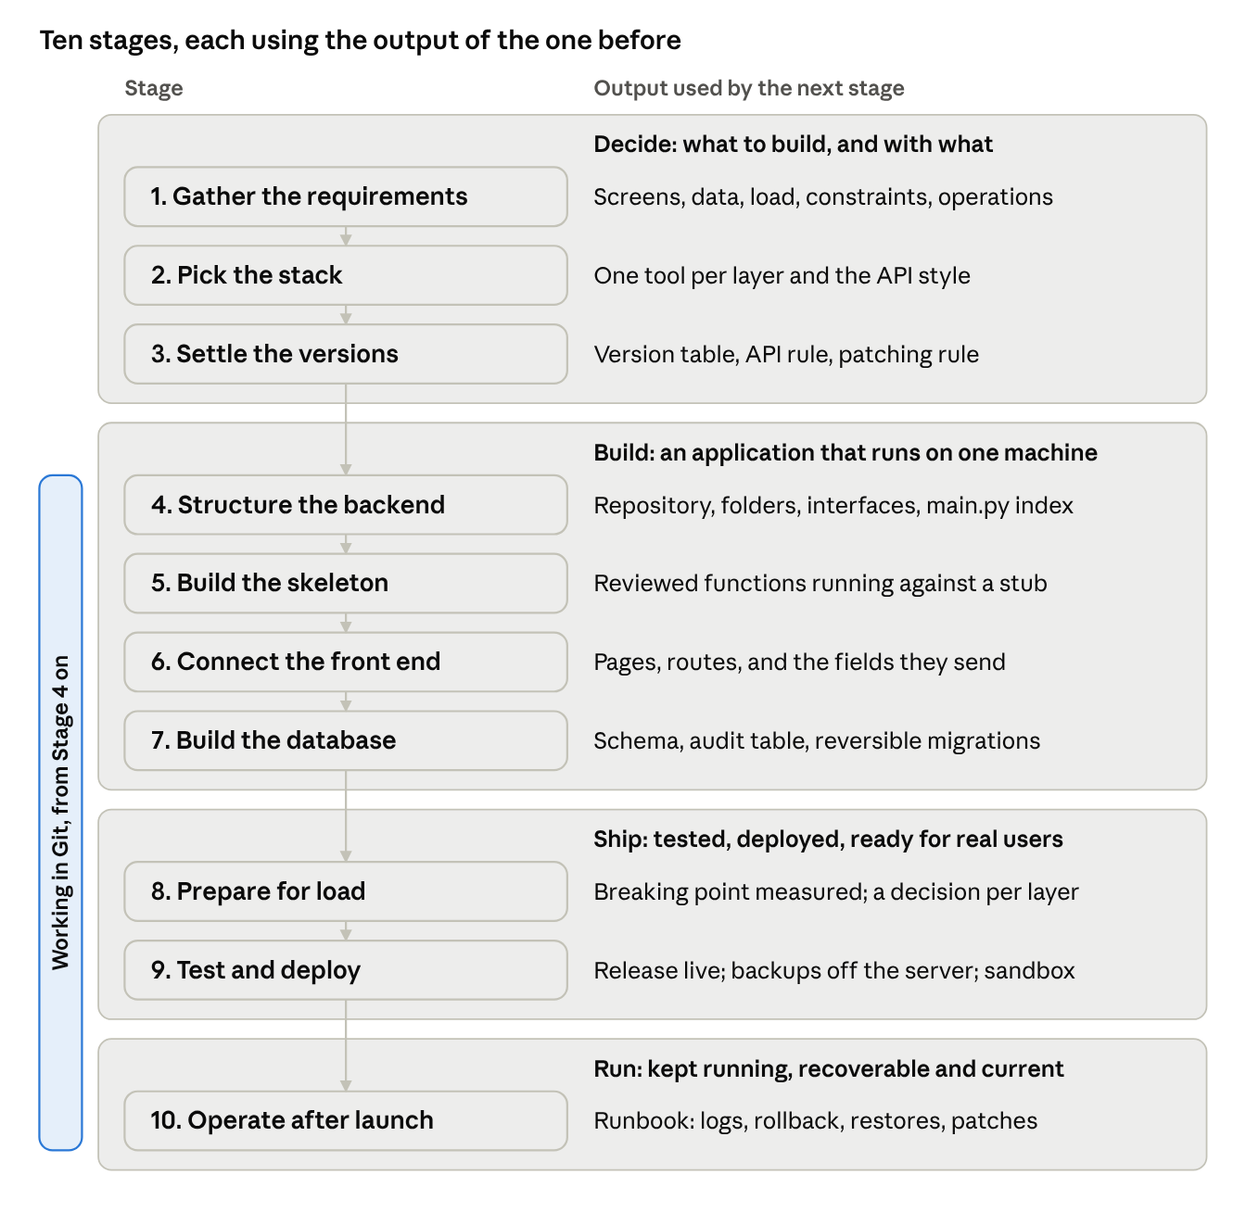
Figure 1. The ten stages and the output each one passes on
Stages 1 to 3 decide what to build and with what. Stages 4 to 7 build it and end with an application that runs on one machine. Stages 8 and 9 prepare it for real users and put it on servers. Stage 10 keeps it running after launch. Each box in Figure 1 names the output that the next stage uses. Working in Git, the chapter near the end of the guide, applies from Stage 4 on.

Why this order
Five rules set the order of the stages. Each one prevents a specific kind of rework.
- Requirements before tools. The stack is chosen to meet the requirements. A tool chosen first limits what the application can do, and the requirements then get changed to fit the tool.
- Structure before code. Versions, folders and interfaces are settled before any function body is written. Every file then has a known place and every function a known contract, which is what makes generated code reviewable.
- Skeleton, then screens, then tables. The backend skeleton runs first, against a stub data layer. The screens come next and settle what the front end sends. The tables are designed last, from the fields the screens and functions actually use. The usual alternative, designing the database first, produces tables for needs that were guessed.
- Measure before adding load layers. Every layer in Stage 8 is another service to deploy, monitor and maintain. Each one is added when a load test shows it is needed. Stage 8 comes before Stage 9 because the layers it adds (a queue, workers, and a Redis instance for the broker) change what Stage 9 deploys.
- Plan operations before launch, run them after. The operating requirements (audit, retention, recovery, downtime) are gathered in Stage 1, the audit table is built in Stage 7, and backups and logs are set up in Stage 9. Stage 10 comes last because it runs these routines on the live application, and each one is set up before the first incident that needs it.

Who decides what
The developer makes the decisions that require understanding the whole application. An AI assistant does work that can be checked against those decisions.
Task | Owner | Stages
Requirements, stack and versions | Developer | 1 to 3
Folder structure, interfaces and the main.py index | Developer | 4
Function skeleton and the comment in each function | Developer | 5
Function bodies, written from the skeleton | AI assistant | 5 to 7
Review of every generated body, including the security checklist | Developer | 5 to 7
Review of every pull request before it merges | A second developer; with one developer, the same developer against the Stage 5 checklist | 4 to 10
Critique of the written design | AI assistant | 4
Debugging with breakpoints | Developer | 5 to 10
Deployment strategy and rollback procedure | Developer | 9 and 10
Patch calendar, rotation schedule and restore tests, each with a named owner | Developer | 10
Change log of what was changed and why | AI assistant | All

The reason for this split: the person who maintains and debugs the application has to understand it, and that understanding comes from making these decisions. Writing every function body by hand does not add to it, so that work goes to the assistant.

Quick reference
Stage | Decision | Default | Choose differently when | Done when
1. Gather the requirements | What the application must do, for whom, under what constraints | Written requirements before any tool is chosen | A throwaway prototype | Screens, data, external services, two load numbers, constraints, target and operating requirements written down
2. Pick the stack | One tool per layer, and the API style | Next.js, Python, PostgreSQL, FastAPI with REST | A constraint mandates another tool; a requirement needs push updates, events or another API style | One tool per layer and the API style, each with its reason
3. Settle the versions | Which releases to build on; what counts as a breaking API change | Supported major version on its latest minor; exact versions recorded; new API version when a client could break | A small system can skip the detailed comparison | Version table with support end dates; breaking-change rule; patching rule
4. Structure the backend | Where each piece of behavior lives | Repository, lock files and branch rules first; folders by role; interfaces first; main.py as the index; design reviewed | .NET work uses MVC | Folders, interfaces and index in place; secrets kept out; design critique done
5. Build the skeleton | Which functions exist and who writes their bodies | You write the skeleton and comments; AI fills the bodies; you review them for correctness and security | A throwaway prototype | Runs locally against a stub; bodies reviewed; one failure traced with a breakpoint
6. Connect the front end | How each screen reaches the backend | Components, then one route per screen, then API calls; credentials checked in the backend | One HTML page is enough | Every screen has a page, a route and an API call; sign-in works; component tests pass
7. Build the database | What is stored and in what structure | Fields, tables with types and constraints, views, indexes, an audit table; schema applied by reversible migrations | Files go to object storage | Schema applied; downgrades tested; full request path works
8. Prepare for load | What breaks first at the expected load | Measure; add queue, rate limits, pooling and replicas only as measured; shard last | Managed cloud services replace self-hosted layers | Breaking point recorded; each layer added or marked not needed
9. Test and deploy | What must be true before go-live, and how it runs | A test plan by layer; CI build; separate services behind a reverse proxy; a deployment strategy that fits the downtime requirement; off-server backups; sandbox first | A cloud deployment service replaces the server steps | Tests recorded; services, backups, health check and sandbox in place; rollback tested
10. Operate after launch | How the application is kept running, recoverable and current | Log retention, error tracking with alerts, a written rollback procedure, monthly restore tests, a patch calendar and secret rotation | Managed services take over some routines | Runbook written, each routine with an owner, and each one run once

The example application
Every stage ends with an example that shows what the stage produces for one application, User Notices. The example uses situations that come up in most business applications: a list of records with a detail page, a sign-in that fails, a bulk send of 5,000 messages, a feature requested after launch, and a year of operation after launch.
User Notices is an internal application. Staff sign in, browse a list of registered users, open and edit a user's details, and schedule SMS notices to groups of users. One notice can go to up to 5,000 users at once. The messages go out through an external SMS provider's API. After launch, the team asks for an internal chatbot that answers staff questions about users and notices.
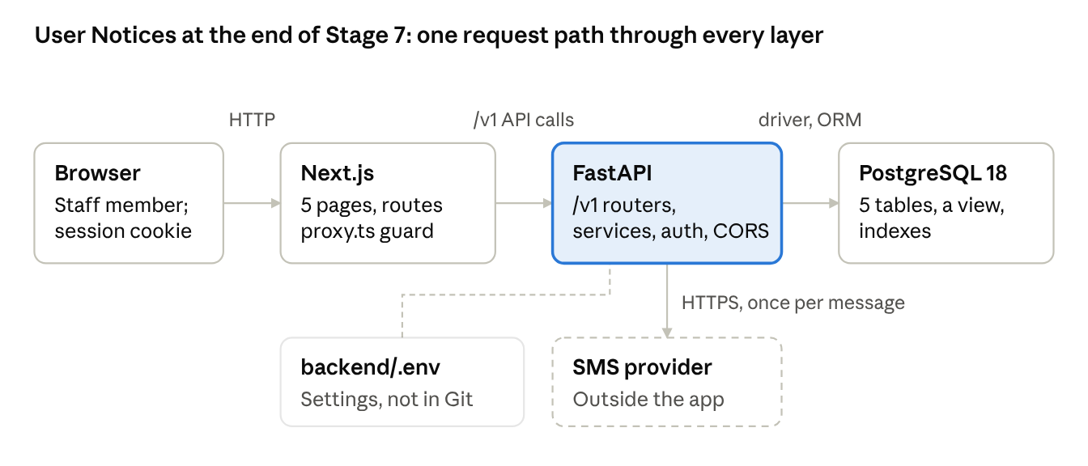
Figure 2. User Notices at the end of Stage 7
Figure 2 shows User Notices at the end of Stage 7, before any load work: the browser, the Next.js front end, the FastAPI backend, the PostgreSQL database, and the SMS provider outside the application. Stages 8 to 10 add to this picture.
DECIDE · STAGE 1 OF 10

Stage 1. Gather the requirements
DECISION IN BRIEF
Decision | What must the application do, for whom, and under what constraints?
Input | A request for an application, and access to the people who will use it
Default | Write the requirements down and settle them before thinking about any tool
Reason | Every later stage takes its input from this one. The stack is chosen against the requirements, not the other way around
Choose differently when | A throwaway prototype with no maintenance ahead can skip written requirements
Output | Screens, stored data, external services, two load numbers, constraints, the deployment target and the operating requirements, written down
First app | Do in full

Steps
- Screens. What does a user do in the application, screen by screen? List each screen and what happens on it. Stage 6 turns each screen into a page and a route.
- Data. What has to be stored and retrieved, including anything that must be logged? Which actions need an audit record of who did what, to which record and when? Stage 7 turns this list into fields and tables, including the audit table.
- External services. What does the application talk to outside itself: other services, APIs, message providers? Stage 2 chooses the API approach from this list.
- Load. How much load to expect, as two separate numbers: registered users, and requests at the same moment (concurrent requests). 100,000 registered users may produce 50 concurrent requests. Note how the load arrives: steady, or in bursts such as a scheduled bulk send. Stage 8 uses these numbers.
- Constraints and deployment target. Which tools are mandated, which database licenses are already held, where data is allowed to live, and where the application will run: a cloud provider or the organization's own servers. Stage 2 treats constraints as overriding its defaults, and Stages 8 and 9 build for the deployment target.
- Operating requirements. How long must each kind of record and log be kept? How much recent data may be lost if the database server fails (the recovery point), and how long may the application be down while it is restored (the recovery time)? When are users working, and how long may an update interrupt them? Stage 9 chooses the deployment strategy and the backups from these answers, and Stage 10 sets the retention, the restore tests and the update windows.

Common mistakes
- Choosing a framework or database before the requirements exist.
- Recording load as one number. Registered users and concurrent requests lead to different decisions in Stage 8.
- Leaving out bursts. A scheduled bulk send is a load pattern even when daily traffic is small.
- Leaving out what must be logged. Logs are stored data and need tables in Stage 7.
- Leaving out the operating requirements. Without a retention period, a recovery point and an acceptable downtime, Stages 9 and 10 have nothing to design the backups, the deployment strategy and the log settings against.

EXAMPLE: USER NOTICES
Item | Requirement
Screens | Sign in; Users list, filtered by group; User detail, to view and edit; New notice, with text, group and send time; Notice history, with the status of each notice and a Send now action
Stored data | Staff accounts, each with a role (editors change users and send notices; viewers only read); users (name, phone number, group, opt-in); groups; notices (text, group, send time, status, author); one send record per message, kept as a log; an audit record per audited action
External services | The SMS provider's API, called once per message
Load | 150 staff accounts and at most 40 concurrent requests. The 60,000 user records are data, not load. Bursts: one notice can go to a group of up to 5,000 users
Constraints | Data stays on the organization's own servers. No cloud provider
Deployment target | Two Ubuntu Server LTS machines in the organization's data center: one for the live application, one for the sandbox (a second copy of the deployment, used for testing, set up in Stage 9)
Audit | Record staff sign-ins (successful and failed), every change to a user's details or opt-in, and every notice created or sent, with the staff member and the time
Retention | Application logs 30 days; web server access logs 90 days; send records and audit records 2 years, as the organization's records policy requires
Recovery | At most one working day of changes may be lost (recovery point: the previous night's backup); the application must be back within one working day (recovery time 8 hours)
Updates | Staff work from 8:00 to 18:00 on weekdays. Updates outside those hours may interrupt the application for up to 5 minutes

CHECKPOINT
- Every screen listed, with what the user does on it
- Stored data listed, including logs
- External services listed
- Load recorded as two numbers, with how it arrives
- Constraints and deployment target written down
- Audit, retention, recovery and update requirements written down

Self-check
- An application will have 80,000 registered users. What second number do you need before Stage 8, and why?
- A nightly job will send 10,000 reminder messages. Where does that belong in the requirements?
- Staff ask who changed a user's opt-in last week, and the application cannot say. Which requirement was missing, and which stages build what it needs?
DECIDE · STAGE 2 OF 10

Stage 2. Pick the stack
DECISION IN BRIEF
Decision | Which tool will each layer of the application use?
Input | The Stage 1 requirements and constraints
Default | Next.js for the front end, Python for the backend, PostgreSQL for the database, and FastAPI serving a REST API
Reason | Each layer is decided against one question from the requirements, and each answer limits the choices for the next: a Python backend means a Python API framework
Choose differently when | A Stage 1 constraint mandates another tool, a license is already held, or no cloud provider is allowed
Output | One tool per layer and the API style, each with its reason written next to it, and a list of the settings the application will read
First app | Do in full

Steps
- Front end. Is a front end needed at all? If so, is one HTML page enough? When the application has several pages with links between them (a users list that opens a user detail page), the default is Next.js with the App Router, where folders under app/ define the routes (Source 1).
- Backend language. What kind of work does the backend do? For AI work and calls to LLM APIs the default is Python, because most of the relevant libraries are Python libraries. Node.js supports the same LLM APIs and is a workable choice. Where the organization's finance or line-of-business systems are built on .NET, use .NET.
- Database. Is the data relational rows and columns, files, or both? The relational default is PostgreSQL unless the organization mandates another database; MSSQL, for example, needs licenses and organizational support. Files go to object storage: S3 when a cloud provider is allowed, otherwise a self-hosted S3-compatible store.
- API style. How do the front end and other programs talk to the backend, and does the server ever need to send something without being asked? The default is a REST API over HTTPS with JSON. Add another style only for the part of the application whose requirement needs it: updates pushed from the server, events sent by another system, or callers that need very different shapes of the same data (see Going deeper: Choosing an API style).
- API framework. For a Python backend the default is FastAPI, which describes the API in an OpenAPI document and shows it at /docs. Write each endpoint function as async def and use libraries that support await for network and database calls, so the server keeps handling other requests while one call waits. When a library has no await support, declare that endpoint with plain def. FastAPI then runs it in a threadpool so it does not block the server (Source 4).
- Settings. List the settings the application will read from its environment: the database connection string, the addresses of other services, API keys, the secret that signs session cookies, and the front end's address. Stage 4 creates the .env file that holds them.

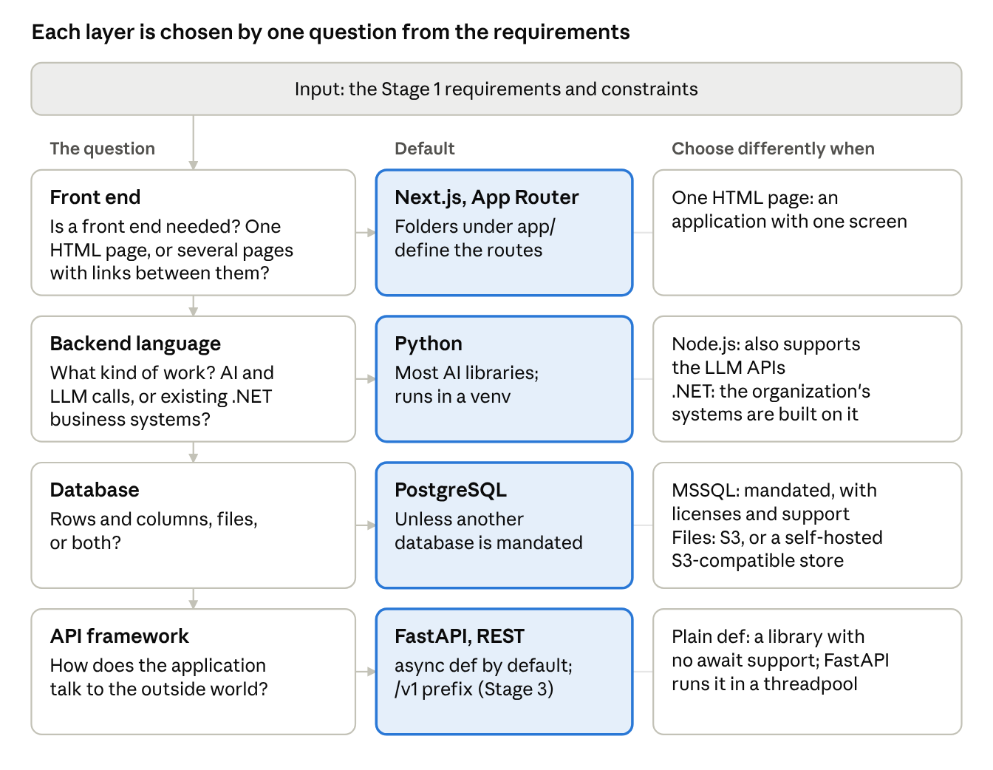
Figure 3. One question per layer, with the default and when to choose differently
BASICS API styles
An API style is the set of rules for how a client asks for something and how the answer comes back: what a request looks like, where it is sent, what format the answer uses, and whether the server can send data without a request.
- Request and response. The client sends a request and waits for one answer. REST, GraphQL, gRPC and SOAP work this way.
- Push. The server sends data when it has something new, over a connection the client keeps open. Server-Sent Events and WebSockets work this way.
- Callback. Another system calls a URL in your application when an event happens on its side. Webhooks work this way.
- Contract. A machine-readable description of the API that tools use to generate documentation, clients and tests: OpenAPI for REST, a schema for GraphQL, .proto files for gRPC, and WSDL for SOAP.

GOING DEEPER

Choosing an API style
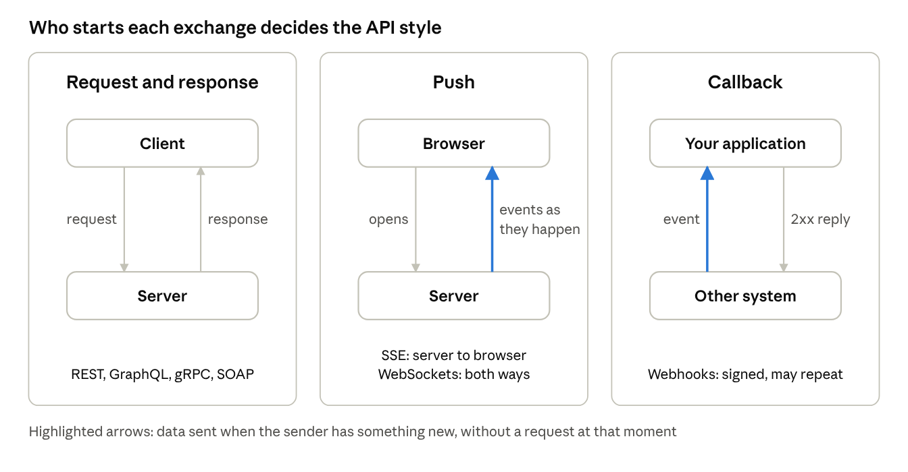
Figure 4. Request and response, push, and callback: who starts each exchange
Style | How it works | Strengths | Limits | Use when
REST over HTTPS with JSON | Each resource has a URL, and HTTP methods (GET, POST, PATCH, DELETE) act on it. OpenAPI describes it (Source 29) | Every language, browser and tool can call it; GET responses can be cached; can be tested with curl or from /docs; versions sit in the path | A screen may need several calls, or receive fields it does not use; the server cannot send without a request | The default for screens that list, view and change records, and for APIs other teams call
Polling | The page repeats a REST GET request every few seconds | Plain REST; nothing new to run on the server | Updates arrive up to one interval late, and requests continue when nothing has changed | Progress that may be a few seconds late, watched by a few people at once
GraphQL | One endpoint, usually /graphql. The client sends a query naming the fields it wants, checked against a typed schema (Source 30) | One request returns exactly the fields a screen needs, across related types; the schema documents itself | HTTP caching needs GET requests, and long queries need persisted queries to fit in a URL; the server must limit query depth and cost; nested fields cause N+1 queries unless batched with a DataLoader (Sources 31 and 32) | Several kinds of client (web, mobile, partners) need different shapes of the same data, and REST endpoints keep being added for each screen
gRPC | Methods defined in .proto files; messages encoded as Protocol Buffers over HTTP/2; client and server code generated; streaming in either or both directions (Sources 33 and 34) | Compact binary messages; a strict contract; four call types, including two-way streaming | Browsers cannot call it directly and need gRPC-Web through a proxy, or Connect; binary messages are harder to inspect (Sources 35, 36 and 37) | Calls between internal services at high volume, or with streaming
WebSockets | The client opens one connection that stays open, and either side can send at any time (Source 38) | Low-latency messages in both directions | Each open connection is held by one server process, so with several processes a shared message layer such as Redis is needed to reach every client; the reverse proxy must pass the upgrade headers (Sources 39 and 40) | Chat, live collaboration, and anything where both sides send often
Server-Sent Events (SSE) | The server keeps an HTTP response open and writes events to it; the browser's EventSource reads them and reconnects on its own (Source 41) | Plain HTTP; automatic reconnection; FastAPI supports it directly from version 0.135.0 (Source 42) | Server to client only; text only; without HTTP/2, a browser allows 6 open connections per domain, shared by all its tabs (Source 43) | Live progress, status updates, notifications, and streaming a chatbot's answer
Webhooks | Another system sends an HTTP request to a URL in your application when an event happens, signed with a shared secret (Source 44) | No polling; the event arrives when it happens | The endpoint must check the signature, drop repeated deliveries by event id, answer quickly and do the work in a queue. Senders retry, so the same event can arrive more than once | Receiving events from a provider: delivery reports, payments, repository events
SOAP | XML messages described by a WSDL file (Sources 45 and 46) | Strict contracts and long-established tooling in older enterprise and government systems | Verbose; few new services offer it | Only to integrate with an existing system that offers nothing else. In Python, the zeep client reads the WSDL

Default. Start with REST. Add another style for one part of the application when a requirement calls for it, and keep REST for the rest. One application can serve REST to its screens, stream one page with SSE, and receive webhooks from a provider.
Questions to ask, in order:
- Is the caller a browser, a script or another team's system? Use REST.
- Must the server send updates without being asked? If only the server sends, use SSE. If both sides send often, use WebSockets.
- Does another system need to tell you when something happens on its side? Receive its webhooks, if that system can reach your application's network; otherwise ask its API on a schedule.
- Do several kinds of client need different shapes of the same data, and are REST endpoints multiplying for each screen? Consider GraphQL, with depth and cost limits.
- Are two internal services exchanging a high volume of calls, or streaming? Consider gRPC.
- Does an existing system you must call offer only SOAP? Use a SOAP client for that one integration.

SCENARIOS

API style
Situation | Choice | Reason
User Notices: staff list, view and edit users and notices | REST | Every screen reads or changes records, and no screen needs updates pushed to it
Notice history should show a 5,000-message send progressing without a reload | SSE for that page | Only the server sends. SSE is plain HTTP and reconnects on its own. WebSockets add two-way traffic the page does not use. If a delay of a few seconds is acceptable, polling needs no new server code
The SMS provider reports each message's delivery status | A scheduled worker task that asks the provider's status API about messages not yet confirmed. A webhook only if the network team opens one path to the provider | User Notices can be reached only inside the organization's network, so the provider cannot call it. A webhook endpoint checks the signature, drops repeats by event id, answers within the provider's time limit, and updates the send record in a queued job
The internal chatbot streams its answer as it is written | SSE | One direction, text only, and the browser reconnects if the connection drops
Staff ask for a channel to message each other | WebSockets, with Redis publish and subscribe once there is more than one backend process | Both sides send, and a message must reach clients connected to other processes
A mobile app and a partner portal need different fields from the same records, and each new screen adds a REST endpoint | GraphQL for those clients, with depth and cost limits | Each client asks one endpoint for the fields it needs
Two internal services exchange thousands of calls a second | gRPC | Binary messages, generated clients and a strict contract; no browser is involved
The national tax office's lookup service offers only SOAP | A SOAP client in one service module; REST everywhere else | The other side fixes the integration; it does not change the application's own API

Common mistakes
- Choosing a tool because it is new or familiar, without a reason tied to a requirement.
- Using plain def to slow down calls to a server that rate limits them. Plain def functions also run concurrently, in a threadpool. Limit outbound calls with a client-side limiter, or with the task queue's rate limit setting in Stage 8.
- Missing a Stage 1 constraint, such as a mandated database, and finding out at deployment.
- Choosing GraphQL or gRPC for an application with one front end whose screens list and edit records. REST covers it with less code.
- Asking the server for updates every second when Server-Sent Events can send them as they happen.
- Accepting webhooks without checking the signature, or processing the same event twice.

EXAMPLE: USER NOTICES
Layer | Choice | Reason
Front end | Next.js with the App Router | Five screens with links between them, and a dynamic route for each user's detail page
Backend language | Python | The team writes Python, and its libraries cover any AI features added later
Database | PostgreSQL | Relational records: users, groups, notices and send records. No files, so no object storage
API style | REST over HTTPS with JSON | Every screen lists, views or changes records. No screen needs updates pushed from the server in the first release, and delivery reports from the SMS provider are not used in it
API framework | FastAPI | async def endpoints; the database driver and the HTTP client used for the SMS provider both support await
Settings | DATABASE_URL, SESSION_SECRET, SMS_API_URL, SMS_API_KEY, ALLOWED_ORIGIN | Read from the environment from Stage 4 on. Later stages add MIGRATION_DATABASE_URL (Stage 7), REDIS_URL (Stage 8), SMS_ALLOWLIST (Stage 9) and SENTRY_DSN (Stage 10), each added to .env.example in the same pull request. The front end has its own settings, NEXT_PUBLIC_API_BASE and API_INTERNAL_URL (Stage 6)
Constraint check | No cloud provider | Every layer runs on the organization's servers; PostgreSQL needs no license

CHECKPOINT
- One tool named per layer, and the API style chosen
- The reason for each choice written next to it
- Every Stage 1 constraint checked against the choices
- Settings listed

Self-check
- An endpoint uses a payment library that has no await support. How do you declare the endpoint, and what does FastAPI do with it?
- The SMS provider accepts a limited number of requests per second. A teammate suggests plain def so the calls go out one at a time. What is wrong with that?
- Your organization already licenses MSSQL and its database team supports it. Which database do you choose, and which stage's output tells you?
- Notice history must show a 5,000-message send progressing without a reload. Which API style do you add for that page, and why not WebSockets?
DECIDE · STAGE 3 OF 10

Stage 3. Settle the versions
DECISION IN BRIEF
Decision | Which release of each tool will the project build on, and what counts as a breaking change to its own API?
Input | The Stage 2 stack
Default | For each platform component, a major version that has had time for fixes and has years of support left, on its latest minor release. The exact version of every dependency recorded. A new API version for any change that could break an existing client
Reason | An unsupported version becomes a continuity problem later, and dependencies without exact versions make two builds differ. Callers depend on the exact shape of what the API returns
Choose differently when | A small system that does not touch major areas of a tool can skip the detailed comparison between versions. Large or financial systems do it in full
Output | A version table with support end dates and the exact version of every dependency, a written breaking-change rule, and a patching rule. The versions go into lock files when the repository is created in Stage 4
First app | Keep short: the version table, the exact versions, a /v1 prefix and the written rule

Steps
- List the components. Everything from Stage 2 that has a version: the operating system, the language runtimes, the database, the frameworks and the main libraries. Components added later, such as Redis in Stage 8, join the table when they are added.
- Platform components. For components that publish support policies (PostgreSQL, Python, Node.js, Next.js), choose a major version that has had time for fixes and has years of support left. A major version released in the last few months has had less time for fixes and for other tools to be tested against it. Run the latest minor release of the chosen major version. PostgreSQL minor releases contain only fixes, and the project recommends always running the current minor release (Source 10).
- Compare with what is in use. If the organization already runs an older version, compare the two: what was added, what changed, what was removed. A version already out of support, such as PostgreSQL 12, needs a plan to move off it.
- Libraries. Libraries without support policies (FastAPI, SQLAlchemy, Alembic and similar) get an exact version, are pinned in a lock file, and are updated deliberately, one at a time, with the tests run after each update. For Python, the lock file is a requirements.txt generated by pip-compile from requirements.in, so the libraries' own dependencies are pinned too.
- Compatibility. Confirm that the parts work together: the Python version, the packages in the project's virtual environment (Source 6), the database driver and the database version.
- Your own API. Write the rule for breaking changes. A breaking change is any change an existing client could fail on: a removed or renamed route or field, a changed type or meaning, a new required input, a changed error code, or a changed authentication requirement. An added optional field or a new route is not breaking. For a breaking change, release a new version, tell the clients before release, and keep the old version running while they move. The version usually sits in the path, /v1/users then /v2/users (Source 26).
- Patching rule. Write down how quickly each kind of update is applied after launch: minor and patch releases of the platform components, security fixes, and library updates, each through the sandbox first. Stage 10 puts the rule on a calendar.

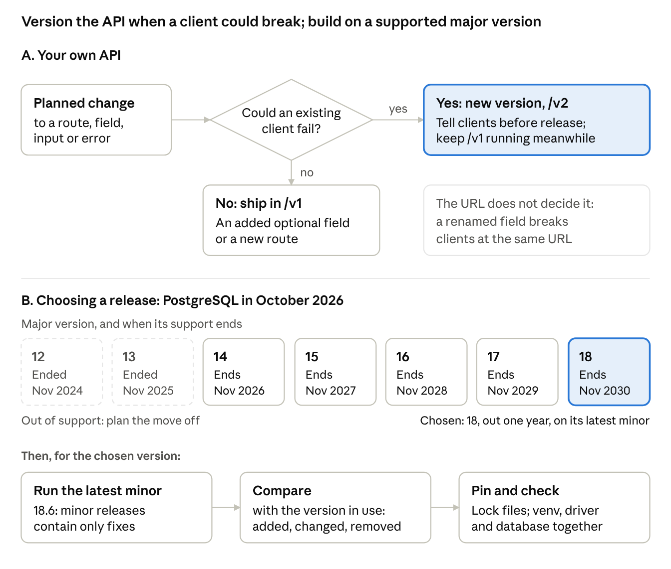
Figure 5. The breaking-change test, and choosing a PostgreSQL release in October 2026

Common mistakes
- Choosing the newest major release because it is the newest.
- Staying on an older minor release for stability. Minor releases contain only fixes; the stability decision is the choice of major version.
- Treating a change as safe because the URL did not change. A field removed from a response breaks clients at the same URL.
- Leaving dependencies unpinned, so the server installs different versions from the ones tested.

EXAMPLE: USER NOTICES
Component | Version chosen | Reason | Support ends
PostgreSQL | 18, latest minor (18.6 in October 2026) | Released September 2025, with five minor releases of fixes since; 19 is at the release candidate stage in October 2026 (Source 10) | November 14, 2030
Python | 3.14, latest patch | 3.15 was released on October 9, 2026, too recently; 3.14 is in its bugfix phase (Source 7) | October 2030, scheduled
Node.js, which runs Next.js | 24 LTS | Production applications should use LTS releases; 26 is not yet LTS (it becomes LTS on October 28, 2026) and has had less time for fixes (Source 8) | April 30, 2028 (Source 9)
Ubuntu Server | 24.04 LTS | The LTS release the organization's infrastructure team supports | May 2029, end of standard support (Source 47)
Next.js | 16, Active LTS | The current Active LTS major version. Next.js supports a major version for two years, so the upgrade to the next major is planned within the year (Source 3) | About October 2027, two years after its October 2025 release (Source 3)
nginx | 1.24, the Ubuntu 24.04 package (Source 155) | Ubuntu maintains its package for the life of the release, so it follows the Ubuntu security updates | May 2029, with Ubuntu
FastAPI, SQLAlchemy, Alembic, psycopg | Exact versions, pinned in requirements.txt in Stage 4 | So every build installs the tested versions | Updated deliberately

Patching rule: minor and patch releases of PostgreSQL, Python, Node.js and Next.js go to the sandbox within two weeks of their release, and to live in the first monthly update window after the sandbox checks pass. A security fix rated critical goes to live within two working days, and on the same day when the advisory reports that the flaw is being exploited. Libraries are updated one at a time, with the tests run after each update.
API rule: every route starts with /v1. A breaking change is any change an existing client could fail on. Today the only client is the User Notices front end, so a breaking change ships together with the matching front end change. If another system starts calling the API, breaking changes go to /v2, with notice to that system's owners before release.

CHECKPOINT
- Version table with the chosen major version and support end date for each platform component
- Exact version recorded for every dependency
- Compatibility across runtime, packages, driver and database confirmed
- Breaking-change rule written: what counts, where the version lives, who is told
- Patching rule written

Self-check
- A response field is renamed and the URL stays the same. Is a new API version needed?
- PostgreSQL 18.6 is available. A colleague suggests staying on 18.2 because it has been out longer. What do you tell them?
- In October 2026, Python 3.15 is a week old and 3.14 is a year old. Which do you choose, and what do you record?
BUILD · STAGE 4 OF 10

Stage 4. Structure the backend
DECISION IN BRIEF
Decision | How will the backend be organized so that anyone can find where a given behavior lives?
Input | The Stage 1 screens, the Stage 2 stack and the Stage 3 versions
Default | Create the repository, its lock files and its branch rules first, and keep secrets out of it from the first commit. Then choose the pattern, create folders by role, write the interfaces before the code, share request-scoped resources through dependency injection, keep main.py as the index of what exists and where, and have an AI assistant critique the written design
Reason | The pattern decides what the folders are, and the folders decide where every file goes. Interfaces written first give the Stage 5 skeleton its function signatures
Choose differently when | .NET work uses MVC (model, view, controller) instead of a layered structure. AI-heavy code such as a RAG chatbot mostly moves and extracts data, so apply object-oriented structure only where it helps
Output | A repository with the lock files, a protected main branch, the folder tree, the interfaces, the .env file excluded from version control and a .env.example committed, and main.py listing each area; a design that an AI assistant has critiqued
First app | Do in full

Steps
- Repository. Run git init before the first file exists. Add a .gitignore that excludes the virtual environment and the .env file. Create the .env file with the settings listed in Stage 2, and commit a .env.example with the same names and placeholder values. Create the backend lock file with the Stage 3 versions: from the backend folder, run python3.14 -m venv .venv, then .venv/bin/pip install pip-tools pre-commit; write requirements.in with the libraries chosen in Stage 3, one per line with its version range (write sqlalchemy[asyncio], not sqlalchemy: the asyncio extra installs greenlet, which the async session needs); then run .venv/bin/pip-compile requirements.in and .venv/bin/pip install -r requirements.txt. The front end's lock file, package-lock.json, is created with the front end in Stage 6. Add a secret scanner that runs before each commit: .pre-commit-config.yaml at the repository root lists the gitleaks hook, and pre-commit install turns it on in each clone. The code reads settings from the environment and never contains them.
- Branch rules. Create an empty repository on the hosting service and push the first commit to main. Then protect main: changes reach it only through a pull request that passes the CI checks and that another developer has approved. With one developer, set the required approvals to 0, keep the required checks, and review each pull request yourself against the Stage 5 checklist; set it to 1 when a second developer joins. From then on, every commit, including the one at each checkpoint, goes on a short-lived branch, one change each. If branches and pull requests are new to you, read Working in Git before Stage 5.
- CI. CI (continuous integration) is the set of checks the hosting service runs on every push. Add a workflow, .github/workflows/ci.yml, that runs the secret scanner (gitleaks), the dependency check (pip-audit, which reports installed packages with known vulnerabilities) and the backend tests on each push and pull request, push it, and mark it as a required check on main. Stage 6 adds the front end checks, Stage 7 the integration tests, and Stage 9 the end-to-end tests, the release build and the deploy to the sandbox.
- Pattern. Choose the pattern before creating any folder. In Python the default is a layered structure: routers receive requests, services do the work, and a data layer talks to the database.
- Folders by role. One folder per role, for example auth, routers, services, db and interfaces. Use the roles your application has.
- Interfaces. For each folder, write the interfaces before the code: the function names, their inputs and what each returns. In Python, write them as typing.Protocol classes, or as stub functions with type hints and a docstring. The Stage 5 skeleton is built from these.
- Dependency injection. A function receives what it needs for one request (a database session, the current user, a settings object) from the framework at call time, instead of creating it. In FastAPI this is Depends, used for shared logic, shared database connections, and security checks such as authentication (Source 5). Reusing a helper from another folder is an ordinary import, not an injection.
- main.py as the index. main.py creates the application and includes one router per area. Above each line, write a one-line comment saying what the area does and which files hold it. A person who has never seen the code reads main.py, finds the area and opens the file. Keep the index current with every change.
- Design critique. Write the requirements, stack, versions and structure into one short design document. Give it to an AI assistant with an instruction to find its weaknesses, and revise before Stage 5.

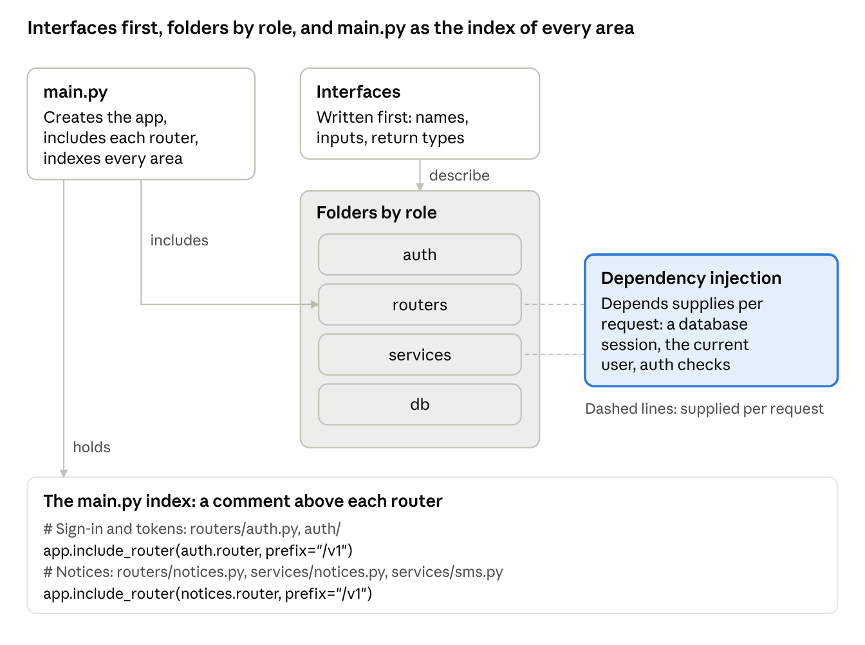
Figure 6. Interfaces, folders by role, dependency injection and the main.py index
BASICS Secrets
A secret is any value that gives access to something: a password, an API key, a token, a signing key, or a connection string that contains a password. The rules start with the first commit:
- Secrets live in .env on each developer's machine and in the server's secrets file (Stage 9), never in the code or in any committed file.
- .env.example lists every setting with a placeholder value, so the names are documented and the values are not.
- A secret scanner such as gitleaks runs before each commit (Sources 48 and 49), and the repository host's push protection, where it is available, blocks pushes that contain a known kind of secret (Source 50).
- A secret that reaches a commit is treated as exposed. Rotate it first (Stage 10), then remove it from the files in a new commit. Rewrite the history only when the organization requires it (Working in Git); rewriting does not remove copies already in other clones (Source 51).

GOING DEEPER

Key project files
What each common file is for, and whether it is committed. Backend paths are relative to backend/, and front end paths to frontend/; .github/, deploy/ and .pre-commit-config.yaml sit at the repository root.
Default. User Notices uses pip-tools, with requirements.in and requirements.txt in backend/. Create .python-version with the Stage 3 Python version now, and .nvmrc with the Node.js version when the front end is created in Stage 6. The files marked as optional are needed only if the project uses uv or containers.
File | Purpose | Committed
requirements.in | The Python libraries you chose directly, with version ranges. pip-compile reads it | Yes
requirements.txt | The backend lock file: the exact version of every library, including the libraries your libraries use. Generated by pip-compile, not edited by hand (Source 52) | Yes
pyproject.toml | Project metadata, the Python version required, and settings for tools such as pytest. It can hold the dependency list instead of requirements.in (Source 53) | Yes
.python-version | The Python version for the project, read by version managers such as uv and pyenv | Yes
.venv/ | The virtual environment: the packages installed on one machine | No
.env | Settings and secrets for one machine | No
.env.example | Every setting name, with placeholder values | Yes
app/main.py | Creates the application and lists each area: the index | Yes
tests/conftest.py | Shared pytest fixtures, such as a test client or a stub store | Yes
alembic.ini, migrations/env.py, migrations/versions/ | Alembic's settings, the script that connects migrations to the models, and one file per migration (Stage 7) (Source 54). env.py reads the database address from the environment, so no password is written in alembic.ini | Yes
package.json | The front end's packages as version ranges, such as ^16.4.0, and its scripts: dev, build, test (Source 55) | Yes
package-lock.json | The front end lock file: the exact version of every installed package, including indirect ones. npm ci installs exactly this and stops with an error if it disagrees with package.json (Sources 56 and 57) | Yes
node_modules/ | The installed front end packages | No
next.config.ts | Next.js settings, such as standalone output for deployment | Yes
tsconfig.json | TypeScript settings | Yes
proxy.ts | The route guard that runs before each matched request (Stage 6) | Yes
app/ (front end) | One folder per route, each with a page file | Yes
public/ | Files served as they are, such as icons | Yes
.next/ | The front end build output | No
.nvmrc | The Node.js version for the project, read by nvm | Yes
.gitignore | What Git must not track: .env, .venv/, node_modules/, .next/ | Yes
README.md | What the application does, how to run it, and where to start reading | Yes
CHANGELOG.md | Notable changes in each release, written for people (Source 58) | Yes
.github/workflows/*.yml | CI: the tests and checks that run on each push and pull request | Yes
.github/CODEOWNERS | Who must review changes to which folders | Yes
.pre-commit-config.yaml | Checks that run before each commit, such as the secret scanner | Yes
.github/pull_request_template.md | The questions every pull request answers: what changed, how it was tested, the security checklist, and any migration | Yes
deploy/ | The systemd units, the nginx configuration and deploy.sh (Stage 9) | Yes
RUNBOOK.md | The operations routines and the incident steps (Stage 10) | Yes
Optional: uv.lock | The lock file uv writes, when the project uses uv instead of pip-tools | Yes
Optional: Dockerfile, compose.yaml, .dockerignore | When the application runs in containers: how to build the image, how to run the containers together, and what to leave out of the build | Yes

Common mistakes
- Starting to code before the folders and interfaces exist, so files end up wherever they were first written.
- Wrapping every cross-folder call in Depends instead of importing it.
- Committing the .env file. If it happens, change every key it held, then remove it from the repository.
- Putting real values in .env.example.
- Committing package.json or requirements.in without its lock file, so each install resolves different versions.
- Not updating main.py when files move, so the index points to files that no longer exist.

EXAMPLE: USER NOTICES
The repository after Stage 4:
user-notices/
.gitignore # .env, .venv/, node_modules/, .next/
.pre-commit-config.yaml # secret scan before each commit
.github/workflows/ci.yml # checks on each push and pull request
README.md # what it does, how to run it
backend/
.env # settings; never committed
.env.example # setting names, placeholders; committed
requirements.in # libraries chosen directly
requirements.txt # lock file: pinned versions from Stage 3
.python-version # 3.14
app/
main.py # creates the app; one router per area
interfaces/ # Protocol classes, written first
auth/ # verify_credentials, issue_token, current_user
routers/ # auth.py, users.py, notices.py
services/ # users.py, notices.py, sms.py
db/ # session.py, models.py
tests/ # unit tests and test stubs (Stage 5)
migrations/ # added in Stage 7
frontend/ # Next.js application, added in Stage 6
Branch rules on the repository host: main accepts changes only through a pull request with one approving review and passing checks, and force pushes to main are blocked (Source 59).
One interface, written before any service code:
# app/interfaces/notices.py
from datetime import datetime
from typing import Protocol
from pydantic import BaseModel

class NoticeSummary(BaseModel):
id: int
text: str
send_at: datetime
status: str # scheduled, sending, sent or failed

class NoticeService(Protocol):
async def schedule_notice(self, text: str, group_id: int,
send_at: datetime, author_id: int) -> NoticeSummary: ...
async def list_notices(self, limit: int = 50) -> list[NoticeSummary]: ...
async def send_notice(self, notice_id: int) -> None: ...
The index in main.py:
# app/main.py
from fastapi import FastAPI
from app.routers import auth, users, notices

app = FastAPI(title="User Notices")

# Each router sets its own path, for example APIRouter(prefix="/notices").
# Sign-in and tokens: routers/auth.py, auth/
app.include_router(auth.router, prefix="/v1")
# List, view and edit users: routers/users.py, services/users.py
app.include_router(users.router, prefix="/v1")
# Notices: routers/notices.py, services/notices.py, services/sms.py
app.include_router(notices.router, prefix="/v1")

CHECKPOINT
- Repository initialized with the backend lock file; .env and the virtual environment excluded by .gitignore
- .env.example committed; a secret scanner runs before each commit
- main protected: a pull request and passing checks required, and a review with two or more developers
- CI runs on each push and pull request, and its checks are required on main
- Pattern named
- Folders created by role
- Interfaces written for each folder
- main.py includes each router, with a comment naming what it does and its files
- Design critiqued by an assistant, and revised
- Work committed

Self-check
- The users router and the notices router both need the staff member who is signed in. Is that dependency injection or an import?
- Both routers use a helper that formats phone numbers. Dependency injection or an import?
- A new developer has to fix how notices are scheduled. Where do they start reading?
- A teammate's install produced different front end package versions from yours, although package.json is the same. What is missing, and which command installs exactly what it records?
BUILD · STAGE 5 OF 10

Stage 5. Build the skeleton
DECISION IN BRIEF
Decision | Which functions does the backend need, and who writes the code inside them?
Input | The Stage 4 interfaces and folders
Default | Write the function skeleton yourself, with a comment in each function saying what it must do and what it depends on. An AI assistant completes the bodies. You review every body against its comment and the security checklist, then run the service locally against a stub data layer and debug it
Reason | Writing every body by hand takes time that does not need to be spent, and an assistant can fill a well-specified skeleton. Because you wrote every function and comment, you know what each one must do, which makes the result checkable
Choose differently when | A throwaway prototype can be generated whole. Anything that will be maintained keeps the skeleton with the developer
Output | A backend that runs end to end on your machine, with reviewed bodies, passing unit tests, and one failure traced with the debugger
First app | Do in full

Steps
- Template functions. List the main operations and create one empty function per operation, in the folder that owns it. A CRUD application starts with sign-in, create, read, update and delete; a RAG chatbot starts with ingest and extract. The names and signatures come from the Stage 4 interfaces.
- Comments. In each function, write what it does, what it depends on (a session or user received through dependency injection, or another function it calls), and what it must not do. The comments are the specification the assistant works from.
- Bodies. Give the skeleton to the assistant and ask it to complete the bodies without adding functions or changing signatures, and to add an entry to the change log (see AI change log) for each one. Read each body against its comment, and against the checklist in Going deeper: Reviewing code for security, before anything runs. Reject or rewrite what does not match.
- Unit tests. Write a unit test for each function as you accept its body, for example with pytest, and run the tests on every change from now on. Unit tests are the first and most numerous kind of test; Stage 9 lists which kind covers each layer.
- Stub data layer. The real schema arrives in Stage 7, so the data layer here is a stub: an in-memory store, or a first version of only the tables the skeleton touches, on a local PostgreSQL.
- Run it. Start the service from the backend folder with uvicorn, the server program that runs FastAPI applications: uvicorn app.main:app --reload. Then call every endpoint. With no front end yet, use the interactive API page that FastAPI serves at /docs (Source 27), or a test client. Fix what breaks before moving to the front end.
- Debug by reference. When something fails, check in this order. Is the backend service running? Which area and file does main.py name for this behavior? Set a breakpoint in that function and repeat the failing action. The call stack shows each call that led there, and the variables view shows the values each call received. A value that is empty where it should not be shows where to look: trace it back to where it was never set or never sent. Learn the debugger rather than relying on an assistant's review of the whole code base; the debugger shows which value was missing.

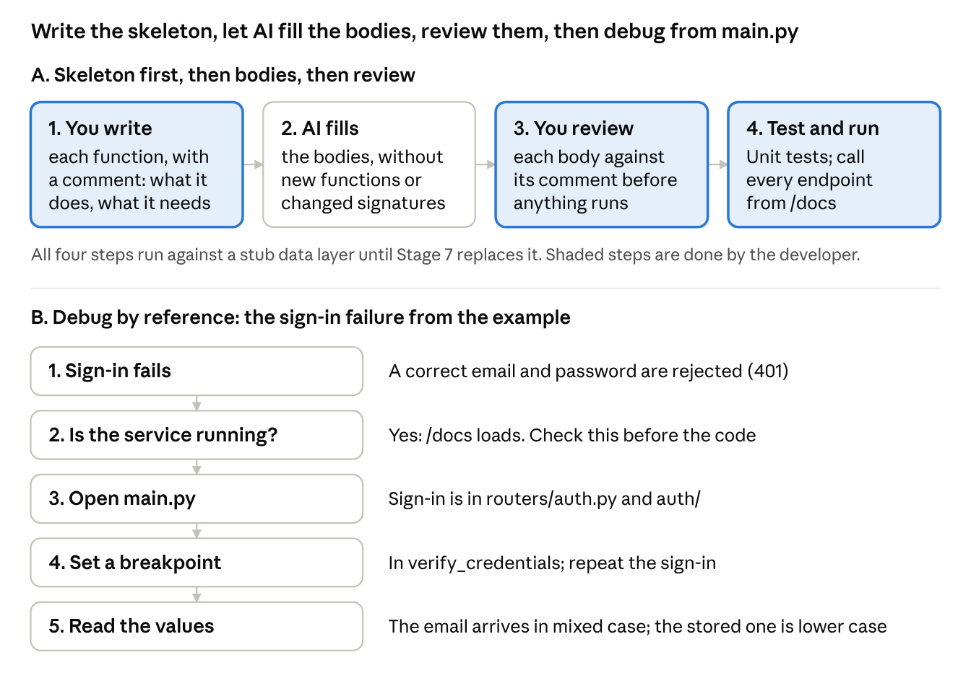
Figure 7. Skeleton, bodies, review and tests, then the debugging path
BASICS Security terms
- Authentication. Checking who the caller is, for example by the session cookie issued at sign-in.
- Authorization. Checking what that caller may do, and to which record.
- Injection. Input that ends up executed as part of a query or a command.
- Dependency. A library the code installs. It is a supply chain risk when it is outdated, has been tampered with, or is not the package that was intended.
- Cross-site scripting (XSS). Text that a user entered is shown on a page as code, and runs in other users' browsers.
- Static analysis. A tool reads the code without running it and reports risky patterns.
- OWASP. The Open Worldwide Application Security Project, which publishes the risk lists and cheat sheets cited below.

GOING DEEPER

Reviewing code for security
Review every body for security as well as against its comment, whoever wrote it. Generated code needs the same review as a colleague's code; it is not a way around review, testing or static analysis (Source 60). A second developer reviews each pull request with the same list before it merges (Working in Git). Automated tools run in CI (Stage 9): they find known patterns and vulnerable packages. The reviewer checks what the tools cannot know, such as who may do what to which record.
Check | What to look for | Risk it covers
1. Access to each record | Every endpoint checks, in the backend, that the caller is signed in and allowed to act on this record, not only on this kind of record | Broken access control (A01:2025) and broken object level authorization (API1:2023) (Sources 61 and 62)
2. Fields a caller may set | The request model lists the fields a caller may change. A PATCH cannot set role, author_id or status unless that is intended | Broken object property level authorization
3. Input checked on the server | Types, lengths and allowed values checked in the backend, whatever the front end also checks | Injection; bad data
4. Parameterized queries | No SQL built by joining strings or with f-strings. Use the ORM, or text() with bound parameters (Source 63) | Injection
5. Secrets | No key, password or internal address in the code, the tests or an error message | Exposed secrets
6. Errors | No stack trace or internal detail in a response. A check that fails denies the request instead of letting it through | Mishandling of exceptional conditions
7. Logging | Sign-in failures and denied requests are logged; passwords, tokens and full phone numbers are not (Source 64) | Logging and alerting failures
8. New dependencies | Each new package exists on the registry, is the one intended, is pinned in the lock file, and passes pip-audit or npm audit. Assistants suggest package names that do not exist, and an attacker can register such a name (Sources 65 and 66) | Software supply chain failures
9. Front end output | No dangerouslySetInnerHTML with user data. Next.js server functions and route handlers (Stage 6) check authorization themselves (Source 67) | Cross-site scripting; broken access control
10. Limits | Lists are paged with a maximum page size; expensive endpoints have a rate limit; uploads have a size limit | Unrestricted resource consumption

SCENARIO A PATCH that sets any field
The assistant's body for update_user:
async def update_user(self, user_id: int, changes: dict) -> User:
user = await self.store.get_user(user_id)
for field, value in changes.items():
setattr(user, field, value)
return await self.store.save_user(user)
Finding: checks 1 and 2. Any signed-in staff member, including a viewer, can change any field of any user, including group_id. Fix: the skeleton is yours, so change the interface first, to update_user(self, user_id: int, changes: UserUpdate, staff: Staff) -> User. UserUpdate holds only name, phone and opted_in, each optional. The router passes the signed-in staff member through Depends(current_user). The service raises PermissionError unless staff.role is editor, applies changes.model_dump(exclude_unset=True), and writes an audit record (Stage 7).

SCENARIO A search built with an f-string
query = text(f"SELECT id, name FROM users WHERE name ILIKE '%{term}%'")
Finding: check 4. A search term that contains a quote changes the query. Fix: send the value as a bound parameter.
query = text("SELECT id, name FROM users WHERE name ILIKE :pattern")
rows = await session.execute(query, {"pattern": f"%{term}%"})
Here the f-string builds the value only; the SQL text stays fixed.

SCENARIO A package that does not exist
The assistant's body for formatting phone numbers imports phonenumber_tools and adds it to requirements.in. Finding: check 8. When this guide was checked, no package of that name was published on PyPI. pip install would fail, or would install whatever someone registers under that name later. Fix: remove it, and use the maintained phonenumbers library after checking its project page; pin it with pip-compile and run pip-audit.

Common mistakes
- Running generated code without reading it.
- Reviewing generated code only for whether it works, not for who may call it.
- Installing a package an assistant named without checking that it exists and is the one intended.
- Letting the assistant add functions the skeleton did not define, or change their signatures.
- Leaving unit tests until Stage 9.
- Treating the stub data layer as the schema and skipping Stage 7.
- Debugging by reading code at random instead of starting from main.py.

EXAMPLE: USER NOTICES
The skeleton for scheduling a notice, as given to the assistant:
# app/services/notices.py
from datetime import datetime
from app.interfaces.notices import NoticeSummary

class Notices:
"""Implements NoticeService from app/interfaces/notices.py."""

def __init__(self, store):
self.store = store # the notices store: a stub until Stage 7

async def schedule_notice(self, text: str, group_id: int,
send_at: datetime, author_id: int) -> NoticeSummary:
# Store a notice with status "scheduled" for the group and send time.
# send_at is a timezone-aware UTC datetime.
# Depends on: self.store.
# Raises ValueError for: empty text, an unknown group, a past send time.
# Does not send any messages; send_notice does that.
...
A unit test written when its body was accepted. Async tests use the pytest-asyncio plugin; run the tests from the backend folder with python -m pytest. tests/stubs.py holds InMemoryNoticeStore, a stand-in for the notices store that keeps notices in a dictionary, and FakeSmsClient, which records each message instead of sending it.
# tests/test_notices.py
import pytest
from datetime import datetime, timedelta, timezone
from app.services.notices import Notices
from tests.stubs import InMemoryNoticeStore

@pytest.mark.asyncio
async def test_schedule_notice_rejects_past_send_time():
notices = Notices(InMemoryNoticeStore(group_ids=[1]))
past = datetime.now(timezone.utc) - timedelta(minutes=5)
with pytest.raises(ValueError):
await notices.schedule_notice("Office closed Friday", group_id=1,
send_at=past, author_id=1)
The first failure traced: sign-in returned 401 for a correct email and password. The service was running, because /docs loaded. main.py named routers/auth.py and auth/ for sign-in. A breakpoint in verify_credentials showed the email arriving as Staff.Member@example.org, while the stored address was staff.member@example.org, and the lookup compared them exactly. The fix: store and compare email addresses in lower case, with a unit test for mixed-case sign-in.

CHECKPOINT
- Every function in the skeleton has a comment and a body reviewed against it and against the security checklist
- Unit tests written for each function, and passing
- Service runs end to end on your machine against the stub data layer
- At least one failure traced through main.py to its file with a breakpoint
- Work committed

Self-check
- The assistant's body for update_user also sends a confirmation SMS, which its comment does not mention. What do you do?
- Sign-in rejects a correct email and password. What are your first three checks, in order?
- Why does this stage run against a stub instead of the real database?
- A generated endpoint lets a staff member with the viewer role change a user's phone number. Which check does it fail, and where is the fix made?
BUILD · STAGE 6 OF 10

Stage 6. Connect the front end
DECISION IN BRIEF
Decision | How does each screen reach the backend?
Input | The Stage 1 screens and the Stage 5 functions
Default | Build the shared components first, give every screen a page and a route, and connect each page to the backend with API calls. Credentials are checked in the backend; the front end guards its routes
Reason | The Stage 1 screens and the user-facing Stage 5 functions should match one to one. The API calls connect the two layers and settle what the front end sends, which Stage 7 needs
Choose differently when | One HTML page is enough when the application has a single screen
Output | Every screen working against the backend, sign-in working end to end, component tests for the shared components, and a route list with the API calls each page makes
First app | Do in full

Steps
- Match screens to functions. Each screen from Stage 1 is a page, each page is a route, and each page reaches its backend function through an API call. A screen with no function, or a function with no screen, is a gap to resolve now.
- Components. Build the components the pages share: forms, tables, navigation. Pages built first each carry their own copy.
- Routes. In Next.js with the App Router, a route is a folder under app/ that contains a page file, and a dynamic segment such as /users/[id] is a folder named [id] (Source 1). Check that every link or button that opens another page has a route, and that some link reaches every page.
- API calls. Each page calls the backend's /v1 endpoints. The browser code builds each address from a setting, NEXT_PUBLIC_API_BASE. During development it holds the backend's local address, http://localhost:8000. In production it is empty, so calls from the browser use the relative path /v1, which the reverse proxy sends to the backend (Stage 9), so the same build runs in the sandbox and in live. Calls made on the Next.js server, in Server Components and route handlers, need an absolute address from a setting such as API_INTERNAL_URL (http://127.0.0.1:8000 on the servers), and pass the staff member's session cookie on.
- CORS. During development the front end and the backend run on different origins (scheme, host and port), so the browser blocks calls from a page to the backend unless the backend allows the front end's origin. In FastAPI, add the CORS middleware with the allowed origin read from .env, and allow credentials so the session cookie is sent. Calls made by the Next.js server, and calls through the reverse proxy in production, are not affected.
- Authentication. The sign-in page sends the credentials to the backend, which checks them and issues a signed session token in a cookie named session. The browser sends the cookie with each API call. The front end guards its routes, redirecting a visitor who is not signed in. In Next.js 16 the guard goes in proxy.ts (called middleware.ts before version 16), and the backend still checks the token on every call (Source 2). In 2025, a flaw in Next.js middleware let requests skip its checks in self-hosted deployments (CVE-2025-29927), which is one reason the backend checks the token itself (Sources 68 and 69). The front end never checks a password.
- Component tests. Test each shared component the way a user uses it, with Vitest and React Testing Library: fill in the form, press the button, read what appears. Install them in frontend/ with npm install --save-dev vitest @vitejs/plugin-react vite-tsconfig-paths jsdom @testing-library/react @testing-library/dom, create vitest.config.mts with the react() and tsconfigPaths() plugins and test: { environment: 'jsdom' } as the Next.js Vitest guide shows (without the jsdom environment, render() fails because there is no document), add "test": "vitest" to the scripts in package.json, and run npm test. These tools do not support async Server Components, so Next.js recommends end-to-end tests for those, which Stage 9 adds (Sources 70 and 71). Add npm ci, npm audit and npm test to the CI workflow.

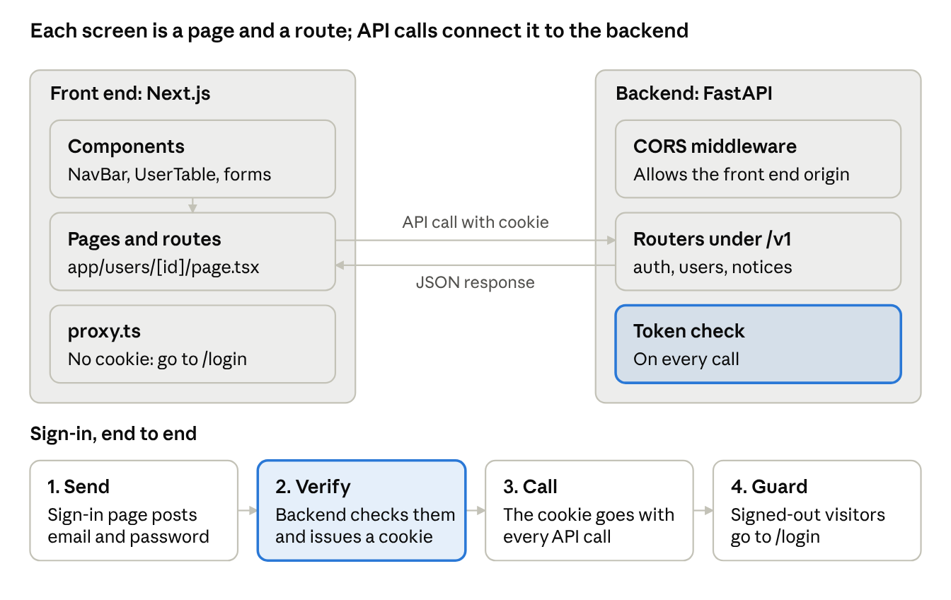
Figure 8. How a page reaches the backend, and sign-in from end to end
BASICS Server and Client Components
- Server Component. A component that runs on the Next.js server and sends finished HTML to the browser. In the App Router, components are Server Components unless marked otherwise.
- Client Component. A component whose file starts with 'use client'. It also runs in the browser, so it can respond to clicks and typing. Forms and tables that change on the page are Client Components.
- Route handler. A route.ts file that answers HTTP requests on the Next.js server, like a small API endpoint.

Common mistakes
- Building every page before the shared components exist.
- Forgetting CORS and reading the browser error as a backend fault.
- Checking credentials in the front end, or relying on the front end guard alone.
- Leaving a page that no link reaches.
- Rendering text that users entered with dangerouslySetInnerHTML.

EXAMPLE: USER NOTICES
Screen | Route folder | API calls
Sign in | app/login/ | POST /v1/auth/login
Users list | app/users/ | GET /v1/users?group={id}
User detail | app/users/[id]/ | GET /v1/users/{id}, PATCH /v1/users/{id}
New notice | app/notices/new/ | POST /v1/notices
Notice history | app/notices/ | GET /v1/notices; POST /v1/notices/{id}/send for Send now

Shared components: NavBar, UserTable, NoticeForm and StatusBadge. During development, NEXT_PUBLIC_API_BASE is http://localhost:8000, so pages call http://localhost:8000/v1, and ALLOWED_ORIGIN in the backend's .env is http://localhost:3000. The route guard:
// frontend/proxy.ts
import { NextResponse } from 'next/server'
import type { NextRequest } from 'next/server'

export function proxy(request: NextRequest) {
if (!request.cookies.has('session')) {
return NextResponse.redirect(new URL('/login', request.url))
}
return NextResponse.next()
}

export const config = { matcher: ['/users/:path*', '/notices/:path*'] }
Link check: the Users list links to each /users/[id] page, Notice history links to New notice, and the NavBar reaches every other page. Component tests: NoticeForm shows an error and makes no API call for empty text or a past send time, UserTable renders one row per user it receives, and NavBar renders a link to every page.

CHECKPOINT
- Every screen from Stage 1 has a page and a route
- Every page reaches the backend through an API call
- Every link has a route, and some link reaches every page
- CORS allows the front end's origin
- Credentials checked in the backend; routes guarded in the front end; sign-in works end to end
- Component tests for the shared components pass
- Work committed

Self-check
- The browser console shows a CORS error when the Users list loads. Which side do you change, and what do you change?
- Why does the front end guard its routes if the backend checks the token on every call?
BUILD · STAGE 7 OF 10

Stage 7. Build the database
DECISION IN BRIEF
Decision | What has to be stored, and in what structure, so the application can write and read it quickly and keep it correct?
Input | What the front end sends (Stage 6), what each function reads and writes (Stage 5), and the Stage 1 data list and audit requirement
Default | List every field, group the fields into tables, give every column a type and the constraints that keep wrong values out, add an audit table the application cannot change, add views for joins used in many places, index the foreign keys and the most-queried columns, and apply the result through reversible migrations
Reason | Tables designed from the fields the application uses hold nothing that no screen or function needs. Constraints stop bad data at the database, whatever code writes it. Migrations make every later schema change recorded, repeatable and reversible
Choose differently when | Files go to object storage beside the database, and a table stores only each file's key
Output | The schema applied by migrations with tested downgrades, the audit table in place, the stub replaced, and the full request path working from the browser
First app | Do in full

Steps
- Fields. Walk through each screen and each function and write down every value it reads or writes, including what must be logged and audited. Finish the list before designing any table.
- Tables and columns. Group the fields into tables, one concept per table, each with a primary key. Give each column a type, decide whether it may be empty, set a default where one applies, and add the constraints that keep wrong values out (see Going deeper: Schema details). Under load, a table that holds too many concepts is one of the first things to split.
- Audit trail. Create the audit table from the Stage 1 audit requirement. The application may add and read audit rows but not change or delete them (see Going deeper: Audit trail).
- Views. A plain view is a saved query: it makes a join reusable and does not change its speed. A materialized view stores the result, which makes a slow dashboard query fast, but PostgreSQL updates it only when REFRESH MATERIALIZED VIEW runs, so the refresh has to be scheduled (Source 16). Add one when a measured query needs it.
- Indexes. Primary keys and unique constraints are indexed automatically. Foreign key columns are not, and usually should be (Sources 13 and 14). Index the columns in the most frequent WHERE and JOIN clauses. A multicolumn index helps when the query constrains its leading column, and PostgreSQL advises using them sparingly (Source 15). Every index adds work to each insert and update and takes storage, so remove indexes that no query uses (Source 12).
- Schema and migrations. Write the tables, views and indexes as SQLAlchemy models, have Alembic's autogenerate write a migration from them, review it, and apply it (the commands are in the Example). Every later change to the schema is a new migration. Give every migration a downgrade and run the round trip (upgrade, downgrade, upgrade) before committing. Each migration must work with the code before it and the code after it (see Going deeper: Changing a schema that is in use).
- Connect. The backend reaches PostgreSQL through a driver or ORM (for example SQLAlchemy over psycopg), using the connection string from .env. The migrations run as a database role that owns the tables, and the application logs in as a second role with only the privileges it needs. A database superuser creates the roles once in each environment, before the first migration (see the Example). The application reads DATABASE_URL, and migrations/env.py reads MIGRATION_DATABASE_URL, so the running application never holds the owner's password. Replace the Stage 5 stub, run the unit tests and the integration tests against PostgreSQL (Stage 9 lists them), and run the full request path from the browser.

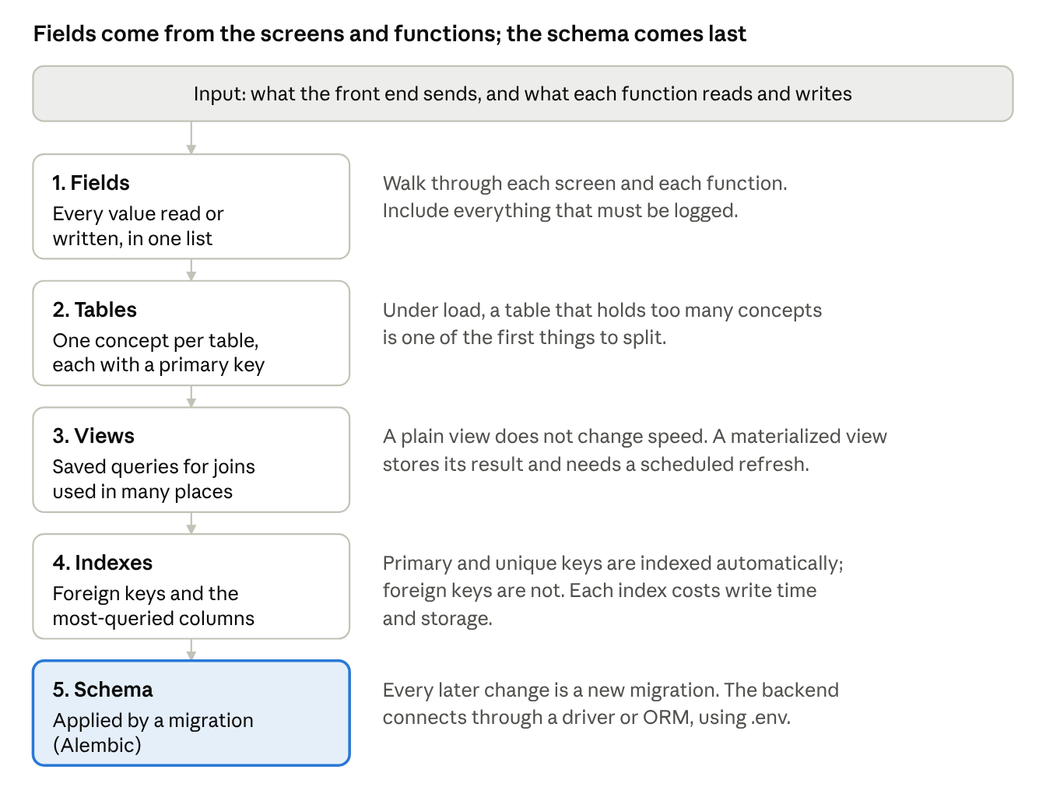
Figure 9. Database build order, from fields to schema
BASICS Schema terms
- Column type. The kind of value a column holds: text, a whole number, a point in time.
- NULL. No value. NOT NULL means the column must always have one.
- Default. The value used when an insert gives none.
- Constraint. A rule the database checks on every insert and update: PRIMARY KEY, NOT NULL, UNIQUE, CHECK and FOREIGN KEY.
- Role. A database account, unrelated to the staff roles (editor, viewer) in User Notices. The role that owns the tables and the role the application logs in as can be different.
- Transaction. A group of statements that the database saves together, or not at all.
- Trigger. A function the database runs on every insert, update or delete on a table.
- Migration. One file that changes the schema. Its upgrade function makes the change, and its downgrade function reverses it.
- Revision and head. The id Alembic gives each migration, and the newest revision. Each migration names the one before it in down_revision.
- Round trip. Upgrade, downgrade, then upgrade again, to show that both directions work.
- Rollback. Going back to the previous release of the code (Stage 9).

GOING DEEPER

Schema details
Choosing the column types:
Value | PostgreSQL type | Reason
Row identifier | bigint GENERATED ALWAYS AS IDENTITY | The database assigns it, and bigint does not run out. Use uuid instead when ids are created outside the database
Text | text, with a CHECK on its length where a limit matters | PostgreSQL has no performance difference between text and varchar(n) (Source 72)
Phone number | text in international format (a + and digits), with a CHECK on the format | A number type drops the +, and phone numbers are never calculated with
Email address | text, stored in lower case, unique | The Stage 5 sign-in failure came from mixed case
Point in time | timestamptz | Stored as UTC and converted for display (Source 73). A timestamp without time zone does not record which zone was meant
Money | numeric, for example numeric(12,2) | Exact. Floating-point types round
Yes or no | boolean NOT NULL, with a default | Allow NULL only when "unknown" has a meaning
Status | text with a CHECK that lists the allowed values | Changing the list is a short migration
Data with no fixed structure | jsonb | For example a provider's raw response. Not for values that are filtered or joined on

The constraints, and what each one stops:
Constraint | What it enforces | In User Notices
PRIMARY KEY | One unique, non-empty identifier per row | id in every table
NOT NULL | A value is always present | Every column except those that are empty until something happens, such as sent_at
UNIQUE | No two rows share the value | staff.email; (notice_id, user_id) in notice_messages
CHECK | A condition on the row's values | The allowed statuses; the phone format; email in lower case
FOREIGN KEY with ON DELETE | The referenced row exists. ON DELETE says what happens when it is deleted: RESTRICT refuses the delete, CASCADE deletes the referring rows too, SET NULL clears the reference | RESTRICT everywhere. Send records and audit rows are never deleted along with a user or a notice

Naming: tables in lower case with underscores, foreign key columns named after the table they point to (group_id), and a name for every constraint and index. A naming convention set on SQLAlchemy's metadata generates the names (ix_, uq_, ck_, fk_, pk_), so a later migration can drop or change a constraint by name (Source 74).
BASICS Application logs and the audit trail
Question | Application log | Audit trail
What it records | What the software did: requests, errors, timings | Who did what to which record, when, and the result
Who reads it | Developers, when debugging | Managers, auditors and support staff answering a complaint
How long it is kept | Days to weeks | As long as the records policy requires
Who may change it | The log system rotates and deletes it | Nobody. The application can only add rows

GOING DEEPER

Audit trail
Record these events: sign-ins, successful and failed; requests that were denied; changes to records made by staff, with the fields that changed; changes to staff accounts and roles; and bulk actions such as sends and exports. Each row says when, who, what, which record, from where, and the outcome. Leave out passwords, session tokens and other secrets, and mask personal data such as phone numbers (Source 64).
Method | How it works | Strengths | Limits
In the service, in the same transaction | The service adds the audit row in the database transaction that makes the change | Knows the staff member and the action; the change and its audit row are saved together or not at all | Changes made outside the application, such as SQL run by hand, are not recorded
Database trigger | A trigger on the table writes a row for every insert, update and delete (Source 75) | Records every change, including SQL run by hand | Does not know the staff member unless the application passes it to the database
pgAudit extension | Writes statement-level audit entries to the PostgreSQL log (Source 76) | Records what each database login ran, for database administrators and compliance | A large volume of log entries; records statements, not business actions

Default. Write the audit row in the service, in the same transaction as the change. Add a trigger for tables that are also changed outside the application.
user = await session.get(User, user_id)
before = {"opted_in": user.opted_in}
user.opted_in = changes.opted_in
session.add(AuditLog(staff_id=staff.id, action="user.update",
entity="users", entity_id=user_id, outcome="success",
details={"opted_in": [before["opted_in"], user.opted_in]},
request_id=request_id))
await session.commit() # both rows are saved here, or neither is
The session opens a transaction on its first query and keeps it open until commit, so the change and the audit row are in one transaction. Do not wrap the block in session.begin(): it raises an error when the session has already run a query, which it has when the signed-in staff member was loaded through Depends.
A middleware gives each request an id, adds it to every log line and to the X-Request-ID response header, and the service receives it, with the signed-in staff member, through Depends.
Protect the audit table from change. A role other than the application's owns it, and the application role gets SELECT and INSERT only, with no UPDATE, DELETE or TRUNCATE (Source 77). Audit rows are copied off the server with the backups (Stage 9), and only the retention job removes them, once the retention period has passed (Stage 10). Audit records are protected from change and deletion so they can be relied on later (Source 78).
SCENARIO A user who opted out received a notice
After launch, a user says they opted out on November 3 and still received a notice that afternoon.
- Read the user's audit rows: SELECT occurred_at, staff_id, action, details FROM audit_log WHERE entity = 'users' AND entity_id = 4810 ORDER BY occurred_at;
- Read the user's send records: SELECT n.id, n.send_at, m.status, m.sent_at FROM notice_messages m JOIN notices n ON n.id = m.notice_id WHERE m.user_id = 4810;
- Compare the times. The message was sent at 14:31. Staff member 12 recorded the opt-out at 14:42, eleven minutes later.
- Reply to the user with the two times. The application behaved as designed. Had the opt-out been recorded before the send, the cause would be in the send code, and the audit row would show the time to look from.

GOING DEEPER

Changing a schema that is in use
During a deploy, and after a code rollback, one version of the code runs against the schema left by the other version's migrations. A migration is safe when the code before it and the code after it both work with the schema it leaves. Changes that would break the older code are split across releases: first expand (add the new structure and use it alongside the old), then contract (remove the old structure once nothing uses it). This is called expand and contract, or parallel change (Source 79).
Change | Releases | How
Add a table | One | The older code ignores it
Add a column that may be empty, or has a default | One | The older code ignores it
Add an index | One | On a large table in use, build it with CREATE INDEX CONCURRENTLY, so writes continue while it builds. It cannot run inside a transaction, so in Alembic the op.create_index call with postgresql_concurrently=True goes inside a with op.get_context().autocommit_block(): block (Sources 80 and 81)
Make an existing column NOT NULL | Two | Release 1 writes the value everywhere and fills in the old rows; release 2 adds NOT NULL
Rename a column, or change its type | Four | Expand, migrate, stop writing, drop. See the scenario below
Remove a column or a table | Two | Release 1 stops using it; release 2 drops it, after a backup

Start each migration with op.execute("SET lock_timeout = '5s'"). A migration that waits longer than that for a lock then fails and can be run again, and the queries queued behind it are not held up.
Write a downgrade for every migration and run the round trip before committing. Alembic's autogenerate writes upgrade and downgrade functions, and its output always needs review (Source 82). A downgrade restores structure, not data: after a migration that drops a column, the downgrade can recreate the column but not its values. Stage 10 covers when to run a downgrade, and when to fix forward or restore instead.
SCENARIO Renaming a column without breaking a rollback
The team wants users.phone renamed to phone_e164. Each release can be rolled back to the one before it.
- Release 1.5.0 (expand). A migration adds phone_e164, allowing NULL. The code writes both columns and still reads phone. A one-off job copies phone into phone_e164 for existing rows. Rolling back to 1.4.0 works: 1.4.0 ignores the new column.
- Release 1.6.0 (migrate). The code reads phone_e164 and still writes both. A migration makes phone_e164 NOT NULL. Rolling back to 1.5.0 works: 1.5.0 still writes both columns.
- Release 1.7.0 (stop writing). A migration removes NOT NULL from phone (ALTER TABLE users ALTER COLUMN phone DROP NOT NULL), and the code removes phone from the SQLAlchemy model, so it neither reads nor writes it. Rolling back to 1.6.0 works: the column still exists, and 1.6.0 writes both columns.
- Release 1.8.0 (contract). After a backup, a migration drops phone. Rolling back to 1.7.0 works: 1.7.0's model has no phone column, so its queries do not name it.

Common mistakes
- Designing tables before the field list is complete.
- Storing phone numbers as numbers, or points in time without a time zone.
- Expecting a plain view to make a query faster.
- Leaving foreign key columns unindexed.
- Changing the schema by hand on a database instead of through a migration.
- Indexing every column in advance.
- Letting the application role update or delete audit rows.
- Renaming or dropping a column in the same release that stops using it.
- Writing a migration with no downgrade, or with one that has never run.

EXAMPLE: USER NOTICES
Table | Fields | Indexes you create
staff | id, email (unique, lower case), password_hash, role (editor or viewer), created_at | None; the primary key and the unique email are indexed automatically
user_groups | id, name (unique) | None
users | id, name, phone (international format), group_id (FK to user_groups), opted_in, updated_at | group_id
notices | id, author_id (FK to staff), group_id (FK to user_groups), text, send_at (timestamptz), status, created_at | author_id; group_id; (status, send_at)
notice_messages | id, notice_id (FK to notices), user_id (FK to users), status (queued, sending, sent or failed), provider_message_id, sent_at | unique (notice_id, user_id); user_id
audit_log | id, occurred_at, staff_id (FK to staff), action, entity, entity_id, outcome, details (jsonb), client_ip, request_id | (entity, entity_id, occurred_at); (staff_id, occurred_at)

The view notice_summary returns one row per notice with its counts of sent and failed messages, for the Notice history page. It is a plain view; it becomes a materialized view only if Notice history is measured as slow. The (status, send_at) index serves the query that finds notices due to send, WHERE status = 'scheduled' AND send_at <= now(), which constrains the leading column, status. The unique (notice_id, user_id) constraint stops a user from getting a second record for the same notice, and its index also serves queries on notice_id, its leading column. The first Alembic migration creates the six tables, the indexes and the view. The view is written by hand with op.execute, since autogenerate writes tables from the models. The naming convention names single-column indexes; an index on more than one column, such as (status, send_at), is given its name in the model.
Part of the first migration, as SQL. The constraint names come from the naming convention:
CREATE TABLE users (
id bigint GENERATED ALWAYS AS IDENTITY,
name text NOT NULL,
phone text NOT NULL,
group_id bigint NOT NULL,
opted_in boolean NOT NULL DEFAULT false,
updated_at timestamptz NOT NULL DEFAULT now(),
CONSTRAINT pk_users PRIMARY KEY (id),
CONSTRAINT fk_users_group_id_user_groups FOREIGN KEY (group_id)
REFERENCES user_groups (id) ON DELETE RESTRICT,
CONSTRAINT ck_users_phone_format
CHECK (phone ~ '^\+[1-9][0-9]{6,14}$')
);
CREATE INDEX ix_users_group_id ON users (group_id);

CREATE TABLE notices (
id bigint GENERATED ALWAYS AS IDENTITY,
author_id bigint NOT NULL,
group_id bigint NOT NULL,
text text NOT NULL,
send_at timestamptz NOT NULL,
status text NOT NULL DEFAULT 'scheduled',
created_at timestamptz NOT NULL DEFAULT now(),
CONSTRAINT pk_notices PRIMARY KEY (id),
CONSTRAINT fk_notices_author_id_staff FOREIGN KEY (author_id)
REFERENCES staff (id) ON DELETE RESTRICT,
CONSTRAINT fk_notices_group_id_user_groups FOREIGN KEY (group_id)
REFERENCES user_groups (id) ON DELETE RESTRICT,
CONSTRAINT ck_notices_text_length
CHECK (char_length(text) BETWEEN 1 AND 640),
CONSTRAINT ck_notices_status
CHECK (status IN ('scheduled', 'sending', 'sent', 'failed'))
);
CREATE INDEX ix_notices_author_id ON notices (author_id);
CREATE INDEX ix_notices_group_id ON notices (group_id);
CREATE INDEX ix_notices_status_send_at ON notices (status, send_at);

CREATE TABLE audit_log (
id bigint GENERATED ALWAYS AS IDENTITY,
occurred_at timestamptz NOT NULL DEFAULT now(),
staff_id bigint,
action text NOT NULL,
entity text NOT NULL,
entity_id bigint,
outcome text NOT NULL,
details jsonb NOT NULL DEFAULT '{}',
client_ip inet,
request_id text,
CONSTRAINT pk_audit_log PRIMARY KEY (id),
CONSTRAINT fk_audit_log_staff_id_staff FOREIGN KEY (staff_id)
REFERENCES staff (id) ON DELETE RESTRICT,
CONSTRAINT ck_audit_log_outcome
CHECK (outcome IN ('success', 'failure', 'denied'))
);
CREATE INDEX ix_audit_log_entity
ON audit_log (entity, entity_id, occurred_at);
CREATE INDEX ix_audit_log_staff_id
ON audit_log (staff_id, occurred_at);
In the models, each id column is mapped_column(BigInteger, Identity(always=True), primary_key=True). Without Identity, SQLAlchemy writes a bigserial column instead of the identity column shown above.
The roles, created once in each environment by a database superuser before the first migration, from deploy/bootstrap.sql. On a server, run it with sudo -u postgres psql -f deploy/bootstrap.sql; the test fixtures run the same file against the test database. usernotices_owner owns the tables and runs the migrations. usernotices_app holds the application's privileges and cannot log in; the application logs in as usernotices_app_a or usernotices_app_b, which are members of it, so the password can be changed without a moment in which the application cannot connect (Stage 10). Each password is set with psql's \password command, so it does not appear in the server log or the shell history.
CREATE ROLE usernotices_owner LOGIN;
CREATE ROLE usernotices_app NOLOGIN;
CREATE ROLE usernotices_app_a LOGIN IN ROLE usernotices_app;
CREATE ROLE usernotices_app_b LOGIN IN ROLE usernotices_app;
CREATE DATABASE usernotices OWNER usernotices_owner;
The privileges, in the first migration. A view needs its own grant, and every later migration that adds a table or a view grants what the application needs on it:
GRANT SELECT, INSERT, UPDATE ON staff, users, user_groups,
notices, notice_messages TO usernotices_app;
GRANT SELECT ON notice_summary TO usernotices_app;
GRANT SELECT, INSERT ON audit_log TO usernotices_app;
The naming convention, set once on the models' metadata in app/db/models.py:
convention = {
"ix": "ix_%(column_0_label)s",
"uq": "uq_%(table_name)s_%(column_0_name)s",
"ck": "ck_%(table_name)s_%(constraint_name)s",
"fk": "fk_%(table_name)s_%(column_0_name)s_%(referred_table_name)s",
"pk": "pk_%(table_name)s",
}
class Base(DeclarativeBase):
metadata = MetaData(naming_convention=convention)
The Alembic commands, from the backend folder. In migrations/env.py, target_metadata is Base.metadata, and the database address comes from MIGRATION_DATABASE_URL:
alembic init migrations # once
alembic revision --autogenerate -m "create tables" # write a migration
alembic upgrade head # apply what is new
alembic downgrade -1 # undo the last one
alembic upgrade head # apply it again
alembic current # the revision applied
staff_id may be empty for a failed sign-in with an unknown email address. One audit row, written when an editor changed a user's opt-in and phone number:
occurred_at | staff_id | action | entity, entity_id | outcome | details
2026-11-03 14:42:05+00 | 12 | user.update | users, 4810 | success | {"opted_in": [true, false], "phone": ["xxx4417", "xxx9902"]}

CHECKPOINT
- Every field listed
- Tables built, one concept per table, each with a primary key
- Every column has a type, NOT NULL where required, a default where one applies, and its constraints
- Audit table in place; the application role can add and read rows but not change or delete them
- Views for reused joins; any materialized view has a refresh schedule
- Foreign key columns and frequently queried columns indexed
- Schema applied through migrations; every migration has a downgrade, and the round trip runs; the stub replaced
- Unit and integration tests pass, and the full request path works from the browser
- Work committed

Self-check
- A teammate adds a plain view to make the Notice history page faster. Will it work?
- Which columns in notice_messages need an index that you have to create yourself?
- The users table needs a new column. How is it added?
- Why is users.phone stored as text with a CHECK, and not as a bigint?
- A release renames a column in its migration and uses the new name straight away. The release is rolled back. What fails, and how should the rename have been done?
- Which database roles write audit rows, and which privileges do they have on audit_log?
SHIP · STAGE 8 OF 10

Stage 8. Prepare for load
DECISION IN BRIEF
Decision | What breaks first at the expected load, and what is added in front of it?
Input | The working application from Stage 7, and the two load numbers and bursts from Stage 1
Default | Measure first, with a load test and a stress test. Then add, one at a time and only where a measurement calls for it: a task queue for slow or bulk work, rate limiting with counters in Redis, connection pooling, and read replicas. Sharding comes last
Reason | Each layer is another service to deploy, monitor and maintain. Measurements decide which layers are worth that cost
Choose differently when | A cloud provider's managed queue, cache and database services replace the self-hosted ones; the design stays the same
Output | A recorded breaking point and working level, and a decision for each layer: added, with the reason and the product chosen, or not needed
First app | Run the load test and the stress test, and complete the decision table. Most first applications add at most a task queue

Steps
- Load test and stress test. A load test sends the expected concurrency at the backend and confirms it holds. A stress test raises the concurrency until something fails, which gives the breaking point. Tools such as k6 or Locust run both. Run them on a machine sized like the deployment target, such as the server that will become the sandbox, not on a laptop. Until Stage 9 sets that server up, install PostgreSQL on it, copy the code and a .env with test values, and start the backend by hand with uvicorn for the test. Record the breaking point and the working level (the highest concurrency with no errors and acceptable response times), and plan for headroom above the expected load, for example twice the expected concurrency.
- Cheaper fixes. Before adding services, check the indexes, split tables that hold too many concepts, and review how the API routes are configured and how much load each one carries.
- Task queue. Work that is slow or arrives in bulk does not run inside a request. The application puts one job per unit of work into a broker, and separate worker processes take jobs from the queue. Celery uses Redis or RabbitMQ as its broker; ARQ uses Redis (Sources 21 and 23). Each worker's concurrency is a setting, and the rate of outbound calls is a separate setting (in Celery, a task's rate_limit, which applies per worker). Run the broker on its own Redis instance with no eviction policy, so queued jobs are never removed to make room for cache entries (Source 22). A job can be delivered more than once, so a task checks whether its work is already done before doing it.
- Rate limiting and cache. Rate limiting runs inside the application as middleware, with the counters in Redis so that every application process sees the same count (Source 24). Apply it to endpoints that receive many requests from one client. A Redis instance can also cache expensive reads. Redis runs as its own service, not inside the backend.
- Connection pooling. PostgreSQL accepts 100 connections by default, each costs memory, and the limit changes only at server start (Source 11). Drivers and ORMs already pool connections inside one process. Add PgBouncer, a connection pooler, when many processes each hold a pool and the total would exceed the limit. Its transaction mode shares connections most, but does not support session state such as SET commands, LISTEN, session-level advisory locks, SQL PREPARE or WITH HOLD cursors, and protocol-level prepared statements need its max_prepared_statements setting, so check what the driver and ORM need first (Source 20).
- Read replicas. Is the application read heavy or write heavy? PostgreSQL standby servers serve read-only queries, and all writes go to the primary (Source 18). The application, or a proxy, must send reads to the replicas. Replication is asynchronous by default, so a read sent right after a write may not see that write (Source 19).
- Sharding. Sharding splits the data across several database servers. It changes how every query is routed, so it comes after everything above has been evaluated. Partitioning is different: it splits a table on the same server and does not add capacity by itself (Source 17).
- Choose the product for each layer. For each layer the measurements call for, choose the product from the comparison in Going deeper: Choosing the load layers, check its license against the Stage 1 constraints, and add it to the Stage 3 version table with its support end date.

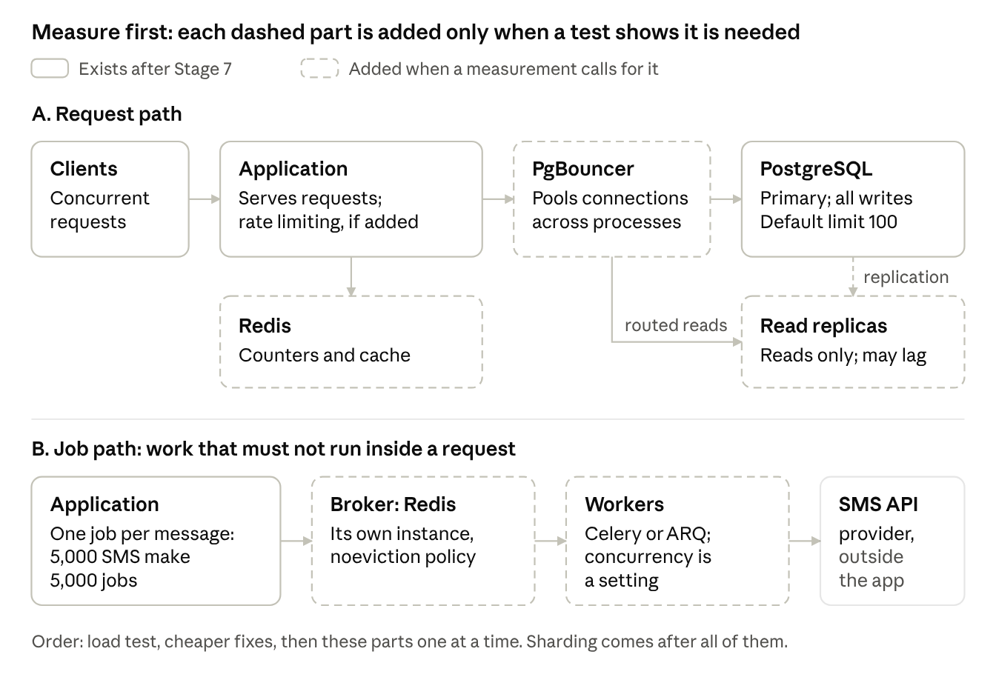
Figure 10. The request path and the job path, with the parts added only when measured
BASICS Load layers
- Queue and broker. A queue holds jobs until a worker takes them. The broker is the service that keeps the queue, such as Redis or RabbitMQ.
- Worker. A process that takes jobs from the queue and runs them.
- Cache. A fast store of answers that can be rebuilt, so repeated reads skip the slow work.
- Connection pooler. A service that shares a few database connections among many processes.
- Read replica. A copy of the database that serves reads.
- Partitioning and sharding. Splitting one table into parts on the same server, or splitting the data across several servers.
- Load balancer. A service that spreads requests across several copies of a service.

GOING DEEPER

Choosing the load layers
Queues and brokers:
Option | How it works | Strengths | Limits | Use when
Celery with a Redis broker | Celery keeps the jobs in Redis, and workers take them from there (Source 83) | One extra service, which may already be running; simple to operate | Needs noeviction and persistence. A job that is not acknowledged returns to the queue after a visibility timeout, which affects jobs scheduled further ahead than that timeout (Source 22) | A Python application with background jobs at moderate volume
PostgreSQL-backed queue, such as Procrastinate, or a jobs table read with SELECT ... FOR UPDATE SKIP LOCKED | Jobs are rows in the application's database, and workers lock and take them (Source 84) | No new service; a job is queued in the same transaction as the change, so a change that is rolled back leaves no job | Adds load and connections to the primary database; lower volume than Redis or RabbitMQ | Moderate volume in an application that already runs PostgreSQL
Celery with RabbitMQ | A message broker with acknowledgements and routing. Quorum queues keep copies on several servers (Source 85) | Jobs survive the loss of one broker server; routing between many queues | Another service to run and learn | Many queues, routing rules, or jobs that must survive a broker server failure
Apache Kafka | A distributed log split into partitions. Messages are kept for a set period, and each consumer group keeps its own position and can read again (Sources 86 and 87) | Very high volume; many independent consumers of the same events; replay | A cluster of brokers and 3 or 5 controllers to run (Source 88); order is kept only within a partition; Celery's Kafka support is experimental | Events shared between many systems, such as billing and analytics, especially when they must be read again
Redis Streams | An append-only log inside Redis, with consumer groups | No new service when Redis already runs | Fewer tools than RabbitMQ or Kafka | Small event streams inside one application
Managed queues (Amazon SQS, Google Pub/Sub, Azure Service Bus) | The cloud provider runs the broker | Nothing to operate | Only where a cloud provider is allowed | A cloud deployment

Caches:
Option | How it works | Strengths | Limits | Use when
In the process | A dictionary or functools.lru_cache inside one process | No network call | Each process has its own copy, lost on restart | Values that do not change while the process runs
Redis or Valkey | A shared in-memory store with expiry times | Shared by every process; data structures; persistence if wanted | Another service, kept separate from the broker | Expensive reads shared across processes; rate-limit counters
Memcached | A simple shared cache of keys and values | Simple and fast | No persistence or replication, and no data structures (Source 89) | Large, simple caches
Materialized view | The database stores a query's result until it is refreshed | No new service | Out of date until refreshed | One slow summary query

Cache data that is read often and changed rarely, load it into the cache when it is first asked for (cache-aside), and never treat the cache as the only copy (Source 90).
Default. For background jobs in a Python application, Celery with its own Redis or Valkey instance, set to noeviction with persistence. No cache until a measured read is slow; then a materialized view for one slow query, or Redis for reads that several processes share.
Database scaling, in the order to consider it:
Option | What it does | Use when
Query and index fixes | Removes slow work | Always first
A larger server | More memory and processors for the same database | Before splitting anything
PgBouncer | Shares connections among processes | The processes' pools add up to more than max_connections
Read replicas | Copies that serve reads; writes still go to the primary | Reads far outnumber writes, and a short delay in reads is acceptable
Partitioning | Splits one large table into parts on the same server, for example one per month | A very large table whose old parts are dropped, or whose queries use one part
Sharding | Splits the data across database servers, for example with the Citus extension (Source 91) | One server cannot hold the data or the writes after everything above

Default. Query and index fixes first, then a larger server. Each later option is added only when a measurement shows the one before it is not enough.
Several copies of the backend need a load balancer in front of them. nginx, already the reverse proxy in Stage 9, can spread requests across them; HAProxy is a dedicated load balancer with more health-check and traffic controls (Sources 92 and 93).
Licenses: Redis 7.4 and later are licensed under RSALv2 or SSPLv1, and Redis 8 adds AGPLv3 as a third choice. Valkey, a fork of Redis 7.2.4 run by the Linux Foundation, uses the BSD license (Sources 94 and 95). Check the version you install against the organization's license rules, as a Stage 1 constraint.
SCENARIOS

Load layers
Situation | Choice | Reason
User Notices: bursts of 5,000 messages from one Python application | Celery with its own Redis instance | Moderate volume, and Redis is simple to run
The organization's license rules do not allow RSAL, SSPL or AGPL software | Valkey as the broker, or RabbitMQ | Valkey is BSD licensed. Check that the Celery and client library versions are tested with it
Jobs must survive the loss of a broker server, and go to several queues by type | RabbitMQ with quorum queues | Copies on several servers; routing by queue
Billing and analytics both need every "notice sent" event, and may need to read last month's again | Kafka, or RabbitMQ streams | Several consumers, each with its own position, and messages kept for a set period
Notice history takes 3 seconds, and its data changes when a send finishes | A materialized view refreshed after each send, before any cache | No new service
The chatbot sends the model server the same questions often | A Redis cache with an expiry, separate from the broker | Shared by all processes, and rebuilt if lost
Monthly reports slow the primary database | One read replica for the reports | Reports can accept a short delay
notice_messages grows by millions of rows a month, and rows older than 2 years are deleted | Partition by ranges of notice_id, with each range sized to hold about a month of notices, and drop the oldest partition; the primary key becomes (notice_id, id) | A unique constraint on a partitioned table must include the partition key, so partitioning by notice_id keeps unique (notice_id, user_id). Dropping a partition is much faster than deleting the rows (Source 17)

Common mistakes
- Adding every layer before measuring anything.
- Sending bulk work from the request handler.
- Sharing one Redis with an eviction policy between the cache and the broker.
- Treating PgBouncer as a load balancer. It is a connection pooler.
- Planning write replicas. Built-in replicas serve reads only.
- Reading from a replica immediately after writing to the primary.
- Using Kafka as the job queue for one application's background jobs.
- Installing a Redis version without checking its license against the organization's rules.

Original practice and this guide
Topic | Original practice | Recommended | Reason
Testing for load | Build in headroom and check whether the added layers hold | Run a load test and a stress test before adding any layer | A measured breaking point shows which layer is needed, and whether any is

EXAMPLE: USER NOTICES
The load test at 40 concurrent staff requests held. The stress test found errors starting at 220 concurrent requests, and the working level, with no errors and responses under one second, was 160: four times the expected load. A bulk test pressed Send now on a notice to 5,000 users: the send ran inside the request, the request stayed open for the whole send, and other staff requests timed out.
Layer | Decision | Reason
Indexes and tables | No change | The load test showed no slow queries
Task queue | Added: Celery, one worker instance with 2 processes (--concurrency=2) | The 5,000-message send has to run outside the request. send_notice now puts one job per message on the queue. Celery tasks are plain functions, so the tasks use a synchronous SQLAlchemy engine and a synchronous HTTP client (httpx.Client), each created once per worker process when it starts, in Celery's worker_process_init hook. httpx is the HTTP client used for the SMS provider
Scheduler | Added: Celery beat, Celery's scheduler process, runs send_due_notices every minute | Scheduled notices need something to start them at their send time. It finds due notices with the (status, send_at) index from Stage 7, and claims each one before queuing its jobs: UPDATE notices SET status = 'sending' WHERE id = :id AND status = 'scheduled' RETURNING id. No job is scheduled ahead with countdown or eta, so the broker's visibility timeout does not affect them
Outbound rate | The send task's rate_limit set below the SMS provider's documented limit | The provider rejects requests above its limit. Celery applies rate_limit per worker instance, and the instance's 2 processes share it (Source 96)
Repeat delivery | The send task claims its message before calling the provider: UPDATE notice_messages SET status = 'sending' WHERE id = :id AND status = 'queued' RETURNING id. If no row comes back, another delivery has it, and the task stops | A job can be delivered twice, and two deliveries can run at the same time; only one of them can change the status
Opt-out | The send task reads users.opted_in just before calling the provider, and skips a user who has opted out | An opt-out can be recorded while a send is in progress
Broker | Its own Redis instance, noeviction policy, persistence turned on; the application reaches it through the REDIS_URL setting | Queued jobs must never be evicted, and must survive a restart
Broker license | Redis 8, checked against the organization's license rules and approved | Redis 7.4 and later changed license; Valkey was the alternative
Rate limiting | Not needed | Staff only; the working level is four times the expected load
Cache | Not needed | No slow reads in the load test
Connection pooling | Not needed | 2 API processes and 2 worker processes, each with SQLAlchemy's default pool of up to 15 connections (Source 28), can open at most 60. PostgreSQL's default limit is 100, of which 3 are reserved for superusers
Read replicas | Not needed | Reads are small and the load test held
Sharding | Not needed | One database server holds the data and the load

CHECKPOINT
- Load test at the expected concurrency and stress test past it; breaking point and working level recorded
- Indexes, table splits and API routes reviewed
- A decision recorded for each layer: queue, rate limiting, cache, pooling, replicas, sharding
- For each layer added, the product chosen from the comparison and its license checked
- Bulk and scheduled work runs in workers; the broker has its own Redis with no eviction
- Work committed

Self-check
- 100,000 registered users, 40 concurrent requests, steady load. Which layers do you add before measuring?
- Six application processes and four worker processes can each open up to 15 connections. Do you need PgBouncer?
- A user saves a change, and the next page, read from a replica, shows the old value. What happened?
- Billing and analytics both need every "notice sent" event, and analytics must be able to read last month's events again. Which option fits, and why not the Celery queue on Redis?
SHIP · STAGE 9 OF 10

Stage 9. Test and deploy
DECISION IN BRIEF
Decision | What has to be true before the application goes live, and how is it put on servers and kept running?
Input | The application, the Stage 8 decisions, and the Stage 1 recovery and update requirements
Default | Plan the tests by layer and run them in a fixed order, have CI build the release, prepare the server so each service runs under its own account and cannot change its code, keep the secrets readable only by root, run each part as a separate service behind a reverse proxy with TLS, choose the deployment strategy from the update requirement, copy backups off the server, and send every change through a sandbox first
Reason | Each kind of test catches a different kind of failure. Separate services can be restarted, updated and scaled one at a time. The deployment strategy and the backups decide how much an update or a failure costs the users
Choose differently when | A cloud provider's deployment service replaces the manual server steps. The separate services, the proxy, migrations at deploy, backups and the sandbox stay
Output | A test plan and its recorded results, the application running on its server with a health check and backups copied off the server, a rollback tested, and a sandbox ready for the first update
First app | Do in full, on the smallest deployment that meets the requirements. A big bang deployment at a planned time is enough when the Stage 1 update requirement allows a short interruption

Steps
- Test plan. For each layer of the application, decide which kinds of test cover it, using the table in Going deeper: Which test for which layer. The unit tests from Stages 5 to 7 are the first row.
- Unit, API and integration tests. Written in Stages 5 to 7 and extended here. They run on every push: the backend against stubs and against a real PostgreSQL, and the front end components on their own. Testcontainers starts PostgreSQL in Docker, so Docker is needed on developers' machines and on the CI runner.
- Functional testing. Name the people who will test and assign every scenario, including the edge cases, to one of them. A scenario is covered only when someone was assigned to it and has tested it.
- Regression script. After each merge to main, CI runs the full suite, including the end-to-end tests against the sandbox, and reports what broke.
- Security and accessibility. Run automated checks on every push: dependency checks (pip-audit, npm audit), static analysis of the code (Bandit, Semgrep) and secret scanning. Run the full security and accessibility audit before release and fix what it finds, for example an API endpoint that should not be reachable.
- Release build. CI (the repository's automated build) builds each merge to main into a release: the front end build, and the backend code with its pinned dependencies, as a package or a container image. The server receives a tested build, not a branch. When a build has passed the sandbox checks and is to go live, its commit is tagged with the release version (Working in Git).
- Server and secrets. Prepare each server with an account for each service that needs different access, the folders, and the firewall (see Going deeper: Preparing the server). The code belongs to root, with the service's account as its group, so a service can read and run its code but not change it. The secrets go in files outside the code folder that only root can read; systemd reads the application's file before starting each backend service. Every internal service listens on 127.0.0.1 only. Releases reach the server without a personal credential: the CI pipeline copies them with its own key to an account that can do nothing else (see the Example).
- Services. Run each part as its own service: the front end (a Node.js process), the backend (uvicorn with several worker processes), the task workers and scheduler, Redis and PostgreSQL. A process manager such as systemd starts each service at boot and restarts it if it stops; in systemd that takes Restart=on-failure in each unit file and systemctl enable for each unit. A reverse proxy such as nginx receives all traffic, handles TLS (HTTPS) and passes each request to the front end or the backend.
- Deployment strategy. Choose how a new release replaces the old one, from the Stage 1 update requirement: whether users can accept a short interruption, how many copies of each service run, and how quickly a bad release must be undone (see Going deeper: Choosing a deployment strategy). Keep the previous release on the server, so going back is a switch and not a rebuild, and test going back in the sandbox.
- Before the first user. Run the migrations once in each deploy, as the role that owns the tables, before the backend services start, not in the application's startup code, where several processes would run them at the same time. Add a health check endpoint. The services write their logs to standard output, and journald, the log store that comes with systemd, keeps them. Schedule database backups, copy each one off the server (see Going deeper: Backups off the server), and restore one as a test.
- Sandbox. Keep a sandbox (a staging environment) built from the same repository, with its own database, its own secrets and its own deployment. Every change goes to the sandbox first, and the same build is then promoted to live. The sandbox cannot reach live data or send messages to real users (see Going deeper: Sandbox and live).

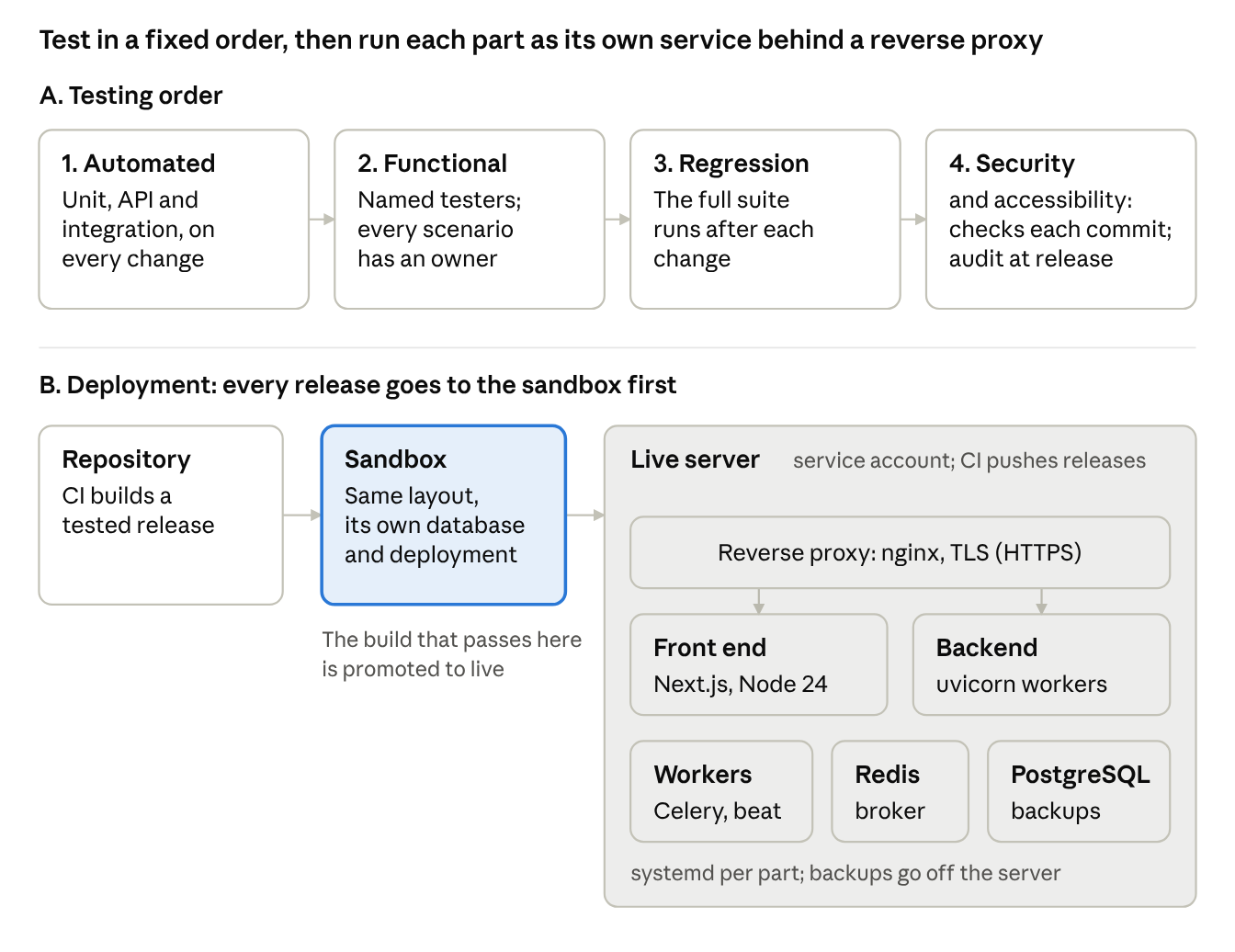
Figure 11. Testing order, and the deployment layout with a sandbox
BASICS Kinds of test
- Unit test. One function on its own, with what it depends on replaced by stubs. It runs in milliseconds.
- API test. Calls one endpoint and checks the status code and the response, including what happens for a caller who is not allowed.
- Integration test. Several real parts together, such as the backend with a real PostgreSQL.
- Component test. One front end component, rendered and used the way a person would use it.
- End-to-end test. A real browser drives the whole application, from sign-in to the result on the screen.
- Migration test. Runs the migrations up and down against a database.
- Smoke test. A few quick calls right after a deploy, to show that the release serves its main screens.
- Contract test. Checks that the API still returns what a known client relies on.
- Property-based test. Generates many inputs from a description, such as the OpenAPI document, and looks for failures.
- Functional testing. People work through scenarios against the requirements.
- Regression run. The whole suite, run after a change, to find what broke elsewhere.

GOING DEEPER

Which test for which layer
Layer | Test | Tool | What it catches | When it runs
Backend function | Unit | pytest, with stubs | Logic errors in one function | Every push
Backend endpoint | API | pytest with FastAPI's TestClient. dependency_overrides replaces the database session or the signed-in user (Source 97) | Routing, validation, status codes, access checks | Every push
Backend and database | Integration | pytest against a real PostgreSQL, started by Testcontainers (Source 98) | SQL errors, constraints, transactions: what the stub hid | Every push, in CI
Background tasks | Unit and integration | pytest calling each task function directly, with FakeSmsClient and a real PostgreSQL | Repeat delivery, the opt-out check, the claim on each message | Every push
Migrations | Migration | pytest-alembic: one head, upgrade from empty, models match the migrations, every downgrade runs (Source 99) | Broken or missing migrations, and downgrades that fail | Every push that touches the schema
Migrations on real data | Migration | alembic upgrade head against the scratch database restored for the monthly test (Stage 10) | Constraints that existing rows break; slow or wrong conversions | Before a release whose migration adds a constraint or changes existing rows
Front end component | Component | Vitest with React Testing Library (Source 70) | Rendering and form behavior of client and synchronous components | Every push
Whole application | End-to-end | Playwright, which drives Chromium, Firefox and WebKit (Source 100) | Sign-in, cookies, the route guard, async Server Components, journeys across pages | Every merge to main, against the sandbox; kept to the main journeys
Deployed release | Smoke | The deploy script calls GET /v1/health, then signs in as the smoke test account and calls GET /v1/users | A release that starts but cannot serve its main screen | Every deploy, in the sandbox and in live
API description | Property-based | Schemathesis, which generates requests from the OpenAPI document (Source 101) | Server errors, and responses that do not match the description | Nightly, or before a release
API used by another team | Contract | Pact (Source 102) | Changes that break that team's client | When either side changes
Capacity | Load and stress | Locust or k6 (Stage 8) | The breaking point and the working level | Before a release that changes sending or queries
Security | Static and dependency checks; a scan of the running application | Bandit, Semgrep, gitleaks, pip-audit and npm audit; ZAP against the sandbox (Source 103) | Risky code patterns, secrets, vulnerable packages, exposed endpoints | The checks on every push; the scan before a release
Accessibility | Automated and by hand | axe inside the Playwright tests; keyboard and screen reader by hand (Source 104) | Missing labels, low contrast, keyboard traps | Automated on every build; by hand before a release
Requirements | Functional | Named testers with assigned scenarios | Requirements not met; edge cases | Each release, in the sandbox

Write many fast tests of the kinds at the top of this table and few slow ones of the kinds further down: unit tests for every function, API and integration tests for every endpoint and query, and end-to-end tests for the main journeys only. When a higher-level test finds a bug that no lower-level test caught, add the lower-level test (Source 105). Use the coverage report to find code that no test runs, not as a target: a high percentage does not show that the tests check the right things (Source 106).
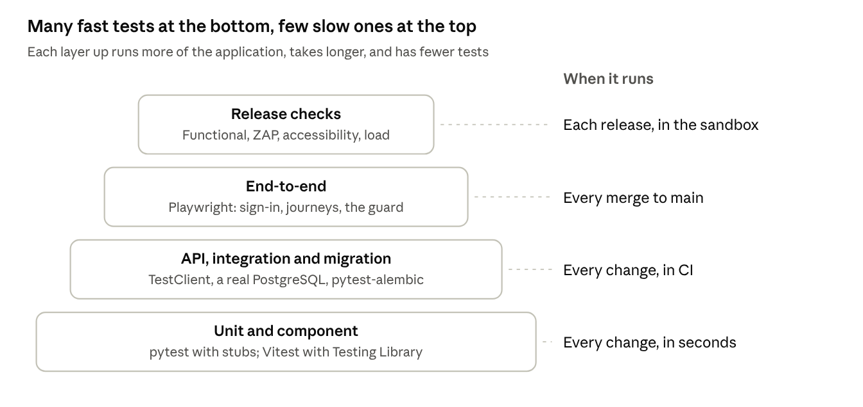
Figure 12. Test layers, from many fast tests to a few slow ones, and when each runs
SCENARIOS

What to test when
Change | Tests to add or run | Reason
The rule that rejects a past send time | A unit test | The rule is in one function
A new field on PATCH /v1/users/{id} | API tests for the field's validation and for a viewer being denied; a migration test if the schema changed | The endpoint checks input and access
A new query with a join | An integration test against PostgreSQL | The stub cannot run SQL
A migration that renames a column | The migration round trip, and an integration test of the queries that use the column | Downgrades and queries fail only against a real database
A migration that adds NOT NULL to an existing column | The migration on the scratch copy of real data | Existing rows may hold values the new rule rejects
The send task | Task tests: a second delivery of the same job, and an opt-out made after queuing | Both happen only when tasks run, not in requests
The NoticeForm component | A component test | The behavior is inside one component
proxy.ts, or sign-in | An end-to-end test: the signed-out redirect, sign-in, and a guarded page | Cookies, redirects and the guard work only in a real browser with the whole application
An upgrade of FastAPI or Next.js | The full regression run, Schemathesis, and the end-to-end journeys | A framework change can affect every endpoint and page
A release | The functional scenarios in the sandbox, the ZAP scan, the accessibility check, and a load test if sending or queries changed | The release checks cover what the automated tests do not

BASICS Server terms
- root and sudo. root is the administrator account on a Linux server. sudo runs one command as root, or as another account with -u.
- Owner, group and mode. Every file has an owner and a group. Its mode says what the owner, the group and everyone else may do with it: read, write, or run (execute). In a mode such as 640, 6 is read and write, 4 is read only, and 0 is no access (Source 107).
- Symbolic link. A file that points to another file or folder. /opt/user-notices/current is one.
- systemd unit. A file in /etc/systemd/system/ that tells systemd how to start one service. systemctl start, stop, restart and status act on it, and journalctl -u shows its output.
- Port and 127.0.0.1. A service listens on a port number. A service bound to 127.0.0.1 can be reached only from the same server.
- SSH key. A pair of files used to log in without a password. The private key stays with the person or the pipeline; the public key goes on the server.
- TLS certificate and private key. The certificate shows browsers the server's name. The private key stays on the server and proves that the server holds the certificate.
- Firewall. Rules on the server that decide which ports other machines can reach.

GOING DEEPER

Preparing the server
Once per server, before the first deploy, as root:
- Install the operating system release from the Stage 3 version table. Ubuntu 24.04's own packages hold older releases of most of the other tools, so each comes from its project, at the version the table records: PostgreSQL 18 from the PostgreSQL apt repository (Source 156); Redis 8 from Redis's apt repository, which installs the redis package and the redis-server service (Source 157); Python 3.14 built from source with make altinstall (Source 158), or installed with uv python install 3.14 (Source 159); Node.js 24 as the prebuilt Linux binary from nodejs.org (Source 8) or from the NodeSource apt repository (Source 160). nginx comes from Ubuntu's own package, version 1.24 (Source 155).
- Create an account for each service that needs different access: useradd --system --no-create-home --shell /usr/sbin/nologin usernotices (the API, the workers and the scheduler), and the same for usernotices-web (the front end). A process can read the environment of other processes under the same account, so the front end, which needs no secrets, does not share the backend's account. On both servers, create usernotices-deploy, the account the pipeline logs in as to deliver releases; on the live server, also create usernotices-backup, the account the backup server logs in as to read the dumps. These two log in over SSH with a key that is limited to one command, so they need a shell: useradd --system --create-home --shell /bin/sh usernotices-deploy, and the same for usernotices-backup.
- Create the folders: install -d -o root -g root -m 755 /opt/user-notices /opt/user-notices/releases, install -d -o usernotices-deploy -g usernotices-deploy -m 750 /opt/user-notices/incoming, and install -d -o root -g root -m 700 /etc/user-notices. Allow the deploy account to run the deploy script, and nothing else, as root, with one line in /etc/sudoers.d/user-notices: usernotices-deploy ALL=(root) NOPASSWD: /usr/local/sbin/user-notices-deploy
- In /etc/redis/redis.conf, set bind 127.0.0.1, maxmemory-policy noeviction, appendonly yes and a password with requirepass, then systemctl restart redis-server.
- Create the database and the roles from deploy/bootstrap.sql (Stage 7), and set each role's password with psql's \password command.
- Allow SSH only from the administrators' network, the CI runner and the backup server, and ports 80 and 443 from everywhere, through the firewall. With ufw, for an administrators' network of 10.20.0.0/24: ufw allow from 10.20.0.0/24 to any port 22 proto tcp, the same line for the runner's and the backup server's addresses, ufw allow 80/tcp, ufw allow 443/tcp, then ufw enable.
- Put the secrets files in /etc/user-notices/ and the TLS certificate and key in /etc/ssl/, copied from the organization's secret store.

GOING DEEPER

Secrets and file permissions on the server
Path | Owner and group | Mode | Reason
/opt/user-notices/releases/1.4.0/backend/ (code and virtual environment) | root:usernotices | Folders 750; files 640; programs in .venv/bin 750 | The backend services read and run the code but cannot change it (Source 108). chmod -R u=rwX,g=rX,o= sets this: X adds execute only to folders and to files that already had it
/opt/user-notices/releases/1.4.0/frontend/ | root:usernotices-web | The same | The same, for the front end's account
/opt/user-notices/current | root | A link to the active release | Switching the link switches the release
/etc/user-notices/backend.env | root:root | 600 | The application's secrets. systemd reads the file before starting each backend service, so the services' account never needs to read it
/etc/user-notices/migrate.env | root:root | 600 | MIGRATION_DATABASE_URL, for usernotices_owner. The deploy script and the retention job read it; no service loads it, so the running application never holds the owner's password
/etc/user-notices/smoke.env | root:root | 600 | The email address and password of the smoke test account, a staff account with the viewer role. Only the deploy script reads it
/var/backups/user-notices/ | postgres:usernotices-backup | Folder 2750; dumps 640 | The nightly dump runs as postgres. The 2 in the folder mode is the setgid bit: each new dump takes the folder's group, so usernotices-backup can read the dumps but not change them
/etc/ssl/private/notices.key | root:root | 600 | The TLS private key, read by nginx when it starts

systemd's documentation says environment variables are not suitable for secrets, because other processes can see them and they pass down to child processes. Its credentials feature (LoadCredential=) gives the service each secret as a file that only the service and root can read (Sources 109 and 48). In each unit, ProtectSystem=strict makes most of the file system read-only for the service, apart from the paths in ReadWritePaths= and the folders systemd creates for it with StateDirectory= and CacheDirectory=.
Default. An EnvironmentFile with mode 600, as in the Example. Use LoadCredential= when the organization's rules do not allow secrets in environment variables.
BASICS Deployment terms
- Release and deploy. A release is a tested build with a version number. Deploying puts a release on the servers. A feature flag can keep new behavior switched off after the deploy and switch it on later.
- Promote. Deploy to live the same build that passed in the sandbox.
- Downtime. Time when users cannot use the application.
- Instance. One running copy of a service.
- Rollback. Going back to the previous release after a bad one.
- Both versions at once. In every strategy except big bang, the old and new versions run at the same time. After any rollback, the old code runs against the new schema. Either way, the database must work with both versions (Stage 7, expand and contract). The same holds for queued jobs: jobs queued by one release are run by the next release's workers, and after a rollback by the previous one's. Change a task's name or arguments the same way: add the new form first, and remove the old one a release later.

GOING DEEPER

Choosing a deployment strategy
Strategy | How it works | Downtime | Going back | Needs | Use when
Big bang (all at once; called Recreate in Kubernetes) | Stop the old version everywhere, then start the new one (Source 110) | Yes, while the services restart | Start the previous release again; fast when it is kept on the server | One server is enough | Users can accept a short interruption at a planned time; first applications; internal tools
Rolling | Replace instances a few at a time behind a load balancer; old and new run side by side (Source 110) | None, if enough instances stay up | Roll the previous version back the same way | Two or more instances, a load balancer and health checks | Several identical instances of a service that keeps no state in memory
Blue-green | Start the new version beside the old one, then switch all traffic to it at the proxy (Source 111) | None; the switch is immediate | Switch back | Room for two copies (two servers, or two copies on different ports) and a database both versions can use | Updates must not interrupt users, and going back must be immediate
Canary | Send a small share of traffic to the new version, compare its errors and response times with the old one, then raise the share (Source 112) | None | Send all traffic back to the old version | A load balancer that splits traffic by weight, metrics for each version, and enough traffic to compare | Many users, and a change whose risk only real traffic will show
Shadow | Copy live requests to the new version and discard its answers; users see only the old version (Source 113) | None | Nothing to undo | Request mirroring, and a new version with no side effects: no messages sent, no writes to live data | Checking a rewritten component against real traffic before it serves anyone
Feature flag | Deploy the code switched off, then switch it on for some or all users (Source 114) | None for the switch | Switch it off | A setting the code reads, and removing flags once they are no longer needed | Separating deploy from release, with any strategy above

Default. Big bang at a planned time outside working hours, with the previous release kept on the server.
Questions to ask, in order:
- Can users accept a short interruption at a planned time (Stage 1)? Use big bang at that time.
- Is no interruption allowed, on one server? Use blue-green with two copies on the same server and nginx switching between them. A configuration reload lets nginx's old workers finish their requests while new workers take new ones (Source 115).
- Do several instances run behind a load balancer? Use rolling.
- Many users, and a change whose risk only real traffic will show? Use canary.
- A rewritten component to check against real traffic first? Use shadow, for requests that only read, or with every side effect switched off.

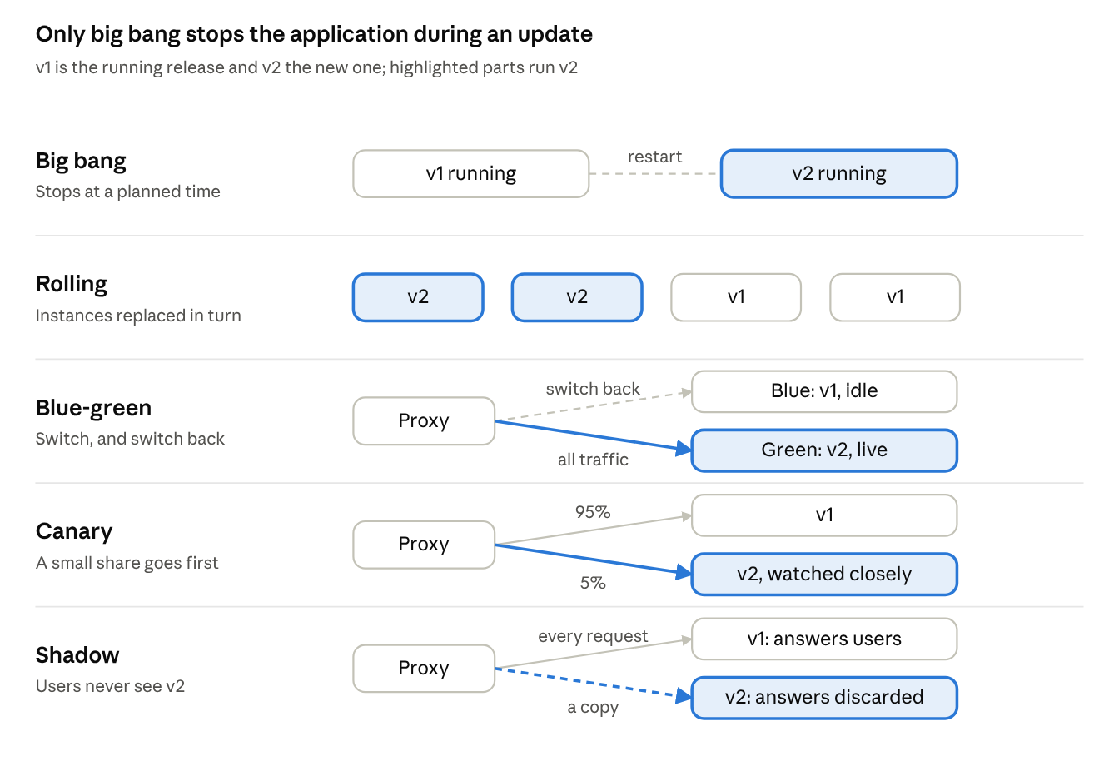
Figure 13. Five deployment strategies and how each moves traffic to the new release
SCENARIOS

Deployment strategy
Situation | Strategy | Reason
User Notices: 150 staff, office hours, internal, one live server | Big bang outside working hours, with the previous release kept in its own folder on the server | Stage 1 allows up to 5 minutes outside working hours, and the previous release stays on the server for a fast rollback
The same application, now used around the clock by a support center | Blue-green on the one server: two copies of the backend and the front end on separate ports, with nginx switched between them. The workers restart on the new release at the switch, and only one scheduler runs at any time | No interruption and an immediate switch back. Two schedulers would start each due notice twice
A public site on six instances behind a load balancer | Rolling, one or two instances at a time | Capacity stays up while instances are replaced
A change to the payment step for 200,000 customers | Canary: 5% of traffic for a day, then 25%, then all, comparing error rates and response times | A problem shows on a small share of users first
A new search service replacing the old one | Shadow: mirror search requests to the new service and compare its answers and timings | Real traffic, and no user sees the new answers
A proposal to mirror Send now requests to a shadow copy | Do not mirror requests that send messages or change data. Mirror only reads, or give the shadow a fake SMS client and its own database | Each mirrored send would reach the users a second time
A release whose migration renames a column | Any strategy, with the rename done by expand and contract | The old and new code use the same schema, at the same time or one after the other after a rollback

BASICS Backup terms
- Recovery point objective (RPO). How much recent data may be lost, measured as time before the failure (Source 116).
- Recovery time objective (RTO). How long the application may be unavailable while it is restored.
- 3-2-1 rule. Three copies of important data, on two kinds of storage, with one copy off-site (Source 117).
- Logical and physical backup. A logical backup holds the database's contents (pg_dump). A physical backup holds the database server's files (pg_basebackup).

GOING DEEPER

Backups off the server
Method | What it gives | Recovery point | Use when
pg_dump each night, plus pg_dumpall --globals-only for the roles | A snapshot of one database, restored with pg_restore. It does not block normal use, apart from changes that need an exclusive lock, such as most ALTER TABLE commands (Source 118) | The time since the last dump | A recovery point of hours to a day; small and medium databases
pg_basebackup with continuous WAL archiving | A copy of the whole database server plus every change since, so it can be restored to any moment: point-in-time recovery (Source 119) | Minutes | A recovery point of minutes
pgBackRest | Full, differential and incremental backups, compression, encryption, retention rules and a remote repository, built on WAL archiving (Source 120) | Minutes | Point-in-time recovery for larger databases, or many backups to manage
Barman | Physical backups with WAL archiving or streaming, run from a separate backup server, with retention rules (Source 121) | Minutes | Point-in-time recovery managed from the backup server

Default. pg_dump each night, copied off the server, when the recovery point is a day or more; pgBackRest when it is minutes.
Rules for every method:
- Copy each backup off the database server, to a machine the database server cannot delete from, for example a backup server that pulls the files.
- Encrypt backups that leave the server, and keep the key apart from the backups.
- Keep one copy offline or off-site (Sources 117 and 122).
- Back up what the database does not hold: the roles, the server configuration, and the secrets. The secrets go to the organization's secret store, not with the data.
- A backup counts only once a restore from it has worked. Restore one before go-live, then every month (Stage 10).
- Time the backup and the pull against the recovery point: a failure between the dump and the pull loses that dump too.

GOING DEEPER

Sandbox and live
Item | Your machine | Sandbox | Live
Data | Seed data | Test data made up for the sandbox. Never a copy of live personal data, unless it is masked | Real data
Secrets | Your own development values | Sandbox values, different from live | Live values, held only on the live server
SMS provider | FakeSmsClient from Stage 5 | The provider's test key, or real sends only to the numbers in SMS_ALLOWLIST | Real sends; SMS_ALLOWLIST empty
Deployment | Any time | Every merge to main, automatically | The same build, promoted after the sandbox checks
Access | You | Developers and testers | Staff; developers only when needed, and recorded
Versions and setting names | The same as live | The same as live | The reference
Backups and restore tests | None | Short retention; no restore of live backups | The full policy; restore tests stay on live (Stage 10)

Every environment runs the same build, with the same versions and the same setting names; only the values differ. The sandbox must not be able to reach live data or send messages to real users.
SCENARIO A test send from the sandbox
A tester presses Send now in the sandbox on a group of 5,000 users. If the sandbox holds a copy of the live users and the live SMS key, 5,000 real people receive a test message.
- Fill the sandbox with made-up users, in groups the testers create.
- Put the provider's test key in the sandbox's secrets file, and set SMS_ALLOWLIST to the testers' phone numbers. services/sms.py sends only to numbers in SMS_ALLOWLIST when the setting is not empty.
- Before go-live, check: the sandbox's users are the made-up set, the sandbox's key is the test key, and one test send reaches only a tester's phone.

Common mistakes
- A personal access token (PAT) on the production server.
- Running the backend from a shell session instead of under a process manager.
- Testing everything through the browser, so the suite is slow and fails for reasons unrelated to the change.
- Treating a coverage percentage as the goal.
- Copying live personal data, or the live SMS key, into the sandbox.
- A secrets file inside the code folder, or readable by every account on the server.
- Code files that the service's own account can change.
- Choosing a zero-downtime strategy without making the migrations and the queued jobs work with both versions.
- Mirroring requests that send messages or change data to a shadow copy.
- No database backups, backups kept only on the database server, or backups that were never restored as a test.
- Changing the schema on the server by hand.
- Deploying a branch instead of a tested release.

Original practice and this guide
Topic | Original practice | Recommended | Reason
Security and accessibility scans | Run once, at the end of development, and fix the findings in one pass | Keep the full audit before release, and add automated checks on every push | A design flaw found at release, for example in authentication, is the most expensive kind to fix
Server access to the code | A personal access token (PAT) from Azure DevOps | A CI pipeline that copies the release with its own key, or a deploy key or service principal where the server must fetch. If a PAT is the only option: read access to one repository, an expiry date, and storage in a secret store | A PAT is tied to one person's account. Microsoft's guidance is to keep PATs out of code and remote URLs and to prefer managed identities for automation (Source 25)
Sandbox contents | A separate branch with only the modules under test | The same build, running the full system, promoted from sandbox to live | A subset does not test the connections between modules, and a long-lived branch collects differences from the main branch

EXAMPLE: USER NOTICES
Part | Runs as | Notes
Repository and CI | GitHub, with a self-hosted runner on the sandbox server | The runner can reach the sandbox and live servers; a runner outside the data center could not
Reverse proxy | nginx | TLS certificate from the organization's internal certificate authority; sends /v1/ requests to the backend and all other requests to the front end
Front end | Next.js standalone server on Node.js 24, account usernotices-web, under systemd | Built by CI; listens on 127.0.0.1:3000
Backend | uvicorn with 2 worker processes, account usernotices, under systemd | Listens on 127.0.0.1:8000; GET /v1/health reports the database and Redis connections
Task workers and scheduler | One Celery worker instance with 2 processes, and one Celery beat, account usernotices, under systemd | Send the SMS jobs; start scheduled notices
Redis | Its own service, on 127.0.0.1, with a password and the noeviction policy | Broker only
PostgreSQL 18 | Its own service, on 127.0.0.1 | Nightly backup, copied off the server; a restore tested before go-live and each month
Sandbox | The second server, same layout, its own database and keys | Every merge to main goes here first

The test plan:
Layer | Tests | When
Services | pytest unit tests against the stubs | Every push
Endpoints | TestClient tests for every endpoint, including a viewer denied each change | Every push
Database | Store tests against PostgreSQL 18 started by Testcontainers; pytest-alembic | Every push
Tasks | The send task and send_due_notices called directly: a repeated delivery, an opt-out after queuing | Every push
Front end | Vitest and React Testing Library for NoticeForm, UserTable and StatusBadge | Every push
Whole application | Playwright: sign in, edit a user, schedule a notice, Send now, the signed-out redirect; axe on each page | Every merge to main, against the sandbox
Requirements | 13 functional scenarios, four named testers | Each release, in the sandbox
Capacity | Locust at 40 and 160 concurrent requests | Before a release that changes sending or queries

The release is one file built by CI: the backend code, requirements.txt, a wheels/ folder written by pip wheel -r requirements.txt -w wheels on the runner (which runs the same Ubuntu release and Python version as the servers), and the front end's standalone build with public/ and .next/static/ copied into it (Source 123). A virtual environment records its own absolute path and cannot be moved (Source 6), so the deploy script creates it on the server. The pipeline copies the release over SSH to a deploy account on the server. That account can write only to /opt/user-notices/incoming/ and can run only /usr/local/sbin/user-notices-deploy through sudo, by one line in /etc/sudoers.d/user-notices. An administrator installs that script from the reviewed repository; the pipeline does not copy it. Each Stage 1 screen has an assigned owner for its functional scenarios. The sandbox holds made-up users, the SMS provider's test key and the four testers' numbers in SMS_ALLOWLIST.
Deployment strategy: big bang outside working hours, with release folders. Each release is unpacked into /opt/user-notices/releases/ under its version, and /opt/user-notices/current links to the active one. The deploy script, deploy/deploy.sh, installed on the server as /usr/local/sbin/user-notices-deploy, runs as root and does the following, in order:
- Unpack the release from /opt/user-notices/incoming/ into /opt/user-notices/releases/1.5.0/, create the virtual environment in the release folder with python3.14 -m venv, install the wheels with the environment's pip install --no-index --find-links wheels -r requirements.txt, compile the bytecode cache with the environment's python -m compileall -q app (the service cannot write to the release folder, so the cache is written now), and then set the owners and modes from the permissions table.
- Stop the beat and worker services. Celery finishes the tasks in progress, and queued jobs stay in Redis.
- Back up the database: sudo -u postgres pg_dump --format=custom --file=/var/backups/user-notices/before-1.5.0.dump usernotices.
- Stop the front end and the API.
- Record the current revision with alembic current, then run alembic upgrade head from the new release's backend folder, as usernotices_owner, with the connection string from /etc/user-notices/migrate.env. Alembic runs the upgrade in a transaction, so if a migration fails, PostgreSQL rolls it back; the script then starts the previous release unchanged and stops.
- Switch the link: ln -sfn /opt/user-notices/releases/1.5.0 /opt/user-notices/current.
- Start the API, the front end, the workers and beat.
- Call GET /v1/health every 5 seconds for up to 60 seconds, then sign in with the account in /etc/user-notices/smoke.env and call GET /v1/users. If either fails, switch the link back and start the previous release.
deploy.sh --rollback runs steps 2, 4, 6 and 7 for the previous release, so the workers and beat also go back to the previous code. A switch back runs the previous code against the migrated schema, so every migration follows expand and contract. Users are interrupted from step 4 until step 7 completes, within the 5 minutes Stage 1 allows.
Backups: at 01:00 each night, a systemd timer runs pg_dump --format=custom and pg_dumpall --globals-only as the postgres account, into /var/backups/user-notices, and deletes local dumps older than 3 days. At 01:30 the organization's backup server pulls the files over SSH as the usernotices-backup account, whose key is limited in authorized_keys to reading that folder (command="rrsync -ro /var/backups/user-notices/"). The backup server encrypts the files and keeps them for 35 days; the first backup of each month also goes to offline storage at another site and is kept for a year. The newest copy off the server is at most 24 hours and 30 minutes old, which meets the Stage 1 recovery point because staff change data only between 8:00 and 18:00: a failure at any hour loses at most one working day of edits. A restore into a scratch database before go-live took 20 minutes.
The backend's systemd unit. Each unit file is kept in deploy/, copied to /etc/systemd/system/, and loaded with systemctl daemon-reload and systemctl enable --now:
# /etc/systemd/system/user-notices-api.service
[Unit]
Description=User Notices API
After=network.target postgresql.service redis-server.service

[Service]
User=usernotices
Group=usernotices
WorkingDirectory=/opt/user-notices/current/backend
EnvironmentFile=/etc/user-notices/backend.env
ExecStart=/opt/user-notices/current/backend/.venv/bin/python -m uvicorn \
app.main:app --host 127.0.0.1 --port 8000 --workers 2
Restart=on-failure
ProtectSystem=strict
NoNewPrivileges=yes
PrivateTmp=yes

[Install]
WantedBy=multi-user.target
The other three units differ in these lines. Running Python with -m means the code files can stay at mode 640. Beat writes its schedule file to the folder systemd creates for it, and only one beat service runs:
# user-notices-worker.service
ExecStart=/opt/user-notices/current/backend/.venv/bin/python -m celery \
-A app.worker worker --concurrency 2

# user-notices-beat.service
StateDirectory=user-notices-beat
ExecStart=/opt/user-notices/current/backend/.venv/bin/python -m celery \
-A app.worker beat --schedule /var/lib/user-notices-beat/schedule

# user-notices-web.service: no EnvironmentFile; the front end holds no secrets
User=usernotices-web
Group=usernotices-web
WorkingDirectory=/opt/user-notices/current/frontend
Environment=PORT=3000 HOSTNAME=127.0.0.1
Environment=API_INTERNAL_URL=http://127.0.0.1:8000
ExecStart=/usr/bin/node server.js
The nginx configuration, deploy/nginx/user-notices.conf, copied to /etc/nginx/sites-available/ and linked into /etc/nginx/sites-enabled/. Check it with nginx -t, then systemctl reload nginx. It keeps the front end and the backend on one origin, and passes each staff member's address to the backend, which uvicorn accepts from 127.0.0.1 by default, so audit rows record the real address (Source 124). Ubuntu 24.04 ships nginx 1.24, which takes http2 as a parameter of listen; nginx 1.25.1 and later also accept a separate http2 on directive (Source 161):
server {
listen 80;
server_name notices.example.internal;
return 301 https://$host$request_uri;
}

server {
listen 443 ssl http2;
server_name notices.example.internal;
ssl_certificate /etc/ssl/notices.crt;
ssl_certificate_key /etc/ssl/private/notices.key;

proxy_set_header Host $host;
proxy_set_header X-Forwarded-For $remote_addr;
proxy_set_header X-Forwarded-Proto $scheme;

location /v1/ { proxy_pass http://127.0.0.1:8000; }
location / { proxy_pass http://127.0.0.1:3000; }
}

CHECKPOINT
- Test plan by layer written; unit, API, integration, task, component, end-to-end, functional, regression, security and accessibility results recorded
- Release built by CI and tagged when promoted; copied by the pipeline to a deploy account that can only run the deploy script
- Servers prepared: an account per service, code owned by root, secrets files readable only by root, internal services on 127.0.0.1, firewall in place
- Each service running under a process manager that restarts it, behind a reverse proxy with TLS
- Deployment strategy chosen from the update requirement; the deploy script backs up before migrating; a rollback to the previous release tested in the sandbox
- Migrations applied by the owner role; health check and smoke test pass; logs kept by journald; backups copied off the server; a restore tested
- Sandbox ready with its own data, keys and SMS_ALLOWLIST, and updates promoted through it

Self-check
- The backend was started from an SSH session and stopped when the session closed. What should run it?
- A fix passed in the sandbox. What is deployed to live?
- Why does every functional test scenario have a named owner?
- You changed proxy.ts. Which kind of test covers the change, and why not a unit test?
- The sandbox holds a copy of the live users and the live SMS key. What can go wrong, and what should the sandbox hold instead?
- Staff now use User Notices around the clock, on one server. Which deployment strategy fits, and what must every migration do?
- The nightly backup is written to /var/backups on the database server, and nothing else happens to it. What is missing?
RUN · STAGE 10 OF 10

Stage 10. Operate after launch
DECISION IN BRIEF
Decision | How is the application kept running, recoverable and current after launch?
Input | The live application and the sandbox from Stage 9, the Stage 1 retention, recovery and update requirements, and the Stage 3 version table and patching rule
Default | Set a retention period for each kind of log; send errors to an error tracker and watch the servers with a monitoring tool, both alerting a named person; write the rollback procedure before it is needed; fix forward rather than downgrade when data is involved; restore a backup every month; patch on a calendar, through the sandbox; rotate secrets on a schedule and whenever one may have been exposed
Reason | Most of an application's life comes after launch. Each routine is cheaper to set up before the first incident that needs it than during that incident
Choose differently when | Managed services take over part of the work, such as a cloud provider's database backups or log storage. The routines stay; the tools change
Output | A runbook with the retention table, the alert rules, the rollback procedure, the restore record, the patch calendar and the rotation schedule, each with an owner, and each routine run once
First app | Do in full, at the smallest scale: journald retention, one error tracker, a scheduled check script for the other alerts, the rollback steps, nightly off-server backups with a monthly restore, a monthly update window and a yearly rotation

Steps
- Logs and retention. List each kind of log, where it is kept, who reads it and how long it is kept, from the Stage 1 retention requirement. Set the retention in the tool that keeps each one: journald for the services' output, logrotate for nginx's files, and a scheduled job for the audit and send records in the database. Logs are not deleted before the required period ends, and are not kept long after it (Sources 64 and 125). Read a service's output with journalctl -u user-notices-api --since "1 hour ago".
- Error tracking. Send every unhandled error from the backend and the front end to an error tracker, which groups repeated errors and shows the stack trace, the release and how many users were affected. Keep personal data out of the events (see Going deeper: Logs, errors and alerts).
- Monitoring and alerts. The error tracker alerts on errors only. Disk space, queue length, a backup that did not arrive and a certificate close to expiry need a monitoring tool: the organization's existing one, or Prometheus with Alertmanager. For a first application, a script run by a systemd timer every 5 minutes can check each value and send the email. The health check is called from another server, so a failure is reported even when the live server is down. The four signals to watch for any service are latency, traffic, errors and saturation (Source 126).
- Rollback procedure. Write the steps before they are needed, and run them once in the sandbox. Going back to the previous release is a switch when the release folders are kept (Stage 9). Write down who decides to roll back, and the check that confirms the rollback worked.
- Migrating backwards. For each release, record how its migrations would be undone: left in place, downgraded, fixed forward, or restored (see Going deeper: Undoing a migration). The deploy script backs up the database before migrating (Stage 9).
- Backups and restores. Check each morning that last night's backup ran and reached the backup server. Each month, restore the latest backup into a scratch database, check it, record how long the restore took against the Stage 1 recovery time, and drop the scratch database. A restore holds live personal data, so it runs on the live server or on a server with the same access rules, never in the sandbox. Delete backups that are older than the retention period.
- Patching. Put the Stage 3 patching rule on a calendar: operating system security updates, the database's minor releases, language runtime patches and library updates (see Going deeper: Patching calendar). Operating system security updates install themselves each day, apart from the packages the application depends on, which go through the sandbox first. A critical security fix is applied outside the calendar. Plan each major upgrade before the support end date in the Stage 3 version table.
- Secret rotation. Replace each secret on a schedule, and at once when it may have been exposed or when someone who could read it leaves. Where the application allows it, rotate with an overlap: create the new secret, deploy it, confirm it works, then revoke the old one (see Going deeper: Rotating secrets).
- Incidents. Record each incident in the incident log: what users saw, the timeline, the cause, the fix and the follow-up actions. Review it without assigning blame, so the discussion stays on the causes and their fixes (Source 127).

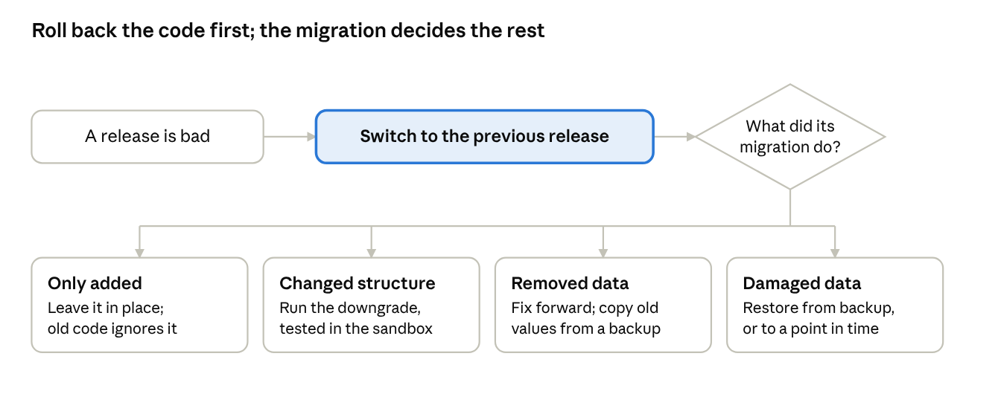
Figure 14. Undoing a bad release: the code first, then what its migration did
BASICS Operations terms
- Retention period. How long a kind of record or log is kept before it is deleted.
- Error tracker. A service that collects application errors, groups them and alerts people.
- Monitoring. Regular measurements of the servers and services, such as disk space and queue length, with alerts when a value passes a limit.
- journald and logrotate. journald keeps the output of systemd services. logrotate renames, compresses and deletes log files that programs such as nginx write.
- Runbook. The written steps for a routine task or an incident, so that anyone on the team can carry them out.
- Incident. An event that stops users working or puts data at risk, such as an outage, data loss or an exposed secret.
- Fix forward. Correcting a problem with a new release instead of going back to the previous one.
- Patch. A release that fixes bugs or security problems without adding features.
- Rotation. Replacing a secret with a new one, then revoking the old one.

GOING DEEPER

Logs, errors and alerts
Where each kind of log is kept, and for how long:
Log | Where | Kept | Set by
Service output: API, workers, scheduler, front end | journald | 30 days | A drop-in file, /etc/systemd/journald.conf.d/retention.conf, with Storage=persistent, MaxRetentionSec=30day, MaxFileSec=1day and a SystemMaxUse= large enough for 30 days of output; then systemctl restart systemd-journald. journald deletes whole files, so MaxFileSec keeps the deletion close to 30 days. Check journalctl --disk-usage after the first week (Source 125)
nginx access and error logs | /var/log/nginx | 90 days | The nginx package's own file, /etc/logrotate.d/nginx, with rotate 90 and its daily and compress lines kept. logrotate reports a second file that names the same logs as a duplicate entry and ignores it, so edit the package's file rather than adding one (Source 128)
Audit records | The audit_log table | 2 years | A systemd timer runs deploy/retention.py at 03:30, as usernotices_owner with the connection string from migrate.env: DELETE FROM audit_log WHERE occurred_at < now() - interval '2 years'
Send records | The notice_messages table | 2 years | The same job: DELETE FROM notice_messages m USING notices n WHERE m.notice_id = n.id AND n.send_at < now() - interval '2 years'; or monthly partitions dropped once they pass 2 years (Stage 8)
Error events | The error tracker | 90 days | The tracker's retention setting
Backups | The backup server | 35 days; monthly copies for 1 year | The backup server's retention rules

Error trackers that keep the data on the organization's servers:
Option | What it is | Needs | Use when
Sentry, self-hosted | The Sentry server, run on your own machine under the Functional Source License; each version becomes Apache 2.0 two years after its release | At least 4 processor cores, 16 GB of memory plus 16 GB of swap, 20 GB of disk, and Docker. Sentry describes it as a minimal setup for simple use cases (Source 129) | A large server is available and the team wants Sentry's full feature set
GlitchTip | An open-source error tracker, MIT licensed, that accepts events from Sentry's client libraries (Sources 130 and 131) | PostgreSQL and about 512 MB of memory (Source 132) | A small setup is enough
A hosted service | The provider runs the tracker | The error data leaves the organization | A cloud provider is allowed

Default. GlitchTip, unless the team needs Sentry's full feature set and has a server for it.
Both self-hosted options use the same client libraries: sentry-sdk in the FastAPI backend and @sentry/nextjs in the front end, each pointed at the organization's own server through the SENTRY_DSN setting. Without send_default_pii, sentry-sdk still sends request bodies, query strings and the values of local variables in each stack frame; in User Notices those include phone numbers. It sends IP addresses and user details only when send_default_pii is turned on (Sources 133 and 134). In the backend, set max_request_body_size="never" and include_local_variables=False, or remove those fields in a before_send function.
GOING DEEPER

Undoing a migration
What the migration did | How to undo it | Reason
Only added: a table, a column that may be empty, an index | Leave it in place and roll back the code | The previous release ignores what was added
Changed structure without losing data: a constraint, NOT NULL on a column | Before switching back, run the downgrade from the new release's backend folder, as usernotices_owner, to the revision the deploy script recorded for the previous release: alembic downgrade followed by that revision id. Run the same downgrade in the sandbox first (Source 54) | Only the new release's folder holds the new migration. A downgrade is needed only when the previous release fails against the new structure, for example a CHECK its writes do not meet
Removed or rewrote data: a dropped column, a conversion of values | Fix forward. If the old values are needed, restore the backup taken before the migration into a scratch database and copy them back | A downgrade can recreate the structure but not the data
Damaged data across the database | Restore from the last backup, or to a moment just before the damage if WAL archiving is in place | Only a backup holds the earlier data

GOING DEEPER

Patching calendar
Component | When updates appear | Rule for User Notices
Ubuntu security updates | As published. On Ubuntu Server, unattended-upgrades installs security updates daily by default (Source 135) | Automatic on the sandbox. On live, automatic except the packages listed in its Unattended-Upgrade::Package-Blacklist (postgresql, nginx, redis), which follow the rows below. A reboot, when a kernel update needs one, in the monthly window
PostgreSQL minor releases | At least once a quarter, on the second Thursday of February, May, August and November, plus releases for urgent fixes (Source 136) | The sandbox within two weeks, then live in the next monthly window. A minor release needs only a restart, after reading its release notes (Source 10)
Python, Node.js and Next.js patch releases | Python bugfix and security releases; Node.js security releases, announced in advance on the Node.js blog (Sources 7 and 137) | The sandbox within two weeks, then live in the next monthly window
Redis and nginx | As published | The same as PostgreSQL
Python and npm libraries | Continuously | Dependabot opens a pull request for each update (Source 138); pip-audit and npm audit run in CI on every push (Source 139); one library per pull request
Critical security fixes | When announced | Live within two working days, after the sandbox, and on the same day when the advisory reports that the flaw is being exploited. Example: CVE-2025-66478, published on December 3, 2025, allowed remote code execution through React Server Components in Next.js 15 and 16 with the App Router. It was fixed in 16.0.7 for the 16.0 line, and the advisory recommended rotating every application secret after patching (Source 140)
Major versions | Yearly or less often | Planned from the support end dates in the Stage 3 version table

GOING DEEPER

Rotating secrets
Rotating on a schedule limits how long a stolen secret works, and restarting the application does not revoke a stolen secret by itself (Source 48).
Secret | How to rotate it | Schedule for User Notices
SMS provider API key | Create a second key at the provider, put it in the secrets file, restart the workers and the API, confirm a test send works, then revoke the old key | Yearly, and at once on exposure
Database password of the application | The application logs in as usernotices_app_a or usernotices_app_b, both members of usernotices_app (Stage 7). Set a new password on the role not in use with psql's \password command, put that role and password in backend.env, restart the API and the workers, and confirm they connect; then set a new password on the other role (Sources 141 and 142). After an exposure, also end the old role's open sessions with pg_terminate_backend | Yearly
Database password of usernotices_owner | Set a new password with \password, and update migrate.env | Yearly
Session signing secret | Replace it in the monthly window and restart the API. Every staff member is signed out, and nobody is working in the window | Yearly
Redis password | Change requirepass and REDIS_URL in the monthly window, then restart Redis and the backend services | Yearly
TLS certificate | Install the new certificate before the old one expires, then reload nginx | Before expiry, with an alert 30 days ahead
Pipeline SSH key | Add the new public key to the deploy account on each server, update the pipeline's secret, then remove the old key | Yearly
Backup server SSH key | Add the new public key to usernotices-backup's authorized_keys with the same command restriction, update the backup server, then remove the old key | Yearly

Default. Rotate with an overlap where the table shows one. Rotate the rest in the monthly window, when staff are not working.
SCENARIO A release breaks the Users list
At 19:10, after the 19:00 deploy of release 1.4.0, the error tracker alerts: GET /v1/users returns 500 for every request. The release's only migration added a column.
- The developer on duty decides to roll back, as the runbook allows for an error on a main screen.
- Roll back: deploy.sh --rollback switches current to release 1.3.2 and restarts the services.
- Check: GET /v1/health returns 200, the Users list loads, and the error tracker shows no new errors from 1.3.2.
- Leave the migration in place. It only added a column, which 1.3.2 ignores.
- The next day, reproduce the failure in the sandbox, add the test that would have caught it, and release 1.4.1 through the sandbox.
- Record the incident and review it.

SCENARIO A migration that damaged data
Release 2.0.0 converted every notice text to a new format. A bug in the conversion cut 300 long texts short.
- Check what the downgrade does: it converts the format back, but cannot restore the characters that were cut.
- Restore the dump the deploy script took before the migration into a scratch database on the live server: createdb notices_scratch, then pg_restore --dbname=notices_scratch with the file before-2.0.0.dump.
- Copy the original texts of the 300 notices, by id, into a temporary table in the live database.
- Fix forward: a one-off script, reviewed like any other change and run in the sandbox first, writes the original texts back to those rows and adds an audit row for each. The texts stay out of the repository.
- Drop the scratch database, add a test for the conversion with a long text, and record the incident.

SCENARIO The live server's disk fails
PostgreSQL runs on the live server, so the database, the Redis queue, the secrets files, the TLS key and the release folders are lost together.
- Record the incident, and tell staff that the application is unavailable and when it is expected back, within the 8-hour recovery time.
- Prepare a replacement server as in Stage 9 (Going deeper: Preparing the server).
- Restore the secrets files and the TLS certificate and key from the organization's secret store.
- Copy the latest backup from the backup server and decrypt it. Restore the roles from the pg_dumpall output with sudo -u postgres psql -f and the file name (the error that the role postgres already exists can be ignored), then create the database and run pg_restore.
- Deploy the release that was live with the deploy script, then stop the beat and worker services before going on.
- List the notices due after the backup: SELECT id, send_at, status FROM notices WHERE send_at >= '2026-11-20 01:00+00' AND status IN ('scheduled', 'sending'); using the backup's date and time. Compare each one with the SMS provider's records, and set status to 'sent' for each one the provider already sent, so it does not go out twice.
- Start the workers and beat. Check the health endpoint, the Users list, and a test send to a group that holds only a tester's phone.
- Changes made after the 01:00 backup are lost. Tell staff which period to check and re-enter.
- Record how long the recovery took, against the recovery time. Rebuild the sandbox server from the runbook once a year, so the time for a full rebuild is known.

SCENARIO The secrets file appears in a screenshot
A developer posts a screenshot of /etc/user-notices/backend.env from the live server in a team chat.
- Delete the screenshot from the chat. Treat every secret in the file as exposed: the SMS key, the database password, the session signing secret and the Redis password. Rotate them now rather than in the next window.
- Create a new SMS key at the provider, put it in backend.env, restart the workers and the API, and send a test to a tester's phone.
- Revoke the old key at the provider.
- Rotate the database password with the two roles and end the old role's sessions, change the Redis password, and replace the session signing secret, which signs every staff member out.
- Check the provider's usage records for sends the application did not make.
- Record the incident.

SCENARIO A critical security fix for the front end framework
An advisory announces a critical vulnerability in Next.js 16, fixed in a new patch release.
- Read the advisory: which versions and which kinds of deployment are affected, whether there is a workaround, and whether the flaw is being exploited.
- On a branch, install the fixed version with npm install next@ followed by the version the advisory names. package.json and package-lock.json both change.
- Open a pull request; CI runs the tests and the audits.
- After the merge, the sandbox receives the release and the end-to-end journeys run.
- Promote the same build to live within two working days, outside working hours, or the same day if the flaw is being exploited.
- If the flaw let attackers run code on the server, rotate every secret the affected service's account could read, as the advisory for CVE-2025-66478 recommended.

SCENARIO A developer with server access leaves
- Remove their accounts and SSH keys: both servers, the backup server, the repository host, the CI system, the error tracker and the SMS provider's console.
- Rotate every secret they could read: the database passwords, including usernotices_owner's, the SMS key, the session secret and the Redis password. If they had root on the live server, also replace the TLS key and the backup account's SSH key.
- Check that no pipeline, scheduled job or key depends on their personal account.
- Record the changes.

Common mistakes
- Keeping logs forever, or deleting audit records along with the application logs.
- Alerts that nobody receives, alerts on everything, or alerts that no tool sends.
- Sending request bodies and local variables with personal data to the error tracker.
- Writing the rollback procedure during the incident.
- Running a downgrade on live that never ran in the sandbox, or expecting it to bring data back.
- Taking backups and never restoring one, or restoring live backups in the sandbox.
- Patching live before the sandbox.
- Revoking the old secret before the new one is deployed.
- Rotating only the secret that leaked, when the same file held others.

EXAMPLE: USER NOTICES
Routine | Setting | Owner
Service logs | journald drop-in, 30 days | Lead developer
Web server logs | logrotate, 90 days | Infrastructure team
Audit and send records | Nightly retention job, 2 years | Lead developer
Error tracking | GlitchTip on an internal server run by the infrastructure team; sentry-sdk in the backend, with request bodies and local variables turned off, and @sentry/nextjs in the front end | Lead developer
Alerts, by email to both developers | GlitchTip: more than 10 errors in 5 minutes. GlitchTip's uptime monitor: GET /v1/health failing for 2 minutes. The infrastructure team's monitoring: disk over 80% full; more than 10,000 jobs in the Redis queue for 15 minutes; no backup file on the backup server by 03:00; a certificate expiring within 30 days | Lead developer
Rollback | deploy.sh --rollback, decided by the developer on duty for an error on a main screen, confirmed by the health check and the Users list | Developer on duty
Restore test | First Monday of each month, after 18:00, into a scratch database on the live server: check the row counts and the latest audit row, record the time, then drop the scratch database | Second developer
Patching | Monthly window on the third Wednesday, 18:30 to 19:30 | Lead developer
Rotation | Every January, as in the rotation table; at once on exposure or when someone with access leaves | Lead developer
Incidents | Recorded in the incident log in RUNBOOK.md and reviewed within a week | Developer on duty

The runbook is RUNBOOK.md in the repository, next to the deploy folder, so it changes with the code it describes. Its sections follow this table, then the incident steps and the incident log.

CHECKPOINT
- Retention set for each kind of log and record, in the tool that keeps it
- Error tracker receiving errors from the backend and the front end, without personal data; alerts reach a named person, each sent by a named tool
- Rollback procedure written and run once in the sandbox
- For each release, how its migrations would be undone is recorded
- Backups checked daily; a restore tested this month, on live or an equivalent server, with its time recorded
- Patch calendar set with an owner; dependency update pull requests turned on
- Rotation schedule set; each secret rotated once, with an overlap where the table gives one
- Runbook committed with the code

Self-check
- A release's only migration added a column that may be empty, and the release must be rolled back. What happens to the migration?
- A migration cut 300 notice texts short. Will alembic downgrade bring them back? If not, what will?
- The SMS key was exposed. In which order do you create, deploy and revoke, and why?
- PostgreSQL publishes a minor release on the second Thursday of November. Where does it go first, and how soon does it reach live under the User Notices patching rule?
- The backup job has run every night for six months, and nobody has restored from it. Is the backup known to work?

Adding a module later
A new requirement after launch is not a new project. It runs through the same stages: its requirements first, then its screens.
In the main build, the backend skeleton came before the screens because the structure did not exist yet. For a module, the structure exists, so after its requirements the module's screens come first and define the backend calls it needs. The tables still come after the calls, for the same reason as in the main build.
- Pause load work. Finish or pause any load or stress testing in progress, so its measurements are not mixed with the change.
- Requirements, stack and versions (Stages 1 to 3). Write the module's screens, data, load and constraints. Check them against the existing stack and the Stage 1 constraints, and add any new tool to the version table.
- Inside or separate. A module that shares the application's data and is changed and deployed with it belongs inside the application. Build it as a separate system only when it is unrelated to the existing one.
- Screens (Stage 6). Design the module's screens, then its pages and routes.
- Backend (Stages 4 and 5). Decide which calls the screens make and which router and service folder own them, and add them to the main.py index. Then the skeleton, the assistant, the review and the unit tests, as before.
- Tables (Stage 7). Decide which tables the module reads, which it changes and which it adds, and apply the change as a migration.
- Load (Stage 8). Add rate limiting and caching for its endpoints, and queue any bulk work, where the load test calls for it.
- Test and deploy (Stage 9). Add the module's tests at each layer, run the regression script and the security and accessibility checks, and promote the release through the sandbox.
- Operate (Stage 10). Add the module's logs, audit events and alerts to the runbook, and its secrets to the rotation schedule.

EXAMPLE: THE USER NOTICES CHATBOT
Step | Decision for the chatbot
Requirements and stack | Answers staff questions about users and notices. The Stage 1 constraint keeps data on the organization's servers, so the language model runs on an internal server behind an HTTP API instead of an outside service. Its client library goes into the version table
Inside or separate | Inside: it answers questions about users and notices through the existing services
Screens | A chat panel on every page, added to the shared layout
Backend | routers/chat.py and services/chat.py, which call the internal model API and the existing users and notices services; both added to the main.py index
Tables | A new chat_messages table (staff member, question, answer, time), kept as a log
Load | A load test with the chat panel found that repeated questions from one staff member kept the model server busy for everyone. Rate limiting added: 20 questions a minute per staff member, counted in a second Redis instance for counters and cache, separate from the broker
Test and deploy | API tests for the chat endpoint, including a viewer's access; an end-to-end test of the chat panel; the regression script; security checks on the new endpoint; sandbox, then live
Operate | Questions and answers recorded in chat_messages and kept 2 years; an alert when the model server's response time passes 10 seconds; the model server's API key added to the rotation schedule

Working in Git
Git records every change to the code and lets several developers change the same files at the same time. This chapter covers what a team needs from Stage 4 on: the daily loop, the team rules, the ways to merge, how to undo a change, and what to do when two people's changes collide. The commands are for Git 2.56. Hosting features use GitHub's names; other hosts offer the same features under similar names.
DECISION IN BRIEF
Decision | How do several developers change the same code without losing work or breaking main?
Input | The repository and the branch rules from Stage 4
Default | GitHub flow: main always passes its tests. Every change is made on a short-lived branch and reaches main through a pull request that passes CI and has one approving review. Pull requests are squash-merged, and history that others have pulled is never rewritten
Reason | Small branches conflict less often, review catches what tests miss, and a main branch that always passes can be released at any time
Choose differently when | A product with several supported versions keeps a branch per version and moves fixes between them with cherry-pick. A team that merges many times a day behind feature flags commits to the main branch directly, which is called trunk-based development (Source 143)
Output | Branch protection on main, a pull request template, CODEOWNERS, tagged releases, and a team that can resolve a conflict and undo a change safely
First app | Do in full. With one developer, set the required approvals to 0, keep the pull requests and the required checks, and review each pull request yourself against the Stage 5 checklist

Steps
- Start from an up-to-date main. git switch main, then git pull.
- One branch per change. git switch -c notice-preview. Keep the branch to one change, and merge it within a day or two; branches that live for weeks accumulate conflicts.
- Commit in small steps. Stage the changes with git add -p, which shows each changed block and asks what to do with it (y stages it, n leaves it out, s splits it, q stops). git diff --staged shows what the commit will contain. Write a message that says what the change does.
- Commit files that belong together in the same commit. package.json with package-lock.json, requirements.in with requirements.txt, a migration with the model change it applies (Stage 7), and main.py with the router it lists.
- Push and open a pull request. git push -u origin notice-preview, then open the pull request on the hosting service's page for the branch, or with gh pr create (Source 144). CI runs the tests and the checks.
- Review. Another developer reviews the change against the Stage 5 security checklist. The author does not approve their own pull request.
- Bring the branch up to date before merging. If main has moved on, update the branch (Scenario: Your branch is behind main) and run the tests again.
- Merge and clean up. Squash and merge on the hosting service, and delete the branch there. Then git switch main, git pull, and git branch -D notice-preview; git branch -d refuses after a squash merge, because main holds a new commit rather than the branch's commits (Source 162).
- Tag each release. CI builds every merge to main and deploys it to the sandbox. When a build has passed the sandbox checks and is to go live, tag its commit: git tag -a v1.4.0 7d41e0b -m "Release 1.4.0", then git push origin v1.4.0. The live deploy installs that commit's build into a release folder named 1.4.0.

The daily loop, as commands:
git switch main
git pull # bring main up to date
git switch -c notice-preview # a branch for one change
git add -p # review and stage the changes
git commit -m "Show a preview of the notice before saving"
git push -u origin notice-preview # then open a pull request
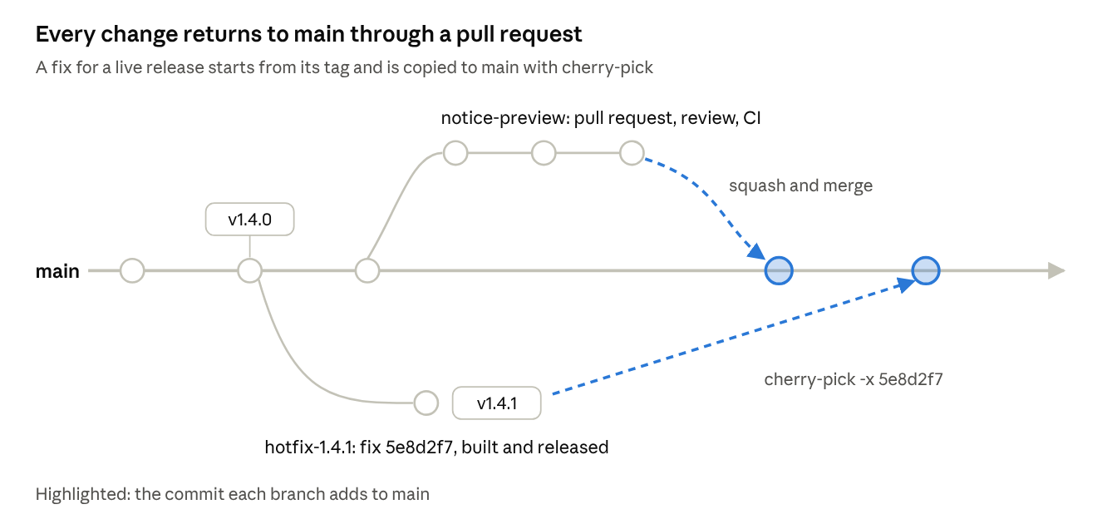
Figure 15. Branches, pull requests, a squash merge and a cherry-picked fix
BASICS Git terms
- Repository. The project's files and their full history.
- Commit. A saved set of changes, with a message and an id (a hash such as 3f2c9a1).
- Branch. A movable name for a line of commits. main is the shared branch that releases are built from.
- Remote. The copy of the repository on the hosting service, usually called origin. git push sends commits to it; git fetch and git pull bring commits from it.
- Pull request. A request to merge a branch into main, where other developers review the change and CI runs the tests.
- Merge. Combining the changes from two branches. When both changed the same lines, Git cannot choose between them and reports a merge conflict.
- Tag. A fixed name for one commit, used to mark releases such as v1.4.0.
- Staging area. The changes chosen for the next commit. git add puts changes there.
- HEAD. The commit your working copy is on, usually the tip of the current branch.
- origin/main. Your copy of the remote's main, as of your last git fetch.
- Force push. A push that replaces the remote branch's commits with yours, used only after a rebase of your own branch.
- Hotfix. A fix made for the release that is live, while main holds newer work.

GOING DEEPER

Merge, squash and rebase
Method | What happens to the history | Use when | Avoid when
Merge commit | The branch's commits stay as they are, joined to main by a merge commit that has two parents (Source 145) | The individual commits on the branch are worth keeping | Branches full of small "fix typo" commits
Squash and merge | All the branch's commits become one commit on main (Source 146) | Short-lived branches with one purpose. This is the default here | The branch holds several separate changes that should stay separate
Rebase and merge | Each commit is replayed on top of main with a new id, and there is no merge commit | A short series of commits that each make sense alone | Others have based work on the branch
git rebase origin/main, on your own branch | Replays your commits on top of the latest main, so your branch is current | Updating your own branch before review | The branch is shared. Use git merge origin/main instead

Do not rebase commits that exist outside your repository and that other people may have based work on (Source 147).
GOING DEEPER

Undoing changes
Situation | Command | Safe on a shared branch
Discard edits to a file you have not committed | git restore backend/app/services/notices.py | Yes. It touches only your working copy
Unstage a file | git restore --staged backend/app/services/notices.py | Yes
Change the last commit, not yet pushed | git commit --amend | Only before pushing
Undo a commit that was pushed | git revert 3f2c9a1. It adds a commit that reverses the earlier one (Source 148) | Yes
Undo a merged pull request | git revert with the squash commit's id; for a merge commit, git revert -m 1 with its id | Yes
Throw away your local commits and match the remote branch | git reset --hard origin/notice-preview | Only on your own work. It discards commits
Find a commit you thought was lost | git reflog, then git switch -c recovered with the commit's id | Yes
Push your own branch after a rebase | git push --force-with-lease --force-if-includes. It refuses if the remote branch holds commits that your branch does not include, such as a colleague's push that your last git fetch brought in. --force-with-lease alone checks only against what you last fetched (Source 149) | Only your own branch

SCENARIO Two people change the same file, on different lines
Developer A changes schedule_notice in services/notices.py. Developer B changes list_notices in the same file and merges first.
- Developer A updates the branch: git fetch, then git rebase origin/main. Git combines the two changes without a conflict, because they touch different lines.
- Run the tests. A merge without a conflict can still break the code, for example when B renamed a function that A's new code calls.
- Push with git push --force-with-lease --force-if-includes, and continue the review.

SCENARIO Two people change the same lines
Developer A changed the error message for a past send time. Developer B changed the same check to allow a 5-minute grace period, and merged first. A brings main into the branch:
git fetch
git merge origin/main
CONFLICT (content): Merge conflict in backend/app/services/notices.py
Automatic merge failed; fix conflicts and then commit the result.
The file now holds both versions between conflict markers:
<<<<<<< HEAD
if send_at < now:
raise ValueError("The send time must be in the future")
=======
if send_at < now - timedelta(minutes=5):
raise ValueError("Send time is in the past")
>>>>>>> origin/main
- Read both sides. In a merge, the part above the ======= line is your branch (HEAD), and the part below is main's version (Source 145). In a rebase the two are swapped: the part above is main with your earlier commits already replayed, and the part below is your commit being replayed. The labels after <<<<<<< and >>>>>>> name each side. To stop and put the branch back as it was, run git merge --abort, or git rebase --abort during a rebase.
- Decide what the code should do. Here it should do both: keep B's grace period and A's message.
- Edit the lines to the final version and delete the three marker lines:
if send_at < now - timedelta(minutes=5):
raise ValueError("The send time must be in the future")
- Run the tests, including the unit test for past send times, and update the test if the grace period changes what it expects.
- Mark the file resolved with git add backend/app/services/notices.py, finish with git commit, and push.
Two settings help with conflicts. git config --global merge.conflictStyle zdiff3 also shows the original lines, so it is clear what each side changed. git config --global rerere.enabled true makes Git remember how you resolved a conflict and reuse the resolution if the same conflict appears again (Sources 150 and 151).

SCENARIO Your branch is behind main
Only you have worked on the branch, and main has moved on since you started.
git fetch
git rebase origin/main
# for each conflict: fix the file, git add it, then
git rebase --continue
git push --force-with-lease --force-if-includes
During the rebase, the part of a conflict above the ======= line is main and the part below is your commit; git rebase --abort puts the branch back as it was. If someone else has pulled your branch, use git merge origin/main instead, and push without force.

SCENARIO Two branches each add a migration
Both branches added an Alembic migration whose parent was the same revision. After both merge, the migration history has two heads, and alembic upgrade head stops with an error.
- Prevent it: CI runs pytest-alembic's single-head test (Stage 9), and the branch rules require a branch to be up to date with main before it merges. The second pull request then runs its checks with the first migration in place, and fails before it merges.
- Fix it on the second branch: find the first branch's revision with alembic heads or alembic history, set the second migration's down_revision to it, so the history is one line again, and run the round trip.
- Or, if both are already merged, create a merge migration with alembic merge -m "merge heads" heads. It has both revisions as parents (Source 152). Check that the two migrations do not change the same table in conflicting ways.

SCENARIO A conflict in package-lock.json
Both branches added a front end package, and the lock file has a conflict.
- Resolve package.json by hand, keeping both packages.
- Run npm install. npm resolves the conflicts in package-lock.json and writes a lock file that includes both branches' packages. npm's documentation describes this for npm 5.7.0 and later (Source 153).
- Commit both files. In CI, npm ci stops with an error if they disagree.
For the backend, resolve requirements.in by hand, take main's lock file with git checkout origin/main -- backend/requirements.txt, then run pip-compile from the backend folder. It keeps main's pinned versions and adds the packages from both branches. Do not edit either lock file by hand.

SCENARIO A fix for live while main is not ready
Release 1.4.0 is live. main already holds unfinished work for 1.5, and a bug in 1.4.0 must be fixed today.
- Create a release branch from the tag, if it does not exist yet, and push it: git switch -c release-1.4 v1.4.0, then git push -u origin release-1.4. Give it the same branch rules as main.
- Branch from it with git switch -c hotfix-1.4.1. Fix the bug, add a test and commit. Note the commit id, for example 5e8d2f7.
- Push and open a pull request into release-1.4; it is reviewed like any other change. After the merge, CI builds release 1.4.1 from release-1.4 and deploys it to the sandbox. Once the checks pass, the same build is promoted to live and its commit is tagged v1.4.1.
- Bring the fix to main: from an up-to-date main, git switch -c port-hotfix-1.4.1, then git cherry-pick -x 5e8d2f7, push, and open a pull request. The -x option adds a line with the original commit's full id, "(cherry picked from commit 5e8d2f7...)", to the message, so the two commits can be matched later (Source 154). If the fix includes a migration, set its down_revision to main's head in the port, as in Scenario: Two branches each add a migration.

SCENARIO A bad commit reached main
A merged pull request broke the sandbox, and others have pulled main since.
git switch main
git pull
git switch -c revert-notice-preview
git revert 9c3b7e2 # the squash commit on main
git push -u origin revert-notice-preview
Open a pull request for the revert and merge it. A revert adds a commit and leaves the history others already have in place. Do not use git reset and a force push on main; the branch protection blocks it.

SCENARIO A secret was committed and pushed
- Rotate the secret first (Stage 10). It has been exposed since the push.
- Remove the file in a new commit, and add its name to .gitignore.
- If the organization requires the history to be cleaned, rewrite it with git filter-repo (a separate tool, installed as the git-filter-repo package) and force push with the team's agreement. Copies in other clones and forks remain, which is why the rotation comes first (Source 51).

Common mistakes
- Committing straight to main.
- Branches that live for weeks before they merge.
- Rebasing or force pushing a branch that someone else has pulled.
- Resolving a conflict by keeping one side without reading the other.
- Committing a resolved conflict without running the tests.
- Undoing a commit on main with git reset and a force push.
- Editing package-lock.json or requirements.txt by hand to resolve a conflict.

EXAMPLE: USER NOTICES
Setting | Value
Branch protection on main | Pull request required, with 1 approving review and review from code owners; approvals dismissed when new commits are pushed; branches must be up to date with main before merging; required checks: tests, pip-audit, npm audit and gitleaks; force pushes blocked
Merge method | Squash and merge only; branches deleted after merging
CODEOWNERS | Changes under backend/migrations/ need the lead developer's review
Pull request template | What changed, how it was tested, the security checklist, and whether the change includes a migration and how it is undone
Releases | A tag such as v1.4.0 on the commit CI built from
Settings on each developer's machine | merge.conflictStyle zdiff3, rerere.enabled true and push.useForceIfIncludes true

CHECKPOINT
- main protected; squash and merge set as the merge method
- Pull request template and CODEOWNERS committed
- Every developer has merged a pull request and resolved one practice conflict
- Releases tagged

Self-check
- You and a colleague changed different functions in the same file, and Git merged them without a conflict. Are you done?
- Your branch is behind main, and only you have worked on it. How do you update it, and how do you push afterwards?
- A merged pull request broke main, and three people have pulled since. How do you undo it?
- Both of you added a front end package, and package-lock.json has a conflict. What do you do?

Documentation and working rhythm
These practices run alongside the stages.

What to document
- API calls. Every call the front end makes, with its route and version.
- Database schema. The tables and what each holds, kept current by the migrations.
- Front end routing. The routes and the reasons for them.
- Distributed components. The queue, cache, pooler and replicas, and how each is deployed.
- Operations runbook. The Stage 10 routines: retention, alerts, rollback, restores, patching and rotation, each with its owner.

Keep this at a high level. Developers work out the detail from the code, and documentation that covers every line goes out of date. The main.py index is the entry point to the detail.

AI change log
When you ask an assistant to write or change a function, ask it in the same prompt to add an entry to one log file: what it decided, what broke, why, and how it was fixed. Keep the file for the life of the project. It can be read directly, or given back to an assistant to produce documentation. Plan for its size: an assistant that reads the whole log at the start of a session spends part of its context on it, and in one long-running project the log took about a quarter of the available context.

Time and sessions
Typical times, from the practice this guide is based on:
- Prototype. A throwaway application with no maintenance ahead can be generated in 5 to 10 minutes.
- Maintained application. Write the architecture by hand first, so that every decision is understood. Then give the written design to an assistant with an instruction to find its weaknesses, and revise. For a small application, plan about two days for the architecture and the boilerplate.
- Session length. Work in uninterrupted sessions of four to five hours. A session broken in the middle of a structure has to restart from the point where the design was last understood.

Checklist
The checkpoint from every stage, in order. Tick each item before starting the next stage, and commit at each checkpoint.
Stage 1. Gather the requirements
- Every screen listed, with what the user does on it
- Stored data listed, including logs
- External services listed
- Load recorded as two numbers, with how it arrives
- Constraints and deployment target written down
- Audit, retention, recovery and update requirements written down
Stage 2. Pick the stack
- One tool named per layer, and the API style chosen
- The reason for each choice written next to it
- Every Stage 1 constraint checked against the choices
- Settings listed
Stage 3. Settle the versions
- Version table with the chosen major version and support end date for each platform component
- Exact version recorded for every dependency
- Compatibility across runtime, packages, driver and database confirmed
- Breaking-change rule written: what counts, where the version lives, who is told
- Patching rule written
Stage 4. Structure the backend
- Repository initialized with the backend lock file; .env and the virtual environment excluded by .gitignore
- .env.example committed; a secret scanner runs before each commit
- main protected: a pull request and passing checks required, and a review with two or more developers
- CI runs on each push and pull request, and its checks are required on main
- Pattern named
- Folders created by role
- Interfaces written for each folder
- main.py includes each router, with a comment naming what it does and its files
- Design critiqued by an assistant, and revised
- Work committed
Stage 5. Build the skeleton
- Every function in the skeleton has a comment and a body reviewed against it and against the security checklist
- Unit tests written for each function, and passing
- Service runs end to end on your machine against the stub data layer
- At least one failure traced through main.py to its file with a breakpoint
- Work committed
Stage 6. Connect the front end
- Every screen from Stage 1 has a page and a route
- Every page reaches the backend through an API call
- Every link has a route, and some link reaches every page
- CORS allows the front end's origin
- Credentials checked in the backend; routes guarded in the front end; sign-in works end to end
- Component tests for the shared components pass
- Work committed
Stage 7. Build the database
- Every field listed
- Tables built, one concept per table, each with a primary key
- Every column has a type, NOT NULL where required, a default where one applies, and its constraints
- Audit table in place; the application role can add and read rows but not change or delete them
- Views for reused joins; any materialized view has a refresh schedule
- Foreign key columns and frequently queried columns indexed
- Schema applied through migrations; every migration has a downgrade, and the round trip runs; the stub replaced
- Unit and integration tests pass, and the full request path works from the browser
- Work committed
Stage 8. Prepare for load
- Load test at the expected concurrency and stress test past it; breaking point and working level recorded
- Indexes, table splits and API routes reviewed
- A decision recorded for each layer: queue, rate limiting, cache, pooling, replicas, sharding
- For each layer added, the product chosen from the comparison and its license checked
- Bulk and scheduled work runs in workers; the broker has its own Redis with no eviction
- Work committed
Stage 9. Test and deploy
- Test plan by layer written; unit, API, integration, task, component, end-to-end, functional, regression, security and accessibility results recorded
- Release built by CI and tagged when promoted; copied by the pipeline to a deploy account that can only run the deploy script
- Servers prepared: an account per service, code owned by root, secrets files readable only by root, internal services on 127.0.0.1, firewall in place
- Each service running under a process manager that restarts it, behind a reverse proxy with TLS
- Deployment strategy chosen from the update requirement; the deploy script backs up before migrating; a rollback to the previous release tested in the sandbox
- Migrations applied by the owner role; health check and smoke test pass; logs kept by journald; backups copied off the server; a restore tested
- Sandbox ready with its own data, keys and SMS_ALLOWLIST, and updates promoted through it
Stage 10. Operate after launch
- Retention set for each kind of log and record, in the tool that keeps it
- Error tracker receiving errors from the backend and the front end, without personal data; alerts reach a named person, each sent by a named tool
- Rollback procedure written and run once in the sandbox
- For each release, how its migrations would be undone is recorded
- Backups checked daily; a restore tested this month, on live or an equivalent server, with its time recorded
- Patch calendar set with an owner; dependency update pull requests turned on
- Rotation schedule set; each secret rotated once, with an overlap where the table gives one
- Runbook committed with the code
Working in Git
- main protected; squash and merge set as the merge method
- Pull request template and CODEOWNERS committed
- Every developer has merged a pull request and resolved one practice conflict
- Releases tagged

Glossary
Term | Meaning | Stage
Alembic | A migrations tool for SQLAlchemy that records each schema change as a versioned script | 7
API | The set of endpoints a program offers to other programs | 2
API versioning | Giving the API a version, usually in the path (/v1), so a breaking change can ship as a new version while the old one keeps running | 3
App Router | The Next.js routing system in which folders under app/ define the routes | 2
async def and await | Python syntax for functions that pause while waiting for a network or database call, so the server can handle other requests meanwhile | 2
Audit trail | A record of who did what to which record, when, and the result, which the application can add to but not change | 7
Authentication | Checking who the caller is, for example by the session cookie issued at sign-in | 5
Authorization | Checking what a caller may do, and to which record | 5
Big bang deployment | Stopping the old version everywhere and starting the new one, with a short interruption | 9
Blue-green deployment | Running the new version beside the old one and switching all traffic to it at once | 9
Branch | A movable name for a line of commits | Git
Branch protection | Rules on the hosting service that control how changes reach a branch, such as a required review and passing checks | 4
Breaking change | A change to the API that an existing client could fail on | 3
Broker | The service that holds queued jobs until a worker takes them, for example Redis | 8
Call stack | In a debugger, the list of function calls that led to the current line | 5
Canary release | Sending a small share of traffic to a new version, and raising the share as its errors and response times allow | 9
Celery | A Python task queue: the application puts jobs on a broker, and Celery worker processes run them | 8
Celery beat | Celery's scheduler process, which puts scheduled tasks on the queue at their times. Only one runs per environment | 8
Cherry-pick | Copying one commit onto another branch | Git
CI | Continuous integration: the repository's automated build and test run on each push | 4
Client Component | A React component marked 'use client' that also runs in the browser, so it can respond to clicks and typing | 6
Commit | A saved set of changes, with a message and an id | Git
Component test | A test of one front end component, used the way a person would use it | 6
Concurrent requests | Requests being handled at the same moment | 1
Connection pool | A set of open database connections that a process reuses instead of opening one per request | 8
Constraint | A rule the database checks on every insert and update, such as NOT NULL, UNIQUE, CHECK or FOREIGN KEY | 7
Contract test | A test that the API still returns what a known client relies on | 9
CORS | Cross-origin resource sharing: the browser rule that blocks calls to another origin unless that server allows the calling origin | 6
Cross-site scripting (XSS) | Text that a user entered is shown on a page as code, and runs in other users' browsers | 5
CRUD | Create, read, update and delete, the basic operations on stored records | 5
Dependency injection | Receiving what a function needs for one request (a session, the current user) from the framework at call time. In FastAPI, Depends | 4
Deploy key | A credential that gives one server read access to one repository, not tied to a person | 9
Driver | The library that connects a program to a database, for example psycopg for PostgreSQL | 7
End-to-end test | A test in which a real browser drives the whole application | 9
Endpoint | One route and HTTP method the API accepts, such as GET /v1/users. FastAPI calls the function that handles it a path operation function | 2
.env file | A file of settings, such as connection strings and keys, loaded into environment variables and never committed | 4
Error tracker | A service that collects application errors, groups them and alerts people | 10
Eviction policy | The rule Redis follows to delete keys when its memory is full. A broker needs noeviction | 8
Expand and contract | Changing a schema over several releases so that the old and the new code both work with it. Also called parallel change | 7
Feature flag | A setting that turns a feature on or off without a deploy | 9
Firewall | Rules on a server that decide which ports other machines can reach | 9
Fix forward | Correcting a problem with a new release instead of going back to the previous one | 10
Force push | A push that replaces the remote branch's commits with yours, used only after a rebase of your own branch | Git
Foreign key (FK) | A column that refers to the primary key of another table | 7
GraphQL | An API style with one endpoint, in which the client names the fields it wants | 2
gRPC | An API style that calls methods defined in .proto files, with binary messages over HTTP/2 | 2
Head (Alembic) | The newest migration revision | 7
Health check | An endpoint that reports whether the service and its connections are working | 9
Hot standby | A PostgreSQL standby server that accepts read-only queries | 8
Incident | An event that stops users working or puts data at risk, such as an outage, data loss or an exposed secret | 10
Index | A database structure that speeds up lookups on one or more columns, at a cost to writes and storage | 7
Injection | Input that ends up executed as part of a query or a command | 5
Integration test | A test of several real parts together, such as the backend with PostgreSQL | 9
Interface | The names, inputs and return types of a set of functions, written before the code | 4
journald | The log store that comes with systemd. It keeps the output of each service, and journalctl reads it | 9
Kafka | A distributed log that keeps messages for a set period, so several consumers can read them and read them again | 8
Layered structure | A backend organized into routers (requests), services (the work) and a data layer (the database) | 4
LLM | Large language model, the kind of model behind an AI chatbot or assistant | 2
Load balancer | A service that spreads requests across several copies of a service | 8
Load test | A test at the expected concurrency, to confirm the application holds it | 8
Lock file | A file that pins the exact version of every dependency, including the dependencies' own dependencies, such as a requirements.txt generated with pip-compile, or package-lock.json | 3
LTS | Long-term support: a release line that receives fixes for a published period | 3
Major and minor version | In PostgreSQL 18.6, 18 is the major version and 6 the minor release. Minor releases contain only fixes | 3
Materialized view | A view whose result is stored, and updated only when it is refreshed | 7
Merge conflict | Two branches changed the same lines, and a person has to choose the result | Git
Middleware | Code that runs on every request before the main handler, used for CORS, rate limiting and route guards | 6
Migration | A recorded, repeatable step that changes the database schema | 7
Monitoring | Regular measurements of servers and services, such as disk space and queue length, with alerts when a value passes a limit | 10
MVC | Model, view, controller: a pattern common in .NET applications | 4
Object storage | A store for files, reached through an API such as S3 | 2
OpenAPI | A machine-readable description of a REST API, which FastAPI generates | 2
Origin | The scheme, host and port of a web address, such as http://localhost:3000 | 6
ORM | Object-relational mapper: a library that maps tables to classes, such as SQLAlchemy | 7
Partitioning | Splitting one table into parts on the same server | 8
PAT | Personal access token: a password substitute tied to one person's account | 9
Patch | A release that fixes bugs or security problems without adding features | 3
PgBouncer | A connection pooler for PostgreSQL | 8
Point-in-time recovery | Restoring a database to any chosen moment, from a base backup and the archived changes since | 9
Polling | Asking the server again at a fixed interval for anything new | 2
Port | The number a service listens on. A service bound to 127.0.0.1 can be reached only from the same server | 9
Primary key | The column that uniquely identifies each row of a table | 7
Process manager | A program, such as systemd, that starts services at boot and restarts them if they stop, when configured to | 9
Promote | Deploy to live the same build that passed in the sandbox | 9
Property-based test | A test that generates many inputs from a description and looks for failures | 9
Protocol | A Python class (typing.Protocol) that declares methods without implementing them, used to write interfaces | 4
Pull request | A request to merge a branch, where the change is reviewed and tested | 4
Pydantic | The Python library FastAPI uses for request and response models: classes that declare each field and its type, and check incoming data against them | 4
RabbitMQ | A message broker with acknowledgements, routing and replicated queues | 8
RAG | Retrieval-augmented generation: a chatbot design that looks up relevant documents and passes them to an LLM with the question | 4
Rate limiting | Capping how many requests one client can make in a period | 8
Read replica | A copy of the database, kept up to date from the primary, that serves read queries | 8
Rebase | Replaying a branch's commits on top of another commit | Git
Recovery point objective (RPO) | How much recent data may be lost, measured as time before a failure | 1
Recovery time objective (RTO) | How long the application may be unavailable while it is restored | 1
Redis | An in-memory data store, used here as a broker, a cache and a store for rate-limit counters | 8
Regression script | A script that runs the full test suite after each change, to find what broke | 9
Release | A tested build with a version number: the front end build and the backend code with its dependencies | 9
Repository | The project's files and their full history, in Git | 4
REST | An API style in which each resource has a URL and HTTP methods such as GET, POST and PATCH act on it | 2
Retention period | How long a kind of record or log is kept before it is deleted | 1
Reverse proxy | A server, such as nginx, that receives all traffic and passes each request to the right service | 9
Revert | A commit that reverses an earlier commit | Git
Revision (Alembic) | The id of one migration. Each migration names the one before it | 7
Role (database) | A database account. The role that owns the tables and the role the application logs in as can be different. Unrelated to the staff roles in User Notices | 7
Rollback | Going back to the previous release after a bad one | 9
Rolling deployment | Replacing a service's instances a few at a time | 9
Round trip | Running a migration up, down and up again, to show that both directions work | 7
Runbook | The written steps for a routine task or an incident | 10
Sandbox | A staging environment that matches live, where every change goes first | 9
Schema | The definitions of the tables, views and indexes | 7
Secret | A value that gives access: a password, an API key, a token, or a connection string that contains a password | 4
Secret rotation | Replacing a secret with a new one, then revoking the old one | 10
Server Component | A React component that runs on the Next.js server and sends finished HTML to the browser | 6
Server-Sent Events (SSE) | An API style in which the server sends events over an HTTP response it keeps open | 2
Service account | A non-personal account that a service runs as | 9
Service principal | A non-personal identity that automation uses to reach a service, in Microsoft's terms | 9
Shadow deployment | Copying live requests to a new version and discarding its answers | 9
Sharding | Splitting data across several database servers | 8
Skeleton | The set of empty functions, with signatures and comments, written before their bodies | 5
Smoke test | A few quick checks right after a deploy, to show that the release serves its main screens | 9
SOAP | An API style that uses XML messages described by a WSDL file | 2
Squash and merge | Merging a branch into main as one commit | Git
SSH key | A pair of files used to log in to a server without a password; the public key goes on the server | 9
Staging area | The changes chosen for the next commit | Git
Stress test | A test that raises the concurrency until something fails, to find the breaking point | 8
Stub | A stand-in for a component that does not exist yet, such as an in-memory store in place of the database | 5
Symbolic link | A file that points to another file or folder | 9
systemd unit | A file that tells systemd how to start and run one service | 9
Tag | A fixed name for one commit, used to mark a release | Git
Task queue | A list of jobs that worker processes run outside the request | 8
Threadpool | A group of threads in which FastAPI runs plain def endpoint functions, so they do not block the server | 2
Three-two-one rule | Three copies of important data, on two kinds of storage, with one copy off-site | 9
TLS | The encryption behind HTTPS | 9
Transaction | A group of database statements that are saved together, or not at all | 7
Trigger | A function the database runs on every insert, update or delete on a table | 7
Unit test | A test of one function on its own | 5
uvicorn | The server program that runs a FastAPI application and handles its HTTP connections, with one or more worker processes | 5
Valkey | A BSD-licensed fork of Redis 7.2.4, run by the Linux Foundation | 8
venv | A Python virtual environment, isolated from the packages installed on the system | 3
View | A saved query that can be used like a table | 7
WAL | Write-ahead log: PostgreSQL's record of every change, which can be archived for point-in-time recovery | 9
Webhook | An HTTP request that another system sends to your application when an event happens | 2
WebSocket | A connection that stays open so that both sides can send at any time | 2
Worker | A process that takes jobs from the queue and runs them | 8
Working level | The highest concurrency at which the application runs with no errors and acceptable response times | 8

Answers to the self-checks

Stage 1
- The number of concurrent requests, and how they arrive. Stage 8 decisions depend on how many requests arrive at the same moment, not on how many users are registered.
- Under load, as a burst of 10,000 messages each night, and under external services, as the message provider. If each message is logged, it is also stored data.
- The audit requirement: which actions need a record of who did what, to which record and when. Stage 7 builds the audit table and the permissions that keep it from being changed, and Stage 10 keeps it for the retention period.

Stage 2
- With plain def. FastAPI runs it in a threadpool, so the blocking call does not stop the server from handling other requests.
- Plain def functions also run concurrently in the threadpool, so the calls do not go out one at a time. Limit the rate with a client-side limiter, or with the task queue's rate limit setting.
- MSSQL. The Stage 1 constraints record it, and a held license with organizational support overrides the PostgreSQL default.
- Server-Sent Events. Only the server sends the progress, and SSE is plain HTTP with automatic reconnection. WebSockets carry messages in both directions, which this page does not need, and the proxy has to pass their upgrade headers.

Stage 3
- Yes. A renamed field breaks every client that reads the old name, whatever the URL.
- Move to 18.6. Minor releases contain only fixes, and PostgreSQL recommends running the current minor release. The stability decision was the major version, 18.
- 3.14: it has had a year of fixes and is scheduled for support until October 2030. Record the version, the reason and the support end date in the version table, and pin it.

Stage 4
- Dependency injection. The signed-in staff member is a request-scoped resource, supplied through Depends.
- An import. The helper is ordinary code with nothing that changes per request.
- main.py. The comment above the notices router names routers/notices.py and services/notices.py, which hold the scheduling code.
- package-lock.json, either not committed or not used. package.json holds version ranges, so each npm install can resolve different versions. Commit package-lock.json and install with npm ci, which installs exactly what the lock file records and stops with an error if it disagrees with package.json.

Stage 5
- Reject the body, or remove the SMS call. A body must match its comment, and the assistant added behavior the skeleton did not define. If a confirmation SMS is wanted, it becomes a requirement and goes into the comment first.
- First, whether the backend service is running: if it is not, nothing in the code matters yet, and the check takes seconds. Second, which area and file main.py names for sign-in. Third, a breakpoint in that function, then the call stack and the variables view.
- The schema is designed in Stage 7 from the fields the front end sends in Stage 6. Building it now would mean guessing those fields.
- Check 1, access to each record. The fix is in the backend: the service checks the staff member's role before making the change. Hiding the button in the front end does not stop a direct API call.

Stage 6
- The backend. Add the front end's origin to the allowed origins in the CORS middleware (ALLOWED_ORIGIN in .env). The browser enforces the rule, but only the backend can allow the origin.
- The guard sends a visitor who is not signed in to the sign-in page instead of showing pages that fail. It does not protect the data. The backend's check on every call does.

Stage 7
- No. A plain view is a saved query and runs the same query each time. If the page is measured as slow, an index or a materialized view with a scheduled refresh is the fix.
- notice_id and user_id are foreign key columns, which PostgreSQL does not index automatically. In the example, the unique (notice_id, user_id) constraint already gives notice_id an index through its leading column, so only user_id needs an index of its own. The id column is the primary key and is already indexed.
- With a new Alembic migration, applied in the sandbox and then in live as part of the deploy.
- A phone number starts with a +, which a number type drops, and phone numbers are never calculated with. Text with a CHECK keeps the exact value and rejects a value in the wrong format.
- The previous release reads and writes the old column name, which no longer exists, so its queries fail. The rename should have used expand and contract: add the new column and write both, read the new one, stop writing the old one, and drop it in a later release.
- usernotices_app_a or usernotices_app_b, the roles the application logs in as. They are members of usernotices_app, which has SELECT and INSERT on audit_log and no UPDATE, DELETE or TRUNCATE. usernotices_owner owns the table and runs the migrations.

Stage 8
- None. Run the load test first. 40 concurrent requests at a steady rate may need no new layers, and the 100,000 registered users do not decide it.
- Yes, or reduce the pools. Ten processes with up to 15 connections each can open 150, above PostgreSQL's default limit of 100, of which 3 are reserved for superusers. The options are PgBouncer, smaller pools, or a higher max_connections on a server with the memory for it.
- Replication lag. Replication is asynchronous by default, so the replica had not yet received the write. Read from the primary right after a write, or send that user's reads to the primary for a short time.
- Kafka, or RabbitMQ streams. Each consumer group keeps its own position and messages are kept for a set period, so analytics can read last month's events again. A Celery queue on Redis gives each job to one worker and removes it once it is done, so a second system cannot receive it and nothing can be read again.

Stage 9
- A process manager such as systemd. With Restart=on-failure in the unit file and the unit enabled, systemd starts the service at boot and restarts it if it stops.
- The same build that passed in the sandbox, promoted to live. Not a branch, and not a new build.
- A scenario is covered only when someone was assigned to it and has tested it. Without an owner, each tester can assume another one covered it.
- An end-to-end test in a real browser. The guard depends on cookies, redirects and the whole application running together, and a unit test does not run proxy.ts against real requests.
- A test send reaches 5,000 real people, and everyone with sandbox access can read live personal data. The sandbox should hold made-up users, the provider's test key and an allowlist of the testers' phones.
- Blue-green on the one server: two backend copies on different ports, with nginx switched between them. Every migration must work with both the old and the new code, by expand and contract.
- A copy off the server, and a tested restore. A backup kept only on the database server is lost with that server. A backup server should pull a copy and encrypt it, one copy should be kept offline at another site, and a restore from it should be tested.

Stage 10
- It stays in place. The previous release ignores a new column that may be empty, so only the code is rolled back.
- No. The downgrade can reverse the structure, but it cannot restore the characters that were cut. Restore the dump the deploy script took before the migration into a scratch database, and write the original texts back with a reviewed one-off script, run in the sandbox first.
- Create the new key, deploy it and confirm it works, then revoke the old one. Revoking first would stop every send until the new key was in place.
- The sandbox first, within two weeks, then live in the next monthly window once the sandbox checks pass.
- No. A backup is known to work only after a restore from it has worked. Restore one into a scratch database this month, and record how long it took.

Working in Git
- No. Run the tests. Changes on different lines can still break each other, for example when one renames a function that the other calls.
- git fetch, then git rebase origin/main, resolving any conflicts (during a rebase, the part above ======= is main). Then git push --force-with-lease --force-if-includes, which refuses if the remote branch holds commits your branch does not include.
- Revert it: create a branch from main, run git revert with the squash commit's id, and merge the revert through a pull request. Do not reset main and force push.
- Resolve package.json by hand, keeping both packages, then run npm install to regenerate package-lock.json, and commit both files. Do not edit the lock file by hand.

Sources
Documentation opened to check this guide, on October 14, 15 and 16, 2026. Sources 1 to 28 were checked for version 2.0, 29 to 154 for version 3.0, and 155 onward for version 3.1.
- Next.js: Layouts and Pages
- Next.js: proxy.js file convention
- Next.js: Support Policy
- FastAPI: Concurrency and async / await
- FastAPI: Dependencies
- Python: venv, creation of virtual environments
- Python Developer's Guide: Status of Python versions
- Node.js: Releases
- Node.js release schedule (nodejs/release)
- PostgreSQL: Versioning Policy
- PostgreSQL: max_connections (postgresqlco.nf)
- PostgreSQL: Indexes, Introduction
- PostgreSQL: Unique Indexes
- PostgreSQL: Constraints, Foreign Keys
- PostgreSQL: Multicolumn Indexes
- PostgreSQL: REFRESH MATERIALIZED VIEW
- PostgreSQL: Table Partitioning
- PostgreSQL: Hot Standby
- PostgreSQL: Log-Shipping Standby Servers
- PgBouncer: Features
- Celery: Introduction to Celery
- Celery: Using Redis as a broker
- arq documentation
- Redis: Build 5 Rate Limiters with Redis
- Azure DevOps: Use personal access tokens
- Azure blog: API versioning with Azure API Management
- FastAPI: First Steps
- SQLAlchemy 2.0: Connection Pooling
- OpenAPI Specification v3.2.1
- GraphQL: Serving over HTTP
- GraphQL: Performance
- GraphQL: Security
- gRPC: Core concepts
- gRPC over HTTP/2 (protocol description)
- gRPC blog: The state of gRPC in the browser
- gRPC-Web
- Connect: Introduction
- RFC 6455: The WebSocket Protocol
- FastAPI: WebSockets
- nginx: WebSocket proxying
- MDN: Using server-sent events
- FastAPI: Server-Sent Events
- MDN: EventSource
- Standard Webhooks specification
- W3C: SOAP Version 1.2 Part 1: Messaging Framework
- W3C: Web Services Description Language (WSDL) 2.0
- Ubuntu: Release cycle
- OWASP Cheat Sheet Series: Secrets Management
- Gitleaks
- GitHub Docs: About push protection
- GitHub Docs: Removing sensitive data from a repository
- pip-tools
- Python Packaging User Guide: Writing your pyproject.toml
- Alembic: Tutorial
- npm Docs: package.json
- npm Docs: package-lock.json
- npm Docs: npm ci
- Keep a Changelog 1.1.0
- GitHub Docs: About protected branches
- OpenSSF: Security-Focused Guide for AI Code Assistant Instructions
- OWASP Top 10:2025
- OWASP API Security Top 10, 2023
- SQLAlchemy 2.1: Working with Transactions and the DBAPI
- OWASP Cheat Sheet Series: Logging
- Spracklen et al.: We Have a Package for You! (USENIX Security 2025)
- OWASP Cheat Sheet Series: Secure Coding with AI
- Next.js: How to think about data security
- GitHub Advisory Database: Authorization Bypass in Next.js Middleware (CVE-2025-29927)
- Vercel: Postmortem on Next.js Middleware bypass
- Next.js: Testing
- Next.js: How to set up Vitest with Next.js
- PostgreSQL 18: Character Types
- PostgreSQL 18: Date/Time Types
- SQLAlchemy 2.1: Configuring Constraint Naming Conventions
- PostgreSQL 18: Trigger Functions (PL/pgSQL)
- pgAudit
- PostgreSQL 18: Privileges
- NIST SP 800-53 Rev. 5: Security and Privacy Controls, control AU-9
- Danilo Sato: ParallelChange
- PostgreSQL 18: CREATE INDEX
- Alembic: Runtime objects (autocommit_block)
- Alembic: Auto Generating Migrations
- Celery: Backends and Brokers
- PostgreSQL 18: SELECT, the locking clause
- RabbitMQ: Quorum Queues
- Apache Kafka: Introduction
- Apache Kafka: KafkaConsumer (Javadoc, 4.3)
- Apache Kafka: KRaft operations
- AWS: Redis OSS vs. Memcached
- Microsoft Azure Architecture Center: Cache-Aside pattern
- Citus
- nginx: Using nginx as HTTP load balancer
- HAProxy
- Redis: Licenses
- Linux Foundation: Valkey launch announcement
- Celery: Tasks
- FastAPI: Testing Dependencies with Overrides
- Testcontainers for Python
- pytest-alembic: Quickstart
- Playwright: Installation
- Schemathesis
- Pact Docs
- ZAP by Checkmarx
- Playwright: Accessibility testing
- Ham Vocke: The Practical Test Pyramid
- Google Testing Blog: Code Coverage Best Practices
- GNU Coreutils: Numeric Modes
- NIST SP 800-44 Version 2: Guidelines on Securing Public Web Servers
- systemd: systemd.exec
- Kubernetes: Deployments
- Martin Fowler: BlueGreenDeployment
- Danilo Sato: CanaryRelease
- nginx: ngx_http_mirror_module
- Pete Hodgson: Feature Toggles (aka Feature Flags)
- nginx: Beginner's Guide
- NIST Glossary: recovery point objective
- CISA: Back Up Business Data
- PostgreSQL 18: SQL Dump
- PostgreSQL 18: Continuous Archiving and Point-in-Time Recovery
- pgBackRest
- Barman
- CISA: #StopRansomware Guide
- Next.js: output (standalone)
- Uvicorn: Settings
- systemd: journald.conf
- Google SRE Book: Monitoring Distributed Systems
- Google SRE Book: Postmortem Culture
- logrotate(8) manual page
- Sentry: Self-Hosted Sentry
- GlitchTip
- GlitchTip backend repository
- GlitchTip: Installation
- Sentry: FastAPI integration
- Sentry: Data Collected (Python)
- Ubuntu Server: Automatic updates
- PostgreSQL: Roadmap
- Node.js blog: Vulnerabilities
- GitHub Docs: Dependabot version updates
- pip-audit
- Next.js: Security Advisory CVE-2025-66478
- PostgreSQL 18: ALTER ROLE
- PostgreSQL 18: Role Membership
- Trunk Based Development
- GitHub Docs: GitHub flow
- Pro Git: Basic Branching and Merging
- GitHub Docs: About merge methods on GitHub
- Pro Git: Rebasing
- Git: git-revert
- Git: git-push
- Git: git-merge
- Git: git-rerere
- Alembic: Working with Branches
- npm Docs (version 6): package-locks, resolving lockfile conflicts
- Git: git-cherry-pick
- Ubuntu packages: nginx in 24.04 (noble)
- PostgreSQL: Linux downloads (Ubuntu)
- Redis: Install Redis on Linux
- Python: Using Python on Unix platforms
- uv: Installing Python
- NodeSource: Node.js binary distributions
- nginx: ngx_http_v2_module
- Git: git-branch

