SUMMER TRAINING REPORT ON

[RANDOM CHAT APPLICATION]

SUBMITTED IN PARTIAL FULFILLMENT OF THE REQUIREMENT FOR THE AWARD

OF THE DEGREE OF

**BACHELOR OF ENGINEERING**

(Computer Science & Engineering)



APRIL-JULY,2021

**SUBMITTED BY:** NAME : PRAJWAL SHARMA UNIVERSITY UID : 19BCS1144

DEPARTMENT OF COMPUTER SCIENCE & ENGINEERING

CHANDIGARH UNIVERSITY GHARUAN, MOHALI

# CERTIFICATE BY COURSE WEBSITE / COMPANY / INDUSTRY / INSTITUTE

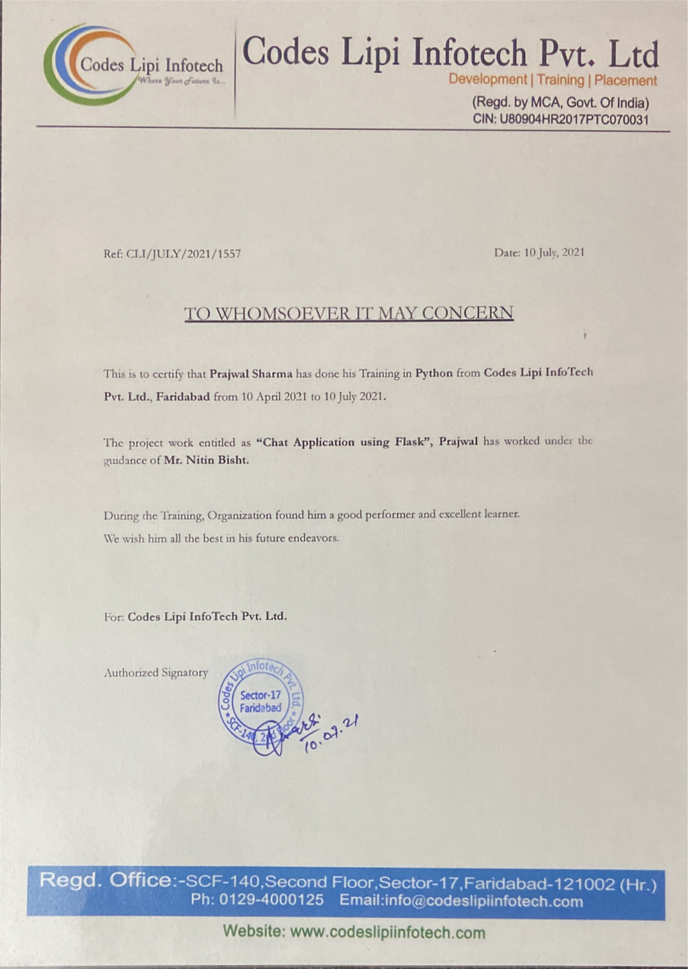

**Instructions**

**Name :** Python

**Issuing Organization :** Codes Lipi InfoTech Pvt. Ltd.

**Issue Date :** 10th July, 2021

**Expiration Date :** *This certification does not expire*

# 

# CANDIDATE'S DECLARATION

I PRAJWAL SHARMA hereby declare that I have undertaken Summer Training in Python during a period from 10th April, 2021 to 10th July, 2021 in partial fulfillment of

requirements for the award of degree of B.E (COMPUTER SCIENCE & ENGINEERING) at CHANDIGARH UNIVERSITY GHARUAN, MOHALI. The work which is being presented in the training report submitted to Department of Computer Science & Engineering at CHANDIGARH UNIVERSITY GHARUAN, MOHALI is an authentic record of training work.

Signature of the Student

The training Viva–Voce Examination of Institutional training has been held on 08/12/2020 and accepted.

Signature of Internal Examiner Signature of External Examiner

**Contents**

1. **INTRODUCTION**
2. **About Python, Flask, Database (PostgreSQL), HTML, CSS, Web Sockets**
3. **Feasibility Study**
4. **Methodology**
5. **Hardware & Software Requirements**
6. **About Project**
7. **IMPLEMENTATION**
8. **FINAL CODES**
9. **Code of Html & JS Part**
10. **Code of CSS Part**
11. **Code of Flask (Python) Part**
12. **Code of Database Part**

# ACKNOWLEDGEMENT

In the present world of competition there is a race of existence in which those are having will to come forward succeed. Project is like a bridge between theoretical and practical working. With this willing I joined this particular project. I would like to express my special thanks of gratitude to my college Chandigarh University who gave me the golden opportunity to do this wonderful project of **Random Chat Application**. I came to know about so many new things I am really thankful to them.

PRAJWAL SHARMA

19BCS1144CSE 1 C

**INTRODUCTION**

**Python :**

Python is an interpreted high-level general-purpose programming language. Its design philosophy emphasizes code readability with its use of significant indentation. Its language constructs as well as its object-oriented approach aim to help programmers write clear, logical code for small and large-scale projects.

Python is dynamically-typed and garbage-collected. It supports multiple programming paradigms, including structured (particularly, procedural), object-oriented and functional programming. It is often described as a "batteries included" language due to its comprehensive standard library.

Guido van Rossum began working on Python in the late 1980s, as a successor to the ABC programming language, and first released it in 1991 as Python 0.9.0. Python 2.0 was released in 2000 and introduced new features, such as list comprehensions and a garbage collection system using reference counting. Python 3.0 was released in 2008 and was a major revision of the language that is not completely backward-compatible. Python 2 was discontinued with version 2.7.18 in 2020.

Python consistently ranks as one of the most popular programming languages.

This project is coded in python 3.9.6.

**Flask :**

Flask is a micro web framework written in Python. It is classified as a microframework because it does not require particular tools or libraries. It has no database abstraction layer, form validation, or any other components where pre-existing third-party libraries provide common functions. However, Flask supports extensions that can add application features as if they were implemented in Flask itself. Extensions exist for object-relational mappers, form validation, upload handling, various open authentication technologies and several common framework related tools.

Flask is a lightweight WSGI web application framework. It is designed to make getting started quick and easy, with the ability to scale up to complex applications. It began as a simple wrapper around Werkzeug and Jinja and has become one of the most popular Python web application frameworks.

Flask offers suggestions, but doesn’t enforce any dependencies or project layout. It is up to the developer to choose the tools and libraries they want to use. There are many extensions provided by the community that make adding new functionality easy.

**Database (PostgreSQL) :**

In computing, a database is an organized collection of data stored and accessed electronically from a computer system. Where databases are more complex, they are often developed using formal design and modelling techniques.

The database management system (DBMS) is the software that interacts with end users, applications, and the database itself to capture and analyze the data. The DBMS software additionally encompasses the core facilities provided to administer the database. The sum total of the database, the DBMS and the associated applications can be referred to as a "database system". Often the term "database" is also used loosely to refer to any of the DBMS, the database system or an application associated with the database.

Computer scientists may classify database-management systems according to the database models that they support. Relational databases became dominant in the 1980s. These model data as rows and columns in a series of tables, and the vast majority use SQL for writing and querying data. In the 2000s, non-relational databases became popular, referred to as NoSQL because they use different query languages.

In this project, a type of SQL is used i.e., **PostgreSQL**.

**PostgreSQL** also known as Postgres, is a free and open-source relational database management system (RDBMS) emphasizing extensibility and SQL compliance. It was originally named POSTGRES, referring to its origins as a successor to the Ingres database developed at the University of California, Berkeley. In 1996, the project was renamed to PostgreSQL to reflect its support for SQL. After a review in 2007, the development team decided to keep the name PostgreSQL and the alias Postgres.

PostgreSQL features transactions with Atomicity, Consistency, Isolation, Durability (ACID) properties, automatically updatable views, materialized views, triggers, foreign keys, and stored procedures. It is designed to handle a range of workloads, from single machines to data warehouses or Web services with many concurrent users. It is the default database for macOS Server and is also available for Windows, Linux, FreeBSD, and OpenBSD.

In this project I used some basic queries like, **CREATE, INSERT, SELECT**.

**HTML :**

The **Hyper Text Markup Language**, or HTML is the standard markup language for documents designed to be displayed in a web browser. It can be assisted by technologies such as Cascading Style Sheets (CSS) and scripting languages such as JavaScript.

Web browsers receive HTML documents from a web server or from local storage and render the documents into multimedia web pages. HTML describes the structure of a web page semantically and originally included cues for the appearance of the document.

HTML elements are the building blocks of HTML pages. With HTML constructs, images and other objects such as interactive forms may be embedded into the rendered page. HTML provides a means to create structured documents by denoting structural semantics for text such as headings, paragraphs, lists, links, quotes and other items. HTML elements are delineated by tags, written using angle brackets. Tags such as <img /> and <input /> directly introduce content into the page. Other tags such as <p> surround and provide information about document text and may include other tags as sub-elements. Browsers do not display the HTML tags, but use them to interpret the content of the page.

HTML can embed programs written in a scripting language such as JavaScript, which affects the behavior and content of web pages. Inclusion of CSS defines the look and layout of content. The World Wide Web Consortium (W3C), former maintainer of the HTML and current maintainer of the CSS standards, has encouraged the use of CSS over explicit presentational HTML since 1997.

**CSS :**

**Cascading Style Sheets** (CSS) is a style sheet language used for describing the presentation of a document written in a markup language such as HTML. CSS is a cornerstone technology of the World Wide Web, alongside HTML and JavaScript.

CSS is designed to enable the separation of presentation and content, including layout, colors, and fonts. This separation can improve content accessibility; provide more flexibility and control in the specification of presentation characteristics; enable multiple web pages to share formatting by specifying the relevant CSS in a separate .css file, which reduces complexity and repetition in the structural content; and enable the .css file to be cached to improve the page load speed between the pages that share the file and its formatting.

Separation of formatting and content also makes it feasible to present the same markup page in different styles for different rendering methods, such as on-screen, in print, by voice (via speech-based browser or screen reader), and on Braille-based tactile devices. CSS also has rules for alternate formatting if the content is accessed on a mobile device.

The name cascading comes from the specified priority scheme to determine which style rule applies if more than one rule matches a particular element. This cascading priority scheme is predictable.

The CSS specifications are maintained by the World Wide Web Consortium (W3C). Internet media type (MIME type) text/css is registered for use with CSS by RFC 2318 (March 1998). The W3C operates a free CSS validation service for CSS documents.

In addition to HTML, other markup languages support the use of CSS including XHTML, plain XML, SVG, and XUL.

**Web Sockets :**

The WebSocket specification defines an API establishing “socket” connections between a web browser and a server. In plain words: there is a persistent connection between the client and the server and both parties can start sending data at any time. The client establishes a WebSocket connection through a process known as the WebSocket handshake. This process starts with the client sending a regular HTTP request to the server. An Upgrade header is included in this request which informs the server that the client wishes to establish a WebSocket connection. Now that the handshake is complete the initial HTTP connection is replaced by a WebSocket connection that uses the same underlying TCP/IP connection. At this point, either party can start sending data.

With Web Sockets, you can transfer as much data as you like without incurring the overhead associated with traditional HTTP requests. Data is transferred through a WebSocket as messages, each of which consists of one or more frames containing the data you are sending (the payload). In order to ensure the message can be properly reconstructed when it reaches the client each frame is prefixed with 4–12 bytes of data about the payload. Using this frame-based messaging system helps to reduce the amount of non-payload data that is transferred, leading to significant reductions in latency.

**Feasibility Study :**

Feasibility study can help you determine whether or not you should proceed with your project. It is essential to evaluate cost and benefit. It is essential to evaluate cost and benefit of the proposed system.

Four types of feasibility study are taken into consideration.

**1. Technical feasibility:** It includes finding out technologies for the project, both hardware and software. For Chat Application, user must have internet connection. While using Application, make sure you have a steady internet connection. It is also not an issue in this era where almost every home or office has Wi-Fi.

**2. Operational feasibility:** It is the ease and simplicity of operation of proposed system. System does not require any special skill set for users to operate it. In fact, it is designed to be used by almost everyone. Kids who still don’t know to write can read out problems for system and get

answers.

**3. Economic feasibility:** Here, we find the total cost and benefit of the proposed system over current system. For this project, the main cost is documentation cost. User also would have to pay for internet connection. As far as maintenance is concerned, it won’t cost too much.

**4. Organizational feasibility:** This shows the management and organizational structure of the project. This project is not built by a team. The management tasks are all to be carried out by a single person. That won’t create any management issues and will increase the feasibility of the

project.

This project is technically feasible with no external hardware requirements. Also, it is simple in operation and does not cost training or repairs. Overall feasibility study of the project reveals that the goals of the proposed system are achievable. Decision is taken to proceed with the project.

**Methodology :**

This project contains three steps:

1. Development of Frontend part using **HTML, CSS**.

2. Coding and Development of Backend part using **FLASK (Python)** and **Web Sockets** using both FLASK and JS.

3. Making and Establishing the **Database** connection.

**Hardware & Software Requirements :**

The software is designed to be light-weighted so that it doesn’t be a burden on the machine running it. This system is being build keeping in mind the generally available hardware and software compatibility. Here are the minimum hardware and software requirement for speaking assistant.

**Hardware:**

• Pentium-pro processor or later.

• RAM 512MB or more.

**Software:**

• Windows 7(32-bit) or above.

• Python 3.0 or later