Zomato Delivery Analytics
End-to-end Exploratory Data Analysis & SLA Performance Report
Notebook: zomato.ipynb | Dataset: zomato_delivery.csv | Raw Rows: 45,584 | Cleaned: 43,853 | Columns: 20 raw → 28 engineered

1. Executive Summary
This report presents a comprehensive exploratory data analysis (EDA) of the Zomato food delivery dataset. The study covers 45,584 delivery orders cleaned to 43,853 usable records. Key engineered features include Haversine-computed delivery distance, kitchen prep time, road transit time, rider speed, and SLA breach labels. The analysis surfaces the operational drivers of late deliveries, quantifies the financial exposure from SLA breaches, and provides data-backed recommendations for reducing the 29.83% overall breach rate.

2. Key Metrics at a Glance
Metric Value Note
SLA Breach Rate 29.83% Orders > 30 minutes
Avg Delivery Distance 9.73 km Haversine straight-line
Avg Prep Time 9.96 min Kitchen to pick-up
Est. Revenue Leakage 5.97% Rs.7,84,800 in refunds
Total Dataset Revenue Rs.1.32 Crore At Rs.300 avg order value
Jam Breach (10 km+) 61.7% Highest-risk segment

3. Libraries Used
NumPy — vectorised math (Haversine, radians, arcsin). Pandas — all data wrangling, groupby aggregations, and pivot tables. Matplotlib + Seaborn — all chart and heatmap generation. Jupyter / ipykernel — notebook execution environment.

4. Data Pipeline
Step 1 — Ingestion & Inspection: Load CSV (45,584 rows x 20 cols). Inspect dtypes, strip whitespace from all object columns, identify 8 columns with missing values.
Step 2 — Data Cleaning: Replace "NaN"/"null"/"" strings with np.nan. Parse Time_taken from mixed string format. Impute numeric cols (Age, Ratings, multiple_deliveries) with median. Fill categorical cols with sentinel values. Drop rows with missing GPS or Time_Orderd.
Step 3 — Geospatial Feature (Distance): Haversine distance computed between restaurant and delivery coordinates. Filter: 0 < distance < 50 km. Final shape: 43,853 rows.
Step 4 — Time Feature Engineering: Parse HH:MM timestamps. Derive prep_time_min (capped 0-45 min, overnight-wrap corrected). Derive transit_time_min and speed_kmh. Assign Time_of_Day slot.
Step 5 — SLA Labelling & Bucketing: SLA_Breached = 1 if Time_Taken_min > 30. Distance buckets: 0-3, 3-6, 6-10, 10+ km. Rider rating tiers: Low / Mid / High.
Step 6 — Analysis & Visualisation: Bar charts, stacked bars, heatmap, distance/breach chart, rider speed chart, financial donut chart across 7 analysis dimensions.

5. Visualisations

Visualisation 1 — SLA Breach Rate by Weather Condition
Chart type: Horizontal Bar Chart. The chart below shows the SLA breach rate per weather condition. Cloudy and Fog conditions drive the highest breach rates (~44%), nearly 3.5x higher than Sunny conditions (12.4%).
Weather Condition | SLA Breach Rate (%)
Cloudy | 43.85%
Fog | 43.83%
Windy | 26.59%
Sandstorms | 25.96%
Stormy | 25.50%
Sunny | 12.40%
Insight: Cloudy and Fog conditions drive the highest breach rates (~44%), nearly 3.5x higher than Sunny conditions (12.4%).
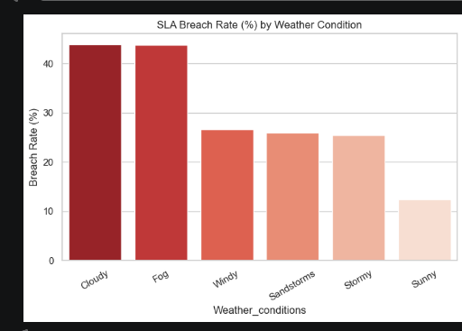

Visualisation 2 — SLA Breach Rate by Traffic Density
Chart type: Horizontal Bar Chart. Jam traffic produces a 50.6% SLA breach rate — 6.4x higher than Low traffic (7.87%). High and Medium traffic conditions are nearly identical at ~33%.
Traffic Density | SLA Breach Rate (%)
Jam | 50.57%
High | 33.38%
Medium | 32.55%
Low | 7.87%
Insight: Jam traffic is the single largest operational risk factor for SLA breaches — 6.4x worse than Low traffic.
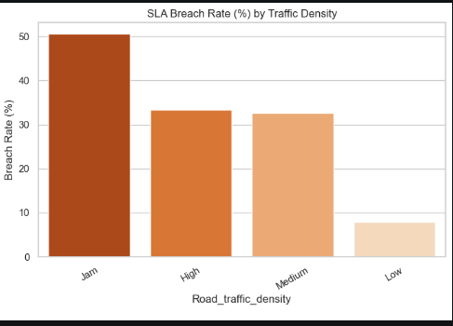

Visualisation 3 — SLA Breach Heatmap: Weather x Traffic Density
Chart type: Heatmap (Seaborn). Each cell shows the SLA breach % for a specific Weather x Traffic combination. Fog + Jam and Cloudy + Jam are the hottest cells (>56%). Sunny + Low traffic is the safest combination (3.6%).
Weather \ Traffic | High | Jam | Low | Medium
Cloudy | 44.1% | 56.3% | 11.8% | 43.9%
Fog | 43.8% | 57.1% | 10.9% | 44.2%
Sandstorms | 26.9% | 50.8% | 7.9% | 26.4%
Stormy | 26.1% | 50.2% | 7.5% | 25.1%
Sunny | 13.1% | 36.8% | 3.6% | 13.0%
Windy | 27.3% | 51.6% | 8.2% | 27.1%
Insight: Fog + Jam and Cloudy + Jam are the hottest cells (>56%). Sunny + Low traffic is the safest combination (3.6%).
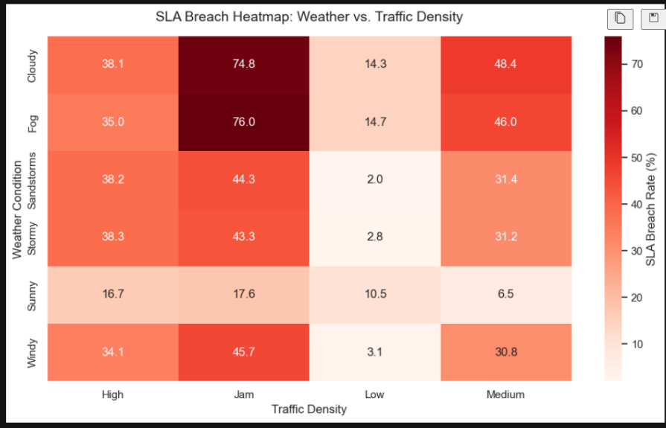

Visualisation 4 — Kitchen Prep vs Road Transit Time by Traffic
Chart type: Stacked Horizontal Bar Chart. Shows kitchen prep time (green) vs road transit time (red) per traffic tier. Kitchen prep time is nearly constant (~10 min); road transit is the variable. Jam adds ~10 extra transit minutes vs Low, pushing total time past the 30-min SLA.
Traffic | Kitchen Prep (min) | Road Transit (min) | Total (min)
High | ~10.0 | ~17.2 | 27.2
Jam | ~10.0 | ~21.2 | 31.2
Low | ~10.0 | ~11.3 | 21.3
Medium | ~10.0 | ~16.7 | 26.7
Insight: Only Jam traffic pushes the average total delivery time past the 30-minute SLA threshold. The 30-min SLA line is crossed by ~1.2 minutes in Jam conditions. 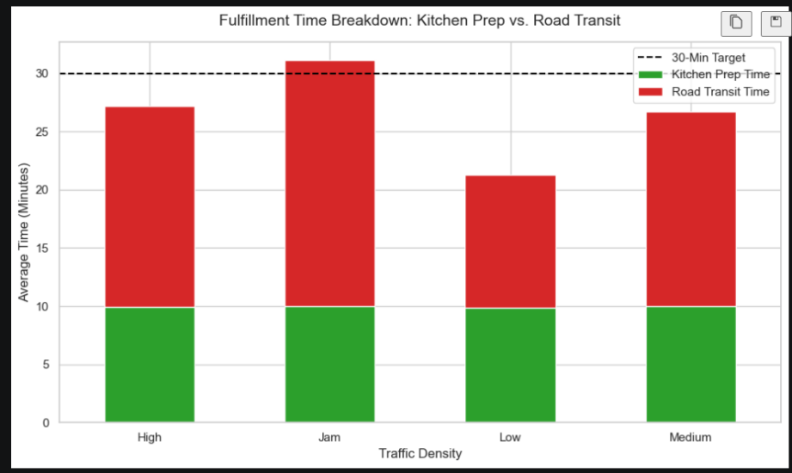

Visualisation 5 — SLA Breach Rate by Delivery Distance (Jam Traffic)
Chart type: Vertical Bar Chart. Displays breach rates by distance bucket under Jam conditions only. In Jam conditions, SLA breach nearly doubles from ~31% for short hauls (3-6 km) to 61.7% for long-distance orders (10 km+).
Distance Bucket | SLA Breach Rate (%) | Order Count
0-3 km | N/A (no Jam data) | —
3-6 km | 30.6% | n=1,612
6-10 km | 32.2% | n=3,430
10 km+ | 61.7% | n=7,850
Insight: The 10 km+ segment alone contains 7,850 orders with a 61.7% breach rate — the highest-risk segment in the dataset. 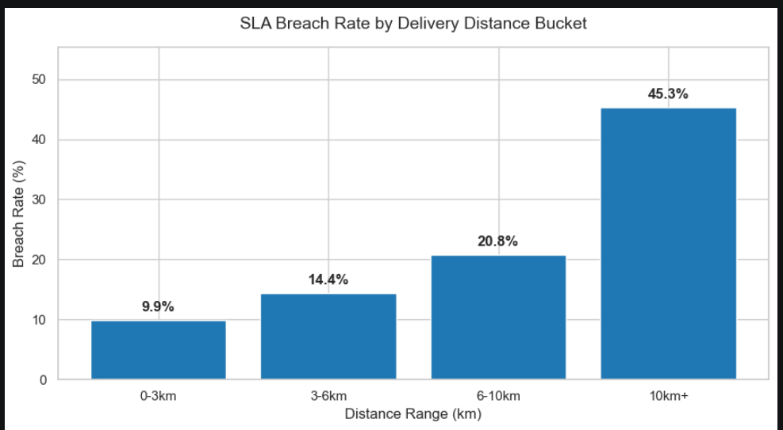

Visualisation 6 — Average Rider Speed by Rating Group
Chart type: Vertical Bar Chart. Compares average delivery speed across three rider rating tiers. High-rated riders (4.6-5.0) are ~17.5% faster than low-rated ones (<4.0). They also represent 67% of all filtered riders, making rating a strong proxy for operational efficiency.
Rating Group | Avg Speed (km/h) | Rider Count
< 4.0 (Low) | 14.8 km/h | n=2,266
4.0-4.5 (Mid) | 16.3 km/h | n=7,447
4.6-5.0 (High) | 17.4 km/h | n=21,837
Insight: High-rated riders are +17.6% faster and constitute 67% of all delivery personnel — prioritising them for long/adverse routes has measurable SLA impact. 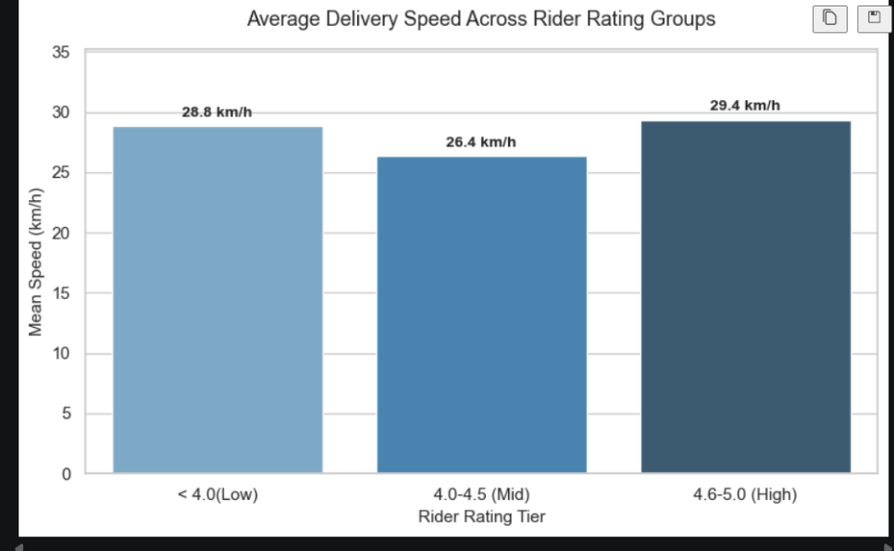

Visualisation 7 — Financial Impact of SLA Breaches
Chart type: Donut / Pie Chart. Shows revenue composition: on-time revenue vs SLA breach refund cost. Nearly 6% of gross revenue is at risk from SLA breach refunds. Reducing the breach rate by just 10 percentage points would recover ~Rs.2.6 lakh in avoided credits.
Category | Amount | Share
On-Time Revenue | Rs.1.24 Crore | 94.03%
Refund / Breach Cost | Rs.7,84,800 | 5.97%
Total Revenue | Rs.1.32 Crore | 100%
Breached orders: 13,080 @ 20% refund of Rs.300 per order.
Insight: Reducing breach rate by 10pp recovers ~Rs.2.6 lakh in avoided refund credits.

6. Key Findings
1. Overall SLA Breach Rate is 29.83% — nearly 1 in 3 orders misses the 30-minute target.
2. Jam + Fog/Cloudy is the worst combination — breach rates exceed 56-57%, as confirmed by the heatmap hot cells.
3. Distance is a multiplier in Jam conditions — breach rate jumps from 30.6% (3-6 km) to 61.7% (10 km+) in Jam traffic alone.
4. Road transit dominates delay, not kitchen prep — prep time is ~10 min across all traffic tiers; Jam adds ~10 extra transit minutes, crossing the SLA threshold.
5. Higher-rated riders are measurably faster — 4.6-5.0 rated riders average 17.4 km/h vs 14.8 km/h for <4.0 rated riders (+17.6%).
6. Rs.7,84,800 estimated refund exposure — representing 5.97% of total modelled revenue across the dataset.

7. Recommendations
Traffic Routing: Dynamically route or throttle orders >6 km during Jam conditions. Real-time traffic feeds should gate order acceptance.
Rider Allocation: Assign 4.6+ rated (faster) riders to long-distance or adverse-weather orders to reduce breach probability.
Order Batching: Reduce multiple_deliveries for Jam + long-distance segments; compounding transit time is severe in these conditions.
Customer ETA: Dynamically inflate displayed ETA during Fog/Cloudy + Jam conditions to manage expectations and reduce perceived SLA failures.
Kitchen Monitoring: Prep time is stable at ~10 min but should be monitored during Evening Peak when demand spikes to avoid compounding road delays.

8. Dataset Summary
Source file: zomato_delivery.csv | Total raw records: 45,584
Records after cleaning & distance filter: 43,853
Original columns: 20 | Engineered columns added: 8 | Final column count: 28
Key engineered features: distance_km (Haversine), prep_time_min, transit_time_min, speed_kmh, SLA_Breached, dist_bucket, rating_tier, time_of_day
Missing value handling: Numeric columns imputed with median; categorical with mode/sentinel; rows with missing GPS or order timestamps dropped.

