Software Requirement Specification Document

For
VITAL EDGE

Prepared by

School of Computer Science and Engineering


<<Date Created>>

Table of Contents
Page Numbers
- Introduction
  - Purpose 03
  - Intended Customers/Users 03
  - Product Scope 04
  - Outline of the document 04
- Overall Description
  - Product Perspective 05
  - Product Functions 05
  - User Classes 06
  - Design and Implementation Constraints 06
- Diagrams
  - UML Diagrams
  - ER Diagrams
  - DFD Diagrams
  - Assumptions and Dependencies
- External Interface Requirements/Screenshots
  - User Interfaces
  - Hardware Interfaces
  - Software Interfaces
  - Communication Interfaces
- Other Non-Functional Requirements
  - Performance Requirements
  - Safety Requirements
  - Security Requirements
  - Software Quality Attributes
  - Business Policies/Rules (if any)
- Testing
  - Block-Box Testing
  - White-Box Testing
- Conclusion
- References
- Acknowledgements

1. Introduction
1.1 Purpose
VITAL EDGE is a comprehensive medical application designed to provide seamless telemedical services. The application enables patients to connect with certified healthcare professionals for remote consultations, medical record management, and emergency assistance. With increasing demand for digital healthcare solutions, this application ensures accessibility, security, and efficiency in healthcare delivery.
1.2 Intended Customers/Users
- Patients: Individuals seeking virtual consultations, medical prescriptions, and healthcare guidance.
- Doctors & Healthcare Professionals: Medical practitioners providing teleconsultations and managing patient health records.
- Hospitals & Clinics: Institutions using the platform to facilitate digital healthcare services.
- Pharmacies: Medicine providers integrating e-prescriptions and digital transactions.
- Medical Insurers: Insurance companies supporting medical claims via digital health records.

1.3 Product Scope
VITAL EDGE offers a multifaceted approach to digital healthcare, integrating teleconsultation, AI-powered diagnostics, appointment scheduling, and secure health data storage. Key features include:
- On-demand teleconsultation via video, audio, and chat.
- Electronic Health Records (EHR) for secure and easy access to medical history.
- AI-based preliminary diagnosis providing symptom-based health assessments.
- Integration with pharmacies for digital prescriptions and medicine delivery.
- Emergency alert system connecting users with nearby healthcare providers.
- Data security and encryption ensuring patient confidentiality and compliance with healthcare regulations.
1.4 Outline of the Document
This document elaborates on the functional and non-functional requirements of VITAL EDGE, detailing its design, implementation, user interactions, and constraints. Various diagrams, testing methodologies, and compliance factors are also included.

2. Overall Description
2.1 Product Perspective
VITAL EDGE is an integrated telemedicine and healthcare assistance platform. The application connects patients with healthcare professionals through real-time consultations, emergency assistance, and an AI-powered health assessment system. The system allows for quick access to medical services, first-aid guidance, and digital prescription management, ensuring a seamless healthcare experience.
2.2 Product Functions
The system follows a structured workflow based on the UML diagram:
- User Authentication: Patients and doctors must log in or register. Authentication ensures secure access.
- Emergency Handling: Users can directly access emergency services if required.
- First Aid & Problem Identification: If no immediate emergency is detected, the system guides users through an inquiry process to determine their symptoms.
- Database Integration: The system retrieves relevant medical records and symptom data.
- Doctor Consultation & Appointment Scheduling: If serious, an immediate consultation is provided; otherwise, an appointment is scheduled.
- Recommended Actions & Medication: Based on the diagnosis, patients receive further medical recommendations and prescriptions.
2.3 User Classes
- Patients: Access telemedicine services and consultations.
- Doctors: Provide remote medical assistance and recommendations.
- Administrators: Manage user authentication and data security.
- Emergency Responders: Handle critical cases requiring urgent attention.
- Pharmacists: Fulfill e-prescriptions based on doctor recommendations.
2.4 Design and Implementation Constraints
- Regulatory Compliance: Follows HIPAA, GDPR, and healthcare data protection laws.
- Multi-Platform Support: Web, Android, and iOS compatibility.
- Security & Data Privacy: AES-256 encryption for patient records.
- Scalability: Capable of supporting a large number of users simultaneously.

6. Diagrams
Modules:
User Authentication Module (Login/Register & Authentication)
Enquiry Module (User submits symptoms)
Problem Identification Module (Diagnosis seriousness)
Serious Case Handling Module (Doctor consultation for urgent cases)
Required Action & Database Module (Fetch problem details)
Medication & Recommendation Module (Suggests treatments)
Doctor Consultation Module (Handles medical advice)

To better understand the architecture and flow of VITAL EDGE, the following diagrams are included:

3.1 Use Case Diagram
Illustrates the interactions between different user roles (patients, doctors, administrators) and system functionalities.

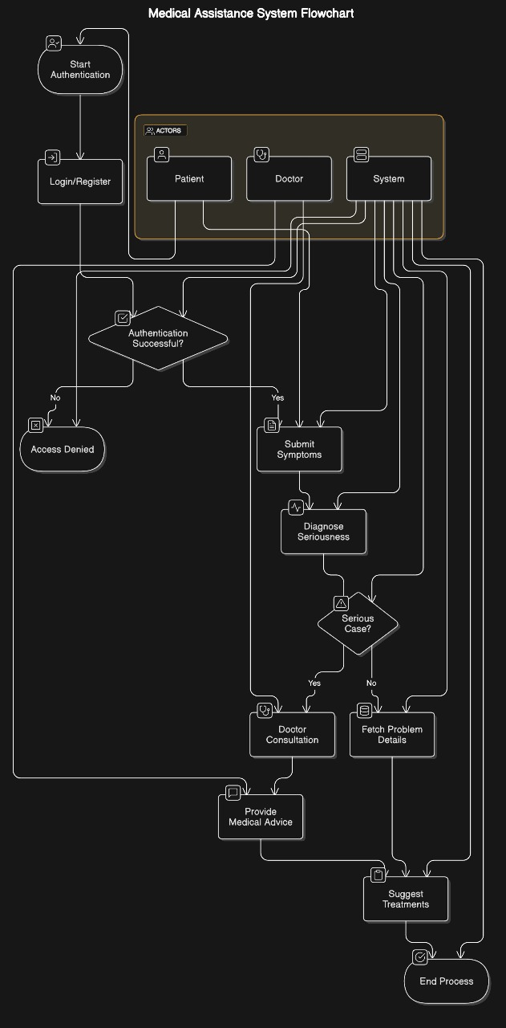

3.2 Class Diagram
Represents the object-oriented structure, showing classes, attributes, and relationships.

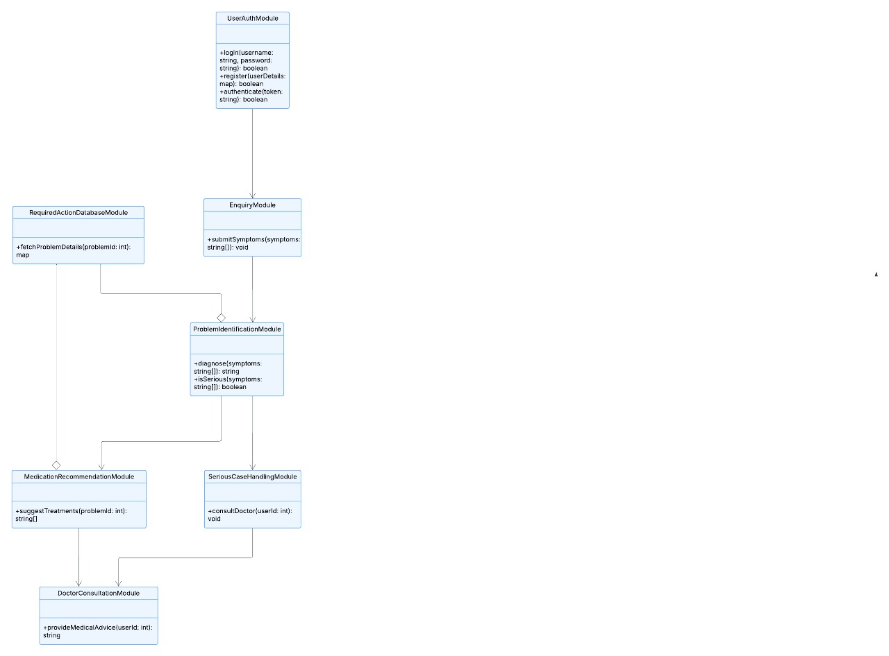
3.3 Sequence Diagram
Depicts the order of interactions between various system components during telemedicine consultations, appointment bookings, and payments.

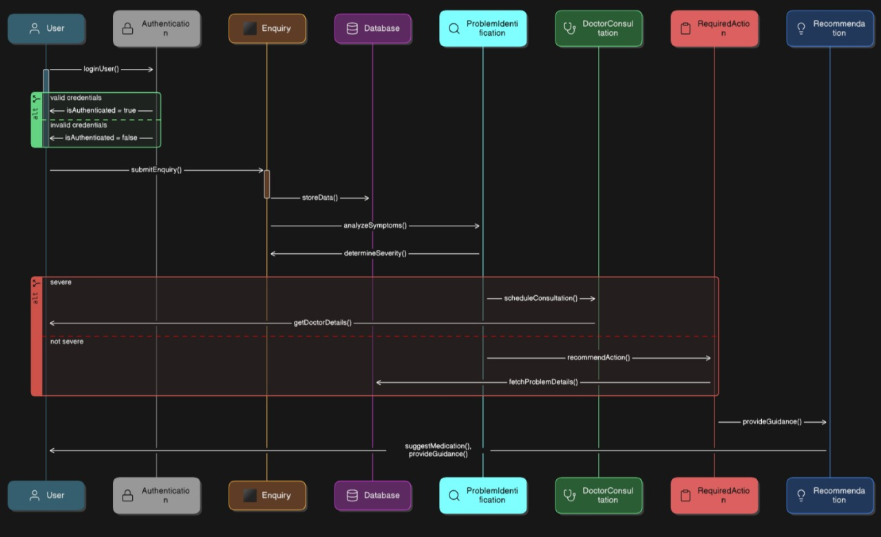
3.4 Activity Diagram
Details workflows such as user registration, teleconsultation process, and report generation.
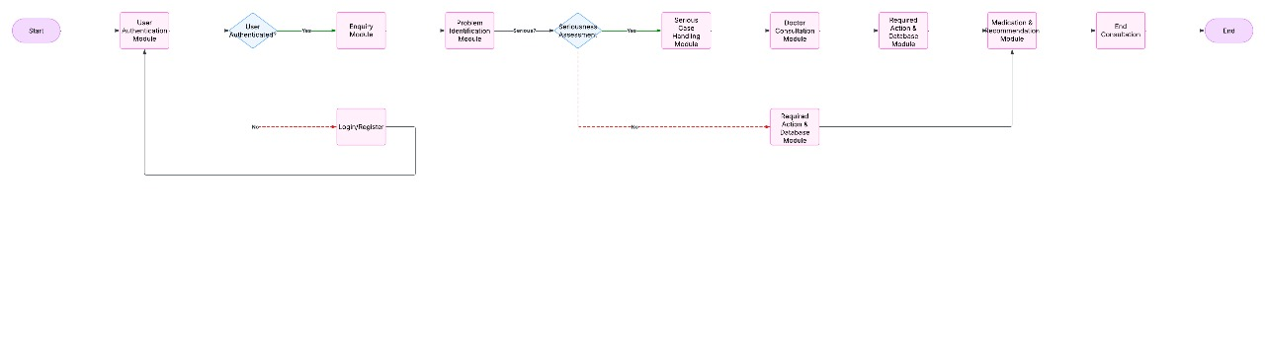

3.5 State Machine Diagram
Represents the different states of the system or user actions and how they transition from one to another (e.g., user authentication, appointment status changes, consultation progress).

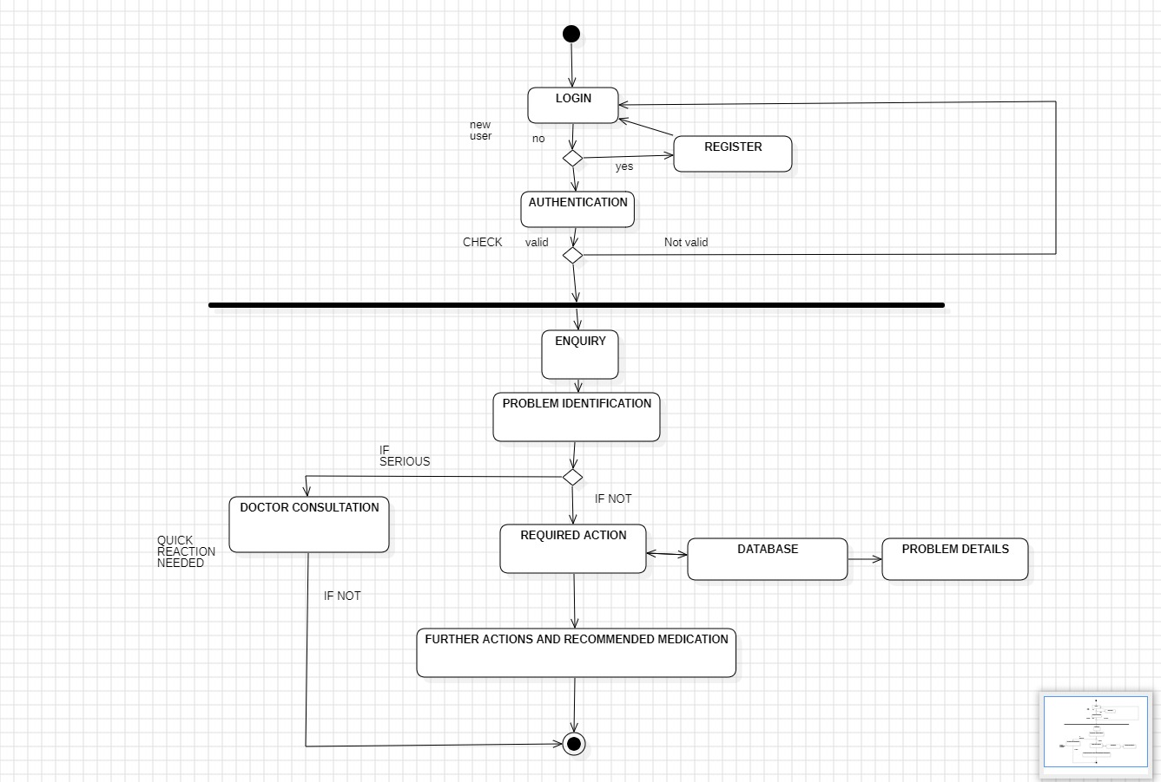

3.6 Entity-Relationship (ER) Diagram
Illustrates the database structure, relationships between entities such as users, appointments, and medical records.
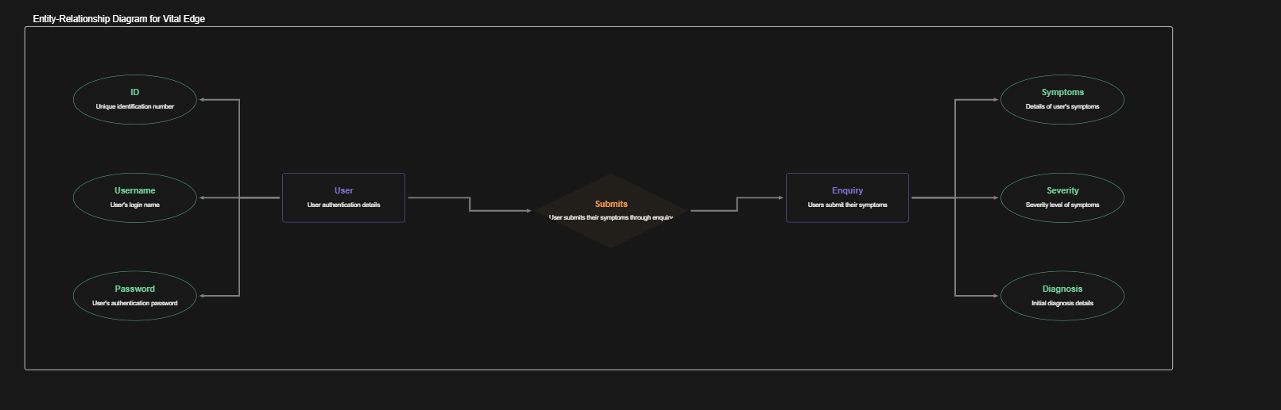

3.7 Deployment Diagram
Represents how the application is deployed across different environments (cloud servers, mobile devices, web browsers).
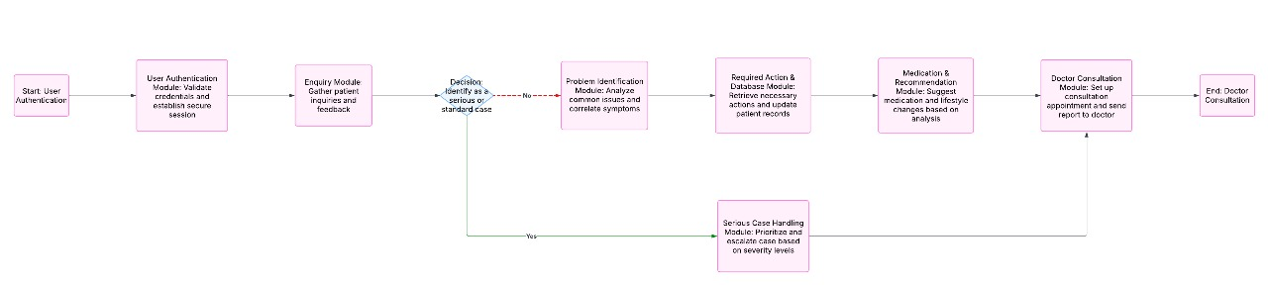

3.8 Component Diagram
Displays the high-level architectural components and their interactions within VITAL EDGE.
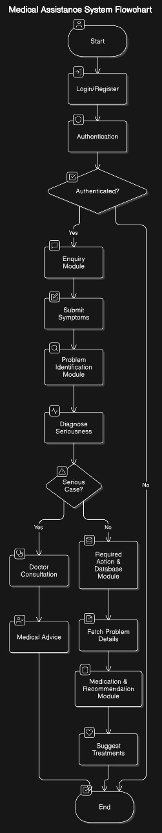
3.9 Communication Diagram
Shows how different components interact and communicate with each other during system operations.

4. External Interface Requirements/Screenshots
4.1 User Interfaces
- Login/Register Page: Secure access for different user roles.
- Emergency Access Button: Directly connects to emergency services.
- Doctor Consultation Interface: Video/audio call system with integrated chat.
- Prescription & Medical History Dashboard: Displays past medical interactions.
4.2 Hardware Interfaces
- Wearable Device Support: Integration with smartwatches for real-time health tracking.
- Device Compatibility: Supports desktops, smartphones, and tablets.
4.3 Software Interfaces
- Cloud-Based Storage: AWS/GCP/Azure for secure medical data storage.
- API Integrations: RESTful APIs to connect with third-party services.
4.4 Communication Interfaces
- Encrypted WebRTC Video Calls: Secure telemedicine consultations.
- AI Chatbot & Live Support: Instant medical inquiries and assistance.
- Doctor-Patient Messaging System: Secure text-based communication.

5. Other Non-Functional Requirements
5.1 Performance Requirements
- Fast Response Time: <200ms latency for real-time interactions.
- High Uptime Guarantee: 99.99% availability for critical healthcare functions.
5.2 Safety Requirements
- Data Recovery Mechanism: Automatic backup for medical records.
- Emergency Service Availability: 24/7 support for critical cases.
5.3 Security Requirements
- Multi-Factor Authentication: Ensures secure login.
- Role-Based Access Control: Restricts access based on user type.
5.4 Software Quality Attributes
- Maintainability: Modular architecture for scalability.
- Usability: User-friendly interface for all age groups.
5.5 Business Policies/Rules
- Regulatory Compliance: Adheres to telemedicine laws.
- Strict Data Retention Policies: Ensures data privacy.

6. Testing
6.1 Black-Box Testing
Black-box testing focuses on evaluating the functionality of the system without considering the internal code structure. Testers provide inputs and observe the outputs to verify correctness.
Black-Box Testing Techniques:
- Equivalence Partitioning: Divides input data into valid and invalid partitions to ensure diverse test coverage.
- Boundary Value Analysis: Tests edge cases at the boundary limits of input ranges.
- Decision Table Testing: Uses decision tables to analyze complex business rules.
- State Transition Testing: Checks system behavior when transitioning between different states.
- Use Case Testing: Verifies application behavior based on user scenarios.
Key Black-Box Test Cases for VITAL EDGE:
- Login & Authentication: Verify user authentication with valid and invalid credentials.
- Appointment Scheduling: Ensure successful booking, modification, and cancellation.
- Telemedicine Video Calls: Validate connection stability and audio/video quality.
- EHR Access: Confirm that users can securely access and modify medical records.
- Payment Processing: Check transaction success and error handling.
6.2 White-Box Testing
White-box testing examines the internal logic, code structure, and implementation of the software. It ensures that each function operates correctly and efficiently.
White-Box Testing Techniques:
- Statement Coverage: Ensures every line of code is executed at least once.
- Branch Coverage: Tests all decision branches (if-else, loops) for correctness.
- Path Coverage: Validates different execution paths in the code.
- Loop Testing: Examines loops for infinite or incorrect iterations.
- Data Flow Testing: Analyzes variable usage across the application.
Key White-Box Test Cases for VITAL EDGE:
- User Authentication Logic: Verify password encryption, token generation, and session management.
- Database Queries: Test efficiency and security of SQL queries.
- API Response Handling: Validate API requests and responses for accuracy and latency.
- Exception Handling: Ensure system stability during failures and invalid inputs.
- Security Checks: Assess vulnerability to SQL injection, XSS, and CSRF attacks.
By implementing a combination of black-box and white-box testing, VITAL EDGE ensures high reliability, security, and user satisfaction in telemedical services.

7. Conclusion
VITAL EDGE is a robust and scalable medical application designed to bridge the gap between patients and healthcare providers. By integrating AI, telemedicine, and secure health data management, it aims to revolutionize the digital healthcare space.
The application ensures real-time, seamless doctor-patient interactions with highly secure and encrypted communication channels. With AI-driven health assessments and efficient appointment scheduling, VITAL EDGE enhances accessibility to healthcare, especially in remote and underserved areas.
Moreover, the platform's compliance with HIPAA & GDPR ensures the protection of sensitive patient data, reinforcing trust between users and the system. Through rigorous black-box and white-box testing, the application guarantees reliability, security, and optimal performance under various conditions.
As the future of healthcare continues to evolve, VITAL EDGE aims to integrate machine learning, IoT-driven health monitoring, and predictive analytics to provide even more advanced medical insights. With continuous updates and optimizations, this application is set to become a comprehensive, go-to solution for digital healthcare services worldwide.

8. References
- HIPAA Compliance Regulations - U.S. Department of Health & Human Services (www.hhs.gov)
- General Data Protection Regulation (GDPR) - European Commission (www.eur-lex.europa.eu)
- Telemedicine Standards and Guidelines - World Health Organization (www.who.int)
- Cloud Security Best Practices - National Institute of Standards and Technology (www.nist.gov)
- Medical Data Encryption Techniques - Journal of Healthcare Informatics (www.jhi.org)

8. Acknowledgements
We extend our deepest gratitude to Prof.SIVA TEJASWI JONNA, our project mentor, for their invaluable guidance, continuous support, and insightful feedback throughout the development of VITAL EDGE. Their expertise in software engineering and healthcare technologies has been instrumental in refining the application.
We also appreciate the support of VIT-AP University and the School of Computer Science and Engineering for providing the necessary resources and infrastructure to develop and test our system.
Lastly, we acknowledge the efforts of our team members, whose dedication and collaboration have made this project a success. Their collective expertise in software development, AI integration, and cybersecurity has ensured that VITAL EDGE meets high standards of performance, security, and usability.

