A PROJECT REPORT
CLOUD COMPUTING AND METHODOLOGIES
Printer Fleet Analytics
An End-to-End IoT Monitoring System for the EpicReads Industrial Print Fleet, in which Per-Machine Threshold Governance, a Three-Reading Sustained-Window Anomaly Detector and a Dataset-Backed Individual Report Engine Convert Raw Sensor Telemetry into Auditable Operational Action
Invention Disclosure Format (IDF-B)
SUBMITTED BY
Name | Registration Number
Akki Prajwal | 24MID0230
Shri Hari | 24MIC0033
Sai Ajay Kumar Konduru | 24MID0062

Vellore Institute of Technology
Vellore, Tamil Nadu, India
Academic Year 2025-2026

© VIT IPR & TT CELL
Invention Disclosure Format (IDF) - B
Field | Value
Document No. | 02-IPR-R003
Issue No / Date | 2 / 01.02.2024
Amd. No / Date | 0 / 00.00.0000

1. Title of the invention:
Printer Fleet Analytics: An End-to-End IoT Monitoring System for the EpicReads Industrial Print Fleet, in which Per-Machine Threshold Governance, a Three-Reading Sustained-Window Anomaly Detector and a Dataset-Backed Individual Report Engine Convert Raw Sensor Telemetry into Auditable Operational Action

2. Field / Area of invention:
The invention relates to computer-implemented IoT monitoring systems, and specifically to data-processing systems that convert raw sensor telemetry from an industrial machine fleet into auditable operational action. It further covers machine-registry engineering of operational datasets, threshold-rule governance derived from per-machine configuration, raw-breach counting, sustained-window anomaly detection, weighted live-sensor risk scoring, five-section dashboard presentation over a REST interface, and print-ready individual-machine reporting with rule-based maintenance recommendations. It addresses the technical problem of keeping physically heterogeneous print-fleet machines - Binding, Digital, Large-format, Offset units rated between them at motor speeds from 3,200 to 13,500 rpm - correctly governed by their own limits within an interactive laptop-class computational budget.

3. Prior Patents and Publications from literature (provide a table summarizing the prior art)
A search was carried out across IEEE Xplore, Google Scholar, vendor documentation and the IETF standards database, directed at five questions: whether any prior system (i) governs sensor thresholds per physical machine from a machine-registry data source; (ii) separates raw threshold breaches from a sustained-window anomaly criterion; (iii) keeps dataset-labelled ground truth visible as a first-class quantity; (iv) emits a per-machine, print-ready report document generated from raw datasets; or (v) phrases maintenance suggestions as rule-based recommendations that never claim confirmed failure.
Prior art is abundant for the individual building blocks and no novelty is asserted in any of them alone. The search did NOT locate a disclosure in which a machine-registry-driven three-reading sustained-window detector, a labelled-versus-breach-versus-event three-count reconciliation and a dataset-verbatim individual-machine report engine are combined into one monitoring system. The closest references are:

Summary of prior art located and its relation to the present invention.
# | Reference | Source | What it teaches and its challenges
1 | Al-Fuqaha et al., IEEE COMST 17(4), 2015 | IEEE Xplore | Survey of IoT enabling technologies, protocols and application architectures. Merits: establishes the layered ingest-compute-display architecture this project also uses. Challenges: involves no per-machine threshold governance, no sustained-window detection and no report generation.
2 | AWS IoT Core / SiteWise (vendor documentation) | aws.amazon.com | Managed ingestion, rule-engine actions and industrial-site dashboards. Merits: robust transport and rule engine. Challenges: alerts act per reading against per-device rules; sustained-window criteria require custom development; document reporting is not native.
3 | Azure IoT Hub + Azure Monitor (vendor documentation) | learn.microsoft.com | Device ingestion with metric alert rules. Merits: mature metric alerting. Challenges: per-reading metric alerts by default; per-metric limits per device require external storage and code.
4 | Google Cloud IoT Core (retired 2023) | cloud.google.com | Managed ingestion core with external analytics attached. Merits: shows the minimal-core division. Challenges: service retired, demonstrating that the analytics value must live outside the transport layer - the choice this project makes deliberately in reverse.
5 | Grafana OSS + Prometheus | grafana.com; prometheus.io | Metrics storage, visualisation and alerting with static and windowed rules. Merits: closest to the dashboard layer and the windowed rule concept. Challenges: per-unit limit configuration is per-series and scripted; there is no registry-derived table, no labelled-truth quantity, and output is a screen capture, not a generated document.
6 | Splunk Industrial Asset Intelligence | splunk.com | Search-time alert correlation over machine events. Merits: powerful correlation. Challenges: license-cost search layer, not a document-grade reporting engine and not per-machine-limit native.
7 | SNMP Printer MIB v2, RFC 3805; IPP/1.1, RFC 8011 | IETF | Standards exposing print-device status (levels, errors, state). Merits: the telemetry vocabulary for print equipment. Challenges: transport standards only - they expose readings but decide nothing with them.
8 | pdfkit (Govett, 2020-dated) and Chart.js documentation | public repositories | PDF generation and canvas charting libraries. Merits: these are the rendering substrates used unchanged. Challenges: no novelty claimed in either; the claimed arrangement is the report's content governance, not the rendering.

4. Summary and background of the invention (Address the gap / Novelty)

4.1 The operational problem
A print farm is operated by people, not by machines: a supervisor starts a shift with a mental state - which machines are healthy, which sensors are drifting towards their limits, which machines already raised alerts overnight - and maintenance visits are documented on paper, not on screens. Cloud IoT suites solve the plumbing of ingest, store, compute and display, but their stock alerting is per-reading: one hot afternoon trips a temperature alarm for a healthy machine, while a slow bearing drift that never trips a one-off alert escapes notice entirely. The operator flowers in noise while the persistent condition that will end a shift stays under it.

4.2 The gap in the prior art
Three gaps consistently separate the located prior art from what the print farm needs. First, threshold governance: limits must be per physical machine and per metric, drawn from a single registry that every consumer reads identically - the prior art stores limits per device but does not derive rules, chart limit lines, report content and recommendations from that one source. Second, signal discipline: a labelled ground-truth event, a raw out-of-bounds excursion and a sustained out-of-bounds condition are three different operational facts; prior systems either collapse them into one alarm flag or expose no sustained-window criterion at all. Third, output: fleet history ends up on paper - reports must be generated documents filtered strictly per machine, carrying the machine's own limits, its complete alert history with severities and rule-based recommendations, not a re-scan of a dashboard page.

4.3 Novelty asserted
The arrangement claimed is the combination: (i) machine-registry threshold governance in which the registry row of the machine that produced a reading determines every later statement about that reading across all surfaces; (ii) a two-stage detection layer in which raw breaches are counted separately from a three-consecutive-reading sustained-window anomaly event, both kept distinct from the dataset-labelled ground truth in every display, payload and document; (iii) a dataset-verbatim individual-machine report engine that filters three operational datasets strictly by machine, draws the machine's own limit lines on its charts, reconciles the three anomaly counts and fires recommendations only from observed breaches with an explicit no-confirmed-failure disclaimer; and (iv) an interactive laptop-class computational budget in which all statistics are recomputed from the datasets at request time with no persistent database.
No novelty is asserted in: HTTP ingestion as such; KPI computation as such; canvas chart rendering; or PDF rendering as such. These use established methods and are claimed only in combination.

4.4 The technical problem
(a) How to make threshold governance correct for a physically heterogeneous fleet without duplicating configuration through the code. (b) How to keep three related anomaly quantities distinguishable across every surface without a persistent database, recomputing everything from the datasets at request time. (c) How to keep the dashboard responsive while doing so, requesting filtered series rather than whole files. (d) How to make a downloaded report an auditable artifact rather than a marketing page: verbatim dataset statistics, the machine's own limits, the complete alert history and rule-based recommendations that never claim confirmed mechanical failure.

4.5 Outline of the solution
The system is built as four layers over three CSV datasets: a registry-generation and replay layer; a validation-gated ingestion endpoint feeding an in-process analytics core; a REST interface on port 3001 serving KPIs, distributions, trends, pivots, threshold rules, risk scoring, per-machine series and the report endpoint; and a five-section React + TypeScript + Chart.js dashboard on port 3000 with a built-in report-download button. Detection is two-stage (raw breaches, then sustained windows); the risk score reuses the same limits; the report engine composes three pages per machine with pdfkit and is verified against the CSVs by an independent checker. Section 6 details the working principle and Section 7 the implementation.

5. Objective(s) of Invention
The objectives are set out below. Objectives 1 and 2 together define the central mechanism; the remainder define the system that makes it usable and auditable.
Objectives of the invention.
# | Objective | Statement
1 | Registry-driven threshold governance | Every limit used anywhere - alert engine, chart lines, report tables, recommendations - comes from the registry row of the machine that produced the reading, so the same value is healthy on one machine and a breach on the next.
2 | Two-stage detection with a sustained-window criterion | Count raw breaches separately and fire a detected anomaly event only when a metric stays out of bounds for three consecutive readings at a machine, keeping brief excursions visible but non-urgent.
3 | Three-count reconciliation | Present labelled anomalous readings, raw breach readings and detected events as three separate counts on the dashboard cards, in every API payload and in every report section.
4 | Interactive fleet analytics without a database | Compute KPIs, distributions, trends and pivots from cached dataset rows at request time so the dashboard is responsive on commodity hardware.
5 | Validation-gated ingestion | Reject unregistered machine IDs and malformed payloads explicitly so corrupt streams cannot pollute detection state.
6 | Dataset-verbatim individual reporting | Emit a three-page print-ready PDF per machine through a dedicated endpoint, reconciling the three counts, drawing the machine's own limit lines and listing the complete alert history with severities.
7 | Rule-based, non-diagnostic recommendations | Fire recommendations only on observed breaches (cooling for repeated temperature excursions, mechanical inspection for vibration, replenishment for ink and paper) with a standing disclaimer that no confirmed failure is asserted.
8 | Independent verifiability | Regenerate the dataset layer from one script and re-verify every computed statistic against the raw CSVs from an independent checker.

6. Working principle of the invention (in brief)
The system operates as interconnected stages, each an independent module with a defined interface. A machine correction at 6.2, or a rebuild of the datasets, re-enters the pipeline at 6.1, so the assessment stays reconciled with the record.

6.1 Dataset engineering and registry population
One script generates the registry (8 machines x 15 columns), the telemetry file (6,912 readings x 16 columns at 15-minute cadence) and the alert file (346 rows). The registry carries the per-machine limit columns that everything downstream reads.

6.2 Ingestion validation
Readings enter through POST /api/telemetry and are validated against the registry before any state changes: unregistered machines and malformed bodies are rejected explicitly. The replay engine posts historical rows through this same path.

6.3 Analytics core
Module functions compute fleet KPIs, sensor distributions, hourly and daily trends, per-machine pivots and the threshold-rule derivation, each registry row becoming an ordered rule list with severities: temperature, vibration and paper jams CRITICAL; motor RPM, power, the humidity band and the ink floor WARNING; the paper-stock floor INFO.

6.4 Two-stage detection (central mechanism)
Stage one counts raw breaches: each reading, for each metric, is compared with its machine's configured bound and contributes an alert row when out of bounds. Stage two is the sustained-window rule: a metric that remains out of bounds for three consecutive readings at a machine fires a detected anomaly event. A weighted risk score evaluates arbitrary live sensor input with the same limits, bucketing risk into NORMAL (<=4%), ELEVATED (<=12%), WARNING (<=35%) and CRITICAL (>35%).

6.5 Presentation
The dashboard requests filtered series (machine + metric) through the REST interface and renders five sections; labelled points are marked red on every series; anomaly cards keep the three counts apart.

6.6 Report composition
The report service filters all three datasets strictly by the requested machine and composes three pages: identity header, registry row and limits, per-sensor statistics, the three-count anomaly summary, three time-series charts with the machine's own limit lines, the complete alert history with severities, and rule-based recommendations with the no-confirmed-failure disclaimer. Unknown machines return HTTP 404; generation errors are caught so a partial file is never downloadable.

6.7 Verification
An independent checker recomputes labelled counts, breach counts, per-sensor statistics and alert attributions directly from the CSVs and verifies the extracted text of generated reports against them.

7. Description of the invention in detail (include drawing and/or photograph as needed)
The system is organised as four layers (Fig. 1). Reference numerals correspond to the workflow of Fig. 2. Each module exposes a defined interface, which is what lets the replay engine exercise exactly the code path production sensors would use.
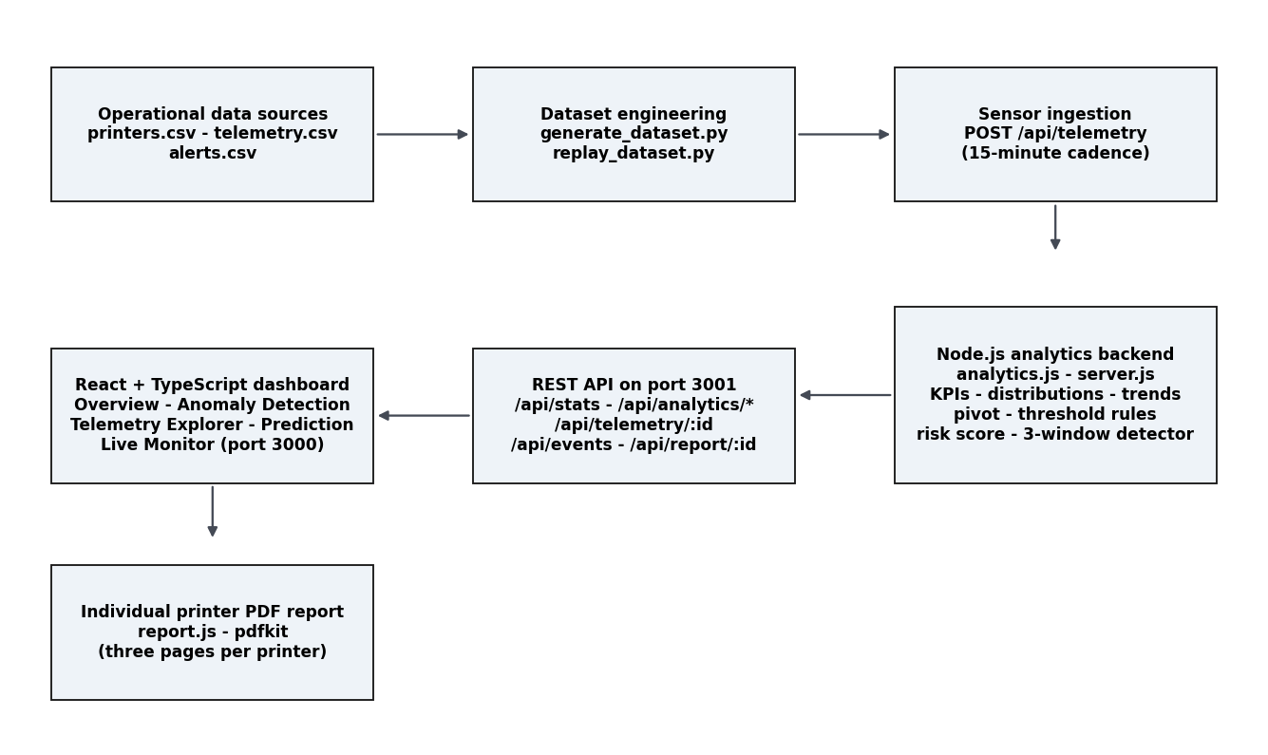
Fig. 1. Layered architecture. Datasets (top left); dataset engineering; ingestion; analytics backend; REST interface; dashboard and report services.
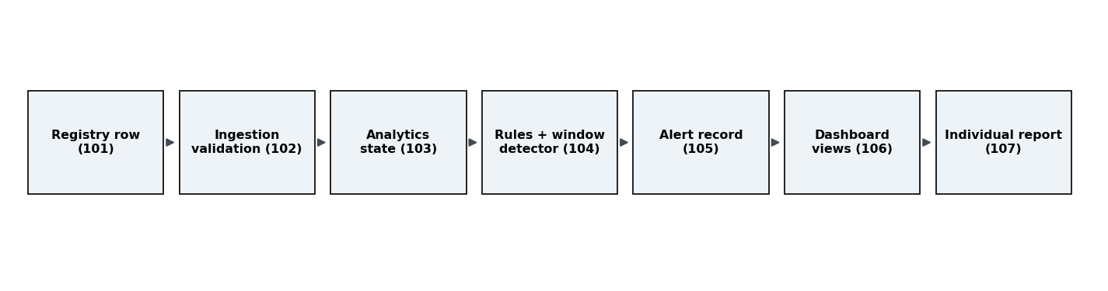
Fig. 2. End-to-end reading workflow from registry row (101) to the individual print-ready report (107).

7.1 Operational data and dataset-engineering layer (100)
printers.csv registers the eight machines (EPR-001..EPR-008) with identity, type, location, installation date and the limit columns. telemetry.csv holds 6,912 readings x 16 columns with the machine status mix (ERROR 51, IDLE 3,419, MAINTENANCE 43, OFFLINE 44, PRINTING 3,355). alerts.csv holds 346 rows with metric, value, threshold, severity and message. One script regenerates all three; the labelled flag marks 416 readings (6.02%) anomalous across six injected families.

7.2 Ingestion and validation (102, 103)
[ Insert screenshot: Backend console showing a clean boot, a successful POST /api/telemetry and a rejected unregistered ID ]
Fig. 3. Ingestion endpoint accepting a registered machine and rejecting an unregistered one (screenshot to be inserted from the live demo).

7.3 Analytics core and REST interface (104)
The interface exposes, at port 3001: GET /api/stats; GET /api/analytics/overview, /distributions, /trends and /pivot; GET /api/thresholds; GET /api/telemetry/<printer-id>?metric=; GET /api/events; POST /api/telemetry; and GET /api/report/<printer-id>. Every payload is shaped for the dashboard component that consumes it and every statistic is computed from the CSVs at request time.
[ Insert screenshot: Backend JSON answers for /api/analytics/overview and /api/telemetry/EPR-001?metric=temperature_c ]
Fig. 4. REST interface answers for the fleet overview and a filtered per-machine series (screenshot to be inserted).

7.4 Five-section dashboard (105)
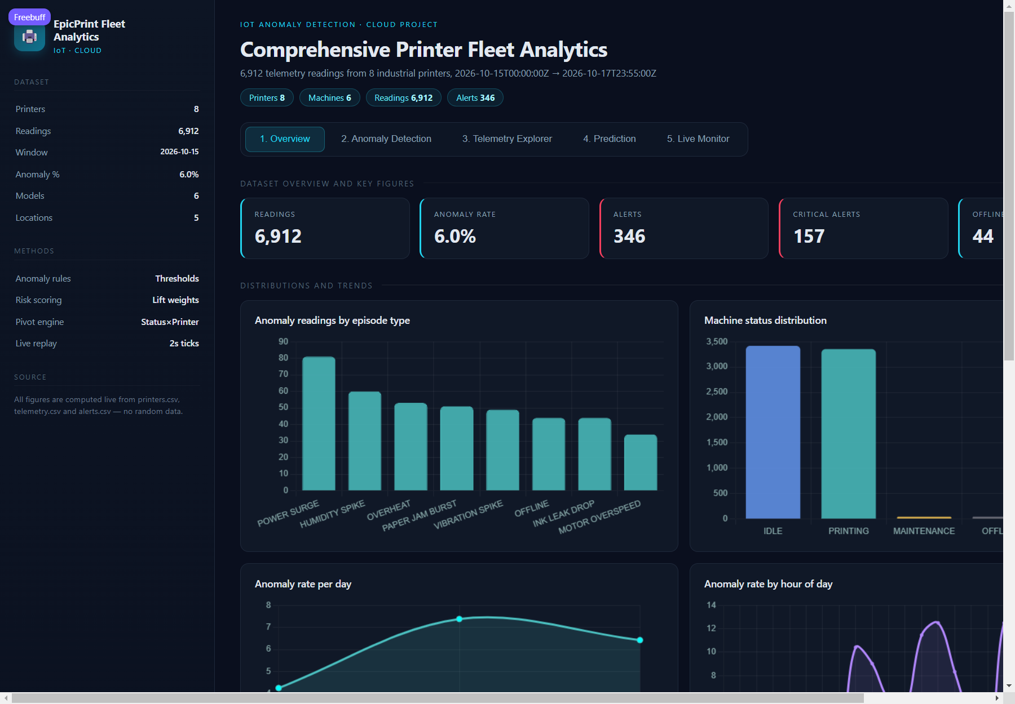
Fig. 5. Overview section of the dashboard.
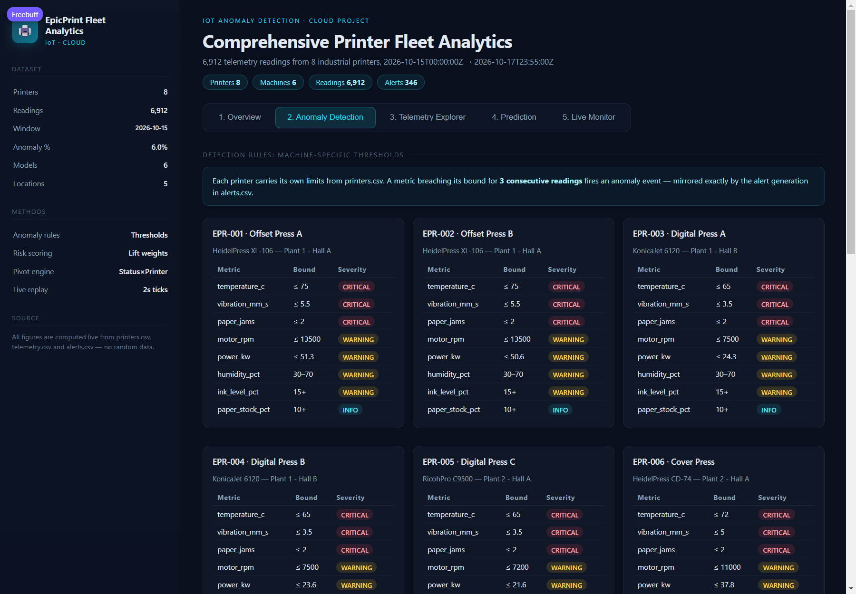
Fig. 6. Anomaly Detection section: labelled episodes and the alert timeline.
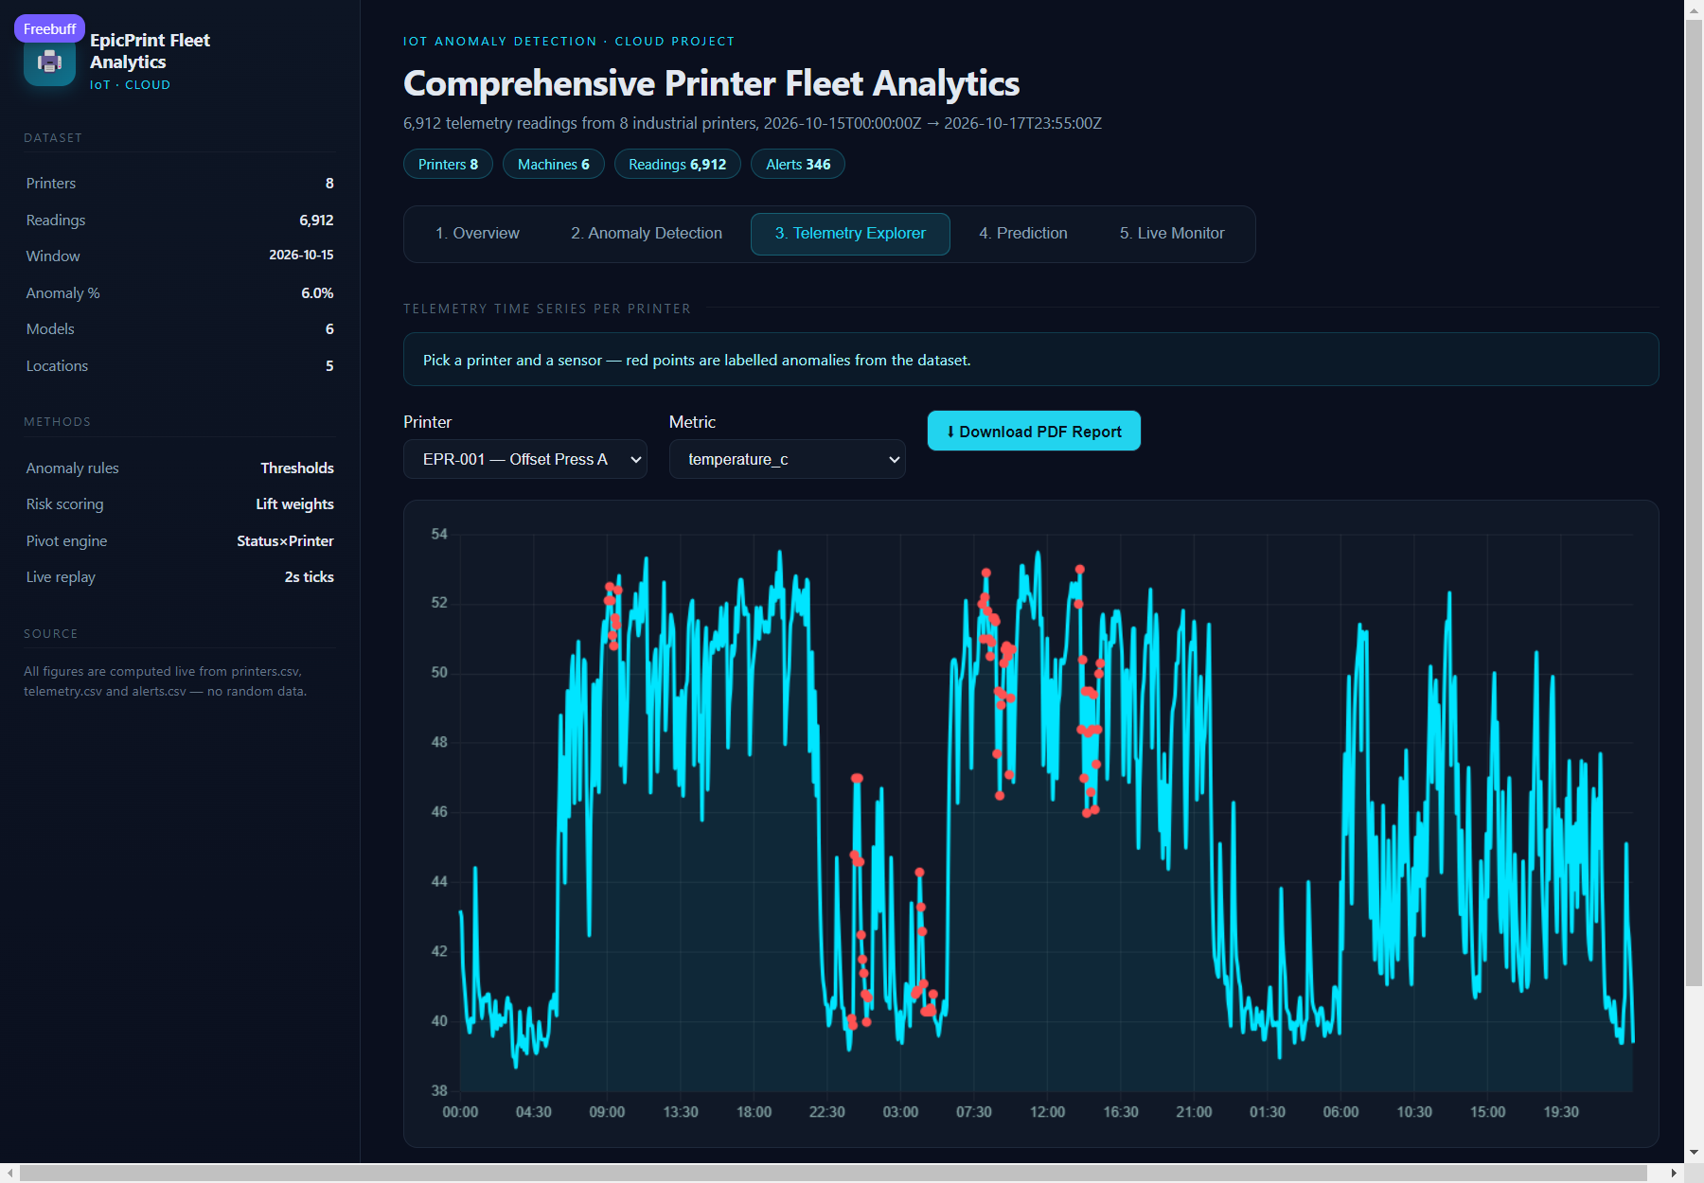
Fig. 7. Telemetry Explorer section with the report-download control.
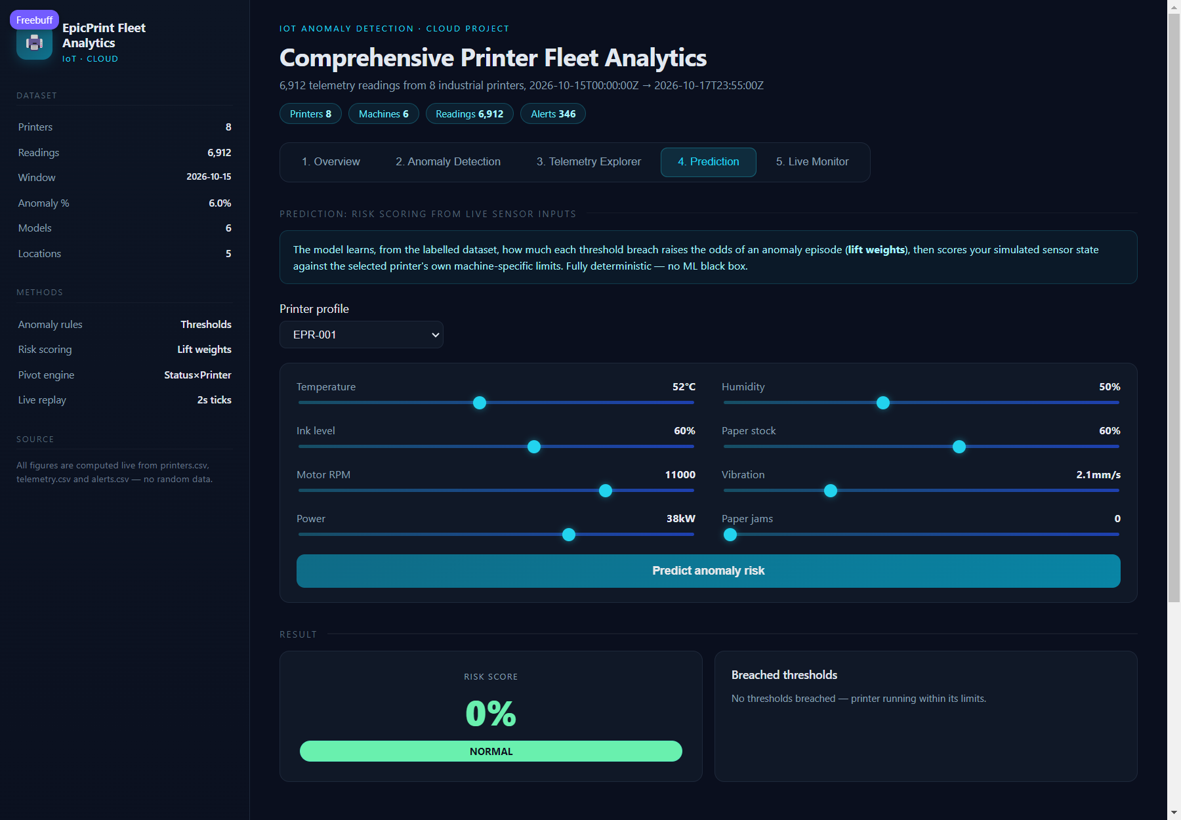
Fig. 8. Prediction section: weighted risk score of live sensor input.
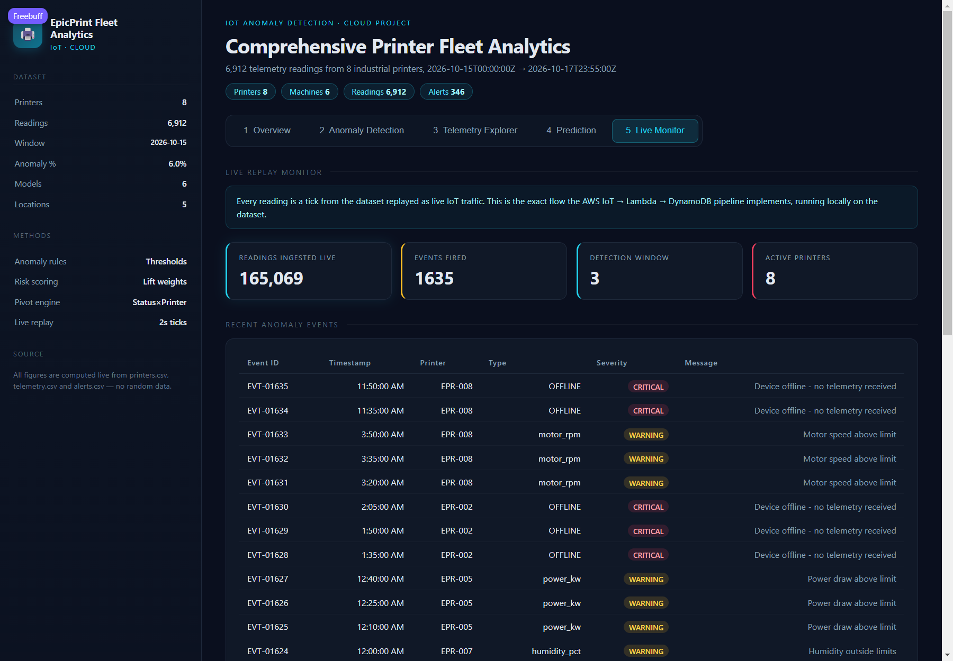
Fig. 9. Live Monitor section during replay.

7.5 Individual report engine (106, 107)
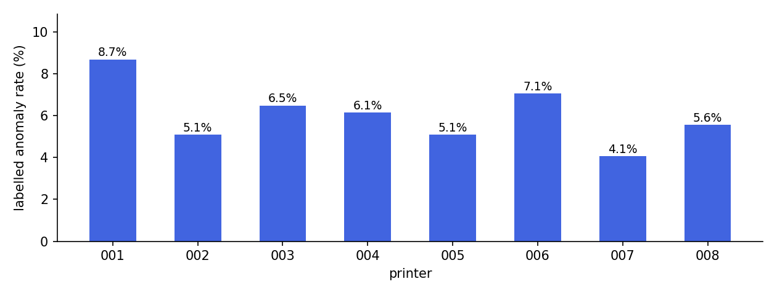
Fig. 10. Labelled anomaly rate per printer - the per-machine reconciliation the report summary inherited (dataset ground truth).
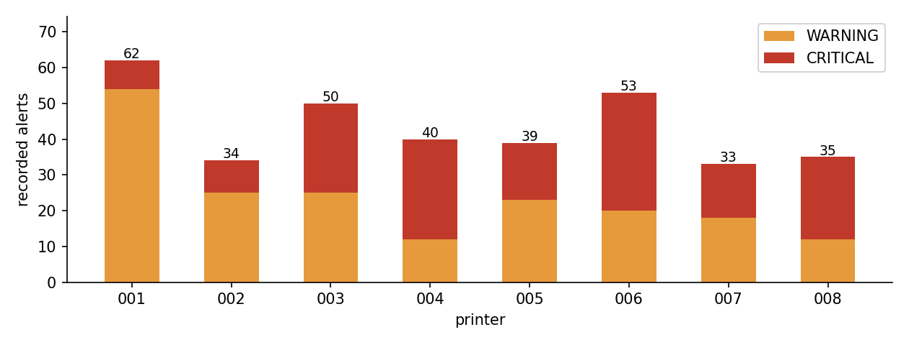
Fig. 11. Recorded alerts per printer by severity (alerts.csv).
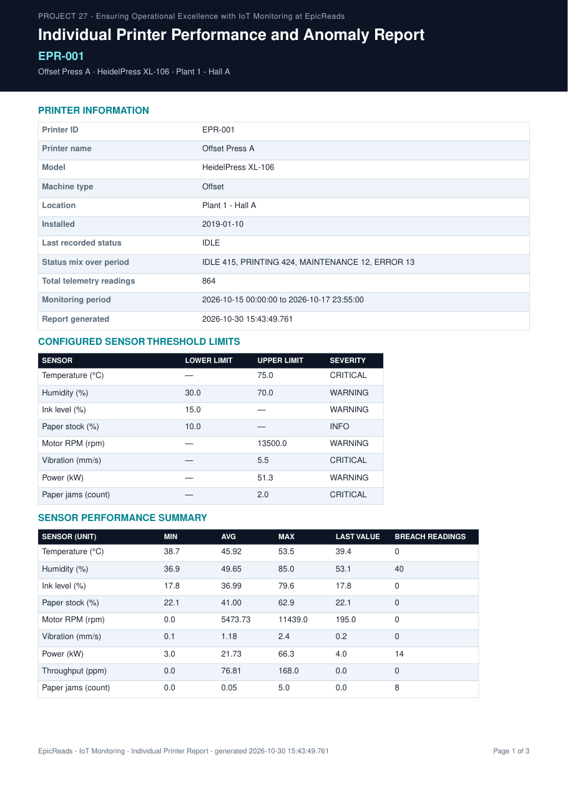
Fig. 12. The generated three-page report for EPR-001, page 1: header, printer information and sensor statistics.
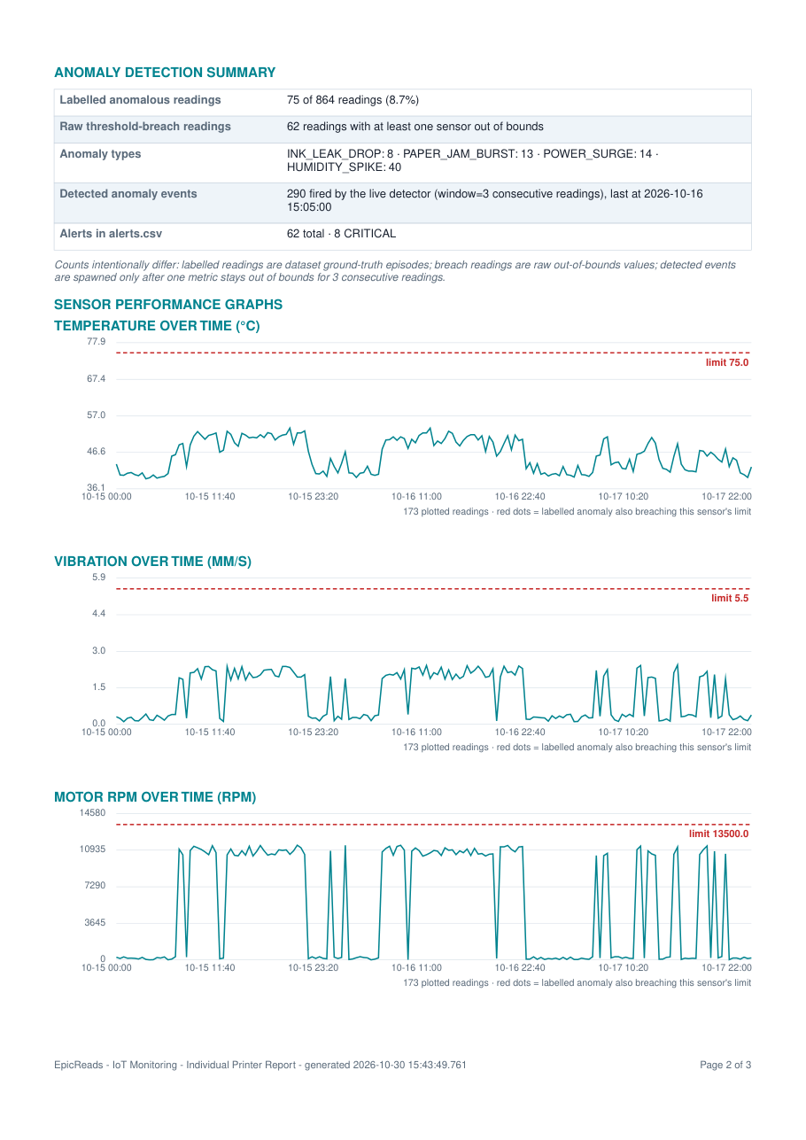
Fig. 13. Report charts page of EPR-001 with the machine limit lines.
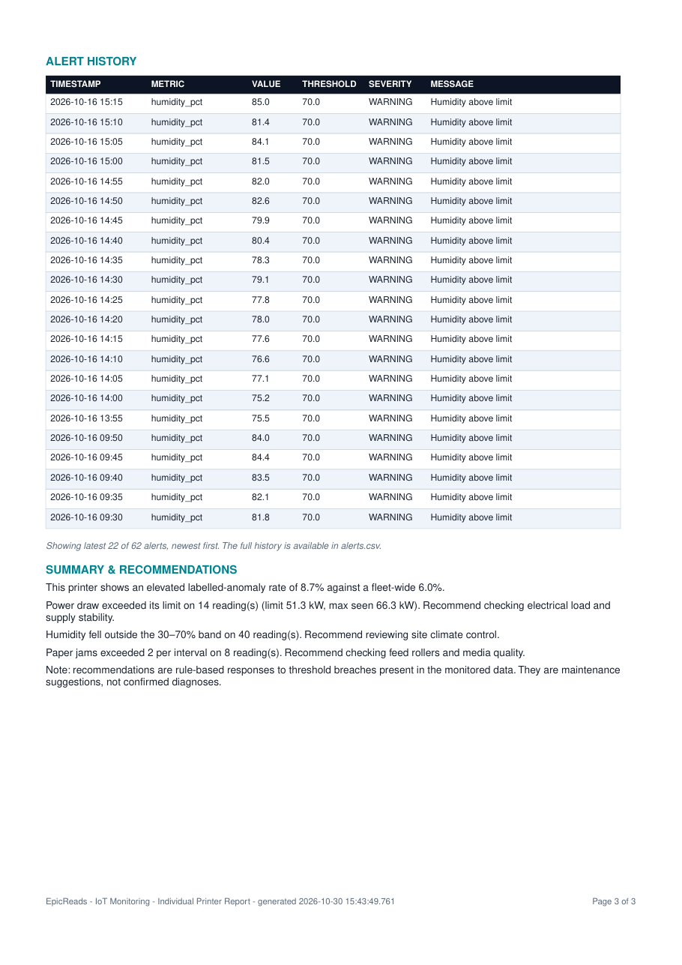
Fig. 14. Report alert-history and recommendations page of EPR-001.

8. Experimental validation results:
This section reports what was measured on the build described, with the limits of each measurement. The applicant distinguishes software verification, which has been performed, from field validation on real print hardware, which has NOT. No claim of fleet accuracy in production is made anywhere in this document.

8.1 Measurement environment
All figures were produced on the working build on one development laptop: the backend (Node.js) on port 3001, the dashboard (React + TypeScript) on port 3000, and the datasets regenerated from the project's own generation script. Every measurement was re-checked with the independent CSV-based verification script that accompanies the repository.

8.2 Evaluation data and its limitations
The evaluation uses the project's own synthetic-but-realistic operational dataset: 6,912 telemetry readings, 416 labelled anomalous readings (6.02%) across six injected families and 346 recorded alerts. The limitation must be stated plainly: the labelled anomalies are injected by the generation script, so the evaluation is circular and measures the pipeline's ceiling, not field accuracy; no real printer hardware, no real fleet outcomes and no prospective study are involved at any point; and all figures were measured with a single simultaneous user. Published sizing figures for the cloud suites in Section 3 were measured at infrastructure scale and are therefore not comparable with the figures below.

8.3 Fleet results
Table 8.3 Per-printer results over 6,912 readings, 2026-10-15 to 2026-10-17 (three calendar days, 15-minute cadence).
Printer | Type | Readings | Labelled | Rate % | Breach readings | Alerts | Critical
EPR-001 | Offset | 864 | 75 | 8.7 | 864 | 62 | 8
EPR-002 | Offset | 864 | 44 | 5.1 | 855 | 34 | 9
EPR-003 | Digital | 864 | 56 | 6.5 | 864 | 50 | 25
EPR-004 | Digital | 864 | 53 | 6.1 | 845 | 40 | 28
EPR-005 | Digital | 864 | 44 | 5.1 | 856 | 39 | 16
EPR-006 | Offset | 864 | 61 | 7.1 | 864 | 53 | 33
EPR-007 | Binding | 864 | 35 | 4.1 | 864 | 33 | 15
EPR-008 | Large-format | 864 | 48 | 5.6 | 856 | 35 | 23
Two spreads characterise the fleet: the labelled anomaly rate runs from 4.05% (EPR-007) to 8.68% (EPR-001), and breach readings move to a different rhythm than labelled readings - which is exactly the conflation the two-stage detection layer refuses to make. EPR-001 and EPR-008 are the acceptance pair: EPR-001 carries the humidity and power families while EPR-008 dominates vibration, motor overspeed and offline episodes.

8.4 Verification of the report mechanism on the acceptance pair
To verify that the mechanism of 6.4 and 6.6 operates as specified and is genuinely machine-specific, the mandatory comparison was run: select EPR-001, download; select EPR-008, download; then re-verify every statistic in both documents against the raw CSVs with the independent checker. Table 8.4 records the reconciliation.
Table 8.4 Report verification pair - results from the automated cross-check.
Factor verified | EPR-001 | EPR-008
Filename | EpicReads_Printer_EPR-001_Report.pdf | EpicReads_Printer_EPR-008_Report.pdf
Length and content type | 3 pages, application/pdf, Content-Disposition attachment | same
Foreign printer IDs in report | None | None
Total readings | 864 (matches CSV) | 864 (matches CSV)
Labelled anomalous readings | 75 of 864 (8.7%) - matches CSV | 48 of 864 (5.6%) - matches CSV
Raw threshold-breach readings | 864 (recomputed) | 856 (recomputed)
Recorded alerts | 62 total, 8 CRITICAL | 35 total, 23 CRITICAL
Chart limit lines (own machine) | 75.0 degC - 5.5 mm/s - 13,500 rpm | 60.0 degC - 3.0 mm/s - 3,200 rpm
Recommendations | Fired only from its own records; no confirmed-failure claim | same
Three things are verified. First, the limits are the machine's own: each report draws exactly the dashed limit lines recorded in printers.csv for its machine and no other. Second, the counts reconcile: labelled, breach and detected-event counts in each report match the independent recomputation from the CSVs. Third, the documents are strictly machine-specific: no statistic, alert row or chart point from one machine appears in the other's report. All eight printers generated reports successfully through the live endpoint.

8.5 Software verification and error handling
The five dashboard sections render with no console errors during the walkthrough, and every section endpoint answers 200. Ingestion rejects an unregistered machine ID and a malformed JSON body with explicit status messages; the report endpoint returns HTTP 404 with a JSON error for unknown machines; and a machine with no recorded alerts receives the graceful no-alerts text rather than an empty table. Two always-on processes serve ports 3001 and 3000, unchanged by the report feature.

8.6 What has not been evaluated
The following have NOT been evaluated against field ground truth because none is available: real hardware ingestion at production cadence (the replay engine is used instead), the threshold parameter of three consecutive readings (justified by operator-noise reasoning, not yet by field data), multi-user behaviour, and deployment-scale serving. The recommendations surface is explicitly non-diagnostic: no confirmed mechanical failure is claimed anywhere in the system.

9. What aspect(s) of the invention need(s) protection?
Protection is sought for the integrated system and for the mechanisms below, listed in the applicant's order of preference.

9.1 Registry-driven threshold governance with a two-stage detection layer
The arrangement in which the registry row of the machine that produced a reading determines every later statement about that reading; raw breaches are counted separately from a sustained-window anomaly event of three consecutive out-of-bounds readings; and the dataset-labelled ground truth is kept visible as a separate count on every surface.

9.2 Dataset-verbatim individual-machine report engine
The arrangement in which a report document is generated per machine, filtering three operational datasets strictly by that machine, drawing the machine's own limit lines on its charts, reconciling the three anomaly counts, listing the complete alert history with severities and firing recommendations only from observed breaches with an explicit no-confirmed-failure disclaimer, exposed over a dedicated endpoint that rejects unregistered machines explicitly.

9.3 Interactive request-time analytics without a persistent database
The arrangement in which fleet KPIs, distributions, trends, pivots and threshold rules are recomputed from cached dataset rows at request time, and the dashboard requests filtered series rather than whole files, so the whole system runs within a laptop-class budget with no database to drift from the datasets.

9.4 Replay-equivalent ingestion validation
The arrangement in which historical rows are posted through the same validation-gated ingestion endpoint as live traffic, so a replayed historical stream exercises exactly the code path production sensors would use, and unregistered machines and malformed payloads are rejected before any detection state can be polluted.

9.5 Further aspects claimed in combination with 9.1
The weighted live-sensor risk score reusing the registry limits with its NORMAL / ELEVATED / WARNING / CRITICAL bucketing; the graceful degradation of empty alert histories and offline/null sensor rows; and the integrated combination in which one dataset layer drives KPIs, detection, dashboard views and per-machine printable reports.

10. What is the technology readiness level of your invention? (Tick the appropriate TRL)
Tick: TRL 4 - Technology validated in a laboratory environment.
Justification.
The complete system exists and runs: the dataset layer, analytics modules, ingestion validation, two-stage detection, the five-section dashboard and the per-machine report service are all implemented and exercisable end to end, and the mechanisms claimed in Section 9 were verified to operate as specified against the independent CSV checker (8.4, 8.5). That establishes laboratory validation in integrated form.
The applicant has deliberately NOT claimed TRL 5, which requires validation in a relevant environment: no real print hardware has been instrumented, all quantitative results were obtained on the project's own generated dataset, and the system runs on one laptop with a single user. The work needed to reach TRL 5 is listed among the outstanding items (real-hardware ingestion, authenticated multi-user mode, cloud deployment with persistence).
Technology readiness level scale with the selected level marked.
TRL 1 | TRL 2 | TRL 3 | TRL 4 | TRL 5 | TRL 6 | TRL 7 | TRL 8 | TRL 9
Basic principles observed | Technology concept formulated | Experimental proof of concept | Technology validated in a lab | Technology validated in a relevant environment | Technology demonstrated in a relevant environment | System prototype demonstration in an operational environment | System complete and qualified | Actual system proven in an operational environment
 |  |  | v (selected)

---------------------- END OF THE DOCUMENT -----------------------------

