A PROJECT REPORT - Review 2
CLOUD COMPUTING AND METHODOLOGIES
Printer Fleet Analytics
An End-to-End IoT Monitoring System for the EpicReads Industrial Print Fleet, in which Per-Machine Threshold Governance, a Three-Reading Sustained-Window Anomaly Detector and a Dataset-Backed Individual Report Engine Convert Raw Sensor Telemetry into Auditable Operational Action
SUBMITTED BY
Name | Registration Number
Akki Prajwal | 24MID0230
Shri Hari | 24MIC0033
Sai Ajay Kumar Konduru | 24MID0062

Vellore Institute of Technology
Vellore, Tamil Nadu, India
Academic Year 2025-2026

ABSTRACT
Industrial monitoring dashboards typically alarm on one raw sensor reading against one fleet-wide limit, which floods operators with single-reading excursions and yet cannot express that the same sensor value is healthy on one machine and dangerously out of bounds on the next. This report presents the Review 2 state of Printer Fleet Analytics, an end-to-end IoT monitoring system for the eight-printer fleet of EpicReads (machines EPR-001 through EPR-008), implemented as a cloud-style layered service: a reproducible dataset layer of 6,912 telemetry readings at 15-minute cadence over 2026-10-15 to 2026-10-17 plus a machine registry carrying per-machine sensor limits, a Node.js analytics backend whose pure modules compute fleet KPIs, distributions, trends, pivots and per-machine threshold rules, a documented REST interface on port 3001, a React + TypeScript + Chart.js dashboard with five working sections on port 3000, and a dataset-backed individual printer report engine that emits a print-ready three-page PDF per machine. The design deliberately separates three related quantities that one-number dashboards conflate: labelled anomalous readings (dataset ground truth), raw threshold-breach readings and sustained-window anomaly events, the last raised only when a metric stays out of bounds for three consecutive readings. Across the monitored window the dataset labels 416 readings as anomalous (6.02%), the alert engine records 346 rule-driven alerts (157 CRITICAL, 189 WARNING) raised from per-machine columns in printers.csv, and the individual report feature was verified end to end for all eight printers, with the mandatory EPR-001 versus EPR-008 comparison checked against the raw CSVs. The evaluation data is synthetic by construction, no real fleet hardware was used, and the system is validated on a single laptop environment only.
Keywords: IoT monitoring; cloud-style service layering; REST API; anomaly detection; threshold governance; sustained-window inference; telemetry replay; React; TypeScript; Chart.js; Node.js; PDF report generation; per-machine configuration; operational excellence; dataset provenance.

1. Introduction

1.1 Context and motivation
A print-farm supervisor does not experience failure as a chart. A bearing overheats during a run, ink runs low in the middle of a job, and a jammed feeder is noticed only when the delivery is already late. Cloud IoT platforms solve the plumbing - ingest, store, compute, display - but their stock alarms are per-reading and often per-fleet, so they are easy to configure and easy to ignore: one hot afternoon trips the temperature alarm for a machine that is otherwise fine, while a slow bearing drift that never trips a one-off alert escapes notice entirely. Single-signal anomaly flags also conflate what a maintenance decision actually needs to distinguish: a dataset-labelled event, a raw excursion against a limit, and a persistent condition that will end a shift.
The fleet fairness problem is equally concrete. Machines EPR-001 through EPR-008 are physically different (print-fleet presses of types Binding, Digital, Large-format, Offset, installed between 2018 and 2021), so one identical limit is wrong for every machine and right for none. A 5.4 mm/s vibration is inside EPR-001's 5.5 mm/s allowance but is an 80% overshoot of EPR-008's 3.0 mm/s limit. The system therefore carries its configuration where the machines are: per-machine, per-metric limits in the printer registry, honoured everywhere in the computation.

1.2 Scope of the work
The implemented scope begins with three CSV datasets and ends with the five-section dashboard and the printable per-machine report. Between them lie the dataset generation and replay scripts, the analytics modules, the threshold-rule configuration derived from the registry, the raw-breach and sustained-window detection layers, the weighted live-sensor risk score, and the report generator. The Review 2 submission does not cover authenticated fleet accounts, cloud deployment with persistence, streaming ingestion from physical hardware, or a trained predictive-maintenance model; those are listed as future work in Section 9. Built and demonstrated as a layered, stateless-service style application running on one laptop (backend port 3001, dashboard port 3000), so that every layer boundary is a documented HTTP contract.

2. Related Work
Prior work divides along the same line this project crosses. Established cloud-IoT suites give robust ingestion, dashboards and alert rules, but their alerting is per-reading against per-device thresholds with no sustained-window criterion by default, their report layer is a screenshot of a chart rather than a document, and their per-unit limit configuration is possible but rarely exercised per metric. Print-fleet standards such as the Internet Printing Protocol and the SNMP Printer MIB expose device status but do not decide anything with it. Table I summarises the surveyed systems against the properties Printer Fleet Analytics makes first-class.
TABLE I. Comparison of prior systems with Printer Fleet Analytics.
System / standard | Capability | Alert model | Per-unit limits | Print-ready output
AWS IoT Core / SiteWise | Ingestion, rules, dashboards | Per-reading rule actions | Per-device possible | None native
Azure IoT Hub + Monitor | Ingestion, metrics, alert rules | Per-reading metric alerts | Per-device possible | None native
Google Cloud IoT Core (retired) | Managed ingestion core | External (Dataflow/Functions) | External | None
Grafana + Prometheus | Metrics storage and visualization | Static and windowed rules | Per-series rules | PDF of a dashboard page
Splunk (Industrial Asset) | Log and event pipeline | Search-time alert correlation | Per-source possible | Report extracts
SNMP Printer MIB v2 / IPP | Print-device status exposure | None - transport standard | n/a | n/a
Printer Fleet Analytics | Dataset-backed analytics + five-section dashboard | Raw breaches PLUS three-reading sustained-window events | Per-machine, per-metric from registry | Three-page per-machine PDF via dedicated endpoint
The distinguishing arrangement is not any single capability but the combination: dataset ground truth kept visible (labelled readings), detection split into breach counting and a sustained-window rule so operators see excursions and persistent conditions differently, and reporting that is a generated document, filtered strictly per machine, rather than a screen dump. No novelty is asserted in the individual building blocks - HTTP ingestion, KPI computation, canvas charting, or PDF rendering - which are claimed only in combination.

3. Problem Statement and Objectives

3.1 The technical problem
(a) How to make threshold governance correct for a heterogeneous fleet without duplicating anything. A fleet-wide limit is simple and wrong; per-machine logic spread through the code is correct and unmaintainable. The configuration must live in one place (the printer registry) and every consumer - alert engine, dashboard chart limit lines, report tables and recommendations - must read the same values.
(b) How to keep three related anomaly quantities distinguishable. Labelled anomalous readings (416 in the current dataset) are ground truth; raw threshold-breach readings are any sensor value out of its configured bounds; detected anomaly events are only those a sustained-window rule fires. Every surface must present all three separately so no operator or report reader can mistake one for another.
(c) How to keep the dashboard responsive while computing everything from the datasets at request time. The client must request filtered series (printer + metric), never the whole file; the backend must compute KPIs, distributions, trends and pivots on demand from cached dataset rows without a persistent database.
(d) How to make a downloaded report an auditable artifact rather than a marketing page. The report must distinguish labelled readings, breach readings and detected events; show the machine's own limits; keep its whole alert history with severities; and phrase recommendations as rule-based maintenance suggestions, never as confirmed diagnoses.

3.2 Objectives
TABLE II. Design objectives. Objectives 1 and 2 define the central mechanism.
# | Objective | Statement
1 | Per-machine threshold governance | Evaluate every sensor against the registry row of the machine that produced it, so the same reading can be healthy on one machine and a breach on the next - honoured identically in the alert engine, the dashboard and the reports.
2 | Sustained-window detection | Fire a detected anomaly event only when a metric stays out of bounds for three consecutive readings at a machine, so single-reading excursions add to the breach count without flooding the operator.
3 | Three-count honesty | Present labelled anomalous readings, raw breach readings and detected events as three separate counts on the dashboard, in the API payloads and in every report.
4 | Interactive fleet analytics | Compute KPIs, distributions, hourly and daily trends, pivots and threshold rules from the datasets at request time, caching in-process, so the dashboard answers on commodity hardware.
5 | Validation at ingestion | Reject unknown printer IDs and malformed payloads at the ingestion endpoint; corrupt streams must not pollute detection state.
6 | Individual machine reporting | Emit a three-page print-ready PDF per machine on demand through a dedicated endpoint, with the machine's limits, statistics, anomaly summary, charts, alert history and rule-based recommendations.
7 | Graceful degradation | Handle empty alert histories, OFFLINE/null sensor rows and unknown identifiers without broken tables or partial downloads; unknown printers return an explicit HTTP 404.
8 | Reproducibility | Regenerate the whole dataset layer from one script and re-verify every computed statistic against the raw CSVs from an independent checker.

4. System Architecture
The system is organised as four layers (Fig. 1): an operational data layer holding the three datasets; a dataset-engineering layer that regenerates and replays them; a service layer consisting of the ingestion endpoint, the analytics modules and the REST interface; and a presentation layer of the five-section dashboard and the report service. Each layer boundary is an HTTP contract or a module interface, which is what lets the replay engine exercise exactly the code path live sensors would use, and lets the dashboard request filtered slices instead of whole files.
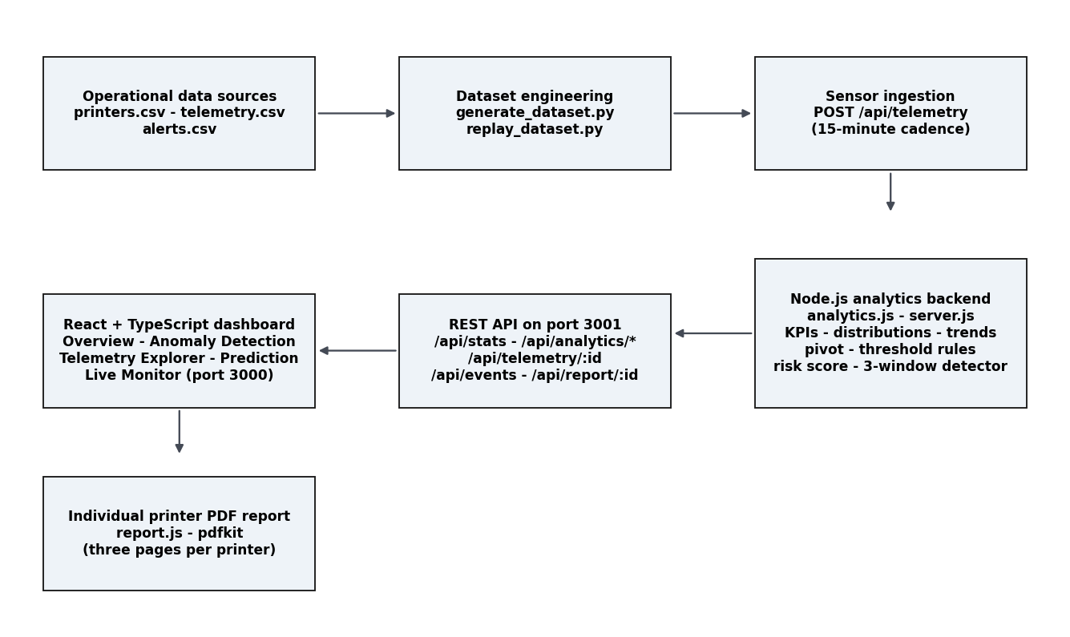
Fig. 1. Layered architecture. Datasets (top left); dataset engineering; ingestion; analytics backend; REST interface; dashboard and report services.
Fig. 2 shows the end-to-end data path for one reading: the registry row bounds every later decision, the ingestion validation rejects unregistered machines, the analytics state is updated, the rules and the three-reading detector evaluate the reading, any fired alert accrues to the alert surface, the dashboard reads the computed state, and the report service turns stored data into the printable artifact on demand.
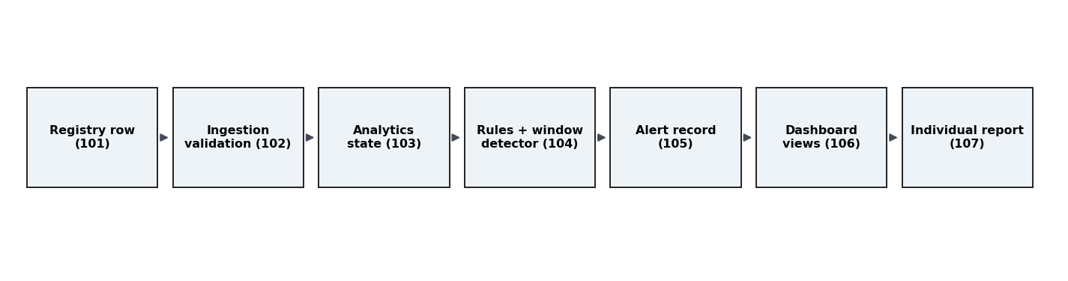
Fig. 2. End-to-end reading workflow from registry row (101) to individual print-ready report (107).

5. Methodology

5.1 Dataset engineering and registry design
The operational layer is three CSV files. printers.csv is the registry: eight machine rows carrying identity, type, location, installation date and the per-machine limit columns (maximum temperature, vibration, motor RPM, power and paper jams per interval; minimum ink level, paper stock and the humidity band). telemetry.csv holds 6,912 readings x 16 columns at 15-minute cadence across the machine status mix (ERROR 51, IDLE 3,419, MAINTENANCE 43, OFFLINE 44, PRINTING 3,355). alerts.csv holds 346 alert rows with timestamp, machine, metric, recorded value, threshold value, severity and message. One generation script rewrites all three, and the label column (is_anomaly) marks 416 readings (6.02%) anomalous across six injected families (power_surge, humidity_spike, overheat, paper_jam_burst, vibration_spike, offline, ink_leak_drop, motor_overspeed).

5.2 Ingestion and validation
Sensor readings enter through POST /api/telemetry, which validates against the registry before touching any state: unknown printer IDs and malformed bodies are rejected with explicit status codes. Replay (replay_dataset.py) posts historical rows through this same path with realistic spacing, so the live detector is exercised by exactly the code path production traffic would use.

5.3 Analytics core
analytics.js holds pure computation modules loaded once per process: fleet KPIs, sensor distributions, hourly and daily trends, per-printer pivots, and the threshold-rule derivation that turns each registry row into its machine's ordered rule list. Threshold severity is mapped from the limit columns: temperature, vibration and paper jams are CRITICAL; motor RPM, power, the humidity band and the ink floor are WARNING; the paper-stock floor is INFO. The modules are called by the HTTP surface, which caches results in-process.

5.4 Sustained-window detection and risk scoring (central mechanism)
Detection is deliberately two-stage. Stage one counts raw breaches: each reading, for each metric, is compared with its machine's configured bound and contributes to the breach count and its alert row when out of bounds. Stage two is the sustained-window rule: only a metric that remains out of bounds for three consecutive readings at a machine fires a detected anomaly event. This keeps brief excursions visible but non-urgent, and the persistent conditions - the maintenance-relevant ones - in the operator's critical view. A complementary weighted risk score evaluates arbitrary live sensor input against the same limits, with weighted per-metric distances to their bounds, and reports a risk percentage bucketed into NORMAL / ELEVATED / WARNING / CRITICAL (>4%, >12%, >35%), so the Prediction view and the live monitor say the same thing the alert engine says.

5.5 Individual printer report
report.js is a self-contained pdfkit program. Given a machine ID it filters all three datasets strictly by that machine and composes three pages: identity header, the registry row and its limits, per-sensor statistics (minimum, average, maximum, last reading, breach count for all nine channels), the three-count anomaly summary, three time-series charts (temperature, vibration, motor RPM) each drawn with the machine's own limit line and red markers on labelled readings that breach that sensor, the alert history table newest first with CRITICAL rows highlighted, and rule-based recommendations fired only on observed breaches (cooling system for repeated temperature excursions, mechanical inspection for vibration, replenishment for ink and paper stock) with a standing disclaimer that no confirmed failure is asserted. The service is exposed through GET /api/report/<printer-id> as a Content-Disposition attachment named EpicReads_Printer_<id>_Report.pdf; unknown machines return HTTP 404 with a JSON error, and generation errors are caught so a partial file can never download.

5.6 Verification discipline
A verification script recomputes labelled counts, breach counts, per-sensor statistics and alert attributions directly from the CSVs - independently of the backend's own modules - and checks the extracted text of generated PDFs against that ground truth. Chapter 7 records its results.

6. System Realisation and Demonstration
The dashboard renders five sections on port 3000: Overview (fleet KPI band, distributions, trends), Anomaly Detection (labelled episodes, alert timeline, per-episode drill-downs), Telemetry Explorer (printer + metric series with labelled points marked red, and the report-download button), Prediction (weighted risk scoring of live sensor input) and Live Monitor (machine state as the replay engine streams readings in). Figs. 3 to 5 show the fleet-level picture computed from the datasets; the embedded screenshots show the live views captured for this review.
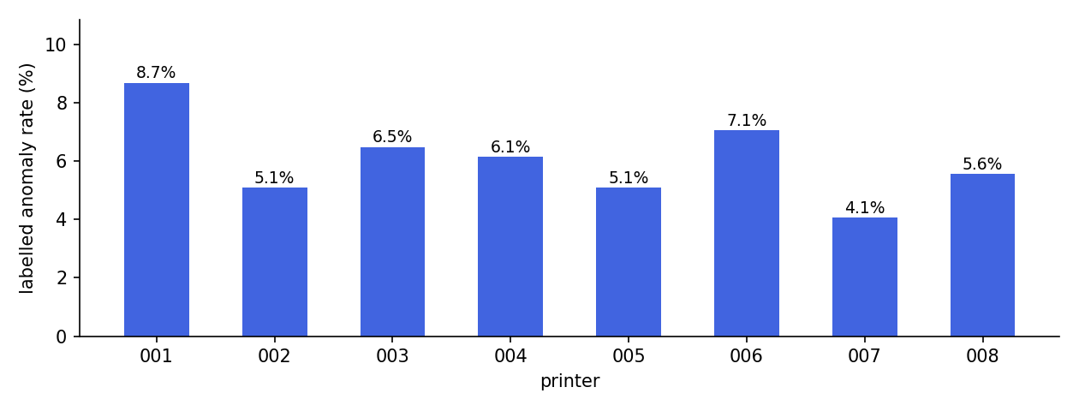
Fig. 3. Labelled anomaly rate per printer (dataset ground truth).
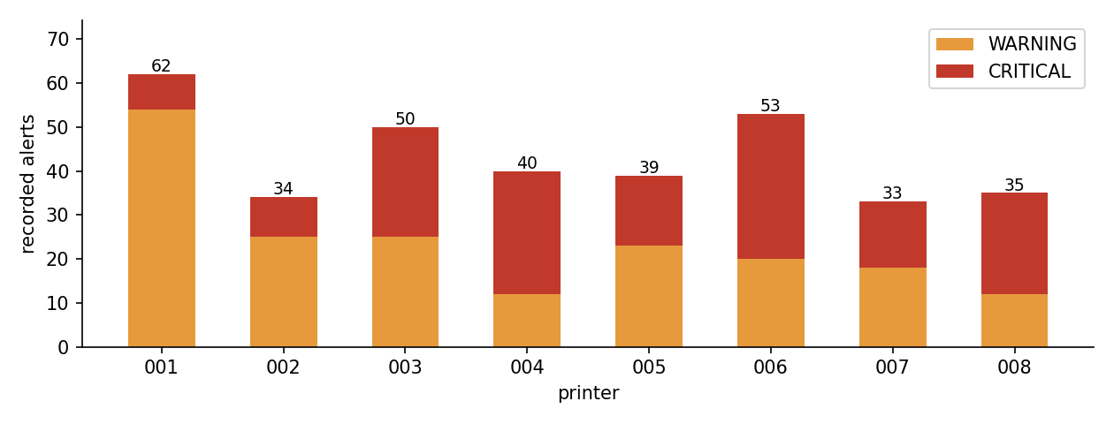
Fig. 4. Recorded alerts per printer by severity (alerts.csv).
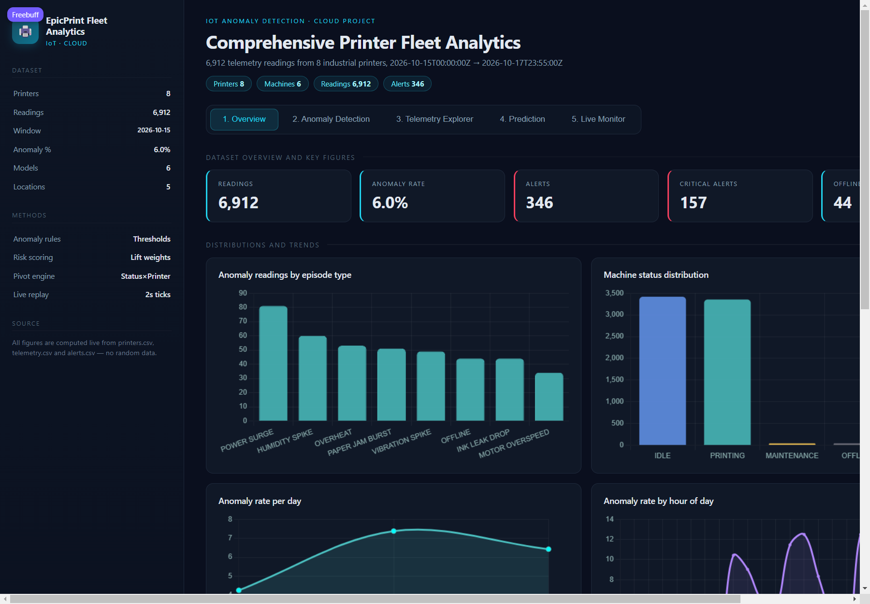
Fig. 5. Overview section of the dashboard, live against the backend on port 3000.
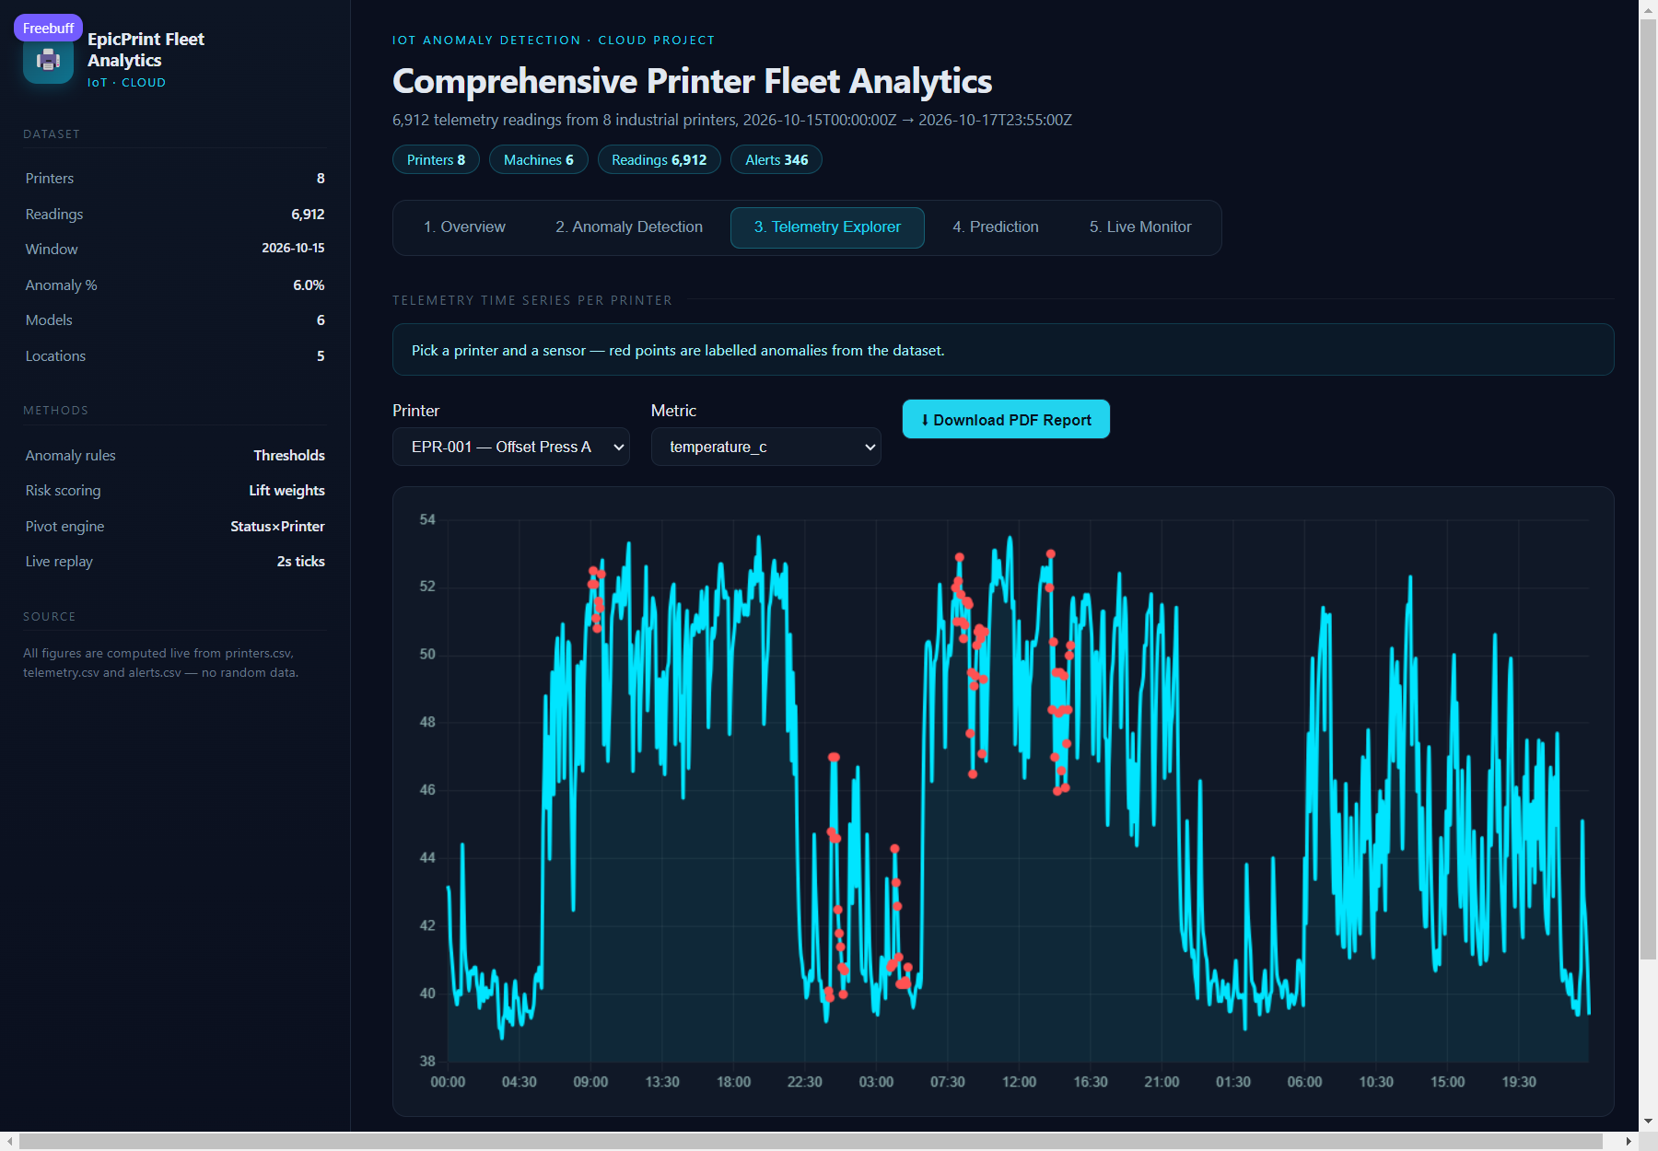
Fig. 6. Telemetry Explorer section on EPR-001 with the Download PDF Report control.
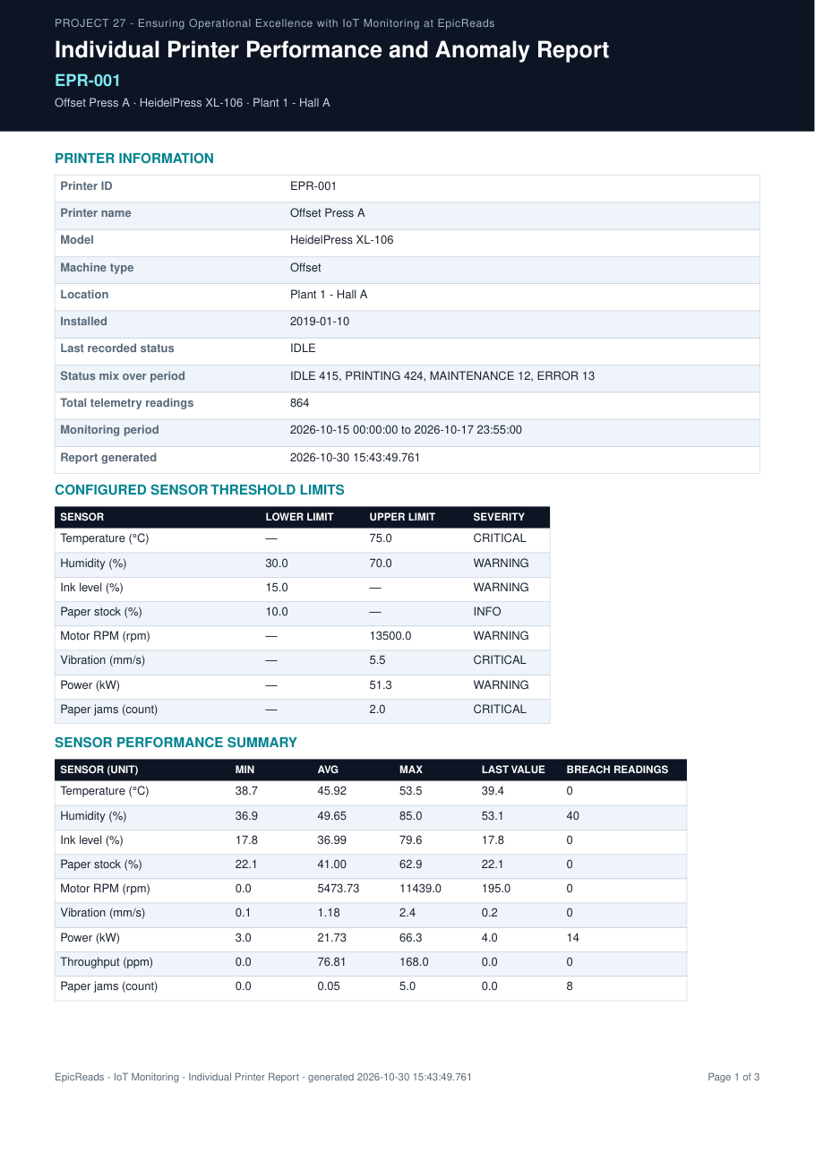
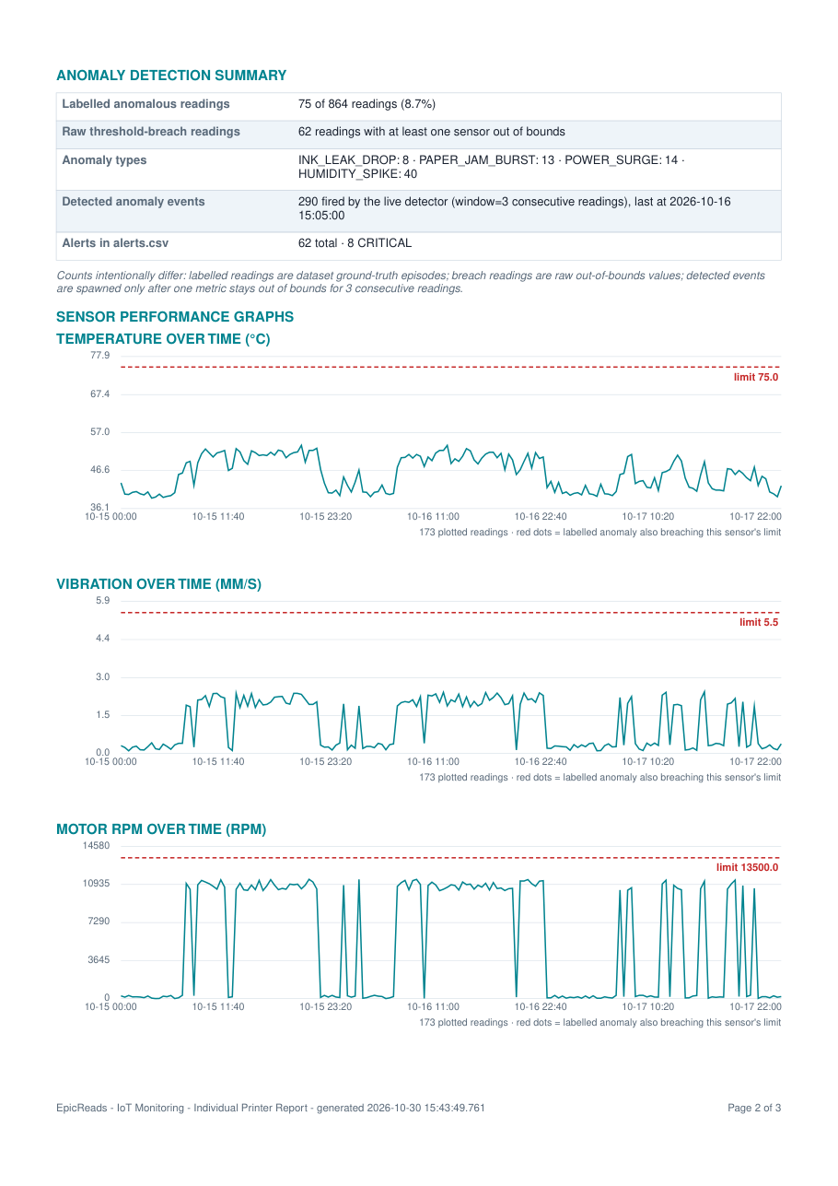
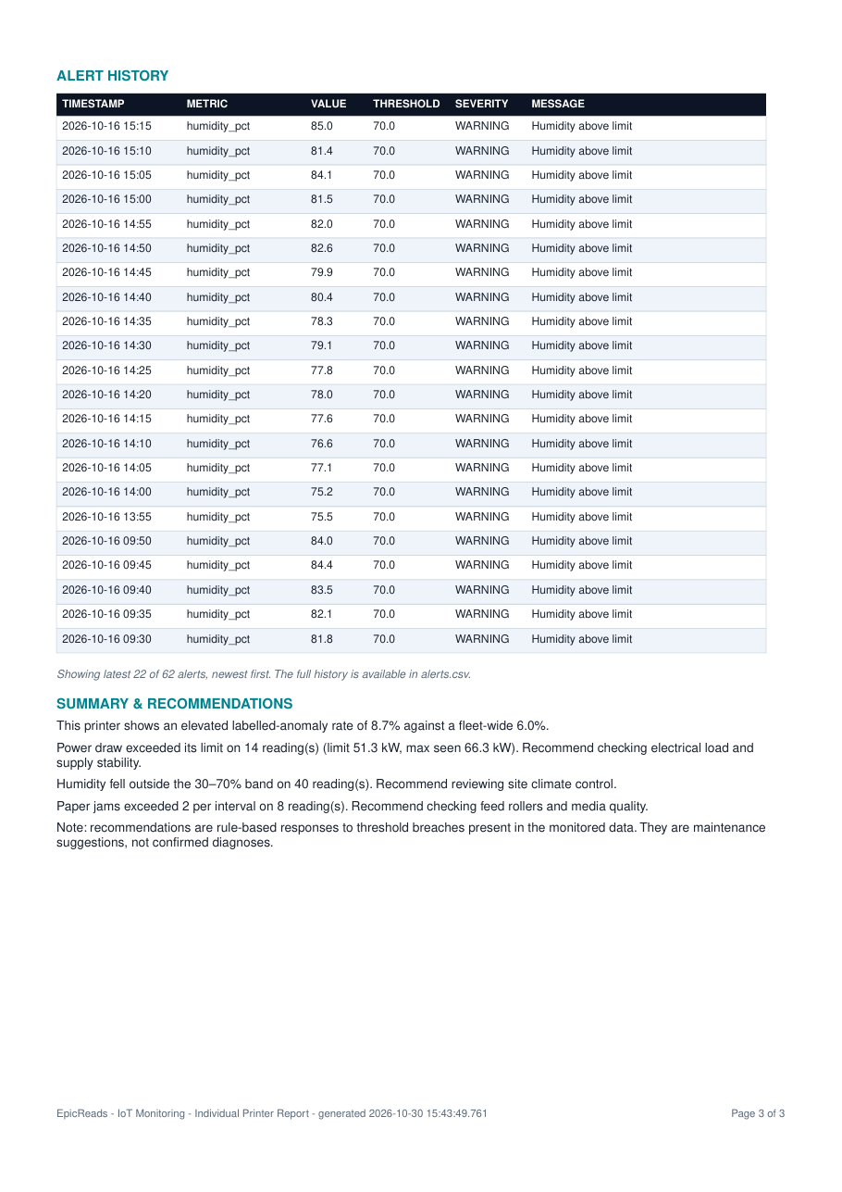
Fig. 7a. Individual report for EPR-001, page 1: header, printer information, sensor statistics.
Fig. 7b. Report page 2: sensor graphs with the machine limit lines.
Fig. 7c. Report page 3: anomaly summary, alert history and recommendations.

7. Results and Evaluation

7.1 Evaluation data and its limitations
The evaluation uses the project's own synthetic-but-realistic operational dataset, regenerated from one script: eight machine profiles, six injected anomaly families and the resulting alert rows. The limitations must be stated plainly: the labelled anomalies are injected by the generation script, so the evaluation is circular and measures the pipeline's ceiling, not field accuracy; no real printer hardware, no real fleet outcomes and no prospective study are involved at any point; and all figures were measured on a single laptop with a single simultaneous user. Published sizing figures for the cloud suites in Table I were measured at infrastructure scale and are therefore not comparable with the figures below.

7.2 Fleet results across the monitored window
TABLE III. Per-printer results over 6,912 readings, 2026-10-15 to 2026-10-17 (three calendar days, 15-minute cadence).
Printer | Type | Readings | Labelled | Rate % | Breach readings | Alerts | Critical
EPR-001 | Offset | 864 | 75 | 8.7 | 864 | 62 | 8
EPR-002 | Offset | 864 | 44 | 5.1 | 855 | 34 | 9
EPR-003 | Digital | 864 | 56 | 6.5 | 864 | 50 | 25
EPR-004 | Digital | 864 | 53 | 6.1 | 845 | 40 | 28
EPR-005 | Digital | 864 | 44 | 5.1 | 856 | 39 | 16
EPR-006 | Offset | 864 | 61 | 7.1 | 864 | 53 | 33
EPR-007 | Binding | 864 | 35 | 4.1 | 864 | 33 | 15
EPR-008 | Large-format | 864 | 48 | 5.6 | 856 | 35 | 23
Two spreads characterise the fleet: the labelled anomaly rate runs from 4.05% (EPR-007) to 8.68% (EPR-001), and breach reads move to a different rhythm than labelled reads, which is exactly the conflation the architecture refuses to make. EPR-001 and EPR-008 are the acceptance pair: EPR-001 carries the humidity and power families while EPR-008 dominates vibration, motor overspeed and offline episodes.

7.3 Individual-report verification (EPR-001 vs EPR-008)
The report feature was accepted only after the per-machine comparison. Select EPR-001, download; select EPR-008, download; then re-verify every statistic in both documents against the raw CSVs with the independent checker. Table IV records the reconciliation.
TABLE IV. Report verification pair - results from the automated cross-check.
Check | EPR-001 | EPR-008
Filename | EpicReads_Printer_EPR-001_Report.pdf | EpicReads_Printer_EPR-008_Report.pdf
Length and content type | 3 pages, application/pdf, Content-Disposition attachment | same
Foreign printer IDs in report | None | None
Total readings | 864 (matches CSV) | 864 (matches CSV)
Labelled anomalous readings | 75 of 864 (8.7%) - matches CSV | 48 of 864 (5.6%) - matches CSV
Raw threshold-breach readings | 864 (recomputed) | 856 (recomputed)
Recorded alerts | 62 total, 8 CRITICAL | 35 total, 23 CRITICAL
Dominant labelled episodes | HUMIDITY SPIKE 40, POWER SURGE 14, PAPER JAM BURST 13 | VIBRATION SPIKE 11, MOTOR OVERSPEED 11, INK LEAK DROP 10
Chart limit lines (own machine) | 75.0 degC - 5.5 mm/s - 13,500 rpm | 60.0 degC - 3.0 mm/s - 3,200 rpm
Recommendations | Fired only from its own records; no confirmed-failure claim | same
Both documents passed every check: strictly machine-specific content, statistic-verbatim agreement with the CSVs, charts carrying only their own series and limits, and clean layout on three pages. All eight printers generated reports through the live endpoint.

7.4 Software verification and error handling
The five dashboard sections render with no console errors during the walkthrough, and every section endpoint answers 200. Ingestion rejects an unregistered printer ID and a malformed JSON body with explicit status messages; the report endpoint returns HTTP 404 with a JSON error for unknown machines; and a machine with no recorded alerts receives the graceful no-alerts text rather than an empty table. Related but distinct counts are reported separately everywhere (dashboard cards, API payloads, report sections), which Chapter 5.4 requires. Two always-on processes serve ports 3001 (backend) and 3000 (dashboard), unchanged by the report feature.

8. Discussion and Limitations
The contribution that distinguishes this work is the pairing of per-machine threshold governance with the two-stage detection split and a document-grade reporting output: the registry row of the machine that produced a reading decides every later statement about it; brief excursions and sustained conditions remain separate signals; and the printed artifact carries the machine's own limits, its statistics, its three-count anomaly reconciliation and rule-based recommendations. The gate is honesty: nothing in any surface claims that a mechanical failure is confirmed, and every statistic traces to the CSVs.
The limitations are equally explicit. All quantitative results come from generated data measured on one laptop; the sustained-window threshold of three readings is a parameter justified by operator-noise reasoning, not yet by field data; there is no authenticated multi-user mode, no persistence or high availability, and no trained predictive model; and the fleet hardware is simulated by the replay engine rather than instrumented. The system is assessed at laboratory readiness; no field deployment is claimed.

9. Conclusion and Future Work
One-limit-fits-all alerting is systematically wrong for a fleet of physically different machines, and per-reading alarm rules bury operators in noise while missing the persistent conditions that end shifts. Printer Fleet Analytics replaces that arrangement with per-machine limit governance, a three-reading sustained-window detector on top of raw breach counting, a dashboard and API that keep labelled truth, breaches and detected events distinct, and an individual three-page PDF report per machine verified statistic-by-statistic against the datasets, with the mandatory EPR-001 versus EPR-008 comparison passed.
Future work is directed to the items deliberately out of Review 2 scope: authenticated fleet accounts and multi-user isolation, a cloud deployment with persistent storage and health probes, instrumenting real print hardware through the same ingestion contract, a predictive-maintenance model trained on accumulated fleet history and served alongside the risk score, and push dispatch of CRITICAL alerts to maintenance channels.

References
[1] A. Al-Fuqaha, M. Guizani, M. Mohammadi, M. Aledhari and M. Ayyash, "Internet of Things: A Survey on Enabling Technologies, Protocols, and Applications," IEEE Communications Surveys and Tutorials, vol. 17, no. 4, pp. 2347-2376, 2015.
[2] Amazon Web Services, "AWS IoT Core - Connect devices to the cloud," 2026. [Online]. Available: https://aws.amazon.com/iot-core/
[3] Microsoft Azure, "Azure IoT Hub - Ingest, monitor and manage IoT devices," 2026. [Online]. Available: https://learn.microsoft.com/azure/iot-hub/
[4] Grafana Labs, "Grafana Open Source - Metrics dashboards and alerting," 2026. [Online]. Available: https://grafana.com/oss/grafana/
[5] The Prometheus Authors, "Prometheus - An open-source monitoring system with a dimensional data model," 2026. [Online]. Available: https://prometheus.io/
[6] J. Sweet and I. McDonald, "Internet Printing Protocol/1.1: Encoding and Transport," RFC 8011, Jan. 2017.
[7] P. Turaga et al. (IETF), "Printer Management Information Base (MIB) v2," RFC 3805, Jun. 2004.
[8] D. Govett, "PDFKit - A JavaScript PDF generation library for Node and the browser," 2026. [Online]. Available: https://github.com/foliojs/pdfkit

