INDEX

|  |  |
| --- | --- |
| SR. No. | Content |
| 1 | Introduction to System |
| 2 | System Analysis   * 1. Existing System   2. Need of Computerization   3. Proposed System   4. Scope and Objective of Proposed System   5. Fact Finding Techniques   6. Feasibility Study |
| 3 | Requirement Specification |
| 4 | System Design   * 1. Entity Relationship Diagram   2. Data Flow Diagram   3. Class Diagram   4.4. Use case Diagram   * 1. Activity Diagram   2. Sequence Diagram   3. Deployment diagram   4. Data Dictionary |
| 5 | System Implementation |
| 6 | Input-Output Screen & Reports |
| 7 | Limitations |
| 8 | Future Enhancements |
| 9 | Conclusion |
| 10 | References |

1. **INTRODUCTION**

In the rapidly evolving landscape of software development, mastering efficient version control is paramount for fostering seamless collaboration, ensuring high code quality, and driving project success.

While platforms like GitHub have transformed the way teams manage their code, numerous challenges remain—ranging from ineffective issue management and the struggle to navigate expansive repositories, to the daunting complexities of code review fatigue.

This project aspires to create a groundbreaking version control system that not only enhances workflow efficiency but also revolutionizes collaboration and elevates code management practices. By tackling fundamental pain points such as inadequate issue tracking, repository intricacies, and cumbersome code reviews, our system will unveil innovative solutions—featuring structured issue management, state-of-the-art repository navigation tools, and streamlined pull request workflows.

With these enhancements, our system will empower development teams with a more intuitive, organized, and productive version control experience, ultimately leading to superior code quality and transformative project outcomes.

# SYSTEM ANALYSIS

System analysis plays a pivotal role in shaping the future of next-generation version control systems. This essential phase not only uncovers existing challenges but also delves deep into understanding user needs. By crafting innovative and effective solutions, we can significantly enhance workflow efficiency, foster collaboration, and elevate code management to new heights.

## 2.1 EXISTING SYSTEM

The current version control system, while effective in managing source code, presents several challenges that hinder development workflow, collaboration, and code quality.

Below are the key issues observed in the existing system

**1. Poor Issue Management Practices**

* **Unclear Issue Descriptions**: Many issues lack proper context, making it difficult for developers to understand and resolve them efficiently.
* **Lack of Proper Labelling**: Without well-defined labels, categorizing and prioritizing issues becomes challenging.
* **Inefficient Tracking & Resolution**: The absence of structured workflows results in issues being overlooked or addressed late.

**Impact:**

* + Developers spend excessive time understanding and categorizing issues.
  + Delays in resolving critical bugs and feature requests.
  + Poor communication between contributors and maintainers.

**2. Difficulty Navigating Large Repositories**

* **Complex Codebases**: Large repositories with thousands of files make it hard to locate specific code sections.
* **Ineffective Search Mechanisms**: Standard search features lack the ability to filter and locate code efficiently.
* **Lack of Modularization**: Poorly structured repositories make code maintenance and onboarding difficult.

**Impact:**

* Reduced productivity due to prolonged search times.
* Increased chances of redundant code or conflicting implementations.
* Steeper learning curve for new contributors.

**3. Potential for Code Review Fatigue**

* **High Volume of PRs**: Developers struggle to manage and review multiple pull requests.
* **Manual Conflict Resolution**: Handling merge conflicts manually increases workload and slows down progress.
* **Inconsistent Review Standards**: Different reviewers use varying review styles, leading to uneven code quality.
* **Unclear PR Prioritization**: Lack of mechanisms to prioritize critical pull requests results in delays.

**Impact:**

* Reviewers experience burnout, leading to delayed or superficial reviews.
* Inconsistent coding standards across the project.
* Increased risk of introducing undetected bugs into the main codebase.

## 2.2 NEED OF COMPUTERIZATION.

In modern software development, efficient version control is crucial for managing code, collaborating effectively, and ensuring high-quality software delivery. However, traditional methods of handling issues, navigating repositories, and reviewing code manually introduce inefficiencies that hinder productivity. To overcome these challenges, **computerization** of version control systems is essential.

**1. Improved Issue Management**

* **Automation of Issue Tracking** – Ensures that issues are well-documented, categorized, and updated in real time.
* **Standardized Templates & Labels** – Helps in providing clear issue descriptions, making problem resolution faster.
* **Automated Notifications** – Keeps all team members informed about issue updates, reducing communication gaps.

**Why Computerization?**

* Eliminates manual tracking errors.
* Ensures systematic issue handling.
* Enhances team coordination with real-time updates.

**2. Efficient Repository Navigation**

* **Advanced Search Mechanisms** – Helps developers quickly locate specific files, functions, or commits within large codebases.
* **Modular Repository Structure** – Organizes code into structured directories for easier maintenance.
* **Repository Analytics** – Provides insights into frequently accessed files, inactive code sections, and contributions.

**Why Computerization?**

* Reduces time spent searching for files.
* Improves code discoverability and accessibility.
* Simplifies repository maintenance and onboarding for new developers.

## 2.3 PROPOSED SYSTEM

The next-generation version control system aims to overcome the limitations of the existing system by introducing structured issue management, advanced repository navigation, and an optimized code review process. These enhancements will streamline workflows, improve collaboration, and boost overall development efficiency.

**1. Improved Issue Management**

To ensure effective tracking and resolution of issues, the system will introduce the following features:

* **Issue Templates** – Standardized templates for bug reports, feature requests, and tasks to maintain consistency.
* **Labels & Tags** – Categorization of issues based on priority, status, and type to enhance tracking.

**Expected Benefits:**

* Faster issue resolution with clear descriptions and categorization.
* Improved communication and transparency within the development team.
* Reduced time spent managing and tracking issues.

**2. Improved Issue Management**

To ensure effective tracking and resolution of issues, the system will introduce the following features:

* **Issue Templates** – Standardized templates for bug reports, feature requests, and tasks to maintain consistency.
* **Labels & Tags** – Categorization of issues based on priority, status, and type to enhance tracking.
* **Automated Notifications** – Real-time updates to keep all stakeholders informed about issue progress.
* **Smart Issue Prioritization** – AI-assisted ranking of issues based on urgency and impact.

**Expected Benefits:**

* Faster issue resolution with clear descriptions and categorization.
* Improved communication and transparency within the development team.
* Reduced time spent managing and tracking issues.

**3. Efficient Code Review**

To address code review fatigue and inefficiencies, the system will implement:

* **PR Prioritization** – Automated ranking of pull requests based on complexity, urgency, and dependency.
* **Standardized Review Templates** – Predefined templates for code reviews to ensure consistency in feedback.
* **Smart Review Assignment** – Intelligent distribution of PRs based on developer expertise and workload.

**Expected Benefits:**

* Reduced reviewer fatigue by prioritizing and automating tasks.
* Faster and more consistent review cycles.
* Improved code quality and reduced risk of undetected bugs.

## 2.4 SCOPE AND OBJECTIVE OF PROPOSED SYSTEM

### Scope of the Proposed System:

The **next-generation version control system** aims to overcome the limitations of existing platforms by introducing structured issue management, advanced repository navigation, and an optimized code review process. These enhancements will **streamline workflows, improve collaboration, and boost overall development efficiency** for modern software team

### Objectives of the Proposed System:

1. **Enhancing Issue Management**

* Standardizing issue tracking with **templates, labels, and tags**.
* Implementing **real-time notifications** for better collaboration.
* Introducing **AI-based prioritization** of issues based on severity and impact.

1. **Optimizing Repository Navigation**

* Using **modular codebase structures** for better file organization.
* Integrating **advanced search tools** for efficient file discovery.
* Implementing **repository analytics** to track usage patterns and contributions.

1. **Improving the Code Review Process**

* Automating **pull request (PR) prioritization** for efficient review workflows.
* Standardizing **review templates** to maintain feedback consistency.
* Assigning PRs intelligently based on **developer expertise and workload**.

**Expected Impact**

* Faster issue resolution and improved project transparency.
* Increased developer productivity by simplifying code navigation.
* Reduced code review fatigue and enhanced software quality.

## 2.5 FACT FINDING TECHNIQUES

Fact-finding techniques are essential in system analysis and design to gather

accurate requirements, understand user needs, and identify existing system

shortcomings. The following methods were used to collect data for the

development of the **next-generation version control system**.

**1. Interviews**

**Purpose**: To gather insights from developers, project managers, and other

stakeholders regarding the challenges they face in version control.

* Conducted structured and unstructured interviews with team members.
* Identified pain points in issue tracking, repository navigation, and code

review processes.

* Gathered suggestions for potential improvements.

**Outcome**: Clear understanding of existing problems and user expectations.

**2. Questionnaires**

**Purpose**: To collect feedback from a larger audience, including developers, testers, and team leads, about their experiences with current version control systems.

* Distributed online surveys with both **open-ended and multiple-choice questions**.
* Focused on common issues such as **PR management, issue tracking, and repository navigation**.
* Collected quantitative and qualitative data to support findings.

**Outcome**: Statistically backed insights on pain points and areas needing improvement.

**3. Observation**

**Purpose**: To analyse real-time usage of existing version control systems and identify inefficiencies in workflow.

* Observed developers **using GitHub for code management, issue tracking, and PR reviews**.
* Noted bottlenecks such as **manual issue categorization, difficulty in searching files, and lengthy code reviews**.
* Evaluated the impact of these inefficiencies on productivity.

**Outcome**: Identified **workflow inefficiencies** that require automation and enhancement.

**4. Document Analysis**

**Purpose**: To review existing version control policies, guidelines, and best practices.

* Analysed GitHub’s **current issue tracking, pull request management, and repository organization guidelines**.
* Reviewed past **bug reports, feature requests, and PR review logs** to understand common patterns.
* Compared different version control tools (GitHub, GitLab, Bitbucket) to identify gaps and potential improvements.

**Outcome**: Data-driven approach to defining system requirements and enhancements.

**5. Prototyping**

**Purpose**: To create an initial model of the proposed system for early feedback.

* Developed a **basic prototype** demonstrating **automated issue tracking, enhanced repository navigation, and optimized PR workflows**.
* Gathered feedback from testers and refined features based on their input.
* Ensured the system meets the needs of developers before full-scale development.

**Outcome**: Early validation of features and better alignment with user expectations.

## 2.6 FEASIBILITY STUDY

The **feasibility study** assesses the practicality of implementing the proposed next-generation version control system. It evaluates various aspects to determine whether the project is **technically, economically, operationally, legally, and schedule-wise feasible**.

**1. Technical Feasibility**

**Purpose**: To determine whether the system can be developed with the available technology and resources.

* Uses **existing version control technologies** like Git and integrates with platforms like GitHub.
* Implements **AI-powered tools for issue prioritization and automated conflict resolution**.
* Employs **modern search algorithms** for enhanced repository navigation.
* Utilizes **cloud-based solutions** for scalability and accessibility.

**Conclusion**: The required technologies are readily available and can be effectively implemented.

**2. Economic Feasibility (Cost-Benefit Analysis)**

**Purpose**: To analyse whether the project is financially viable by comparing costs and benefits.

* **Development Costs** – Includes system design, programming, and testing.
* **Operational Costs** – Hosting, maintenance, and updates.
* **Training Costs** – Minimal, as it integrates with existing workflows.
* **Expected Benefits** – Increased developer productivity, reduced code review time, and improved issue tracking.

**Cost-Benefit Justification**

* Reduction in development time increases overall efficiency.
* Fewer errors and faster issue resolution save operational costs.
* Improved code quality leads to fewer post-production defects.

**Conclusion**: The long-term benefits **outweigh the initial costs**, making it **economically viable**.

**3. Operational Feasibility**

**Purpose**: To assess whether the system will function effectively within the organization’s workflow.

* Designed to integrate **seamlessly** with GitHub and other version control platforms.
* Improves existing workflows without **requiring major process changes**.
* Increases efficiency in **issue tracking, repository navigation, and code reviews**.
* Reduces reviewer fatigue, making it more **user-friendly and effective**.

**Conclusion**: The system is **highly feasible** in improving software development efficiency.

**4. Legal Feasibility**

**Purpose**: To ensure compliance with software licensing, data privacy, and industry regulations.

* Complies with **open-source licensing** when integrating with Git-based platforms.
* Adheres to **data protection laws** (e.g., GDPR, CCPA) when handling user data.
* Uses **secure authentication and access control mechanisms** to prevent unauthorized access.

**Conclusion**: The system **meets legal and regulatory requirements** and poses no legal risks.

**5. Schedule Feasibility**

**Purpose**: To evaluate whether the system can be developed within the required timeline.

* The system follows an **agile development approach**, ensuring incremental progress.
* Estimated development time: **4-6 months**, including testing and deployment.
* Early-stage **prototyping** ensures faster validation and reduces delays.

**Conclusion**: The project **can be completed on time** with proper resource allocation.

# 3. REQUIREMENT SPECIFICATION

**Hardware and Software Requirements**

This section details the necessary **hardware and software specifications** required for the **next-generation version control system**.

**Hardware Requirements**

**1.1 Server or Cloud Infrastructure**

The system requires a **reliable server or cloud environment** to host repositories, manage databases, and support continuous integration.

**Minimum Server Specifications:**

* **CPU**: Quad-core processor or equivalent.
* **RAM**: 8 GB or more.
* **Storage**: 100 GB or more (SSD recommended for faster access to large repositories).
* **Optional**: High-performance storage solutions (e.g., NVMe SSDs).

**1.2 Development Machines**

Contributors and developers need **capable machines** to work efficiently on the system.

**Minimum Specifications:**

* **CPU**: Dual-core processor or equivalent.
* **RAM**: 4 GB or more.
* **Operating System**: Windows, macOS, or Linux.

**1.3 Networking Requirements**

A **stable and high-speed internet connection** is essential for seamless collaboration.

**Networking Specifications:**

* **Reliable internet connection** for repository access and CI/CD pipelines.
* **Sufficient bandwidth** for data synchronization and file transfers.

**2. Software Requirements**

**2.1 Server-Side Requirements**

**Backend:**

* **Node.js** – Version 22.12.01 LTS (for handling API requests and backend logic).
* **JavaScript (ES14)** – Latest ECMAScript features for optimal performance.

**Database:**

* **MongoDB Atlas** – Version 8.0.4-current (cloud-based NoSQL database).
* **Query Language:** MongoDB Query Language (MQL) (JavaScript-like syntax).

**2.2 Frontend Requirements**

**Frontend Framework:**

* **React.js** – Version 19.0.0 (modern UI development).
* **HTML5** – For structuring web pages.
* **JavaScript (ES14)** – For client-side logic.
* **Tailwind CSS** – Version 3.4.15 (for efficient and responsive styling).
* **CSS3** – Advanced styling capabilities.

# 4. SYSTEM IMLEMENTATION

The **system design** phase includes various diagrams and data structures that define the architecture, flow, and interactions within the **next-generation version control system**.

**4.1 Entity Relationship Diagram (ERD)**

**Purpose:** Defines the relationships between different entities in the system, such as users, repositories, issues, pull requests, and reviews.

**Key Entities:**

* **User** (UserID, Name, Email, Role)
* **Repository** (RepoID, Name, Owner, CreatedAt)
* **Issue** (IssueID, RepoID, Title, Description, Status, AssignedTo, CreatedAt)
* **PullRequest** (PRID, RepoID, Title, Status, CreatedBy, AssignedReviewer)
* **Review** (ReviewID, PRID, ReviewerID, Comments, Status)

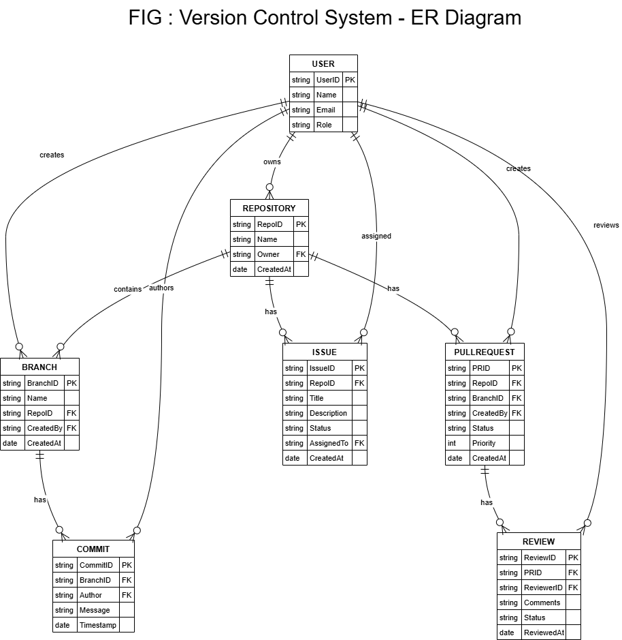

# SYSTEM IMLEMENTATION

System implementation refers to the process of translating the design and requirements of a system into a functional and operational system. It involves the actual development, configuration, integration, and deployment of software, hardware, and other components to create a working system that meets the specified goals and objectives. Here's an overview of the system implementation process of the Vintage Emporium:

* **Requirement Analysis:** Gather detailed requirements by understanding the functionality and features expected from the system. Identify user roles, their interactions, and data flow within the system. Create a detailed functional specification document.
* **Technology Stack Selection:** Choose appropriate technologies for the development of the web application, such as programming languages (e.g. HTML, CSS3, JavaScript, PHP) and databases (e.g., MySQL). Consider factors like scalability, security, and ease of development.
* **Database Design:** Design the database schema to store user details, product information, orders, payment status, and other relevant data. Establish relationships between entities and ensure the database structure supports the system's requirements.
* **User Registration and Login:** Implement a user registration module with features like password hashing and secure user authentication. Develop the login functionality with appropriate session management techniques.
* **Product Management**: Design and implement features for searching and displaying products to users. Enable users to add products to their Wishlist or cart. Write proper code to handle search queries and display relevant results.
* **Cart and Checkout:** Develop functionalities for managing the user's shopping cart, including adding or removing products. Implement a secure checkout process that collects user details, shipping address, and payment information.
* **User Profile Management:** Create user profiles where users can view and update their personal information, manage addresses, and track their

activities. Implement mechanisms to securely update and store user profiles.

* **Admin Panel:** Develop an admin panel with features for admin login, authentication, and authorization. Enable the admin to add, update, and delete products. Provide options to view and manage user accounts, including user deletion. Implement a message management system to view user messages.
* **Analytics:** Incorporate analytics functionalities to generate insights on total users, orders placed, pending orders, completed orders, and other relevant metrics.
* **Testing and Quality Assurance:** Conduct thorough testing, including unit testing, integration testing, and user acceptance testing, to ensure the system functions as intended. Fix any identified issues or bugs before deployment.
* **Deployment:** Deploy the web application to a production environment, ensuring the server infrastructure is properly configured. Consider scalability, load balancing, and caching mechanisms for optimal performance.
* **Continuous Improvement:** Gather user feedback and monitor system performance post-deployment. Continuously enhance the system by releasing updates, adding new features, and addressing user needs.

System implementation is a complex process that requires collaboration between developers, designers, testers, and stakeholders. Following best practices, employing coding standards, and conducting regular maintenance will ensure a reliable and efficient system.

# LIMITATIONS

While implementing an e-commerce website for vintage products, there are some limitations to consider:

* **Product Availability and Quality:** As vintage products are unique and limited in quantity, there may be challenges in ensuring consistent availability. The system should have mechanisms to handle out-of-stock products and manage inventory accurately. Additionally, maintaining the quality and authenticity of vintage products can be difficult, and the system should implement measures to verify and describe the condition of each item accurately.
* **Limited Product Information:** Vintage products often lack detailed information, such as standardized product codes or specifications. This can make it challenging to provide comprehensive product details to users. The system should allow for flexible and customizable product descriptions to accommodate the unique characteristics of vintage items.
* **Targeted Marketing:** With a limited customer base, it becomes essential to implement targeted marketing strategies to reach potential customers effectively.
* **Limited Market Size:** The market for vintage products may be relatively niche compared to mainstream retail. This limitation may affect the number of potential customers and the growth potential of the business. Targeted marketing efforts and niche-specific strategies may be necessary to reach the intended audience effectively.
* **Cost:** Implementing and maintaining the system can involve significant costs, including development resources, infrastructure, security measures, and ongoing maintenance.
* **Scalability:** As the user base and data volume grow, the system may face scalability challenges. The architecture and infrastructure need to be designed and implemented in a way that allows for easy scaling to handle increased traffic and data processing.

# FUTURE ENHANCEMENTS

While implementing an e-commerce website for vintage products, there are several future enhancements that can be considered to improve the system and enhance the user experience. Some potential enhancements include:

* **Enhanced Search and Filtering:** Implementing advanced search functionality with filters based on product attributes, era, condition, and price range can make it easier for users to find specific vintage items of interest.
* **Personalized Recommendations:** Utilizing customer data, purchase history, and browsing patterns, the system can provide personalized product recommendations to users. This can be achieved by implementing recommendation algorithms that suggest relevant vintage items based on the user's preferences and previous interactions.
* **Mobile Application:** Developing a dedicated mobile application for the e- commerce platform can provide a more convenient and accessible shopping experience for users on smartphones and tablets. The app can include features such as push notifications, personalized offers, and a seamless mobile shopping interface.
* **Live Chat and Customer Support:** Integrating live chat functionality or chatbots can enhance customer support by allowing users to seek assistance in real-time. This feature can help address inquiries, provide product recommendations, and resolve issues promptly.
* **Auction or Bidding System:** Implementing an auction or bidding feature can introduce a dynamic and engaging element to the platform. Users can bid on unique or rare vintage items, creating a sense of excitement and encouraging higher customer engagement.
* **Newsletter Subscription:** Implement a newsletter subscription feature where users can sign up to receive regular newsletters featuring new vintage arrivals, exclusive promotions, styling tips, and curated content.

# CONCLUSION

In conclusion, The Vintage Emporium offers a seamless and user- friendly shopping experience, with easy-to-use search and filter tools to help you find exactly what you're looking for. The Vintage Emporium website for vintage products offers a comprehensive platform that allows users to register, login, and engage in various activities such as searching for products, adding them to their Wishlist or cart, and proceeding to checkout. The system facilitates a seamless user experience by providing features like order placement, profile management, and tracking of payment status.

The inclusion of a messaging system allows users to communicate with the admin, addressing any queries or concerns they may have. On the admin side, the system enables the admin to perform essential tasks such as managing products, including addition, update, and deletion, as well as accessing vital information such as the total number of users, orders placed, and their respective statuses.

While the system provides a solid foundation for an e-commerce platform, it also has limitations, such as limited customer base due to the niche nature of vintage products and the need for continuous efforts to source and maintain a diverse inventory.

Overall, The Vintage Emporium is designed to be completely responsive, user-friendly with dynamic products and offer a seamless shopping experience.

# REFERENCES

* 1. Web Development Tutorials For Beginners In Hindi: HTML, CSS, JavaScript & More - By CodeWithHarry: These tutorials provide a comprehensive and detailed information about the necessary skills required for web development.
  2. https://developer.mozilla.org: This website contained different examples and explanations related to HTML and CSS which helps in the process of developing the website. The various examples related to the different topics of web development made web development easy to understand.
  3. https://[www.w3schools.com](http://www.w3schools.com/) : This website is a great place to learn different concepts in a simple and easy to learn manner. The different examples make it easier to understand the concepts clearly.
  4. https://[www.php.net:](http://www.php.net/) This website is very useful as it contains different materials related to php and also contained different examples with syntax in order to properly understand different php concepts.
  5. https://[www.tutorialspoint.com:](http://www.tutorialspoint.com/) This website contains different resources related to web development and topics. The comprehensive yet simple explanations about different concept made the process of web development easy.