CONTENTS
- INTRODUCTION……………………………………………………………………...2
- DISEASE……………………………………………………………………………….3
- CONVOLUTIONAL NEURAL NETWORK (CNN)………………………………….4
- DIFFERENT TYPES OF CNN MODELS……………………………………………..5
- RESULTS………………………………………………………………………………7
- CHALLENGES FACED DURING MODEL CREATION……………………………10
- CONCLUSION………………………………………………………………………...12
- REFERENCES…………………………………………………………………………13

INTRODUCTION
Rice is one of the most important staple food crops, feeding more than half of the world’s population. Ensuring healthy rice production is therefore critical for global food security. However, rice plants are highly susceptible to several diseases, including Bacterial Leaf Blight, Brown Spot, and Leaf Smut, which can significantly reduce crop yield and quality. Early and accurate detection of these diseases plays a vital role in preventing large-scale losses for farmers.
Traditionally, disease detection in crops has relied on manual observation by farmers or agricultural experts. This method is time-consuming, prone to errors, and often requires expert knowledge. With the advancement of technology, artificial intelligence (AI) and deep learning have emerged as powerful tools for automating this process. In particular, Convolutional Neural Networks (CNNs) have demonstrated excellent performance in image classification tasks, making them suitable for identifying patterns of plant diseases directly from leaf images.
The objective of this project is to build a reliable deep learning model capable of detecting rice leaf diseases with high accuracy. By using a dataset of rice leaf images and applying multiple CNN architectures, the project evaluates and compares models to identify the best-performing approach. The study not only focuses on classification but also integrates disease-specific treatment suggestions, making the system a practical decision-support tool for farmers.
Overall, this project highlights how AI can transform traditional agriculture into a data-driven, smart farming approach, providing farmers with quick, accurate, and actionable insights. This contributes to sustainable agriculture, reduces dependency on chemical treatments, and ensures better food security for the growing population.

RICE LEAF DISEASES
1. Bacterial Leaf Blight (BLB)
Bacterial Leaf Blight is one of the most destructive diseases of rice, caused by the bacterium Xanthomonas oryzae pv. oryzae. It usually begins at the tip of the leaf and spreads downwards, causing yellowing and drying of the leaf. In severe cases, it can lead to complete leaf death and yield loss. The disease spreads through contaminated water, wind, and infected seeds. Preventive measures include using resistant rice varieties, proper field drainage, and avoiding excessive nitrogen fertilizers. Treatment often involves spraying copper-based bactericides or Streptocycline solutions.
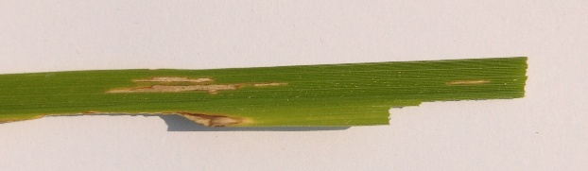
2. Brown Spot
Brown Spot is a fungal disease caused by Bipolaris oryzae. It appears as small, circular to oval, brown lesions on the leaves, which gradually enlarge and reduce photosynthesis. Nutrient deficiencies, particularly nitrogen, make rice plants more vulnerable to this disease. Preventive measures include balanced use of fertilizers, seed treatment with fungicides, and maintaining soil health. Effective treatments include spraying fungicides such as Carbendazim or Mancozeb. This disease is particularly serious because it can affect crops both in the field and during storage.
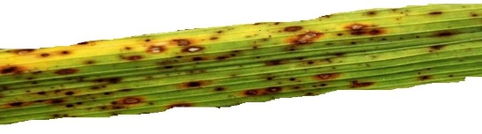
3. Leaf Smut
Leaf Smut is a fungal disease caused by Entyloma oryzae. It is identified by the presence of small black spots or streaks on rice leaves, which later develop into smut sori. While it typically does not cause complete crop failure, severe infections can weaken the plant and reduce yield quality. The disease spreads mainly through wind and rain splash. Preventive measures include using resistant rice varieties, practicing crop rotation, and ensuring proper sanitation in fields. Treatment involves seed treatment with fungicides and foliar sprays of Propiconazole.
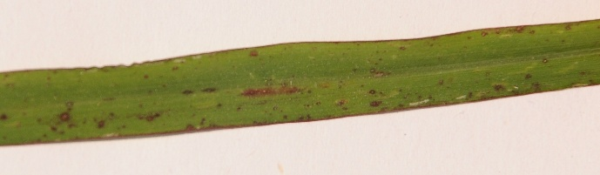
CONVOLUTIONAL NEURAL NETWORK (CNN)
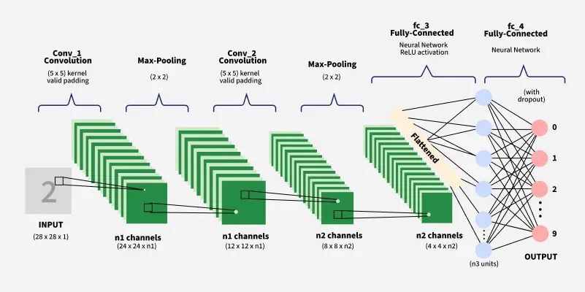
The image above illustrates the general working process of a Convolutional Neural Network (CNN). CNNs are designed to automatically learn patterns from images and are widely used in tasks such as image classification, object detection, and medical imaging.
The process begins with the input layer, where an image is provided in pixel form. The first stage is the convolution operation, where small filters (kernels) slide across the image to detect important features such as edges, corners, and textures. These filters generate feature maps that highlight specific patterns within the image.
After convolution, the model applies pooling layers (commonly max-pooling), which reduce the size of the feature maps by keeping only the most important information. This step lowers computational complexity and ensures the model focuses on dominant features while becoming more robust to variations like shifts and rotations.
The network then stacks multiple convolution and pooling layers to extract increasingly complex features. Early layers learn simple patterns like lines, while deeper layers capture higher-level structures such as shapes or objects. Once features are extracted, the output is flattened into a single vector.
Finally, this vector is passed through fully connected layers, which act like a traditional neural network. These layers combine the extracted features to make a prediction. The last layer, called the output layer, contains neurons representing different classes, and the model assigns probabilities to each class to identify the final prediction.
In summary, CNNs work by combining convolution, pooling, and fully connected layers to transform raw images into meaningful predictions, learning automatically from data without the need for manual feature extraction.
DIFFERENT TYPES OF CNN MODELS
In this project, a total of eight CNN-based architectures were implemented and compared for rice leaf disease detection. Each model has unique characteristics, advantages, and limitations, which influence its performance on image classification tasks.
1. LeNet
LeNet is one of the earliest CNN architectures, consisting of simple convolutional and pooling layers followed by fully connected layers. It is computationally light and easy to implement but limited in depth, making it less powerful for complex datasets. In this project, LeNet served as a baseline model for comparison.
2. VGG
The VGG model is known for its simplicity and depth, using multiple stacked convolutional layers with small 3×3 filters. VGG achieves good performance by learning fine details, but it has a high number of parameters, which increases computation and memory requirements.
3. ResNet
ResNet introduced residual connections that allow very deep networks to train effectively without vanishing gradients. By adding shortcut connections, ResNet improves accuracy and stability. This makes it highly effective for classification tasks and one of the most widely used deep learning architectures.
4. MobileNetV1
MobileNet is a lightweight CNN architecture designed for mobile and embedded vision applications. It uses depth wise separable convolutions to reduce computation while maintaining accuracy. In this project, MobileNetV1 achieved the highest accuracy of 0.944, making it the best-performing model for rice leaf disease classification.
5. DenseNet
DenseNet connects each layer to every other layer in a feed-forward manner, improving feature reuse and gradient flow. This results in efficient training, reduced overfitting, and strong accuracy. DenseNet was one of the top-performing models in this study.
6. InceptionV3
InceptionV3 uses “Inception modules” that apply multiple convolution filters of different sizes in parallel. This allows the model to capture features at different scales.
7. Xception
Xception is an extension of Inception that relies heavily on depth wise separable convolutions. It is more efficient than InceptionV3 and provides competitive accuracy. Xception is powerful for image classification tasks but requires more computational resources.
8. Custom CNN
A custom CNN with three convolutional layers and one dense layer was implemented. This model provided decent performance (0.833 accuracy) but was outperformed by transfer learning models. The custom CNN was useful for understanding the dataset and validating the need for deeper architectures.
In summary, traditional models like LeNet and Custom CNN gave moderate results, while advanced transfer learning models like DenseNet, Xception, and InceptionV3 significantly improved accuracy. Among them, InceptionV3 proved to be the most effective architecture for this rice leaf disease detection project.

RESULTS
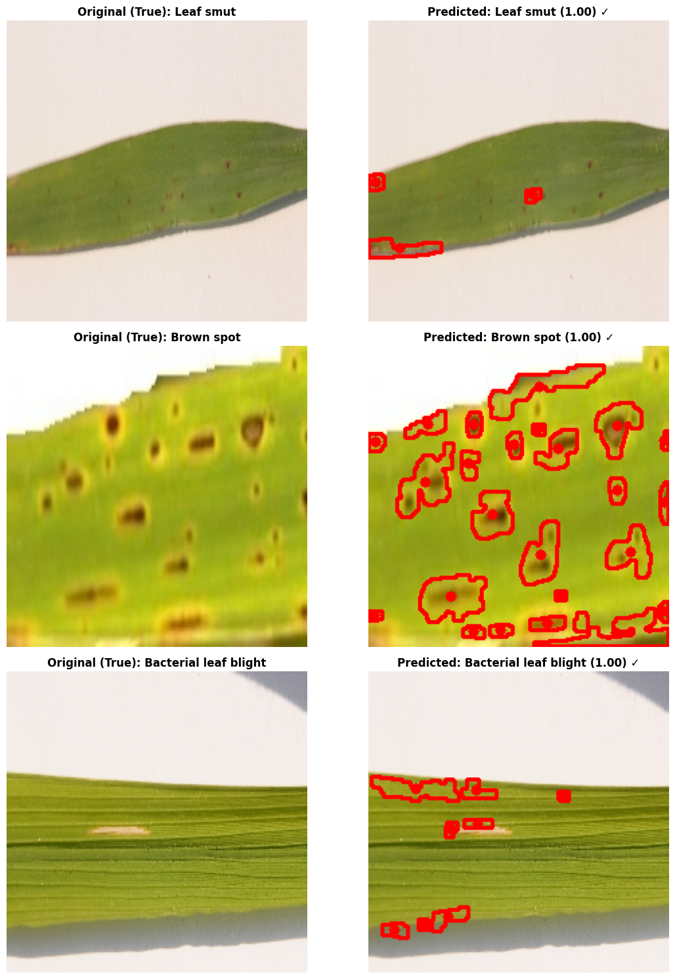
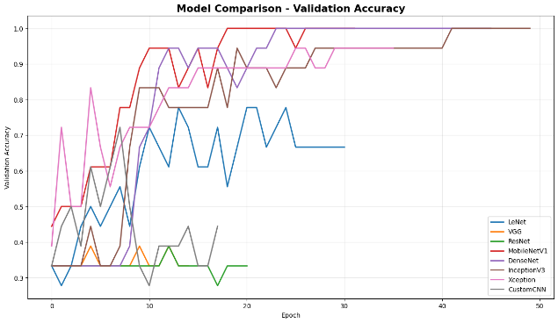
RESULTS

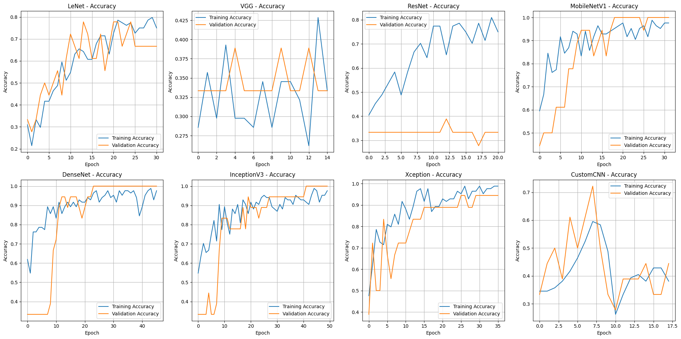

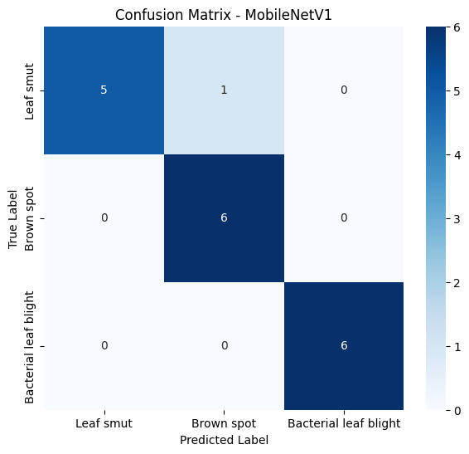
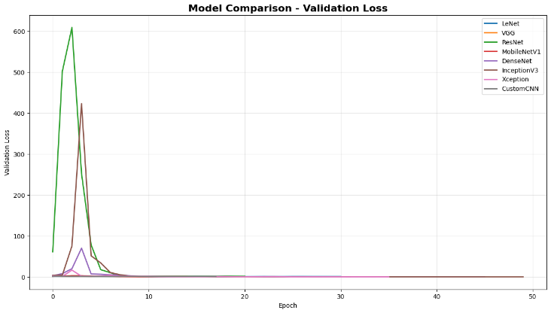

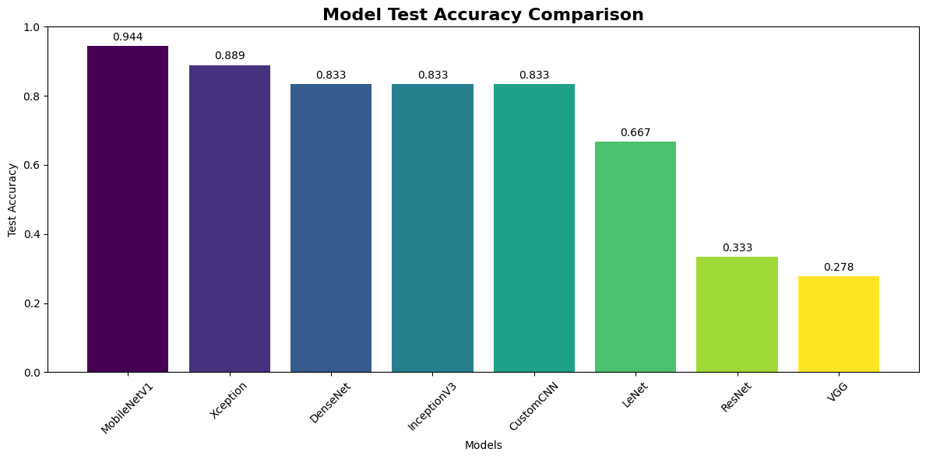

The experiments were conducted using eight deep learning architectures: LeNet, VGG, ResNet, MobileNetV1, DenseNet, InceptionV3, Xception, and a Custom CNN. Each model was trained for up to 50 epochs with data augmentation, EarlyStopping, and to avoid overfitting.
The performance of the models was measured on the test dataset. Among all architectures, MobileNetV1 achieved the highest accuracy of 0.944, making it the most suitable model for rice leaf disease prediction. The results clearly show that transfer learning using deep pretrained networks significantly outperformed the traditional CNN approach.
Accuracy test results:
MODEL | ACCURACY
MobileNetV1 | 0.944444
Xception | 0.888889
DenseNet | 0.833333
InceptionV3 | 0.833333
CustomCNN | 0.833333
LeNet | 0.666667
ResNet | 0.333333
VGG | 0.277778

The training and validation curves are shown below. The accuracy graph demonstrates consistent improvement with InceptionV3, while the loss curve indicates stable convergence without major overfitting.
Final Test Accuracy: 0.944 (MobileNetV1)

CHALLENGES FACED DURING MODEL CREATION
1. Model Architecture Design
- The first challenge was designing the architecture, as I experimented with 8 different models to predict rice leaf diseases.
2. Hyperparameter Tuning
- Selecting the right number of dense layers, convolutional filters, and dropout values was difficult, since proper tuning directly impacts model performance and helps achieve lower loss.
3. CNN Experimentation
- I initially applied 3 convolutional layers with a 128-unit dense layer, which gave an accuracy of 0.833. However, increasing the dense layer size to 500 units reduced the accuracy instead of improving it.
4. Need for Multiple Models
- I realized that relying on a single CNN was not sufficient, so I experimented with multiple models to improve performance.
5. Model Variety
- I applied several architectures: InceptionV3, DenseNet, MobileNetV1, Custom CNN, LeNet, Xception, ResNet, and VGG.
6. Dense Layer Consistency
- For consistency, I used dense layers of size 256 across all models.
7. Best Performance
- Among them, MobileNetV1 performed the best, achieving a test accuracy of 0.944.
8. Training Time in Google Collab
- With 50 epochs, each model took ~15 minutes in Collab, so training 8 models required over 1 hour. Re-tuning could easily take 1–1.5 hours.

9. Local Training Optimization
- To solve this, I installed TensorFlow on my laptop, which reduced the total training time for all models to just 16 minutes, saving several hours.
10. Final Outcome
- After overcoming these challenges, I achieved high accuracy and reliable results with my chosen models.

CONCLUSION
This project explored the use of Convolutional Neural Networks (CNNs) and transfer learning for rice leaf disease detection. A total of eight different architectures were tested, including LeNet, VGG, ResNet, MobileNetV1, DenseNet, InceptionV3, Xception, and a Custom CNN. Among these, MobileNetV1 achieved the highest accuracy of 0.944, establishing it as the best-performing model for this task. The results demonstrated that transfer learning approaches provided significant improvements compared to traditional CNNs.
The experiments also highlighted the importance of Model Tuning and Optimization. By applying data augmentation, dropout regularization, and callbacks such as EarlyStopping, the models were able to achieve better generalization and reduce overfitting. While a basic CNN provided moderate accuracy, deeper architectures like InceptionV3 and DenseNet delivered higher performance, showing the effectiveness of pretrained models in image classification problems.
In addition to classification, the project integrated Disease area detection and treatment suggestions. This feature enhances the system’s usefulness by not only predicting the disease but also offering practical guidance for farmers, such as fungicide sprays, bactericides, crop rotation, and improved field management. This makes the model both a diagnostic and a Decision-Support Tool for sustainable agriculture.
Despite the success, the project faced challenges in Training Time and Computational Resources. Running eight models for 50 epochs each in Google Collab required significant time, but this was mitigated by installing TensorFlow locally, reducing the overall training time. Future improvements include expanding the dataset, experimenting with ensemble methods, and developing a mobile application for real-time field deployment. Overall, this project provides a strong foundation for AI-powered agricultural solutions that can help improve crop health and global food security.

REFERENCES
- IRRI (International Rice Research Institute). Rice Knowledge Bank: Rice Diseases. Available at: http://www.knowledgebank.irri.org
- Ou, S.H. (1985). Rice Diseases. Commonwealth Mycological Institute, Kew, UK.
- Prasad, B., & Eizenga, G. C. (2008). Rice blast disease: a review. Agricultural Sciences, 1(1), 37–47.
- Simonyan, K., & Zisserman, A. (2014). Very Deep Convolutional Networks for Large-Scale Image Recognition (VGG). arXiv:1409.1556.
- He, K., Zhang, X., Ren, S., & Sun, J. (2016). Deep Residual Learning for Image Recognition (ResNet). Proceedings of the IEEE Conference on Computer Vision and Pattern Recognition (CVPR), 770–778.
- Szegedy, C., Vanhoucke, V., Ioffe, S., Shlens, J., & Wojna, Z. (2016). Rethinking the Inception Architecture for Computer Vision (InceptionV3). CVPR, 2818–2826.
- Chollet, F. (2017). Xception: Deep Learning with Depthwise Separable Convolutions. CVPR, 1251–1258.
- Huang, G., Liu, Z., Van Der Maaten, L., & Weinberger, K. Q. (2017). Densely Connected Convolutional Networks (DenseNet). CVPR, 4700–4708.
- Howard, A. G., Zhu, M., Chen, B., Kalenichenko, D., et al. (2017). MobileNets: Efficient Convolutional Neural Networks for Mobile Vision Applications. arXiv:1704.04861.
- Zhang, X., Qiao, Y., Meng, F., Fan, C., & Zhang, M. (2018). Identification of rice diseases using deep convolutional neural networks. Neurocomputing, 267, 378–384.

