**ECS765P - Big Data Processing - 2021/22**

**Course Work Ethereum Analysis**

Student Name – Prajwal Bhadravathi Narayana Murthy

Student ID – 210897324

EECS ID – EC211218

Table of Contents

1. Part A – Time Analysis.

1.1. Create Bar plot to determine number of transactions every month

1.2. Create bar plot to determine average value of transactions each month

2. Part B – Top Ten Most Popular Services.

3. Part C

4. Part D

4.1. Scam Analysis

4.1.1. Popular Scams

4.2. Miscellaneous Analysis

4.2.1. Fork the Chain

4.2.2. Comparative Analysis

4.3.3. Gas Guzzlers

**1) Part A – Time Analysis**

Create a bar plot showing the number of transactions occurring every month between the start and end of the dataset. Create a bar plot showing the average value of transactions in each month between the start and end of the dataset.

**1.1) Create a bar plot showing the number of transactions occurring every month between the start and end of the dataset.**

**Code Explanation:**

For this task, MapReduce approach is used to determine the number of transactions occurring every month.

Mapper Function:

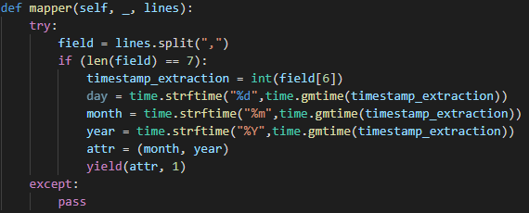

* The input for mapper here is the transactions file. The length of the file is checked. If the length is not equal to 7, it is considered as malformed record.
* Day Month and Year is extracted from timestamp field.
* Month and year are used as key attributes.
* For each and every transaction record, 1 is considered as value.

Reducer and Combiner Function:

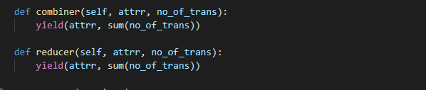

* Combiner is used to reduce the execution time.
* Summation of every key attributes (month and year) along with all of its value is done in the reducer.
* The output file is generated and the below graph is plotted using the output with the help of Excel.

**Graph Analysis**

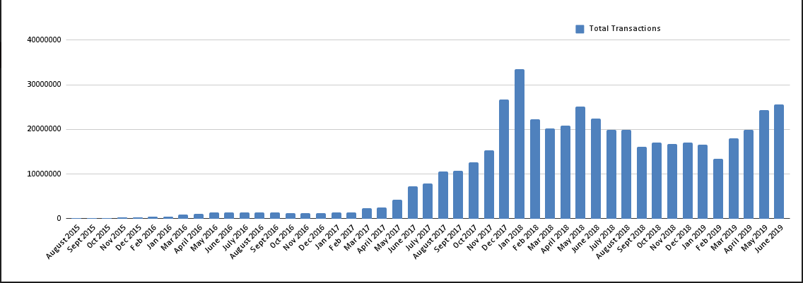

* Based on the output from the MapReduce program, above graph is plotted.
* From the plot, we could observe that the highest number of transactions were made in **January 2018**.
* On 11 December 2017, the total supply of Ether on Ethereum classic was hard capped at ETC 210700000 **by Gotham hard fork**, which **possibly could be a reason** for sudden **increase** in number of transactions in **December 2017** and **January 2018**.

**The Job ID for this Task is “job_1637317090236_23434”**

**1.2) Create a bar plot showing the average value of transactions in each month between the start and end of the dataset**

**Code Explanation:**

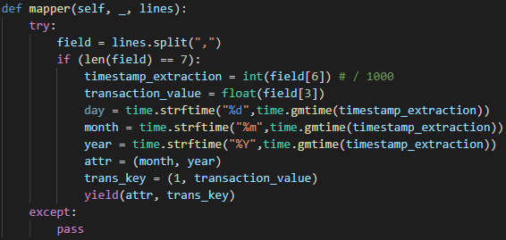

* **MapReduce approach** is used for this task to get the average value of transactions in each month.
* Similar to task 1, the mapper receives input from transactions, and length check is made on each record to identify malformed records.
* Month and Year is extracted from timestamp and yielded as key, whereas **transaction value along with 1** is yielded as value.

**Reducer and Combiner functions:**

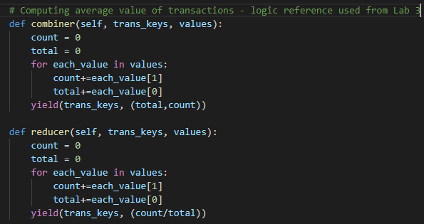

* Reducer function aggregates the count and value of the transactions in each month.
* Later, the count is divided by the total to compute the average value of transaction.
* Combiner is used to reduce the computing time.
* The output generated is plotted using Excel.

**Graph Analysis**

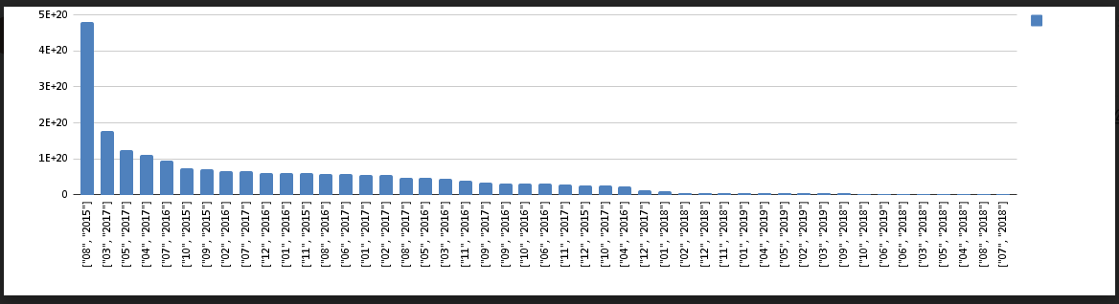

* The observation from the above is that, the **average transaction** value was the **highest during the initial days** of the dataset due to the **less number of transactions**. However, once the crypto buzzword spread the world, the Ethereum **transactions count increased** rapidly through-out the years thus resulting in the **plummeting of average transaction value**.

**The Job ID for this Task is “job_1637317090236_23766”**

## 2) Part B - TOP TEN MOST POPULAR SERVICES

Evaluate the top 10 smart contracts by total Ether received.

**Code Explanation:**

* To implement the task, MapReduce MRStep approaches is used.

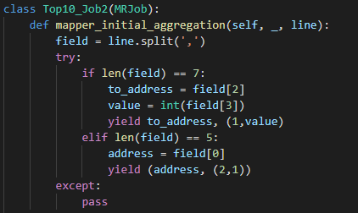

* Both **Transactions** and **Contracts** dataset has been fed to the first mapper.
* Since two files are received as input, we have to differentiate the files based on the length each record.
* If a record is from Transactions dataset, **address** is considered as key and **value** is taken as value. ‘1’ is passed along with value to differentiate from contracts dataset.
* Similarly, only address field is used from Contracts and we are passing ‘2’ along with counter 1 to distinguish it from transactions.
* The first reducer verifies the values passed and checks if it’s true, which determines the existence and validity of that record. Later, the sum of all values are computed

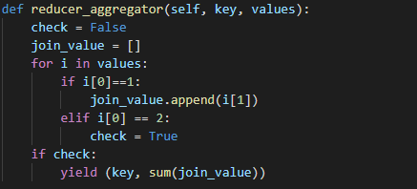

* The second mapper receives the yielded values from first reducer and combines key and values. None is considered as key.
* The second reducer sorts the values in descending to compute the top 10 values using the lambda function.

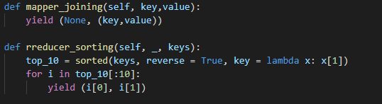

* Below is the output of the top10 most popular services

|  |  |
| --- | --- |
| 0xaa1a6e3e6ef20068f7f8d8c835d2d22fd5116444 | 8.41551E+25 |
| 0xfa52274dd61e1643d2205169732f29114bc240b3 | 4.57875E+25 |
| 0x7727e5113d1d161373623e5f49fd568b4f543a9e | 4.56206E+25 |
| 0x209c4784ab1e8183cf58ca33cb740efbf3fc18ef | 4.31704E+25 |
| 0x6fc82a5fe25a5cdb58bc74600a40a69c065263f8 | 2.70689E+25 |
| 0xbfc39b6f805a9e40e77291aff27aee3c96915bdd | 2.11042E+25 |
| 0xe94b04a0fed112f3664e45adb2b8915693dd5ff3 | 1.55624E+25 |
| 0xbb9bc244d798123fde783fcc1c72d3bb8c189413 | 1.19836E+25 |
| 0xabbb6bebfa05aa13e908eaa492bd7a8343760477 | 1.17065E+25 |
| 0x341e790174e3a4d35b65fdc067b6b5634a61caea | 8.379E+24 |

**Job ID’s for this task:**

<http://andromeda.student.eecs.qmul.ac.uk:8088/proxy/application_1648683650522_5397>

<http://andromeda.student.eecs.qmul.ac.uk:19888/jobhistory/job/job_1648683650522_5474>

**3. Part C – Top Ten Most Active Miners.**

Evaluate the top 10 miners by the size of the blocks mined

**Code Explanation:**

* MapReduce approach is used for this task.
* In the first Job,
* The blocks dataset has been used for the mapper to fetch the miner and size.

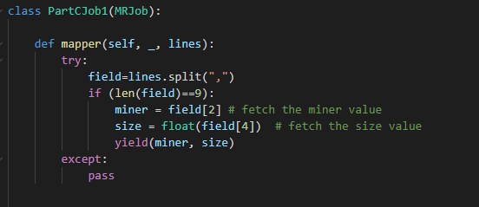

* Miner is taken as key and size as value.
* In the reducer, summation of all the value is done and yielded as value and key being the same.
* Combiner is used to reduce the computation time.

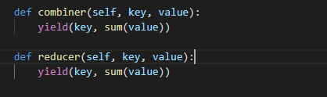

* Another MapReduce code has been written which takes the input of first Job and computes the top10 most active miners.

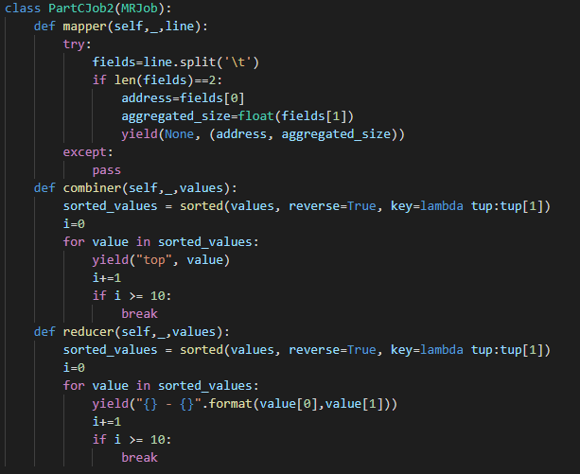

* The mapper of second job takes the output from first job which is tab separated and verifies the length of the record.
* Address and Aggregated size from Job1 output is yielded as value with key being None.
* In the reducer, lambda function is used to sort all the pairs in descending order and iterated throughout for 10 times to yield the top 10 miners.
* Below are the Job ID’s for the task and output of top 10 miners.

Top 10 miners:

|  |  |
| --- | --- |
| 0xea674fdde714fd979de3edf0f56aa9716b898ec8 | 23989401188 |
| 0x829bd824b016326a401d083b33d092293333a830 | 15010222714 |
| 0x5a0b54d5dc17e0aadc383d2db43b0a0d3e029c4c | 13978859941 |
| 0x52bc44d5378309ee2abf1539bf71de1b7d7be3b5 | 10998145387 |
| 0xb2930b35844a230f00e51431acae96fe543a0347 | 7842595276 |
| 0x2a65aca4d5fc5b5c859090a6c34d164135398226 | 3628875680 |
| 0x4bb96091ee9d802ed039c4d1a5f6216f90f81b01 | 1221833144 |
| 0xf3b9d2c81f2b24b0fa0acaaa865b7d9ced5fc2fb | 1152472379 |
| 0x1e9939daaad6924ad004c2560e90804164900341 | 1080301927 |
| 0x61c808d82a3ac53231750dadc13c777b59310bd9 | 692942577 |

**The Job ID’s for this tasks are:**

<http://andromeda.student.eecs.qmul.ac.uk:8088/cluster/app/application_1649894236110_2287>

<http://andromeda.student.eecs.qmul.ac.uk:8088/proxy/application_1649894236110_2295>

**4) Part D - Data Exploration**

**4.1) Scam Analysis**

Utilizing the provided scam dataset, what is the most lucrative form of scam? Does this correlate with certainly known scams going offline /inactive?

**Code Explanation:**

* The First task is to identify the most lucrative form of scam, for which Spark is used.
* The scams.json file is converted to scams.csv files using python’s pandas framework and used as input.

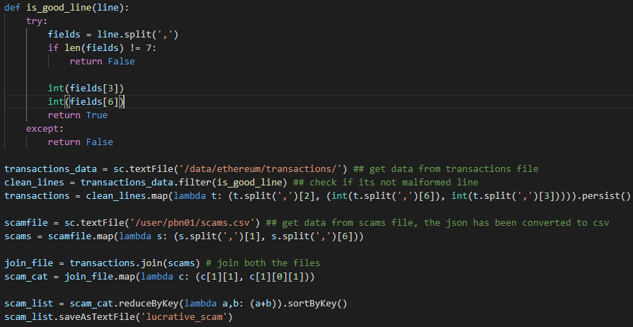

* Function is_good_line() is defined to check the length of transactions dataset.
* Using the map transformation (address, timestamp, and value) fields are obtained.
* persist() is used to save the result of RDD in cache memory, which makes further computation faster.
* Scams.csv files is read and mapped using map transformation which produces (address, category)
* The two obtained files are joined using join transformation.
* The values from join transformation are mapped to obtain (category, value).
* The value field is aggregated using a lambda function based on category and later sorted to obtain the most lucrative scams.
* From the output below, we could observe that the Scamming is the most lucrative scam type.

|  |
| --- |
| **(u'Phishing', 26927757396110618476458L)** |
| **(u'Fake ICO', 1356457566889629979678L)** |
| **(u'Scamming', 38407781260421703730344L)** |

**Task 2 : Does this correlate with certainly known scams going offline /inactive?**

**Code Explanation:**

* In this code also, we will be using the scams.json files to evaluate the correlation.
* As implemented in previous code, the records are checked if they are clean or malformed.
* Address is taken as key and value is taken as value and constant 1 is sent to distinguish the record.
* From scams.json file, category and status as sent as value for reducer and address as key along with 2 as constant to distinguish the record.

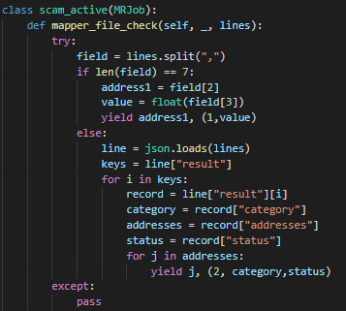

* In reducer, we will check the record mapping. If it’s one, it’s been added to values. Else, its been added to categories and status as this pair is from scams.json file.

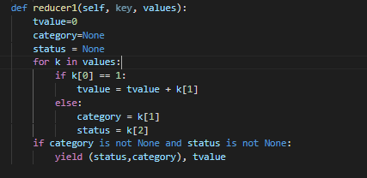

* The second mapper just receives the values and forwards that to second reducer where the summation of total number of scams and its category is calculated.
* Below is the output from the MapReduce program.

|  |  |  |
| --- | --- | --- |
| **Scam Type** | **State** | **Volume** |
| Scamming | Active | 2.2096952356679193e+22 |
| Phishing | Inactive | 1.4886777707995027e+19 |
| Fake ICO | Offline | 1.35645756688963e+21 |
| Phishing | Offline | 2.2451251236751494e+22 |
| Scam | Offline | 0 |
| Phishing | Suspended | 1.63990813e+18 |
| Phishing | Active | 4.5315978714979395e+21 |
| Scamming | Offline | 1.6235500337815102e+22 |
| Scamming | Suspended | 3.71016795e+18 |

**The Job ID’s for this tasks are below:**

<http://andromeda.student.eecs.qmul.ac.uk:8088/proxy/application_1648683650522_7702>

http://andromeda.student.eecs.qmul.ac.uk:8088/proxy/application_1649894236110_0635

**4.2 Miscellaneous Analysis.**

**4.2.1 Fork The Chain.**

We will observer Forks on below two different timelines.

* Byzantium – October 16 2017

**Code Explanation:**

* MapReducer is used for this task to analyses the fork.
* The transaction dataset is given as input.
* In mapper, only specific month and year when fork occurred is taken as key and gas price is yielded as value.
* Aggregation of count of transaction and gas price is done by the reducer.
* Combiner is used to reduce the time taken to compute.
* The output generated is explained with plot

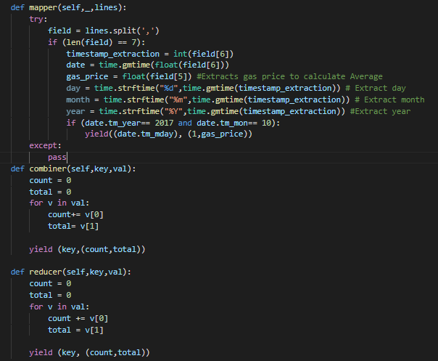

**Graph Analysis**

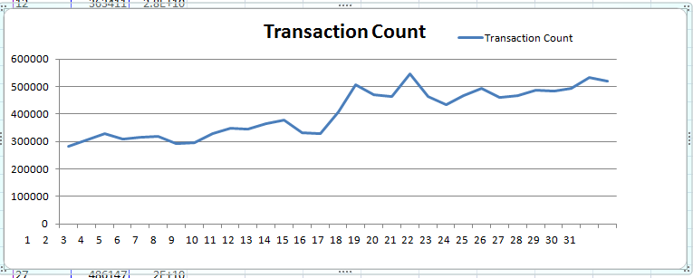

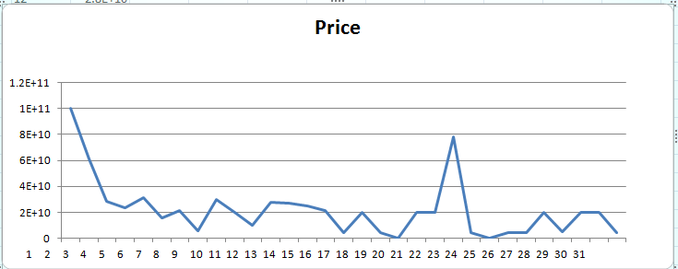

* The **Byzantium fork** which happened on October 16 2017 has been considered for our Fork analysis.
* From the plots we could see that the price dropped slightly after the fork and went to the lowest on 18th before rising again.
* However, the number of transaction which was steadily increasing till 15th of October, took a small dip on the day of fork(16th October). Furthermore, after fork due to decrease in price, we could see that the transaction increased exponentially for a week.
* From the above analysis, we could conclude that the due to fork on 16thOctober, the price of ETH decreased with resulted in increase in transactions.

**Job ID for this task is below:** http://andromeda.student.eecs.qmul.ac.uk:8088/proxy/application_1648683650522_7828

**4.2.2 Comparative Analysis**

I have executed the Part B in MapReduce, for the analysis I have executed the same program in Spark.

The time is calculated using 4 runs each of both Spark and MapReduce.

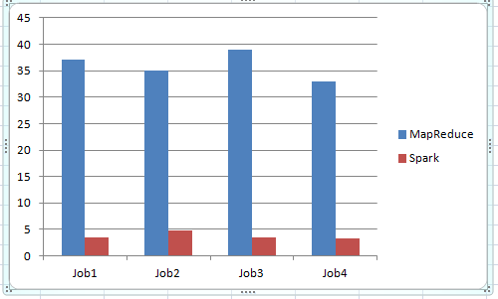

|  |  |  |
| --- | --- | --- |
| Job | MapReduce | Spark |
| Job1 | 37 | 3.4 |
| Job2 | 35 | 4.8 |
| Job3 | 39 | 3.53 |
| Job4 | 33 | 3.3 |
| Average | 36 | 3.7575 |

Looking at the average we could see that the Spark programming is faster than MapReduce.

The reason for this is Spark processes and retains data in memory for subsequent steps, whereas MapReduce processes data on disk. As a result, for smaller workloads, Spark's data processing speeds are up to 100x faster than MapReduce.

**Job ID’s for this tasks are**

<http://andromeda.student.eecs.qmul.ac.uk:8088/proxy/application_1649894236110_1126>

<http://andromeda.student.eecs.qmul.ac.uk:8088/proxy/application_1649894236110_1292>

<http://andromeda.student.eecs.qmul.ac.uk:8088/proxy/application_1649894236110_1777>

<http://andromeda.student.eecs.qmul.ac.uk:8088/cluster/app/application_1649894236110_1901>



C:\Users\Admin\Desktop\BDP\spark2job.JPG

C:\Users\Admin\Desktop\BDP\spark3job.JPG

C:\Users\Admin\Desktop\BDP\spark4job.JPG

obID’s for th

**4.2.3 Gas Guzzlers**

For any transaction on Ethereum a user must supply [gas](https://coinsutra.com/ethereum-beginners-guide/ether-gas-limit-price-fee). How has gas price changed over time? Have contracts become more complicated, requiring more gas, or less so? Also, could you correlate the complexity for some of the top-10 contracts found in Part-B by observing the change over their transactions.

Task 1 - How has gas price changed over time?

**Code Explanation:**

* MapReduce approach is used to compute the gas price change.
* Timestamp is extracted from the transactions dataset and considered as key whereas; gas price is taken an value.
* The average of price of each month is computed in the reducer.
* Combiner is added to reduce computation time.
* The output is shown in below plot.

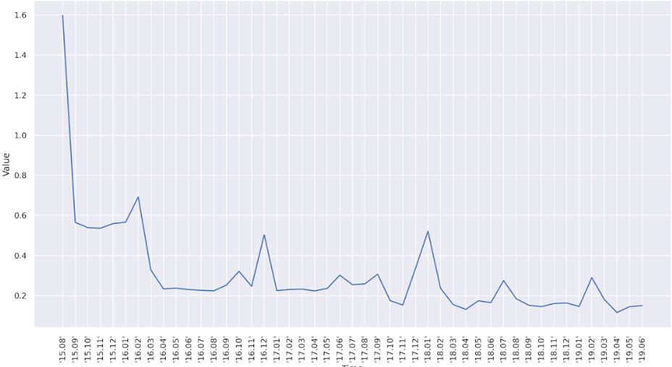

**Task 2: Have contracts become more complicated, requiring more gas, or less so?**

Contract Complexity over time

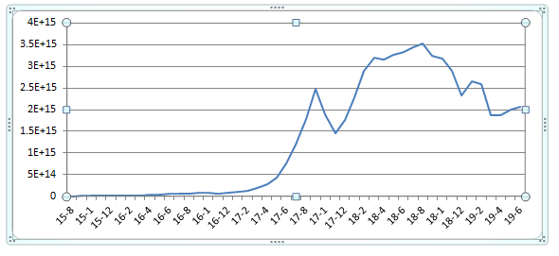

**JobID’s for this task**

[**http://andromeda.student.eecs.qmul.ac.uk:8088/proxy/application_1649894236110_4431**](http://andromeda.student.eecs.qmul.ac.uk:8088/proxy/application_1649894236110_4431)

[**http://andromeda.student.eecs.qmul.ac.uk:8088/cluster/app/application_1649894236110_4789**](http://andromeda.student.eecs.qmul.ac.uk:8088/cluster/app/application_1649894236110_4789)

[**http://andromeda.student.eecs.qmul.ac.uk:8088/cluster/app/application_1648683650522_7622**](http://andromeda.student.eecs.qmul.ac.uk:8088/cluster/app/application_1648683650522_7622)