**A**

**LAB REPORT**

**ON**

**c programming**

**Phase II**

**By**

**Prajwal Dahal**

**Exam Roll No: 03**



**Submitted to:**

**Indra PC**

**IT Department**

**Kantipur College of Management and Information Technology**

In partial fulfillment of the requirements for the Course

C programming

Mid Baneshwor, Kathmandu

<<Month>> <<Year>>

**TABLE OF CONTENTS**

1 Write a program to find greatest characters among three characters using nested if. 1

1.1 Source Code 1

1.2 Output Window 1

2 Write program to display 3 number taken from user in ascending order. 3

2.1 Source Code 3

2.2 Output Window 4

3 Write program to display 2nd greatest word using nested if. 5

3.1 Source Code 5

3.2 Output Window 5

4 Write program to demonstrate use of switch case statement. 6

4.1 Source Code 6

4.2 Output Window 7

5 Write a program to find sum of square of number from 1 to 10 using while loop. 8

5.1 Source code: 8

5.2 Output window: 8

6 Write a program to reverse the digit of number using while loop. 9

6.1 Source code: 9

6.2 Output window: 9

7 Write a program to display even number from 1 to 100 using do-while loop. 10

7.1 Source code: 10

7.2 Output window: 10

8 Write a program to take input which is only divisible by 7. 11

8.1 Source code 11

8.2 Output window 11

9 Write a program to print odd number from 1 to 100 using continue. 12

9.1 Source code: 12

9.2 Output window 12

10 Write a program to take input which is even using infinite loop. 13

10.1 Source code 13

10.2 Output window 13

11 Write a program to display following pattern: 14

11.1 Source code: 14

11.2 Output window: 14

12 Write a program to display following pattern: 15

12.1 Source code: 15

12.2 Output window 15

13 Write a program to print the following pattern 15

13.1 Source code: 16

13.2 Output window 17

14 Write a program to display the following pattern: 18

14.1 Source code: 18

14.2 Output window 18

15 Write a program to take 10 integer from user and display them in ascending order using selection sort. 19

15.1 Source code: 19

15.2 Output window 19

16 Write a program to take two 3*4 matricies and display their sum. 20

16.1 Source code: 20

16.2 Output windows: 21

17 Write a program to take 2*3 matrix and 3*2 matrix and display multiplication of two matrices. 22

17.1 Source code: 22

17.2 Output window 23

18 Write a program to take 4*5 matrix and transpose the matrix. 24

18.1 Source code 24

18.2 Output window 24

19 Write a program to demonstrate nested structure. 25

19.1 Source code: 25

19.2 Output window: 25

20 Write a program to demonstrate the use of union; 26

20.1 Source code: 26

20.2 Output window 26

21 Write a program to write content to the file using fputs. 27

21.1 Source code 27

21.2 Output window 27

22 Write a program to read content from file “trial.txt” using fgets. 28

22.1 Source code: 28

22.2 output windows: 28

23 write a program to write a character in the file using fputc. 29

23.1 Source code: 29

24 Write a program to read whole file using fgetc. 30

24.1 Source code: 30

24.2 Output window 30

25 Write a program to take name age address and height of 5 student and write the content on file. 31

25.1 Source code: 31

25.2 Output window 31

26 Write a program to read a content from struct1.txt and display it in screen. 32

26.1 Source code: 32

26.2 Output window 32

27 Write a program to read a record of student from file struct1.txt according to user input. 33

27.1 Source code: 33

27.2 Output window: 33

28 Write a program to demonstrate the use of ftell and rewind function. 34

28.1 Source code: 34

28.2 Output window: 34

29 Write a program to take 2 number and find their sum using function. 35

29.1 Source code: 35

29.2 Output windows: 35

30 Write a program to add 10 number taken from user and find their total sum. 36

30.1 Source code: 36

30.2 Output window: 36

31 Write a program to take name age and address of 1 student and display them using function. 37

31.1 Source code 37

31.2 Output windows: 37

32 Write a program to find sum of at least 10 number using command line argument. 38

32.1 Source code: 38

32.2 Output window : 38

33 Write a program to take 5 character from user and display them using pointer. 39

33.1 Source code: 39

33.2 Output windows 39

34 Write a program to swap the value of two variable using macros. 40

34.1 Source code: 40

34.2 Output window: 40

# Write a program to find greatest characters among three characters using nested if.

## Source Code

#include<stdio.h>

int main()

{

char a,b,c;char grt;

printf("enter a three: ");

a=getchar();

b=getchar();

c=getchar();

if(a>b)

{

if(a>c)

{

grt=a;

}

else

{

grt=c;

}

}

else

{

if(b>c)

{

grt=b;

}

else

{

grt = c;

}

}

printf("greatest=");

putchar(grt);

return 0;

}

## Output Window

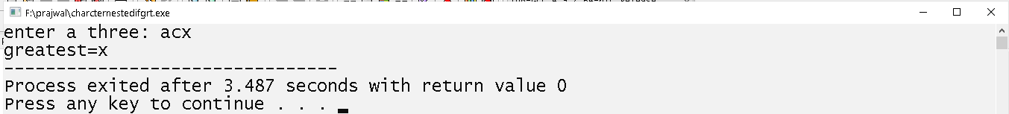

# Write program to display 3 number taken from user in ascending order.

## Source Code

#include<stdio.h>

int main()

{

int a,b,c;int high,mid,small;

printf("enter a three character: ");

scanf("%d%d%d",&a,&b,&c);

if(a>b && a>c)

{

high=a;

if(b>c)

{

mid=b;

small=c;

}

else

{

mid=c;

small=b;

}

}

else if(b>a && b>c)

{

high=b;

if(a>c)

{

mid=a;

small=c;

}

else

{

mid=c;

small=a;

}

}

else

{

high=c;

if( a>b)

{

mid=a;

small=b;

}

else

{

mid=b;

small=a;

}

}

printf("%d %d %d",small,mid,high);

return 0;

}

## Output Window

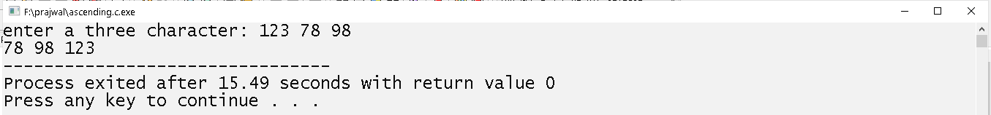

# Write program to display 2nd greatest word using nested if.

## Source Code

#include<stdio.h>

#include<string.h>

int main()

{

char a[10];char b[10]; char c[10];int x,y,z;

printf("enter three string: ");

scanf("%s %s %s",a,b,c);

x=strcmp(a,b);

y=strcmp(b,c);

z=strcmp(a,c);

if(x>0 && z>0)

{

If(y>0

printf("the 2nd greatest word is: %s",b)

else

printf("the 2nd greatest word is: %s",c);

}

else if(x<0 && y>0)

{

if(z>0)

printf("the 2nd greatest word is: %s",a)

else

printf("the 2nd greatest word is: %s",c);

}

else

{

if(x>0)

printf("the 2nd greatest word is: %s",a)

else

printf("the 2nd greatest word is: %s",b);

}

return 0;

}

## Output Window

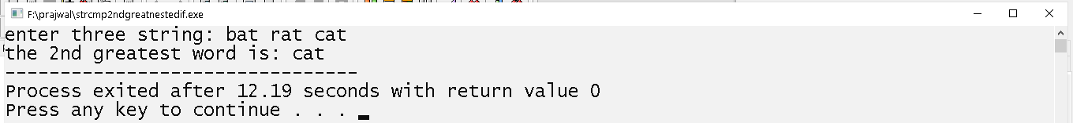

# Write program to demonstrate use of switch case statement.

## Source Code

#include<stdio.h>

int a;

void input()

{

printf("enter a number: ");

scanf("%d",&a);

}

void evenodd()

{

if(a % 2 == 0)

{

printf("even");

}

else

{

printf("odd");

}

}

void positivenegetive()

{

if(a>0)

{

printf("positive");

}

else

printf("negetive");

}

int main()

{

int b;

printf("\nchoose a number:\n1.to check even-odd\n”);

printf(“2.to check positive-negetive\n");

scanf("%d",&b);

switch(b)

{

case 1:

input();

evenodd();

break;

case 2:

input();

positivenegetive();

break;

default: printf("invalid menu number\n");

}

return 0;

}

## Output Window

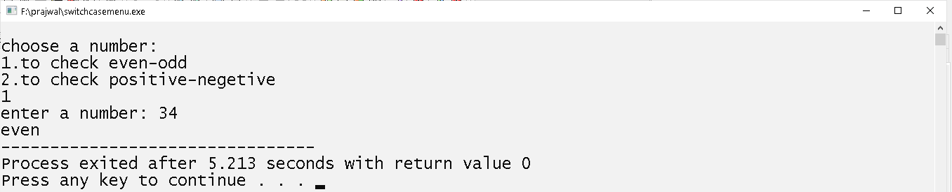

# Write a program to find sum of square of number from 1 to 10 using while loop.

## Source code:

#include<stdio.h>

#include<math.h>

int main()

{

int i=1,a=1;int sum=0;

while(i<=10)

{

sum+=pow(a,2);

i++;

a++;

}

printf("sum=%d",sum);

return 0;

}

## Output window:



# Write a program to reverse the digit of number using while loop.

## Source code:

#include<stdio.h>

int main()

{

int num,rslt,rev=0;

printf("enter a number: ");

scanf("%d",&num);

while(num>0)

{

rslt=num % 10;

rev=rev*10+rslt;

num=num/10;

}

printf("%d",rev);

return 0;

}

## Output window:

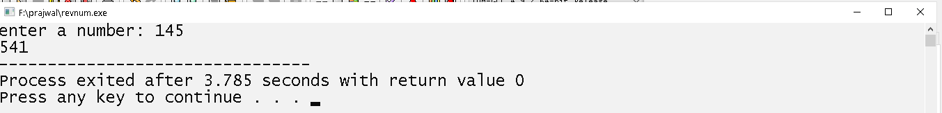

# Write a program to display even number from 1 to 100 using do-while loop.

## Source code:

#include<stdio.h>

int main()

{

int i=2;

do

{

printf(" %4d",i);

i+=2;

}while(i<100);

return 0;

}

## Output window:

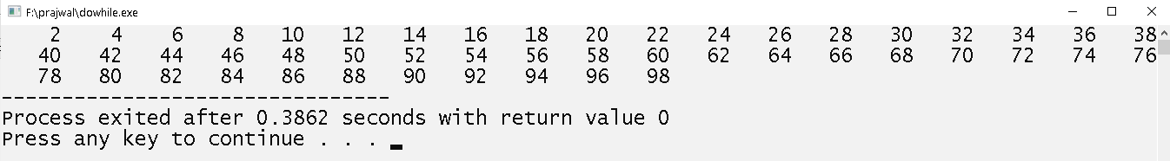

# Write a program to take input which is only divisible by 7.

## Source code

#include<stdio.h>

int main()

{

int a;

do

{

printf("enter a number divisible by 7: ");

scanf("%d",&a);

}while(a%7!=0);

printf("input taken=%d",a);

return 0;

}

## Output window

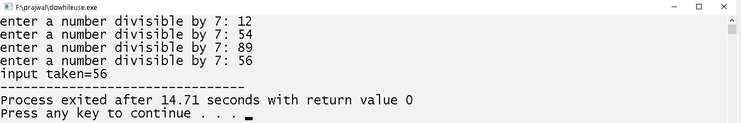

# Write a program to print odd number from 1 to 100 using continue.

## Source code:

#include<stdio.h>

int main()

{

int i=0;

while(i<100)

{

i++;

if(i%2==0)

{

continue;

}

printf(" %4d",i);

}

return 0;

}

## Output window

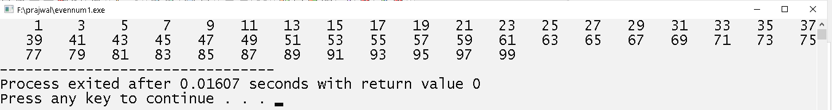

# Write a program to take input which is even using infinite loop.

## Source code

#include<stdio.h>

int main()

{

int a;

while(1)

{

printf("enter a number: ");

scanf("%d",&a);

if(a%2==0)

break;

}

printf("input taken:%d",a);

return 0;

}

## Output window

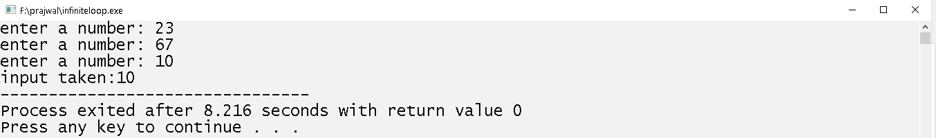

# Write a program to display following pattern:



## Source code:

#include<stdio.h>

int main()

{

int i,j;

for(i=0;i<5;i++)

{

for(j=0;j<i;j++)

{

printf("%4c",'*');

}

printf("\n");

}

return 0;

}

## Output window:

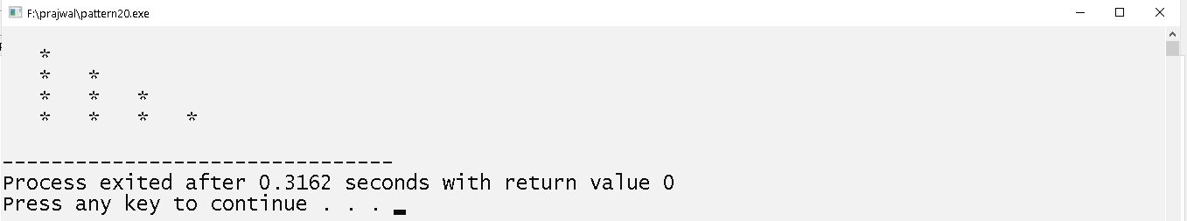

# Write a program to display following pattern:

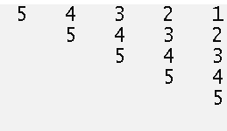

## Source code:

#include<stdio.h>

int main()

{

int i,j;int v=5;

for(i=1;i<=5;i++)

{

v=5;

for(j=1;j<=5;j++)

{

if(i<=j)

{

printf("%4d",v);

v--;

}

else

{

printf("%4c", ' ');

}

}

printf("\n");

}

return 0;

}

## Output window

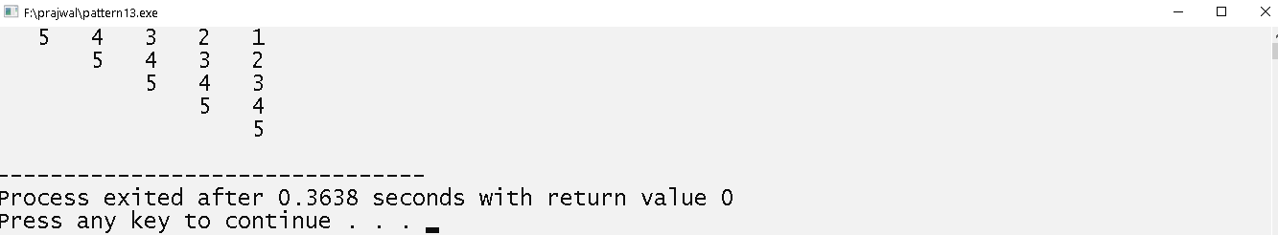

# Write a program to print the following pattern

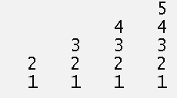

## Source code:

#include<stdio.h>

int main()

{

int i,j;int v=5;

for(i=4;i>=0;i--)

{

for(j=1;j<=4;j++)

{

if(i<=j)

{

printf("%4d",v);

}

else

{

printf("%4c",' ');

}

}

v--;

printf("\n");

}

return 0;

}

## Output window

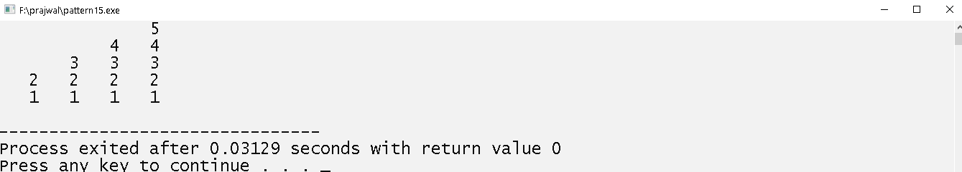

# Write a program to display the following pattern:

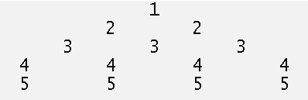

## Source code:

#include<stdio.h>

int main()

{

int i,j;int v=1;

for(i=4;i>=0;i--)

{

for(j=1;j<=4;j++)

{

if(i<=j)

{

printf("%4d",v);

}

printf("%4c",' ');

}

v++;

printf("\n");

}

return 0;

}

## Output window

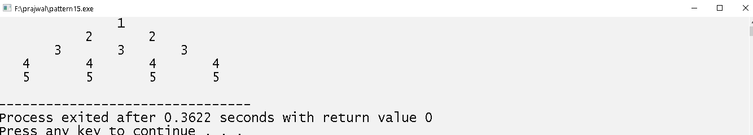

# Write a program to take 10 integer from user and display them in ascending order using selection sort.

## Source code:

#include<stdio.h>

int main()

{

int a[10];int i,j;int temp;

printf("enter a 10 number: ");

for(i=0;i<10;i++)

{

scanf("%d",&a[i]);

}

for(i=0;i<10;i++)

{

for(j=i+1;j<10;j++)

{

if(a[i]>a[j])

{

temp=a[i];

a[i]=a[j];

a[j]=temp;

}

}

}

for(i=0;i<10;i++)

{

printf("%4d",a[i]);

}

return 0;

}

## Output window

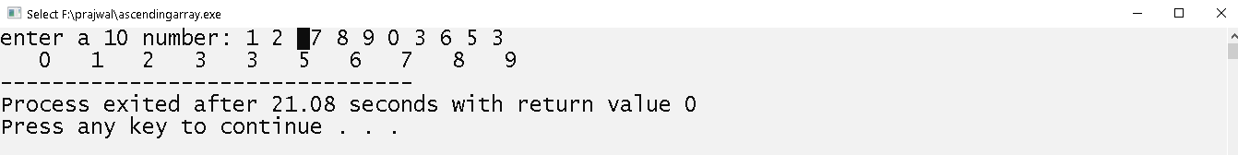

# Write a program to take two 3*4 matricies and display their sum.

## Source code:

#include<stdio.h>

int main()

{

int a[3][4]; int b[3][4];int sum[3][4];

int i,j;

printf("enter elements of 1st 3*4 matrix:\n");

for(i=0;i<3;i++)

{

for(j=0;j<4;j++)

{

scanf("%d",&a[i][j]);

}

}

printf("enter elements of 2nd 3*4 matrix:\n");

for(i=0;i<3;i++)

{

for(j=0;j<4;j++)

{

scanf("%d",&b[i][j]);

}

}

for(i=0;i<3;i++)

{

for(j=0;j<4;j++)

{

sum[i][j]=a[i][j]+b[i][j];

}

}

for(i=0;i<3;i++)

{

for(j=0;j<4;j++)

{

printf("%4d",sum[i][j]);

}

printf("\n");

}

return 0;

}

## Output windows:

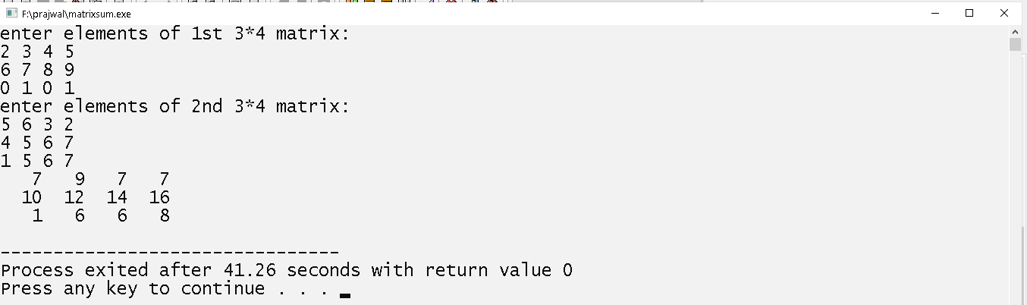

# Write a program to take 2*3 matrix and 3*2 matrix and display multiplication of two matrices.

## Source code:

#include<stdio.h>

int main()

{

int a[2][3]; int b[3][2];int mul[2][2];

int i,j,k;

printf("enter elements of 1st 2*3 matrix:\n");

for(i=0;i<2;i++)

{

for(j=0;j<3;j++)

scanf("%d",&a[i][j]);

}

printf("enter elements of 2nd 3*2 matrix:\n");

for(i=0;i<3;i++)

{

for(j=0;j<2;j++)

scanf("%d",&b[i][j]);

}

for(i=0;i<2;i++)

{

for(j=0;j<2;j++)

{

mul[i][j]=0;

for(k=0;k<3;k++)

mul[i][j]=mul[i][j]+a[i][k]*b[k][j]

}

}

for(i=0;i<2;i++)

{

for(j=0;j<2;j++)

printf("%d\t",mul[i][j])

printf("\n");

}

return 0;

}

## Output window

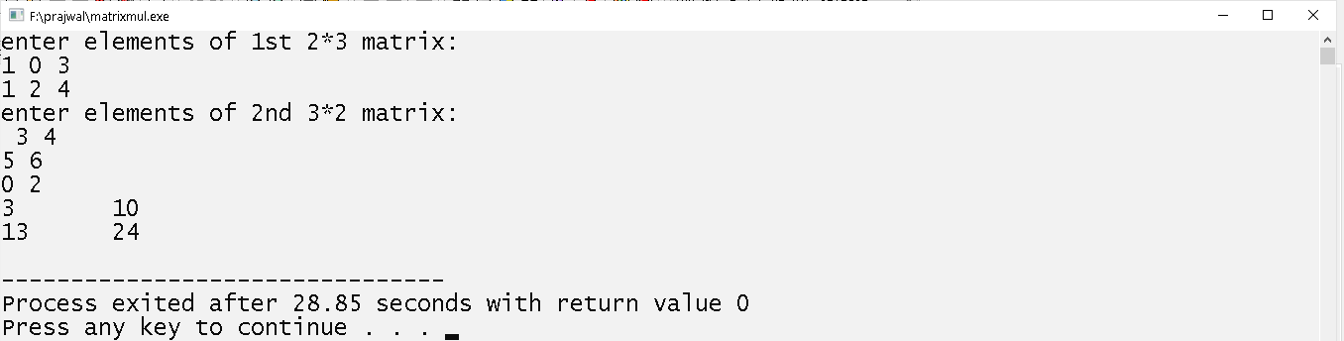

# Write a program to take 4*5 matrix and transpose the matrix.

## Source code

#include<stdio.h>

int main()

{

int a[4][5];int i,j;

printf("enter a element of 4*5 matrix: \n");

for(i=0;i<4;i++)

{

for(j=0;j<5;j++)

{

scanf("%d",&a[i][j]);

}

}

for(i=0;i<5;i++)

{

for(j=0;j<4;j++)

{

printf("%4d",a[j][i]);

}

printf("\n");

}

return 0;

}

## Output window

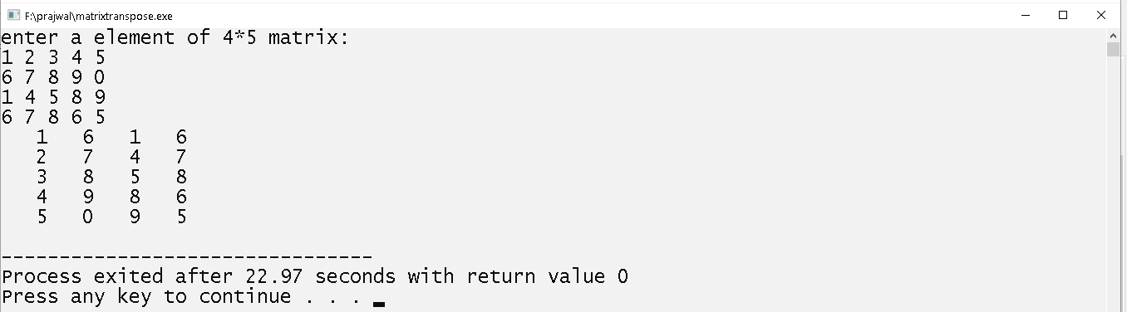

# Write a program to demonstrate nested structure.

## Source code:

#include<stdio.h>

struct employee

{

float salary;

};

struct person

{

char name[50];

int age;

float height;

struct employee e;

}p;

int main()

{

struct person p = {"hari",24,180.5,{15000.50}};

printf("%s\t%d\t%.2f\t%.2f",p.name,p.age,p.height,p.e.salary);

return 0;

}

## Output window:

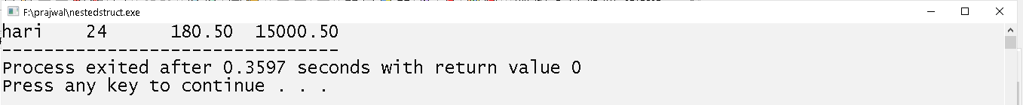

# Write a program to demonstrate the use of union;

## Source code:

#include <stdio.h>

#include <string.h>

union Data {

int i;

float f;

char str[20];

};

int main( )

{

union Data data;

data.i = 10;

data.f = 220.5;

strcpy( data.str, "C Programming");

printf( "data.i(garbage value) : %d\n", data.i);

printf( "data.f(garbage value) : %.2f\n", data.f);

printf( "data.str : %s\n", data.str);

return 0;

}

## Output window

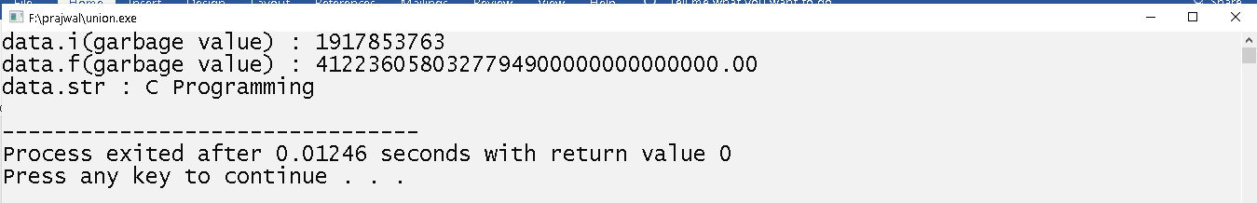

# Write a program to write content to the file using fputs.

## Source code

#include<stdio.h>

int main()

{

char a[50];

FILE *fp;

FILE *fptr;

fp=fopen("trial.txt","w");

printf("enter a text to the file: ");

gets(a);

fputs(a,fp);

return 0;

}

## Output window

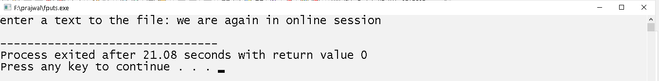

# Write a program to read content from file “trial.txt” using fgets.

## Source code:

#include<stdio.h>

int main()

{

char a[50];

FILE *fp;

fp=fopen("trial.txt","r");

fgets(a,50,fp);

puts(a);

return 0;

}

## output windows:

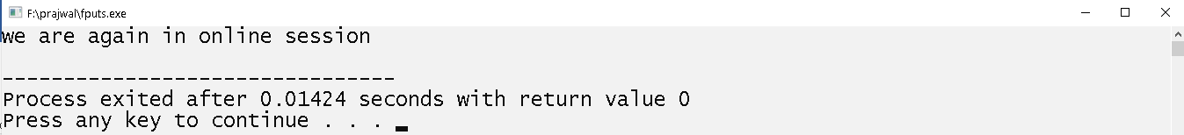

# write a program to write a character in the file using fputc.

## Source code:

#include<stdio.h>

#include<stdlib.h>

int main()

{

FILE *fptr;

int ch;

fptr=fopen("myfile.txt","w");

if(fptr==NULL)

{

printf("error finding file:\n");

exit(1);

}

fputc('a',fptr);

fclose(fptr);

return 0;

}

# Write a program to read whole file using fgetc.

## Source code:

#include<stdio.h>

int main()

{

FILE *fp;char a;

fp=fopen("trial2.txt","r");

if(fp==NULL)

printf("error opening file ");

top:

if(!feof(fp))

{

a=fgetc(fp);

putchar(a);

goto top;

}

return 0;

}

## Output window

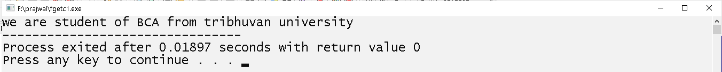

# Write a program to take name age address and height of 5 student and write the content on file.

## Source code:

#include<stdio.h>

struct student

{

char name[20];

char address[50];

int age;

float height;

}s[4];

int main()

{

FILE *fp; int i;

fp=fopen("struct1.txt","w");

printf("enter a name age,height and address of 4 student below:");

for(i=0;i<4;i++

scanf("%s%d%f%s",s[i].name,&s[i].age,&s[i].height,s[i].address);

fwrite(s,sizeof(s),4,fp);

return 0;

}

## Output window

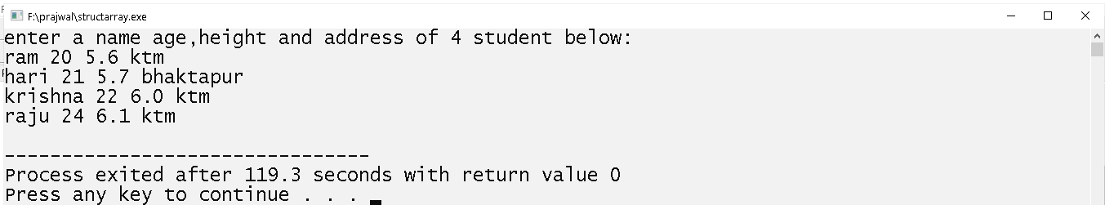

# Write a program to read a content from struct1.txt and display it in screen.

## Source code:

#include<stdio.h>

struct student

{

char name[20];

char address[50];

int age;

float height;

}s[4];

int main()

{

FILE *fp; int i;

fp=fopen("struct1.txt","r");

fread(s,sizeof(s),4,fp);

for(i=0;i<4;i++)

printf("%s\t%d\t%f\t%s\n",s[i].name,s[i].age,s[i].height,s[i].address);

return 0;

}

## Output window

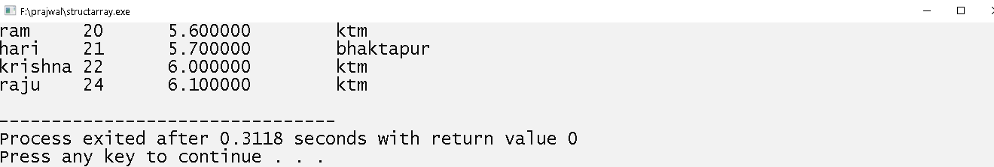

# Write a program to read a record of student from file struct1.txt according to user input.

## Source code:

#include<stdio.h>

struct student

{

char name[20];

char address[50];

int age;

float height;

}s;

int main()

{

FILE *fp;int n;

fp=fopen("struct1.txt","r");

printf("enter a record number to be displayed: ");

scanf("%d",&n);

fseek(fp,(n-1)*sizeof(struct student),0);

fread(&s,sizeof(s),1,fp);

printf("%s\t%d\t%f\t%s\n",s.name,s.age,s.height,s.address);

fclose(fp);

return 0;

}

## Output window:

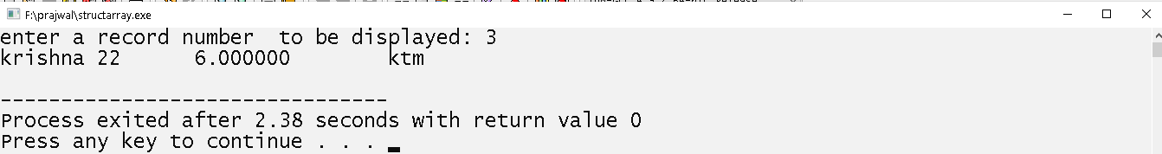

# Write a program to demonstrate the use of ftell and rewind function.

## Source code:

#include<stdio.h>

int main()

{

FILE *fp;int a;

fp=fopen("trial2.txt","r");

printf("cursor at begining:%d\n",ftell(fp));

fseek(fp,21,0);

printf("cursor at%d position after using fseek\n",ftell(fp));

rewind(fp);

printf("cursor is at %d position after using rewind\n",ftell(fp));

return 0;

}

## Output window:

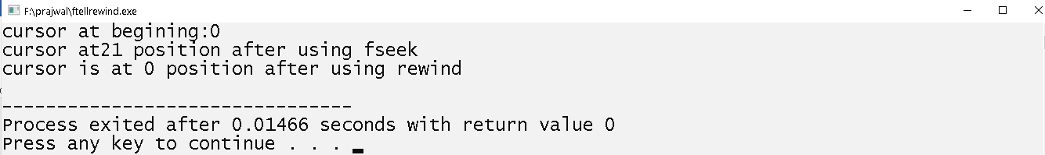

# Write a program to take 2 number and find their sum using function.

## Source code:

#include<stdio.h>

int sum(int x,int y)

{

int s;

s=x+y;

return s;

}

int main()

{

int s;

int a,b;int k;

a=10;b=10;

k=sum(a,b);

printf("%d",k);

k=sum(4,5);

printf("%d",k);

return 0;

}

## Output windows:

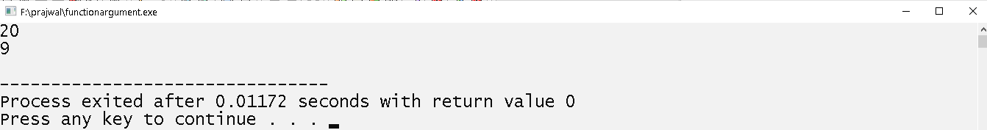

# Write a program to add 10 number taken from user and find their total sum.

## Source code:

#include<stdio.h>

int input()

{

int k;

int i;

int a[10];

printf("enter a 10 numbers: ");

for(i=0;i<10;i++)

scanf("%d",&a[i]);

k=sum(a);

return k;

}

int sum(int a[])

{

int i;int sum=0;

for(i=0;i<10;i++)

sum+=a[i];

return sum;

}

int main()

{

int k;

k=input();

printf("sum=%d",k);

return 0;

}

## Output window:

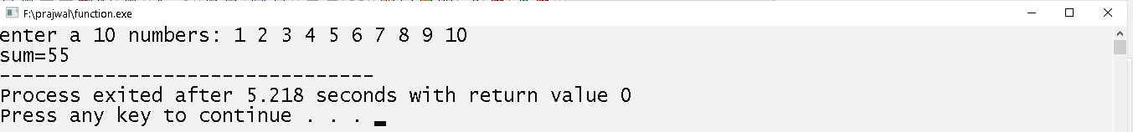

# Write a program to take name age and address of 1 student and display them using function.

## Source code

#include<stdio.h>

struct student

{

char name[20];

int age;

float height;

};

void display(struct student s)

{

printf("%s\t%d\t%.2f",s.name,s.age,s.height);

}

int main()

{

struct student s;

printf("enter a name age and height: ");

gets(s.name);

scanf("%d\t%f",&s.age,&s.height);

display(s);

return 0;

}

## Output windows:

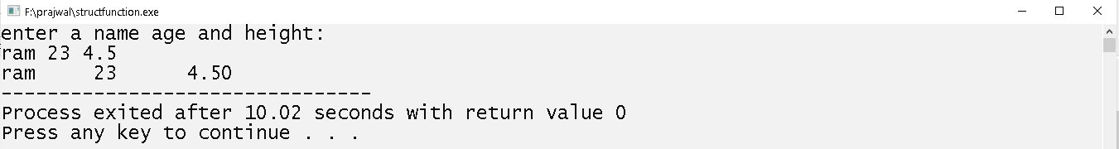

# Write a program to find sum of at least 10 number using command line argument.

## Source code:

#include<stdio.h>

int main(int argc,char* argv[])

{

int i;int sum=0;

if(argc>10)

{

for(i=0;i<argc;i++)

sum+=atoi(argv[i]);

printf("sum=%d",sum);

}

else

printf("error less than 10 numbers");

return 0;

}

## Output window :

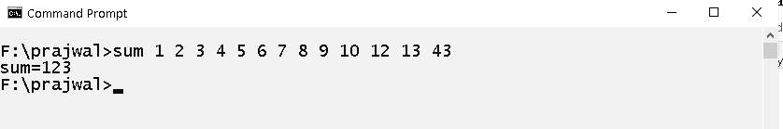

# Write a program to take 5 character from user and display them using pointer.

## Source code:

#include<stdio.h>

int main()

{

char charc[5],i;

printf("enter a characters below:\n");

for (i=0;i<5;i++)

{

printf("enter character%d: ",i+1);

scanf("%c",charc+i);

fflush(stdin);

}

for (i=0;i<5;i++)

{

printf("%4c",*(charc+i));

}

return 0;

}

## Output windows

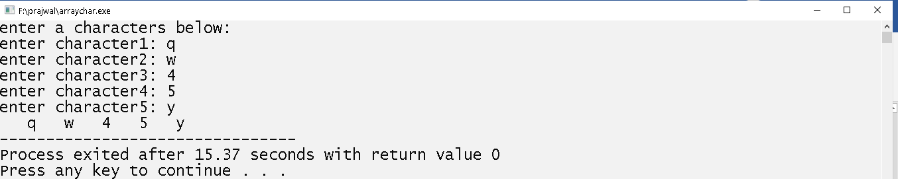

# Write a program to swap the value of two variable using macros.

## Source code:

#include<stdio.h>

#define SWAP(a,b) a=a+b;b=a-b;a=a-b

int main()

{

int a,b;

printf("enter two number: ");

scanf("%d%d",&a,&b);

printf("values before swapping:a=%d b=%d\n",a,b);

SWAP(a,b);

printf("values before swapping:a=%d b=%d\n",a,b);

return 0;

}

## Output window:

