**A**

**LAB REPORT**

**ON**

**C PROGRAMMING**

**Phase I**

**By**

**Prajwal Dahal**

**Exam Roll No:**



**Submitted to:**

**Pradip Bhochhibhoya**

**IT Department**

**Kantipur College of Management and Information Technology**

In partial fulfillment of the requirements for the Course

C programming

Mid Baneshwor, Kathmandu

October 2020

**TABLE OF CONTENTS**

1. Write program to display your name. 5

1.1 Source Code 5

1.2 Output Window 5

2. Write program to display following pattern using escape sequences: 6

2.1 Source Code 6

2.2 Output Window 6

3. If a=2 ,b=3,c=5 Write a program to evaluate a following expression 7

3.1 Source Code 7

3.2 Output Window 7

4. Write a program to take 1 integer data, 1 float, 1 double, 1 character and 1 string from user and display it. 8

4.1 Source Code 8

4.2 Output Window 8

5. Take 6 integers from user and display their average. Write type casting statement explicitly to calculate average. 9

5.1 Source Code 9

5.2 Output Window 9

6. Write program to take co-efficient (a, b, c) of quadratic equation from user and display their roots. 10

6.1 Source Code 10

6.2 Output Window 10

7. Write program to take 1 character from user and Check it is 'c' or not. 11

7.1 Source Code 11

7.2 Output Window 11

8. Write a program to take string data from user and check whether it is “kantipur” or not. 12

8.1 Source Code 12

8.2 Output Windows 12

9. Write program to take 2 integers from user and display their sum if 1st number is greater than 2nd number, display their product if 2nd number is greater than 1st number otherwise display their average. 13

9.1 Source Code 13

9.2 Output Window 13

10. Write program to take 3 integers from user and display greatest integer. 14

10.1 Source Code 14

10.2 Output Window 14

11. Write a program to take 3 character from user and find the smallest character 15

11.1 Source Code 15

11.2 Output Windows 15

12. Write a program to take 3 character from user and display the middle character. 16

12.1 Source Code 16

12.2 Output Windows 16

13. Write a program to take 3 string and display greatest string. 17

13.1 Source Code 17

13.2 Output Windows 18

14. Write program to display even numbers from 2 to 50. 19

14.1 Source Code 19

14.2 Output Window 19

15. Write program to display odd numbers from 1 to 200. 20

15.1 Source Code 20

15.2 Output Windows 20

16. Write program to display multiples of 7 from 20 to 300. 21

16.1 Source Code 21

16.2 Output Window 21

17. Write program to display of six ASCII character set with their respective values in Octal, Decimal and Hexadecimal Number System. 22

17.1 Source Code 22

17.2 Output Windows 22

18. Write program to calculate and display the sum of first 20 natural numbers 23

18.1 Source Code 23

18.2 Output Window 23

19. Write program to take lower bound and upper bound integer value from user and display integer numbers between them. 24

19.1 Source Code 24

19.2 Output Window 24

20. Write a program to take 2 input from user and display the sum of odd number between them 25

20.1 Source Code 25

20.2 Output Window 25

21. Write a program to display following series: 25

21.1 Source Code 26

21.2 Output Window 26

22. Write program to take 6 integers from user and display them. 27

22.1 Source Code 27

22.2 Output Windows 27

23. Write a program to take 6 string from user and display them. 28

23.1 Source Code 28

23.2 Output Window 28

24. Write program to take 15 integers from user and display even numbers only. 29

24.1 Source Code 29

24.2 Output Window 29

25. Write a program to take 15 integers from user and display the average of odd number only. 30

25.1 Source Code 30

25.2 Output Window 30

26. Write a program to take 15 integers from user and display average of multiples of 7. 31

26.1 Source Code 31

26.2 Output Window 31

27. Write a program to take 15 integer from the user and display it in reverse order. 32

27.1 Source Code 32

27.2 Output Window 32

28. Write a program to take 15 integer from user and search 75 in it . 33

28.1 Source Code 33

28.2 Output Window 33

29. Write a program to take 15 integers from user and display greatest number. 33

29.1 Source Code 34

29.2 Output Window 34

30. Write a program to take 15 integers from user and display smallest number. 35

30.1 Source Code 35

30.2 Output Window 35

31. Write program to take 5 integers in two arrays, let say A and B then display the sum array after adding A and B, i.e. A+B. 36

31.1 Source Code 36

31.2 Output Window 37

32. Write a program to take title, author and price of a book and display them. 38

32.1 Source code: 38

32.2 Output window: 38

33. Write a program using structure to take (name, age and height) of 5 person and display them. 39

33.1 Source code: 39

33.2 Output windows 40

34. Write a program to take name, age, height, address of 3 person and display the record of person whose age is greater than 20 and less than 30. 41

34.1 Source code: 41

34.2 Output windows 41

35. Write a program to demonstrate a use of pointers. 42

35.1 Source code: 42

35.2 Output windows: 42

36. Write a program to take 6 integers from user and store them in num.txt. 43

36.1 Source code: 43

36.2 Output window: 43

37. Write a program to take 6 integers from file num.txt and display them. 44

37.1 Source code: 44

37.2 Output Window: 44

38. Write a program to store name, age and height of 4 person and store them in person.txt. 45

38.1 Source code: 45

38.2 Output Window: 45

39. Write a program to read the data from file “person.txt” and display them. 46

39.1 Source code 46

39.2 Output windows 46

40. Write a program to take 10 integers from user and display the sum using function. 47

40.1 Source code: 47

40.2 Output Windows: 47

41. Write a program to display the length of total character in the string using function. 48

41.1 Source code 48

41.2 Output Windows 48

# Write program to display your name.

## Source Code

#include<stdio.h>

int main()

{

int i;

Printf(“Prajwal Dahal”);

return 0;

}

## Output Window

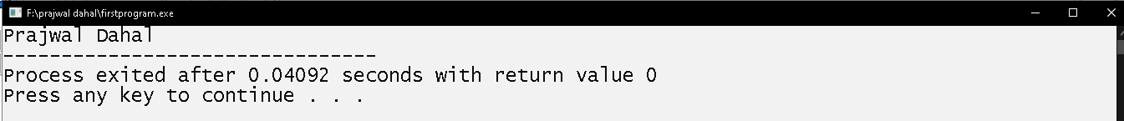

# Write program to display following pattern using escape sequences:

**Apple    Ball**

**Cat**

**Elephant        Football**

## Source Code

#include<stdio.h>

 int main ()

 {

printf("Apple\tBall\nCat\nElephant\t\tFootball");

return 0;

}

## Output Window

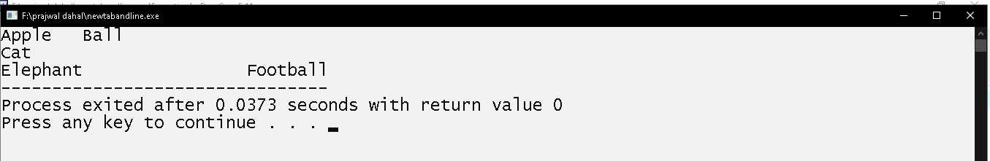

# If a=2 ,b=3,c=5 Write a program to evaluate a following expression

$\sqrt[3]{ab}$**+ $\sqrt[5]{bc}$ + $\sqrt{ac}$**

## Source Code

#include<stdio.h>

#include<math.h>

int main()

{

float a = 2;

float b = 3;

float c = 5; float rslt1,rslt2,rslt3,finalrslt;

rslt1 = a*b;

rslt2 = b*c;

rslt3 = a*c;

finalrslt=pow(rslt1,0.25)+pow(rslt2,0.2)+sqrt(rslt3);

printf("%f",finalrslt);

return 0;

}

## Output Window

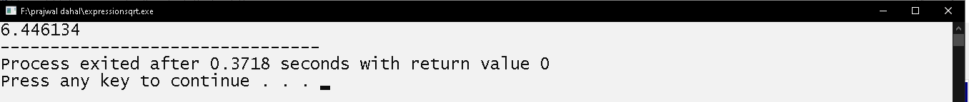

# Write a program to take 1 integer data, 1 float, 1 double, 1 character and 1 string from user and display it.

## Source Code

#include<stdio.h>

int main()

{

int num;float num2; double num3; char ch;char str[50];

printf("enter a number: ");

scanf("%d",&num);

printf("enter a float number: ");

scanf("%f",&num2);

printf("enter a double number: ");

scanf("%lf",&num3);

printf("enter a character: ");

fflush(stdin);

scanf("%c",&ch);

printf("enter a word: ");

scanf("%s",str);

printf("\nintegerdata=%d\n",num);

printf("floatdata=%f\n",num2);

printf("doubledata=%lf\n",num3);

printf("character=%c\n",ch);

printf("string=%s\n",str);

return 0;

}

## Output Window

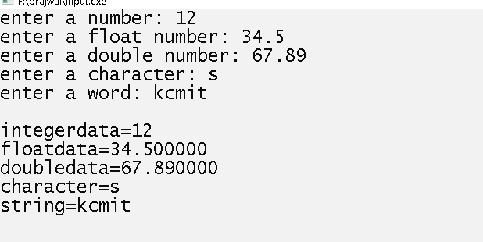

# Take 6 integers from user and display their average. Write type casting statement explicitly to calculate average.

## Source Code

#include<stdio.h>

int main()

{

int num1,num2,num3,num4,num5,num6;

float avg;

printf("enter 1st number? ");

scanf("%d",&num1);

printf("enter 2nd number? ");

scanf("%d",&num2);

printf("enter 3rd number? ");

scanf("%d",&num3);

printf("enter 4th number? ");

scanf("%d",&num4);

printf("enter 5th number? ");

scanf("%d",&num5);

printf("enter 6th number? ");

scanf("%d",&num6);

avg=(num1+num2+num3+num4+num5+num6)/(float)6;

printf("avg=%f",avg);

return 0;

}

## Output Window

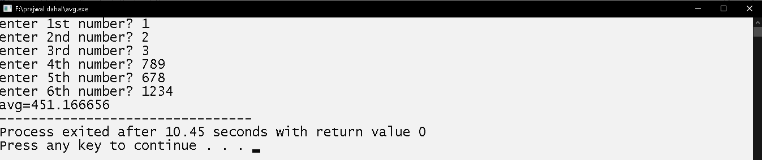

# Write program to take co-efficient (a, b, c) of quadratic equation from user and display their roots.

**Formula to calculate roots: $x =\frac{-b±\sqrt{b^{2}-4ac}}{2a}$**

## Source Code

#include<stdio.h>

#include<math.h>

int main()

{

int a,b,c;

double sqr,result1,result2;

printf("enter the first coefficient of quardatic equation? ");

scanf("%d",&a);

printf("enter the second coefficient of quardatic equation? ");

scanf("%d",&b);

printf("enter the third coefficient of quardatic equation? ");

scanf("%d",&c);

sqr=sqrt(b*b-4*a*c);

result1=(-b+sqr)/(2*a);

result2=(-b-sqr)/(2*a);

printf ("ans:(%f, %f)", result1, result2);

return 0;

}

## Output Window

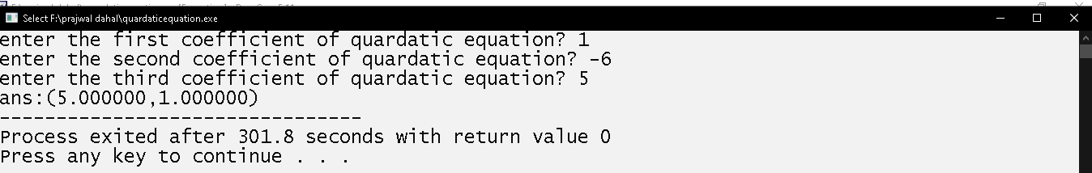

# Write program to take 1 character from user and Check it is 'c' or not.

## Source Code

#include<stdio.h>

int main()

{

char c;

printf("enter a character: ");

scanf("%c",&c);

if(c=='c')

{

printf("entered character is c");

}

if(c!='c')

{

printf("entered character isnot c");

}

return 0;

}

## Output Window

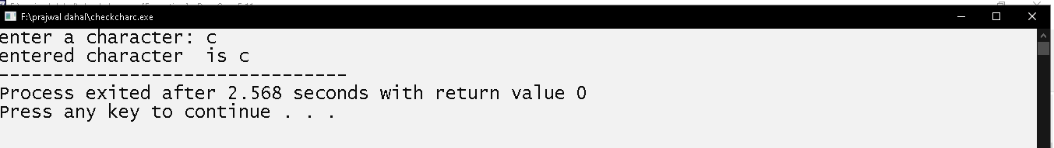

# Write a program to take string data from user and check whether it is “kantipur” or not.

## Source Code

#include<stdio.h>

#include<string.h>

int main()

{

char c[20];

int d;

printf("enter a word: ");

scanf("%s",c);

d=strcmp(c,"kantipur");

if(d==0)

{

printf("entered word is kantipur");

}

else

{

printf("entered word isn,t kantipur");

}

return 0;

}

## Output Windows

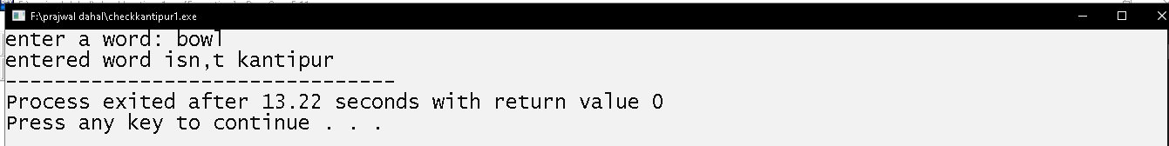

# Write program to take 2 integers from user and display their sum if 1st number is greater than 2nd number, display their product if 2nd number is greater than 1st number otherwise display their average.

## Source Code

#include<stdio.h>

int main()

{

    int a,b;

    printf("enter a number: ");

    scanf("%d",&a);

    printf("enter a second number: ");

    scanf("%d",&b);

    if(a>b)

    {

        printf("sum=%d",a+b);

    }

    else if (b>a)

    {

        printf("product=%d",a*b);

    }

    else

    {

        printf("average=%f",(a+b)/(float)2);

    }

    return 0;

}

## Output Window

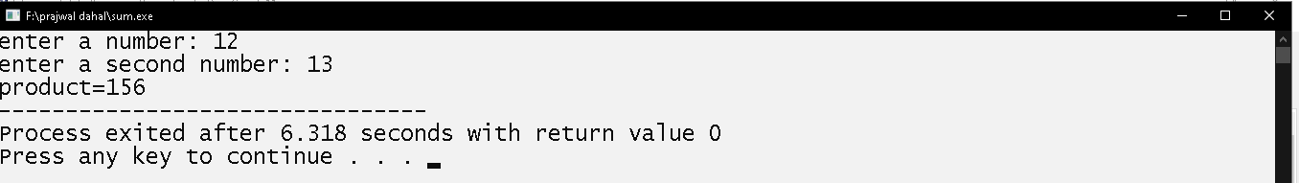

# Write program to take 3 integers from user and display greatest integer.

## Source Code

#include<stdio.h>

int main()

{

int a,b,c;

printf("enter a number: ");

scanf("%d",&a);

printf("enter a second number: ");

scanf("%d",&b);

printf("enter third number: ");

scanf("%d",&c);

if(a>=b&&a>c)

{

printf("%d is greatest number",a);

}

else if(b>a&&b>=c)

{

printf("%d is greatest number",b);

}

else if(c>=a&&c>b)

{

printf("%d is greatest number",c);

}

else

{

printf("all are equal");

}

return 0;

}

## Output Window

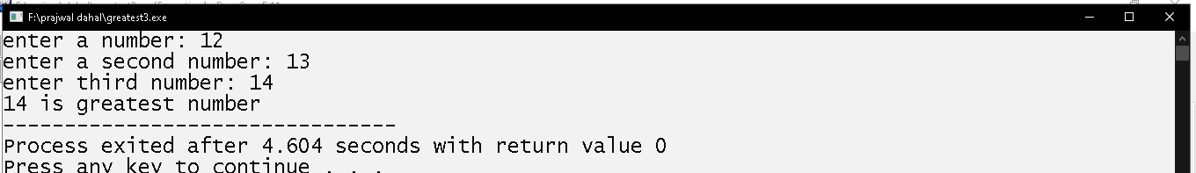

# Write a program to take 3 character from user and find the smallest character

## Source Code

#include<stdio.h>

int main()

{

char a,b,c;

printf("enter a character: ");

scanf("%c",&a);

fflush(stdin);

printf("enter a second character: ");

scanf("%c",&b);

fflush(stdin);

printf("enter third character: ");

scanf("%c",&c);

if(a<=b&&a<c)

{

printf("%c is smallest character",a);

}

else if(b<a&&b<=c)

{

printf("%c is smallest character",b);

}

else if(c<=a&&c<b)

{

printf("%c is smallest character",c);

}

else

{

printf("all are equal");

}

return 0;

}

## Output Windows

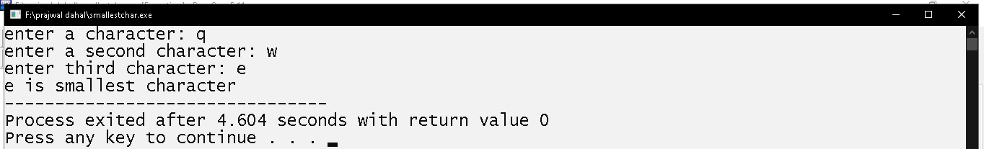

# Write a program to take 3 character from user and display the middle character.

## Source Code

#include<stdio.h>

int main()

{

char a,b,c;

printf("enter a character: ");

scanf("%c",&a);

fflush(stdin);

printf("enter a second character: ");

scanf("%c",&b);

fflush(stdin);

printf("enter third character: ");

scanf("%c",&c);

if(a>b&&a<c||a<b&&a>c)

{

printf("%c is middle character",a);

}

else if(b>a&&b<c||b<a&&b>c)

{

printf("%c is middle character",b);

}

else if(c<a&&c>b||c>a&&c<b)

{

printf("%c is middle character",c);

}

else

{

printf("two of them or all are equal");

}

return 0;

}

## Output Windows

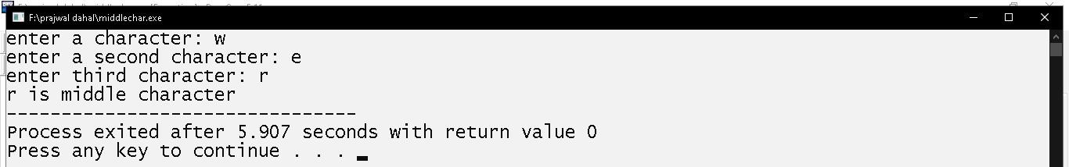

# Write a program to take 3 string and display greatest string.

## Source Code

#include<stdio.h>

#include<string.h>

int main()

{

char a[20],b[20],c[20];

int rslt,rslt1,rslt2;

printf("enter a word: ");

scanf("%s",a);

fflush(stdin);

printf("enter a second word: ");

scanf("%s",b);

fflush(stdin);

printf("enter third word: ");

scanf("%s",c);

rslt=strcmp(a,b);

rslt1=strcmp(a,c);

rslt2=strcmp(b,c);

if(rslt>=0&&rslt1>0)

{

printf("%s is greatest word",a);

}

else if(rslt<0&&rslt2>=0)

{

printf("%s is greatest word",b);

}

else if(rslt1<=0&&rslt2<0)

{

printf("%s is greatest word",c);

}

else

{

printf("all are equal");

}

return 0;

}

## Output Windows

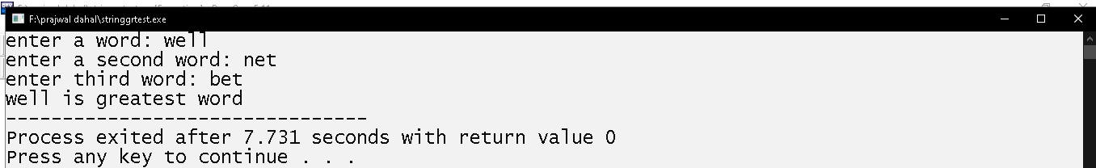

# Write program to display even numbers from 2 to 50.

## Source Code

#include<stdio.h>

int main()

{

int a;

printf("\t");

for(a=2;a<=50;a+=2)

{

printf("%d\t",a);

}

return 0;

}

## Output Window

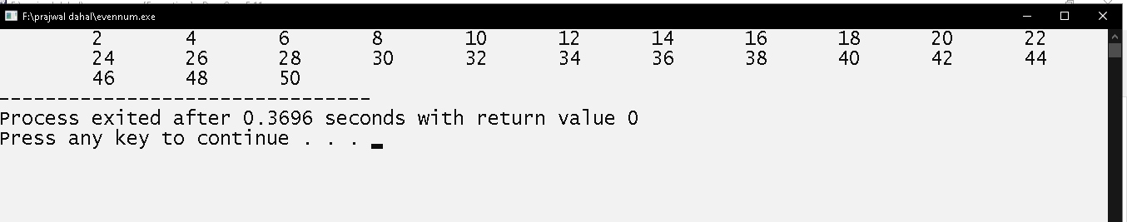

# Write program to display odd numbers from 1 to 200.

## Source Code

#include<stdio.h>

int main()

{

int a;

printf("\t");

for(a=1;a<=200;a+=2)

{

printf("%d\t",a);

}

return 0;

}

## Output Windows

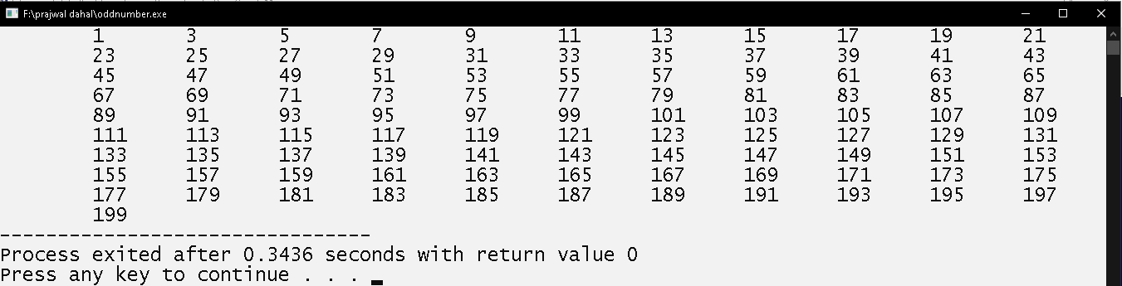

# Write program to display multiples of 7 from 20 to 300.

## Source Code

#include<stdio.h>

int main()

{

int i;

printf("\t");

for(i=21;i<=300;i+=7)

{

printf("%d\t",i);

}

return 0;

}

## Output Window

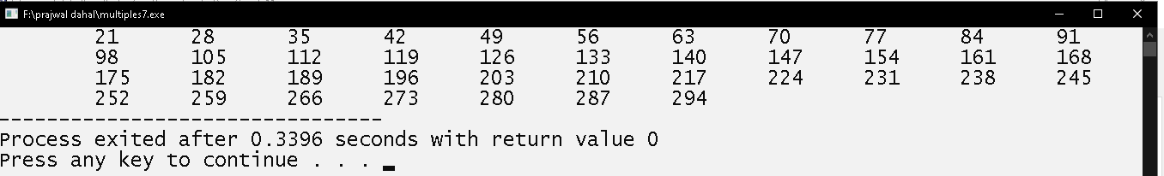

# Write program to display of six ASCII character set with their respective values in Octal, Decimal and Hexadecimal Number System.

## Source Code

#include<stdio.h>

int main()

{

int i;

for(i=65;i<=70;i++)

{

printf("character=%c\n",i);

printf("asciivalue=%d\thexadecimal=%x\toctal=%o\n\n",i,i,i);

}

return 0;

}

## Output Windows

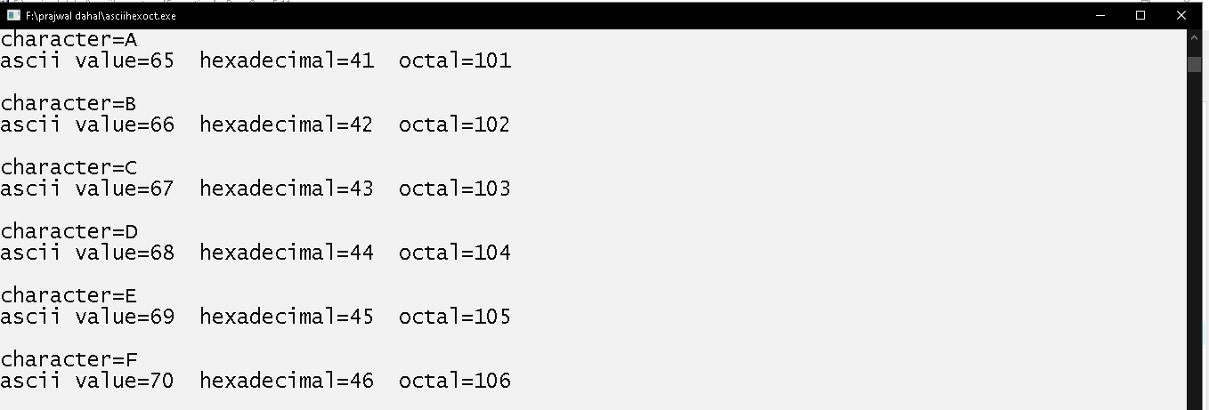

# Write program to calculate and display the sum of first 20 natural numbers

## Source Code

#include<stdio.h>

int main()

{

int i,sum=0;

for(i=1;i<=20;i++)

{

sum+=i;

}

printf("sum=%d",sum);

return 0;

}

## Output Window

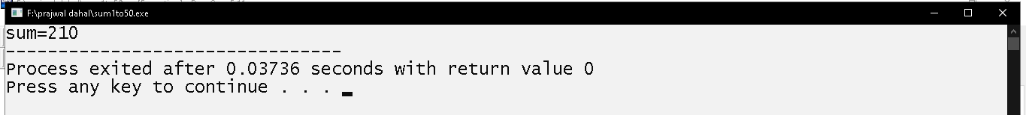

# Write program to take lower bound and upper bound integer value from user and display integer numbers between them.

## Source Code

#include<stdio.h>

int main()

{

    int a,b,i;

    printf("enter a integer: ");

    scanf("%d",&a);

    printf("enter second integer(>first integer): ");

    scanf("%d",&b);

    for(i=a+1;i<b;i++)

    {

        printf("%d\t",i);

    }

    return 0;

}

## Output Window

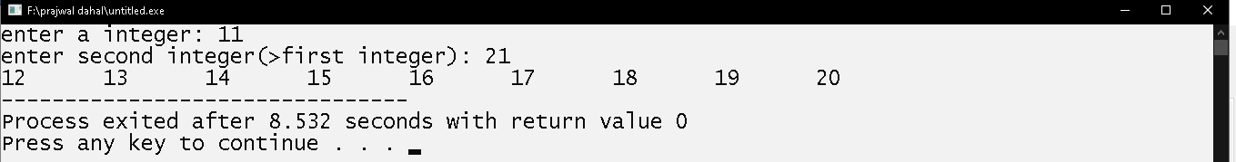

# Write a program to take 2 input from user and display the sum of odd number between them

## Source Code

#include<stdio.h>

int main()

{

int a,b,i,sum=0;

printf("enter a integer: ");

scanf("%d",&a);

printf("enter second integer: ");

scanf("%d",&b);

if(b>a)

{

for(i=a+1;i<b;i++)

{

if(i%2==1)

{

sum+=i;

}

}

}

else

{

for(i=b+1;i<a;i++)

{

if(i%2==1)

{

sum+=i;

}

}

}

printf("sum=%d",sum);

return 0;

}

## Output Window

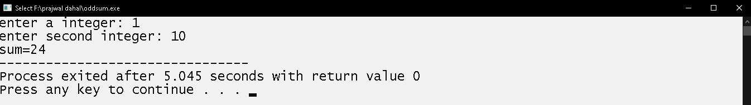

# Write a program to display following series:

**9,28,14,7,22 until the number is 1**

## Source Code

#include<stdio.h>

int main()

{

int i,a=9;

for(;a!=1;)

{

if(a%2==0)

{

a/=2;

}

else

{

a=a*3+1;

}

printf("%4d",a);

}

return 0;

}

## Output Window

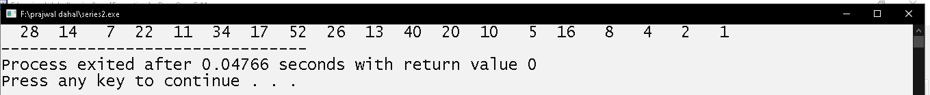

# Write program to take 6 integers from user and display them.

## Source Code

#include<stdio.h>

int main()

{

int a[6],i;

printf("enter 6 numbers below:\n\n")

for (i=0;i<6;i++)

{

printf("enter number%d: ",i+1);

scanf("%d",&a[i]);

}

for (i=0;i<6;i++)

{

printf("%d\n",a[i]);

}

return 0;

}

## Output Windows

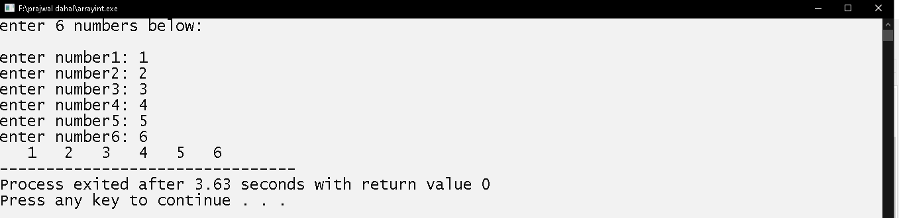

# Write a program to take 6 string from user and display them.

## Source Code

#include<stdio.h>

int main()

{

char str[6][20],i;

printf("enter 6 words below:\n");

for (i=0;i<6;i++)

{

printf("enter word%d: ",i+1);

scanf("%s",&str[i]);

fflush(stdin);

}

Printf(“\n”);

for (i=0;i<6;i++)

{

printf("\n%s\t",str[i]);

}

return 0;

}

## Output Window

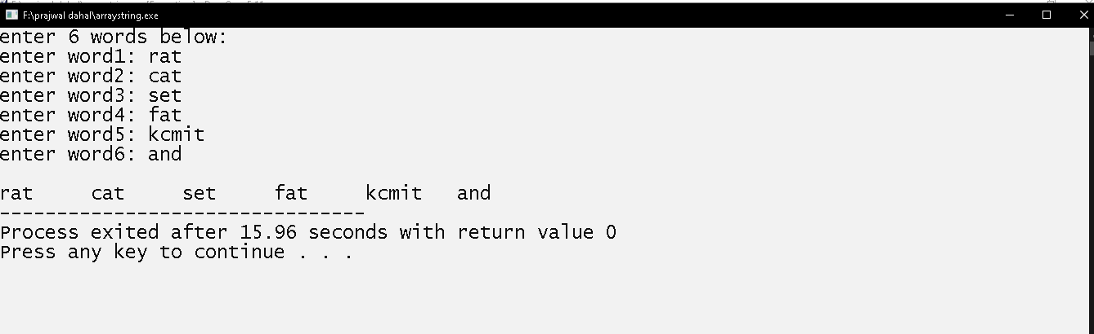

# Write program to take 15 integers from user and display even numbers only.

## Source Code

#include<stdio.h>

int main()

{

int a[15],i;

printf("enter 15 numbers below:\n\n");

for (i=0;i<15;i++)

{

printf("enter number%d: ",i+1);

scanf("%d",&a[i]);

}

printf("\nentered even numbers are:\n\n");

for (i=0;i<15;i++)

{

if(a[i]%2==0)

{

printf("%d\t",a[i]);

}

}

return 0;

}

## Output Window

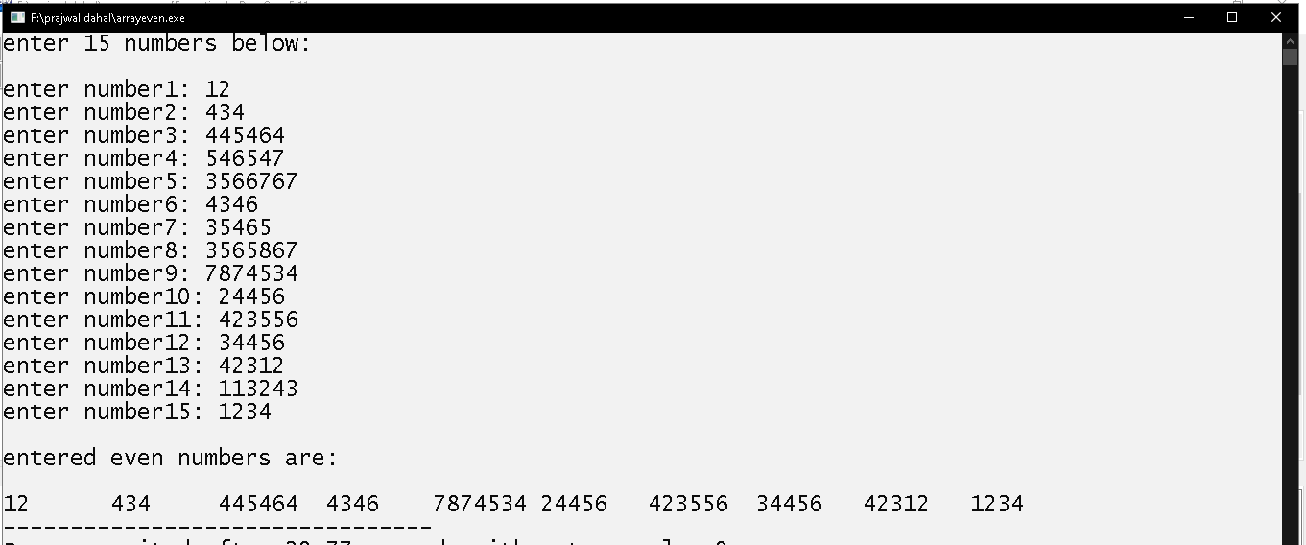

# Write a program to take 15 integers from user and display the average of odd number only.

## Source Code

#include<stdio.h>

int main()

{

int a[15],i;int sum=0;int count=0;

printf("enter 15 numbers below:\n\n");

for (i=0;i<15;i++)

{

printf("enter number%d: ",i+1);

scanf("%d",&a[i]);

}

for (i=0;i<15;i++)

{

if(a[i]%2==1)

{

sum+=a[i];

count++;

}

}

printf("\navg=%f",sum/(float)count);

return 0;

}

## Output Window

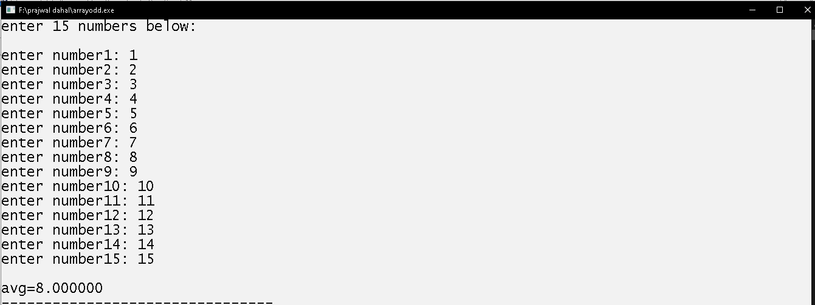

# Write a program to take 15 integers from user and display average of multiples of 7.

## Source Code

#include<stdio.h>

int main()

{

    int a[15],i;int sum=0,count=0;

    printf("enter 15 numbers below:\n\n");

    for (i=0;i<15;i++)

    {

        printf("enter number%d: ",i+1);

        scanf("%d",&a[i]);

    }

        for (i=0;i<15;i++)

    {

        if(a[i]%7==0)

        {

        sum+=a[i];

         count++;

        }

    }

    printf("avg=%f",sum/(float)count);

    return 0;

}

## Output Window

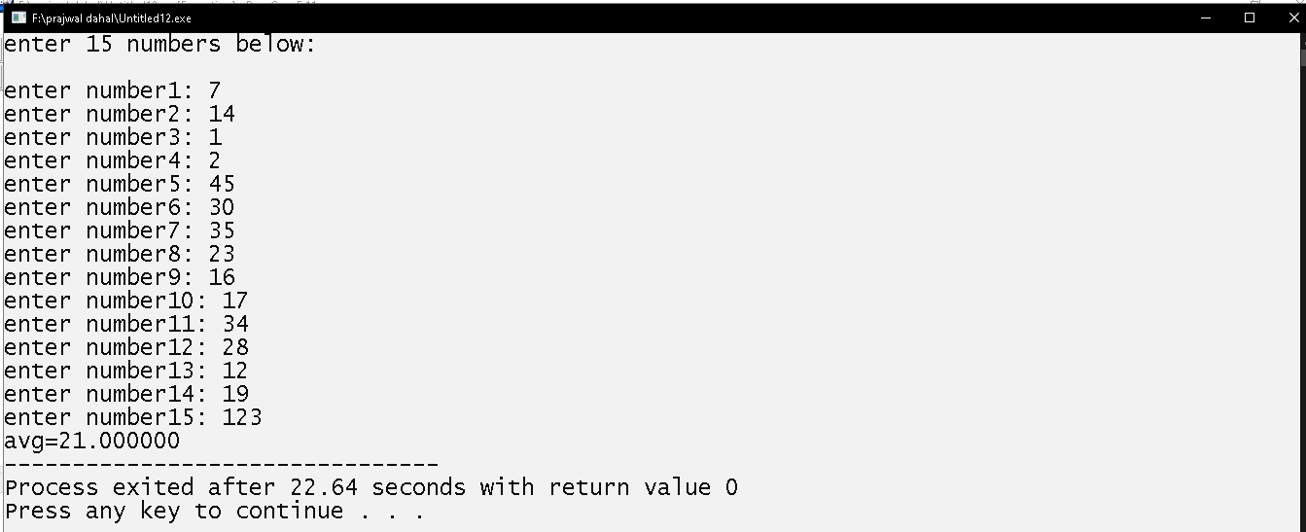

# Write a program to take 15 integer from the user and display it in reverse order.

## Source Code

#include<stdio.h>

int main()

{

int a[15],i;

printf("enter 15 numbers below:\n\n");

for (i=0;i<15;i++)

{

printf("enter number%d: ",i+1);

scanf("%d",&a[i]);

}

printf("\t");

for (i=14;i>=0;i--)

{

printf("%d\t",a[i]);

}

return 0;

}

## Output Window

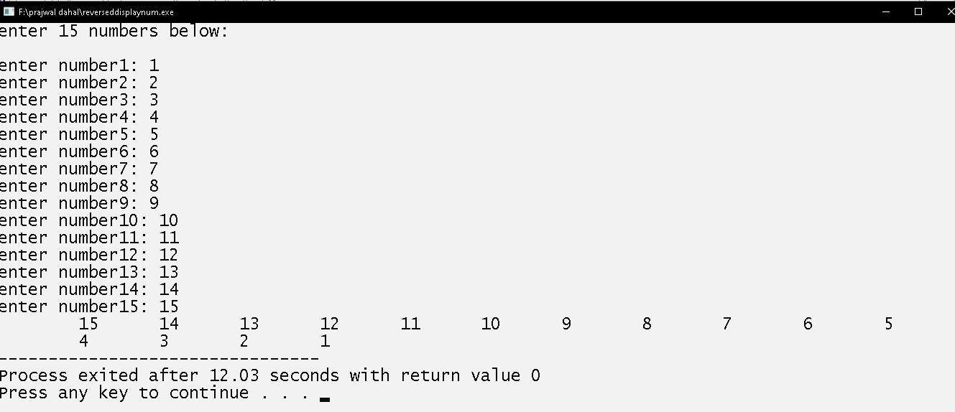

# Write a program to take 15 integer from user and search 75 in it .

## Source Code

#include<stdio.h>

int main()

{

int a[15],i;int count=0;

printf("enter 15 numbers below:\n\n");

for (i=0;i<15;i++)

{

printf("enter number%d: ",i+1);

scanf("%d",&a[i]);

}

for (i=0;i<15;i++)

{

if(a[i]==75)

{

printf("\n\nfound in %d position\n",i+1);

count++;

}

}

if(count==0)

{

printf("\n\n75 isnot found");

}

return 0;

}

## Output Window

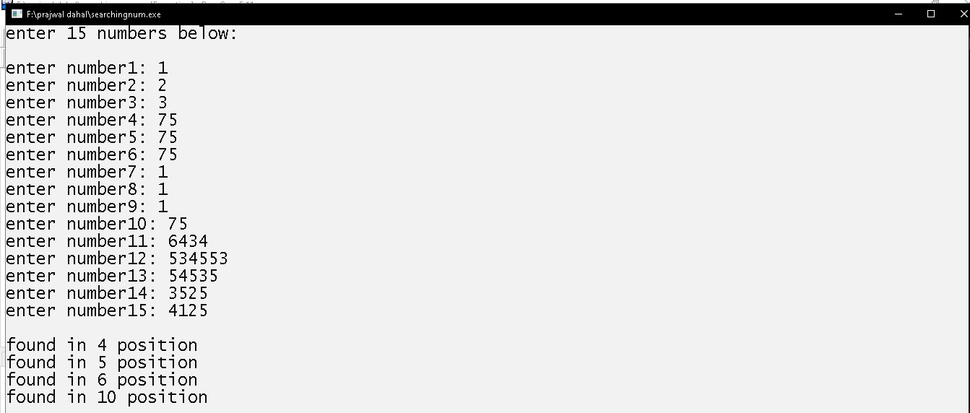

# Write a program to take 15 integers from user and display greatest number.

## Source Code

#include<stdio.h>

int main()

{

int a[15],i;int g;

printf("enter 15 numbers below:\n\n");

for (i=0;i<15;i++)

{

printf("enter number%d: ",i+1);

scanf("%d",&a[i]);

}

g=a[0];

for (i=0;i<15;i++)

{

if(a[i]>g)

{

g=a[i];

}

}

printf("\ngreatest num=%d",g);

return 0;

}

## Output Window

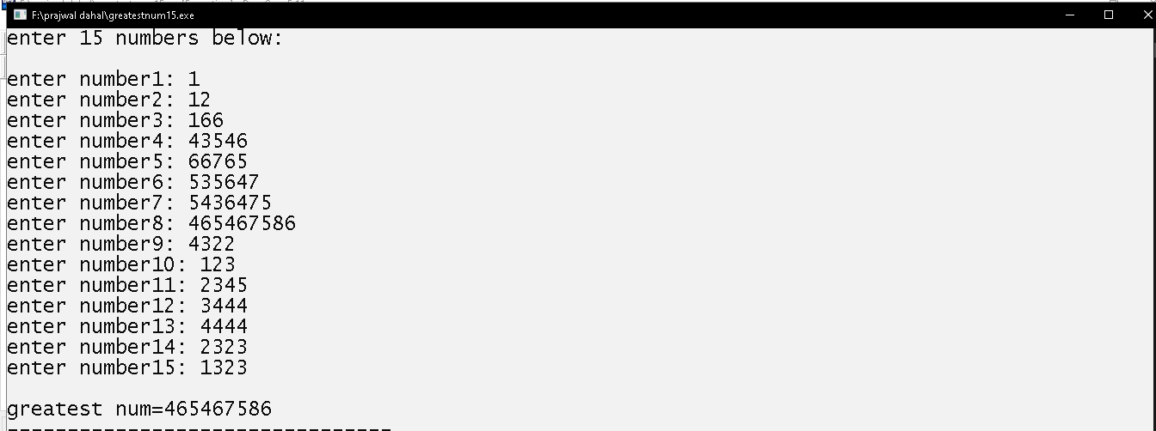

# Write a program to take 15 integers from user and display smallest number.

## Source Code

#include<stdio.h>

int main()

{

int a[15],i;int s;

printf("enter 15 numbers below:\n\n");

for (i=0;i<15;i++)

{

printf("enter number%d: ",i+1);

scanf("%d",&a[i]);

}

S=a[0];

for (i=0;i<15;i++)

{

if(a[i]<s)

{

s=a[i];

}

}

printf("\nsmallest num is %d",s);

return 0;

}

## Output Window

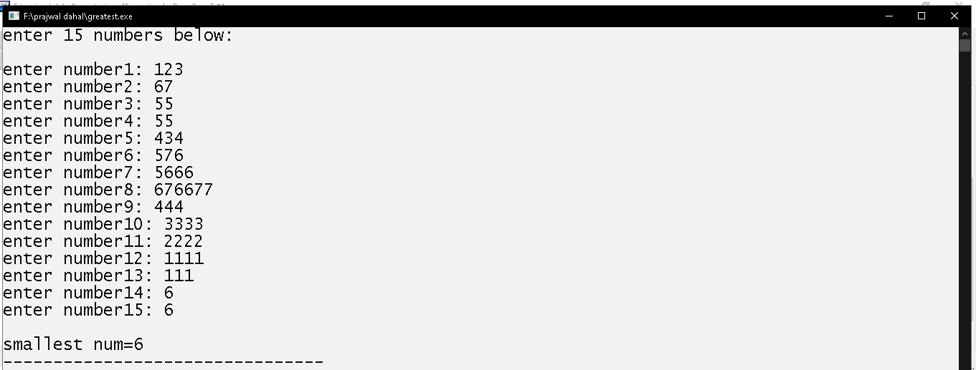

# Write program to take 5 integers in two arrays, let say A and B then display the sum array after adding A and B, i.e. A+B.

## Source Code

#include<stdio.h>

int main()

{

int a[5],b[5],i,sum[5];

printf("enter 5 numbers below:\n\n");

for (i=0;i<5;i++)

{

printf("enter number%d: ",i+1);

scanf("%d",&a[i]);

}

printf("\n\nenter again 5 numbers...\n");

for (i=0;i<5;i++)

{

printf("enter number%d: ",i+1);

scanf("%d",&b[i]);

}

for (i=0;i<5;i++)

{

sum[i]=a[i]+b[i];

}

printf("\ncorresponding sum result:\n");

for (i=0;i<5;i++)

{

printf("%d\n",sum[i]);

}

return 0;

}

## Output Window

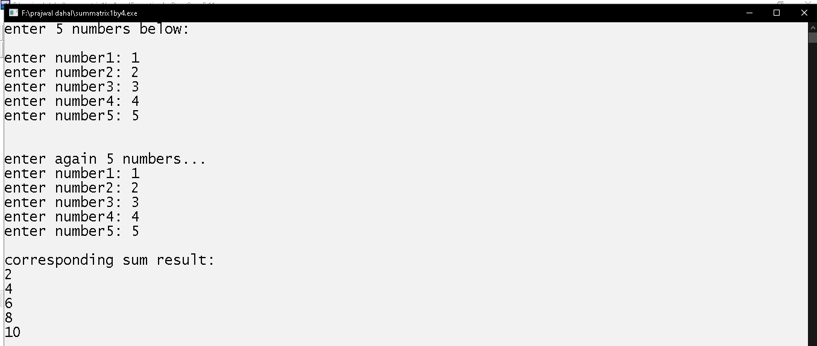

# Write a program to take title, author and price of a book and display them.

## Source code:

#include<stdio.h>

struct book

{

char title[20];

char author[20];

float price;

}b;

int main()

{

printf("enter a title of book: ");

gets(b.title);

printf("enter a author of book: ");

gets(b.author);

printf("enter a price of book: ");

scanf("%f",&b.price);

printf("%s\t%s\t%f",b.title,b.author,b.price);

return 0;

}

## Output window:

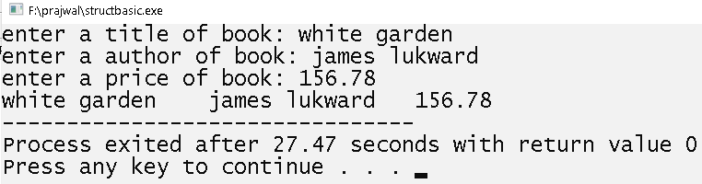

# Write a program using structure to take (name, age and height) of 5 person and display them.

## Source code:

#include<stdio.h>

struct student

{

char name[20];

char address[50];

int age;

float height;

}s[4];

int main()

{

int i;int a;

printf("enter a name age,height and address of 4 student below:);

for(i=0;i<4;i++)

{

scanf("%s%d%f%s",s[i].name,&s[i].age,&s[i].height,s[i].address);

}

printf("\n");

for(i=0;i<4;i++)

{

printf("%s\t%d\t",s[i].name,s[i].age);

printf("%.2f\t%s\n",s[i].height,s[i].address);

}

return 0;

}

## 

## Output windows

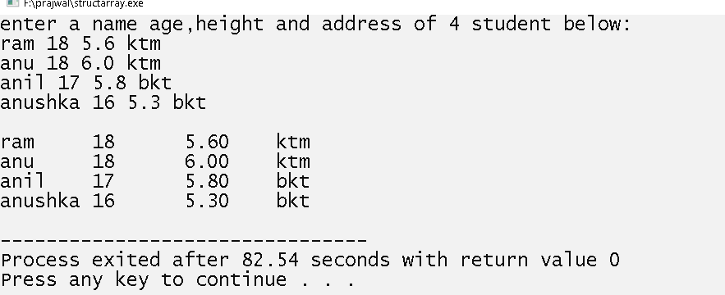

# Write a program to take name, age, height, address of 3 person and display the record of person whose age is greater than 20 and less than 30.

## Source code:

#include<stdio.h>

struct person

{

char name[20];

char address[50];

int age;

float height;

}s[3];

int main()

{

int i;int a;

printf("enter a name,age,height and address of 3 person below:");

for(i=0;i<3;i++)

{

scanf("%s%d%f%s",s[i].name,&s[i].age,&s[i].height,s[i].address);

}

for(i=0;i<3;i++)

{

if(s[i].age>20&&s[i].age<30)

{

printf("%s\t%d\t",s[i].name,s[i].age);

printf("%.2f\t%s",s[i].height,s[i].address);

}

}

return 0;

}

## Output windows

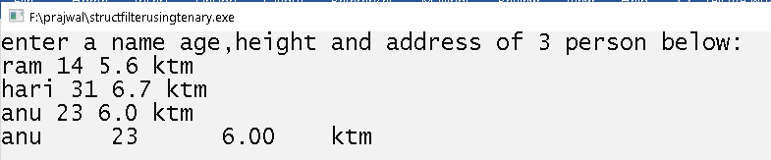

# Write a program to demonstrate a use of pointers.

## Source code:

#include<stdio.h>

int main()

{

int *p,a;char b;

printf("enter a number: ");

scanf("%d",&a);

p = &a; /*store address of a variable*/

printf("a=%d\n",a);

*p=123;/*store '123' in the memory address store by 'p' pointer variable*/

printf("memoryadress(p)=%d\n",p);

printf("value(a)=%d",a);

return 0;

}

## Output windows:

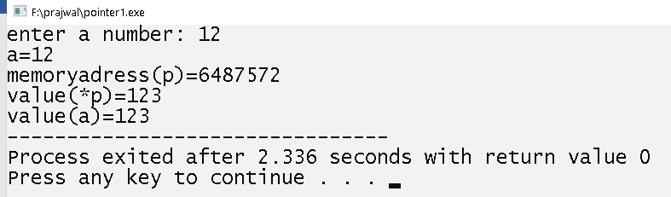

# Write a program to take 6 integers from user and store them in num.txt.

## Source code:

#include<stdio.h>

int main()

{

FILE *f;

int a[15],i;

f=fopen("num.txt","w");

printf("enter 6 numbers below:\n");

for (i=0;i<6;i++)

{

scanf("%d",&a[i]);

}

for (i=0;i<6;i++)

{

fprintf(f,"%4d",a[i]);

}

return 0;

}

## Output window:

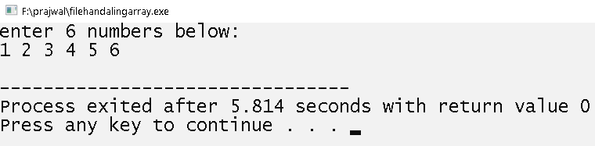

# Write a program to take 6 integers from file num.txt and display them.

## Source code:

#include<stdio.h>

int main()

{

FILE *fp;

int a[6],i;

fp=fopen("num.txt","r");

for (i=0;i<6;i++)

{

fscanf(fp,"%d",&a[i]);

}

for (i=0;i<6;i++)

{

printf("%4d",a[i]);

}

return 0;

}

## Output Window:

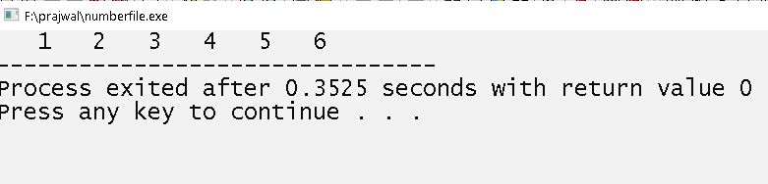

# Write a program to store name, age and height of 4 person and store them in person.txt.

## Source code:

#include<stdio.h>

struct person

{

char name[40];

int age;

int height;

}p[4];

int main()

{

FILE *fp;

int i;

fp=fopen("person.txt","w");

printf("enter name age and height of 4 person:\n");

for(i=0;i<4;i++)

{

scanf("%s%d%f",p[i].name,&p[i].age,&p[i].height);

}

for(i=0;i<4;i++)

{

fprintf(fp,"%s\t%d\t%f\n",p[i].name,p[i].age,p[i].height);

}

return 0;

}

## Output Window:

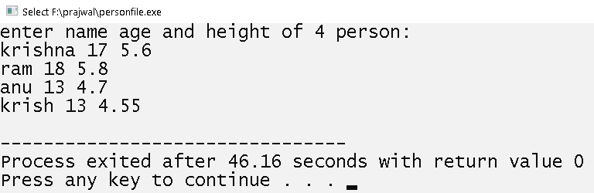

# Write a program to read the data from file “person.txt” and display them.

## Source code

#include<stdio.h>

struct person

{

char name[40];

int age;

float height;

}p[4];

int main()

{

FILE *fp;

int i;

fp=fopen("person.txt","r");

if(fp==NULL)

{

printf("error");

}

for(i=0;i<4;i++)

{

fscanf(fp,"%s%d%f",p[i].name,&p[i].age,&p[i].height);

}

for(i=0;i<4;i++)

{

printf("%s\t%d\t%.2f\n",p[i].name,p[i].age,p[i].height);

}

return 0;

}

## Output windows

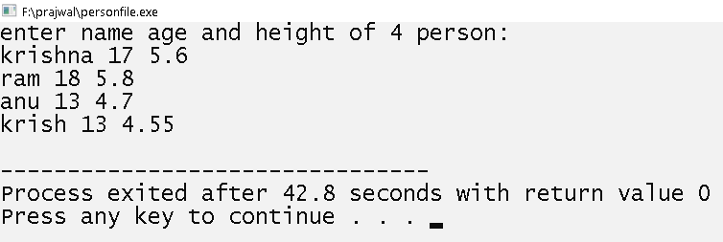

# Write a program to take 10 integers from user and display the sum using function.

## Source code:

#include<stdio.h>

int num[10];int i; int sum;

void input()

{

printf("enter a 10 numbers:");

for(i=0;i<10;i++)

{

scanf("%d",&num[i]);

}

}

void add()

{

for(i=0;i<10;i++)

{

sum+=num[i];

}

}

void display()

{

printf("sum is %d",sum);

}

int main()

{

input();

add();

display();

return 0;

}

## Output Windows:

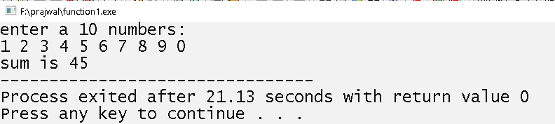

# Write a program to display the length of total character in the string using function.

## Source code

#include<stdio.h>

#include<string.h>

char a[50];int k;

void input()

{

printf("enter a string: ");

gets(a);

}

void charlength()

{

k=strlen(a);

}

void output()

{

printf("length of '%s' is %d",a,k);

}

int main()

{

input();

charlength();

output();

return 0;

}

## Output Windows

