**A**

**LAB REPORT**

**ON**

**Database Administration**

**By**

**Prajwal Dahal**

**TU Reg-no: 6-2-388-03-2019**



**Submitted to:**

**Pradip Bhochhibhoya**

**Lecturer**

**Kantipur College of Management and Information Technology**

In partial fulfillment of the requirements for the Course

Database Administration

Mid Baneshwor, Kathmandu

February 2024

TABLE OF CONTENTS

1 Configure Database in oracle using DBCA 1

2 Create a connection with SQL developer to created database. 3

3 Create user and grant privilege to connect to database. 4

3.1 Query 4

3.2 Output Window 4

4 Create tablespace in oracle database. 5

4.1 Query 5

4.2 Output Window 5

5 Create user and assign 5mb quota on tablespace created above. 6

5.1 Query 6

5.2 Output 6

6 Create profile and assign it to user. 7

6.1 Query 7

6.2 Output Window 7

7 Create Pluggable database in container database. 8

7.1 Query 8

7.2 Output Window: 8

8 Use TNSPING to Test Oracle Net Connectivity. 9

8.1 Command 9

8.2 Output Window 9

9 Checking log mode and altering database to archive log mode. 10

9.1 Query 10

10 Checking listener status in oracle database 11

10.1 Output Window 11

11 Backup database using RMAN utility 12

11.1 Query 12

# Configure Database in oracle using DBCA

* Run DBCA command from Command Line

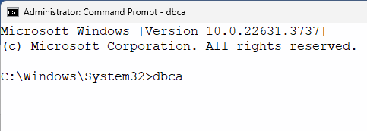

* GUI Window will appear. Select create database from the option and click next button. 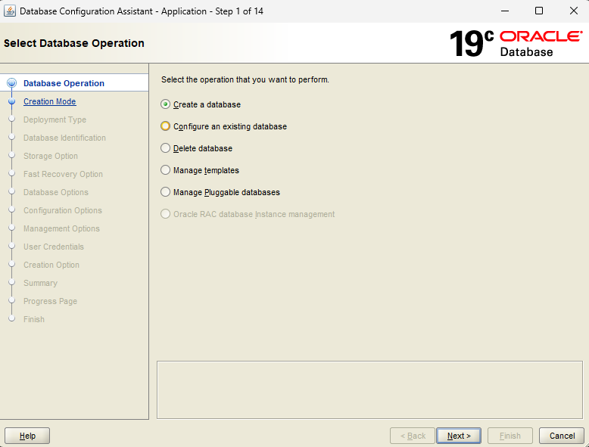
* 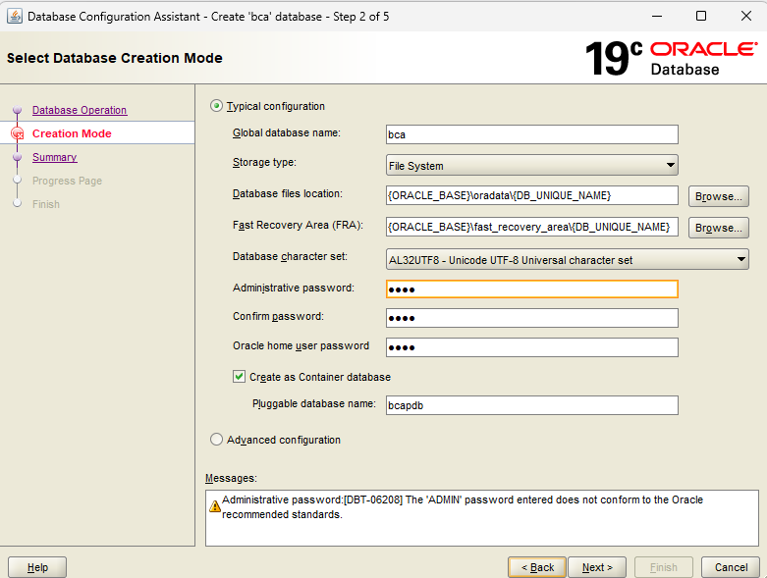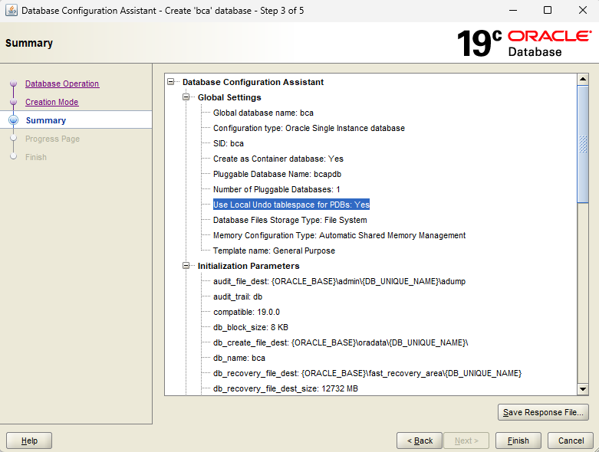Setup typical installation and clicked on next-next

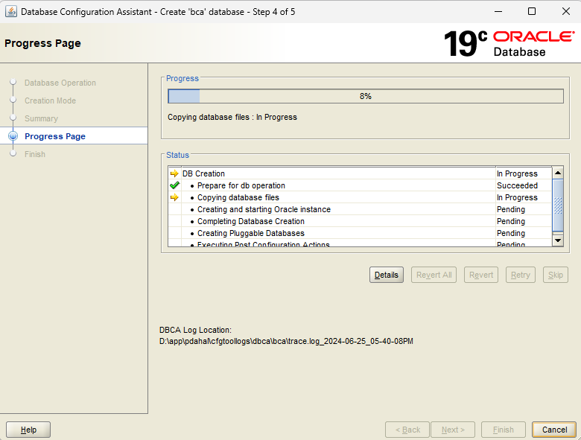

# Create a connection with SQL developer to created database.

* Open SQL developer and create new connection and fill the filed with valid value and connect to bcapdb service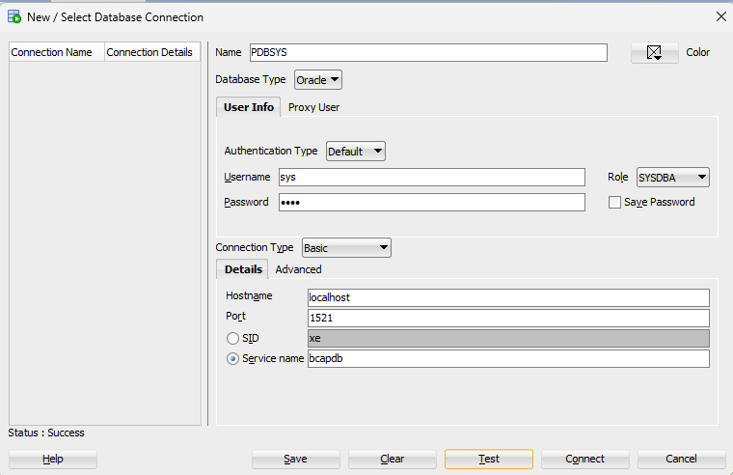

# Create user and grant privilege to connect to database.

## Query

CREATE user prajwal IDENTIFIED BY prajwal;

Grant CONNECT, RESOURCE, CREATE SESSION to prajwal;

## Output Window

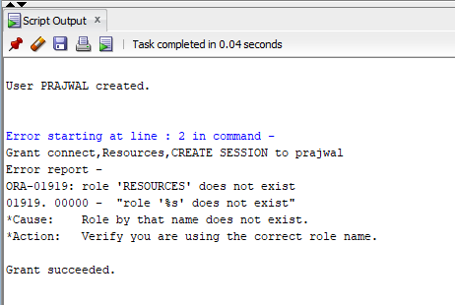

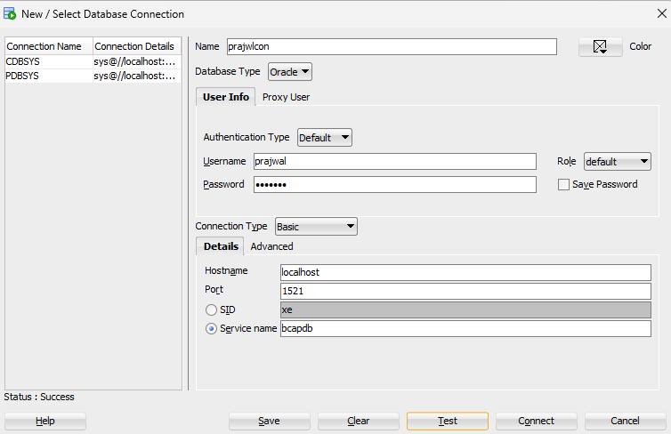

# Create tablespace in oracle database.

## Query

create tablespace tbs01 Datafile 'D:\datafiles\tbs0101.dbf' size 10m blocksize 8k;

## Output Window

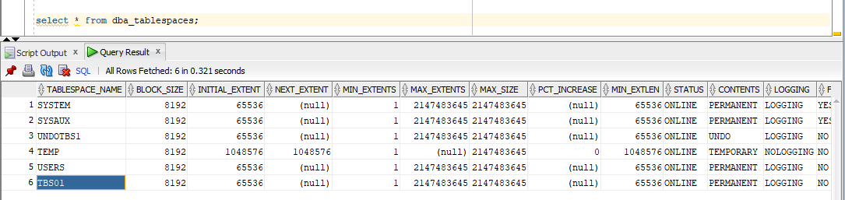

# Create user and assign 5mb quota on tablespace created above.

## Query

Create user prajwal02 identified by prajwal2 default Tablespace tbs01 quota 5m on tbs01;

## Output

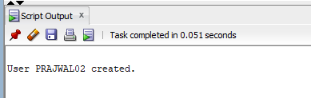

# Create profile and assign it to user.

## Query

CREATE PROFILE my_profile1 LIMIT

SESSIONS_PER_USER 5

CPU_PER_SESSION 10000

CONNECT_TIME 600

IDLE_TIME 30

PASSWORD_LIFE_TIME 90;

Alter user prajwal02 profile my_profile1;

## Output Window

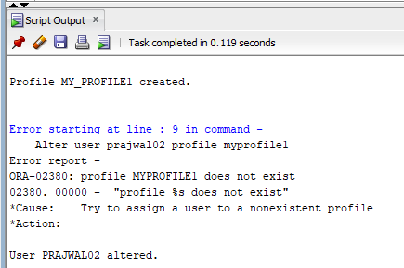

# Create Pluggable database in container database.

## Query

show con_name;

CREATE PLUGGABLE DATABASE bcapdb2

ADMIN USER prajwal IDENTIFIED BY prajwal;

Alter session set container=bcapdb2;

show con_name;

## Output Window:

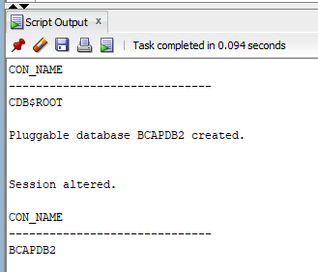

# Use TNSPING to Test Oracle Net Connectivity.

## Command

Tnsping bca

## Output Window

# Checking log mode and altering database to archive log mode.

## Query

SQL> SELECT LOG_MODE FROM V$DATABASE;

LOG_MODE

------------

NOARCHIVELOG

SQL> SHUTDOWN IMMEDIATE;

Database closed.

Database dismounted.

ORACLE instance shut down.

SQL> startup mount;

ORACLE instance started.

Total System Global Area 2516579496 bytes

Fixed Size 9270440 bytes

Variable Size 553648128 bytes

Database Buffers 1946157056 bytes

Redo Buffers 7503872 bytes

Database mounted.

SQL> alter database archivelog;

Database altered.

SQL> SELECT LOG_MODE FROM V$DATABASE;

LOG_MODE

------------

ARCHIVELOG

# Checking listener status in oracle database

## Output Window

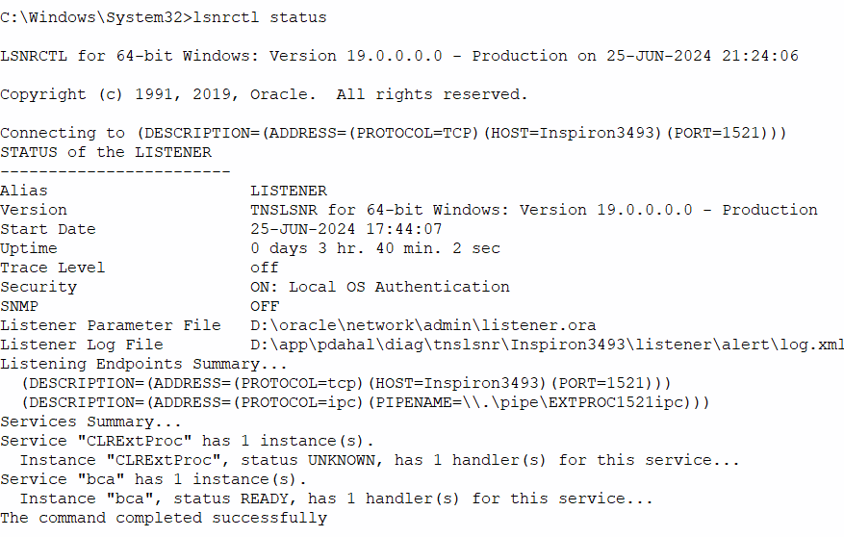

# Backup database using RMAN utility

## Query

C:\Windows\System32>rman target /

Recovery Manager: Release 19.0.0.0.0 - Production on Tue Jun 25 22:08:29 2024

Version 19.3.0.0.0

Copyright (c) 1982, 2019, Oracle and/or its affiliates. All rights reserved.

connected to target database: BCA (DBID=1930167002)

RMAN> BACKUP DATABASE;

Starting backup at 25-JUN-24

using target database control file instead of recovery catalog

allocated channel: ORA_DISK_1

channel ORA_DISK_1: SID=505 device type=DISK

channel ORA_DISK_1: starting full datafile backup set

channel ORA_DISK_1: specifying datafile(s) in backup set

input datafile file number=00001 name=D:\APP\PDAHAL\ORADATA\BCA\DATAFILE\O1_MF_SYSTEM_M7ODFDQ2_.DBF

input datafile file number=00003 name=D:\APP\PDAHAL\ORADATA\BCA\DATAFILE\O1_MF_SYSAUX_M7ODGT7N_.DBF

input datafile file number=00004 name=D:\APP\PDAHAL\ORADATA\BCA\DATAFILE\O1_MF_UNDOTBS1_M7ODHMQM_.DBF

input datafile file number=00007 name=D:\APP\PDAHAL\ORADATA\BCA\DATAFILE\O1_MF_USERS_M7ODHO4Z_.DBF

channel ORA_DISK_1: starting piece 1 at 25-JUN-24

channel ORA_DISK_1: finished piece 1 at 25-JUN-24

piece handle=D:\APP\PDAHAL\FAST_RECOVERY_AREA\BCA\BACKUPSET\2024_06_25\O1_MF_NNNDF_TAG20240625T220834_M7OVR6QW_.BKP tag=TAG20240625T220834 comment=NONE

channel ORA_DISK_1: backup set complete, elapsed time: 00:00:46

channel ORA_DISK_1: starting full datafile backup set

channel ORA_DISK_1: specifying datafile(s) in backup set

input datafile file number=00010 name=D:\APP\PDAHAL\ORADATA\BCA\91A52D17D4E94165BFD41C62988B7D79\DATAFILE\O1_MF_SYSAUX_M7OFL2MJ_.DBF

input datafile file number=00009 name=D:\APP\PDAHAL\ORADATA\BCA\91A52D17D4E94165BFD41C62988B7D79\DATAFILE\O1_MF_SYSTEM_M7OFL2J2_.DBF

input datafile file number=00011 name=D:\APP\PDAHAL\ORADATA\BCA\91A52D17D4E94165BFD41C62988B7D79\DATAFILE\O1_MF_UNDOTBS1_M7OFL2MV_.DBF

input datafile file number=00013 name=D:\DATAFILES\TBS0101.DBF

input datafile file number=00012 name=D:\APP\PDAHAL\ORADATA\BCA\91A52D17D4E94165BFD41C62988B7D79\DATAFILE\O1_MF_USERS_M7OFM8D3_.DBF

channel ORA_DISK_1: starting piece 1 at 25-JUN-24

channel ORA_DISK_1: finished piece 1 at 25-JUN-24

piece handle=D:\APP\PDAHAL\FAST_RECOVERY_AREA\BCA\91A52D17D4E94165BFD41C62988B7D79\BACKUPSET\2024_06_25\O1_MF_NNNDF_TAG20240625T220834_M7OVSOJO_.BKP tag=TAG20240625T220834 comment=NONE

channel ORA_DISK_1: backup set complete, elapsed time: 00:00:45

channel ORA_DISK_1: starting full datafile backup set

channel ORA_DISK_1: specifying datafile(s) in backup set

input datafile file number=00006 name=D:\APP\PDAHAL\ORADATA\BCA\DATAFILE\O1_MF_SYSAUX_M7ODSJ8L_.DBF

input datafile file number=00005 name=D:\APP\PDAHAL\ORADATA\BCA\DATAFILE\O1_MF_SYSTEM_M7ODSJ6M_.DBF

input datafile file number=00008 name=D:\APP\PDAHAL\ORADATA\BCA\DATAFILE\O1_MF_UNDOTBS1_M7ODSJ9K_.DBF

channel ORA_DISK_1: starting piece 1 at 25-JUN-24

channel ORA_DISK_1: finished piece 1 at 25-JUN-24

piece handle=D:\APP\PDAHAL\FAST_RECOVERY_AREA\BCA\24240407AFB642BBBD9367A417ADE125\BACKUPSET\2024_06_25\O1_MF_NNNDF_TAG20240625T220834_M7OVV2R9_.BKP tag=TAG20240625T220834 comment=NONE

channel ORA_DISK_1: backup set complete, elapsed time: 00:00:35

channel ORA_DISK_1: starting full datafile backup set

channel ORA_DISK_1: specifying datafile(s) in backup set

input datafile file number=00015 name=D:\APP\PDAHAL\ORADATA\BCA\61E63737ECC54BA18E5EF3EDD0378D96\DATAFILE\O1_MF_SYSAUX_M7OQ8TB3_.DBF

input datafile file number=00014 name=D:\APP\PDAHAL\ORADATA\BCA\61E63737ECC54BA18E5EF3EDD0378D96\DATAFILE\O1_MF_SYSTEM_M7OQ8T7R_.DBF

input datafile file number=00016 name=D:\APP\PDAHAL\ORADATA\BCA\61E63737ECC54BA18E5EF3EDD0378D96\DATAFILE\O1_MF_UNDOTBS1_M7OQ8TBR_.DBF

channel ORA_DISK_1: starting piece 1 at 25-JUN-24

channel ORA_DISK_1: finished piece 1 at 25-JUN-24

piece handle=D:\APP\PDAHAL\FAST_RECOVERY_AREA\BCA\61E63737ECC54BA18E5EF3EDD0378D96\BACKUPSET\2024_06_25\O1_MF_NNNDF_TAG20240625T220834_M7OVW67M_.BKP tag=TAG20240625T220834 comment=NONE

channel ORA_DISK_1: backup set complete, elapsed time: 00:08:11

Finished backup at 25-JUN-24

Starting Control File and SPFILE Autobackup at 25-JUN-24

piece handle=D:\APP\PDAHAL\FAST_RECOVERY_AREA\BCA\AUTOBACKUP\2024_06_25\O1_MF_S_1172614733_M7OWCLNO_.BKP comment=NONE

Finished Control File and SPFILE Autobackup at 25-JUN-24

**Restoring and Recovery**

RMAN> shutdown immediate

database closed

database dismounted

Oracle instance shut down

RMAN> STARTUP MOUNT;

connected to target database (not started)

Oracle instance started

database mounted

Total System Global Area 2516579496 bytes

Fixed Size 9270440 bytes

Variable Size 553648128 bytes

Database Buffers 1946157056 bytes

Redo Buffers 7503872 bytes

RMAN> RESTORE DATABASE

2> ;

Starting restore at 25-JUN-24

allocated channel: ORA_DISK_1

channel ORA_DISK_1: SID=130 device type=DISK

skipping datafile 5; already restored to file D:\APP\PDAHAL\ORADATA\BCA\DATAFILE\O1_MF_SYSTEM_M7ODSJ6M_.DBF

skipping datafile 6; already restored to file D:\APP\PDAHAL\ORADATA\BCA\DATAFILE\O1_MF_SYSAUX_M7ODSJ8L_.DBF

skipping datafile 8; already restored to file D:\APP\PDAHAL\ORADATA\BCA\DATAFILE\O1_MF_UNDOTBS1_M7ODSJ9K_.DBF

skipping datafile 9; already restored to file D:\APP\PDAHAL\ORADATA\BCA\91A52D17D4E94165BFD41C62988B7D79\DATAFILE\O1_MF_SYSTEM_M7OFL2J2_.DBF

skipping datafile 10; already restored to file D:\APP\PDAHAL\ORADATA\BCA\91A52D17D4E94165BFD41C62988B7D79\DATAFILE\O1_MF_SYSAUX_M7OFL2MJ_.DBF

skipping datafile 11; already restored to file D:\APP\PDAHAL\ORADATA\BCA\91A52D17D4E94165BFD41C62988B7D79\DATAFILE\O1_MF_UNDOTBS1_M7OFL2MV_.DBF

skipping datafile 12; already restored to file D:\APP\PDAHAL\ORADATA\BCA\91A52D17D4E94165BFD41C62988B7D79\DATAFILE\O1_MF_USERS_M7OFM8D3_.DBF

skipping datafile 13; already restored to file D:\DATAFILES\TBS0101.DBF

skipping datafile 14; already restored to file D:\APP\PDAHAL\ORADATA\BCA\61E63737ECC54BA18E5EF3EDD0378D96\DATAFILE\O1_MF_SYSTEM_M7OQ8T7R_.DBF

skipping datafile 15; already restored to file D:\APP\PDAHAL\ORADATA\BCA\61E63737ECC54BA18E5EF3EDD0378D96\DATAFILE\O1_MF_SYSAUX_M7OQ8TB3_.DBF

skipping datafile 16; already restored to file D:\APP\PDAHAL\ORADATA\BCA\61E63737ECC54BA18E5EF3EDD0378D96\DATAFILE\O1_MF_UNDOTBS1_M7OQ8TBR_.DBF

channel ORA_DISK_1: starting datafile backup set restore

channel ORA_DISK_1: specifying datafile(s) to restore from backup set

channel ORA_DISK_1: restoring datafile 00001 to D:\APP\PDAHAL\ORADATA\BCA\DATAFILE\O1_MF_SYSTEM_M7ODFDQ2_.DBF

channel ORA_DISK_1: restoring datafile 00003 to D:\APP\PDAHAL\ORADATA\BCA\DATAFILE\O1_MF_SYSAUX_M7ODGT7N_.DBF

channel ORA_DISK_1: restoring datafile 00004 to D:\APP\PDAHAL\ORADATA\BCA\DATAFILE\O1_MF_UNDOTBS1_M7ODHMQM_.DBF

channel ORA_DISK_1: restoring datafile 00007 to D:\APP\PDAHAL\ORADATA\BCA\DATAFILE\O1_MF_USERS_M7ODHO4Z_.DBF

channel ORA_DISK_1: reading from backup piece D:\APP\PDAHAL\FAST_RECOVERY_AREA\BCA\BACKUPSET\2024_06_25\O1_MF_NNNDF_TAG20240625T220834_M7OVR6QW_.BKP

channel ORA_DISK_1: piece handle=D:\APP\PDAHAL\FAST_RECOVERY_AREA\BCA\BACKUPSET\2024_06_25\O1_MF_NNNDF_TAG20240625T220834_M7OVR6QW_.BKP tag=TAG20240625T220834

channel ORA_DISK_1: restored backup piece 1

channel ORA_DISK_1: restore complete, elapsed time: 00:00:36

Finished restore at 25-JUN-24

RMAN> RECOVER DATABASE

2> ;

Starting recover at 25-JUN-24

using channel ORA_DISK_1

starting media recovery

media recovery complete, elapsed time: 00:00:03

Finished recover at 25-JUN-24

RMAN> alter database open

2> ;

Statement processed