**A**

**LAB REPORT**

**ON**

**cOMPUTER nETWORKING**

**By**

**Prajwal Dahal**

**Exam Roll No: 388-51-22-00006**



**Submitted to:**

**Sudip Raj Khadka**

**Lecturer**

**Kantipur College of Management and Information Technology**

In partial fulfillment of the requirements for the Course

Computer Networking

Mid Baneshwor, Kathmandu

May 2023

**Table of Content**

**Introduction to packet tracer and simulation 1**

**Assign IP Address to an end device 3**

**Creating and configuring a simple peer-to-peer network having two PC’s and testing the connectivity between them. 6**

**Creating a local area network and testing the connectivity within the network. 8**

**Interconnecting two different Network and testing the connectivity between them. 12**

**Configuring DHCP server to assign IP address dynamically. 15**

**Static Routing 18**

**HTTP And DNS Server 21**

**Lab 1**

# Introduction to packet tracer and simulation

**OBJECTIVES:**

* To know about packet tracer.
* To be familiar with interface of cisco packet tracer and know how to work on it.

**BACKGROUND THEORY:**

Cisco Packet Tracer is a network simulation tool developed by Cisco Systems. It allows users to create and simulate network topologies and experiment with different network configurations without the need for physical hardware. Packet Tracer provides a graphical interface where users can drag and drop networking devices such as routers, switches, and PCs onto a workspace. The interface of Cisco Packet Tracer is shown below.

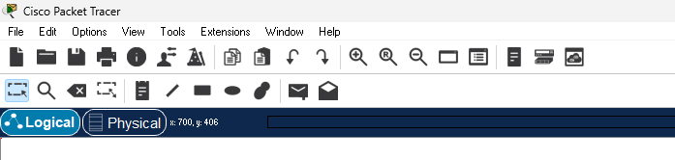

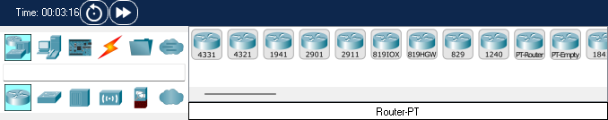

**Fig: Interface of Cisco Packet Tracer**

**OBSERVATION AND FINDING**

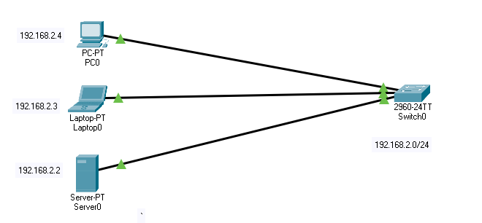Connecting fro.

**Fig: Connectivity between different devices**

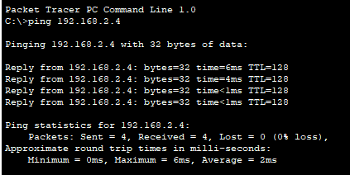

**DISCUSSION:**

The basic use of Cisco Packet Tracer is demonstrated in this lab. We also use many tools like Switch, PC, Server, Laptop to know about the working environment of this cisco packet tracer.

**CONCLUSION:**

The aim of this lab is to become familiar with Cisco Packet Tracer and its working environment.

**Lab 2**

# Assign IP Address to an end device

**OBJECTIVES:**

* To know how to assign the IP address to the devices.

**BACKGROUND THEORY:**

IP address stand for Internet Protocol address. It is a unique numeric value assigned to a network device, and it is used for the identification and location of a network device. IP address are of two types they are:

* **IPV4**

IPv4 addresses are 32-bit numbers represented in a dotted-decimal format. They consist of four sets of numbers ranging from 0 to 255, separated by periods. For example, an IPv4 address may look like this: 192.168.0.1.

* **IPV6**

IPv6 addresses are 128-bit numbers represented in hexadecimal format. They consist of eight sets of four hexadecimal digits separated by colons. For example, an IPv6 address may look like this: 2001:0db8:85a3:0000:0000:8a2e:0370:7334.

**PROCESS FOR Assigning IP address**

Step1: click on pc to assign IP address

Step2: dialog box will appear and go to desktop tab.

Step3: under desktop tab, click on IP configuration.

Step4: assign an IP address and close the dialog box.

**OBSERVATION AND FINDING:**

Assigning IP address.

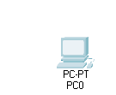

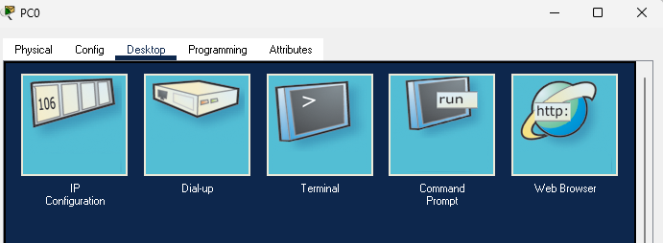

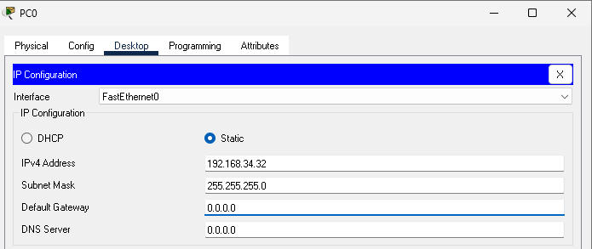

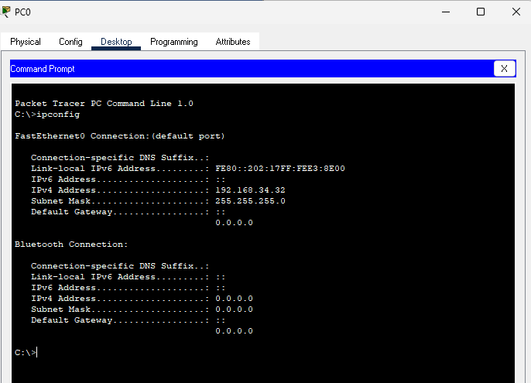**OUTPUT:**

**DISCUSSION:**

IP address is assigned to the device.

**CONCLUSION:**

The aim of the lab is to know how to assign the IP address to the devices.

**Lab 3**

# Creating and configuring a simple peer-to-peer network having two PC’s and testing the connectivity between them.

**OBJECTIVES:**

* To implement peer-to-peer network using packet tracer.
* To test Connectivity
* To communicate between two computer using peer to peer network

**BACKGROUND THEORY:**

Peer-to-peer (P2P) networking is a distributed networking model in which participants, known as peers, communicate and share resources directly with each other, without relying on a central server or authority. In a P2P network, each peer can act as both a client and a server, enabling them to both request and provide resources. In a peer-to-peer network, peers establish direct connections with each other, forming a decentralized network.

**PROCESS FOR Creating Peer to Peer Network and Communicate Between Peers**

Step 1: Drag and drop two devices and assign them a unique IP address

Step 2: Connect devices using copper cross-over.

Step 3: To test connectivity, ping the IP address of connected devices

**OBSERVATIONS AND FINDING:**

Implement peer-to-peer network in between two PC’s and testing connectivity between them.

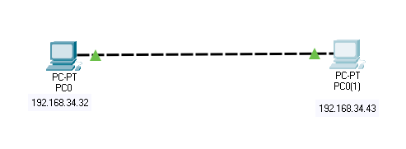

**Fig: peer-to-peer network**

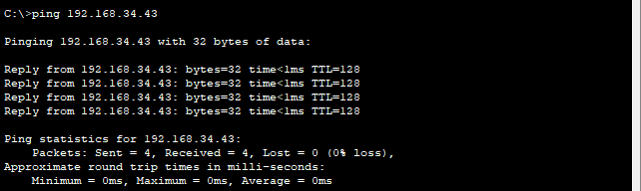**OUTPUT**

**DISCUSSION:**

Use of peer-to-peer network is demonstrated in this lab. We use two PC’s and connect between them and assign them IP address, test their connectivity and send message between them.

**CONCLUSION:**

In this lab we simulate the peer to peer network and its working process.

**Lab 4**

# Creating a local area network and testing the connectivity within the network.

**OBJECTIVE:**

* To create a local area network using packet tracer and testing connectivity within network.
* To know the working process of hub and Switch using simulation

**BACKGROUND THEORY:**

Local area network (LAN) is a computer network that spans a relatively small geographical area, such as a home, office building, school, or a small group of buildings. It is designed to connect computers, devices, and resources within a limited area, allowing them to communicate and share information. LANs are commonly used in homes and businesses to facilitate the sharing of resources, such as printers, scanners, and files, as well as to enable communication between connected devices. By connecting computers and devices on a LAN, users can share data, collaborate on projects, and access shared resources conveniently.

Hub, in the context of computer networking, is a basic networking device that connects multiple devices in a local area network (LAN). It operates at the physical layer (Layer 1) of the OSI model, which means it simply receives incoming data signals on one port and broadcasts them out to all other connected ports.

A switch is a networking device that connects multiple devices within a local area network (LAN) and directs network traffic between them. Unlike a hub, a switch operates at the data link layer (Layer 2) and can intelligently manage and forward data packets based on the MAC addresses of the connected devices.

**OBSERVATIONS AND FINDING**

Implement a local area network and testing the connectivity within the network.

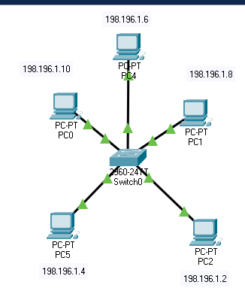

**Fig: Local Area Network using Switch**

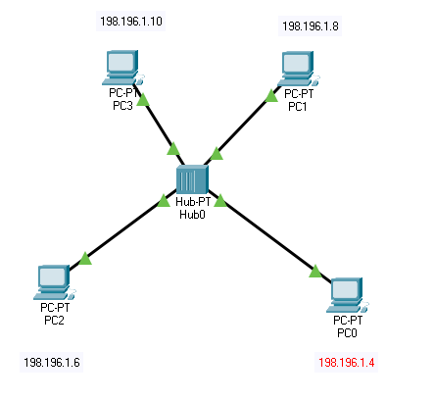

**Fig: Local Area Network using Hub**

**OUTPUT**

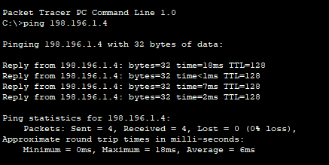

**DISCUSSION:**

We demonstrate LAN network in this lab. Also use simulation to distinguish the working process of the hub and switch. We find that hub broadcast message to all the connected devices whereas switch send message to its receiver only.

**CONCLUSION:**

In this lab we demonstrate LAN network using both hub and switch and simulate the working process of hub and switch

**Lab 5**

# Interconnecting two different Network and testing the connectivity between them.

**OBJECTIVES:**

* To connect two different network using router.
* To send message from one network to another Network.

**BACKGROUND THEORY:**

Router is use for connecting two dissimilar network. In this lab we use router for connecting two different network.

**Process for Interconnecting Two Different Network**

Step 1: create two LAN network.

Step 2: drag and drop the router and connect router to two different switches

Step 3: assign IP address for each port and enable the port of router

Step 4: assign gateway for each device.

**OBSERVATIONS AND FINDING**

Interconnecting two different Network and testing the connectivity between them.

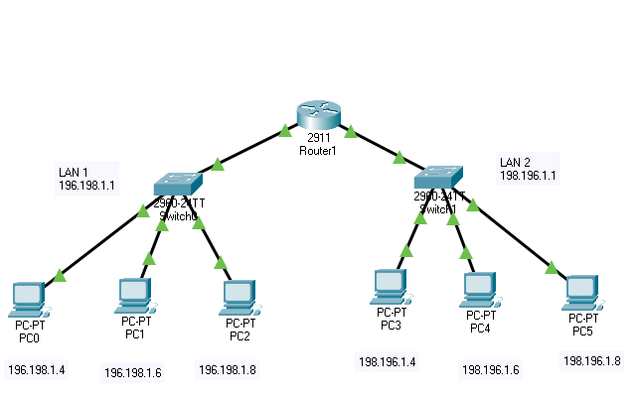

**Fig: Interconnection of LAN**

**OUTPUT:**

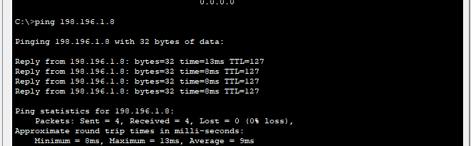

**DISCUSSION:**

We have interconnect two different LAN and test the connectivity.

**CONCLUSION:**

In this lab we interconnect two different network using Router.

**Lab 6**

# Configuring DHCP server to assign IP address dynamically.

**OBJECTIVES:**

* To configure DHCP server and assign IP address using DHCP.

**BACKGROUND THEORY:**

DHCP stands for Dynamic Host Configuration Protocol. It is a network protocol used to automatically assign IP addresses and network configuration parameters to devices on a network. DHCP allows devices, such as computers, smartphones, and network devices, to obtain the necessary network settings without manual configuration.

**PROCESS FOR DHCP SERVER TO ASSIGN IP ADDRESSES:**

Step 1: drag and drop required no of desktop, a switch and a server

Step 2: Go to configuration of a server then click on interface and give the IP address of the server.

Step 3: Go to services of the server, click on DHCP option then on the DHCP service.

Step 4: Go to IP configuration of the desktop then on the DHCP.

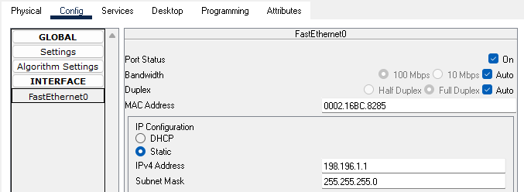

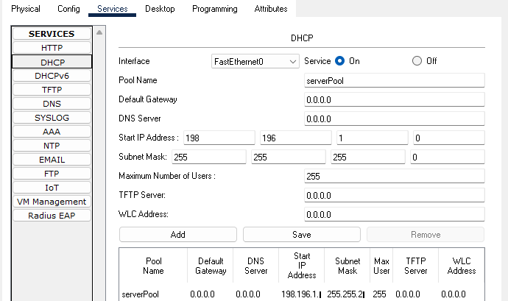

**Fig: Server configuration**

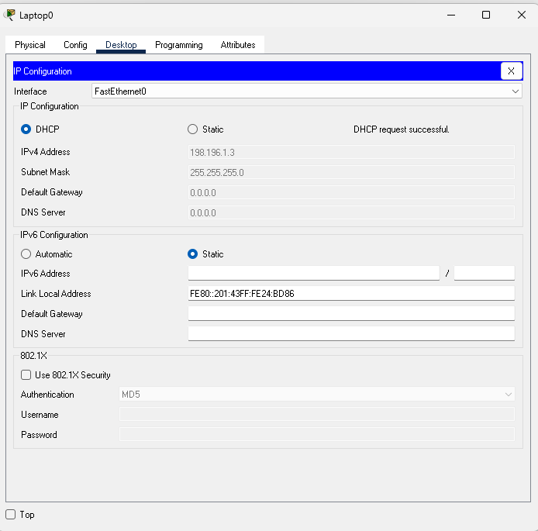

**Fig: IP assignment automatically to PCs.**

**OBSERVATION AND FINDING:**

Automatically Assigning IP Address using DHCP.

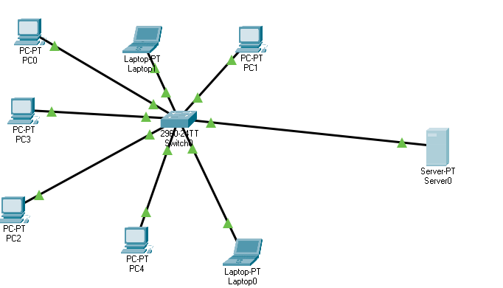

**DISCUSSION:**

DHCP server configuration is implemented in this lab.

**CONCLUSION:**

We have simulate how DHCP server is use for assigning IP address.

**Lab 7**

# Static Routing

**OBJECTIVES:**

* To know about static routing.
* To know how to give IP route to router.

**BACKGROUND THEORY:**

Static routing is a networking technique where network administrators manually configure the routes in a routing table. In static routing, the routing table is populated with fixed routes, which specify how data packets should be forwarded from one network node to another.

**PROCESS FOR STATIC ROUTING**

Step1: Set up required devices and connect with routers

Step2: configure the required setting for network connectivity

Step3: assign port IP address for all routers

Step4: Set a static route for router one and two

Step6: Communicate from one node to another

**OBSERVATION AND FINDINGS:**

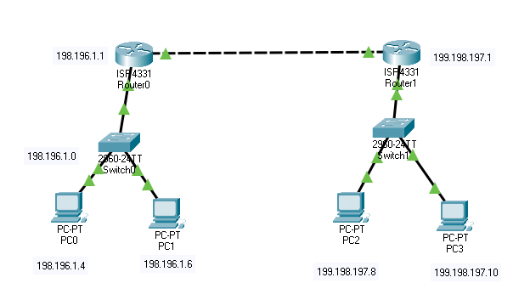

**Fig: Static Routing**

**OUTPUT**

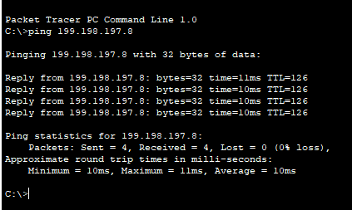

**DISCUSSION:**

Static Routing using GUI is implemented where network admin have to manually add the routing table.

**CONCLUSION:**

In this lab, we add routing table for the router manually.

**Lab 8**

# HTTP And DNS Server

**OBJECTIVES:**

* To know about DNS and Web server.
* To know how DNS server and Web server work.

**BACKGROUND THEORY:**

A DNS server is a computer server that contains a database of public IP addresses and their associated hostnames. It resolves or translates those names to IP addresses as requested. DNS servers run special software and communicate with each other using special protocols. They are also referred to as name servers, name servers, and domain name system servers.

A web server is a computer system that delivers web content to end-users over the internet via a web browser. It is capable of accepting requests via HTTP or its secure variant HTTPS.

**PROCESS FOR adding HTTP and DNS server**

Step 1: drag and drop two server for each DNS and HTTP, one desktop, a switch and assign IP address to servers and pc.

Step 2: For http server enable the http services on configuration of server.

Step 3: For DNS server enable DNS service and add domain name and its corresponding address.

Step 6: run domain name in pc web browser

**OBSERVATION AND FINDINGS:**

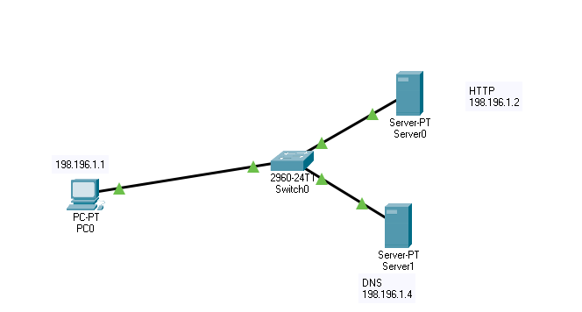

**Fig: configuring HTTP and DNS server**

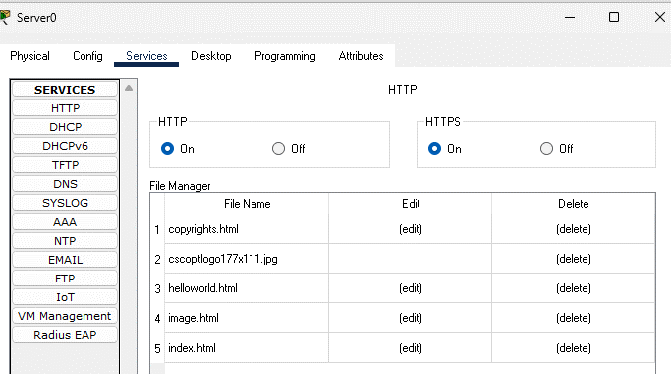

**Fig: HTTP services**

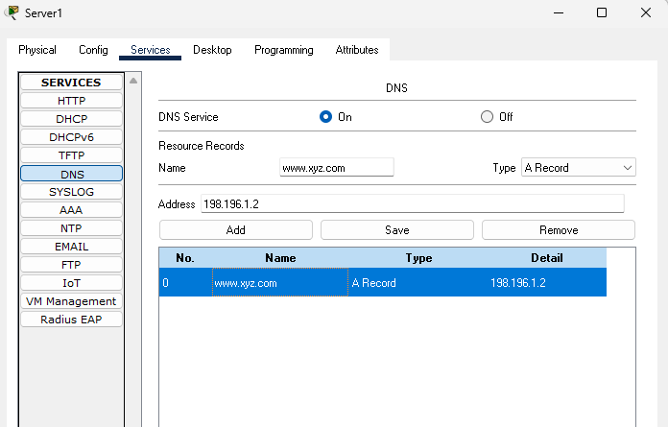

**Fig: DNS services**

**OUTPUT:**

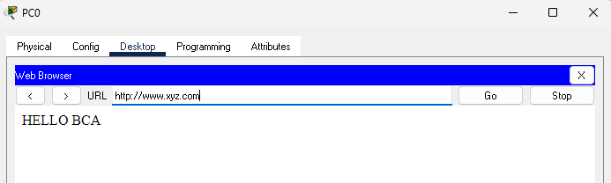

**DISCUSSION:**

We communicate with web server using domain name in this lab.

**CONCLUSION:**

In this lab, we add web server address in DNS server with domain name xyz.com and access the http server with that domain.