**A**

**LAB REPORT**

**ON**

**Computer Graphics and Animation**

**By**

**Prajwal Dahal**



**Submitted to:**

**Rakesh Shrestha**

**Lecturer**

**Kantipur College of Management and Information Technology**

In partial fulfillment of the requirements for the Course

Dot net Technology

Mid Baneshwor, Kathmandu

November 2022

TABLE OF CONTENTS

1 Write a program to implement DDA Algorithm in java. 1

1.1 Source Code 1

1.2 Output Window 2

2 Write a program to implement bresenhem algorithm in java. 4

2.1 Source Code 4

2.2 Output Window 7

3 Write a program to implement midpoint circle algorithm in java. 9

3.1 Source Code 9

3.2 Output Window 11

4 Write a program to demonstrate 2D translation in java. 12

4.1 Source Code 12

4.2 Output Window 13

5 Write a program to implement 2D Scaling in java. 14

5.1 Source Code 14

5.2 Output Windows 16

6 Write a program to demonstrate 2D rotation about origin. 17

6.1 Source Code 17

6.2 Output Window 19

7 Write a program to demonstrate shearing in Y-direction in java. 21

7.1 Source Code 21

7.2 Output Window 22

8 Write a program to demonstrate shearing in X-direction relative to other reference. 23

8.1 Source Code 23

8.2 Output Window 25

9 Write a Program to demonstrate reflection about X-axis. 26

9.1 Source Code 26

9.2 Output Window 28

10 Write a program to demonstrate reflection about diagonal y=x. 29

10.1 Source Code 29

10.2 Output Window 31

11 Write a Program to draw ellipse using midpoint ellipse algorithm. 32

11.1 Source Code 32

11.2 Output Window 35

# Write a program to implement DDA Algorithm in java.

## Source Code

import java.awt.*;

import javax.swing.*;

public class DDA extends JFrame{

public DDA()

{

JPanel p = new JPanel();

getContentPane().add(p);

setSize(900, 900);

setDefaultCloseOperation(JFrame.EXIT_ON_CLOSE);

}

public void paint(Graphics g)

{

int x1=100, y1=100, x2=600, y2=600, steps=0;

int dx=x2-x1;

int dy = y2-y1;

if(Math.abs(dx)>Math.abs(dy))

steps = Math.abs(dx);

else

steps = Math.abs(dy);

int xInc = (int)dx/steps;

int yInc = (int)dy/steps;

for(int i=0; i<steps; i++)

{

g.drawLine(x1, y1, x1, y1);

x1= x1+ xInc;

y1 = y1+yInc;

}

}

public static void main(String[] args)

{

DDA d = new DDA();

d.setVisible(true);

}

}

## Output Window

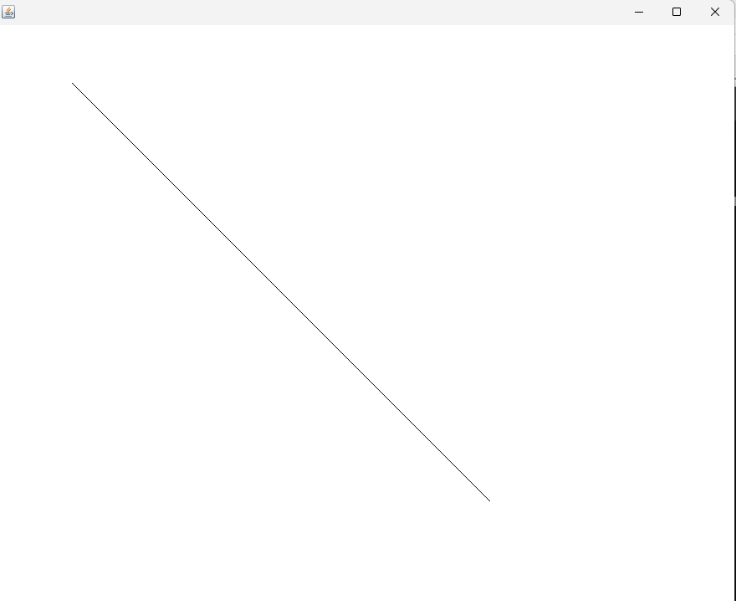

# Write a program to implement bresenhem algorithm in java.

## Source Code

import javax.swing.*;

import java.awt.*;

import java.util.Scanner;

class bresenhem extends JFrame{

private int x1, y1, x2, y2;

public bresenhem(){

Scanner sc = new Scanner(System.in);

System.out.print("enter x1 and y1: ");

x1=sc.nextInt();

y1=sc.nextInt();

System.out.print("enter x2 and y2: ");

x2=sc.nextInt();

y2=sc.nextInt();

setVisible(true);

setBounds(200,100,400,400);

setDefaultCloseOperation(EXIT_ON_CLOSE);

}

public void slopePositiveLess(int dx,int dy,Graphics g){

g.drawLine(x1,y1,x1,y1);

int p0=2*dy-dx;

for(int i=0;i<dx;i++)

{

if(p0<0){

x1++;

g.drawLine(x1,y1,x1,y1);

p0=p0+2*dy;

}

else{

x1++;

y1++;

g.drawLine(x1,y1,x1,y1);

p0=p0+2*dy-2*dx;

}

}

}

public void slopePositiveGreat(int dx,int dy,Graphics g){

g.drawLine(x1,y1,x1,y1);

int p0=2*dx-dy;

for(int i=0;i<dy;i++){

if(p0<0){

y1++;

g.drawLine(x1,y1,x1,y1);

p0=p0+2*dx;

}

else{

x1++;

y1++;

g.drawLine(x1,y1,x1,y1);

p0=p0+2*dx-2*dy;

}

}

}

public void slopeNegetiveLess(int dx,int dy,Graphics g){

g.drawLine(x1,y1,x1,y1);

int p0=2*dy-dx;

for(int i=0;i<dx;i++){

if(p0<0){

x1++;

g.drawLine(x1,y1,x1,y1);

p0=p0+2*dy;

}

else{

x1++;

y1--;

g.drawLine(x1,y1,x1,y1);

p0=p0+2*dy-2*dx;

}

}

}

public void slopeNegetiveGreat(int dx,int dy,Graphics g){

g.drawLine(x1,y1,x1,y1);

int p0=2*dx-dy;

for(int i=0;i<dy;i++){

if(p0<0){

y1--;

g.drawLine(x1,y1,x1,y1);

p0=p0+2*dx;

}

else{

x1++;

y1--;

g.drawLine(x1,y1,x1,y1);

p0=p0+2*dx-2*dy;

}

}

}

public void paint(Graphics g){

super.paint(g);

int dx=x2-x1;

int dy=y2-y1;

float m = (float)dy/dx;

float mabs=Math.abs(m);

dx=Math.abs(dx);

dy=Math.abs(dy);

if(mabs < 1 && m > 0)

slopePositiveLess(dx,dy,g);

else if(mabs < 1 && m < 0)

slopeNegetiveLess(dx,dy,g);

else if(mabs > 1 && m>0)

slopePositiveGreat(dx,dy,g);

else

slopeNegetiveGreat(dx,dy,g);

}

public static void main(String []args){

new bresenhem();

}

}

## Output Window

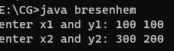

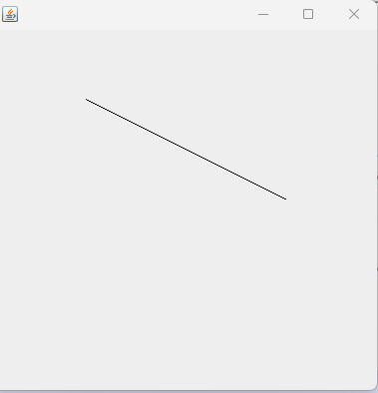

# Write a program to implement midpoint circle algorithm in java.

## Source Code

import java.awt.*;

import javax.swing.*;

class MidCircle extends JFrame{

int x=200,y=300,r=100;

public MidCircle(){

setVisible(true);

setSize(600,600);

setDefaultCloseOperation(EXIT_ON_CLOSE);

}

public void drawPoints(Graphics g,int x1,int y1){

g.drawLine(x+x1,y+y1,x+x1,y+y1);

g.drawLine(x+x1,y-y1,x+x1,y-y1);

g.drawLine(x-x1,y+y1,x-x1,y+y1);

g.drawLine(x-x1,y-y1,x-x1,y-y1);

g.drawLine(x+y1,y+x1,x+y1,y+x1);

g.drawLine(x-y1,y+x1,x-y1,y+x1);

g.drawLine(x+y1,y-x1,x+y1,y-x1);

g.drawLine(x-y1,y-x1,x-y1,y-x1);

}

public void drawCircle(Graphics g){

int x1=0,y1=r;

drawPoints(g,x1,y1);

int p0=1-r;

while(true){

if(p0<0){

x1++;

drawPoints(g,x1,y1);

p0=p0+2*x1+1;

}

else{

x1++;

y1--;

drawPoints(g,x1,y1);

p0=p0+2*x1+1-2*y1;

}

if(x1>=y1){

break;

}

}

}

public void paint(Graphics g){

super.paint(g);

drawCircle(g);

}

public static void main(String []args){

MidCircle mc = new MidCircle();

}

}

## Output Window

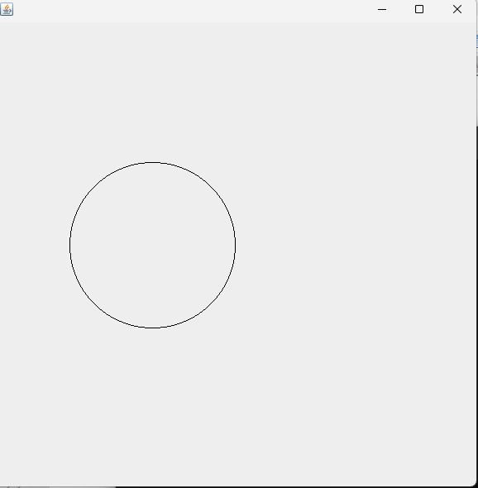

# Write a program to demonstrate 2D translation in java.

## Source Code

import javax.swing.*;

import java.awt.*;

public class translation extends JFrame {

private int[][]t={{1,0,600},{0,1,100},{0,0,1}}; //translation matrix

private int[][]v={{100,500,300},{300,400,500},{1,1,1}}; //vertex

public translation()

{

setBounds(200,10,600,600);

setDefaultCloseOperation(EXIT_ON_CLOSE);

setVisible(true);

}

void drawTriangle(Graphics g){

g.drawLine(v[0][0],v[1][0],v[0][1],v[1][1]); //drawing AB

g.drawLine(v[0][2],v[1][2],v[0][0],v[1][0]); // drawing CA

g.drawLine(v[0][1],v[1][1],v[0][2],v[1][2]); // drawing BC

}

@Override

public void paint(Graphics g) {

super.paint(g);

drawTriangle(g);

drawTranslation(g);

}

private void drawTranslation(Graphics g) {

int[][]l= new int[3][3];

for (int i = 0; i < 3; i++) {

for (int j = 0; j < 3; j++) {

for (int k = 0; k < 3; k++) {

l[i][j]+=t[i][k]*v[k][j];

}

}

}

g.drawLine(l[0][0],l[1][0],l[0][1],l[1][1]); //drawing AB

g.drawLine(l[0][2],l[1][2],l[0][0],l[1][0]); // drawing CA

g.drawLine(l[0][1],l[1][1],l[0][2],l[1][2]); //drawing BC

}

public static void main(String[] args) {

new translation();

}

}

## Output Window

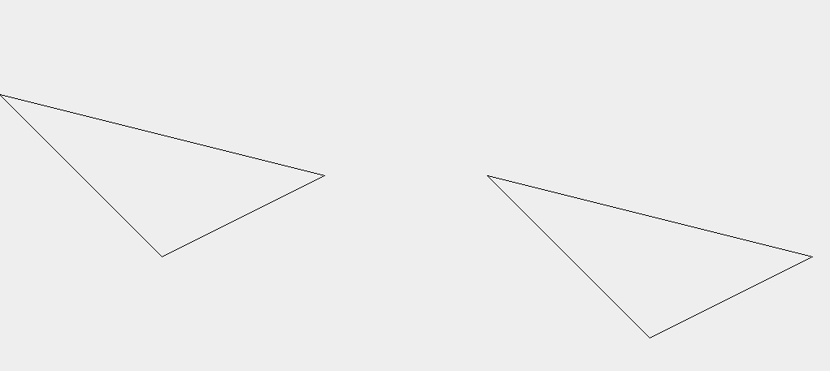

# Write a program to implement 2D Scaling in java.

## Source Code

import javax.swing.*;

import java.awt.*;

public class Scaling extends JFrame {

private int[][]s={{2,0,0},{0,3,0},{0,0,1}}; //scaling matrix

private int[][]v={{100,150,200},{100,200,150},{1,1,1}}; //vertex

public Scaling()

{

setBounds(200,10,600,600);

setDefaultCloseOperation(EXIT_ON_CLOSE);

setVisible(true);

}

@Override

public void paint(Graphics g) {

super.paint(g);

drawTriangle(g);

drawScaling(g);

}

private void drawScaling(Graphics g) {

int[][]l= new int[3][3];

for (int i = 0; i < 3; i++) {

for (int j = 0; j < 3; j++) {

for (int k = 0; k < 3; k++) {

l[i][j]+=s[i][k]*v[k][j];

}

System.out.println(l[i][j]);

}

}

g.drawLine(l[0][0],l[1][0],l[0][1],l[1][1]); //drawing AB

g.drawLine(l[0][2],l[1][2],l[0][0],l[1][0]); // drawing CA

g.drawLine(l[0][1],l[1][1],l[0][2],l[1][2]); //drawing BC

}

void drawTriangle(Graphics g){

g.drawLine(v[0][0],v[1][0],v[0][1],v[1][1]); //drawing AB

g.drawLine(v[0][2],v[1][2],v[0][0],v[1][0]); // drawing CA

g.drawLine(v[0][1],v[1][1],v[0][2],v[1][2]); // drawing BC

}

public static void main(String[] args) {

new Scaling();

}

}

## Output Windows

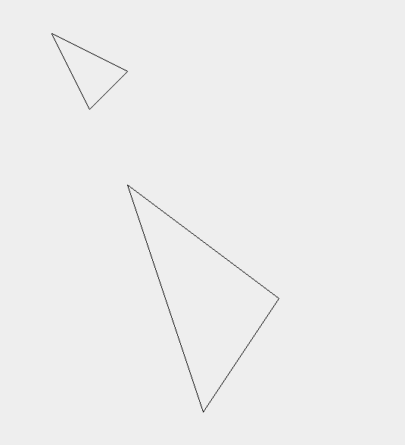

# Write a program to demonstrate 2D rotation about origin.

## Source Code

import javax.swing.*;

import java.awt.*;

import java.util.Scanner;

public class Rotation extends JFrame {

private double[][]r; //rotation matrix

private int[][]v={{100,30,300},{80,10,60},{1,1,1}}; //vertex

public Rotation()

{

Scanner sc = new Scanner(System.in);

System.out.print("enter a rotation degree: ");

Double x2=sc.nextDouble();

r= new double[][]{{Math.cos(x2), -Math.sin(x2), 0} , {Math.sin(x2),Math.cos(x2) , 0}, {0, 0, 1}};

setSize(600,600);

setDefaultCloseOperation(EXIT_ON_CLOSE);

setVisible(true);

}

@Override

public void paint(Graphics g) {

super.paint(g);

drawTriangle(g);

drawRotation(g);

}

private void drawRotation(Graphics g) {

int[][]l= new int[3][3];

for (int i = 0; i < 3; i++) {

for (int j = 0; j < 3; j++) {

for (int k = 0; k < 3; k++) {

l[i][j]+=r[i][k]*v[k][j];

}

System.out.println(l[i][j]);

}

}

g.drawLine(l[0][0]+300,l[1][0]+100,l[0][1]+300,l[1][1]+100); //drawing AB

g.drawLine(l[0][2]+300,l[1][2]+100,l[0][0]+300,l[1][0]+100);

// drawing CA

g.drawLine(l[0][1]+300,l[1][1]+100,l[0][2]+300,l[1][2]+100); //drawing BC

}

void drawTriangle(Graphics g){

g.drawLine(v[0][0]+300, v[1][0]+100, v[0][1]+300, v[1][1]+100); //drawing AB

g.drawLine(v[0][2]+300, v[1][2]+100, v[0][0]+300, v[1][0]+100); // drawing CA

g.drawLine(v[0][1]+300, v[1][1]+100, v[0][2]+300, v[1][2]+100); // drawing BC

}

public static void main(String[] args) {

new Rotation();

}

}

## 

## Output Window



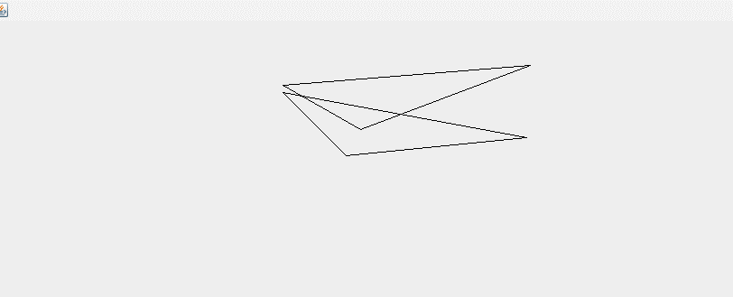

# Write a program to demonstrate shearing in Y-direction in java.

## Source Code

import javax.swing.*;

import java.awt.*;

public class Shearing extends JFrame {

private int[][]s={{1,2,0},{0,1,0},{0,0,1}}; //shearing matrix

private int[][]v={{100,150,200},{100,200,150},{1,1,1}}; //vertex

public Shearing()

{

setBounds(200,10,600,600);

setDefaultCloseOperation(EXIT_ON_CLOSE);

setVisible(true);

}

@Override

public void paint(Graphics g) {

super.paint(g);

drawTriangle(g);

drawShear(g);

}

private void drawShear(Graphics g) {

int[][]l= new int[3][3];

for (int i = 0; i < 3; i++) {

for (int j = 0; j < 3; j++) {

for (int k = 0; k < 3; k++) {

l[i][j]+=s[i][k]*v[k][j];

}

System.out.println(l[i][j]);

}

}

g.drawLine(l[0][0],l[1][0],l[0][1],l[1][1]); //drawing AB

g.drawLine(l[0][2],l[1][2],l[0][0],l[1][0]); // drawing CA

g.drawLine(l[0][1],l[1][1],l[0][2],l[1][2]); //drawing BC

}

void drawTriangle(Graphics g){

g.drawLine(v[0][0],v[1][0],v[0][1],v[1][1]); //drawing AB

g.drawLine(v[0][2],v[1][2],v[0][0],v[1][0]); // drawing CA

g.drawLine(v[0][1],v[1][1],v[0][2],v[1][2]); // drawing BC

}

public static void main(String[] args) {

new Shearing();

}

}

## Output Window

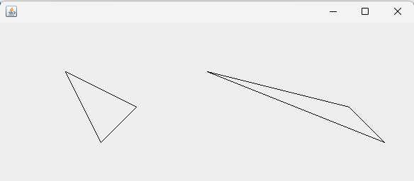

# Write a program to demonstrate shearing in X-direction relative to other reference.

## Source Code

import javax.swing.*;

import java.awt.*;

public class ShearingX extends JFrame {

private int[][]s={{1,2,-2*3},{2,1,0},{0,0,1}}; //shearing matrix

private int[][]v={{100,150,200},{100,200,150},{1,1,1}}; //vertex

public ShearingX()

{

setBounds(200,10,600,600);

setDefaultCloseOperation(EXIT_ON_CLOSE);

setVisible(true);

}

@Override

public void paint(Graphics g) {

super.paint(g);

drawTriangle(g);

drawScaling(g);

}

private void drawScaling(Graphics g) {

int[][]l= new int[3][3];

for (int i = 0; i < 3; i++) {

for (int j = 0; j < 3; j++) {

for (int k = 0; k < 3; k++) {

l[i][j]+=s[i][k]*v[k][j];

}

System.out.println(l[i][j]);

}

}

g.drawLine(l[0][0],l[1][0],l[0][1],l[1][1]); //drawing AB

g.drawLine(l[0][2],l[1][2],l[0][0],l[1][0]); // drawing CA

g.drawLine(l[0][1],l[1][1],l[0][2],l[1][2]); //drawing BC

}

void drawTriangle(Graphics g){

g.drawLine(v[0][0],v[1][0],v[0][1],v[1][1]); //drawing AB

g.drawLine(v[0][2],v[1][2],v[0][0],v[1][0]); // drawing CA

g.drawLine(v[0][1],v[1][1],v[0][2],v[1][2]); // drawing BC

}

public static void main(String[] args) {

new ShearingX();

}

}

## Output Window

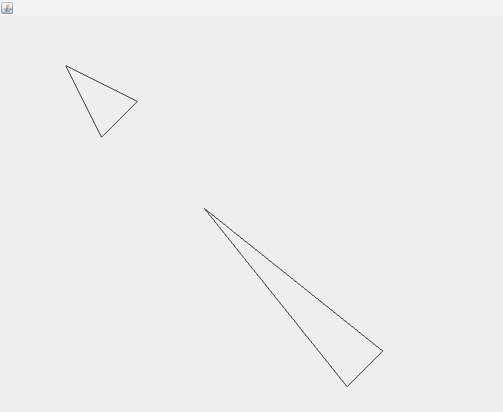

# Write a Program to demonstrate reflection about X-axis.

## Source Code

import javax.swing.*;

import java.awt.*;

public class Reflection extends JFrame {

private int[][]s={{1,0,0},{0,-1,0},{0,0,1}}; //reflection matrix

private int[][]v={{100,30,300},{65,10,60},{1,1,1}}; //vertex

public Reflection()

{

setSize(600,600);

setDefaultCloseOperation(EXIT_ON_CLOSE);

setVisible(true);

}

@Override

public void paint(Graphics g) {

super.paint(g);

drawTriangle(g);

drawScaling(g);

}

private void drawScaling(Graphics g) {

int[][]l= new int[3][3];

for (int i = 0; i < 3; i++) {

for (int j = 0; j < 3; j++) {

for (int k = 0; k < 3; k++) {

l[i][j]+=s[i][k]*v[k][j];

}

System.out.println(l[i][j]);

}

}

g.drawLine(l[0][0]+200,l[1][0]+100,l[0][1]+200,l[1][1]+100); //drawing AB

g.drawLine(l[0][2]+200,l[1][2]+100,l[0][0]+200,l[1][0]+100); // drawing CA

g.drawLine(l[0][1]+200,l[1][1]+100,l[0][2]+200,l[1][2]+100); //drawing BC

}

void drawTriangle(Graphics g){

g.drawLine(v[0][0]+300, v[1][0]+100, v[0][1]+300, v[1][1]+100); //drawing AB

g.drawLine(v[0][2]+300, v[1][2]+100, v[0][0]+300, v[1][0]+100); // drawing CA

g.drawLine(v[0][1]+300, v[1][1]+100, v[0][2]+300, v[1][2]+100); // drawing BC

}

public static void main(String[] args) {

new Reflection();

}

}

## Output Window

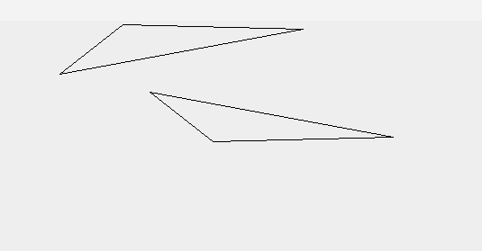

# Write a program to demonstrate reflection about diagonal y=x.

## Source Code

import javax.swing.*;

import java.awt.*;

public class Reflection extends JFrame {

private int[][]s={{0,1,0},{1,0,0},{0,0,1}}; //reflection matrix

private int[][]v={{100,30,300},{65,10,60},{1,1,1}}; //vertex

public Reflection()

{

setSize(600,600);

setDefaultCloseOperation(EXIT_ON_CLOSE);

setVisible(true);

}

@Override

public void paint(Graphics g) {

super.paint(g);

drawTriangle(g);

drawScaling(g);

}

private void drawScaling(Graphics g) {

int[][]l= new int[3][3];

for (int i = 0; i < 3; i++) {

for (int j = 0; j < 3; j++) {

for (int k = 0; k < 3; k++) {

l[i][j]+=s[i][k]*v[k][j];

}

System.out.println(l[i][j]);

}

}

g.drawLine(l[0][0]+200,l[1][0]+100,l[0][1]+200,l[1][1]+100); //drawing AB

g.drawLine(l[0][2]+200,l[1][2]+100,l[0][0]+200,l[1][0]+100); // drawing CA

g.drawLine(l[0][1]+200,l[1][1]+100,l[0][2]+200,l[1][2]+100); //drawing BC

}

void drawTriangle(Graphics g){

g.drawLine(v[0][0]+300, v[1][0]+100, v[0][1]+300, v[1][1]+100); //drawing AB

g.drawLine(v[0][2]+300, v[1][2]+100, v[0][0]+300, v[1][0]+100); // drawing CA

g.drawLine(v[0][1]+300, v[1][1]+100, v[0][2]+300, v[1][2]+100); // drawing BC

}

public static void main(String[] args) {

new Reflection();

}

}

## Output Window

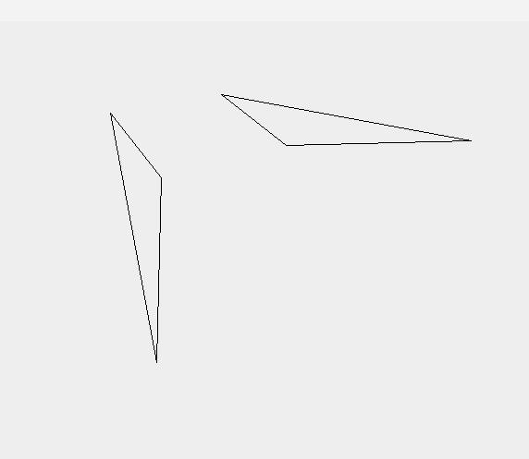

# Write a Program to draw ellipse using midpoint ellipse algorithm.

## Source Code

import javax.swing.*;

import java.awt.*;

public class MidEllipse extends JFrame {

int x=300,y=300,rx=100,ry=200,twory,tworx;

public MidEllipse(){

tworx=2*rx*rx;

twory=2*ry*ry;

setVisible(true);

setSize(600,600);

setDefaultCloseOperation(EXIT_ON_CLOSE);

}

public void drawPoint(Graphics g,int x1,int y1){

g.drawLine(x+x1,y+y1,x+x1,y+y1);

g.drawLine(x+x1,y-y1,x+x1,y-y1);

g.drawLine(x-x1,y+y1,x-x1,y+y1);

g.drawLine(x-x1,y-y1,x-x1,y-y1);

}

public void drawRadiusX(Graphics g){

int x1=0,y1=ry;

int ryd=twory*x1;

int rxd=tworx*y1;

double p0=ry*twory-rx*rx*ry+(1/4*rx*rx);

System.out.println(p0+ " first");

while(ryd<rxd){

if(p0<0){

x1++;

drawPoint(g,x1,y1);

p0=p0+ryd+ry*ry;

System.out.println(p0+","+x1+","+y1);

}

else{

x1++;

y1--;

drawPoint(g,x1,y1);

p0=p0+ryd+ry*ry-rxd;

System.out.println(p0+","+x1+","+y1);

}

ryd=2*ry*ry*x1;

rxd=2*rx*rx*y1;

}

drawRadiusY(g,x1,y1);

}

private void drawRadiusY(Graphics g, int x1, int y1) {

int ryd=twory*x1;

int rxd=twory*y1;

int p0= ry*ry*(x1+1/2)*(x1+1/2)+rx*rx*(y1-1)*(y1-1)-rx*rx*ry*ry;

System.out.println("r2"+p0);

while(y1>0){

if(p0>0){

y1--;

drawPoint(g,x1,y1);

p0=p0-rxd+rx*rx;

System.out.println(p0+","+x1+","+y1);

}

else{

x1++;

y1--;

drawPoint(g,x1,y1);

p0=p0+ryd+rx*rx-rxd;

System.out.println(p0+","+x1+","+y1);

}

ryd=2*ry*ry*x1;

rxd=2*rx*rx*y1;

}

}

public void paint(Graphics g){

super.paint(g);

drawRadiusX(g);

}

public static void main(String []args){

new MidEllipse();

}

}

## Output Window

