**A**

**PROJECT REPORT**

**ON**

**E-Library**

**By**

**Prajwal Dahal**

**Exam Roll No: 388-51-22-00006**



**Submitted to:**

**Pradip Bhochhibhoya**

**Lecturer**

**Kantipur College of Management and Information Technology**

In partial fulfillment of the requirements for the Course

MIS and E-Business

Mid Baneshwor, Kathmandu

May 2023

# Acknowledgement

This project is prepared in the partial fulfillment of the requirement for the course MIS and E-Commerce. The satisfaction and success of completion of this task would be incomplete without heartfelt thanks to people whose constant guidance, support and encouragement made this work successful. On doing this undergraduate project we have been fortunate to have help, support and encouragement from many people we would like to acknowledge them for their cooperation.

My first thanks goes to Tribhuvan University for designing such a worthy syllabus and making us do this project. My next batch of thanks goes to the Management of **KCMIT** without whose help our project would have been impossible.

We are grateful to our subject teacher and project guide **Mr. Pradip Bhochhibhoya** for the guidance, inspiration and constructive suggestion that help us in the preparation of this project. Last but not the least I want to thank every direct and indirect hands that were involved in completion of this project .This project has been a wonderful experience where we have learnt and experienced many beneficial things.

**Table of Contents**

Acknowledgement i

Chapter 1: Introduction 2

1.1: Introduction to E-commerce 2

1.2: Introduction to MIS 2

1.3: Introduction to E-library 3

Chapter 2: Planning 4

2.1: Introduction 4

2.2: E-commerce planning Process 4

2.3: Feasibility Analysis 6

Chapter 3: Network Infrastructure 7

3.1: Introduction 7

3.2: World Wide Web (WWW) 7

3.3: Internet 7

3.4: Information highway 7

Chapter 4: Process of Building Website 8

4.1: Process of Building Website 8

4.2: Hosting a website 8

4.3: User and Admin Account 8

Chapter 5: Payment Gateway 9

5.1: Payment Gateway 9

5.2: E-sewa payment gateway 9

Chapter 6: Handling Security Issues 10

6.1: Handle security issue 10

Chapter 7: Screen Capture 11

Chapter 8: Conclusion 18

# Introduction

## Introduction to E-commerce

Ecommerce, short for electronic commerce, refers to the buying and selling of goods and services over the internet. E-commerce has transformed the way people shop and interact with businesses. It offers convenience, flexibility, and accessibility, enabling customers to browse and purchase products or services from the comfort of their homes or wherever they have internet access. It has eliminated geographical barriers, allowing businesses to reach a global customer base and consumers to access products from around the world.

An Ecommerce website is an information technology method in which traders, business/distributors/marketers can sell products/services and the customer can purchase on that website electronically by using the internet on the mobile and computer.

There are several types of ecommerce models, including business-to-consumer (B2C), where businesses sell directly to consumers through online platforms or websites, and consumer-to-consumer (C2C), where individuals sell products or services to other individuals through online marketplaces. Additionally, there are business-to-business (B2B) transactions, where businesses conduct commerce with other businesses online and consumer-to-business (C2B), where individual consumers or end-users create value or provide services to businesses.

## Introduction to MIS

MIS stands for Management Information System. It refers to the use of technology, people, and processes to collect, store, organize, and analyze data in order to support managerial decision-making, strategic planning, and operational activities within an organization. MIS plays a crucial role in helping organizations effectively manage and utilize information to achieve their goals. It involves the use of various technologies, such as databases, software applications, and communication networks, to gather and process data from different sources.

The major component of MIS are as follows:

* **People**
* **Data**
* **Business**
* **Hardware**
* **Software**

## Introduction to E-library

An e-library, short for electronic library, refers to a digital or online collection of resources, including books, journals, articles and other educational materials. It is a virtual library that allows users to access and retrieve information electronically through digital platforms or websites. One of the major reason why E-library has become popular is resource can be access anywhere and anytime.

This E-library project has following features:

* User can rent book for specific days by paying some amount using digital wallet.
* If the days specify by user is finished, user cannot access the resource further.
* Admin can add resources and can watch who have rented a book.
* Admin can add

# Planning

## Introduction

The success of a strategy in ecommerce should be measured by the sales that are generated and ultimately profits made. Without proper planning it is hard to get success in this competitive market.

## E-commerce planning Process

The e-commerce planning process involves several key steps to effectively launch and manage an e-commerce business. Here is a simplified overview of the process:

* Define business goals and target audience.
* Choose an appropriate e-commerce platform.
* Design a user-friendly website and optimize the user experience.
* Develop product strategy, inventory management, and secure payment/shipping options.
* Implement effective marketing strategies, monitor performance, and adapt as needed.

1. **Define business goals and target audience**

The first step of the e-commerce planning is to identity the objective and identify the specific audience you want to target. Find what you want to achieve such as increase sales. This helps you tailor your strategies and offerings to meet the needs and preferences of your target customers.

1. **Choose an appropriate e-commerce platform**

Select an e-commerce platform that suits your business requirements, taking into account factors such as scalability, features, security, and integration capabilities. The platform will serve as the foundation for your online store.

1. **Design a user-friendly website and optimize the user experience**

Create a visually appealing and easy-to-navigate website that aligns with your brand. Focus on providing a seamless user experience, ensuring clear product information, intuitive navigation, and a smooth checkout process. Optimize your website for mobile devices to accommodate mobile users. Host website as per requirement for remote access.

1. **Develop product management, and secure payment/shipping options**

Determine your product offerings, sourcing strategy, and pricing. Implement secure payment gateways and establish reliable shipping options to provide a seamless buying experience.

1. **Implement effective marketing strategies, monitor performance, and adapt as needed:**

Develop a comprehensive marketing plan to attract customers and drive traffic to your e-commerce site. Utilize various marketing channels such as search engine optimization, content marketing, social media marketing, and email campaigns. Monitor key performance metrics and customer feedback to assess the effectiveness of your strategies, make data-driven decisions, and adapt your approach as necessary.

|  |  |  |  |  |  |  |  |  |  |  |  |  |
| --- | --- | --- | --- | --- | --- | --- | --- | --- | --- | --- | --- | --- |
| Task | October | | | | November | | | | December | | | |
| week 1 | week 2 | week 3 | week 4 | week 1 | week 2 | week 3 | week 4 | week 1 | week 2 | week 3 | week 4 |
| Planning |  |  |  |  |  |  |  |  |  |  |  |  |
| Requirement analysis |  |  |  |  |  |  |  |  |  |  |  |  |
| UI design |  |  |  |  |  |  |  |  |  |  |  |  |
| Database design |  |  |  |  |  |  |  |  |  |  |  |  |
| Report writing |  |  |  |  |  |  |  |  |  |  |  |  |
| Implementation |  |  |  |  |  |  |  |  |  |  |  |  |
| Testing and debugging |  |  |  |  |  |  |  |  |  |  |  |  |

**Gantt Chart**

## Feasibility Analysis

Feasibility analysis is an assessment of the practicality and achievability of a proposed website. It includes assessing technical requirements, available resources, desired functionality and user experience, time constraints, and long-term maintenance needs. The analysis helps determine if the website design project is viable and can be successfully executed. It also include determining if the website is financially viable.

# Network Infrastructure

## Introduction

Network infrastructure refers to the interconnected components, hardware, and software that facilitate communication and data transfer within a computer network. It serves as the backbone of an organization's IT infrastructure and enables the flow of information between devices, systems, and users. Network infrastructure is required for e-commerce to transport content.

## World Wide Web (WWW)

The WWW is an information space where documents and resources, such as web pages, images, videos, and files, are linked together through hyperlinks. It is a subset of the internet, specifically focused on web-based content. The WWW is based on hypertext and hyperlinks, which connect web pages and enable users to move between different resources with a simple click.

## Internet

Internet is a decentralized network that allows devices to communicate and exchange data using standardized protocols. It provides a framework for transmitting information across different networks, regardless of the underlying technologies or hardware used.

## Information highway

The information highway is a metaphorical concept that represents a global network infrastructure facilitating the rapid and efficient exchange of information. It refers to the interconnected system of computers, servers, and communication networks, primarily the internet, which enables the seamless flow of data, knowledge, and multimedia content. The information highway emphasizes the accessibility, connectivity, and speed of communication, transcending physical barriers and enabling individuals, organizations, and governments to access, share, and collaborate on information and resources in real-time.

The components of Information Highway are given below:

* Consumer Access Equipment
* Local Access Equipment
* Global Information Distribution Network

# Process of Building Website

## Process of Building Website

This online Shopping website is a single vendor website, which is make on PHP

Some Step of the procedure of website building as follow:

* First I download and install XAMPP for server on laptop
* Second Download and install visual Studio Code is for code editor
* Third Start MYSQL and Apache server
* Start designing and developing our website with SQL queries
* Test you website on your computer
* Deploy website on online server

## Hosting a website

* I registered free domain from bytehost.
* Migrate all the files from localhost to cpanel.
* Also import database created in localhost.

## User and Admin Account

User can register to web application from URL:

<http://elibrary.byethost14.com/elib/register.php>

Admin and user can login into website from URL:

http://elibrary.byethost14.com/elib/login.php

# Payment Gateway

## Payment Gateway

A payment gateway is an online service that securely processes payment transactions between buyers and sellers. It is integrated into e-commerce websites or online platforms and allows customers to make payments using various methods such as credit cards, debit cards, digital wallets, or bank transfers. The payment gateway encrypts and protects the customer's payment information, verifies the transaction with relevant financial institutions, and ensures secure transmission and storage of data. It plays a crucial role in authorizing and settling transactions, providing a seamless user experience, and offering additional features like recurring billing and multi-currency support. Payment gateways charge fees for their services, which can vary based on factors such as transaction volume and payment method. Overall, payment gateways simplify online payments, enhance security, and enable businesses to accept payments from customers worldwide.

In our e-library application, we have use e-sewa payment gateway.

## E-sewa payment gateway

e-sewa is a popular payment gateway and digital wallet service in Nepal. To integrate e-sewa as a payment gateway, you would need to sign up as a merchant and obtain API credentials. These credentials are used to connect your website or application with e-sewa's system. You would design and implement a smooth payment flow within your platform, allowing customers to select e-sewa as a payment option during checkout. When a customer chooses e-sewa, your system sends a payment request to e-sewa's servers, which processes the transaction and provides a response. You handle the response to update the transaction status on your platform and confirm the payment to the customer. Thorough testing and monitoring of the integration are essential to ensure its proper functioning in both testing and live environments.

# Handling Security Issues

## Handle security issue

Following security issue are handle in our website:

* User should successfully logged in to do activities in web app
* User should successfully logged in before accessing the rented book.
* Admin also need to log in before performing activities in the web app.

# Screen Capture

* **For Registering account**

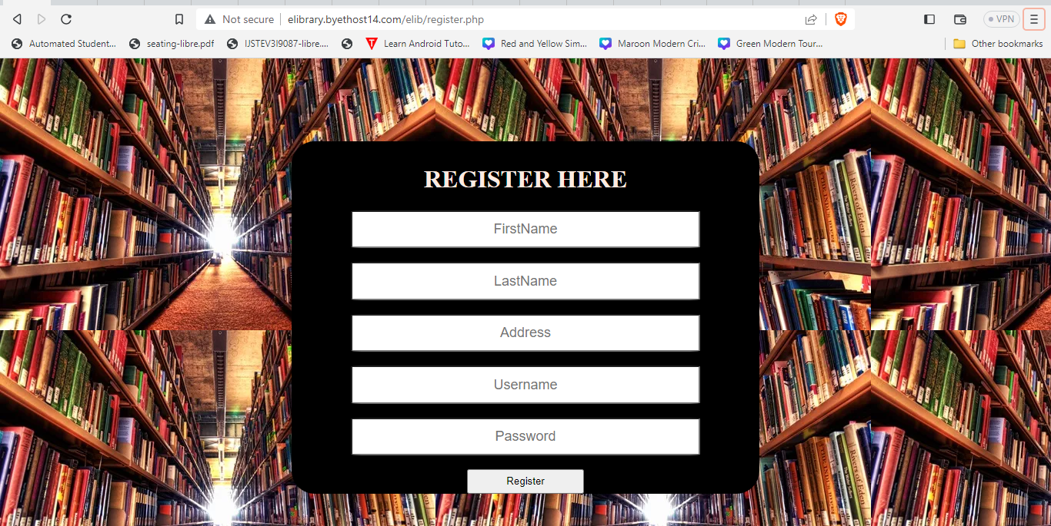For registering an account user need to enter first name, last name, address, username and password.

* **For Login**

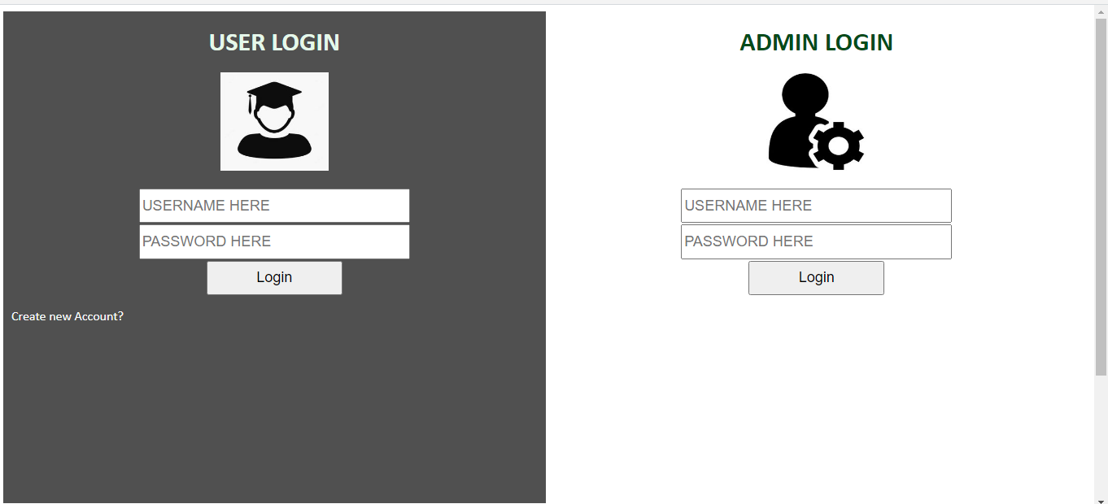User and admin can login own dashboard using Username and password

* 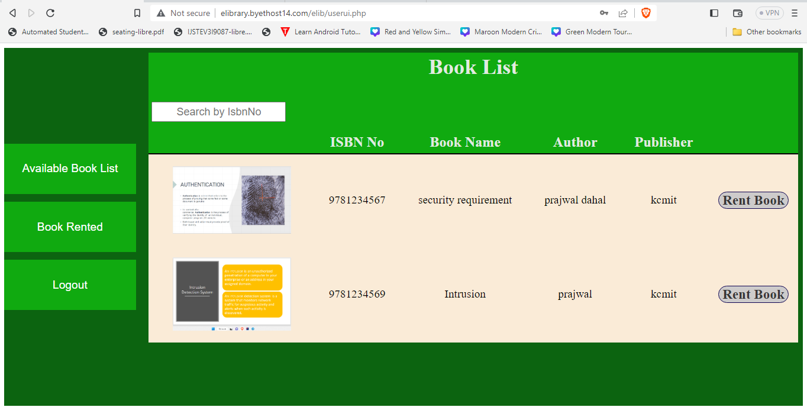**User Account Login Dashboard**

* **User Rent Book**

User can rent book by clicking on rent book button. User can specify the date for returning the book.

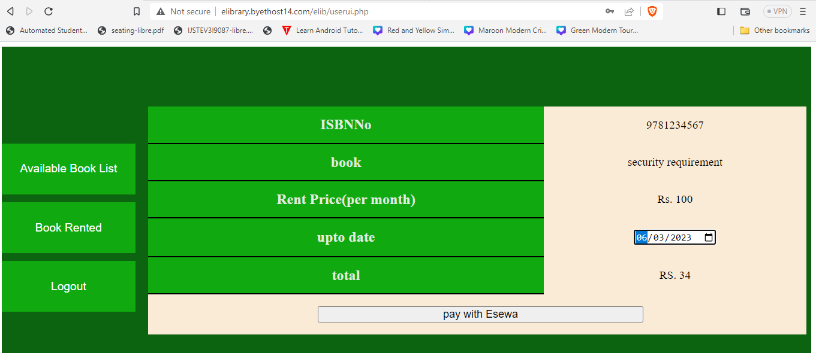

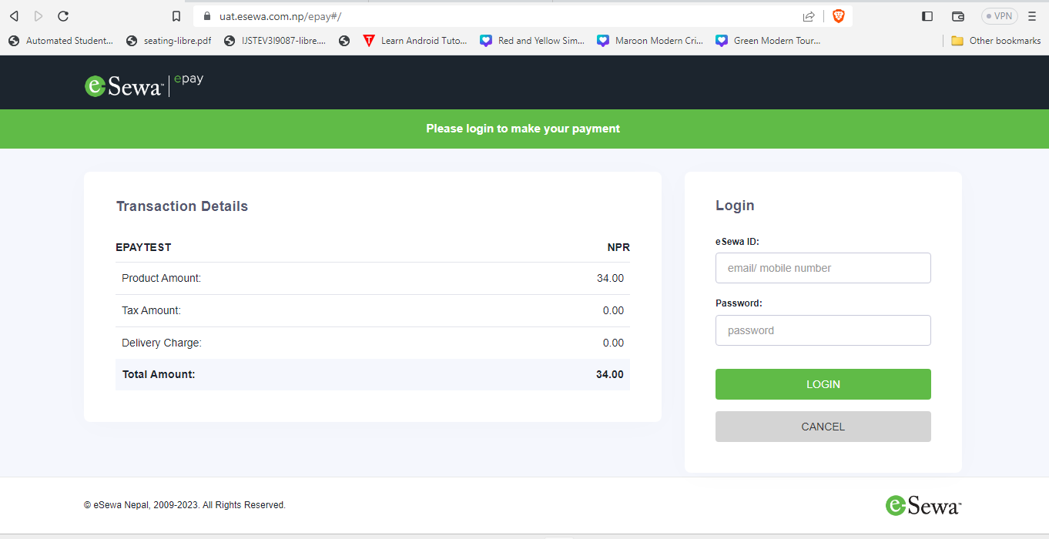

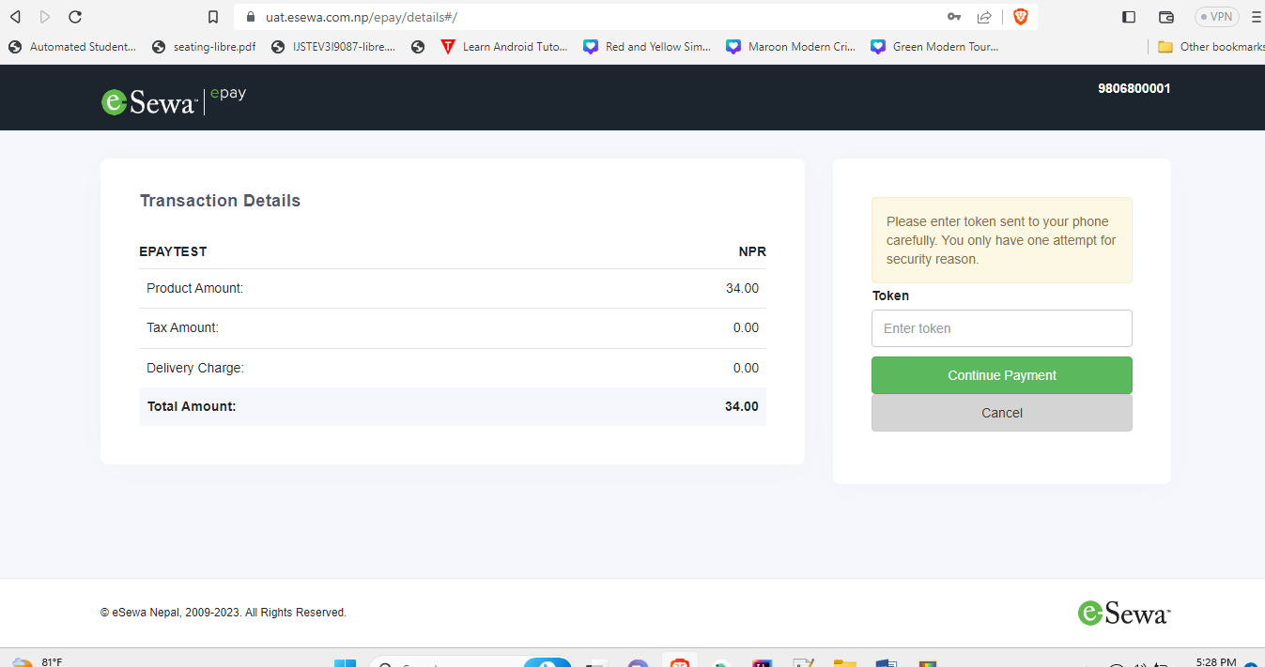

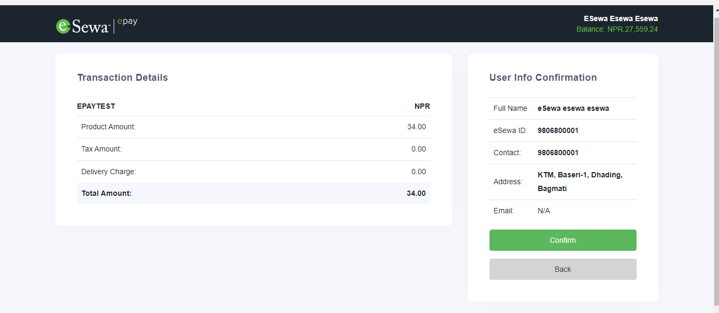

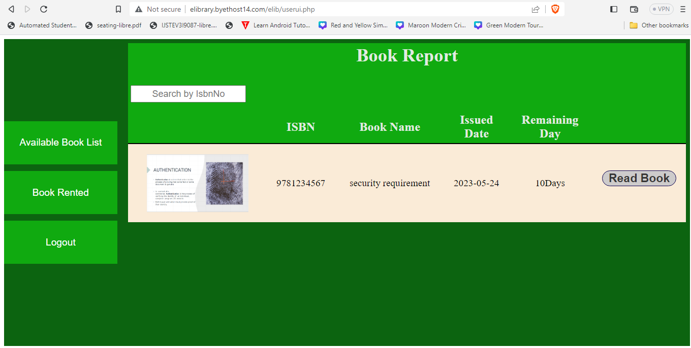

* **Reading Rented Book**

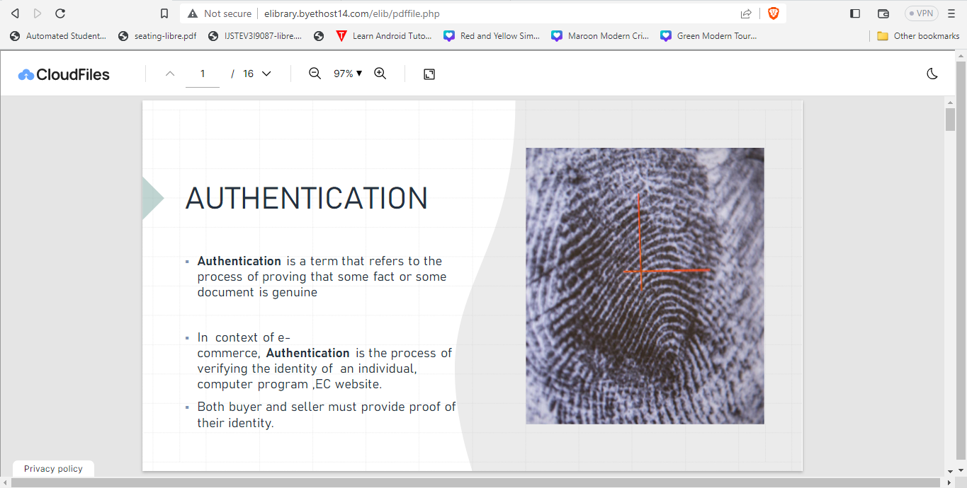For reading rented book user can click on read book.

* **Admin Dashboard**

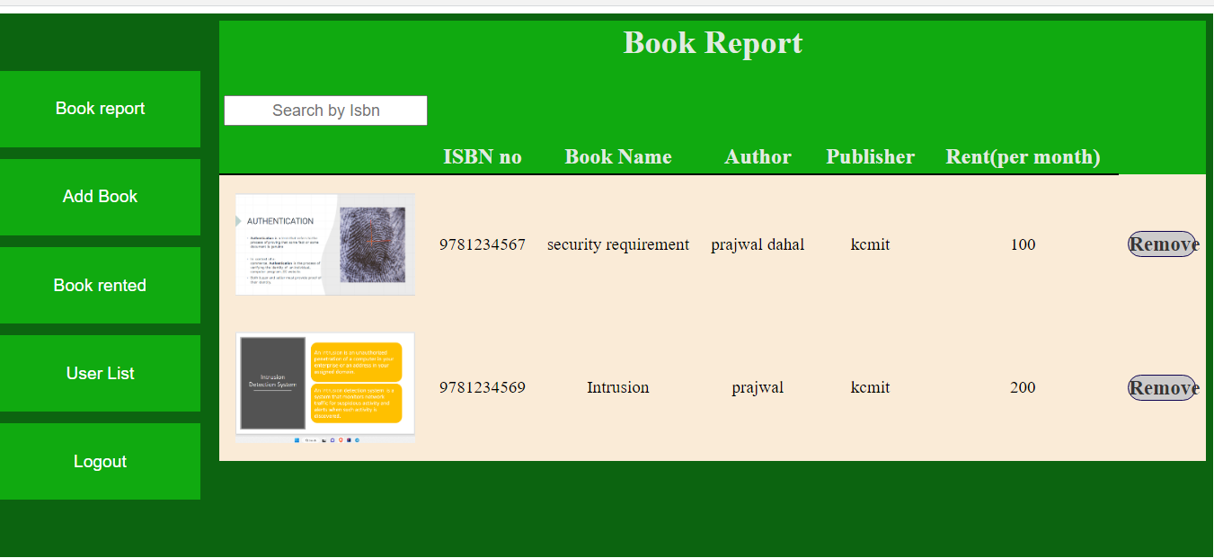Admin can remove book.

* **Add Book**

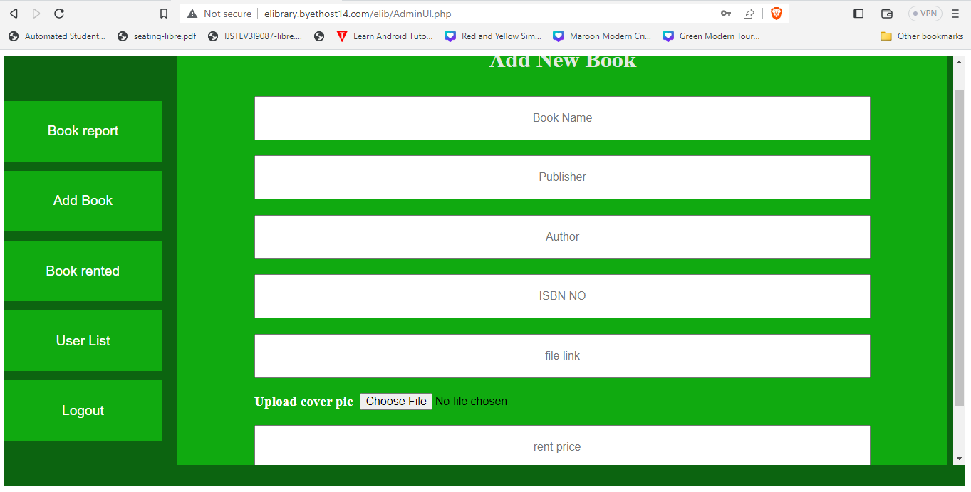

* **Book rented**

Admin can view book rented by user

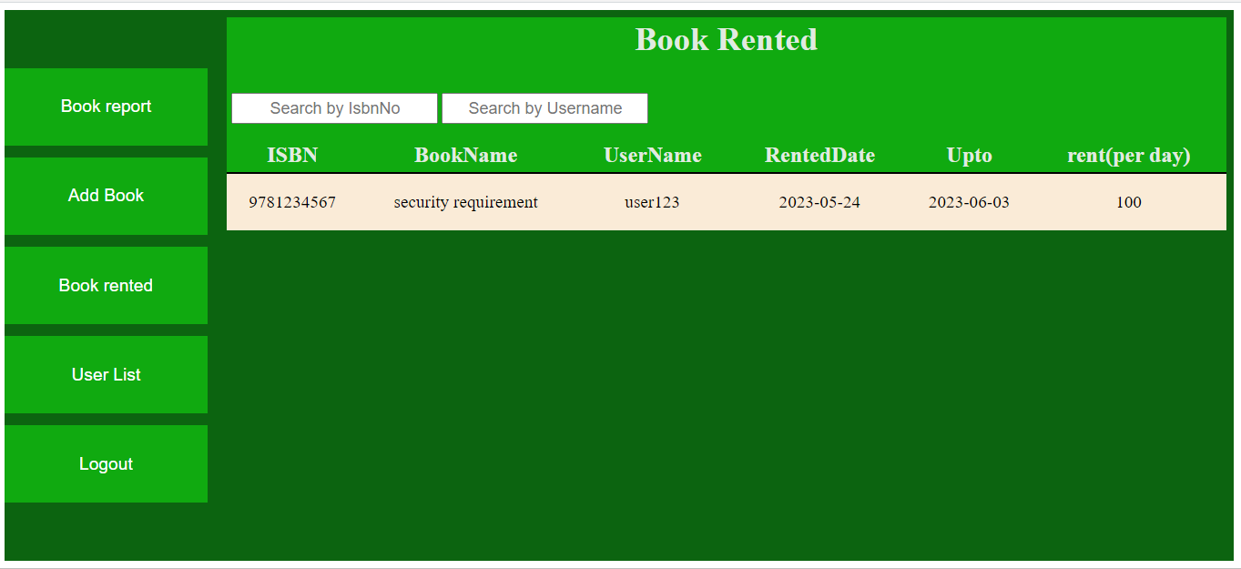

* **User List**

Admin can view registered user.

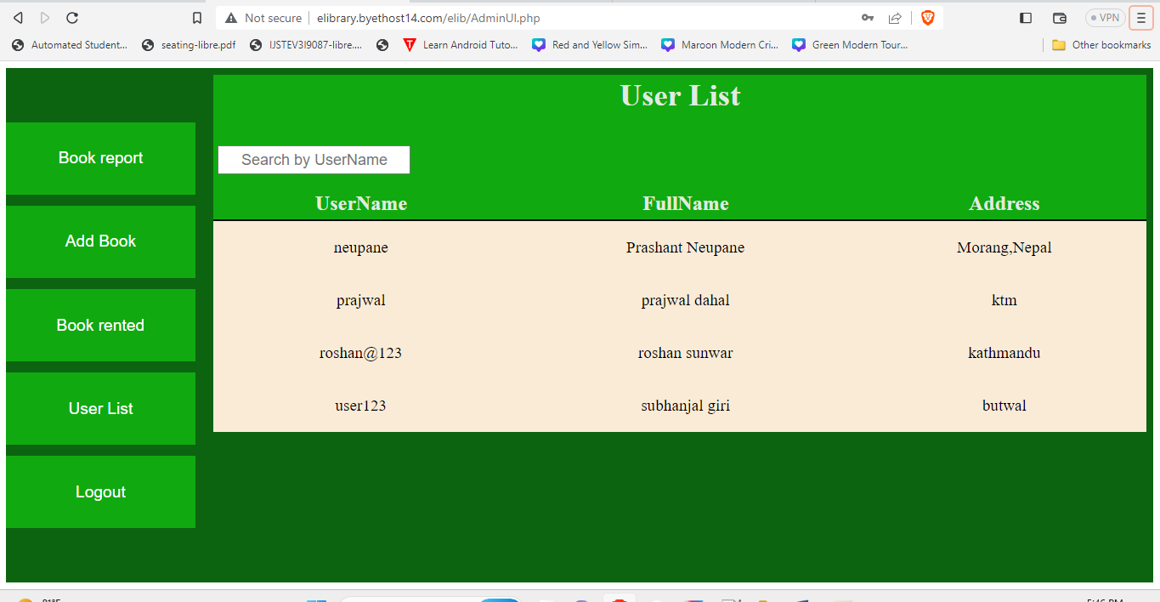

# Conclusion

The “**e-library**” system was made using PHP, JavaScript, and CSS and for data storing MYSQL database is use. Talking about this e-library system, it has all required essential feature. User can rent the resources added by admin and by paying per month price for renting a book. After time specify by user is finished when user logged into the system it will automatically remove it from user resources rented list.

Admin can add/remove the resources, can also view list of resources which are in rent. Admin can also view registered user detail.