**A**

**LAB REPORT**

**ON**

**Network Programming**

**By**

**Prajwal Dahal**

**TU REG no: 6-2-388-03-2019**



**Submitted to:**

**Harendra Subedi**

**Lecturer**

**Kantipur College of Management and Information Technology**

In partial fulfillment of the requirements for the Course

Network Programming

Mid Baneshwor, Kathmandu

December 2023

TABLE OF CONTENTS

1 Write a program to display IP address of ‘google.com’ by using InetAddress class. 1

1.1 Source Code 1

1.2 Output Window 1

2 Write a program to display mac address and IP Address of your pc. 2

2.1 Source Code 2

2.2 Output Window 3

3 Write a program to retrieve protocol, port, host and file from URL. 4

3.1 Source Code 4

3.2 Output Window 4

4 Write a program to construct URI with schema, authority, path, query and fragments. 5

4.1 Source Code 5

4.2 Output Windows 5

5 Write a program to demonstrate use of URLEncoder and URLDecoder class. 6

5.1 Source Code 6

5.2 Output Window 6

6 Write a program to set the cookie and retrieved cookie using CookieManager class. 7

6.1 Source Code 7

6.2 Output Window 8

7 Write a program to read data from the server. 9

7.1 Source Code 9

7.2 Output Window 10

8 Write a Program to retrieve specific header fields. 11

8.1 Source Code 11

8.2 Output Window 12

9 Write a program to demonstrate client-server communication using Socket. 13

9.1 Source Code 13

9.2 Output Window 15

10 Write a Program to demonstrate Multithreaded Server. 16

10.1 Source Code 16

10.2 Output Window 19

11 Write a program to demonstrate daytime client. 20

11.1 Source Code 20

11.2 Output Window 20

12 Write a program to demonstrate client-server communication using UDP protocol. 21

12.1 Source Code 21

12.2 Output Window 22

13 Write a Program to demonstrate multicast communication. 24

13.1 Source Code 24

13.2 Output Window 26

14 Write a Program to demonstrate secure socket. 27

14.1 Source Code 27

14.2 Output Windows 29

15 Write a program to add two numbers using RMI. 30

15.1 Source code 30

15.2 Output Window 31

16 Write program to implement the concept on Filling and Draining buffer, Duplicating buffer, Slicing buffer and Compact buffer. 33

16.1 Source code 33

16.2 Output window 34

# Write a program to display IP address of ‘google.com’ by using InetAddress class.

## Source Code

package qstn;

import java.net.InetAddress;

import java.net.UnknownHostException;

public class GoogleIpAddress {

public static void main(String[] args) {

try

{

InetAddress address = InetAddress.getByName("www.google.com");

System.out.println("IP address: " + address.getHostAddress());

} catch (UnknownHostException e) {

System.out.println("Hostname not found");

}

}

}

## Output Window

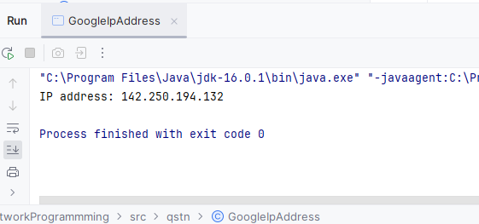

# Write a program to display mac address and IP Address of your pc.

## Source Code

package qstn;

import java.net.InetAddress;

import java.net.NetworkInterface;

import java.net.SocketException;

import java.net.UnknownHostException;

import java.util.Arrays;

import java.util.Enumeration;

public class IPAddressMACAddress {

public static void main(String[] args) throws SocketException, UnknownHostException {

InetAddress localhost = InetAddress.getLocalHost();

String ipAddress = localhost.getHostAddress();

System.out.println("IP Address: " + ipAddress);

Enumeration<NetworkInterface> interfaces = NetworkInterface.getNetworkInterfaces();

while (interfaces.hasMoreElements()) {

NetworkInterface interface1 = interfaces.nextElement();

byte[] macAddress = interface1.getHardwareAddress();

if (macAddress != null) {

String macAddressStr = "";

for (int i = 0; i < macAddress.length; i++) {

macAddressStr += String.format("%02X",macAddress[i]);

if (i < macAddress.length - 1) {

macAddressStr += ":";

}

}

System.out.println("MAC Address: " + macAddressStr);

}

}

}

}

## Output Window

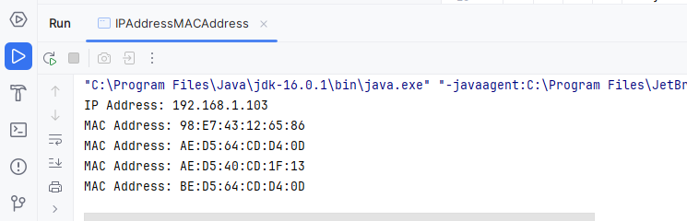

# Write a program to retrieve protocol, port, host and file from URL.

## Source Code

import java.net.URL;

import java.net.MalformedURLException;

public class URLExample {

public static void main(String[] args) {

try {

URL url = new URL("https://www.kcmit.edu.np:8080/index.html");

System.out.println("Protocol: " + url.getProtocol());

System.out.println("Host: " + url.getHost());

System.out.println("Port: " + url.getPort());

System.out.println("File: " + url.getFile());

} catch (MalformedURLException e) {

e.printStackTrace();

}

}

}

## Output Window

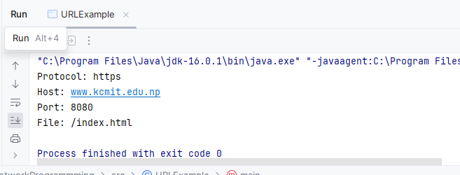

# Write a program to construct URI with schema, authority, path, query and fragments.

## Source Code

import java.net.URI;

import java.net.URISyntaxException;

public class URITestCreate1 {

public static void main(String[] args) {

try {

URI uri = new URI("https", "kcmit.edu.np", "/path", "query=param","DCfragment");

System.out.println("URI: " + uri.toString());

} catch (URISyntaxException e) {

e.printStackTrace();

}

}

}

## Output Windows

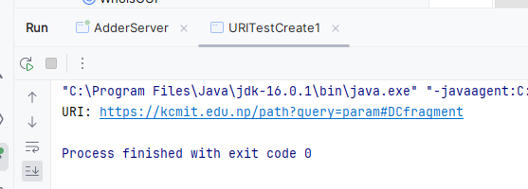

# Write a program to demonstrate use of URLEncoder and URLDecoder class.

## Source Code

import java.io.UnsupportedEncodingException;

import java.net.URLDecoder;

import java.net.URLEncoder;

public class URLEncoderExample {

public static void main(String[] args) {

try {

String url = "https://kcmit.edu.np/notices/";

String encodedString = URLEncoder.encode(url, "UTF-8");

System.out.println("Encoded String: " + encodedString);

String decodedString = URLDecoder.decode(encodedString, "UTF-8");

System.out.println("Decoded String: " + decodedString);

} catch (UnsupportedEncodingException e) {

e.printStackTrace();

}

}

}

## Output Window

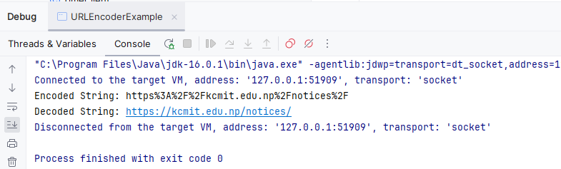

# Write a program to set the cookie and retrieved cookie using CookieManager class.

## Source Code

package qstn;

import java.net.*;

import java.util.List;

public class CookieStoreExample {

public static void main(String[] args) throws URISyntaxException {

CookieManager cookieManager = new CookieManager();

CookieStore cookieStore = cookieManager.getCookieStore();

URI uri= new URI("http://example.com");

HttpCookie cookie = new HttpCookie("name", "value");

cookie.setDomain(uri.toString());

cookie.setPath("/");

cookie.setMaxAge(1000);

cookieStore.add(uri, cookie);

List<HttpCookie> retrievedCookie = cookieStore.get(uri);

System.out.println(retrievedCookie);

for(HttpCookie cookie1:retrievedCookie){

System.out.println(cookie1.getName());

System.out.println(cookie1.getValue());

System.out.println(cookie1.getDomain());

}

cookieStore.remove(uri, cookie);

}

}

## Output Window

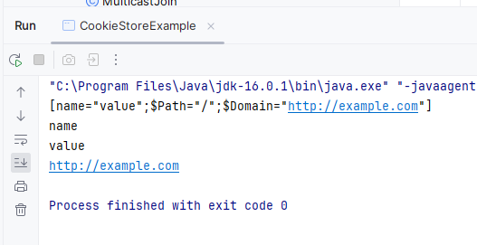

# Write a program to read data from the server.

## Source Code

package qstn;

import java.io.*;

import java.net.*;

public class URLDataRetrievalExample {

public static void main(String[] args) {

String url = "https://www.kcmit.com";

try {

URL Url = new URL(url);

HttpURLConnection httpURLConnection = (HttpURLConnection) Url.openConnection();

InputStream inputStream=httpURLConnection.getInputStream();

InputStreamReader inputStreamReader=new InputStreamReader(inputStream);

BufferedReader reader=new BufferedReader(inputStreamReader);

String line;

while ((line = reader.readLine()) != null) {

System.out.println(line);

}

reader.close();

} catch (IOException e) {

e.printStackTrace();

}

}

}

## Output Window

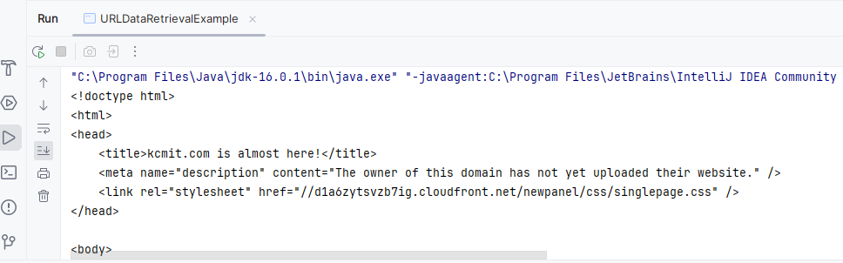

# Write a Program to retrieve specific header fields.

## Source Code

package qstn;

import java.io.*;

import java.net.*;

import java.util.*;

public class HeaderFieldExample {

public static void main(String[] args) {

try {

URL url = new URL("http://www.kcmit.edu.np");

HttpURLConnection connection = (HttpURLConnection) url.openConnection();

String contentType = connection.getContentType();

int contentLength = connection.getContentLength();

String contentEncoding = connection.getContentEncoding();

Date date = new Date(connection.getDate());

Date lastModified = new Date(connection.getLastModified());

Date expires = new Date(connection.getExpiration());

System.out.println("Content-Type: " + contentType);

System.out.println("Content-Length: " + contentLength);

System.out.println("Content-Encoding: " + contentEncoding);

System.out.println("Date: " + date);

System.out.println("Last-Modified: " + lastModified);

System.out.println("Expires: " + expires);

connection.disconnect();

} catch (IOException e) {

e.printStackTrace();

}

}

}

## Output Window

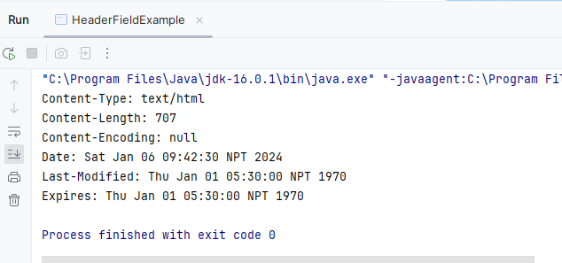

# Write a program to demonstrate client-server communication using Socket.

## Source Code

package qstn;

import java.io.IOException;

import java.io.OutputStream;

import java.net.ServerSocket;

import java.net.Socket;

public class Server {

public static void main(String[] args) {

try {

ServerSocket serverSocket = new ServerSocket(12345);

System.out.println("Server started");

Socket clientSocket = serverSocket.accept();

System.out.println("Client connected");

OutputStream outputStream = clientSocket.getOutputStream();

String message = "Hello client!";

outputStream.write(message.getBytes());

System.out.println("Message sent");

serverSocket.close();

} catch (IOException e) {

e.printStackTrace();

}

}

}

package qstn;

import java.io.IOException;

import java.io.InputStream;

import java.net.Socket;

public class Client {

public static void main(String[] args) {

try {

Socket socket = new Socket("localhost", 12345);

System.out.println("Connected to server");

InputStream inputStream = socket.getInputStream();

byte[] buffer= new byte[1234];

int bytesRead = inputStream.read(buffer);

String message = new String(buffer, 0, bytesRead);

System.out.println("Received message: " + message);

socket.close();

} catch (IOException e) {

e.printStackTrace();

}

}

}

## Output Window

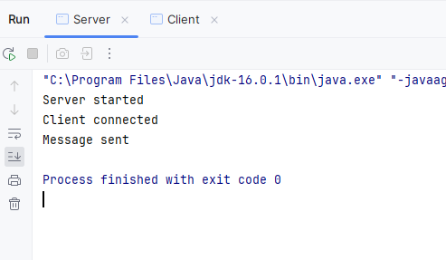

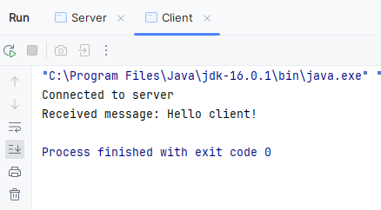

# Write a Program to demonstrate Multithreaded Server.

## Source Code

import java.io.IOException;

import java.io.PrintWriter;

import java.net.ServerSocket;

import java.net.Socket;

import java.util.Scanner;

public class MultiThreadedServer {

public static void main(String[] args) {

final int PORT = 12345;

try (ServerSocket serverSocket = new ServerSocket(PORT)) {

System.out.println("Server listening on port " + PORT);

while (true) {

Socket clientSocket = serverSocket.accept();

System.out.println("New connection from " + clientSocket.getInetAddress());

Thread clientThread = new Thread(() -> handleClient(clientSocket));

clientThread.start();

}

} catch (IOException e) {

e.printStackTrace();

}

}

private static void handleClient(Socket clientSocket) {

try (

Scanner input = new Scanner(clientSocket.getInputStream());

PrintWriter output = new PrintWriter(clientSocket.getOutputStream(), true)

) {

while (input.hasNextLine()) {

String clientMessage = input.nextLine();

System.out.println("Received from " + clientSocket.getInetAddress() + ": " + clientMessage);

output.println("Server: " + clientMessage);

}

} catch (IOException e) {

e.printStackTrace();

} finally {

System.out.println("Connection with " + clientSocket.getInetAddress() + " closed.");

try {

clientSocket.close();

} catch (IOException e) {

e.printStackTrace();

}

}

}

}

import java.io.IOException;

import java.io.PrintWriter;

import java.net.Socket;

import java.util.Scanner;

public class Client {

public static void main(String[] args) {

final String SERVER_HOST = "localhost";

final int SERVER_PORT = 12345;

try (

Socket socket = new Socket(SERVER_HOST, SERVER_PORT);

Scanner scanner = new Scanner(System.in);

PrintWriter output = new PrintWriter(socket.getOutputStream(), true)

) {

System.out.println("Connected to the server.");

Thread receiveThread = new Thread(() -> {

try (Scanner input = new Scanner(socket.getInputStream())) {

while (input.hasNextLine()) {

System.out.println("Server: " + input.nextLine());

}

} catch (IOException e) {

e.printStackTrace();

}

});

receiveThread.start();

while (true) {

System.out.print("Client: ");

String message = scanner.nextLine();

output.println(message);

}

} catch (IOException e) {

e.printStackTrace();

}

}

}

## Output Window

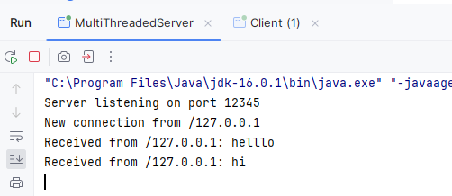

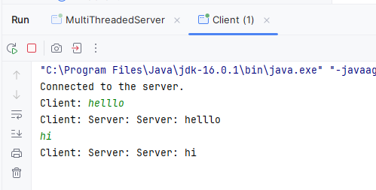

# Write a program to demonstrate daytime client.

## Source Code

import java.net.*;

import java.io.*;

public class DayTimeClient {

public static void main(String[] args) {

try {

Socket theSocket = new Socket("time.nist.gov", 13); // Connect to the server on port 13 (Daytime)

InputStream timeStream = theSocket.getInputStream();

BufferedReader bufferedReader=new BufferedReader(new InputStreamReader(timeStream));

String line;

while ((line = bufferedReader.readLine()) != null) {

System.out.println(line);

}

theSocket.close();

} catch (IOException ex) {

System.out.println(ex.getMessage());

}

}

}

## Output Window

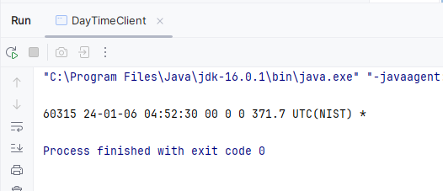

# Write a program to demonstrate client-server communication using UDP protocol.

## Source Code

import java.io.IOException;

import java.net.DatagramPacket;

import java.net.DatagramSocket;

public class UdpServer {

public static void main(String[] args) throws IOException {

DatagramSocket datagramSocket=new DatagramSocket(9876);

byte[]buffer =new byte[1024];

DatagramPacket datagramPacket=new DatagramPacket(buffer,buffer.length);

datagramSocket.receive(datagramPacket);

byte[]sendData=datagramPacket.getData();

DatagramPacket datagramPacket1=new DatagramPacket(sendData,sendData.length,datagramPacket.getAddress(),datagramPacket.getPort());

datagramSocket.send(datagramPacket1);

}

}

import java.io.IOException;

import java.net.*;

import java.util.Scanner;

public class UdpClient {

public static void main(String[] args) throws IOException {

Scanner sc = new Scanner(System.in);

String message =sc.nextLine();

DatagramSocket clientSocket=new DatagramSocket();

byte[] sendbytes=message.getBytes();

byte[]buffer=new byte[1024];

DatagramPacket datagramPacket=new DatagramPacket(sendbytes,sendbytes.length, InetAddress.getByName("localhost"),9876);

clientSocket.send(datagramPacket);

DatagramPacket recieve=new DatagramPacket(buffer,buffer.length);

clientSocket.receive(recieve);

byte[]x=recieve.getData();

System.out.println(new String(x).trim());

}

}

## Output Window

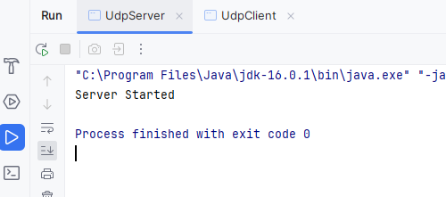

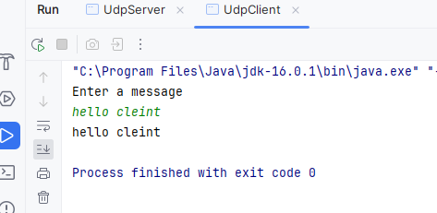

# Write a Program to demonstrate multicast communication.

## Source Code

import java.net.DatagramPacket;

import java.net.InetAddress;

import java.net.MulticastSocket;

public class MulticastReceiver {

public static void main(String[] args) {

try {

int port = 12345;

InetAddress group = InetAddress.getByName("239.0.0.1");

MulticastSocket socket = new MulticastSocket(port);

socket.joinGroup(group);

byte[] buffer = new byte[1024];

while (true) {

DatagramPacket packet = new DatagramPacket(buffer, buffer.length);

socket.receive(packet);

String message = new String(packet.getData(), 0, packet.getLength());

System.out.println("Received: " + message);

}

} catch (Exception e) {

e.printStackTrace();

}

}

}

import java.io.IOException;

import java.net.*;

import java.util.Scanner;

public class MulticastClient {

public static void main(String[] args) {

try {

System.out.print("enter a number: ");

Scanner sc= new Scanner(System.in);

String message =sc.nextLine();

byte[] sendBuffer = message.getBytes();

InetAddress multicastGroup = InetAddress.getByName("239.0.0.1");

int port = 12345;

MulticastSocket socket = new MulticastSocket();

socket.joinGroup(multicastGroup);

DatagramPacket sendPacket = new DatagramPacket(sendBuffer, sendBuffer.length, multicastGroup, port);

socket.send(sendPacket);

byte[] receiveBuffer = new byte[1024];

DatagramPacket receivePacket = new DatagramPacket(receiveBuffer, receiveBuffer.length);

socket.receive(receivePacket);

String receivedMessage = new String(receivePacket.getData(), 0,receivePacket.getLength());

System.out.println("Server says: " + receivedMessage);

socket.leaveGroup(multicastGroup);

socket.close();

} catch (IOException e) {

e.printStackTrace();

}

}

}

## Output Window

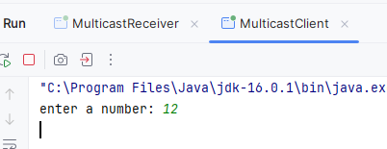

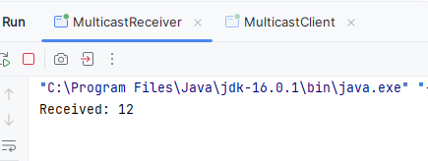

# Write a Program to demonstrate secure socket.

## Source Code

import javax.net.ssl.HandshakeCompletedEvent;

import javax.net.ssl.HandshakeCompletedListener;

import javax.net.ssl.SSLSocket;

import javax.net.ssl.SSLSocketFactory;

import java.io.*;

public class HTTPClient {

public static void main(String[] args) {

int port = 443;

String host = "www.usps.com";

try {

SSLSocketFactory factory

= (SSLSocketFactory) SSLSocketFactory.getDefault( );

SSLSocket socket = (SSLSocket) factory.createSocket(host, port);

socket.addHandshakeCompletedListener(handshakeCompletedEvent -> System.out.println("handshake completed"));

String[] supported = socket.getSupportedCipherSuites( );

socket.setEnabledCipherSuites(supported);

Writer out = new OutputStreamWriter(socket.getOutputStream( ));

out.write("GET http://" + host + "/ HTTP/1.1\r\n");

out.write("Host: " + host + "\r\n");

out.write("\r\n");

out.flush( );

BufferedReader in = new BufferedReader(

new InputStreamReader(socket.getInputStream( )));

String s;

while (!(s = in.readLine( )).equals("")) {

System.out.println(s);

}

System.out.println( );

String contentLength = in.readLine( );

int length = Integer.MAX_VALUE;

try {

length = Integer.parseInt(contentLength.trim( ), 16);

}

catch (NumberFormatException ex) {

ex.printStackTrace();

}

System.out.println(contentLength);

String c;

int i = 0;

while ((c = in.readLine() )!=null && i++ < length) {

System.out.println(c);

}

System.out.println( );

out.close( );

in.close( );

socket.close( );

}catch (IOException ex) {

System.err.println(ex);

}

}}

## Output Windows

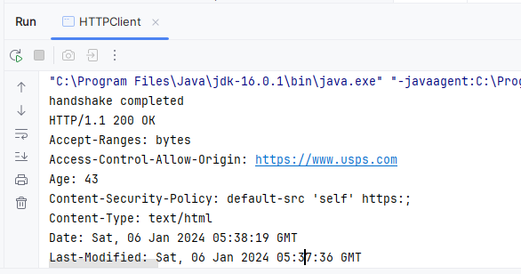

# Write a program to add two numbers using RMI.

## Source code

package RMI;

import java.rmi.Remote;

import java.rmi.RemoteException;

public interface Adder extends Remote {

int add(int a, int b) throws RemoteException;

}

package RMI;

import java.rmi.RemoteException;

import java.rmi.server.UnicastRemoteObject;

public class AdderImpl extends UnicastRemoteObject implements Adder {

public AdderImpl() throws RemoteException {

super();

}

public int add(int a, int b) throws RemoteException {

return a + b;

}

}

package RMI;

import java.rmi.registry.LocateRegistry;

import java.rmi.registry.Registry;

public class AdderServer {

public static void main(String[] args) {

try {

Adder adder = new AdderImpl();

Registry registry = LocateRegistry.createRegistry(1099);

registry.rebind("Adder", adder);

System.out.println("Server is ready to accept requests...");

} catch (Exception e) {

e.printStackTrace();

}

}

}

package RMI;

import java.rmi.registry.LocateRegistry;

import java.rmi.registry.Registry;

public class AdderClient {

public static void main(String[] args) {

try {

Registry registry = LocateRegistry.getRegistry("localhost", 1099);

Adder adder = (Adder) registry.lookup("Adder");

int result = adder.add(5, 10);

System.out.println("Result from server: " + result);

} catch (Exception e) {

e.printStackTrace();

}

}

}

## Output Window

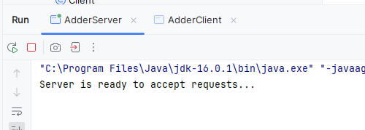

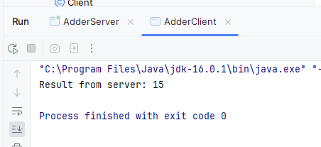

# Write program to implement the concept on Filling and Draining buffer, Duplicating buffer, Slicing buffer and Compact buffer.

## Source code

package qstn;

import java.nio.ByteBuffer;

public class ByteBufferOperations {

public static void main(String[] args) {

ByteBuffer buffer = ByteBuffer.allocate(10);

for (int i = 1; i <= 5; i++) {

buffer.put((byte) i);

}

System.out.println("Original Buffer: " + byteArrayToHexString(buffer.array()));

buffer.flip();

while (buffer.hasRemaining()) {

System.out.println("Drained Byte: " + buffer.get());

}

ByteBuffer duplicateBuffer = buffer.duplicate();

System.out.println("Duplicated Buffer: " + byteArrayToHexString(duplicateBuffer.array()));

buffer.clear();

buffer.put(new byte[]{1, 2, 3, 4, 5, 6, 7, 8, 9, 10});

buffer.position(3).limit(7);

ByteBuffer slicedBuffer = buffer.slice();

System.out.println("Sliced Buffer: " + byteArrayToHexString(slicedBuffer.array()));

buffer.clear();

buffer.put(new byte[]{1, 2, 3, 4, 5});

buffer.flip();

buffer.get();

buffer.compact();

System.out.println("Compacted Buffer: " + byteArrayToHexString(buffer.array()));

}

private static String byteArrayToHexString(byte[] array) {

StringBuilder hexString = new StringBuilder();

for (byte b : array) {

hexString.append(String.format("%02X ", b));

}

return hexString.toString().trim();

}

}

## Output window

