

**Tribhuvan University**

**Faculty of Humanities and Social Sciences**

**Seatplanner**

**A PROJECT REPORT**

**Submitted to**

**Department of Computer Application**

**Kantipur College of Management and Information Technology**

***In partial fulfillment of the requirements for the Bachelors in Computer Application***

Submitted by

**Prajwal Dahal [3880791]**

August, 2022

Under the Supervision of

**Mr. Sudip Khadka**



**Tribhuvan University**

**Faculty of Humanities and Social Sciences**

**Kantipur College of Management and Information Technology**

**Supervisor’s Recommendation**

We hereby recommend that this project prepared under my supervision by **Prajwal Dahal** entitled “**Seatplanner.**” in partial fulfillment of the requirements for the degree of Bachelor of Computer Application is recommended for the final evaluation.

**Mr. Sudip Khadka**

**SUPERVISOR**

Kantipur College of Management and Information Technology

Department of BCA



**Tribhuvan University**

**Faculty of Humanities and Social Sciences**

**Kantipur College of Management and Information Technology**

**LETTER OF APPROVAL**

This is to certify that this project prepared by **Prajwal Dahal** entitled “**Seatplanner**” in partial fulfillment of the requirements for the degree of Bachelor in Computer Application has been evaluated. In our opinion, it is satisfactory in the scope and quality as a project for the required degree.

Mr.

External Examiner

Tribhuvan University Signature Date

Mr. Amit Pandey

HOD/Coordinator

KCMIT Signature Date

Mr. Sudip Khadka

Supervisor

KCMIT Signature Date

# Acknowledgement

This project is prepared in the partial fulfillment of the requirement for the degree of Bachelor in Computer Application (BCA). The satisfaction and success of completion of this task would be incomplete without heartfelt thanks to people whose constant guidance, support and encouragement made this work successful. On doing this undergraduate project we have been fortunate to have help, support and encouragement from many people we would like to acknowledge them for their cooperation.

Our first thanks goes to Tribhuvan University for designing such a worthy syllabus and making us do this project. Our next batch of thanks goes to the faculty of Management of KCMIT without whose help our project would have been impossible. This list includes Principal of KCMIT, **Mrs. Lalita Chand** Our very sincere and heartfelt thanks go to **Mr. Sudip Khadka** our project supervisors who constantly guided us through the project time period. Without his guidance, our project would have been impossible. Last but not the least we want to thank every direct and indirect hands that were involved in completion of this project.

This project has been a wonderful experience where we have learnt and experienced many beneficial things.

**Prajwal Dahal [3880791]**

# Abstract

The main aim of this project is to provide simple platform to the examiner where they can generate automatic seat plan for examinee within a few minute. The develop systems will simplify Seatplanning process by automatically generating seat plan report in excel file. It will reduce time and effort for examiner which require in traditional way of seat planning. The develop system was designed and implemented using Java and MySQL.

**Table of Contents**

Acknowledgement i

Abstract ii

Chapter 1: Introduction 1

1.1: Introduction 1

1.2: Problem Statement 1

1.3: Objective 1

1.4: Scope 2

1.5: Overview of Report 2

Chapter 2: Background Story and Literature Review 3

2.1: Background Story 3

2.2: Literature Review 3

Chapter 3: System Analysis and Methodology 5

3.1: System Analysis 5

3.1.1: Requirement Analysis 5

3.1.2: Feasibility Study 8

3.2: Methodology 10

3.2.1: Algorithm 10

3.2.2: Flowchart 11

3.2.3: Data flow diagram (DFD) 12

3.2.4: Entity Relationship Diagram 15

Chapter 4: Result analysis and Discussion 16

4.1: Result Analysis 16

4.2: Test cases 16

Chapter 5: Conclusion and Recommendation 42

5.1: Limitation 42

5.2: Future Recommendation 42

5.3: Conclusion 42

References 43

Annex 44

**List of Figures**

Figure 3.1.1.1: Use case diagram…………………………………........……6

Figure 3.1.2.1: Gantt chart of seatplanner…………………………………..9

Figure 3.2.2.1: Flowchart of seatplanner……………………………………11

Figure 3.2.3.1: Context Diagram of seatplanner……………….……………12

Figure 3.2.3.2: Level 1 Dataflow Diagram of seatplanner…………………..13

Figure 3.2.3.3: Level 2 Dataflow Diagram of Seatplanner…………………..14

Figure 3.2.4.1: Entity Relationship diagram of Seatplanner…………………15

**List of Tables**

Table 4.2.1: Test Case for Login…………………………………………………………16

Table 4.2.2: Test case for add, update and delete student………………………………..20

Table 4.2.3:Test case for add,update and delete room…………………………………...26

Table 4.2.4: Test case for seat plan generation…………………………………………..32

Table 4.2.5: Test case for change password……………………………………………..37

**List of Abbreviation**

|  |  |
| --- | --- |
| ER | Entity Relationship |
| DFD | Data Flow Diagram |
| MySQL | Structure Query Language |

# Introduction

## Introduction

Majority of educational institutes are dealing with issues for making seat plan for examinee in examination. They are facing issues like repetition of same examinee and no seat plan for some examinee as people tends to forgot things. Manual Seatplanning also takes lots of time and effort.

By looking at the worldwide trend of traditional system of work being replaced by Computer based System for efficient and fast output, we are motivated to make ‘Seatplanner’ which reduces time and effort of examiner.

This System is made by using free technology available on internet such as XAMPP for server and MySQL, Intellij Idea as IDE for java which performed operation like add, update and delete student and room data, generate seat plan report in Excel file.

## Problem Statement

Traditional system of Seatplanning may not be reliable because of the problem which usually occurred such as forgot to put name of examinee in the seat plan report, repetition of same examinee. Examiner has to give lots of time and effort for making manual seat plan.

## Objective

The main aim of this project is to design and implement Computer based Seatplanning

The specific objectives are:

* To develop a system for examiner to add examinee and generate automatic seat plan for exams in excel file.
* To reduce time and effort for examiner to make seat plan
* To solve problem of manual Seatplanning such as repetition of examinee and no seat for examinee.

## Scope

Scope of this project is very broad, few of them are:

* This can be used in educational institutions as well as in corporate world for exams.
* This can be use by those universities where there are very high number of student.

## Overview of Report

The report contains altogether have seven chapters. The first chapter “Introduction” contains whole information of the project “Seatplanner”. It is sub-headed into five topics. The chapter contains the introduction, problem statements, objectives, scope and overview of report of our project. Similarly, chapter two consists of the background study and literature review of the report. In addition, chapter three is all about the methods by which our project is being completed. It is sub headed in two topics: system analysis and methodology of the project. Under system analysis functional and non-functional requirement are made, feasibility analysis in technical, operational and economic, schedule feasibility of the project is analyzed. Under methodology, algorithm, flowchart, data flow diagram and E-R diagram of the project is designed. The chapter four consists of the details of the implementation and test cases of system. Chapter five includes limitation, future enhancement, conclusion and recommendation of our project. There can be some changes in future in this project to make more effective is included and also consists of overall summary of the project.

# Background Story and Literature Review

## Background Story

This present era has been termed to be an information age. An age where the demand for information dramatically increased. The computer has been the most useful thing for getting or accessing information nowadays.

The unending global and social change that we find ourselves in as a result of rapid transformation from the industrial age to an information age brought about the introduction of computer into the information industry. This introduction (the use of computers) has rapidly affected all areas of life ranging from homes, industries and of course the educational system.

However, with the economic development and advancement in science and technology, adding to the rapid increase in the population of the country (Nigeria), education becomes the dream of every parent for her child, leaving behind the initial philosophy against education. This lead to massive increase of students in schools and there have been a silent cry for an efficient system that will manage students and department numerous files in different universities.

Presently in the Educational institute, due to the increasing number of students, seat allocation for examination has become problem for Educational institute as it consumes lots of time and effort.

However, this created a lot of problems associated with hall allocation and there are no rigid guidelines as to which method should be used. This project “Seatplanner” will consider the allocation of seats in room for examination.

## Literature Review

Before making this project, a brief study on old seat allocation system were made. Various paper regarding seat allocation system were studied.

‘Seating arrangement Tools for examinations’ [1] developed by Ashti Fatima Alam using C/C++. The main drawback was it was not efficient & was not user friendly.

‘Exam hall seating arrangement System’ [2] using PHP developed by Prof. S.S.Aravinth, G.Pavithra is an online system, where student registration to be done first.

‘Examination Management Automation System’ [3] developed by Vamsi Krishna Yepuri, Gopi Chand Pamu, Naveen Kodali, Pradyumna L According to the paper, the system has been designed to simplify the allocation of halls, seating arrangement of students and allocating staff to the examination halls. Allocation of faculty to corresponding rooms will be done by the exam cell coordinator in the form of word documents and excel sheets and also allocation of students to their corresponding rooms.

# System Analysis and Methodology

## System Analysis

Systems Analysis the process of observing systems for development purposes. It helps in understanding of complex structure of the system. It also gives an advantage of understanding and comparing the subsystems functions with complete system.

### Requirement Analysis

1. **Functional Requirement:**

**These are the requirements that the end user specifically demands as basic facilities that the system should offer.** **It specifies ‘What should the software system do?’ All these functionalities need to be necessarily incorporated into the system as a part of the contract. They are basically the requirements stated by the user which one can see directly in the final product.**

**Login/Logout**

* **To make a system secure, User should log in before starting using the system and log out after he/she finishes.**

**Manage Student**

* **User can update, delete and add student**

**Manage Room**

* **User can update, delete and add room**

**Generate Report**

* **Report can be generated in Excel file and directly open that file in Excel**

**Change Password**

* **Admin can change Password.**

#### 

**Figure 3.1.1.1: Use-case diagram**

1. **Non-functional Requirement:**

**Non-Functional Requirement specifies the quality attribute of a software system. They judge the software system based on Responsiveness, Usability, Security, Portability and other non-functional standards that are critical to the success of the software system. This requirement describe how the functional requirement are implemented on the system.**

**Requirement Analysis produced the following non-functional requirement:**

**Reliability:**

**The degree to which the software regularly executes the stated functions without failure is referred to as reliability. All the function stated in this project will performed accurately.**

**Availability:**

**This software need computer system to operate. If you have computer system you can use this software 24 hours per day.**

**Security:**

**In order to prevent unauthorized access user needs to login with username and password for using this software.**

**Performance:**

The system performance is very fast. The report generation time is very quick.

### ****Feasibility Study****

1. **Technical Feasibility:**

This study is carried out to check technical requirement of the system. Seatplanner is made using java which is platform independent language. It can be use in all types of operating system with java virtual machine (JVM) installed. This system can be use on computer with very basic specification. So, this software is technically feasible.

1. **Economic feasibility:**

The program uses community edition of Intellij Idea for developing this system which is free of cost. The project is the part of academic qualification for Bachelor in Computer Application - Tribhuvan University and there is no monetary factor involved. So, the project is economically feasible.

1. **Operational feasibility:**

This study is carried out to check the acceptance of the system. Seatplanner is design using simple UI so user can learn very fast to use it. So, project is operationally feasible.

1. **Schedule Feasibility:**

Schedule Feasibility is defined as the probability of a project to be completed within its scheduled time limits, by a planned due date. If a project has a high probability to be completed on-time, then its schedule feasibility is high. If we want to see the project completed before they can lose their utility, we need to give proper attention to controlling their schedule feasibility.

The final schedule of the project is given below:

|  |  |  |  |  |  |  |  |  |  |  |  |  |
| --- | --- | --- | --- | --- | --- | --- | --- | --- | --- | --- | --- | --- |
| Task | April | | | | May | | | | June | | | |
| week 1 | week 2 | week 3 | week 4 | week 1 | week 2 | week 3 | week 4 | week 1 | week 2 | week 3 | week 4 |
| Planning |  |  |  |  |  |  |  |  |  |  |  |  |
| Requirement analysis |  |  |  |  |  |  |  |  |  |  |  |  |
| UI design |  |  |  |  |  |  |  |  |  |  |  |  |
| Database design |  |  |  |  |  |  |  |  |  |  |  |  |
| Report writing |  |  |  |  |  |  |  |  |  |  |  |  |
| Implementation |  |  |  |  |  |  |  |  |  |  |  |  |
| Testing and debugging |  |  |  |  |  |  |  |  |  |  |  |  |

**Figure 3.1.2.1: Gantt chart of Seatplanner**

## Methodology

This section describes how actually system is implemented and work. To understand actual workflow of the system various model are shown in this section.

### Algorithm

1. Start
2. Enter login username and password.
3. If password and username is correct
   * + - 1. user can add, update and delete student
         2. user can add update and delete room
         3. user can generate seat plan report in excel
         4. user can change password
         5. user can view generated file

Else

Show invalid credential message.

1. End

### Flowchart

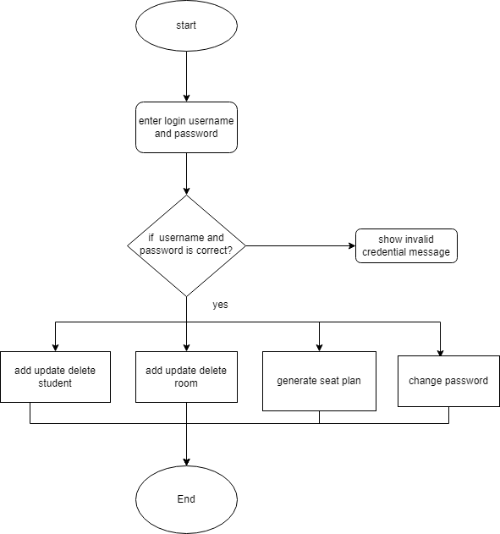

**Figure 3.2.2.1 Flowchart of Seatplanner**

### Data flow diagram (DFD)

1. **Context diagram (level 0 DFD)**

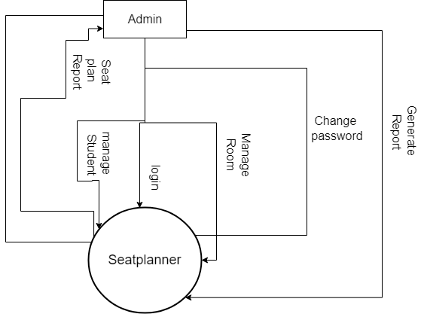

**Figure 3.2.3.1: Context Diagram of Seatplanner**

1. 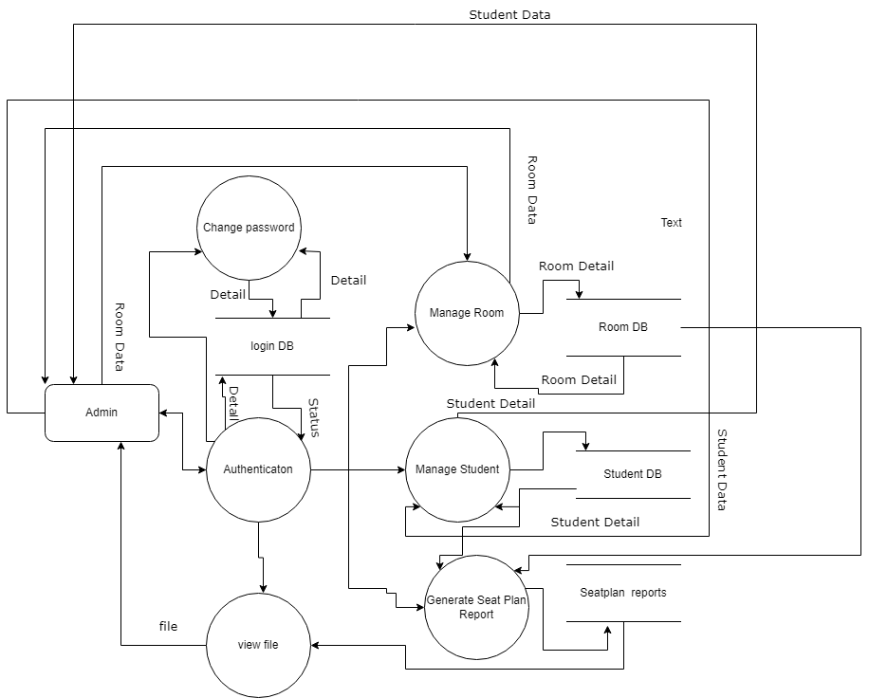**Level 1 DFD**

**Figure 3.2.3.2: Level 1 Dataflow Diagram of Seatplanner**

1. **Level 2 DFD**

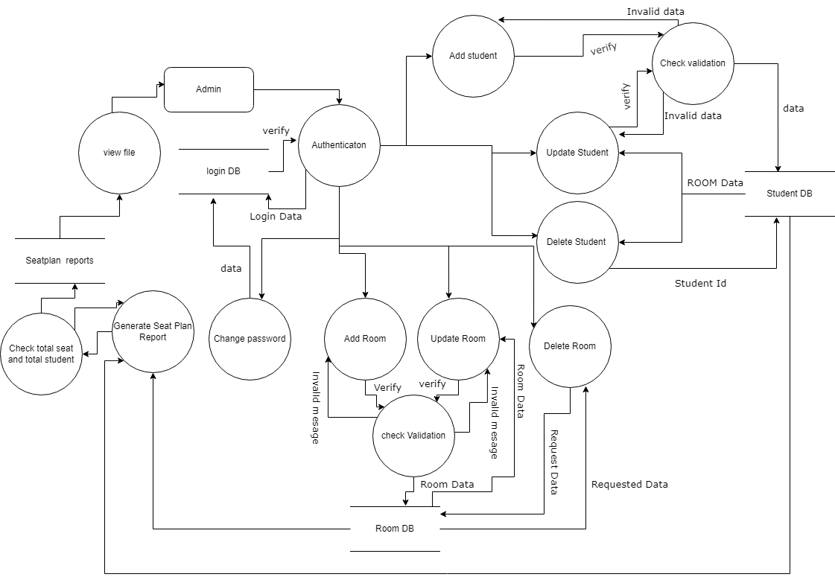

**Figure 3.2.3.3: Level 2 Dataflow Diagram of Seatplanner**

### Entity Relationship Diagram

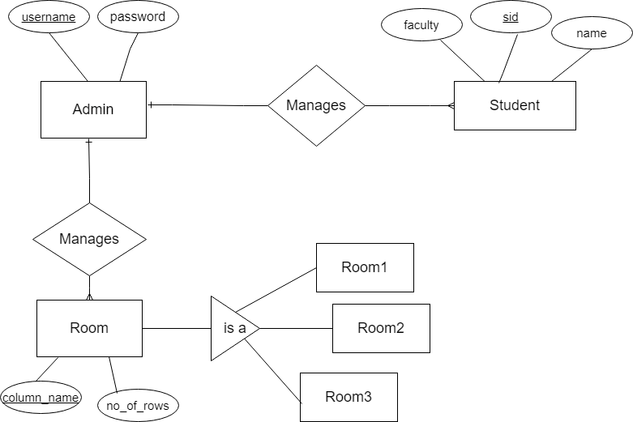

**Figure 3.2.4.1: Entity Relationship Diagram of Seatplanner**

# Result analysis and Discussion

## Result Analysis

Despite project was not planned in proper manner, we made many changes while building the project for simplicity and additional features. Many additional features were added as per supervisor suggestion. Some of the features could not be added because of time bounds making them the limitation and future recommendation of this project

The screenshot of the project is shown in the Annex chapter.

## Test cases

**Table 4.2.1: Test Case for Login**

|  |  |  |  |
| --- | --- | --- | --- |
| Test case id | 1 | | |
| Test case description | Login | | |
| Prerequisites | Enter the username and password. Click login | | |
| Test scenario 1 | User click login button without entering username and password | | |
| Test data | Username:  Password: | | |
| Step | Expected output | Actual Result | Pass/fail |
|  | Please check credential | Please check credential | Pass |
|  | | | |
| Test scenario 2 | Admin enter a wrong password or username | | |
| Test data | Username: User  Password: 123 | | |
| Step | Expected output | Actual Result | Pass/fail |

|  |  |  |  |  |
| --- | --- | --- | --- | --- |
|  | Please check credential | | Please check credential | Pass |
|  | | | | |
| Test scenario 3 | | Admin enter valid username and password | | |
| Test data | | Username: admin  Password: root@123 | | |
| Step | | Expected output | Actual Result | Pass/fail |
|  | | Add Student Window open | Add Student Window open | Pass |
|  | |  |  |  |

**Test case scenario 1:**

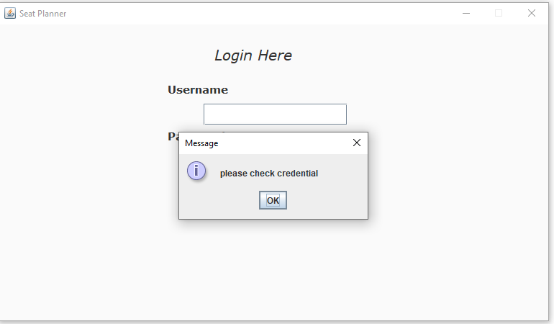

**Test case scenario 2:**

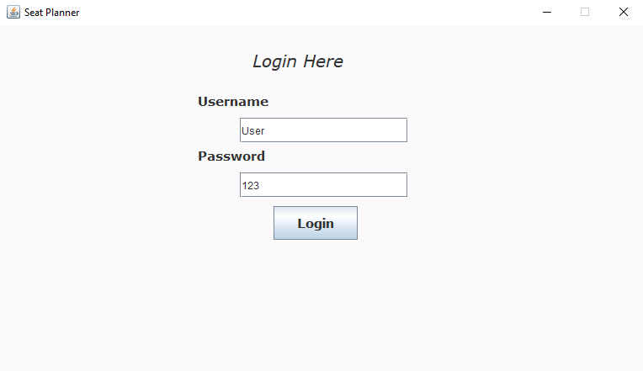

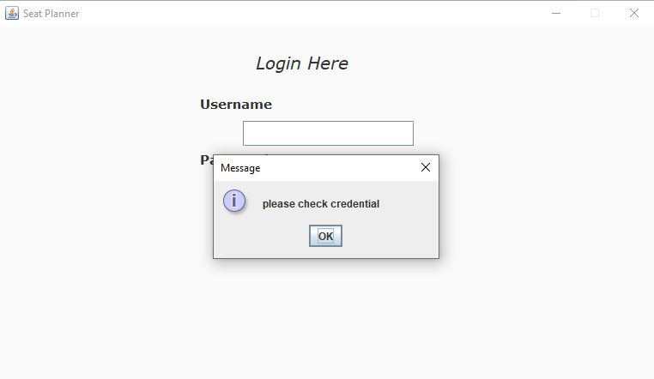

**Test case scenario 3:**

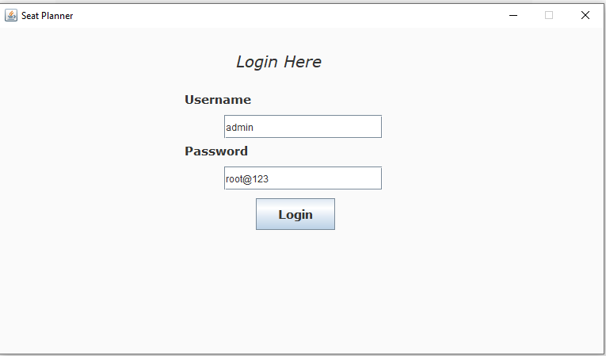

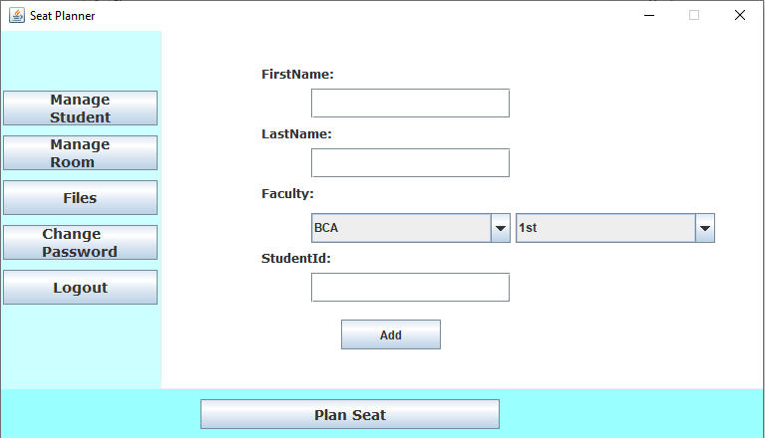

#### Table 4.2.2: Test case for add, update, delete student

|  |  |  |  |
| --- | --- | --- | --- |
| Test Case ID | 2 | | |
| Test Case Description | Add, update, delete Student | | |
| Prerequisites: | All the field must be filled. | | |
| Test Scenario | 1. Enter the First Name, Last Name, faculty, student id. 2. Click Add button. 3. Update the student to create some changes. | | |
|  | 4. Delete the student if necessary. | | |
| Test Data | First Name: prajwal Last Name: Dahal  Faculty: BCA 1st  Student Id: 322  **Update data:**  Faculty: BBA 1st  **Delete data:**  Student Id: 322 | | |
| Step | Expected Result | Actual Result | Pass/Fail |
| 1. | Student added | Student added. | Pass |
|  |  |  |  |
| 2. | Do you want to update student with id=322? | Do you want to update student with id =322? | Pass |
|  |  |  |  |
| 3. | Do you want to delete student with id 322? | Do you want to delete student with id 322? | Pass |
|  |  |  |  |

**Test Scenario:**

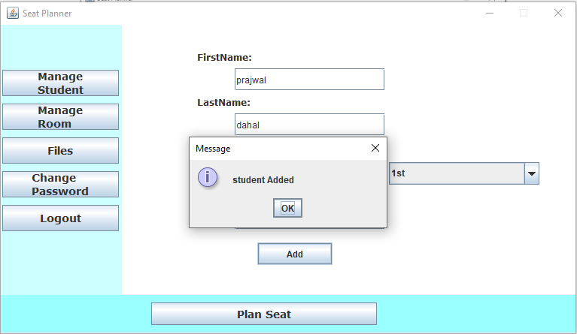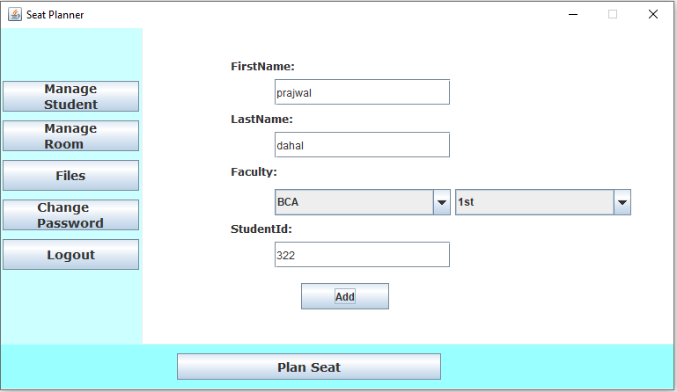 **Add Student**

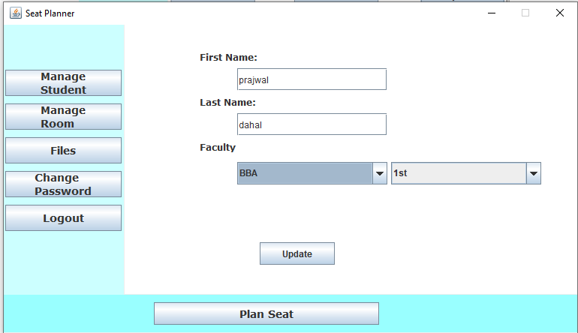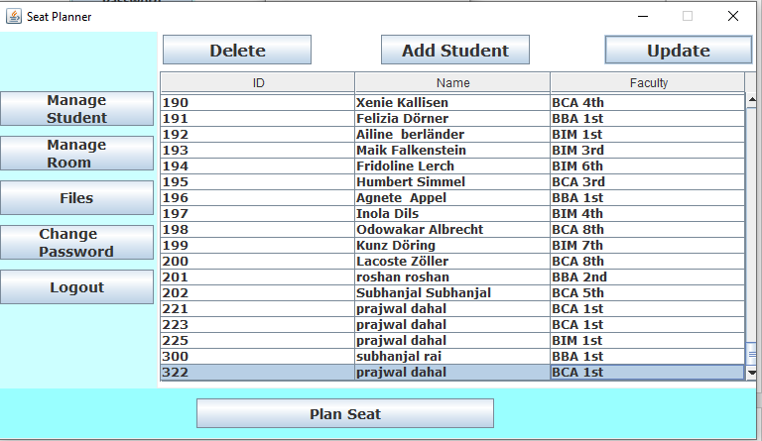**Update Student:**

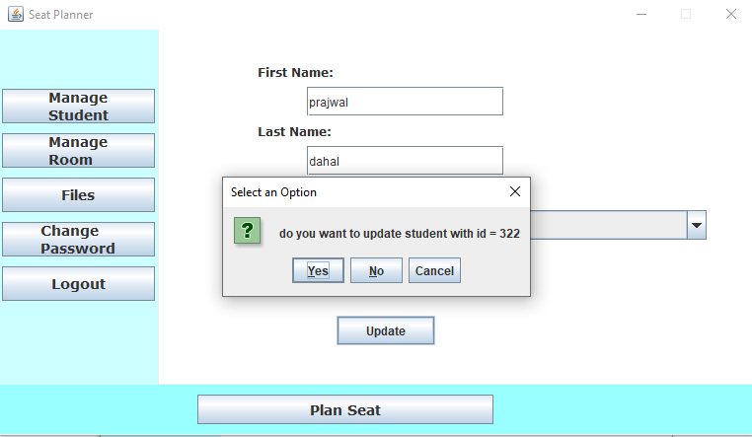

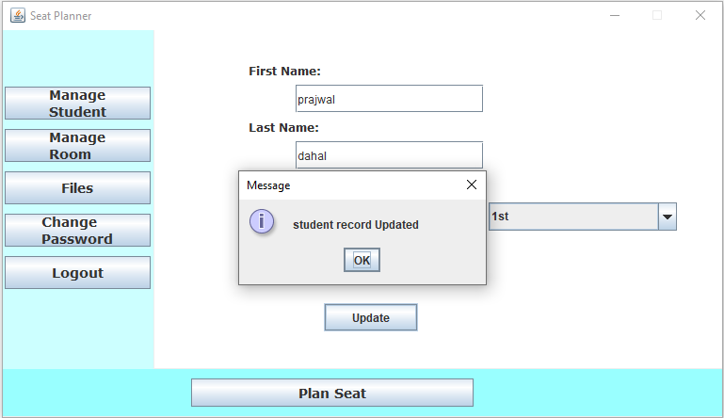

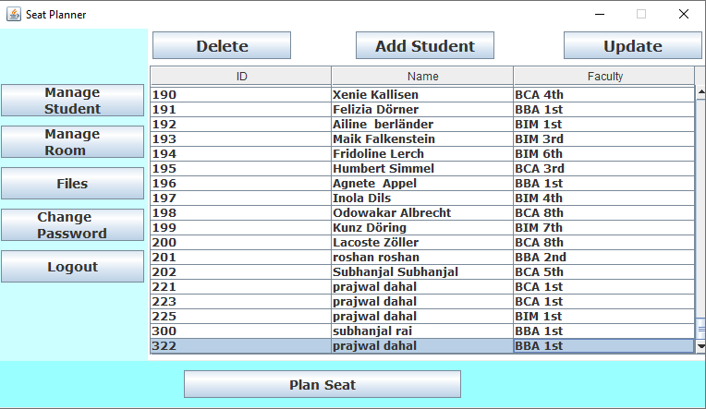**Delete Student:**

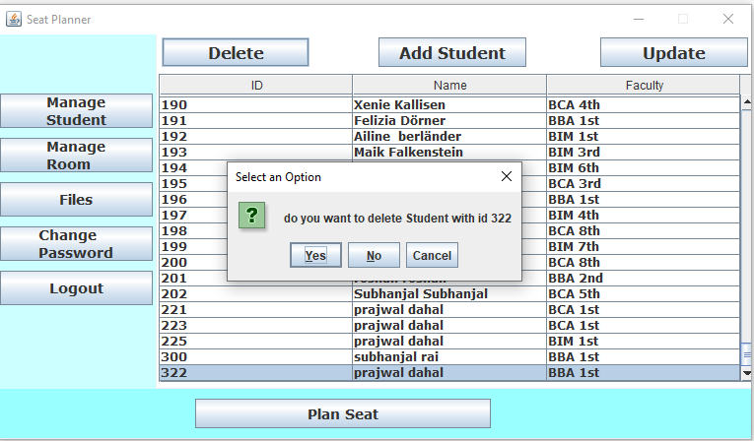

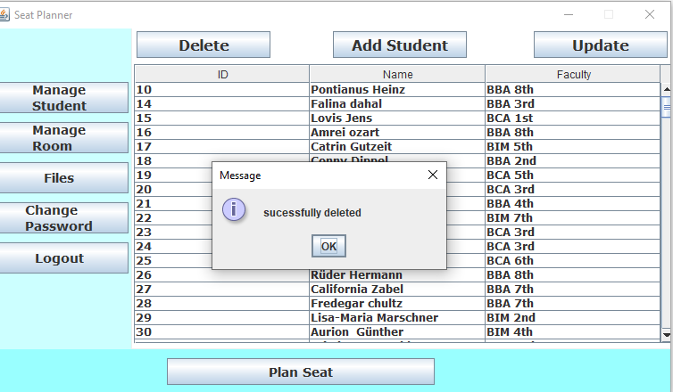

#### Table 4.2.3: Test case for add, update and delete room

|  |  |  |  |  |  |
| --- | --- | --- | --- | --- | --- |
| Test Case ID | | 3 | | | |
| Test Case Description | | Add and delete Room | | | |
| Prerequisites: | | All the field must be filled. | | | |
| Test Scenario | | 1. Enter room name and select number of column 2. Click on continue 3. Fill no of rows in each column 4. Click on add | | | |
| Test Data | | **Add data**  Room Name: room20  No of column : 2  Column1 no of rows:6  Column2 no of rows:7  **Update Room:**  Room Name:room2  No of column2:2  Column1 no of rows:8  Column2 no of rows:6  **Delete room :**  Room: room2 | | |
| Step | | Expected Result | Actual Result | Pass/Fail |
|  | | New room added | New room added. | Pass |
|  | |  |  |  |
|  | | Do you want to delete room2? | Do you want to delete room2? | Pass |
| 3. | | Do you want to update room? | Do you want to update room? | Do you want to update room? |

**Test Scenario:**

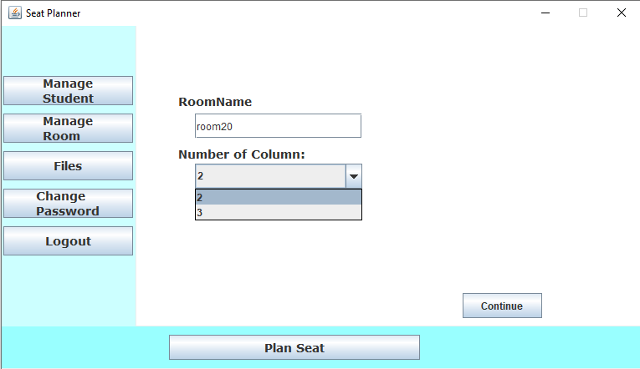 **Add Room:**

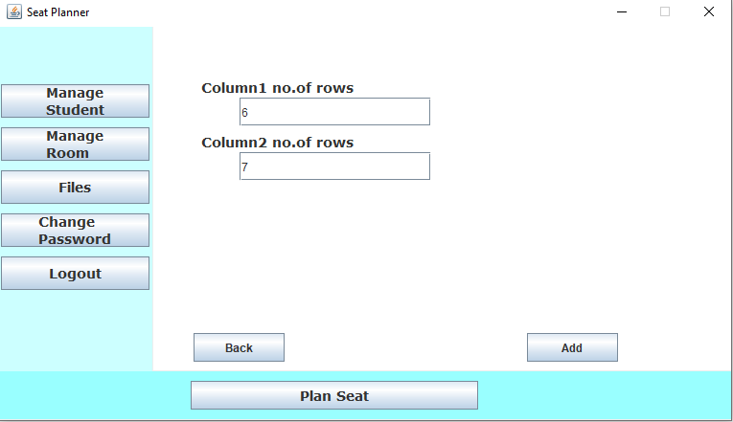

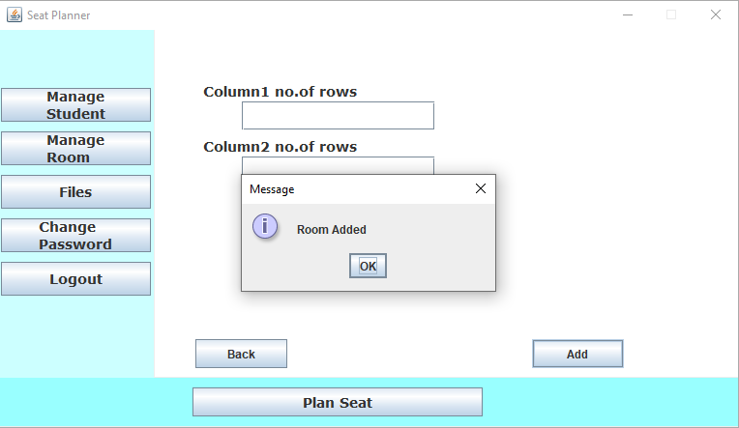

**Update Room:**

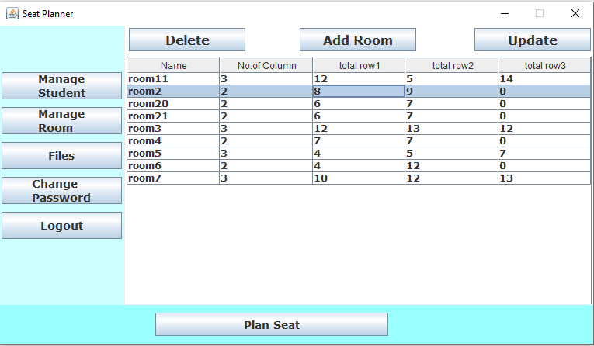

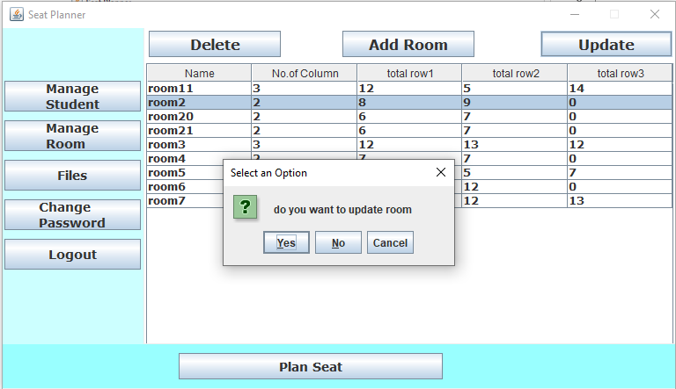

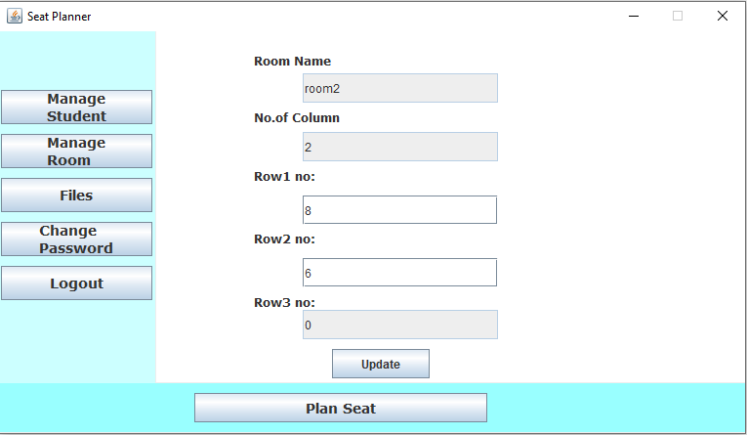

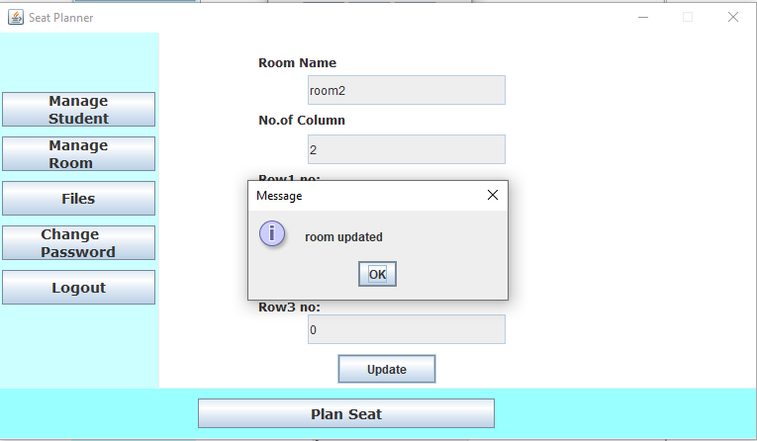

**Delete Room:**

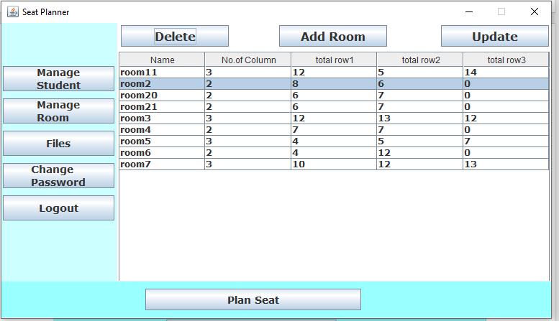

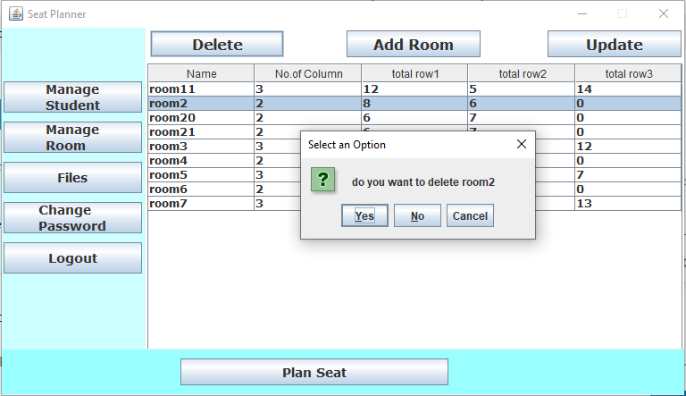

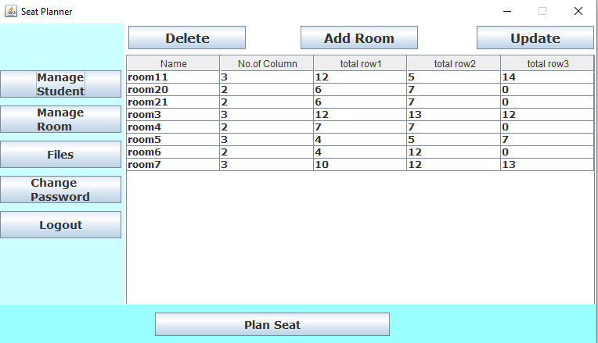

##### Table 4.2.4: Test case for seat plan generation

|  |  |  |  |
| --- | --- | --- | --- |
| Test case id | 4 | | |
| Test case description | Seat plan generation | | |
| Prerequisites | should have store at least one student and one room | | |
| Test scenario 1 | 1. Click on plan seat 2. Select faculty for seat plan and click on select 3. Select room for seat plan and click on select   (select less or equal number of student than seat available) | | |
| Test data | Selected faculty: BBA 1st, BBA 2nd , BBA 4th  Selected room:room3,room4 | | |
| Step | Expected output | Actual Result | Pass/fail |
|  | Excel file created | Excel file created | Pass |

|  |  |  |  |
| --- | --- | --- | --- |
| Test scenario 2 | 1. Click on plan seat 2. Select faculty for seat plan and click on select 3. Select room for seat plan and click on select   (select more number of student than seat available) | | |
| Test data | Selected faculty: : BBA 1st, BBA 2nd , BBA 4th  Selected room: room20 | | |
| Step | Expected output | Actual Result | Pass/fail |
| 1. | Seat is less than total student  Total seat=13  Total student=22 | Seat is less than total student  Total seat=13  Total student=22 | Pass |
|  |  |  |  |

**Test Scenario 1:**

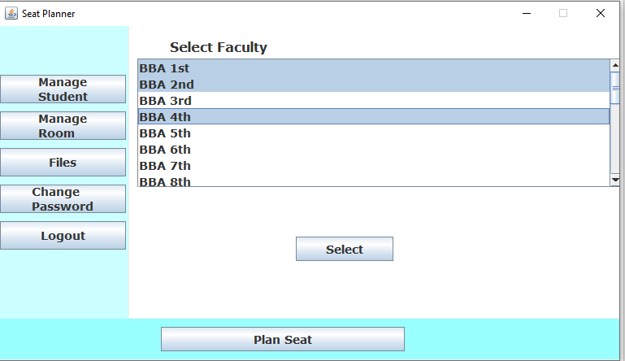

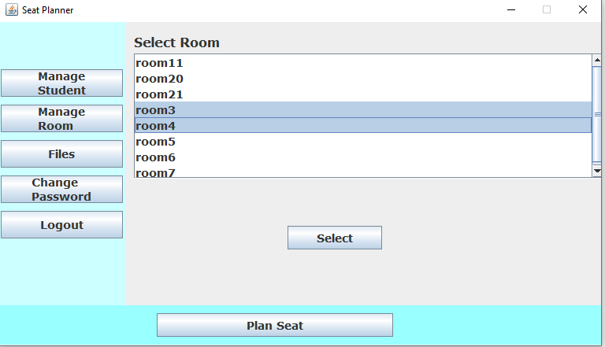

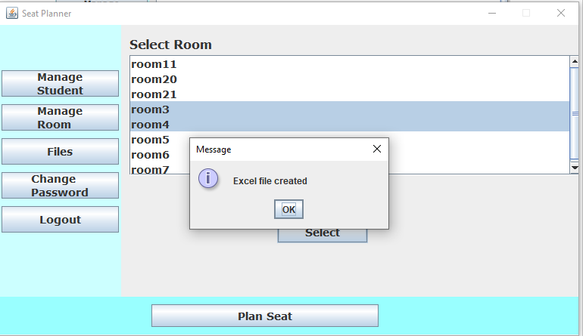

**Test Scenario 2:**

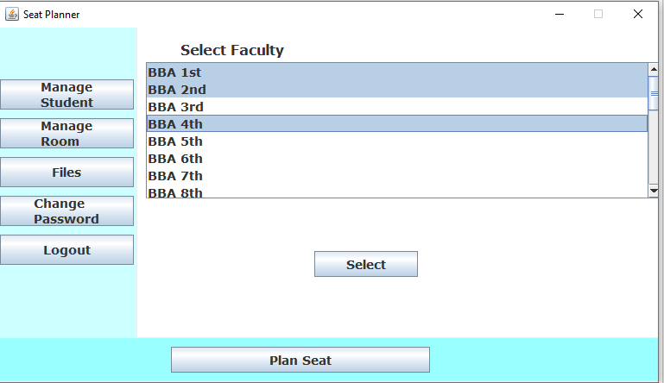

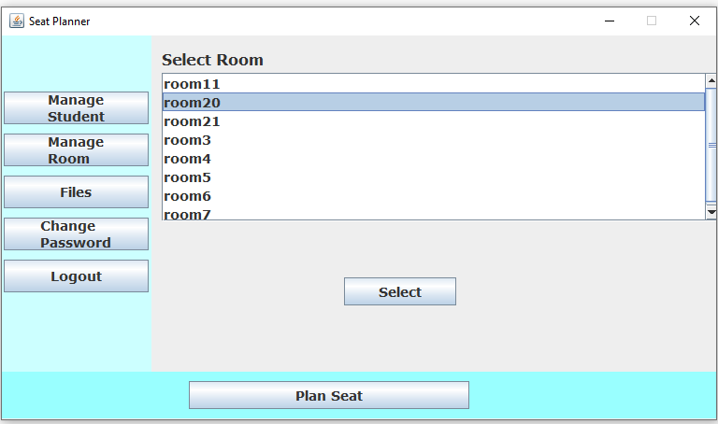

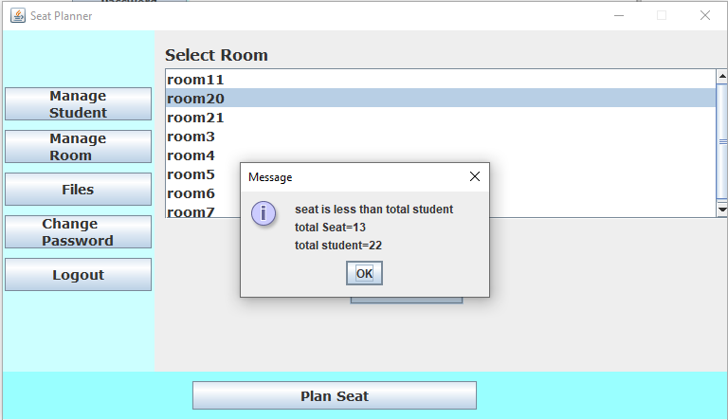

##### Table 4.2.5: Test case for change password

|  |  |  |  |
| --- | --- | --- | --- |
| Test case id | 5 | | |
| Test case description | change password | | |
| Prerequisites | should not left field empty | | |
| Test scenario 1 | 1.enter invalid username and password | | |
|
|
|
| Test data | username: prajwal | | |
| password: prajwal123 | | |
| password:prajwal12345  confirm password:prajwal12345 | | |
|  | | |
| Step | Expected output | Actual Result | Pass/fail |
|  | username and password cannot find | username and password cannot find | Pass |
|  |  |  |  |
| Test scenario 2 | enter valid username and password but doesn’t match new password and confirm password | | |
|
|
|
|
| Test data | username: admin | | |
| password:root@123 | | |
| password :root11234  confirm password:root1234 | | |
| Step | Expected output | Actual Result | Pass/fail |
|  | new password and confirm password doesn’t match | new password and confirm password doesn’t match | Pass |
|  |  |  |  |
| Test scenario 2 | Enter valid data. | | |
|
|
|
|
| Test data | Username: admin | | |
| password:root@123 | | |
| password :root  confirm password: root | | |
| Step | Expected output | Actual Result | Pass/fail |
|  | password changed | password changed | Pass |

**Test Scenario 1:**

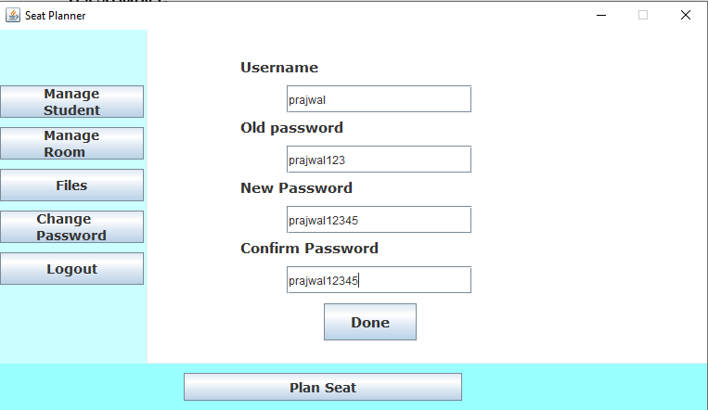

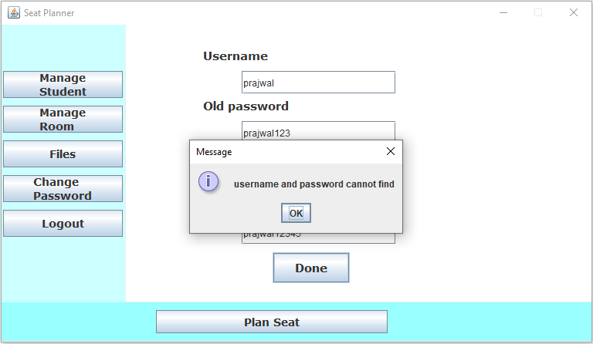

**Test Scenario 2:**

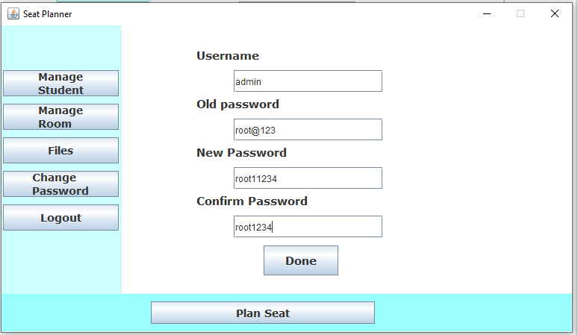

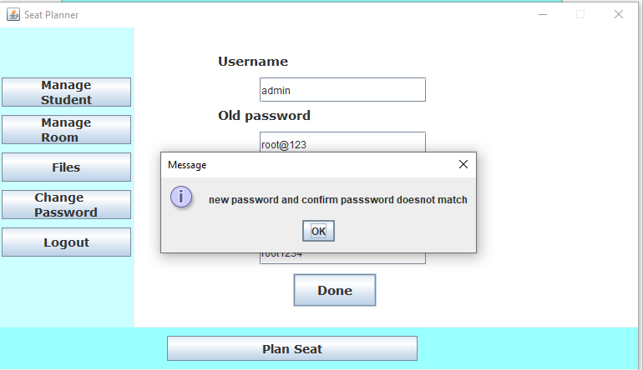

**Test Scenario 2:**

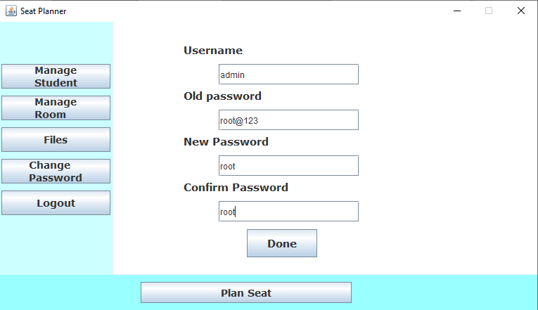

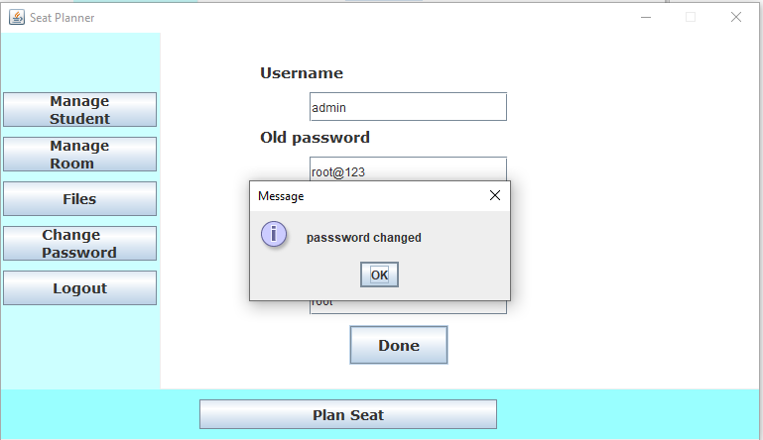

# Conclusion and Recommendation

## Limitation

There are some limitations for the current system to which solutions can be provided as a future development.

1. No feature added for elective courses
2. You cannot update room name and no of column.
3. If selected room exceeds no of student then also new sheet will be created in the excel file.
4. No record of student in which room, seat is allocated for them.

## Conclusion

This application is great advantage to all the educational institutes as it is simplifying the seating arrangement by automatically generating the seats for the students. Project results in reduction of manpower & workload on staff. It benefits all the educational institutes by reducing the complexity involved while allocating examination rooms for the students. This application has features like create report in excel file which cannot be found in most of the system which enhance the usability of the application.

## Future Recommendation

Here is what can be added in future to this swing application to increase its usability and user experience. There is lot to be done. We will need lot of time and effort for all of these to be done. In future, application design can be enhancement. System can update the room name so that if there is any error or change admin can update it. Courses will be categorize and seat plan can be generated according to elective courses.

# References

|  |  |
| --- | --- |
| [1] | A. F. Alam, "papers:ijeast," februrary 2016. [Online]. Available: https://www.ijeast.  com/papers/8-10,Tesma104,IJEAST.pdf. |
| [2] | G. S.S.Aravinth, "EXAM_HALL_SEATING_ARRANGEMENT  _SYSTEM_USING_PHP:academic.edu," 2014. [Online]. Available: https://www.academia.edu/30521526/EXAM_HALL_SEATING_ARRANGEMENT_  SYSTEM_USING_PHP. |
| [3] | G. C. P. N. K. P. L. Vamsi Krishna Yepuri, "archives:irjet.net," april 2018. [Online]. Available: https://www.irjet.net/archives/V5/i4/IRJET-V5I4614.pdf. |

# Annex

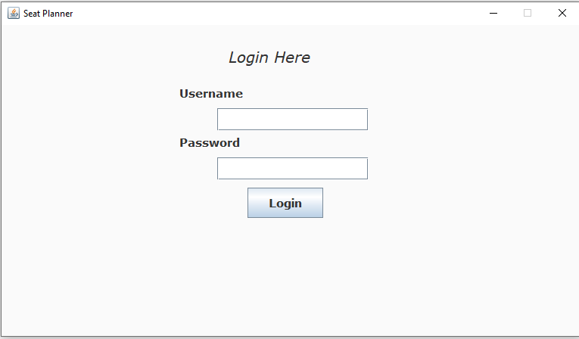

**Login form**

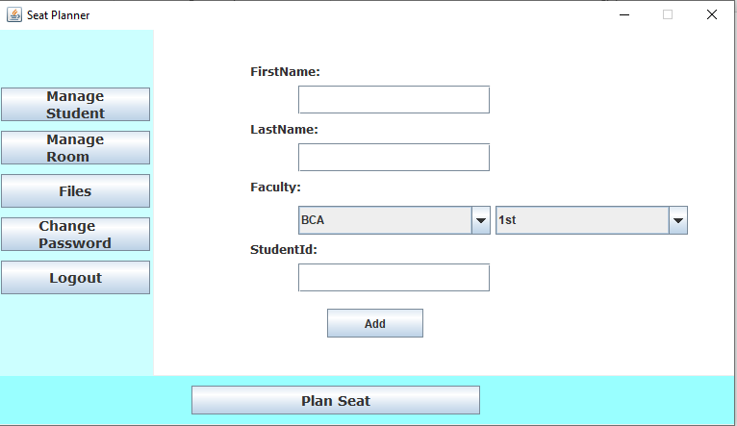

**Add Student**

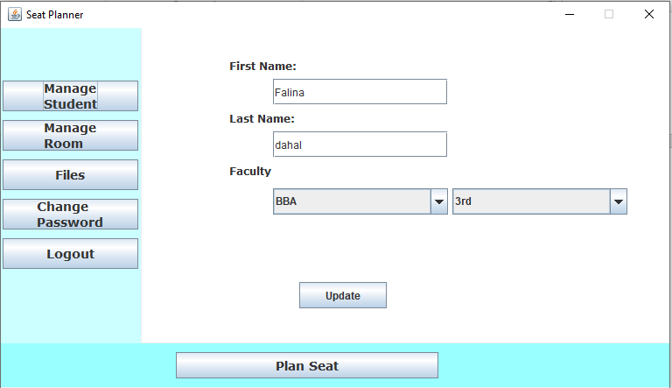

**Update Student**

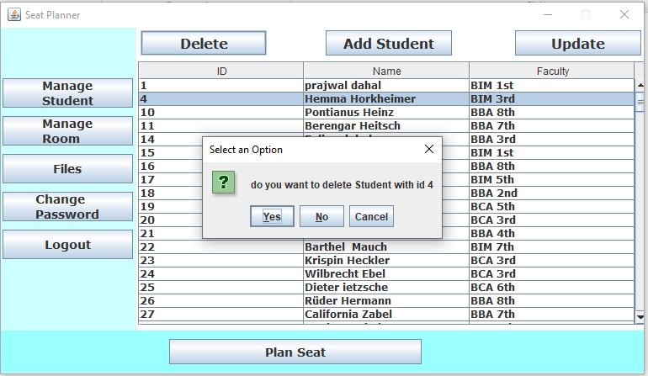

**Delete Student**

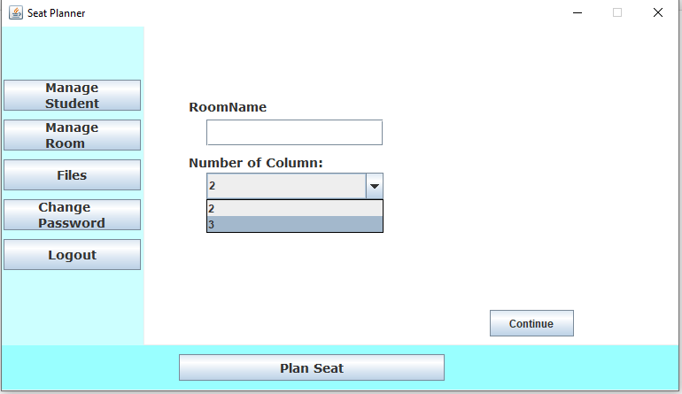

**Add Room**

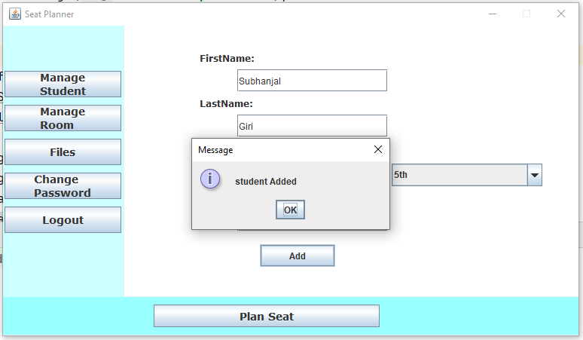

**Student Added**

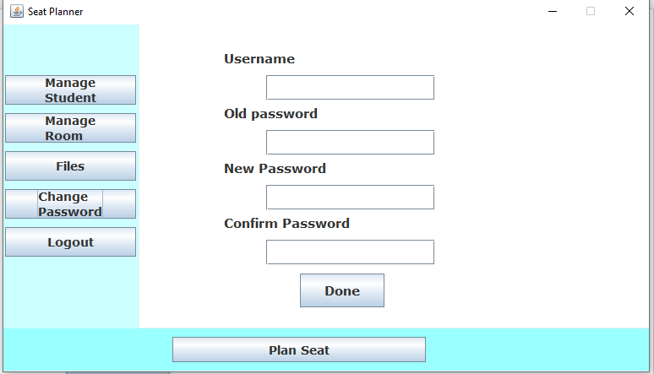

**Change Password**

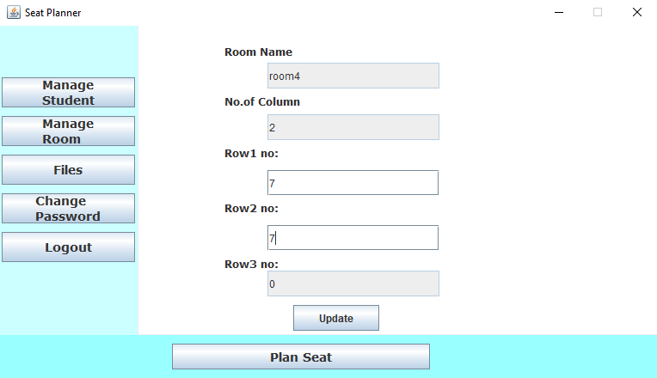

**Update Room**

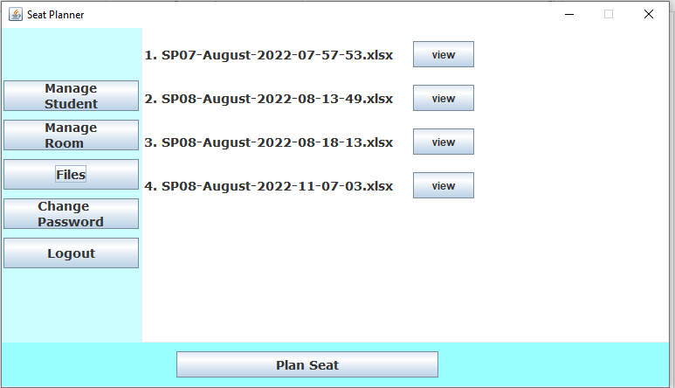

**Created File List**

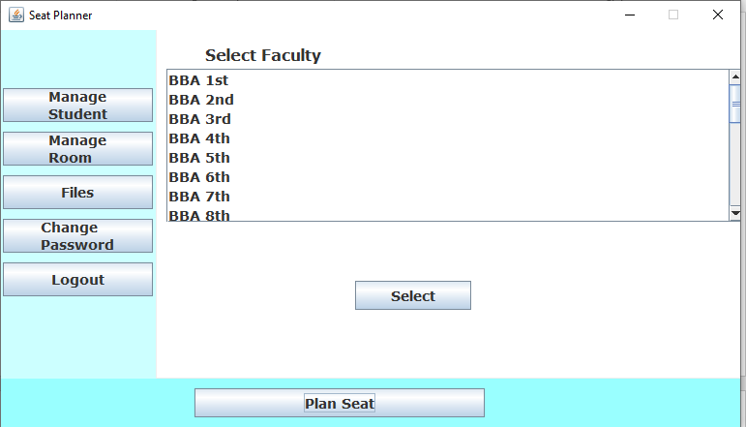

**Generate Report step 1**

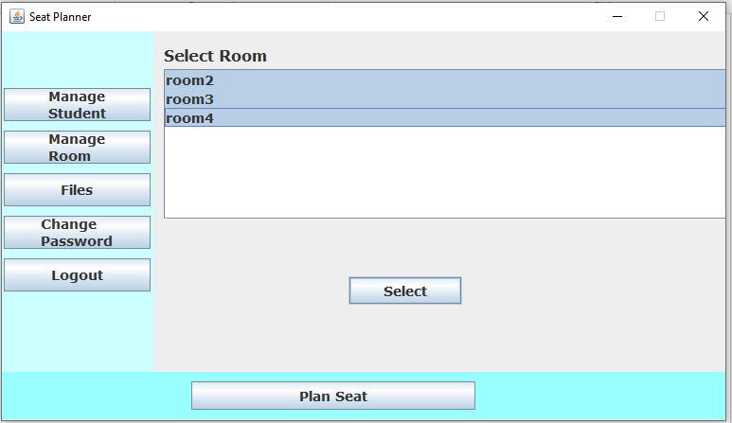

**Generate Report step 2**

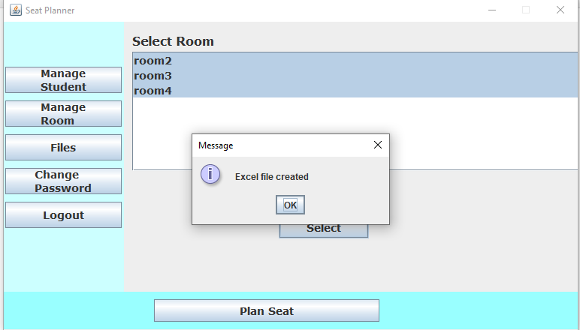

**Generate report step 3**

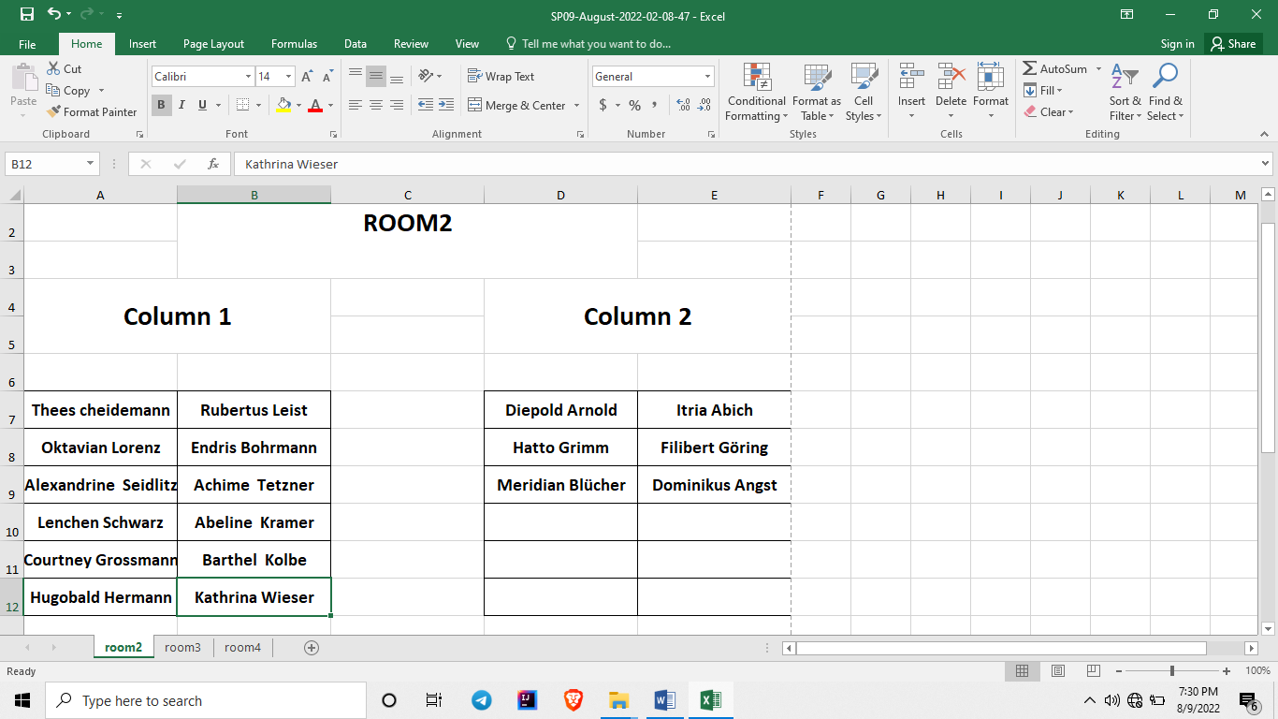

**Generated Report Sample**