Lab 2 — Agile Product Backlog (Epics & User Stories)
Digital Art Commission & Watermarking Portal | Problem Statement #58 | Jira project key: DIG
PES University — Dept. of CSE • Built from the Lab 1 functional requirements • SRN: PES1UG24CS593 • Name: ____________________ Date: ____________
1. Epic
Scoped as instructed to a single epic. The epic chosen is the one carrying FR-001, the watermarking requirement named in the problem statement itself; it also absorbs the WIP upload half of FR-003 and the draft review portion of FR-004.
Epic | Epic name | Description | Traces to | Stories | Points
Epic 1 | WIP Draft Upload & Watermark Protection | Accept versioned work-in-progress drafts from the Digital Artist against an open milestone, and guarantee that the Client Buyer only ever sees a watermarked derivative while the original stays unreachable until payment. | FR-001, FR-003, FR-004 / UC-03, UC-04, UC-05 | 6 | 34
2. User Stories
Six user stories, all in "As a … / I want … / So that …" form. Story points use the Fibonacci scale (1, 2, 3, 5, 8, 13) and estimate complexity, volume and uncertainty together — not hours.
ID | Summary | User story | Priority | SP | Epic | Traces to | Sprint
1.1 | Upload a versioned WIP draft | As a digital artist, I want to upload a WIP draft against an open milestone with a version note, so that the buyer can follow progress and no earlier version is lost. | Highest | 8 | Epic 1 | FR-003 / UC-03 | Sprint 1
1.2 | Apply a diagonal watermark to every draft | As a client buyer, I want every draft I view to carry a diagonal watermark with the commission ID and my buyer identifier, so that unfinished artwork cannot be lifted and reused before it is paid for. | Highest | 8 | Epic 1 | FR-001 / UC-04 | Sprint 1
1.3 | Notify the buyer when a draft is ready | As a client buyer, I want to be notified when a new watermarked draft is published, so that I review it promptly instead of checking the portal on the off chance. | Medium | 3 | Epic 1 | FR-004 / UC-05 | Sprint 1
1.4 | Keep originals in private storage | As a digital artist, I want my original upload kept in private storage with no buyer-facing link, so that the unwatermarked file is never reachable before payment. | Highest | 5 | Epic 1 | FR-001 / UC-03 | Sprint 2
1.5 | Fail closed if watermarking fails | As a digital artist, I want the system to withhold the preview and flag the version when watermarking fails, so that a processing error never leaks an unprotected draft to the buyer. | High | 5 | Epic 1 | FR-001 / UC-04 | Sprint 2
1.6 | Review a watermarked draft | As a client buyer, I want to open the latest watermarked draft for a milestone, so that I can judge progress before approving or asking for changes. | High | 5 | Epic 1 | FR-004 / UC-05 | Sprint 2
3. Estimation summary
Distribution | 1–2 pts | 3 pts | 5 pts | 8 pts
Number of stories | 0 stories | 1 stories | 3 stories | 2 stories
Total backlog size: 34 story points across 6 stories. Sprint 1 committed and accepted 19; Sprint 2 committed and accepted 15. The epic closed with nothing left in the backlog.
Why Fibonacci: the gaps widen as the numbers grow, which forces a decision between "roughly 5" and "roughly 8" instead of false precision like 6 or 7. Anything estimated at 13 or above is treated as too big and split before it enters a sprint.
4. Appendix A — Jira evidence
A1. Backlog with the epic panel open — Epic 1 holds 6 work items estimated at 34 points
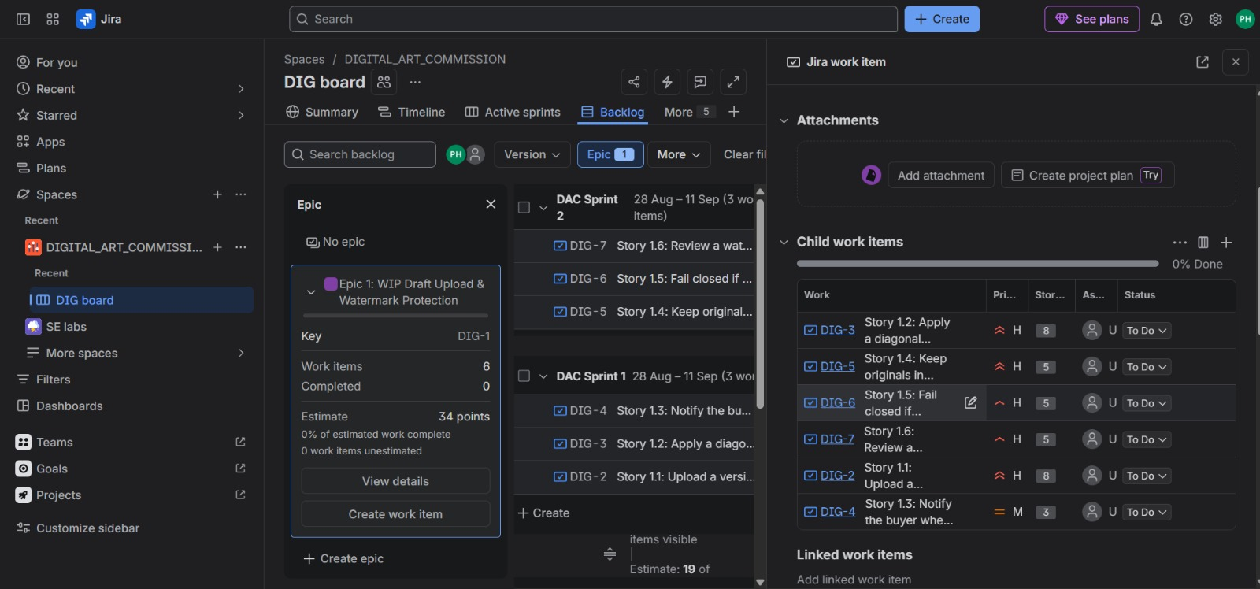
A2. Story point assignments and priorities across the epic’s child work items
