Lab 2 — Sprint Plan, Estimation & Reflection
Digital Art Commission & Watermarking Portal | Problem Statement #58
PES University — Dept. of CSE • SRN: PES1UG24CS593 • Name: ____________________ Date: ____________
1. Sprint 1
Sprint goal: An artist can upload a versioned WIP draft and the buyer is notified of a watermarked preview — never the original.
Duration: 2 weeks • Committed: 19 story points • Completed: 19 • Carried over: none
ID | User story | Epic | Priority | SP | End-of-sprint status
1.1 | Upload a versioned WIP draft | Epic 1 | Highest | 8 | Done
1.2 | Apply a diagonal watermark to every draft | Epic 1 | Highest | 8 | Done
1.3 | Notify the buyer when a draft is ready | Epic 1 | Medium | 3 | Done
2. Sprint 2
Sprint goal: Originals stay unreachable and the buyer can review drafts safely, including when watermarking fails.
Duration: 2 weeks • Committed: 15 story points • Completed: 15 • Carried over: none
ID | User story | Epic | Priority | SP | End-of-sprint status
1.4 | Keep originals in private storage | Epic 1 | Highest | 5 | Done
1.5 | Fail closed if watermarking fails | Epic 1 | High | 5 | Done
1.6 | Review a watermarked draft | Epic 1 | High | 5 | Done
3. Velocity
Sprint | Duration | Committed | Completed | Achieved | Outcome
Sprint 1 | 2 weeks | 19 | 19 | 100 % | All three committed stories accepted
Sprint 2 | 2 weeks | 15 | 15 | 100 % | All three committed stories accepted; epic closed
Average | 2 weeks | 17 | 17 | 100 % | 34 of 34 points delivered across the two sprints
4. Planning Poker record
Each story was discussed briefly, three estimators voted at the same time, and outliers explained their reasoning before a consensus number was agreed. The five stories below produced the widest spread.
Story | Votes | Agreed | What the discussion surfaced
1.1 Upload a versioned WIP draft | 5 / 8 / 8 | 8 | Uploading is simple; immutable versioning and the assignment check are what carried the estimate to 8.
1.2 Apply a diagonal watermark to every draft | 8 / 8 / 13 | 8 | Image processing is well-understood, but proving that no unwatermarked preview escapes is the hard half — sized for verification, not for drawing the overlay.
1.4 Keep originals in private storage | 3 / 5 / 5 | 5 | The 3 vote assumed a storage-permission change only; the team added effort for testing that no buyer-facing link resolves to an original.
1.5 Fail closed if watermarking fails | 3 / 5 / 8 | 5 | The spread was about how many failure paths exist. The team took the middle value and accepted it might be optimistic.
5. Burndown analysis
See Lab2_Burndown_Charts.pdf for both sprints, and the Jira exports in screenshots/. The grey guideline is where the team should be assuming linear progress; the red line is the work actually remaining. Both sprints step down cleanly to zero — every committed story was accepted. In the Jira exports (Appendix B) the drops all land on the first day, because the sprints were simulated in one session rather than across the two-week timebox; the guideline, which assumes linear progress over calendar time, therefore sits well above the remaining-values line for most of the chart. Because both sprints were run in one session, the Jira charts compress every step onto the first day; the sequence of values is still the real one.
6. Reflection
1. Did your estimations reflect the actual effort?
On the surface completely — both sprints delivered every committed point, 19 and then 15. That is weaker evidence than it looks. Nothing slipped, so no estimate was ever tested against a story that ran long, and two sprints of a compressed simulation cannot distinguish accurate estimates from generous ones. The most interesting estimate in the epic remains untested: Story 1.5 Fail closed if watermarking fails drew votes of 3, 5 and 8 in Planning Poker because nobody had counted the failure paths, and it was accepted at 5 without the disagreement ever being resolved by evidence. A team finishing everything two sprints running is at least as likely to be under-committing as estimating well.
2. Was your backlog well-prioritized?
The two stories that give the epic its purpose — 1.1 versioned upload and 1.2 the diagonal watermark, both Highest — went into Sprint 1, so the protection promise was demonstrable at the first review. The clear misjudgement is that 1.3 Notify the buyer, a Medium story, was scheduled ahead of 1.4 Keep originals in private storage, which is Highest. Until 1.4 shipped in Sprint 2, the buyer was seeing a watermarked preview while the original file was still reachable — half a guarantee, and the wrong half to ship first. Priority was applied story by story rather than by asking what makes the epic safe to demonstrate.
3. How did your simulated sprint align with your plan?
Both sprints matched the plan exactly in content and outcome, but two deviations should be recorded. Each sprint was timeboxed at two weeks (28 August to 11 September) rather than the one week the lab specifies, so the per-sprint velocity is not a weekly figure. And both were simulated inside a single working session, which is why the remaining-values line drops vertically on the first day while the guideline slopes gently across a fortnight of calendar time. The sequence of values is real — 19 → 11 → 3 → 0 and 15 → 10 → 5 → 0 — because points burn only when a whole story is accepted; the timing is not.
4. What insights did the burndown chart give about your team’s capacity?
Across the two sprints the team accepted 34 of 34 points, roughly 17 per two-week sprint. That number should be treated as a floor rather than a measure: capacity is only revealed when a sprint fails to fit, and neither of these did. With the epic closed and nothing left in the backlog, there is also no work left to forecast against, so the velocity figure cannot yet be validated. The more useful reading is the shape. Every drop is 3, 5 or 8 points arriving at once, so between accepted stories the chart shows no movement at all even while work is happening. Splitting the two 8-point stories would have made progress visible earlier — the lesson worth carrying into the next epic, where the payment and signed-URL work is larger and riskier than anything here.
7. Appendix B — Jira evidence
B1. Sprint 1 active board — work spread across To Do, In Progress and Done
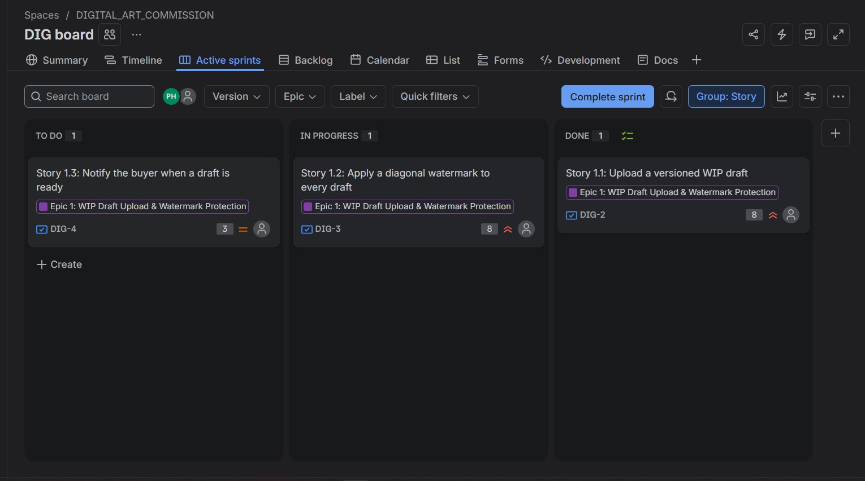
B2. Sprint 2 burndown chart (Story Points)
