**Experiment:**Design a system for a box with four cabinets such that, whenever an empty cabinet is occupied by anything, it automatically changes its color from green to blue.

**Circuit diagram:**

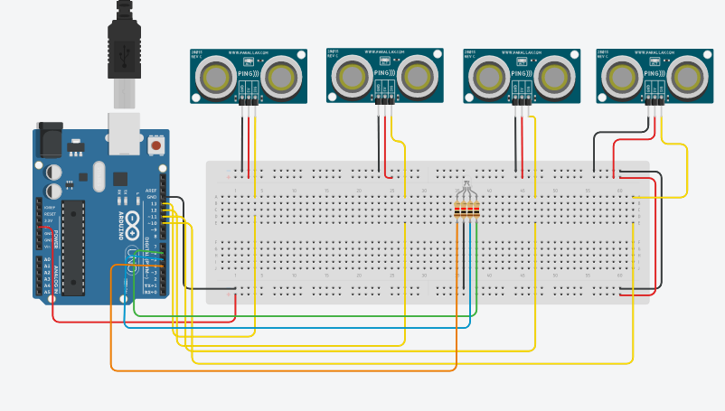

**Theory:** Ultrasonic sensors will detect any object directly facing it; which can be manipulated to perform desired task

**Working :** When an object is present in the cabinet of the box the ultrasonic sensor present in that cabinet detects the obstacle and hence the Led is turned from green to blue

**Learning and observation:** We observed that the LED glows when an obstacle is detected within 10inches of the ultrasonic sensor.

**Problem and Troubleshooting:**

Connections may not be properly configurated

Error in code

Error in compilation

Led may be fused

**Precautions:**

Connections should be proper

Led must be working

Compilation should be successful

**Learning outcomes:**

Working of arduino

Working of ultrasonic sensors

Working of rgbw leds

Coding of arduino

Applications of tinkerCad