**EXPERIMENT-2**

**DESIGN AN LED CHASER**

**Circuit diagram:**

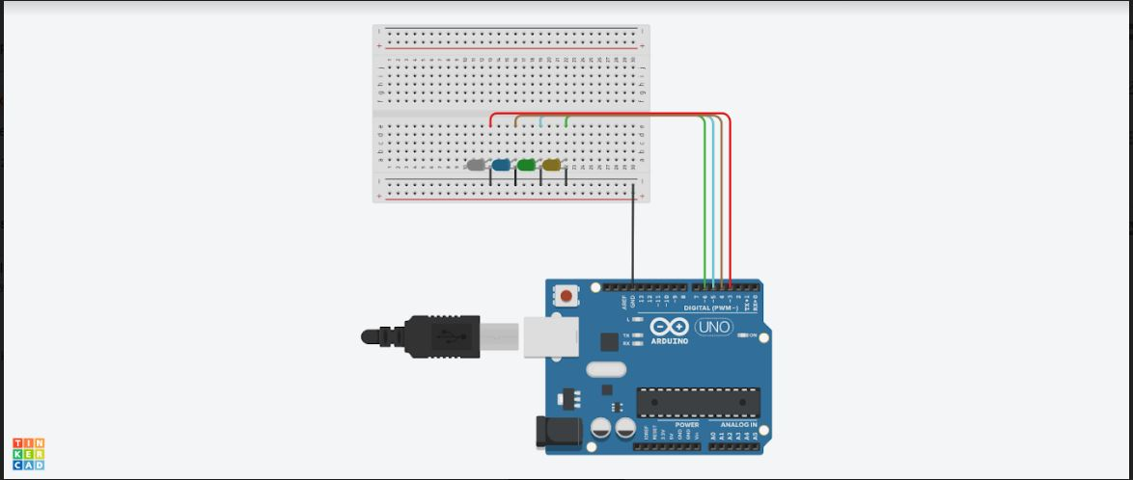

**THEORY**

**Concepts used:** 1. Ohms law

2. Circuit completion

3.

**Learning and Observations:** 1.

**Problems and Troubleshooting:**

**Precautions:**

**Learning Outcomes:**