**BEEE EXPERIMENTS LAB FILE**

Experiment 5: Designing an obstacle detector and distance measuring device

Circuit Diagram:

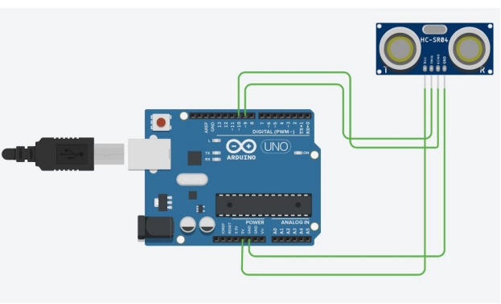

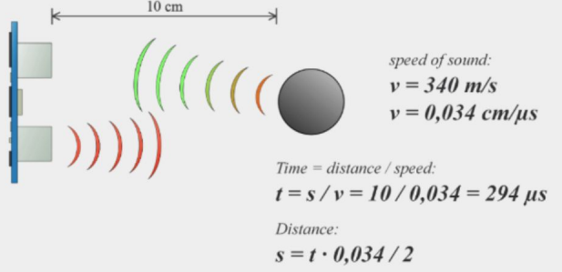

**THEORY**

**CONCEPTS USED:**

1. This experiment shows how the obstacle detector works.
2. The obstacle detector works on the principle of transmitting and receiving the Ultrasonic signal, and calculating the distance by measuring the time between transmitting and receiving the signal.
3. Coding in ARDUINO IDE.
4. Use of serial ports.

**LEARNING AND OBSERVATIONS:**

1. Connection between the arduino and Ultrasonic signal transmitter IC.
2. Concept of calculation of distance on the basis of signal transmission and receiving.
3. Coding to be done for Arduino.
4. Basic understanding of Electrical Connections.
5. What’s inside the Ultrasonic Signal Transmitter IC.
6. Making circuits using Arduino .
7. Purpose of Serial.begin(9600).
8. Coding to be done on Arduino.exe for stimulation of the experiment.
9. The working of ARDUINO and its coding.

**PROBLEMS AND TROUBLESHOOTING:**

No problem occurred during the execution of the experiment.

**PRECAUTIONS:**

1. Wrong connections of ports can lead to failure of experiment.
2. Port Selection for Arduino can be incorrect due to which it won’t upload on Arduino Board and resulting in failure of experiment.
3. Using multimeter to check whether the devices are damaged or not.
4. The workplace are should be dry and not in close proximity to water.
5. Correct sets of instructions to be passed to successfully execute the experiment.
6. Make sure the connections are appropriate and there is no loose connection.

**LEARNING OUTCOMES:**

1. Connecting Arduino and the Ultrasonic signal Transmitter.
2. Concept of distance measuring using the Ultrasonic Signal.
3. Working and coding of Arduino.
4. Using multimeter to see if the circuit is closed or not.
5. I now have appropriate knowledge about the working of transmitter.
6. I now have appropriate knowledge about wiring and connections.