**BEEE EXPERIMENTS LAB FILE**

Experiment 3: Doorbell using buzzer and Arduino

Circuit Diagram:

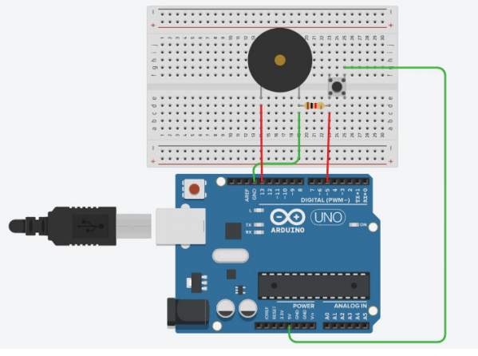

**THEORY**

**CONCEPTS USED:**

1. Connection of multiple wires to breadboard.
2. A circuit is made in which 2 digital pins are used where a pin (7) is connected to a buzzer which is further connected to ground. Now another pin (say 12) is connected to switch. One end of the switch is connected to 5V supply and intersection of pin 12 and switch is connected to resistor which is connected to ground from another end.
3. Value of resistance is very high. The resistors are used to resist the flow of current.
4. Coding is done in such a way that when switch is pressed buzzer starts making sound and again when switch is pressed buzzer do not make any sound.
5. The use of multimeter to check connections.
6. The use of switch.

**LEARNING AND OBSERVATIONS:**

1. The connections of buzzer and switch with arduino.
2. Ground has least resistance to flow of charge.
3. The working of ARDUINO and its coding.
4. Not using resistances can damage the circuits by excessive flow of current.
5. Breadboard connections can get shorted if the circuit is not proper.
6. A multimeter can be used to check circuit breaks.

**PROBLEMS AND TROUBLESHOOTING:**

1. Loose connections on the breadboard can lead to an open circuit. Problem recognized using multimeter.
2. No other problems occurred.

**PRECAUTIONS:**

1. The workplace are should be dry and not in close proximity to water.
2. Breadboard connections should not be short circuited.
3. Make sure the connections are appropriate and there is no loose connection.
4. Be careful while working with electrical equipment.
5. Port Selection for Arduino can be incorrect due to which it won’t upload on Arduino Board and resulting in failure of experiment.

**LEARNING OUTCOMES:**

1. Using switch and buzzer.
2. Working and coding of Arduino.
3. The use of breadboard for making connections.
4. Series and parallel connection of resistors.
5. Using multimeter to see if the circuit is closed or not.
6. I now have appropriate knowledge about the working of switch and buzzer.
7. I now have appropriate knowledge about wiring and connections.