**Assignment No: - 1**

**Q1. Write a python program to print the following string in a specific format Code:**

str='''Twinkle, twinkle, little star, How I wonder what you are!

Up above the world so high, Like a diamond in the sky.

Twinkle, twinkle, little star,

How I wonder what you are''' print(str)

**Output:**

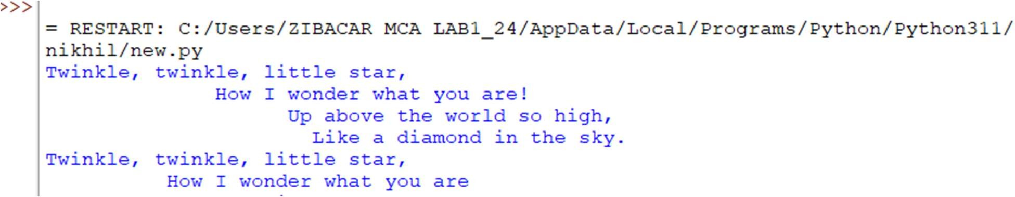

**Q2. Write a program to perform arithmetic operation Code:**

#arithmetic operations a=25

b=56

print("Value of a :{} \nValue of b :{}".format(a,b))

print(" ")

c=a+b

print("Addition of a:{} and b:{} is {}".format(a,b,c)) c=a-b

print("Subtraction of a:{} and b:{} is {}".format(a,b,c))

c=a*b

print("Multiplication of a:{} and b:{} is {}".format(a,b,c))

c=a/b

print("Division of a:{} and b:{} is {}".format(a,b,c))

c=a%b

print("Modulus of a:{} and b:{} is {}".format(a,b,c))

c=a//b

print("Floor Division of a:{} and b:{} is {}".format(a,b,c))

c=a**b

print("Exponent of a:{} and b:{} is {}".format(a,b,c))#

**OUTPUT:**

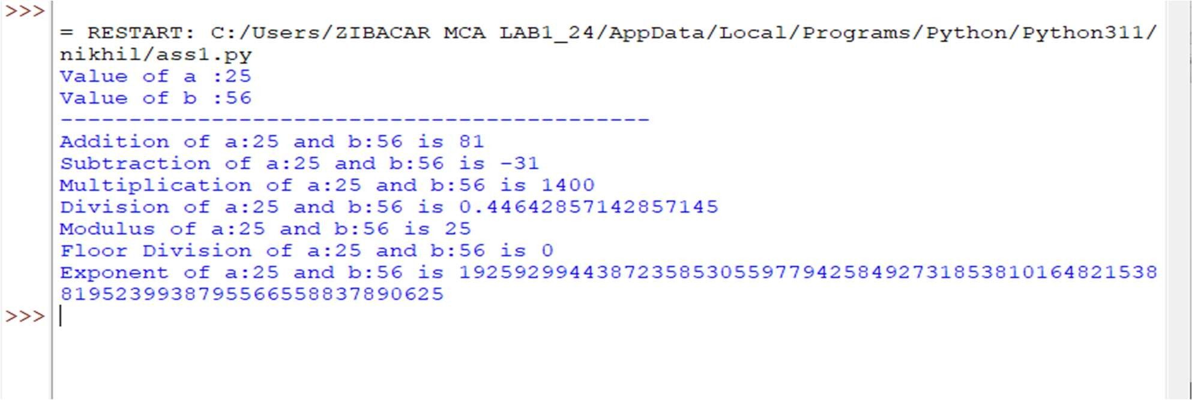

**Q3.Write a program to perform an List operations ? Code:-**

list1=[1,'programing',2,5,6,8] list2=[1,2,3,4,5]

print("List is : " ,list1) print("type of list :",type(list1))

print("access elements on range :(slicing) ",list1[1:3]) print("concatination",list1+list1)

print("repetition :-",list1*3)

**Output:**

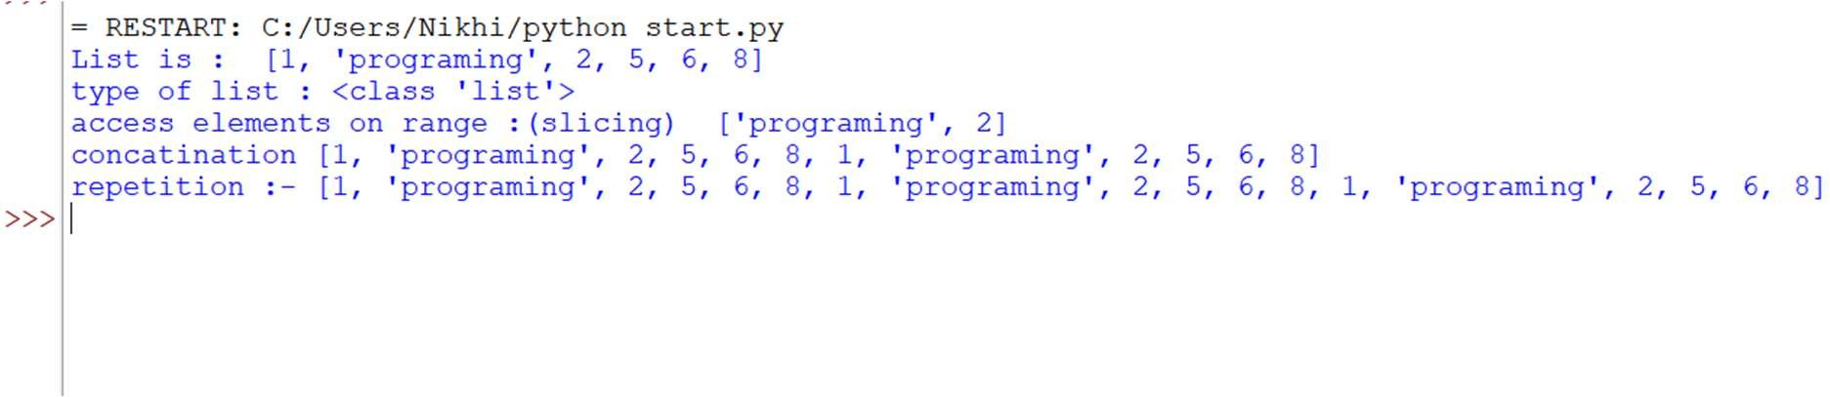

**Q4..Write a program to perform an Tuple operations ? Code :-**

tuple1=(1,2,3,4,5,6,7)

print("Tuple operations :-") print("slicing :-",tuple1[1:5])

str1=("nikhil") tuple2=tuple(str1)

print("Concationation :-",tuple2+tuple1) print("repetition :-",tuple1*3)

**Output:**

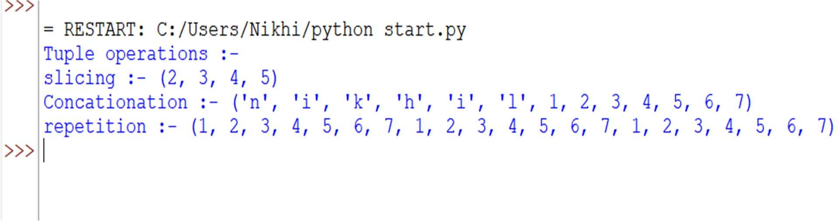

**Q5..Write a program using dictionary to access value using keys. Code :** my_dict={1:'nikhil',2:'chaitanya',3:'Sagar',4:'saurabh',5:'sameer',6:'aniket'} print()

print("keys are :-",my_dict) print(my_dict.keys()) print(my_dict.values()) **Output:**

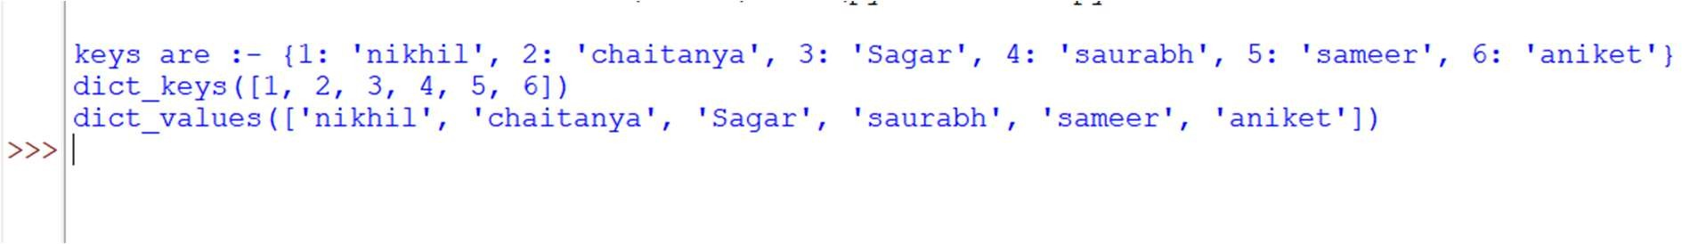

**Q6..Write a program to perform an Set operations ? Code :**

set1=set()

print("empty set created :- ",set1)

set1={32,2,3}

print("value is assigned ",set1) set1.add(10)

set1.add(15) set1.add(20)

print("adding element :- ",set1) set1.remove(32)

print("removed element :- ",set1)

**Output :**

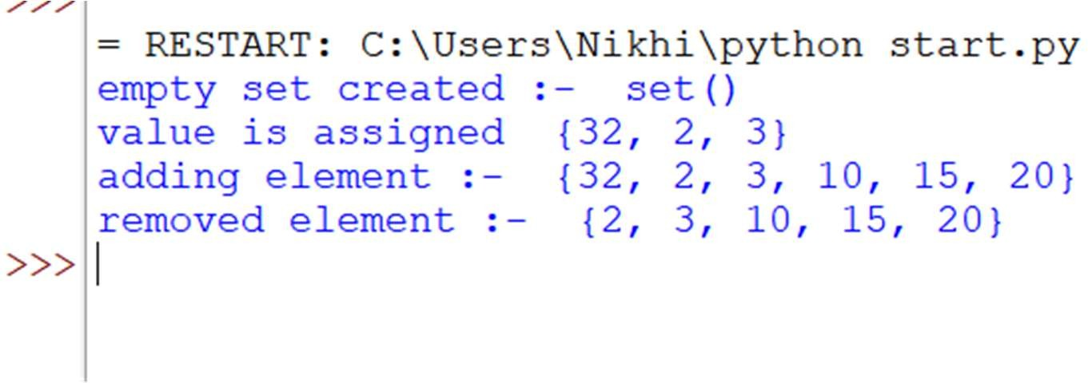

**Q7.Write a python program to get a largest number from given list. Code:-**

print("""********largest num in list********\n""") list1=[1,2,3,4,5,6,7]

print(list1) largest=max(list1)

print("largest number in list1 is {}".format(largest))

**Output:-**

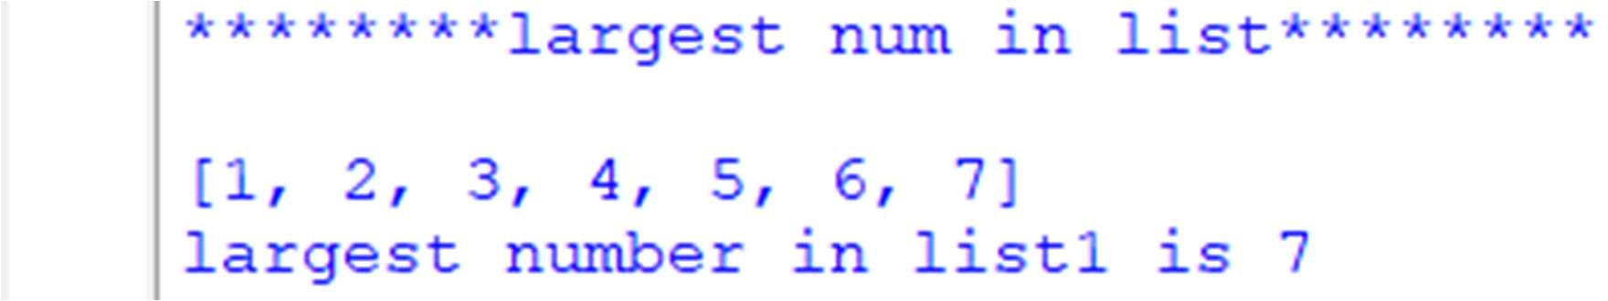

**Q8.Write a python program for factorial of number. Code:-**

print("""********factorial********\n""") a=5

f=1

for i in range(1,a+1):

f*=i

print("factorial of {}! is {}".format(a,f))

**Output:-**

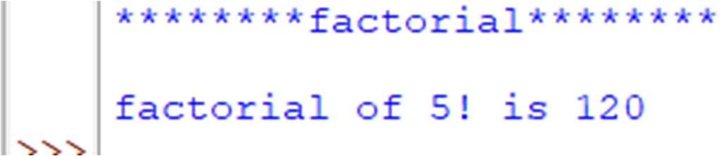

**Q9.Write a python code to check enter number is prime or not? Code:**

n = 7 #and 8 if n>1:

for i in range(2, int(n/2)+1): if (n % i) == 0:

print(n, "is not a prime number") else:

print(n, "is a prime number") break

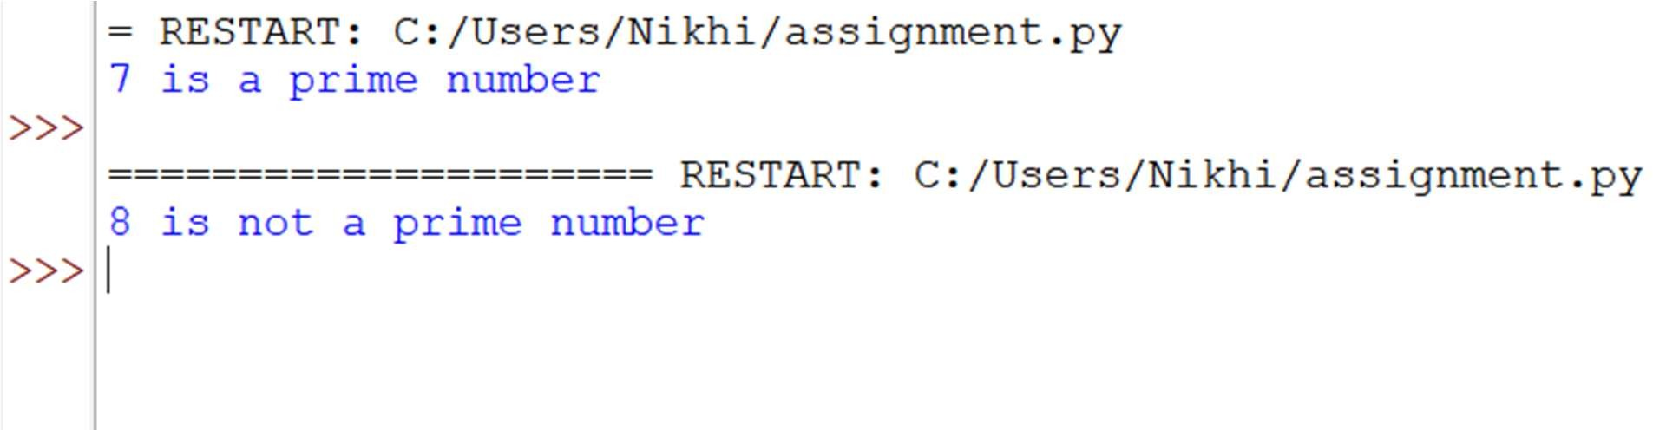

**Q10.Write a program to display Fibonacci series up to a given number by using range function.**

v = 0

k = 1

n=int(input("enter number to find fibonacci series :- ")) if n < 0:

print("Incorrect input") elif n == 0:

print(0) elif n == 1: print(k)

else:

print(1)

for i in range(1, n): c = v + k

v = k k = c

print(k)

print("the fibonacci series of first ",n," number is :-",k)

**Output:-**

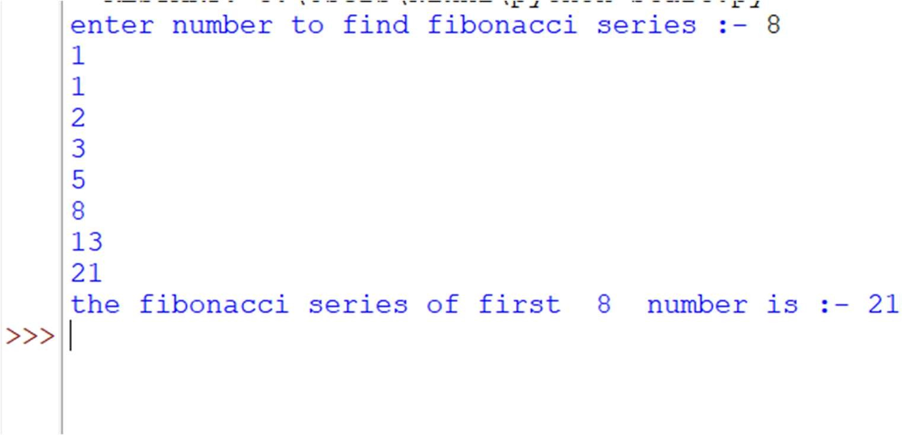

**Q11. Write a python program to identify total number of digits present in given number? Code:**

l=445567

print(len(str(l)))

n=(input("enter number to count digit :- ")) print(len(str(n)))

**Output:-**

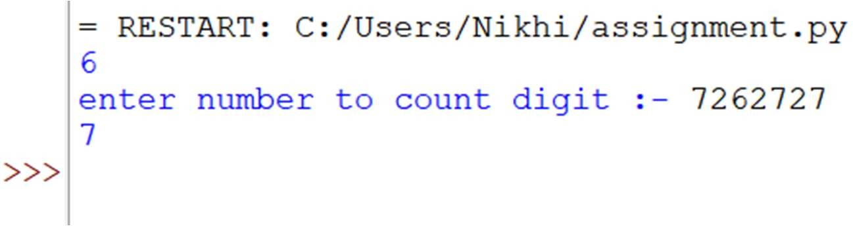

**Q12.Write a program using for loop with: 1.String:-**

print("Using a String :- ") name = "Nikhil"

for char in name: print(char,end="",)

print("\n")

**Output:-**

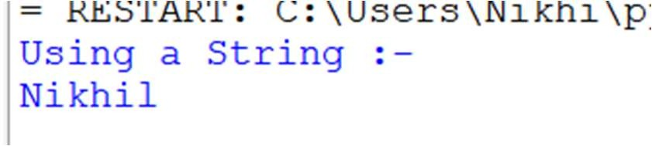

1. **Integer:-**

print("Using an Integer :-") age = 5

for i in range(age): print(f"Year: {i + 1}")

print("\n")

**Output:-**

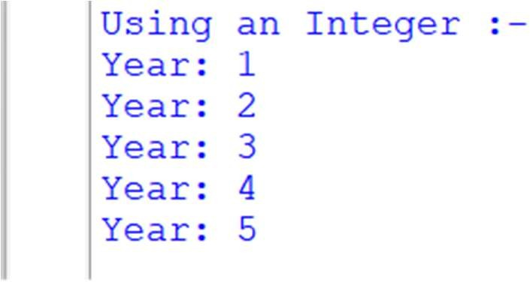

1. **Enumerate:-**

print("Using Enumerate :- ")

names = ["nikhil", "Siddharth", "Aniket"] for index, name in enumerate(names):

print(f"Person {index + 1}: {name}") print("\n")

**Output:-**

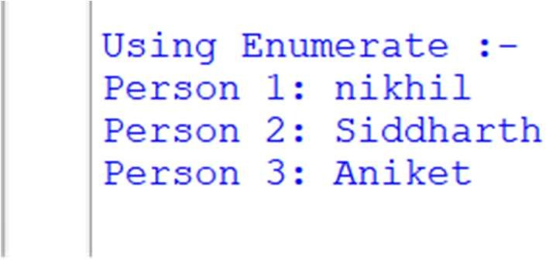

1. **Nested For Loop:-**

print("Using Nested For Loops :-")

grades = [["A", "B", "C"], ["O", "A", "A"], ["O", "A", "B"]]

for i in range(len(grades)): print(f"Grades for Person {i + 1}:") for grade in grades[i]:

print(f" Grade: {grade}") print("\n")

**Output: -**

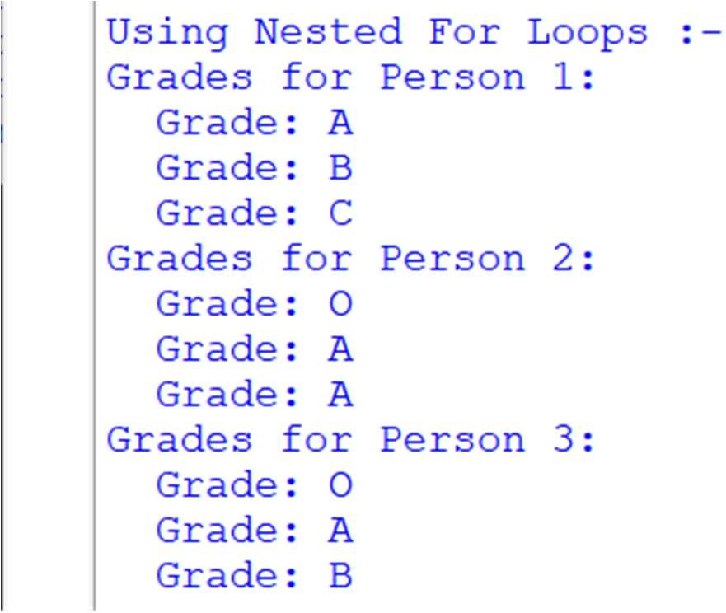

1. **List:-**

print("Using a List :-")

fruits = ["apple", "mango", "cherry"] for fruit in fruits:

print(f"Fruit: {fruit}") print("\n")

**Output:-**

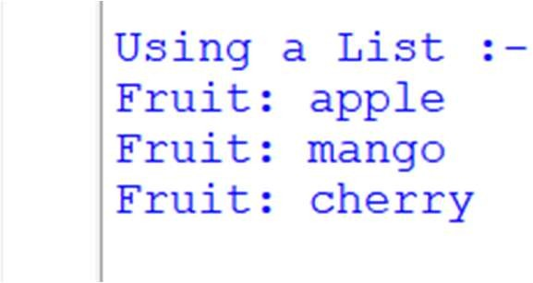

1. **Dictionary:-**

print("Using a Dictionary :-")

people_dict = {"nikhil": 21, "saurabh": 50, "sagar": 35} for person, age in people_dict.items():

print(f"{person}: {age} years old") print("\n")

**Output:-**

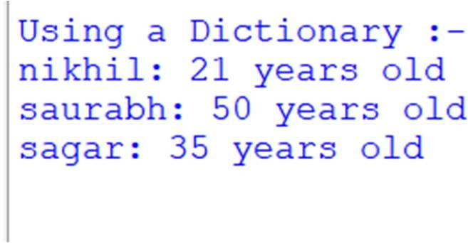

1. **Tuple:-**

print("Using a Tuple :- ") sample_tuple = (2, 3, 4) for item in sample_tuple:

print(f"Tuple Item: {item}") print("\n")

**Output:-**

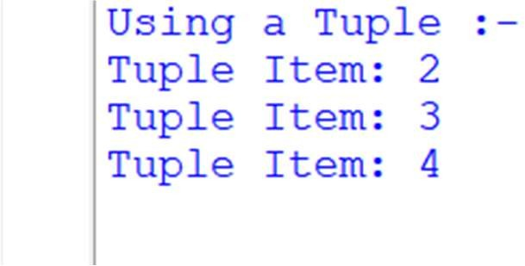

**8. zip():-**

print("Using zip() :-")

names = ["nikhil", "sameer", "saurabh","sagar"] ages = [21, 30, 35, 49]

for name, age in zip(names, ages): print(f"{name} is {age} years old.")

print("\n")

**Output:-**

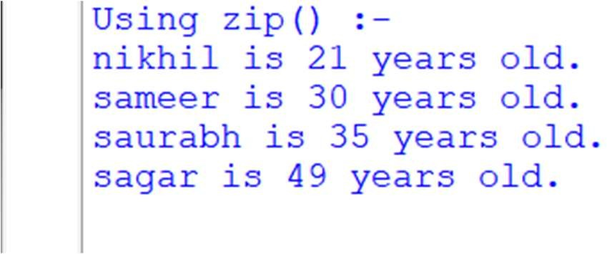

**Q13.Write a program to perform Loop manipulation using pass, continue, break and else Code:-**

**Using ‘Continue’**

numbers = [1, 2, 3, 4, 5, 6, 7, 8, 9, 10]

print("Using 'continue':") for num in numbers:

if num % 2 == 0: continue

print(num)

**Output:-**

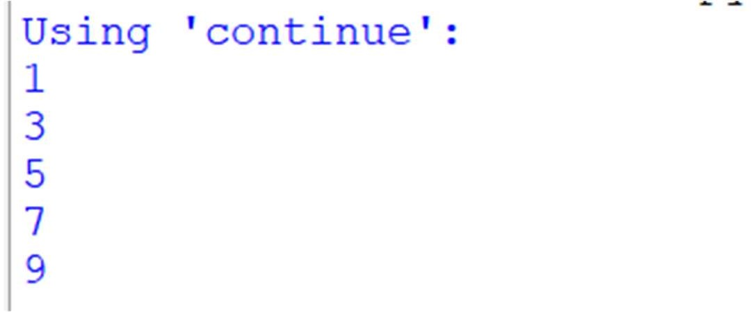

**Using ‘Pass’**

numbers = [1, 2, 3, 4, 5, 6, 7, 8, 9, 10]

print("\nUsing 'pass':") for num in numbers:

if num % 2 == 0: pass

print(f"Processed number: {num}")

**Output:-**

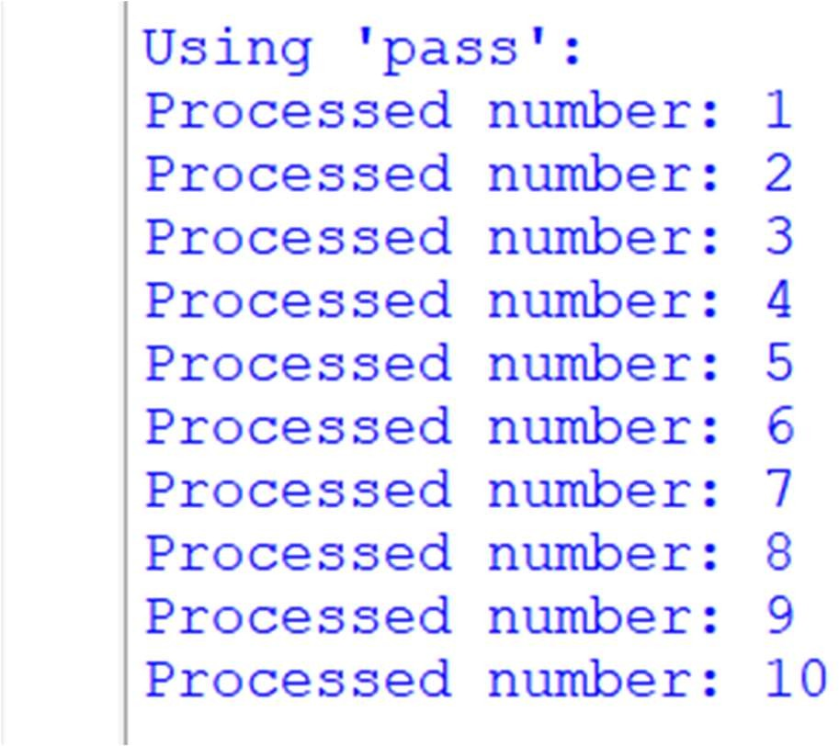

**Using ‘Break’**

numbers = [1, 2, 3, 4, 5, 6, 7, 8, 9, 10]

print("\nUsing 'break':") for num in numbers:

if num > 5: break print(num)

**Output:-**

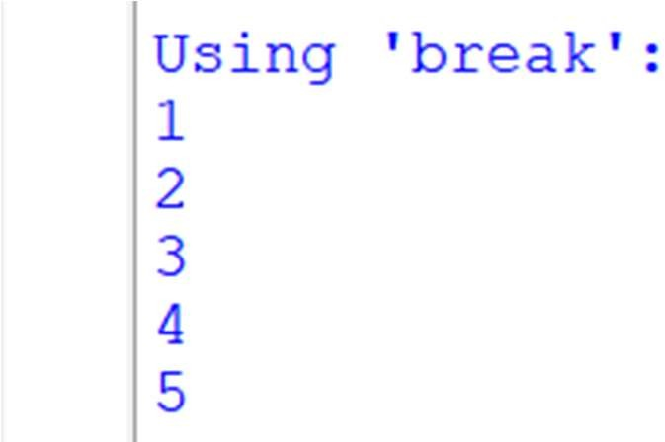

**Using ‘else’**

numbers = [1, 2, 3, 4, 5, 6, 7, 8, 9, 10]

print("\nUsing 'else':") for num in numbers:

if num == 5:

print("Found 5, exiting the loop.") break

else:

print("Loop completed without finding 5.")

**Output:-**

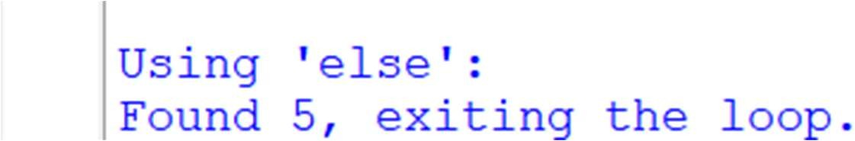

**Q14.Write a program to perform Comprehensions on List Dictionaries. Code:-**

print("list dictionaries comprehensions") people = [

{'name': 'nikhil', 'age': 21},

{'name': 'suarabh', 'age': 25},

{'name': 'sagar', 'age': 15},

{'name': 'sameer', 'age': 22},

]

names = [p['name'] for p in people]

print("Names:", names)

ages = [p['age'] for p in people] print("Ages:", ages)

older_than_20 = [p['name'] for p in people if p['age'] > 20] print("Names older than 20:", older_than_20) name_age_dict = {p['name']: p['age'] for p in people} print("Name to Age:", name_age_dict)

**Output:-**

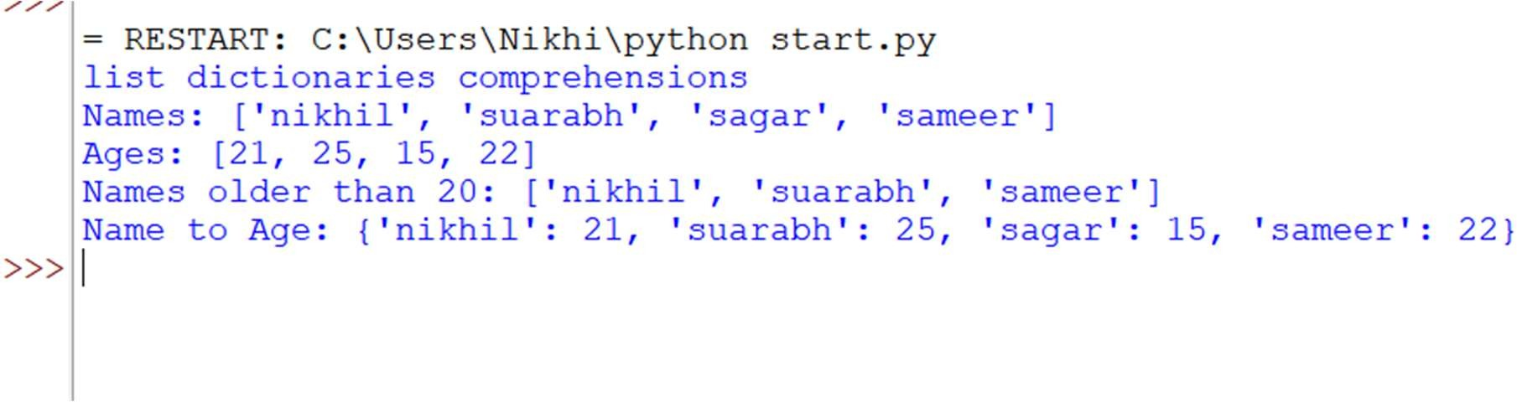

**Q15.Write a program to Find all the numbers from 1-500 that have three in them. Code:-**

numbers_with_three = [] for num in range(1, 501):

if '3' in str(num): numbers_with_three.append(num)

print("Numbers from 1 to 500 that contain the digit '3':") print(numbers_with_three)

print("The Total number are ",len(numbers_with_three))

**Output:-**

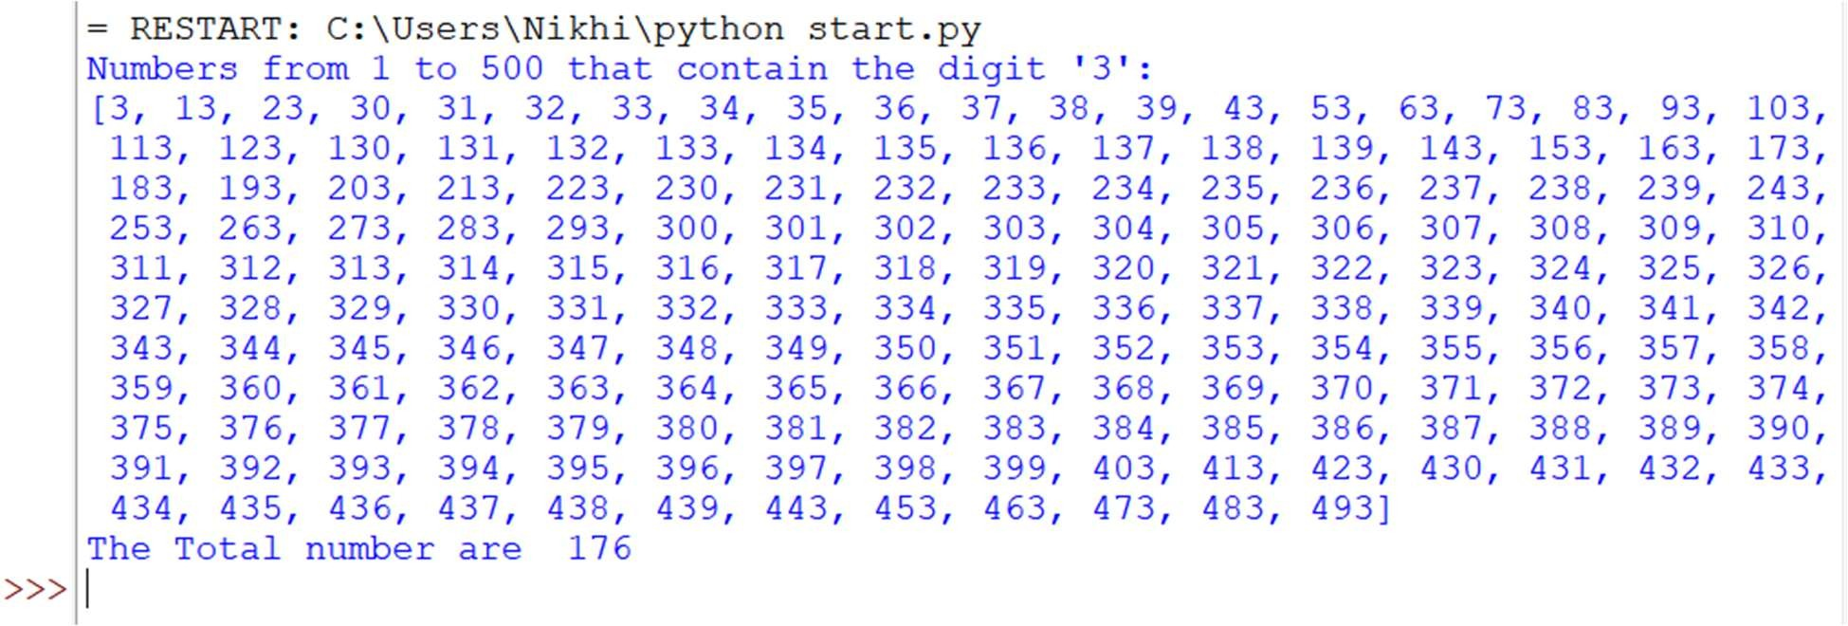

**Q16.Write a python program for numbers=range(20) produce a list containing the word "even"**

**if the number is even or the word "odd" if the number is odd Code:-**

numbers = range(20) even_odd_list = [] for num in numbers:

if num % 2 == 0: even_odd_list.append("even")

else:

even_odd_list.append("odd") print(even_odd_list)

**Output:-**

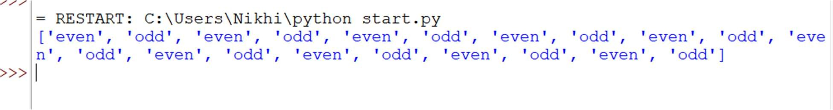

**17.Find the common numbers in two list 1[1,3,4,5,6,7]**

**2[5,2,8,7,1,3]**

**Code:-**

list1 = [1, 3, 4, 5, 6, 7]

list2 = [5, 2, 8, 7, 1, 3]

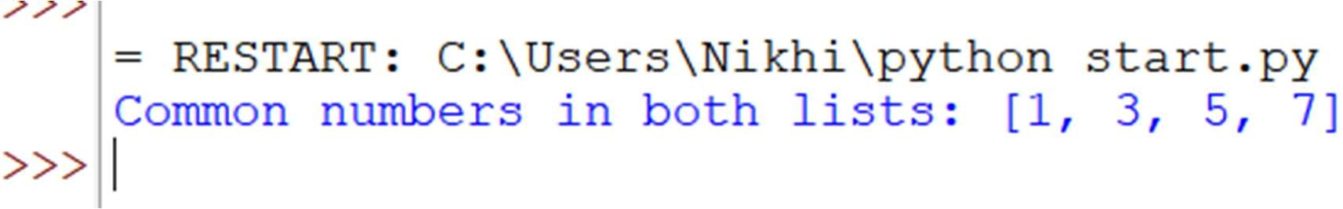cn = list(set(list1) & set(list2)) print("Common numbers in both lists:", cn) **Output:-**