Q.1 implement a nested function that calculates compound interest using non-local variables.

def compound_interest(principal, rate, time):

    def calculate():

        nonlocal principal

        principal = principal * (1 + rate / 100) ** time

        return principal

    return calculate()

# Example usage

principal_amount = 1000

annual_rate = 5

time_period = 2

final_amount = compound_interest(principal_amount, annual_rate, time_period)

print(f"The final amount after {time_period} years is: {final_amount}")

OUTPUT:

|  |
| --- |
|  |

Q.2 write a program using lambda to filter even numbers from a list.

numbers = [1, 2, 3, 4, 5, 6, 7, 8, 9, 10]

even_numbers = list(filter(lambda x: x % 2 == 0, numbers))

print("Even numbers:", even_numbers)

OUTPUT:

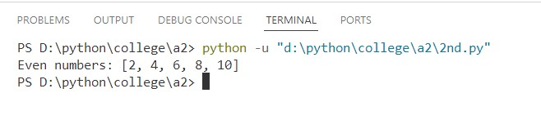

Q.3 write a progrme using lambda to find area of triangle.

base = 10

height = 5

area_of_t;riangle = lambda b, h: 0.5 * b * h

area = area_of_triangle(base, height)

print(f"The area of the triangle is: {area}")

OUTPUT:

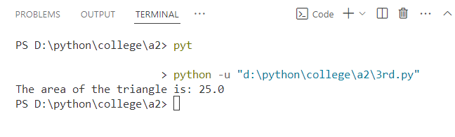

Q.4 create a generator function to yeild fibonacci numbers upto a certain limit.

def fibonacci(limit):

a, b = 0, 1

while a <= limit:

yield a

a, b = b, a + b

# Example usage

limit = 100 # Set the limit for Fibonacci numbers

for number in fibonacci(limit):

print(number,"\t", end="")

OUTPUT:

Q.5 develop a custom python module with functions for basic statistical operations (mean,median,mode)

# statistics_module.py

def mean(numbers):

return sum(numbers) / len(numbers)

def median(numbers):

sorted_numbers = sorted(numbers)

n = len(numbers)

mid = n // 2

if n % 2 == 0:

return (sorted_numbers[mid - 1] + sorted_numbers[mid]) / 2

else:

return sorted_numbers[mid]

def mode(numbers):

frequency = {}

for number in numbers:

frequency[number] = frequency.get(number, 0) + 1

max_frequency = max(frequency.values())

modes = [key for key, value in frequency.items() if value == max_frequency]

if len(modes) == 1:

return modes[0]

return modes

********************

# main.py

import statistics_module as stats

numbers = [1, 2, 2, 3, 4, 4, 4, 5, 6]

mean_value = stats.mean(numbers)

median_value = stats.median(numbers)

mode_value = stats.mode(numbers)

print(f"Mean: {mean_value}")

print(f"Median: {median_value}")

print(f"Mode: {mode_value}")

OUTPUT:

Q.6 Write a program to handle file reading errors and log them to a separate file.

import logging

logging.basicConfig(filename='error_log.txt', level=logging.ERROR, format='%(asctime)s - %(levelname)s - %(message)s')

def read_file(file_path):

try:

with open(file_path, 'r') as file:

content = file.read()

return content

except FileNotFoundError:

logging.error(f"File not found: {file_path}")

return None

except IOError:

logging.error(f"IO error occurred while reading the file: {file_path}")

return None

# Example usage

file_path = 'example.txt'

file_content = read_file(file_path)

if file_content:

print("File content:")

print(file_content)

else:

print("An error occurred. Check the error_log.txt file for details.")

OUTPUT:

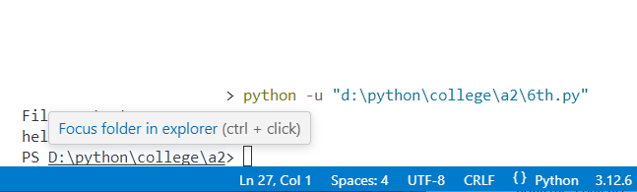

Q.7 create a custom exception class AgeException and use it to validate user input.

# Define the custom exception class

class AgeException(Exception):

def __init__(self, message="Invalid age provided"):

self.message = message

super().__init__(self.message)

# Function to validate age

def validate_age(age):

if age < 0 or age > 120:

raise AgeException(f"Age {age} is not valid. Age must be between 0 and 120.")

# Example usage

try:

user_age = int(input("Enter your age: "))

validate_age(user_age)

print(f"Your age is {user_age}.")

except AgeException as e:

print(e)

except ValueError:

print("Please enter a valid integer for age.")

OUTPUT:

