DAY 1 — Introduction to Data Analytics & Data Science
Day: Friday , Date: 11-09-2026
1). Task Description:
Understand the fundamentals of Data Analytics and Data Science, including their definitions, roles, types of analytics, lifecycle, real-world applications, and technologies used.

Task Elaboration:
- Learned Data Analytics and Data Science fundamentals.
- Studied the roles of Data Analyst and Data Scientist.
- Learned the four types of analytics.
- Understood the Data Science lifecycle and its workflow.
- Studied real-world applications and commonly used technologies.

- Definition of Data Analytics
Data Analytics is the process of collecting, cleaning, analyzing, and interpreting data to find useful insights and support better decision-making.

- Definition of Data Science
Data Science is a field that uses statistics, programming, machine learning, and data analysis to extract insights and build predictive models from data.

- Difference Between Data Analyst and Data Scientist
Data Analyst | Data Scientist
- Analyzes existing data | - Builds predictive and ML models
- Focuses on reports and insights | - Focuses on predictions and advanced analysis
- Uses SQL, Excel, Power BI, Tableau | - Uses Python, ML, SQL, statistics
- Answers: "What happened and why?" | - Answers: "What may happen next?"

- Types of Analytics
- Descriptive Analytics – What happened?
- Diagnostic Analytics – Why did it happen?
- Predictive Analytics – What is likely to happen?
- Prescriptive Analytics – What should be done?

- Data Science Lifecycle
The main steps are:
Problem Definition → Data Collection → Data Cleaning → Exploratory Data Analysis (EDA) → Feature Engineering → Model Building → Model Evaluation → Deployment → Monitoring.

6. Real-World Examples
- E-commerce: Product recommendations and customer behaviour analysis.
- Banking: Fraud detection and credit-risk prediction.
- Healthcare: Disease prediction and patient analysis.
- Transportation: Route optimization and demand forecasting.

7. Technologies Used by Data Analysts
- Excel / Google Sheets
- SQL / MySQL
- Python
- Power BI / Tableau
- Pandas / NumPy

8. Technologies Used by Data Scientists
- Python / R
- SQL
- Pandas / NumPy
- Scikit-learn
- TensorFlow / PyTorch
- Jupyter Notebook
- Power BI / Tableau
- Git / GitHub

DAY 1 — Learn Python basics.
Day: Friday , Date: 11-09-2026
2). Task Description:
Learn the basics of Python programming, including variables, data types, operators, conditions, loops, and different data structures.

Task Elaboration:
- Learned Python variables and basic data types.
- Practiced strings, integers, floats, and Boolean values.
- Studied Python collections: lists, tuples, sets, and dictionaries.
- Created programs for calculator, number checking, grading, tables, factorial, Fibonacci, vowel counting, and string reversal.

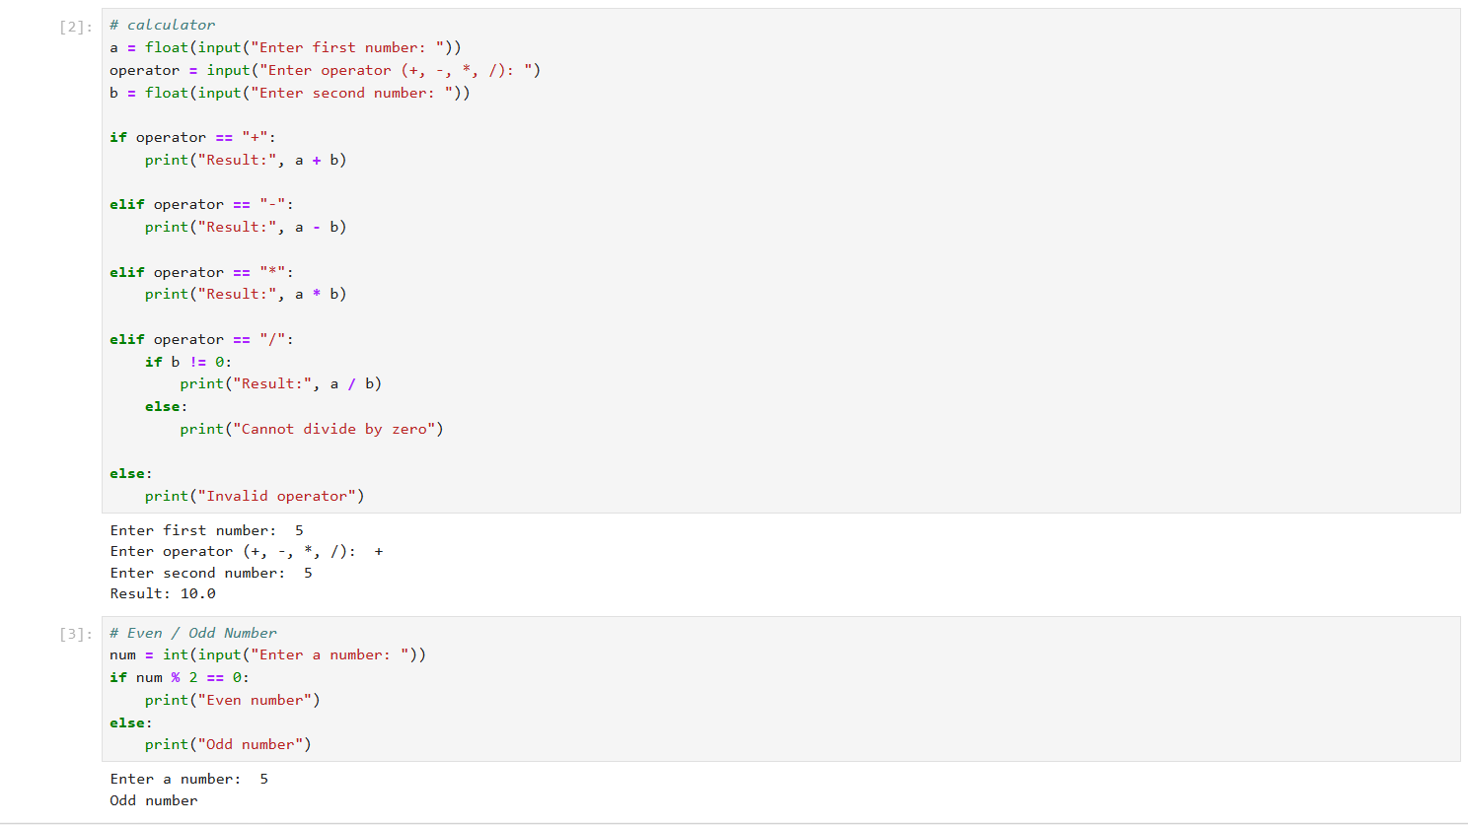

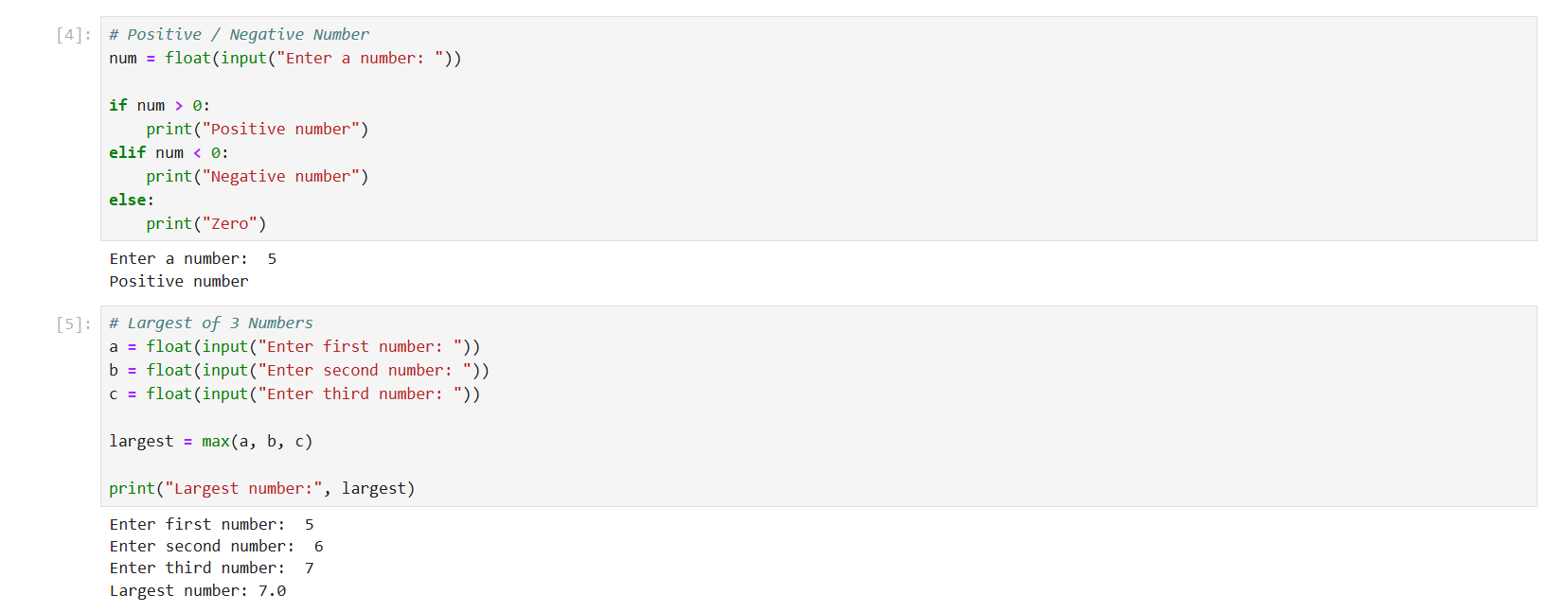

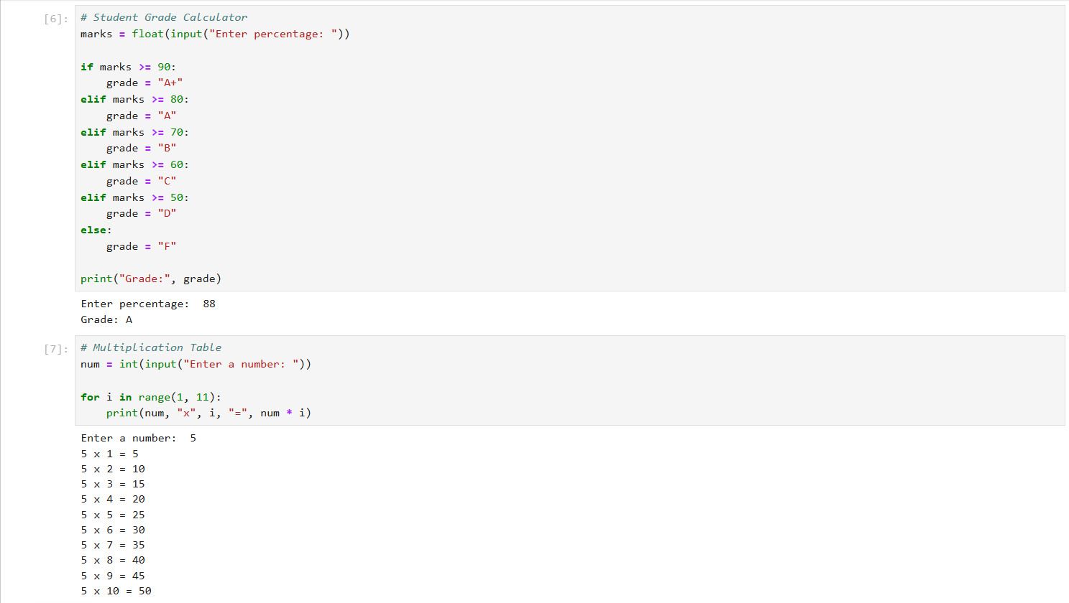

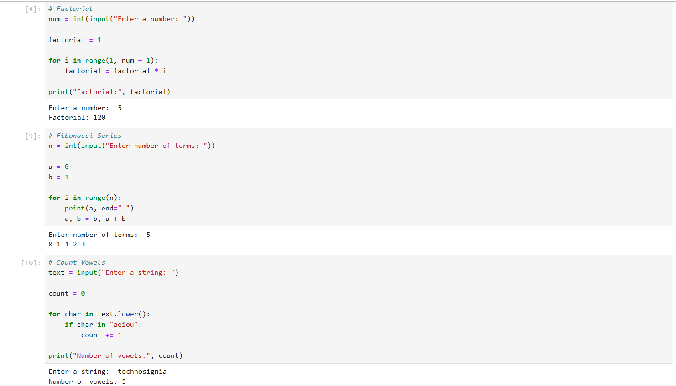

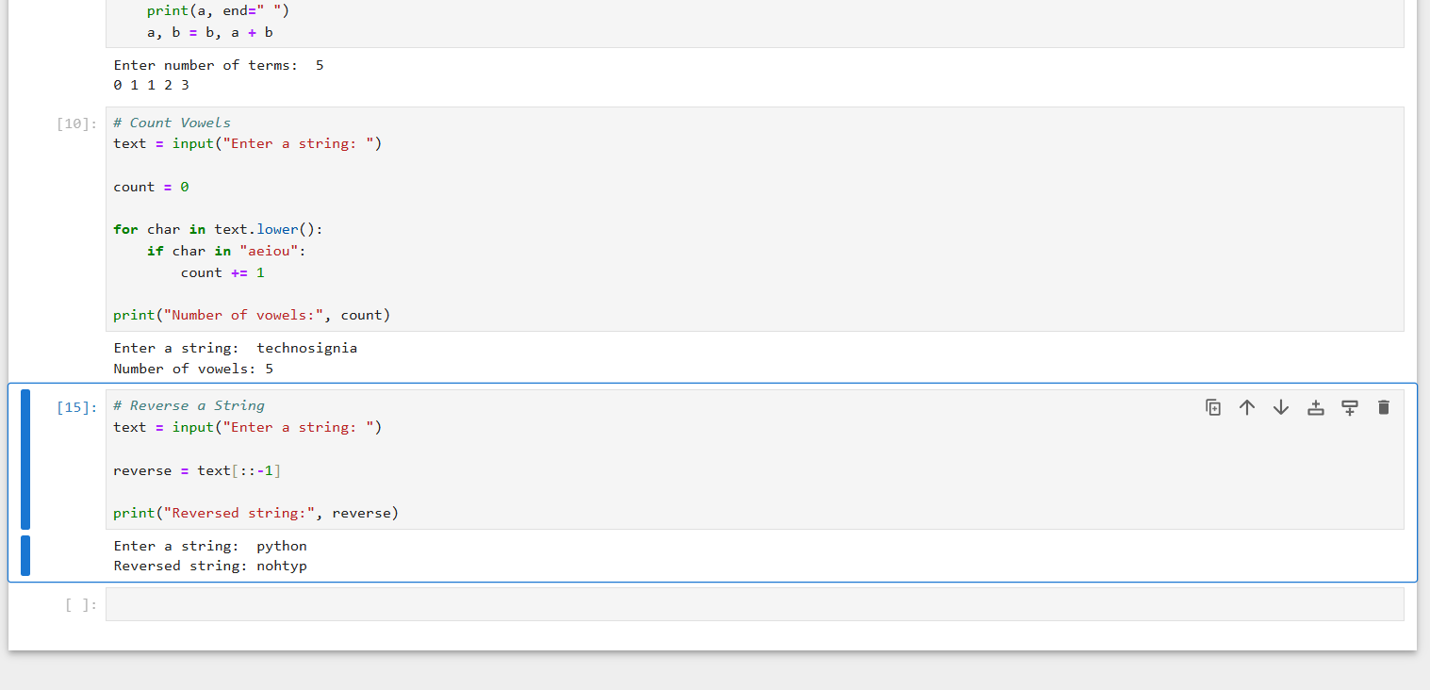

DAY 3 — Functions + Advanced Python Basics
Day :-- Saturday Date :-- 12-09-2026

Task Description:
Learn Python functions and advanced Python basics, including parameters, return values, lambda functions, map(), filter(), comprehensions, exception handling, and modules.

Task Elaboration:
- Created functions to calculate average, maximum, minimum, percentage, and grade.
- Used parameters and return values in the functions.
- Called all functions in one Python program and tested the output.
- Practiced writing reusable, readable, and maintainable code.

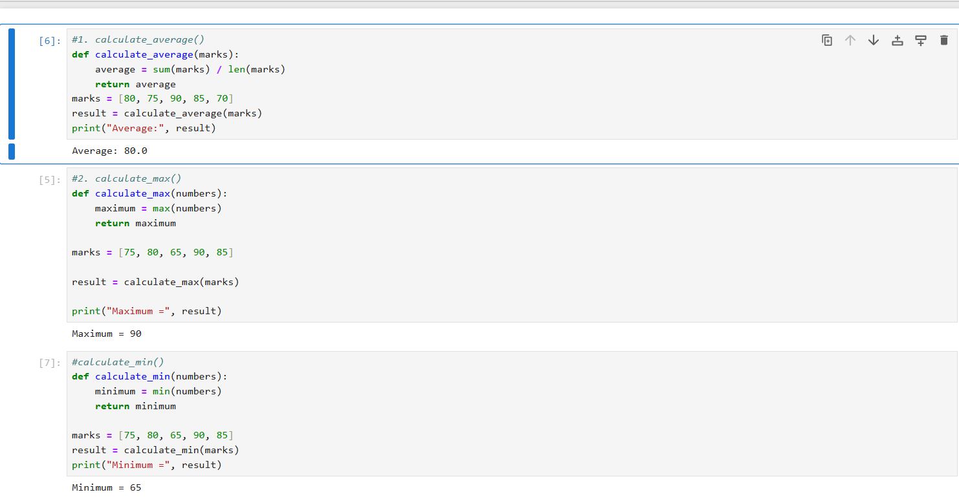

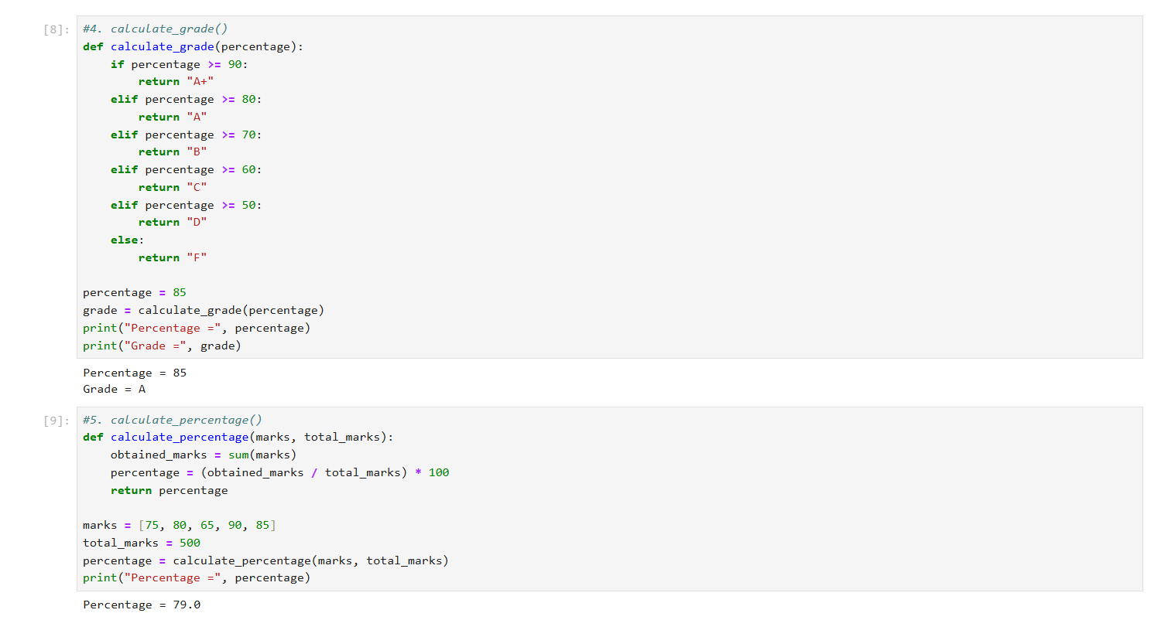

DAY 4 — NumPy
Day :-- Tuesday , Date :-- 15-09-2026

Task Description:
I learn NumPy and perform numerical analysis on a sales dataset using NumPy arrays.
Task Elaboration:
Created a NumPy array containing sales data.
Performed Total, Average, Maximum, Minimum, Standard Deviation, Median, 25th Percentile, and 75th Percentile calculations.
Also practiced 1D/2D arrays, reshaping, and matrix multiplication.

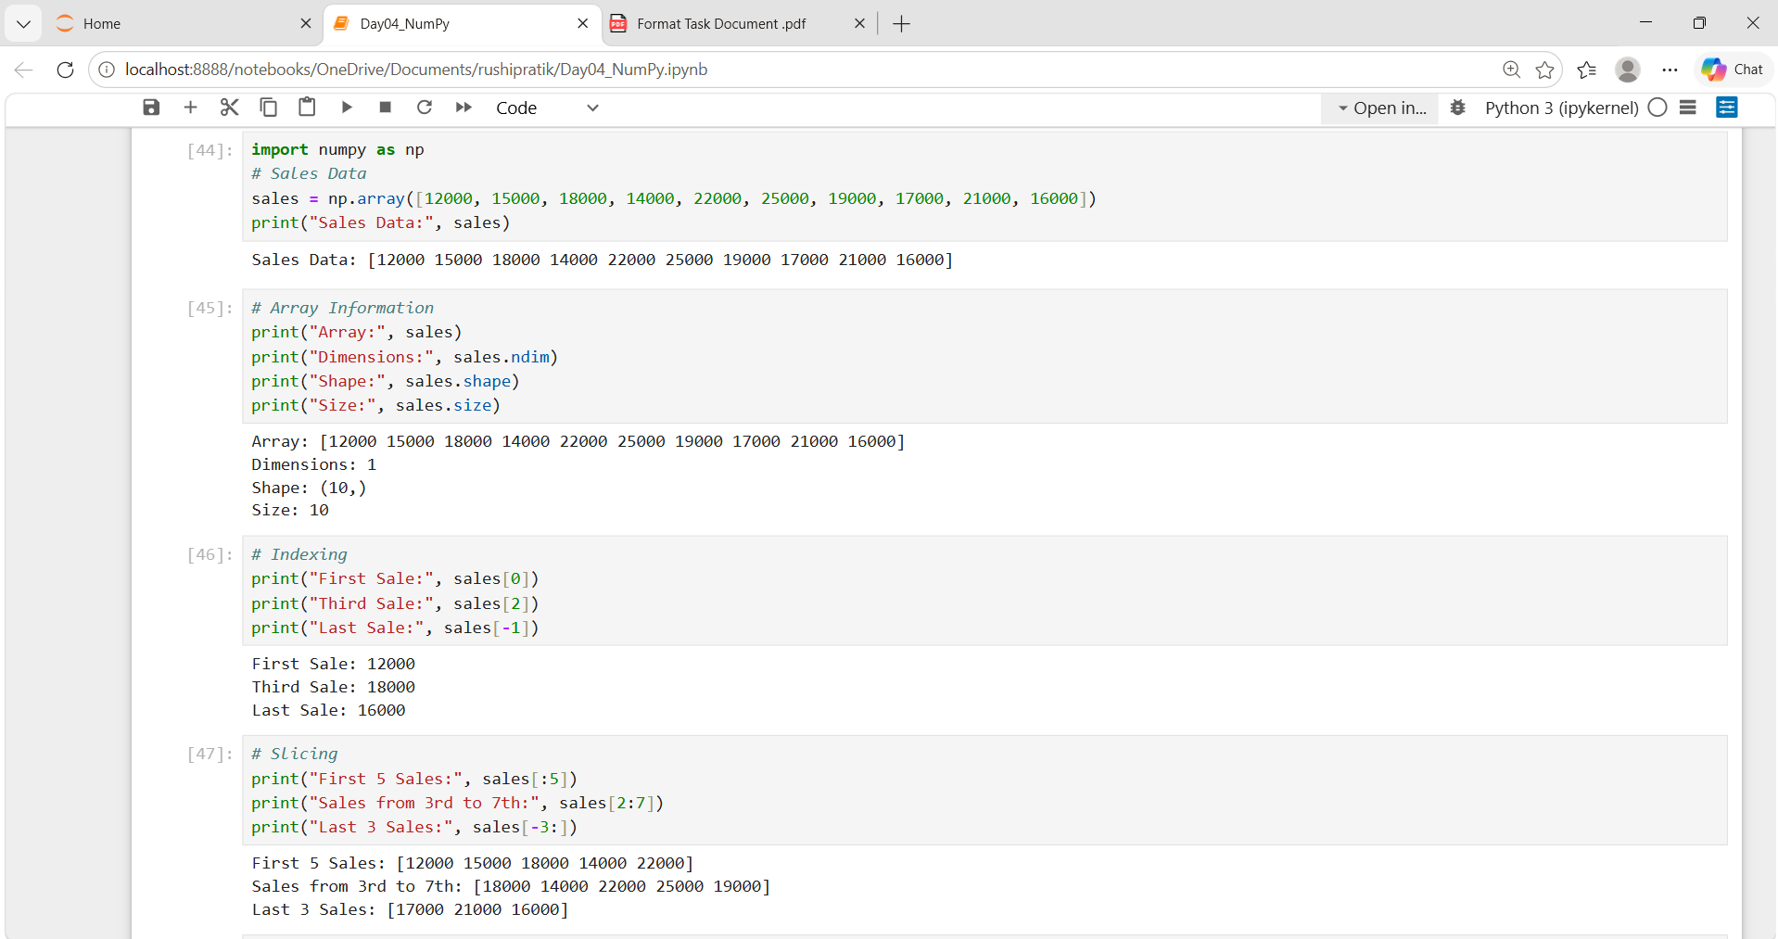
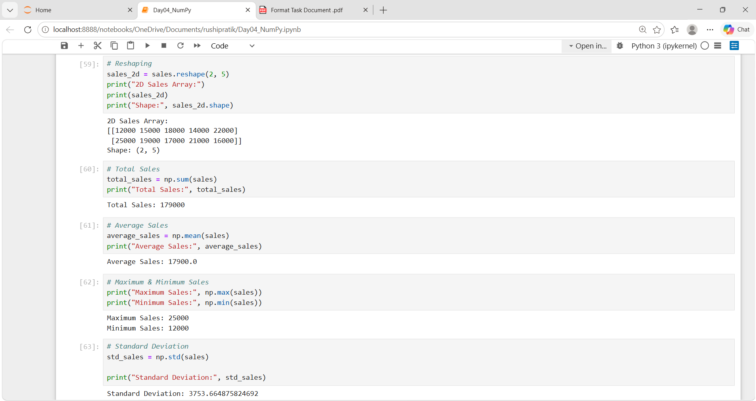

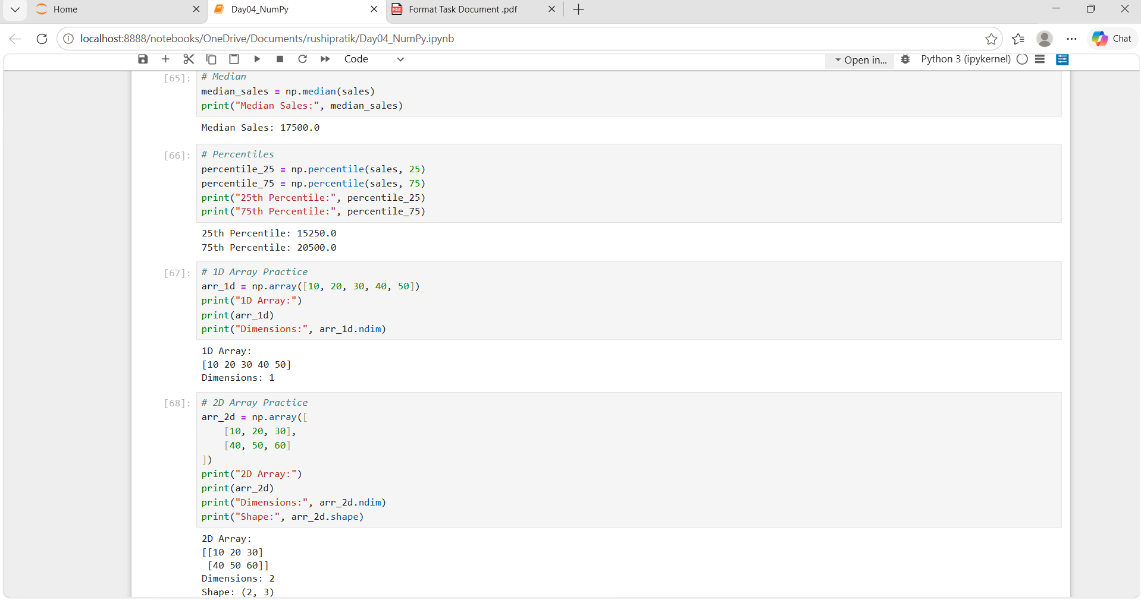
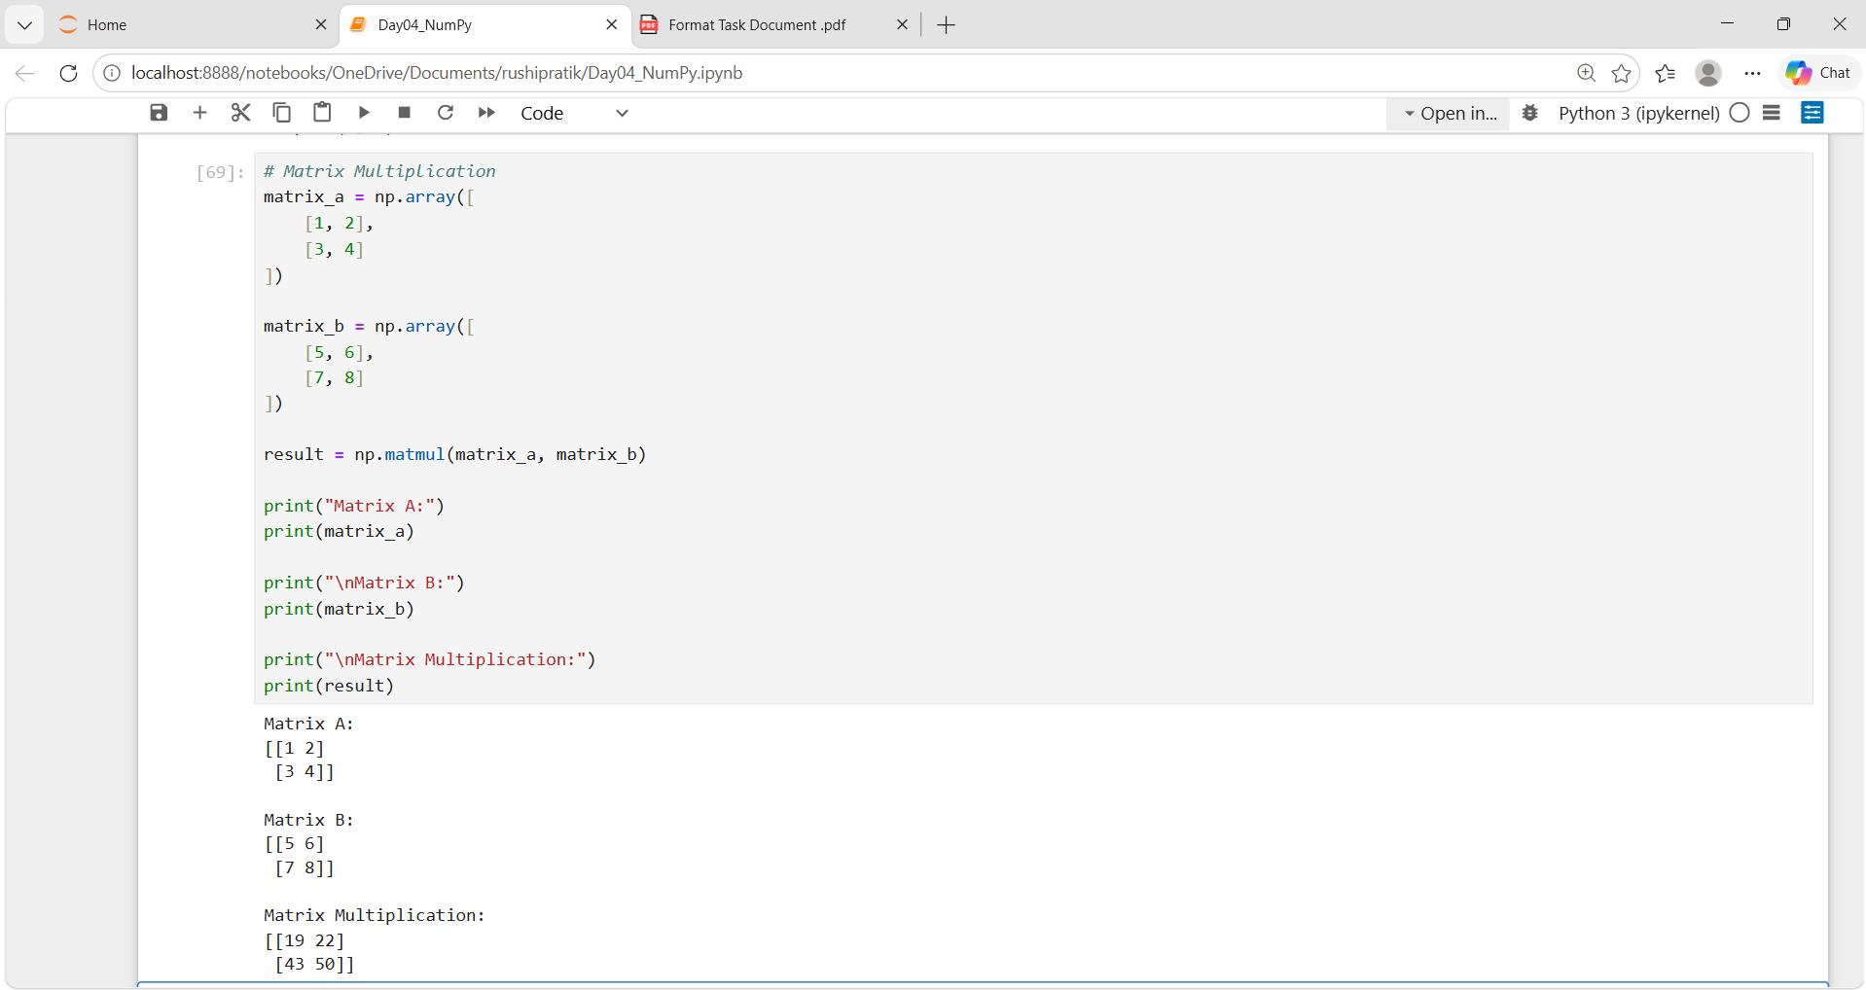

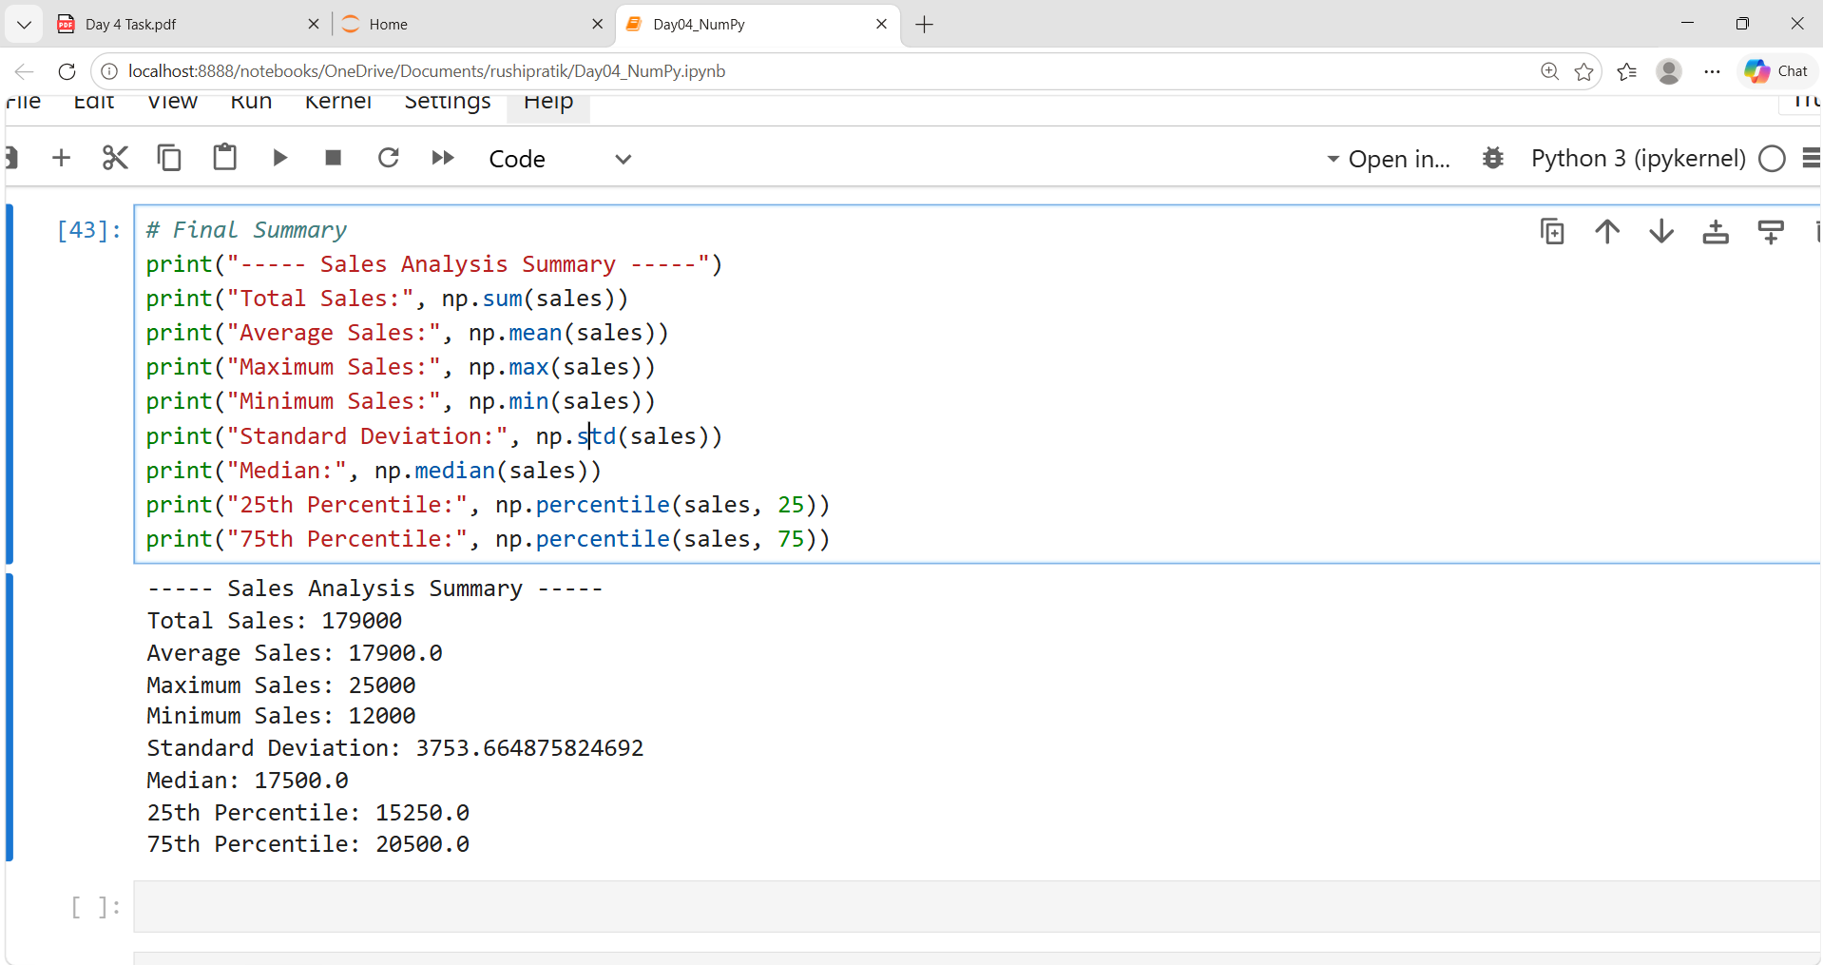

DAY 5 — Pandas Basics
Day :-- Wednesday , Date :-- 16-09-2026

Task Description:
Understand the fundamentals of Pandas, including Series, DataFrames, data loading, data inspection, and summary statistics

Task Elaboration:
- Loaded the dataset using read_csv().
- Displayed the first and last 10 rows.
- Checked the number of rows, columns, and data types.
- Identified missing values in the dataset.
- Generated summary statistics using describe().
- Practiced Pandas Series and DataFrame operations.

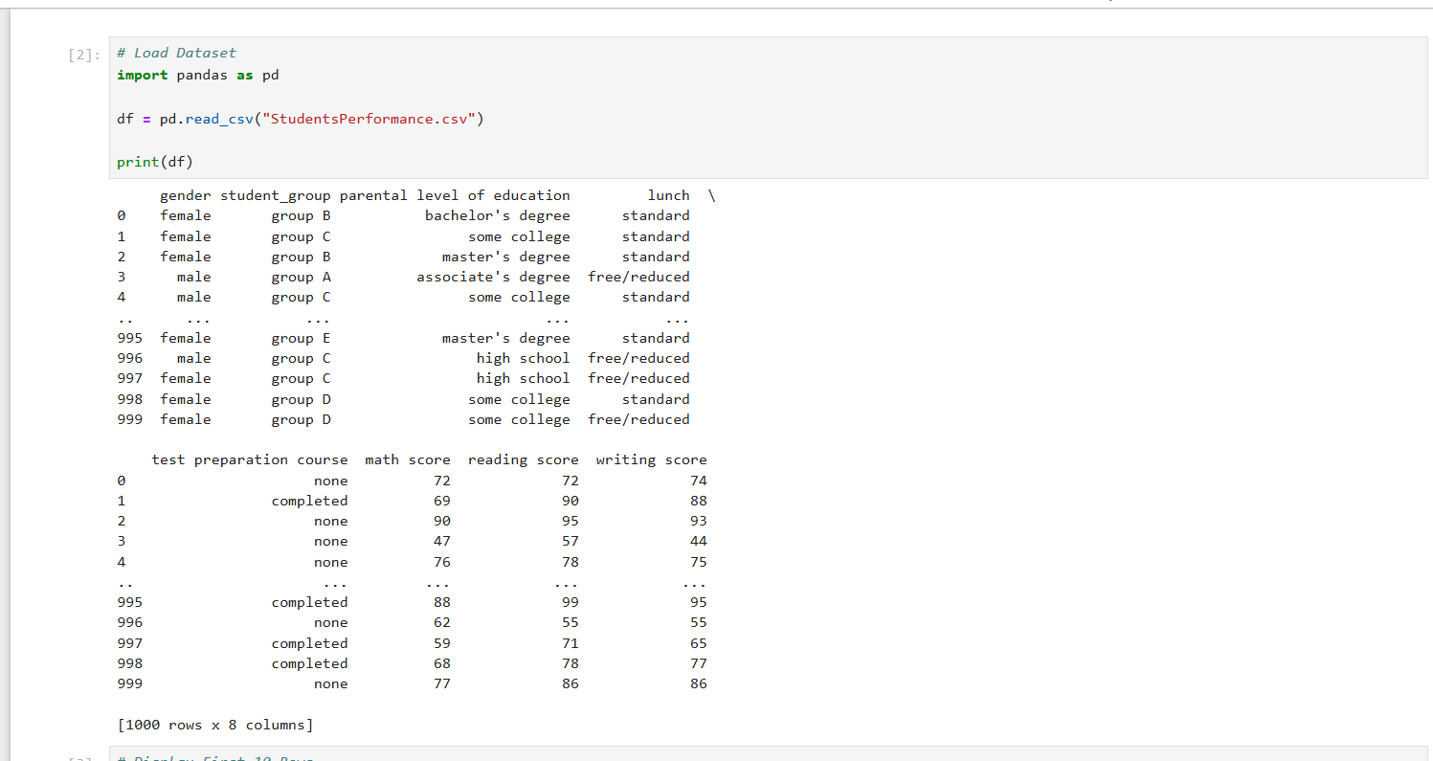

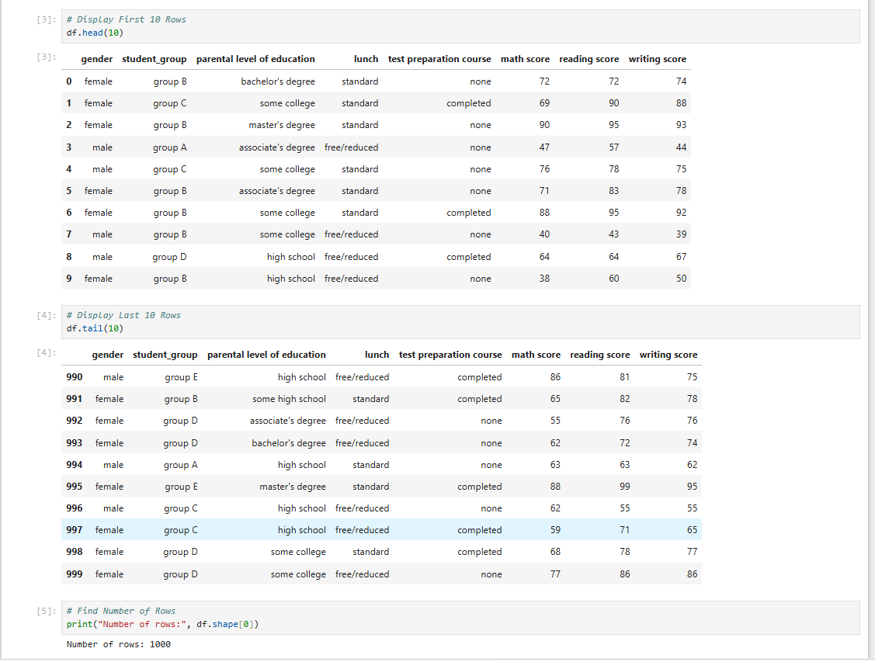

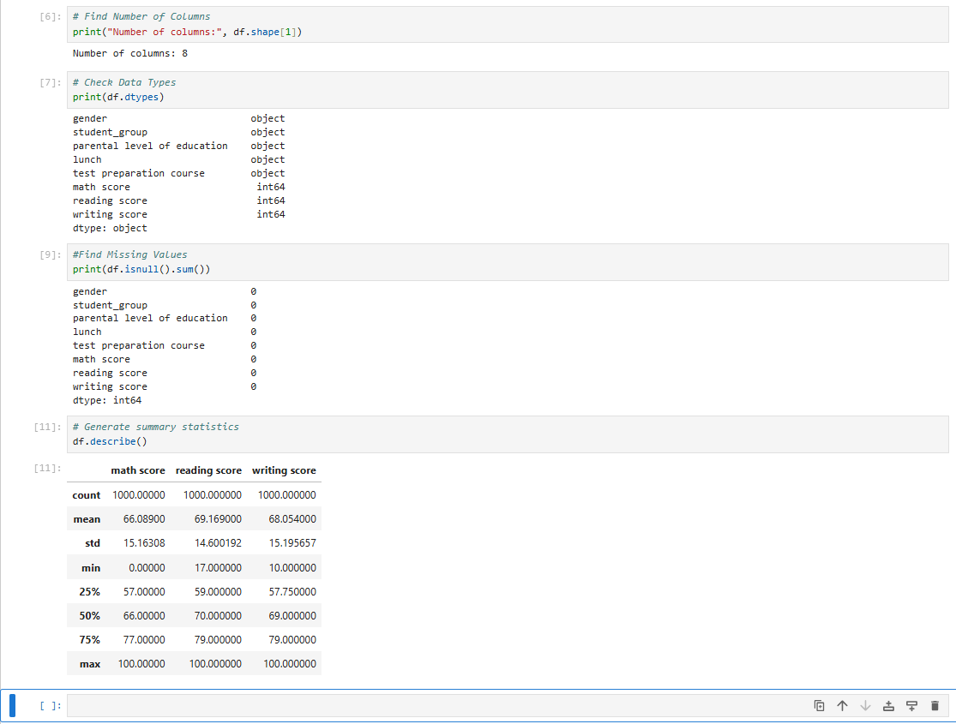

DAY 6 — Data Cleaning
Day :-- Thursday , Date :-- 17-09-2026

Task Description:
Learn how to identify and clean data issues such as missing values, duplicates, incorrect data types, inconsistent text, incorrect values, and abnormal (outside the expected range.) values using Pandas.

Task Elaboration:
- Identified missing values and duplicate records.
- Corrected data types and inconsistent(Same information written in different ways.) text values.
- Removed duplicates and handled missing data.
- Identified and handled abnormal values in the dataset.
- Created before-cleaning and after-cleaning datasets for comparison.
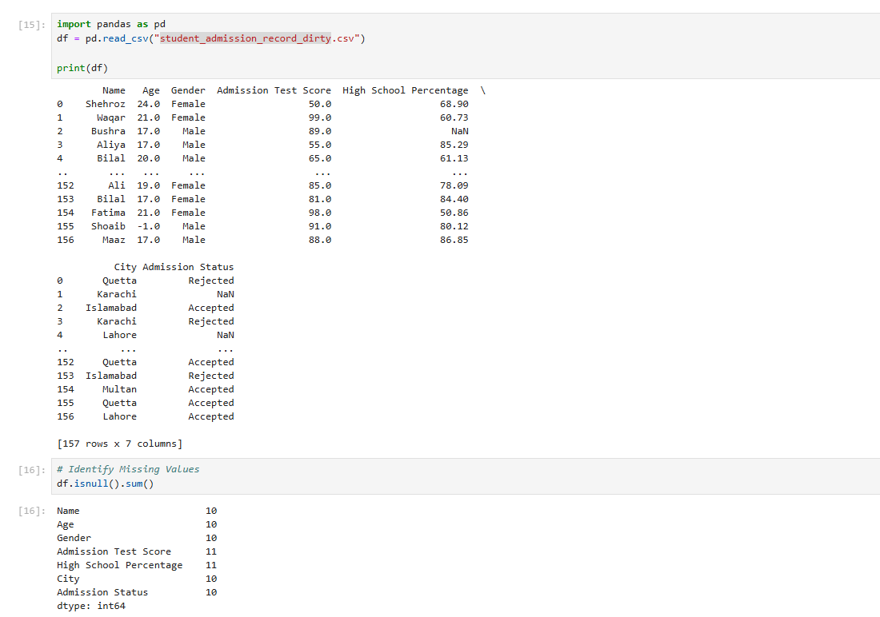

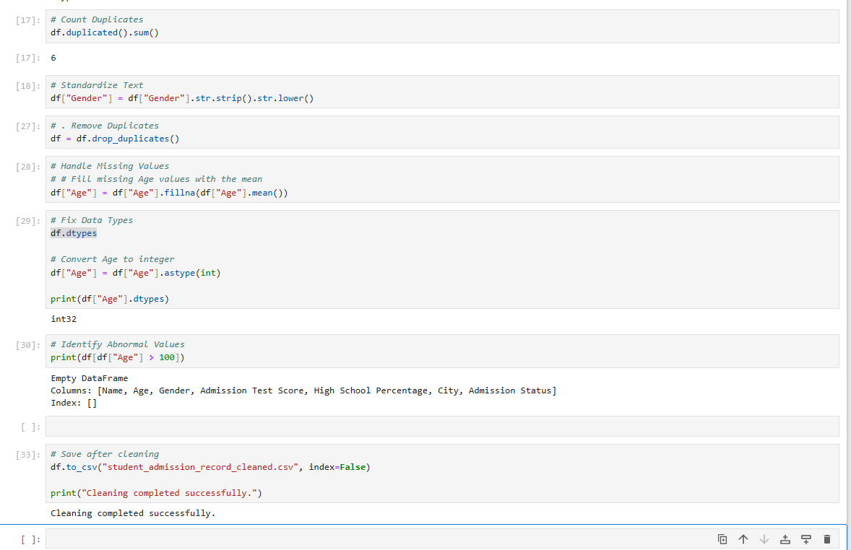

DAY 7 — SQL Fundamentals
Day :-- Friday , Date :-- 18-09-2026

Task Description:
Learn and practice SQL fundamentals by creating a database and working with related tables. The task focuses on understanding basic SQL concepts such as databases, tables, rows, columns, primary keys, foreign keys, and commonly used SQL clauses and statements.
Task Elaboration:
In this task, I created a database and three related tables: customers, products, and orders. I practiced creating table structures, defining primary keys and foreign keys, and understanding relationships between tables.
I also practiced SQL commands and clauses including SELECT, WHERE, ORDER BY, GROUP BY, HAVING, DISTINCT, and CASE to retrieve, filter, sort, group, and analyze data from the tables.
This task helped me understand the fundamentals of SQL and how relational databases are structured and queried.

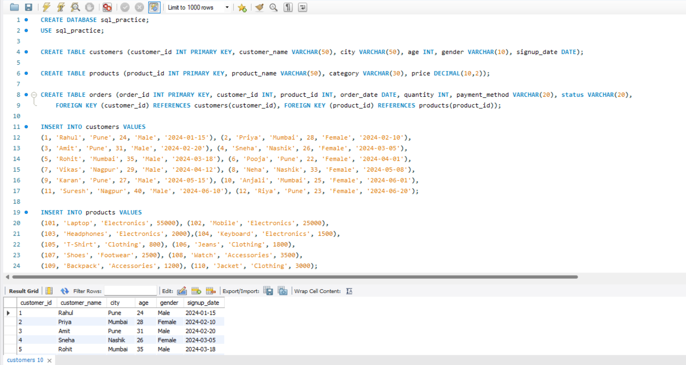
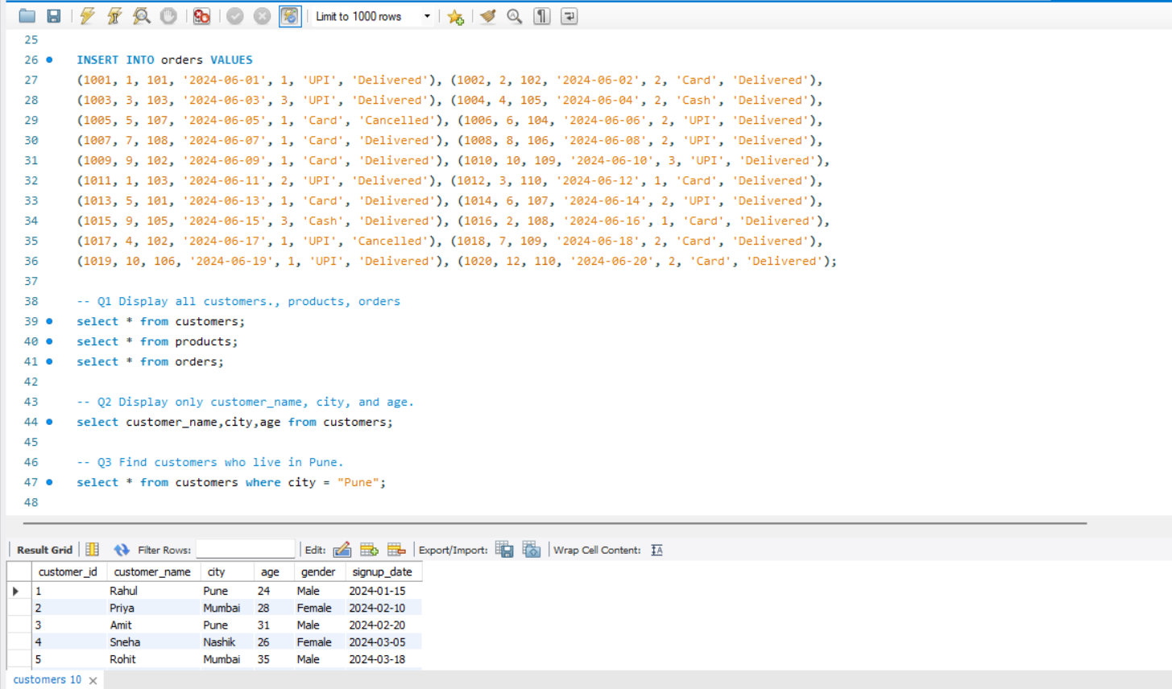

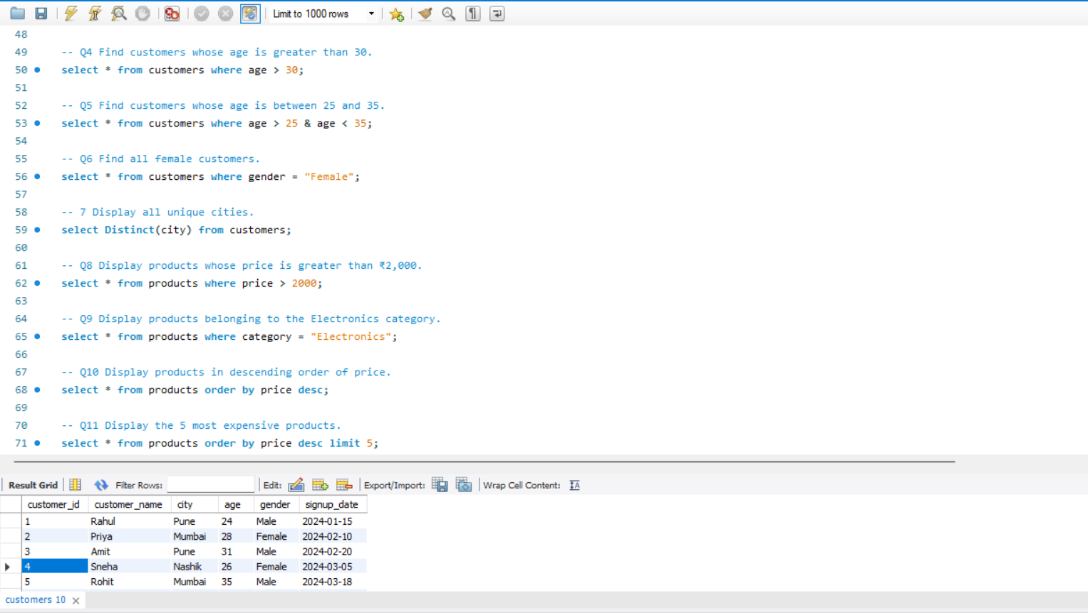

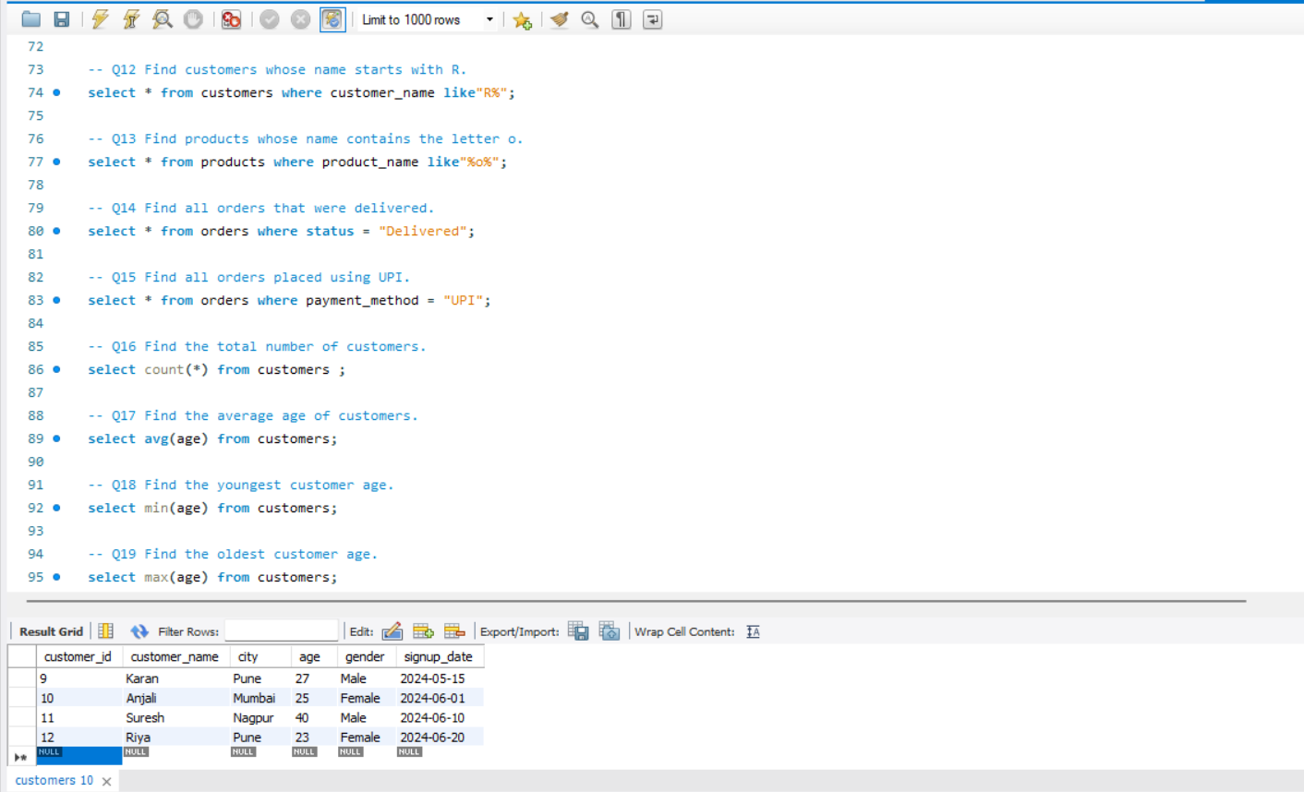

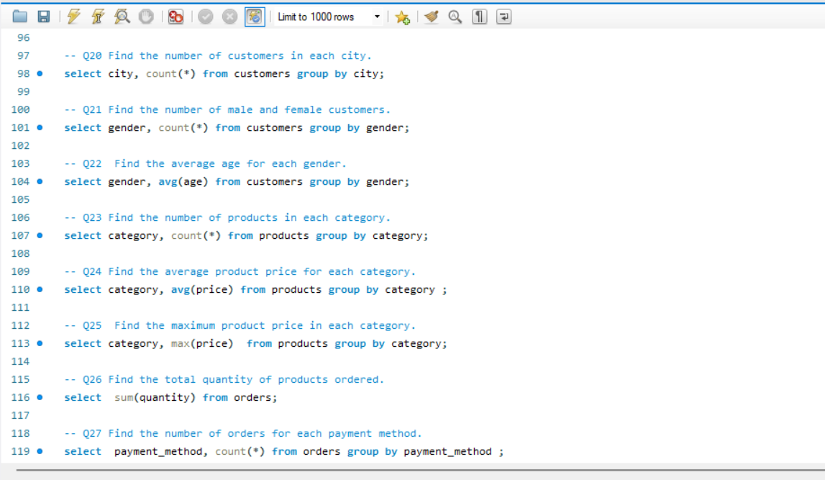

DAY 8 — Advanced SQL
Day :-- Saturday , Date :-- 19-09-2026

Task Description:
Learn and practice advanced SQL concepts including JOINs, Subqueries, CTEs, and Window Functions for data analysis.

Task Elaboration:
Implemented advanced SQL queries using INNER JOIN, LEFT JOIN, Subqueries, CTEs, ROW_NUMBER(), RANK(), DENSE_RANK(), LAG(), and LEAD(). Solved analytical problems such as Top 3 Customers, Top 3 Products per Category, Customer Ranking, Monthly Revenue, Previous Month Revenue, MoM Growth, and Employee Salary Ranking. Completed a minimum of 20 advanced SQL queries.

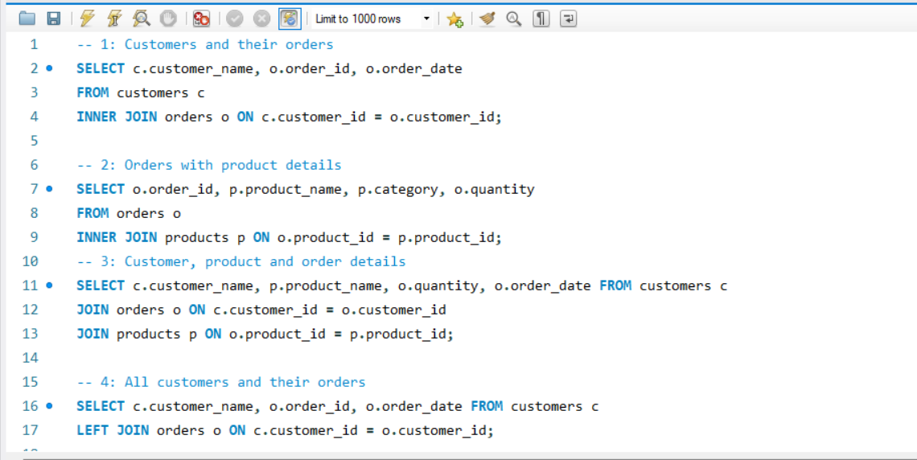

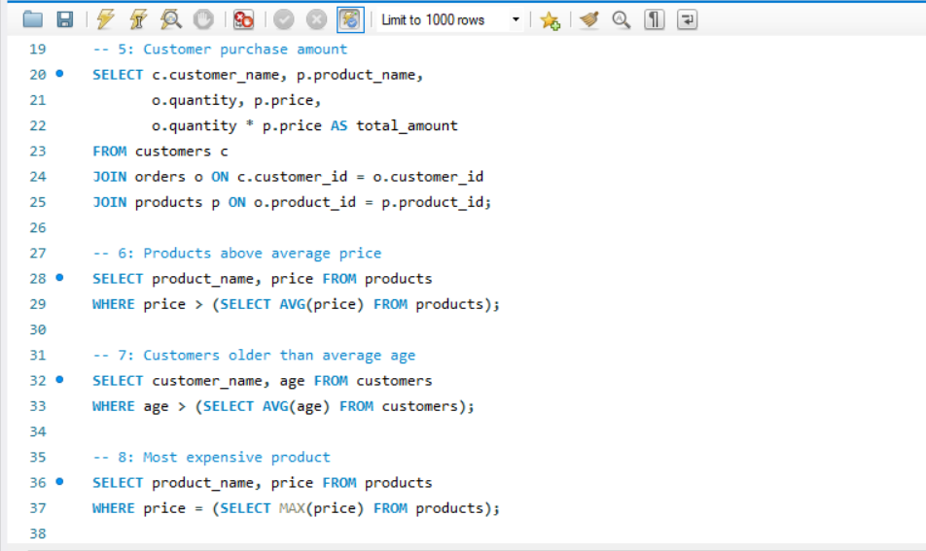

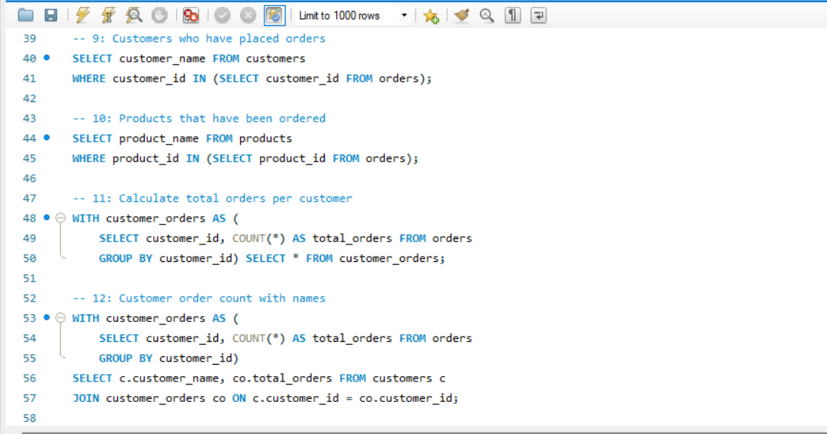

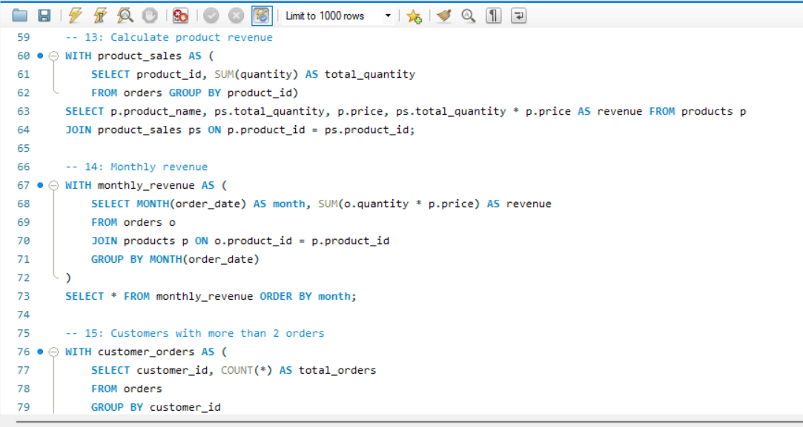

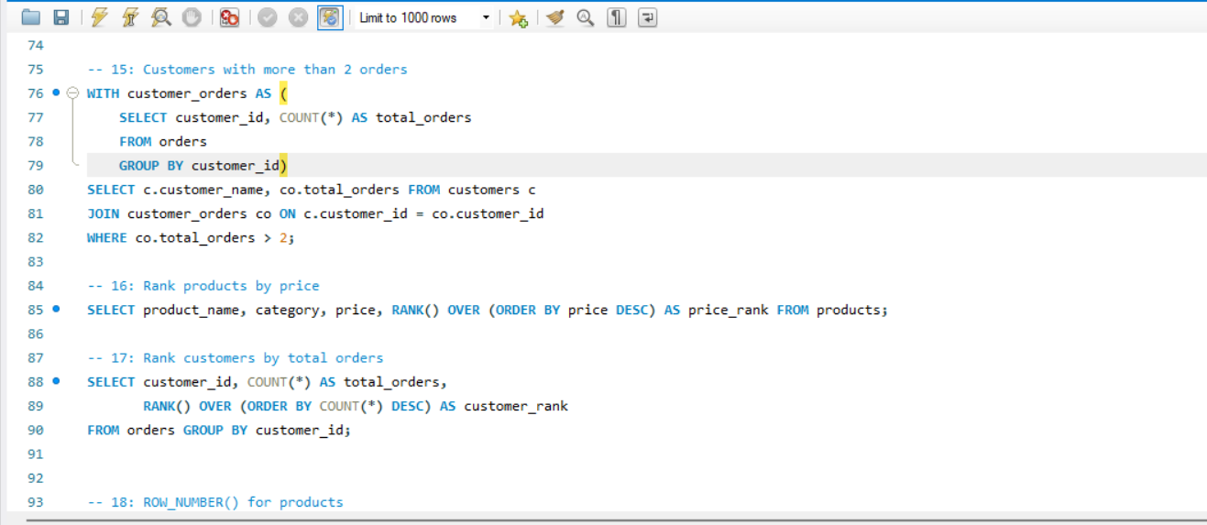

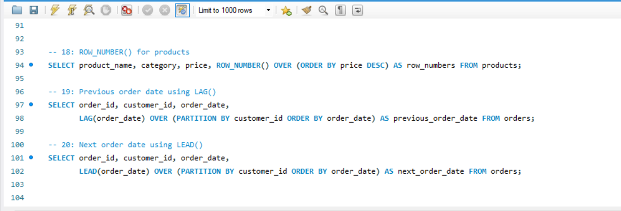

DAY 9 — Statistics
Day :-- Monday , Date :-- 21-09-2026

Task Description
Learn and apply basic statistical concepts including Mean, Median, Mode, Range, Variance, Standard Deviation, Percentile, Quartile, IQR, Correlation, and Covariance using a dataset.

Task Elaboration
In this task, I worked with a dataset and used Python libraries such as Pandas and NumPy to calculate different statistical measures. I calculated measures of central tendency, data spread, and relationships between variables. I also interpreted the results to understand what each statistical value represents and how it helps in analyzing data. A basic visualization was created to understand the distribution of the data.

The concepts covered were:
- Mean
- Median
- Mode
- Range
- Variance
- Standard Deviation
- Percentile
- Quartile
- Interquartile Range (IQR)
- Correlation
- Covariance
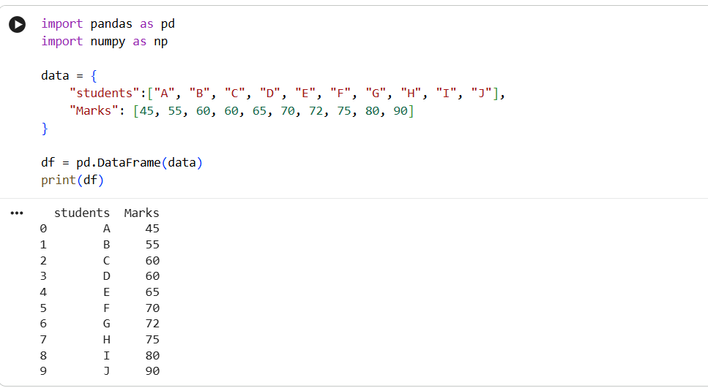

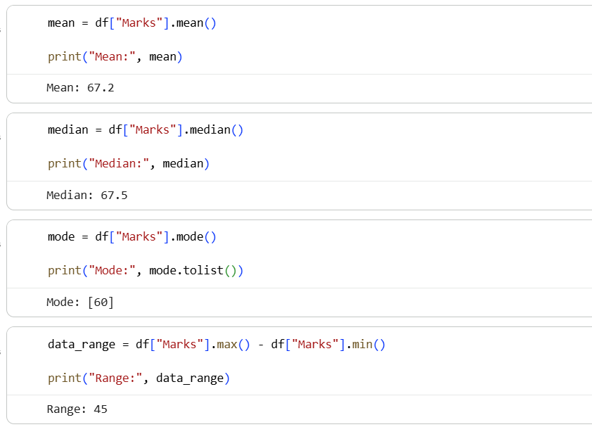

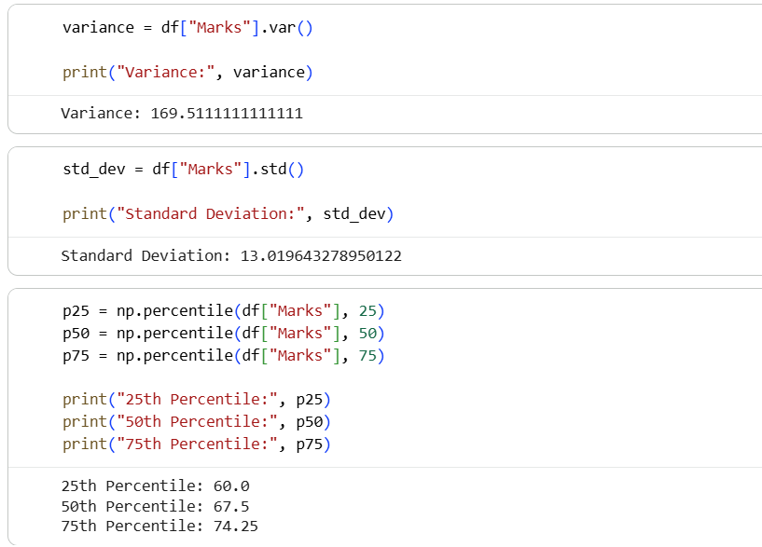

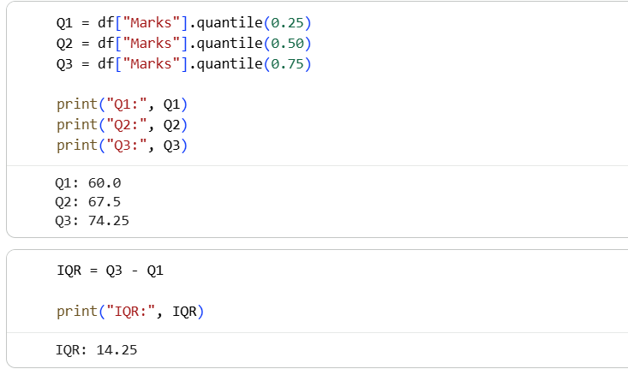

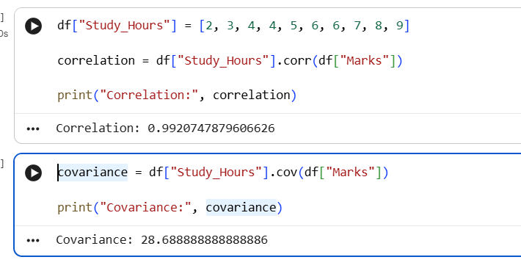

DAY 9 — Statistics
Day :-- Wednesday , Date :-- 23-09-2026
Task Description:
Learn the basics of probability and its important concepts used in Data Science and Machine Learning.

Task Elaboration:
Study probability, conditional probability, independent/dependent events, Bayes’ theorem, normal distribution, and binomial distribution. Solve at least 15 probability problems and implement 5 problems using Python.

1. Question: A fair coin is tossed once. What is the probability of getting Heads?
Total outcomes = 2 → {H, T}
Favourable outcomes = 1
Answer:
$$P\left(H\right)=\frac{1}{2}=0.5=50\%$$

2. Question: A fair die is rolled once. What is the probability of getting a 6?

Total outcomes = 6
Favourable outcomes = 1
Answer:
$$P\left(6\right)=\frac{1}{6}=0.1667=16.67\%$$

3. Question: A fair die is rolled once. What is the probability of getting a 6?
Even numbers = {2, 4, 6} → 3 outcomes
Answer:
$$P\left(Even\right)=\frac{3}{6}=\frac{1}{2}=50\%$$
4. Question: One card is drawn from a standard deck of 52 cards. What is the probability of getting an Ace?
There are 4 Aces in 52 cards.
Answer:
P(Ace)= 4/52 ​= 1/13 ​≈ 7.69%

5. Question: One card is drawn from a standard deck. What is the probability of getting a Heart?
There are 13 Hearts in 52 cards.
Answer:
P(Heart)= 13/52 ​= ¼ ​= 25%

6. Question: Two fair coins are tossed. What is the probability of getting two Heads?

Possible outcomes:
HH, HT, TH, TT
Only HH is favourable.
Answer:
P(HH)= 1/4 ​=25%

Question: Two dice are rolled. What is the probability that the sum is 7?
Favorable combinations:
(1,6), (2,5), (3,4), (4,3), (5,2), (6,1)
6 favorable outcomes out of 36.
P(Sum=7)= 6/36​= 1/6​

Final Answer: 1/6 ≈ 16.67%

Question: A bag contains 5 red balls and 3 blue balls. What is the probability of selecting a red ball?
Total balls = 8
Red balls = 5
$$P\left(Red\right)=\frac{5}{8}$$
Final Answer: 0.625 or 62.5%

Question: A bag contains 4 red and 6 blue balls. Two balls are selected without replacement. What is the probability that both are red?
$$P\left(R_{1}\right)=\frac{4}{10}$$
After selecting one red:
$$P\left(R_{2}\right)=\frac{3}{9}$$
Therefore,
$$P\left(R_{1}∩R_{2}\right)=\frac{4}{10}×\frac{3}{9}=\frac{2}{15}$$
Final Answer: 2/15 ≈ 13.33%

Question: A class has 20 students: 12 boys and 8 girls. What is the probability of selecting a girl?
$$P\left(Girl\right)=\frac{8}{20}=\frac{2}{5}$$
Final Answer: 0.4 or 40%

Question: A disease affects 2% of a population. A test correctly detects the disease 95% of the time and has a 5% false-positive rate. What is the probability that a person actually has the disease given that the test is positive?
Given:
- P(Disease) = 0.02
- P(Positive | Disease) = 0.95
- P(Positive | No Disease) = 0.05
Using Bayes' theorem:
$$P\left(Disease∣Positive\right)=\frac{0.95×0.02}{\left(0.95×0.02\right)+\left(0.05×0.98\right)} \\ =\frac{0.019}{0.068}≈0.2794$$
Final Answer: ≈ 27.94%

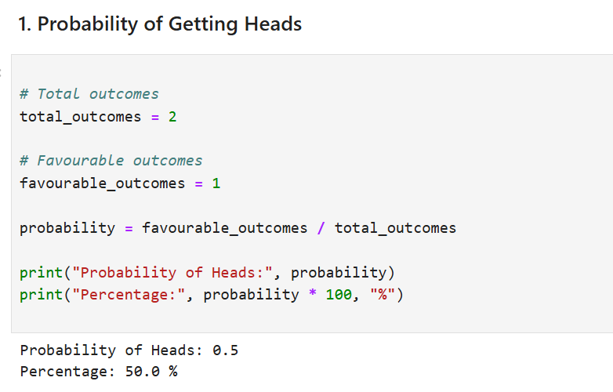

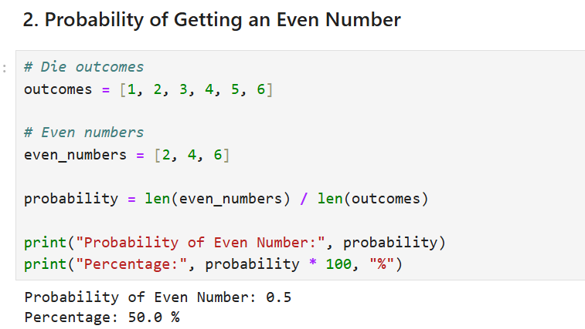

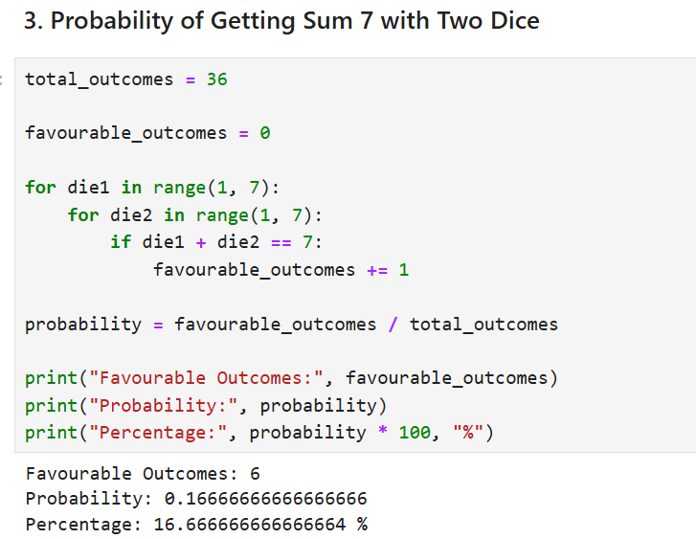

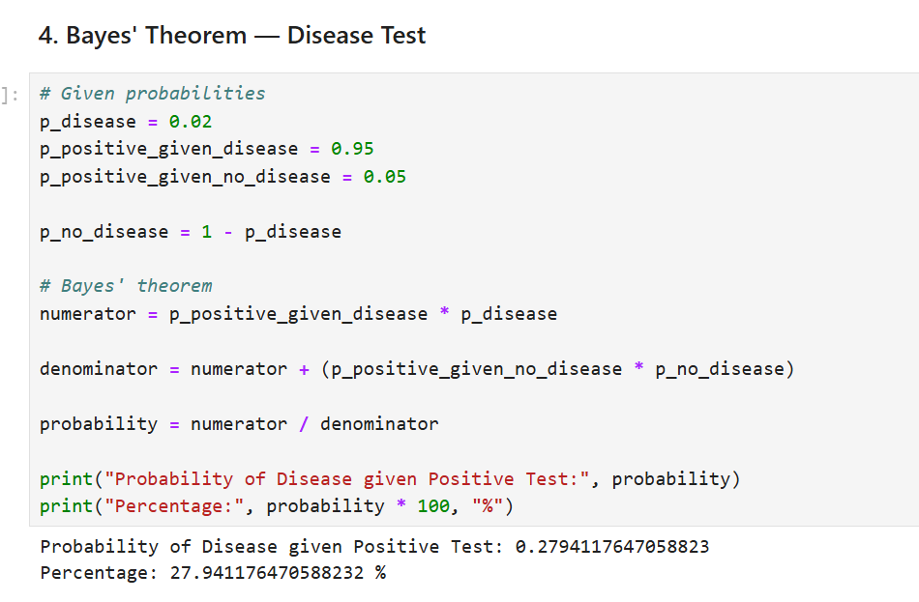

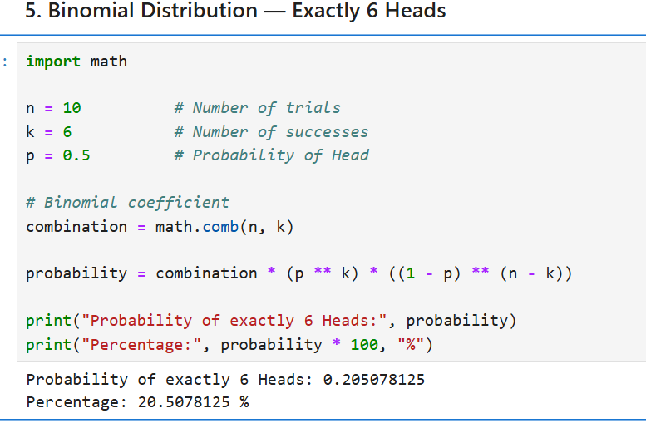

DAY 11 — Matplotlib
Day :-- Thursday , Date :-- 24-09-2026
Task Description
Learn Matplotlib and create different types of visualizations using a single dataset to understand and communicate patterns, trends, and relationships in data.

Task Elaboration

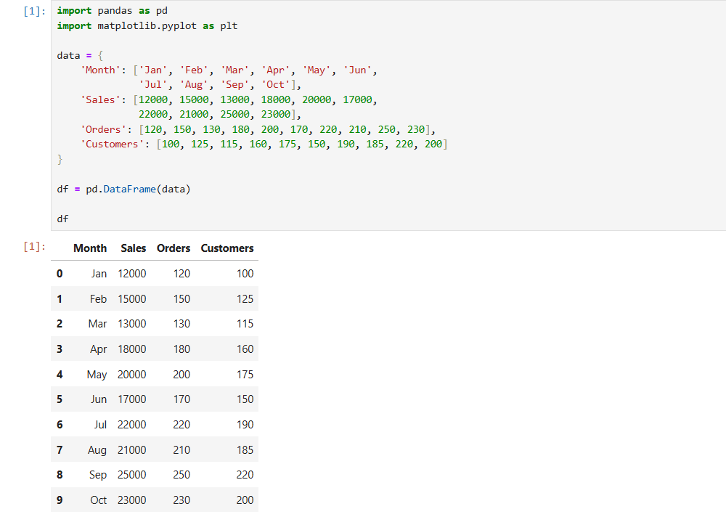

Line Chart
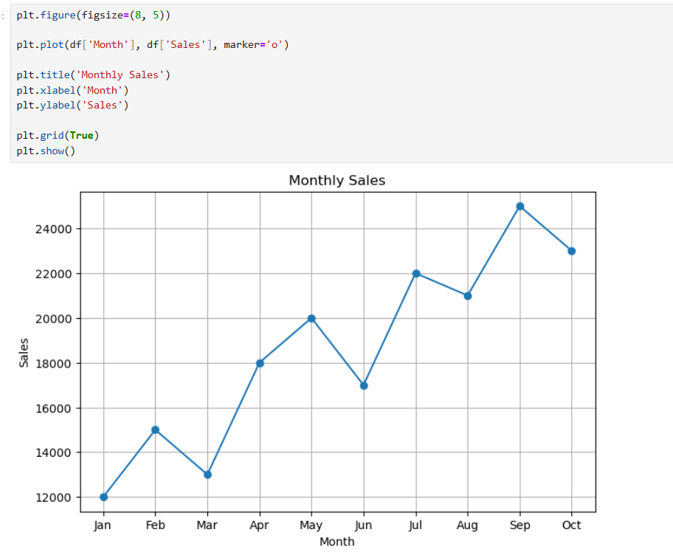
Interpretation: Sales generally increased over the months, with the highest sales in September.

Bar Chart
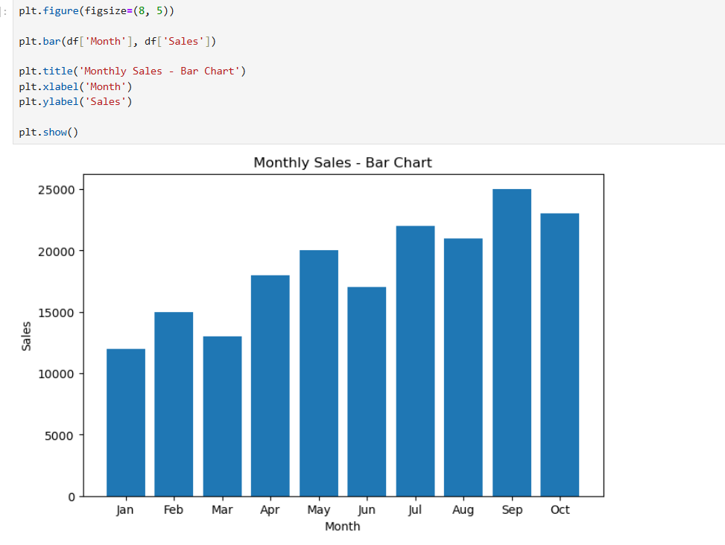

Interpretation: The bar chart makes it easy to compare sales between different months.

Horizontal Bar Chart

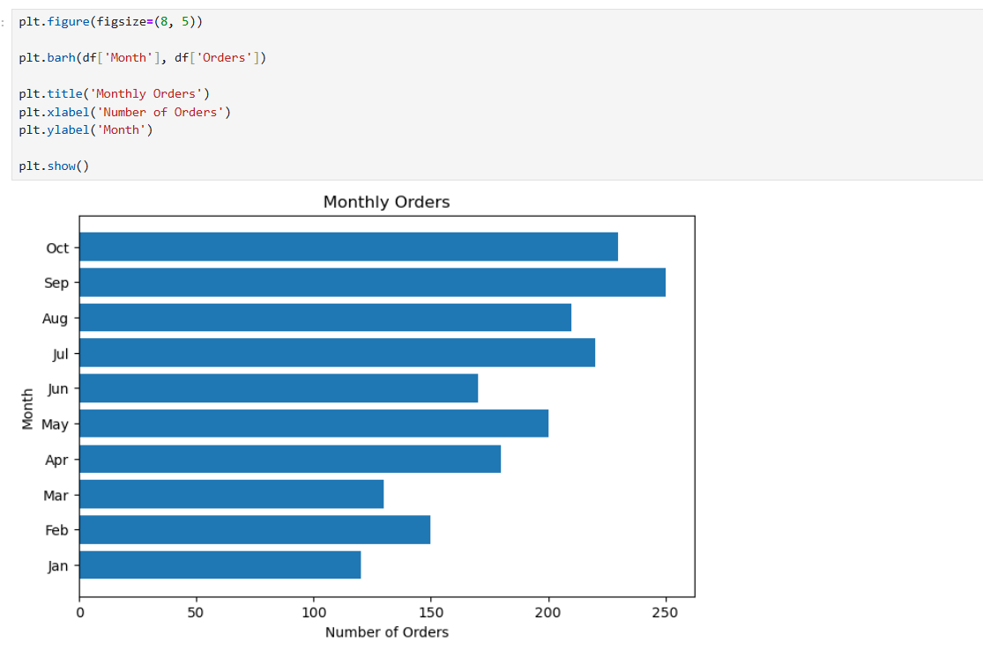
Interpretation: September recorded the highest number of orders.

Histogram
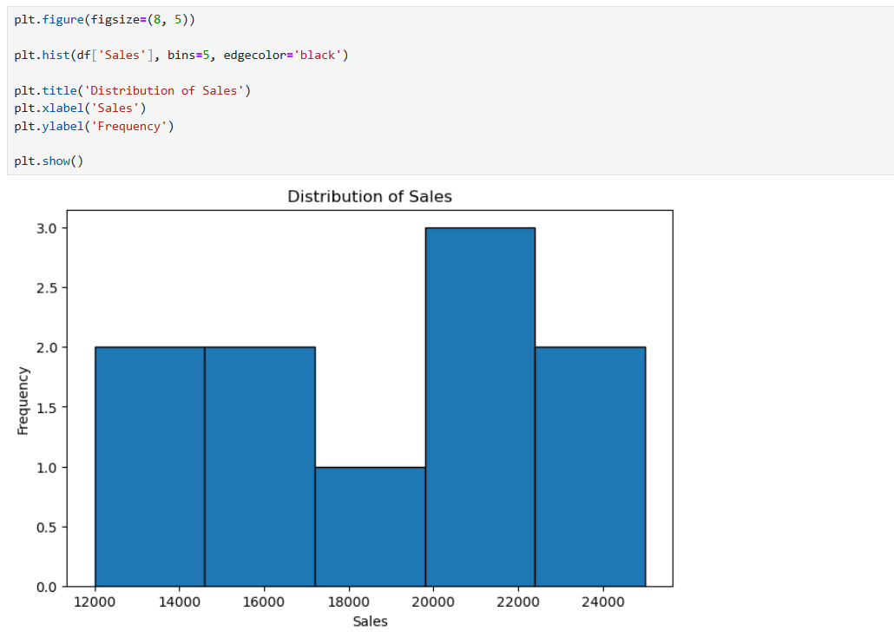
Interpretation: The histogram shows how frequently different sales ranges occur.

Scatter Plot
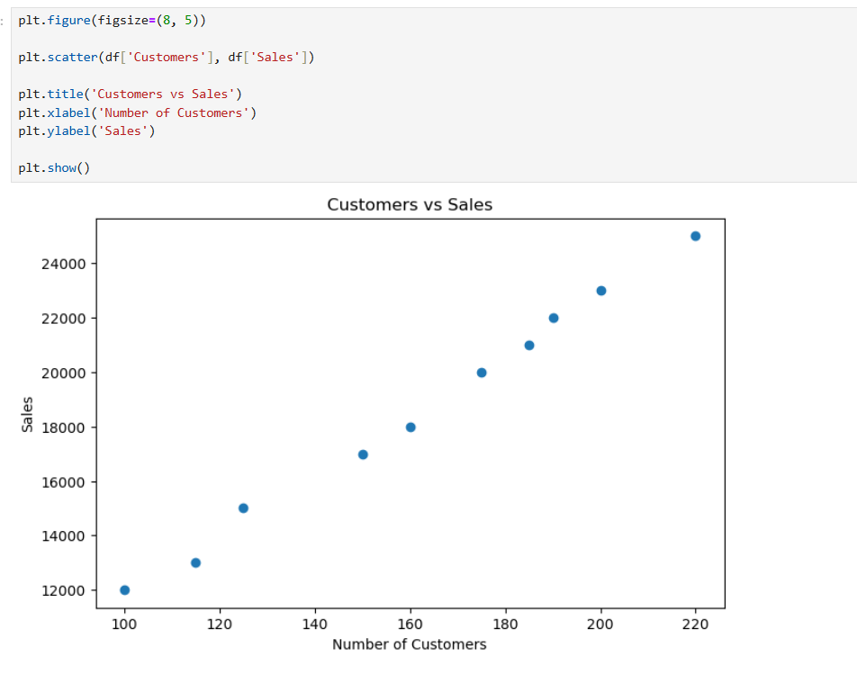

Interpretation: Sales generally increase as the number of customers increases, indicating a positive relationship

Pie Chart
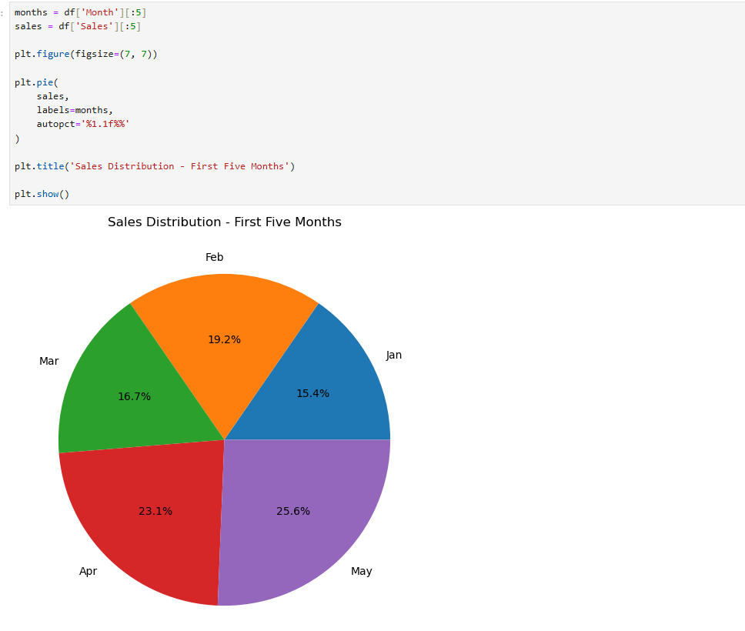

Interpretation: The pie chart shows the percentage contribution of each month to total sales during the first five months.

Box Plot
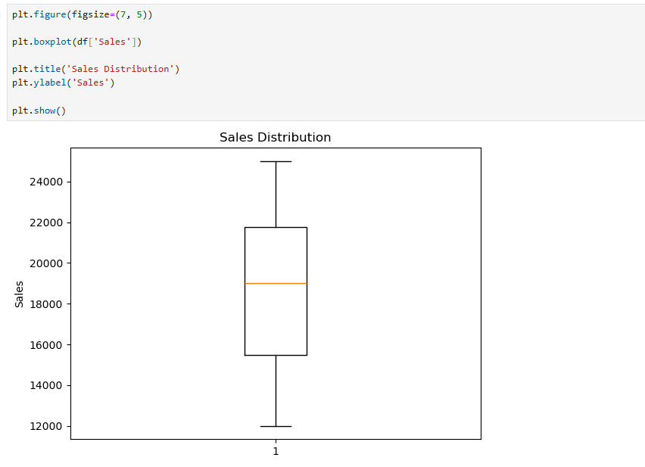

Interpretation: The box plot shows the median, spread, and possible outliers in the sales data.

Area Chart
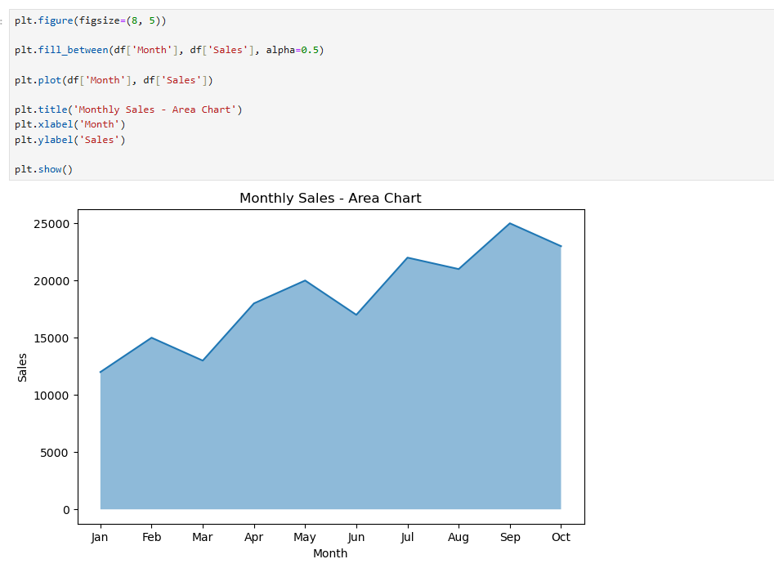

Interpretation: The area chart highlights the overall growth and changes in sales over time.

Multiple Line Chart
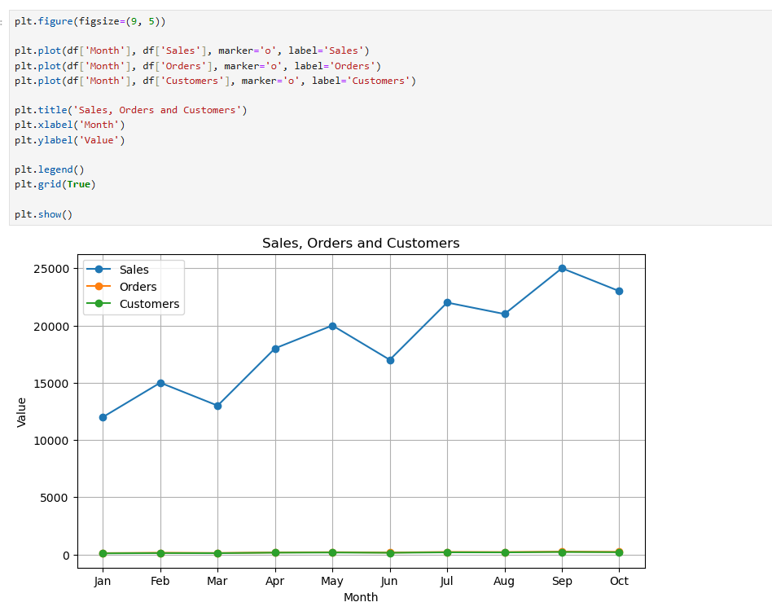

Interpretation: The chart compares sales, orders, and customers across the months and helps identify their overall trends.

DAY 12 — Seaborn + Advanced EDA
Day :-- Thursday , Date :-- 24-09-2026

Task Description
Learn Seaborn and Exploratory Data Analysis (EDA) techniques to understand data distributions, categories, outliers, and relationships between variables before applying machine learning or making business decisions.

Task Elaboration
In this task, I performed Advanced EDA using Python, Pandas, Matplotlib, and Seaborn. I first loaded and inspected the dataset to understand its structure, columns, data types, and basic statistics.
I then created different visualizations to analyze the dataset:
- Distribution Analysis
Used distribution plots to understand how numerical variables are distributed and identify patterns such as skewness and concentration of values.
- Category Analysis
Used countplots to analyze the frequency of different categories and understand which categories occur more frequently.
- Outlier Analysis
Used boxplots and violin plots to identify potential outliers, compare distributions, and understand the spread of numerical variables across different categories.
- Correlation Analysis
Created a correlation heatmap to identify the strength and direction of relationships between numerical variables.
- Pairwise Relationship Analysis
Used a pairplot to visualize relationships between multiple numerical variables and observe patterns, clusters, and possible correlations.
- Observations
After analyzing all the visualizations, I documented 5–10 important observations about the dataset, including distributions, category patterns, outliers, and relationships between variables.

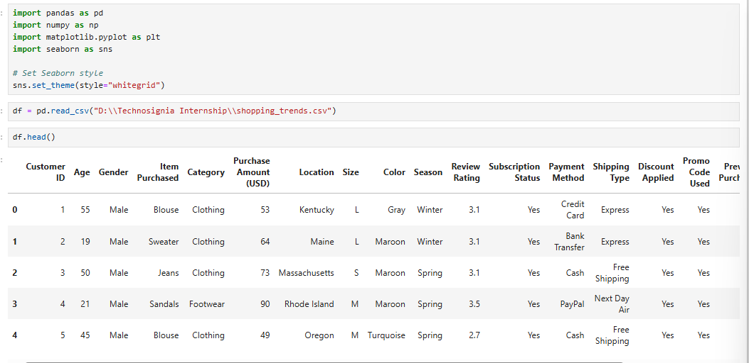

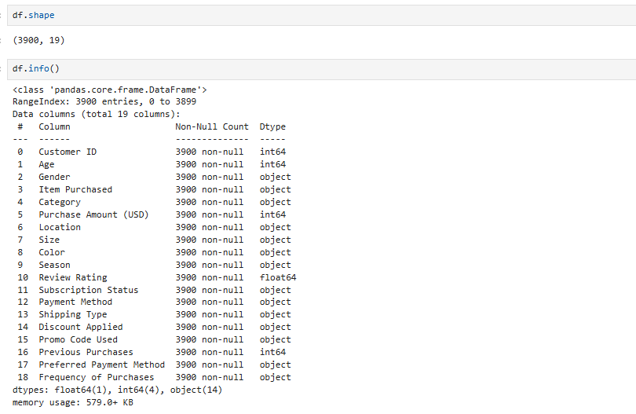

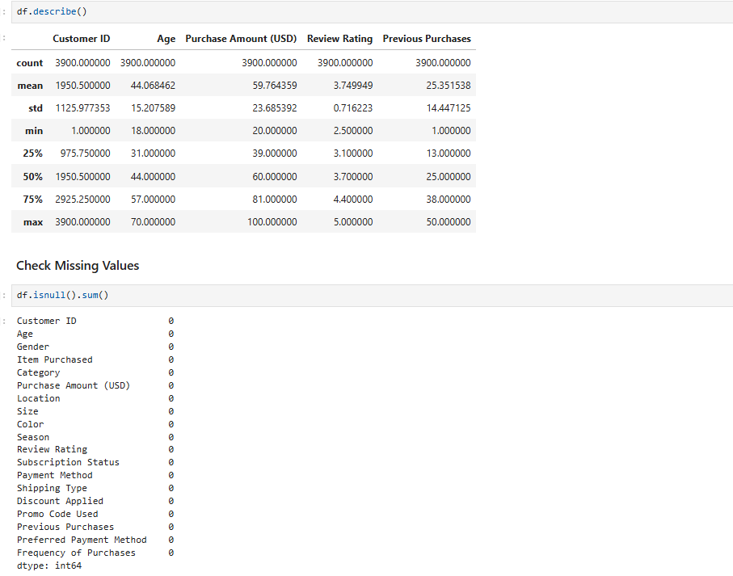

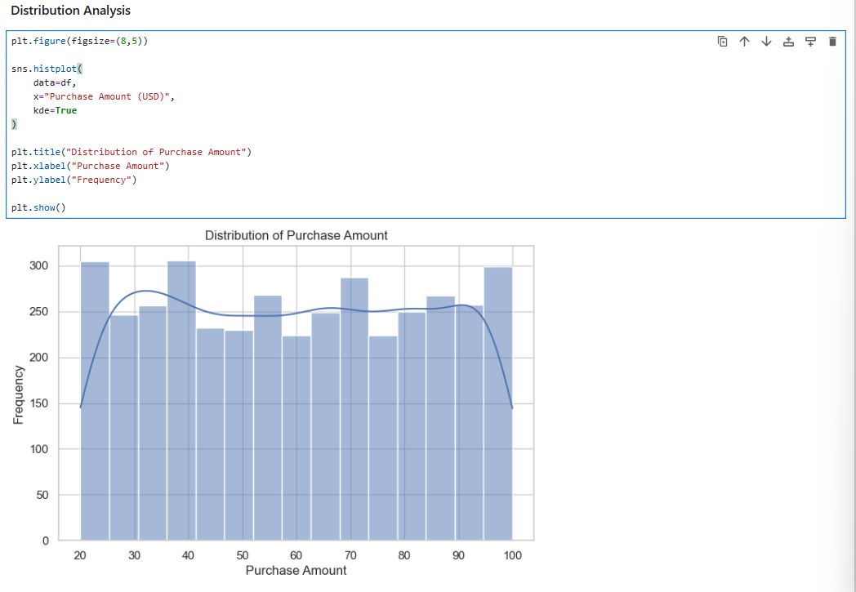

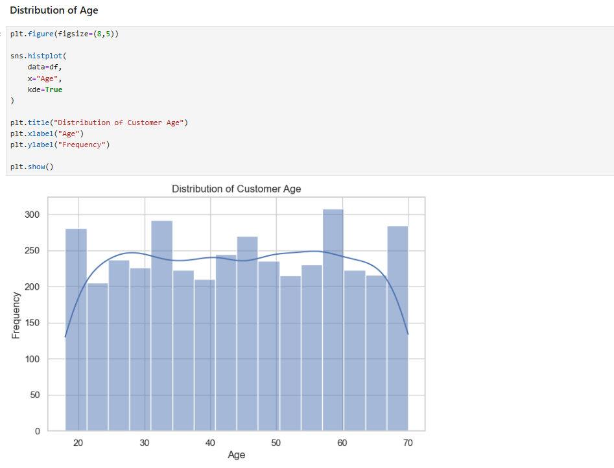

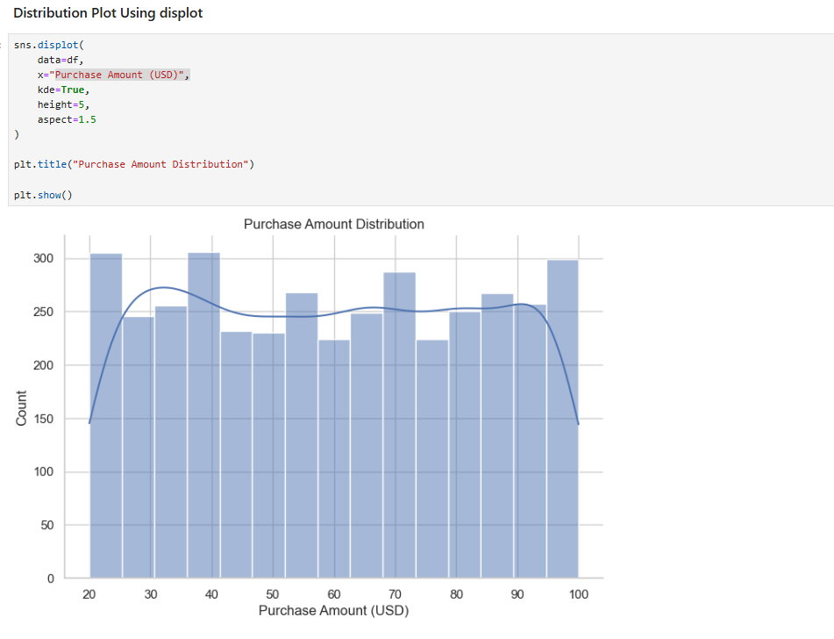
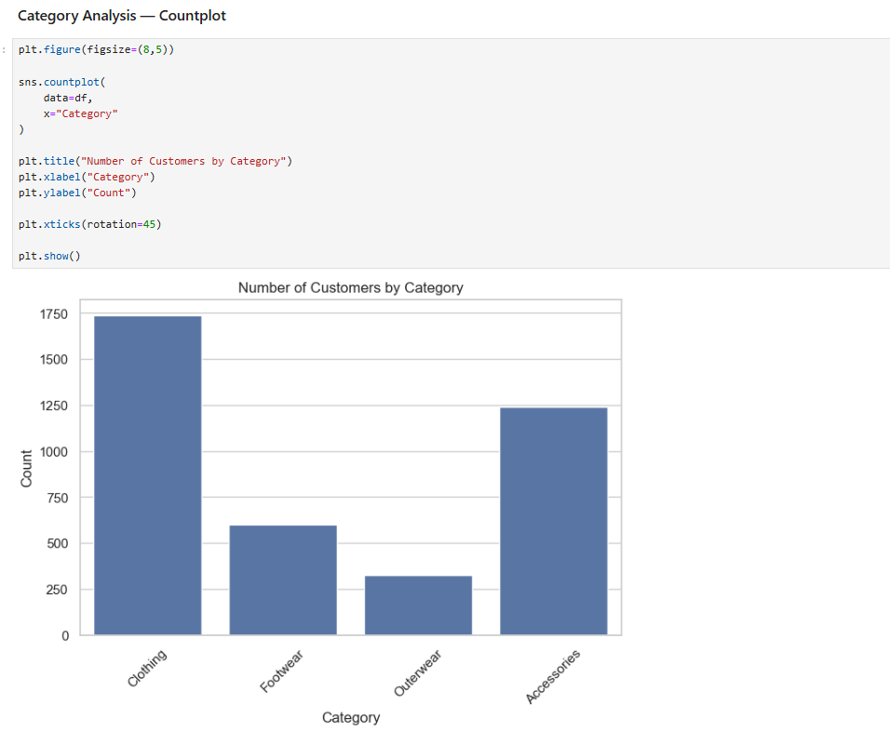
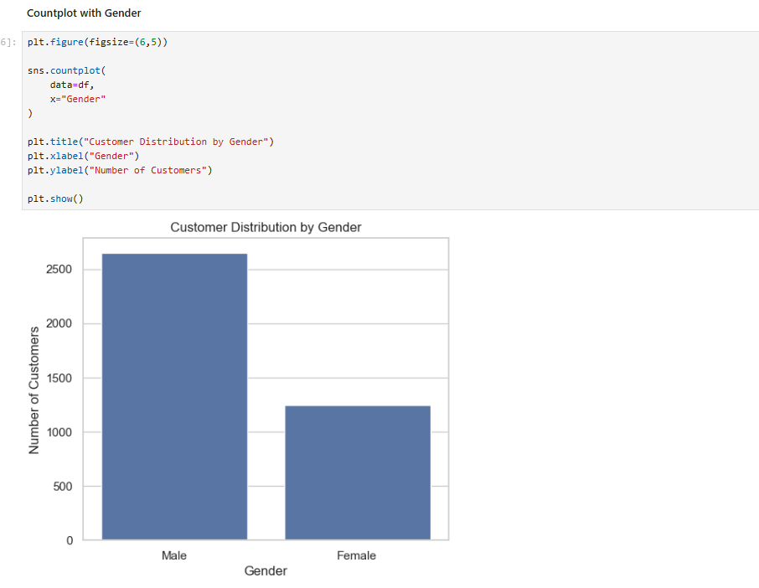

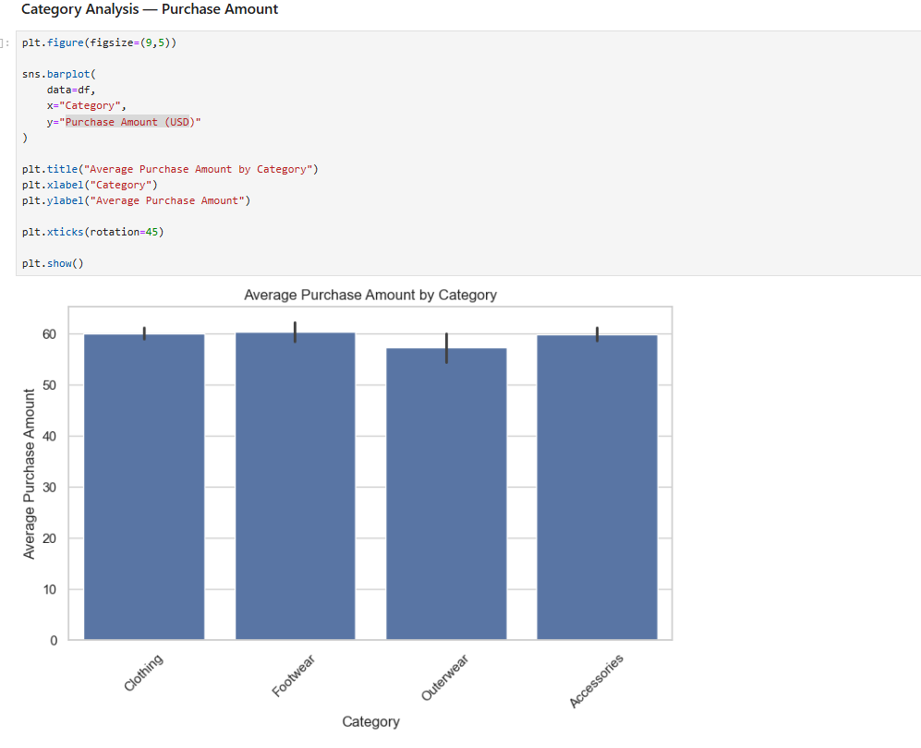
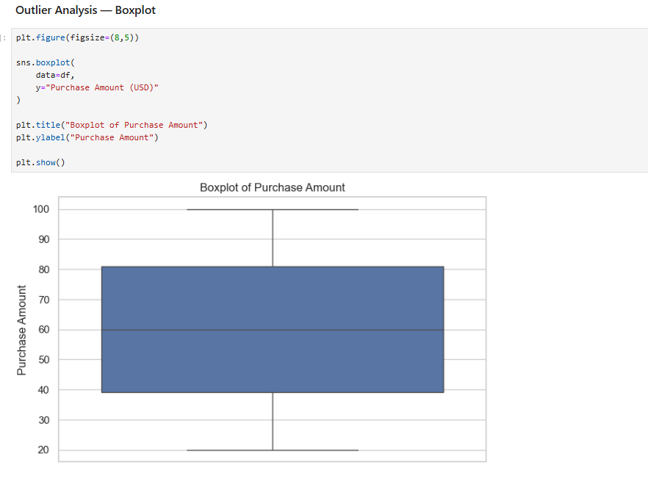
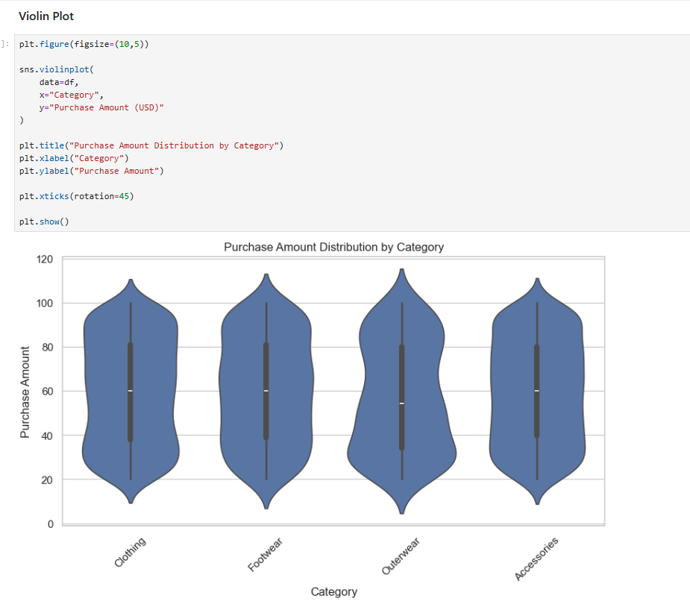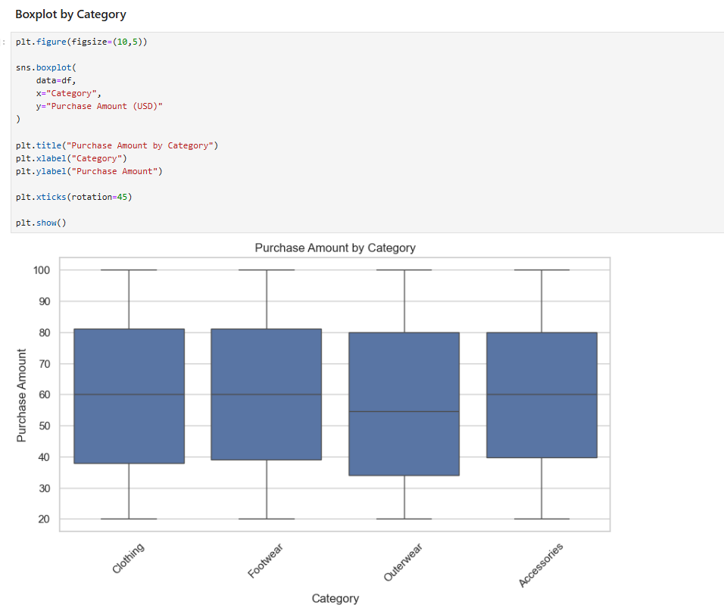
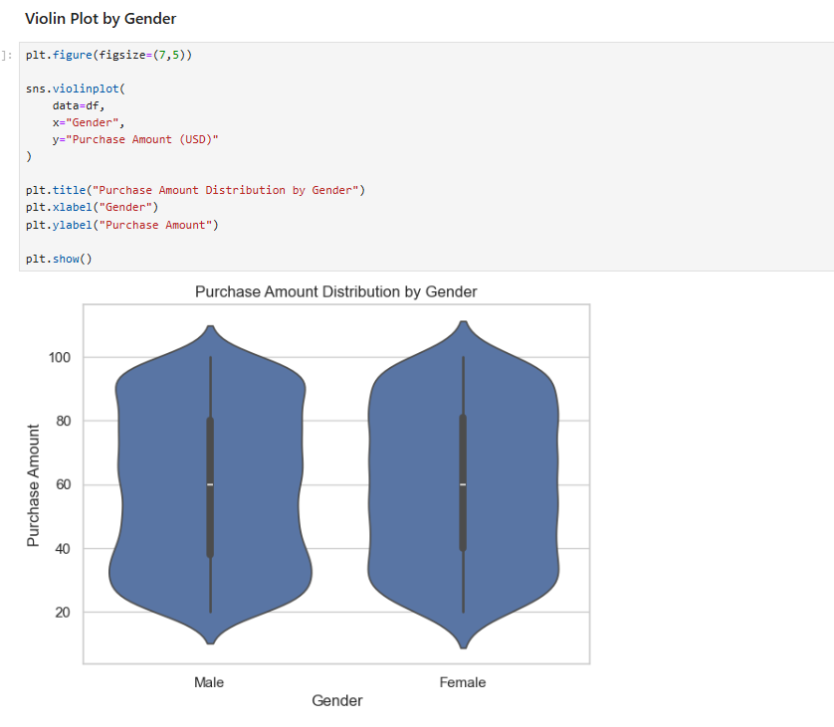

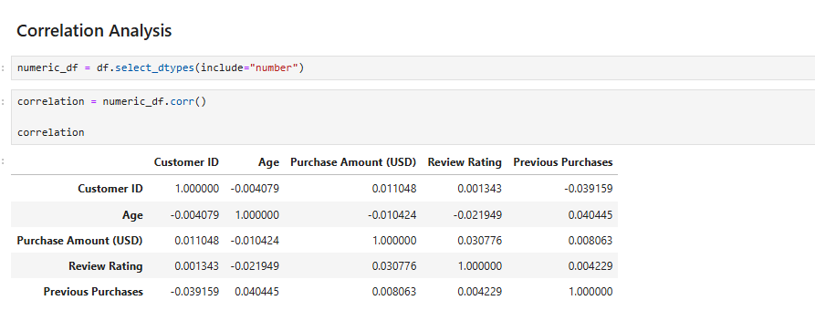

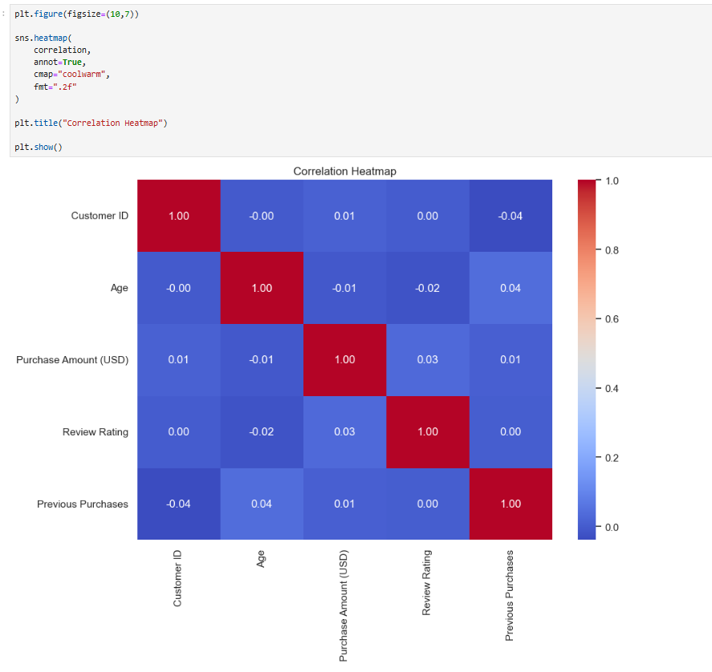

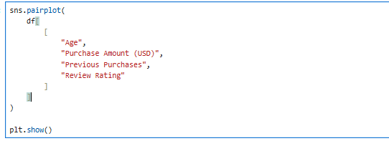

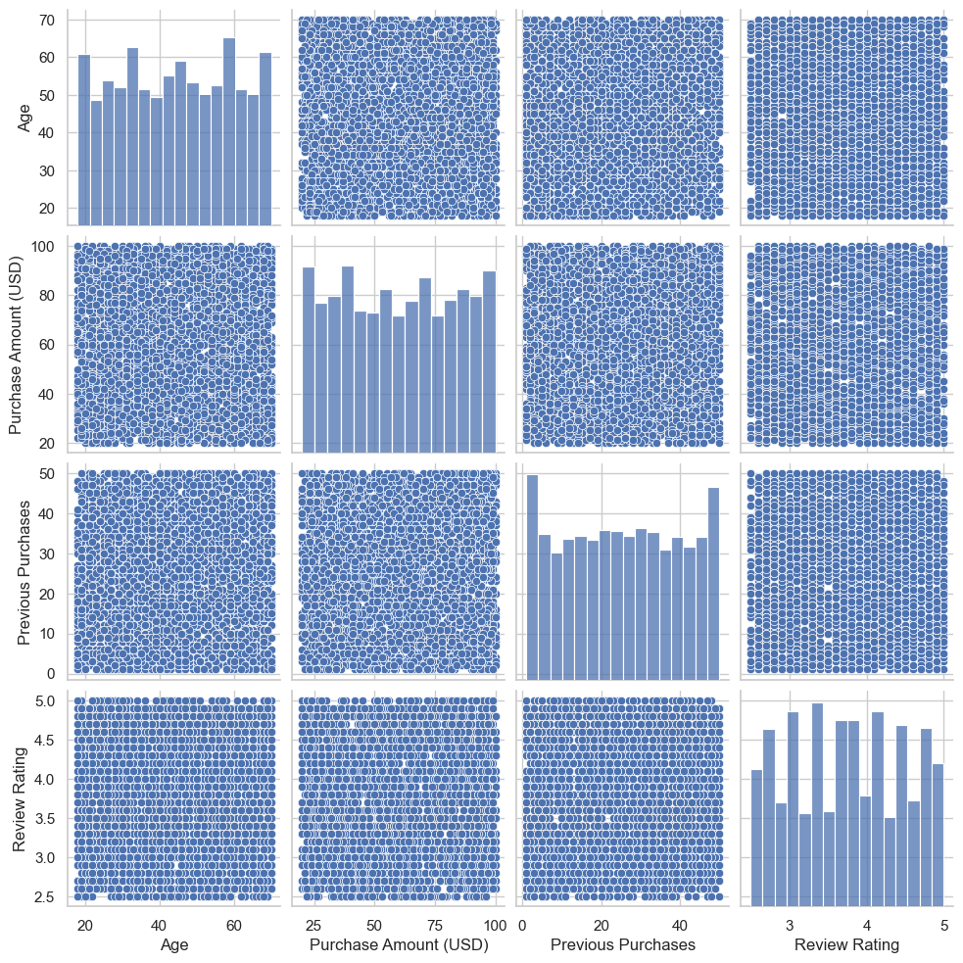

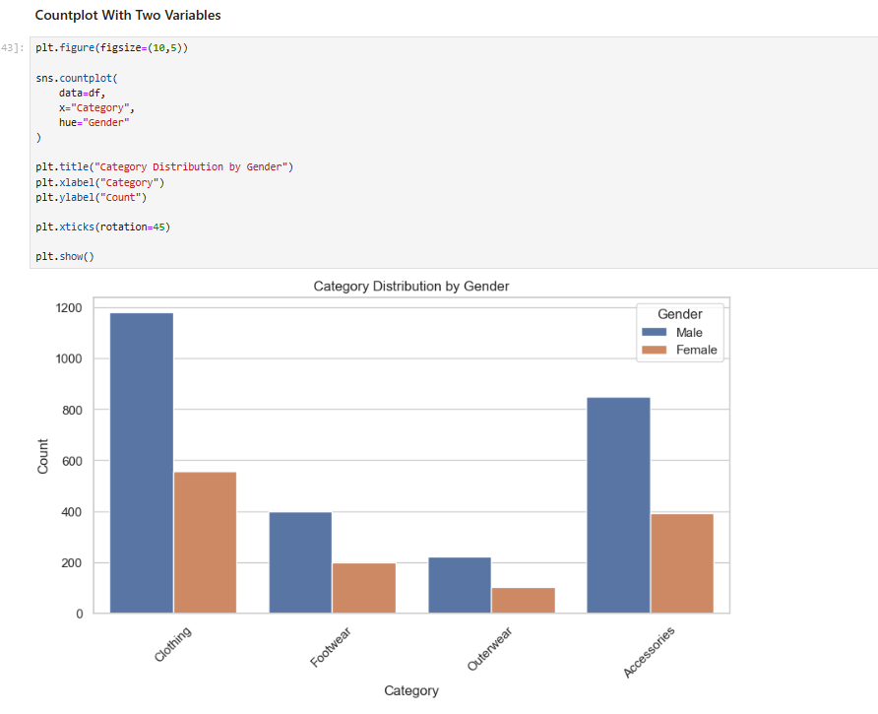
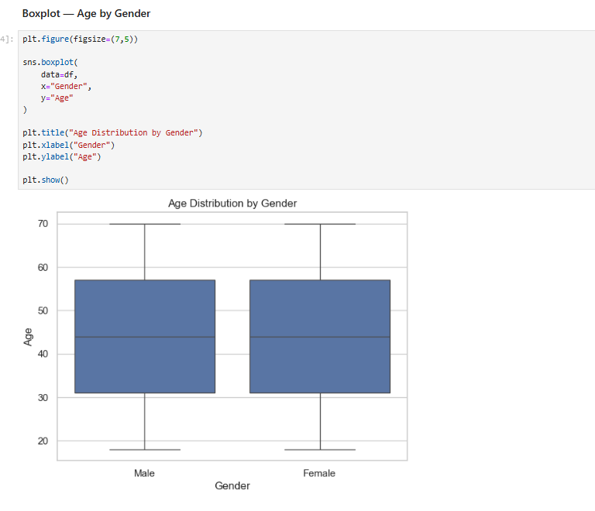
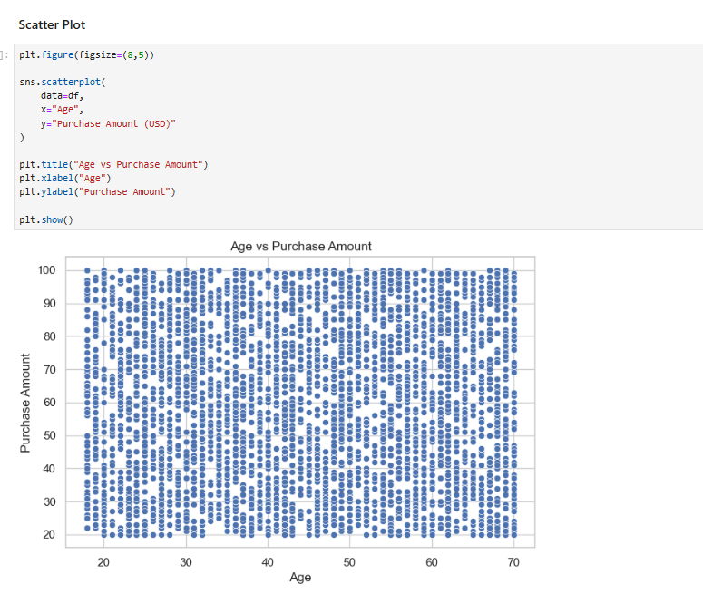
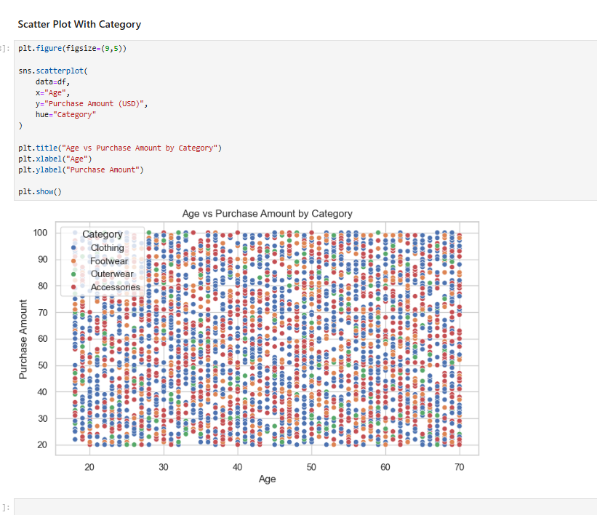

OBSERVATIONS:
1. The distribution plot shows how customer purchase amounts are distributed across the dataset.
2. Most customers belong to the categories with higher frequencies in the countplot.
3. The boxplot shows the median and spread of purchase amounts across different categories.
4. Some observations appear outside the boxplot whiskers, indicating potential outliers.
5. The violin plot shows differences in the distribution and density of purchase amounts between categories.

6. The correlation heatmap shows the strength of relationships between numerical variables.
7. Some numerical variables show positive correlation with each other.
8. The pairplot helps identify relationships and patterns between multiple numerical variables.
9. The scatter plot helps visualize the relationship between customer age and purchase amount.
10. EDA helps identify patterns, outliers, and relationships that should be considered before further analysis or machine learning.

DAY 13 — Power BI
Day :-- Friday , Date :-- 25-09-2026

Task Description
Learn the fundamentals of Microsoft Power BI, including importing data, transforming data using Power Query, setting correct data types, applying filters and slicers, and creating different types of visualizations.
Task Elaboration
- Imported the sales dataset into Power BI.
- Used Power Query to clean and transform the data.
- Set appropriate data types and applied filters.
- Created visuals including Cards, Charts, Table/Matrix, and Slicers.
- Created KPIs for Total Sales, Total Orders, and Total Customers.
- Analyzed Sales by Category, Sales by Region, and Monthly Sales.
- Designed all visuals into a one-page interactive Sales Dashboard.
- Saved the dashboard as a .pbix file and captured a screenshot as proof of completion.

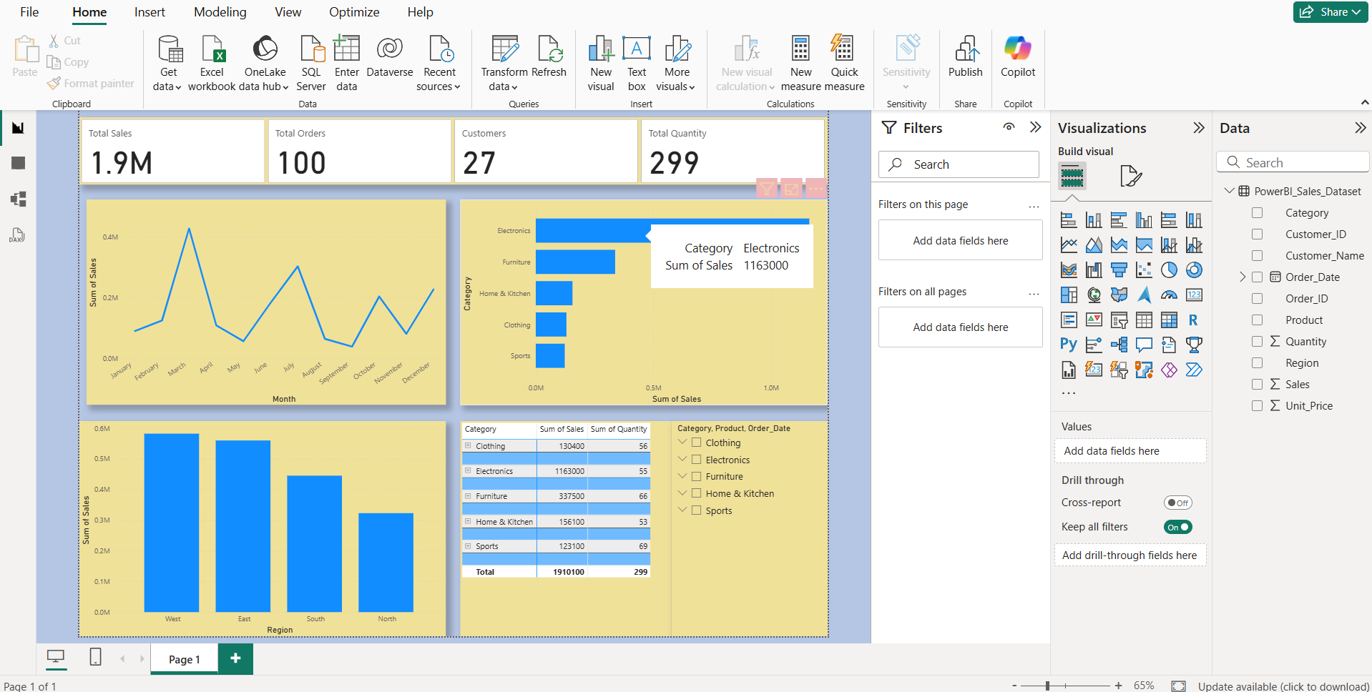

DAY 14 — DAX
Day :-- Friday , Date :-- 25-09-2026
Task Description
Learn the basics of DAX (Data Analysis Expressions) in Power BI and create measures for revenue, profit, orders, customers, and profitability. Also practice important DAX functions used for dynamic calculations.

Task Elaboration
Created measures for Total Revenue, Total Profit, Total Orders, Total Customers, Average Order Value, and Profit Margin. Also practiced DAX functions such as CALCULATE, FILTER, ALL, SUMX, COUNTROWS, and DISTINCTCOUNT to perform dynamic calculations and analyze sales data.

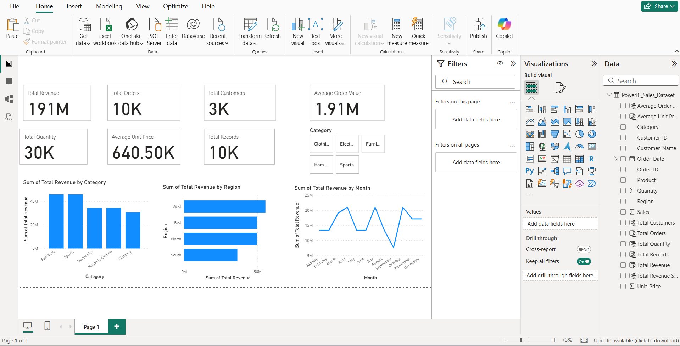

DAY 15 — Git & GitHub
Day :-- Saturday , Date :-- 26-09-2026
Task Description
The objective of this task is to learn the fundamentals of Git and GitHub and understand how they are used for version control, project management, and collaboration. The task involves creating a GitHub repository, organizing internship work, and uploading the completed Days 1–14 tasks to the repository.
Task Elaboration
In this task, I learned the basic concepts and workflow of Git and GitHub. I understood how Git helps track changes in files and how GitHub is used to store and manage projects remotely.
The following concepts were studied and practiced:
- Repository – A project folder managed by Git that contains files and their version history.
- Clone – Copying an existing remote GitHub repository to the local computer.
- Commit – Saving changes to the local Git repository with a meaningful message.
- Push – Uploading committed changes from the local repository to GitHub.
- Pull – Downloading the latest changes from the remote GitHub repository.
- Branch – Creating a separate line of development to work on changes independently.
- Merge – Combining changes from one branch into another branch.
- .gitignore – Specifying files and folders that should not be tracked or uploaded to GitHub.
- README – A documentation file that explains the project, its purpose, structure, and usage.
“https://github.com/tejes123s/Daily-Internship-Tasks.git”
DAY 16 — Machine Learning Fundamentals
Day :-- Saturday , Date :-- 26-09-2026

Task Description
The objective of this task is to understand the fundamental concepts of Artificial Intelligence (AI), Machine Learning (ML), and Deep Learning (DL). The task also focuses on understanding different types of machine learning techniques, including Supervised Learning, Unsupervised Learning, Regression, Classification, and Clustering.

Task Elaboration
I studied the following fundamental concepts:
- AI – Broad field of creating intelligent systems.
- Machine Learning – Systems that learn patterns from data.
- Deep Learning – Machine Learning using neural networks with multiple layers.
- Supervised Learning – Learning from labeled data.
- Unsupervised Learning – Finding patterns in unlabeled data.
- Regression – Predicting continuous numerical values.
- Classification – Predicting categories or classes.
- Clustering – Grouping similar data points.

Real-World Problem Analysis
1. House Price Prediction
Problem: Predict the price of a house.
↓
Type: Supervised Learning → Regression
↓
Features: Area, bedrooms, location, bathrooms, age of house
↓
Target: House Price
↓
Possible Algorithm: Linear Regression, Random Forest Regressor

2. Student Pass/Fail Prediction
Problem: Predict whether a student will pass or fail.
↓
Type: Supervised Learning → Classification
↓
Features: Attendance, study hours, previous marks, assignments
↓
Target: Pass / Fail
↓
Possible Algorithm: Logistic Regression, Decision Tree

3. Customer Segmentation
Problem: Group customers based on their purchasing behavior.
↓
Type: Unsupervised Learning → Clustering
↓
Features: Age, income, purchase frequency, spending amount
↓
Target: No predefined target
↓
Possible Algorithm: K-Means Clustering

4. Email Spam Detection
Problem: Identify whether an email is spam or not.
↓
Type: Supervised Learning → Classification
↓
Features: Email text, word frequency, sender information
↓
Target: Spam / Not Spam
↓
Possible Algorithm: Naive Bayes, Logistic Regression

5. Sales Forecasting
Problem: Predict future product sales.
↓
Type: Supervised Learning → Regression
↓
Features: Previous sales, month, price, promotions
↓
Target: Future Sales
↓
Possible Algorithm: Linear Regression, Random Forest Regressor

6. Customer Churn Prediction
Problem: Predict whether a customer will leave a service.
↓
Type: Supervised Learning → Classification
↓
Features: Usage, tenure, monthly charges, complaints
↓
Target: Churn / No Churn
↓
Possible Algorithm: Logistic Regression, Random Forest

7. Disease Prediction
Problem: Predict whether a patient has a particular disease.
↓
Type: Supervised Learning → Classification
↓
Features: Age, blood pressure, glucose level, BMI
↓
Target: Disease / No Disease
↓
Possible Algorithm: Logistic Regression, Decision Tree

8. Product Recommendation
Problem: Recommend products to customers based on their behavior.
↓
Type: Unsupervised Learning / Recommendation
↓
Features: Purchase history, ratings, browsing history
↓
Target: Recommended Products
↓
Possible Algorithm: K-Means, Collaborative Filtering

9. Credit Risk Prediction
Problem: Predict whether a loan applicant is likely to default.
↓
Type: Supervised Learning → Classification
↓
Features: Income, credit score, loan amount, employment status
↓
Target: Default / No Default
↓
Possible Algorithm: Logistic Regression, Random Forest

10. Employee Salary Prediction
Problem: Predict an employee's salary based on their profile.
↓
Type: Supervised Learning → Regression
↓
Features: Experience, education, job role, skills
↓
Target: Salary
↓
Possible Algorithm: Linear Regression, Random Forest Regressor

