Assignment 1.1

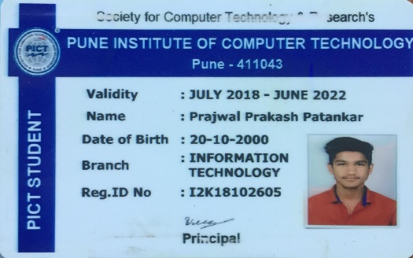

Name : Prajwal Patankar

Roll No. : 33244

Class : TE – 10

Batch : M – 10

Problem Statement :

A website which helps us to choose a motorcycle from the various motorcycles, scooters and imported bikes available in the market .

Screenshots

Home Page

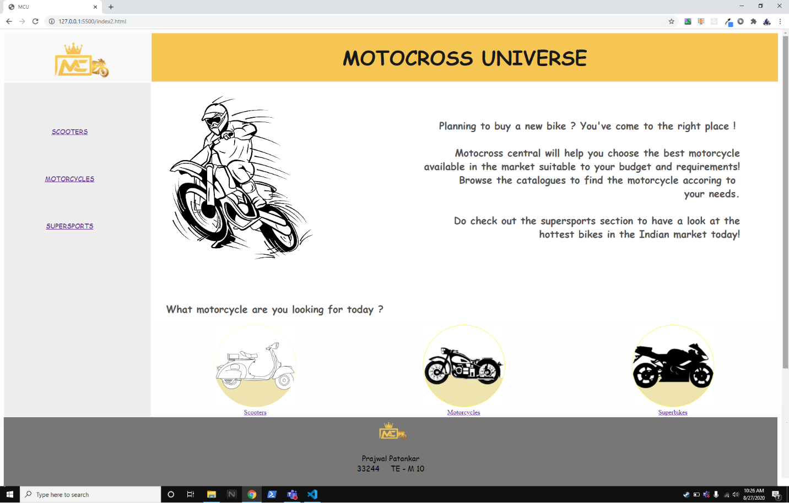

Page 1 ( Scooters Section )

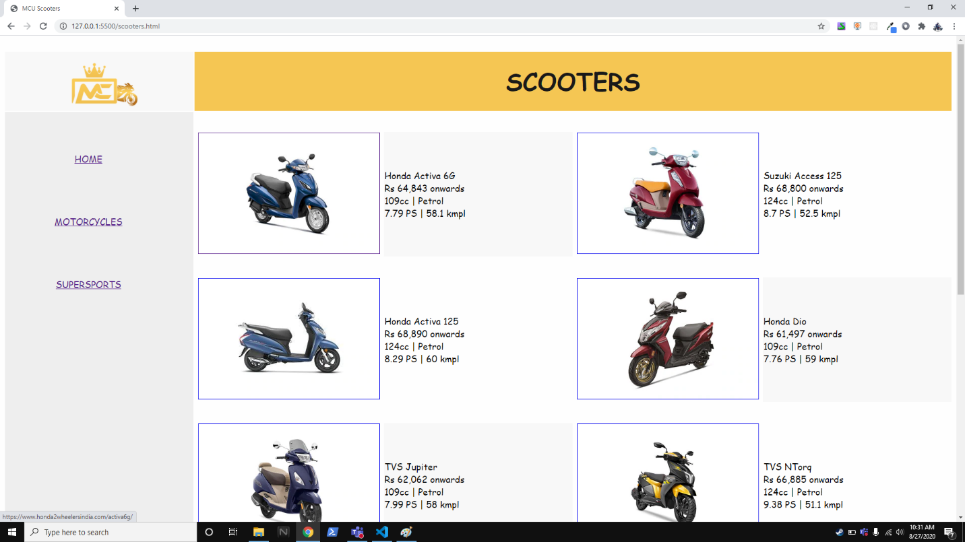

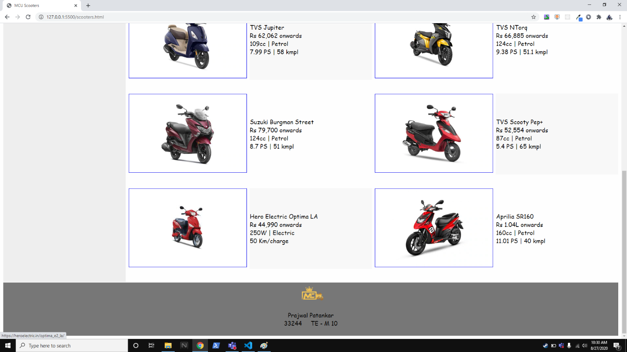

Page 2 ( Motorcycles Section )

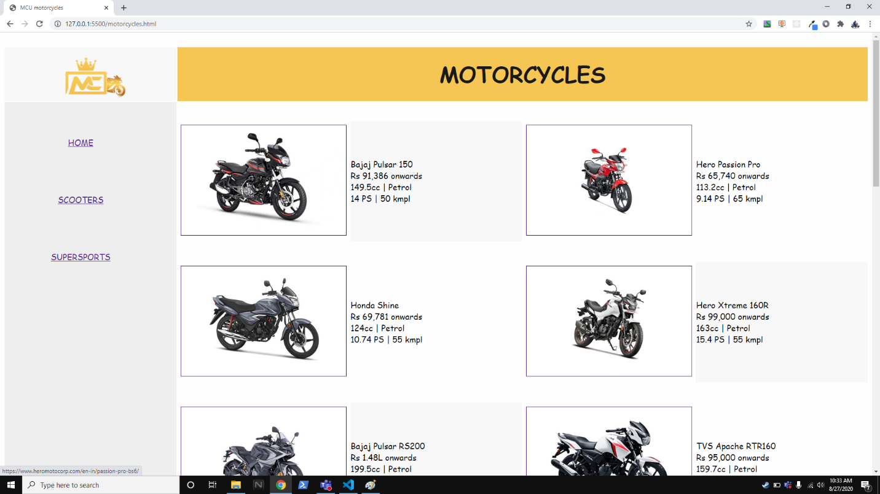

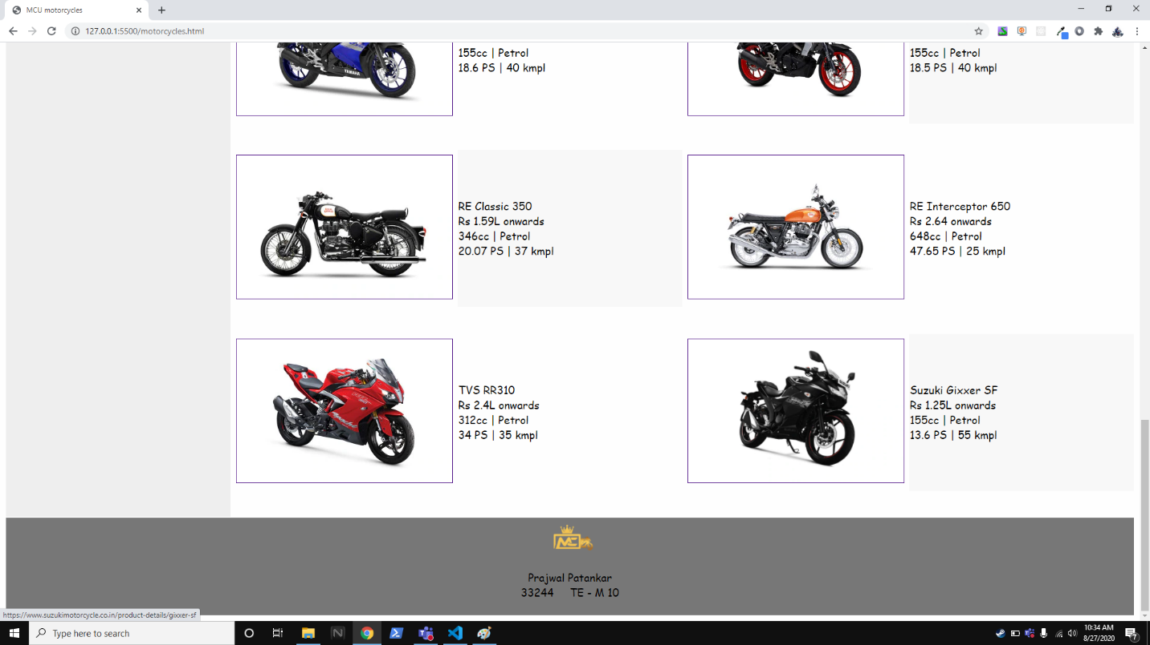

Page 3 ( Superbikes Section )

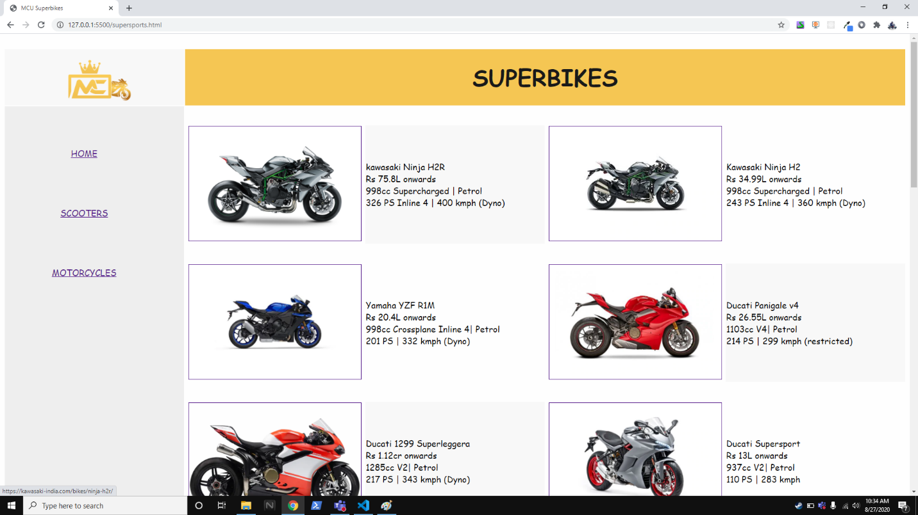

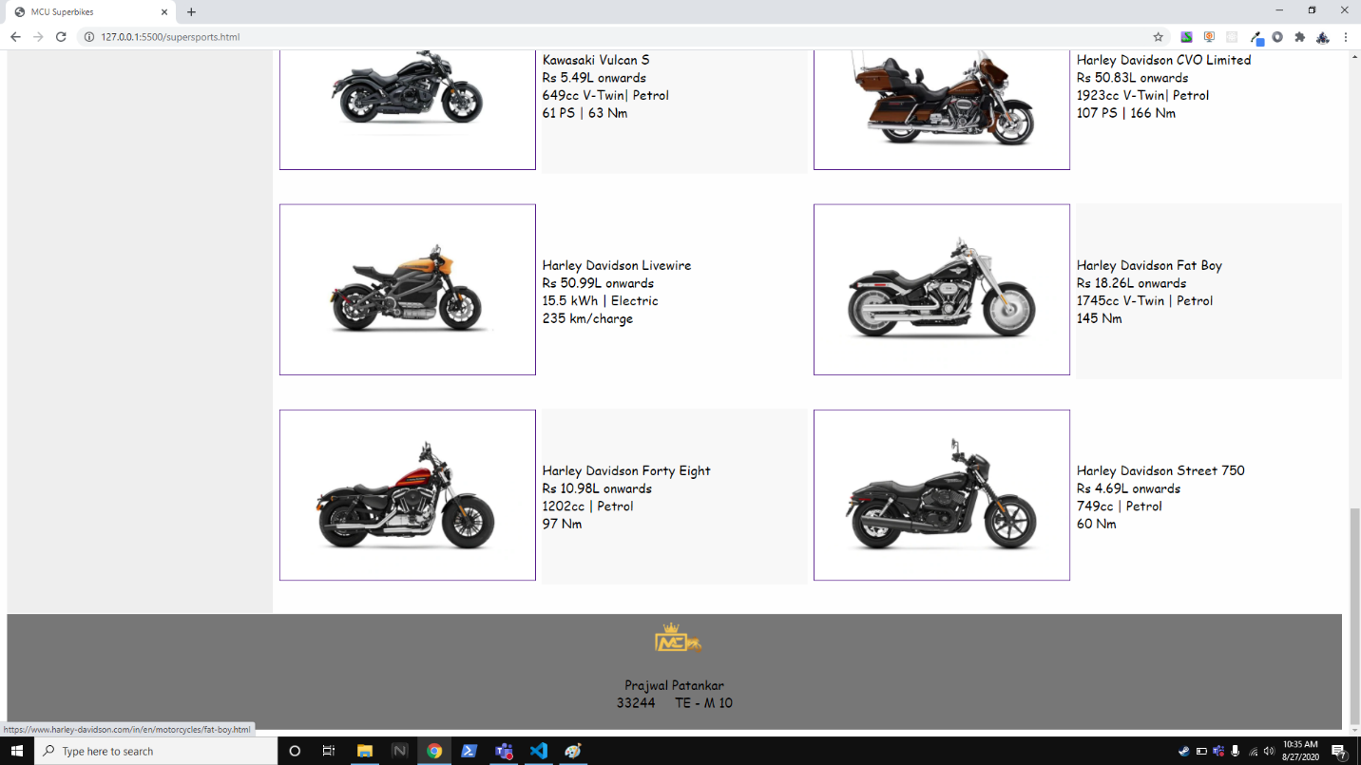

Code

Home Page

<!DOCTYPE html>

<html lang="en">

    <head>

        <meta charset="utf-8">

        <title>

            MCU

        </title>

    </head>

    <body bgcolor=#fefefe>

        <table width=100% border="0px">

            <tr align="center" >

                <td bgcolor="#f8f8f8"><a href="./index2.html"><img src="./img/logo.png" height="112px" width="200px"></a></td>

                <td colspan="4" bgcolor="#f5c653"><h1><font face="cursive" color="#191919" size=7>MOTOCROSS UNIVERSE</font></h1></Motocross></td>

            </tr>

            <tr>

                <td align="center" rowspan="3" bgcolor="#eeeeee">

                    <font face="cursive" color="#a8a8a8" size=3>

                        <br><br><br>

                        <a href="./scooters.html">SCOOTERS</a>&nbsp;&nbsp;&nbsp;&nbsp;&nbsp;&nbsp;&nbsp;&nbsp;<br><br><br><br><br>

                        <a href="./motorcycles.html">MOTORCYCLES</a>&nbsp;&nbsp;&nbsp;&nbsp;&nbsp;&nbsp;&nbsp;&nbsp;<br><br><br><br><br>

                        <a href="./supersports.html">SUPERSPORTS</a>&nbsp;&nbsp;&nbsp;&nbsp;&nbsp;&nbsp;&nbsp;&nbsp;

                        <br><br><br><br><br><br><br><br><br><br><br><br><br><br><br><br><br><br><br>

                    </font>

            </tr>

            <tr>

                <td colspan="4" style="background-image: url(./img/bgimg.png);">

                    <h3 align="right">

                        <font face="cursive" color="#505050" size=5>

                            <br><br>

                            Planning to buy a new bike ? You've come to the right place ! &nbsp;&nbsp;&nbsp;&nbsp;&nbsp;&nbsp;&nbsp;&nbsp;<br><br>

                            Motocross central will help you choose the best motorcycle&nbsp;&nbsp;&nbsp;&nbsp;&nbsp;&nbsp;&nbsp;&nbsp;<br>

                            available in the market suitable to your budget and requirements!&nbsp;&nbsp;&nbsp;&nbsp;&nbsp;&nbsp;&nbsp;&nbsp;<br>

                            Browse the catalogues to find the motorcycle accoring to &nbsp;&nbsp;&nbsp;&nbsp;&nbsp;&nbsp;&nbsp;&nbsp;<br>

                            your needs.&nbsp;&nbsp;&nbsp;&nbsp;&nbsp;&nbsp;&nbsp;&nbsp;<br><br>

                            Do check out the supersports section to have a look at the&nbsp;&nbsp;&nbsp;&nbsp;&nbsp;&nbsp;&nbsp;&nbsp;<br>

                            hottest bikes in the Indian market today!&nbsp;&nbsp;&nbsp;&nbsp;&nbsp;&nbsp;&nbsp;&nbsp;<br><br><br><br>

                        </font>

                    </h3>

                    <h3 align="left">

                        <font face="cursive" color="#505050" size=5>

                            <br>&nbsp;&nbsp;&nbsp;What motorcycle are you looking for today ?

                        </font>

                    </h3>

                </td>

            </tr>

            <tr align="center">

                <td>

                    <a href="./scooters.html"><img src="./img/scootcir.png" width="200px" height="200px"><br> Scooters </a>

                </td>

                <td>

                    <a href="./motorcycles.html"><img src="./img/motcir.png" width="200px" height="200px"><br> Motorcycles </a>

                </td>

                <td>

                    <a href="./supersports.html"><img src="./img/supcir.png" width="200px" height="200px"><br> Superbikes </a>

                </td>

            </tr>

            <!--Footer-->

            <tr bgcolor="#777777">

                <td colspan="5" align="center">

                    <font face="cursive" size=4>

                        <a><img src="./img/logo.png" width="100px" height="56px"></a>

                        <br><br>Prajwal Patankar<br>33244 &nbsp;&nbsp;&nbsp; TE - M 10<br><br>

                    </font>

                </td>

            </tr>

        </table>

    </body>

</html>

Page 1 (Scooters)

<!DOCTYPE html>

<html lang="en">

    <head>

        <meta charset="utf-8">

        <title>

            MCU Scooters

        </title>

    </head>

    <body bgcolor=#fefefe>

        <table width=100% border="0px">

            <tr>

                <td width=20%>&nbsp;</td>

                <td width=20%>&nbsp;</td>

                <td width=20%>&nbsp;</td>

                <td width=20%>&nbsp;</td>

                <td width=20%>&nbsp;</td>

            </tr>

            <tr align="center" >

                <td bgcolor="#f8f8f8"><a href="/index2.html"><img src="./img/logo.png" height="112px" width="200px"></a></td>

                <td colspan="4" bgcolor="#f5c653"><h1><font face="cursive" color="#191919" size=7>SCOOTERS</font></h1></Motocross></td>

            </tr>

            <tr>

                <td align="center" rowspan="11" bgcolor="#eeeeee">  <!--need to edit before adding rows-->

                    <font face="cursive" color="#a8a8a8" size=4>

                        <br><br><br>

                        <a href="/index2.html">HOME</a>&nbsp;&nbsp;&nbsp;&nbsp;&nbsp;&nbsp;&nbsp;&nbsp;<br><br><br><br><br>

                        <a href="/motorcycles.html">MOTORCYCLES</a>&nbsp;&nbsp;&nbsp;&nbsp;&nbsp;&nbsp;&nbsp;&nbsp;<br><br><br><br><br>

                        <a href="/supersports.html">SUPERSPORTS</a>&nbsp;&nbsp;&nbsp;&nbsp;&nbsp;&nbsp;&nbsp;&nbsp;

                        <br><br><br><br><br><br><br><br><br><br><br><br><br><br><br><br><br><br><br><br><br><br><br><br><br><br><br><br><br><br><br><br><br><br><br><br><br><br><br><br><br><br><br><br><br><br>

                </font>

                </td>

                <td colspan="4"><br><br></td>

            </tr>

            <tr>

                </td>

                <td align="center" >

                    <a href="https://www.honda2wheelersindia.com/activa6g/"><img src="/imgscoot/honda-activa-6g_360x240.webp" height="240px" width="360px" border="1px"></a>

                </td>

                <td align="left" bgcolor=#f8f8f8>

                    <font face="cursive" size=4>

                    Honda Activa 6G<br>Rs 64,843 onwards<br>109cc | Petrol<br>7.79 PS | 58.1 kmpl

                    </font>

                </td>

                <td align="center" >

                    <a href="https://www.suzukimotorcycle.co.in/product-details/all-new-access-125"><img src="/imgscoot/bs6-suzuki-access-125-right-side-view_360x240.webp" height="240px" width="360px" border="1px"></a>

                </td>

                <td align="left">

                    <font face="cursive" size=4>

                    Suzuki Access 125<br>Rs 68,800 onwards<br>124cc | Petrol<br>8.7 PS | 52.5 kmpl

                    </font>

                </td>

            </tr>

            <tr>

                <td colspan="4"><br><br></td>

            </tr>

            <tr>

                <td align="center" >

                    <a href="https://www.honda2wheelersindia.com/activa125-BS-VI/"><img src="./imgscoot/2019-activa-125-right-side-view_360x240.webp" height="240px" width="360px" border="1px"></a>

                </td>

                <td align="left">

                    <font face="cursive" size=4>

                    Honda Activa 125<br>Rs 68,890 onwards<br>124cc | Petrol<br>8.29 PS | 60 kmpl

                    </font>

                </td>

                <td align="center" >

                    <a href="https://www.honda2wheelersindia.com/dio-BS-VI/"><img src="./imgscoot/honda-dio_360x240.webp" height="240px" width="360px" border="1px"></a>

                </td>

                <td align="left" bgcolor=#f8f8f8>

                    <font face="cursive" size=4>

                    Honda Dio<br>Rs 61,497 onwards<br>109cc | Petrol<br>7.76 PS | 59 kmpl

                    </font>

                </td>

            </tr>

            <tr>

                <td colspan="4"><br><br></td>

            </tr>

            <tr>

                <td align="center" >

                    <a href="https://www.tvsjupiter.com/"><img src="./imgscoot/jupiter_360x240.webp" height="240px" width="360px" border="1px"></a>

                </td>

                <td align="left" bgcolor=#f8f8f8>

                    <font face="cursive" size=4>

                    TVS Jupiter<br>Rs 62,062  onwards<br>109cc | Petrol<br>7.99 PS | 58 kmpl

                    </font>

                </td>

                <td align="center" >

                    <a href="https://www.tvsmotor.com/ntorq/"><img src="./imgscoot/tvs-ntorq-125a-right-side-view_360x240.webp" height="240px" width="360px" border="1px"></a>

                </td>

                <td align="left">

                    <font face="cursive" size=4>

                    TVS NTorq<br>Rs 66,885 onwards<br>124cc | Petrol<br>9.38 PS | 51.1 kmpl

                    </font>

                </td>

            </tr>

            <tr>

                <td colspan="4"><br><br></td>

            </tr>

            <tr>

                <td align="center" >

                    <a href="https://www.suzukimotorcycle.co.in/product-details/burgman-street"><img src="/imgscoot/right-side-burgman_360x240.webp" height="240px" width="360px" border="1px"></a>

                </td>

                <td align="left" >

                    <font face="cursive" size=4>

                    Suzuki Burgman Street<br>Rs 79,700  onwards<br>124cc | Petrol<br>8.7 PS | 51 kmpl

                    </font>

                </td>

                <td align="center">

                    <a href="https://www.tvsscooty.com/Scooty-Pep-Plus/"><img src="/imgscoot/tvs-scoot-pep-plus-bs6-right-side-view_360x240.webp" height="240px" width="360px" border="1px"></a>

                </td>

                <td align="left" bgcolor=#f8f8f8>

                    <font face="cursive" size=4>

                    TVS Scooty Pep+<br>Rs 52,554 onwards<br>87cc | Petrol<br>5.4 PS | 65 kmpl

                    </font>

                </td>

            </tr>

            <tr>

                <td colspan="4"><br><br></td>

            </tr>

            <tr>

                <td align="center" >

                    <a href="https://heroelectric.in/optima_e2_la/"><img src="/imgscoot/hero-electric-optima-la-right-side-view_360x240.webp" height="240px" width="360px" border="1px"></a>

                </td>

                <td align="left" bgcolor=#f8f8f8>

                    <font face="cursive" size=4>

                    Hero Electric Optima LA<br>Rs 44,990  onwards<br>250W | Electric<br>50 Km/charge

                    </font>

                </td>

                <td align="center" >

                    <a href="https://www.aprilia.com/in_EN/models/scooters/sr/SR-160/"><img src="/imgscoot/aprilia_360x240.webp" height="240px" width="360px" border="1px"></a>

                </td>

                <td align="left">

                    <font face="cursive" size=4>

                    Aprilia SR160<br>Rs 1.04L onwards<br>160cc | Petrol<br>11.01 PS | 40 kmpl

                    </font>

                </td>

            </tr>

            <tr>

                <td colspan="4"><br><br></td>

            </tr>

            <!--Footer-->

            <tr bgcolor="#777777">

                <td colspan="5" align="center">

                    <font face="cursive" size=4>

                        <a><img src="./img/logo.png" width="100px" height="56px"></a>

                        <br><br>Prajwal Patankar<br>33244 &nbsp;&nbsp;&nbsp; TE - M 10<br><br>

                    </font>

                </td>

            </tr>

        </table>

    </body>

</html>

Page 2 (Motorcycles)

<!DOCTYPE html>

<html lang="en">

    <head>

        <meta charset="utf-8">

        <title>

            MCU motorcycles

        </title>

    </head>

    <body bgcolor=#fefefe>

        <table width=100% border="0px">

            <tr>

                <td width=20%>&nbsp;</td>

                <td width=20%>&nbsp;</td>

                <td width=20%>&nbsp;</td>

                <td width=20%>&nbsp;</td>

                <td width=20%>&nbsp;</td>

            </tr>

            <tr align="center" >

                <td bgcolor="#f8f8f8"><a href="/index2.html"><img src="./img/logo.png" height="112px" width="200px"></a></td>

                <td colspan="4" bgcolor="#f5c653"><h1><font face="cursive" color="#191919" size=7>MOTORCYCLES</font></h1></Motocross></td>

            </tr>

            <tr>

                <td align="center" rowspan="17" bgcolor="#eeeeee">   <!--need to edit before adding rows-->

                    <font face="cursive" color="#a8a8a8" size=4>

                        <br><br><br>

                        <a href="/index2.html">HOME</a>&nbsp;&nbsp;&nbsp;&nbsp;&nbsp;&nbsp;&nbsp;&nbsp;<br><br><br><br><br>

                        <a href="/scooters.html">SCOOTERS</a>&nbsp;&nbsp;&nbsp;&nbsp;&nbsp;&nbsp;&nbsp;&nbsp;<br><br><br><br><br>

                        <a href="/supersports.html">SUPERSPORTS</a>&nbsp;&nbsp;&nbsp;&nbsp;&nbsp;&nbsp;&nbsp;&nbsp;

                        <br><br><br><br><br><br><br><br><br><br><br><br><br><br><br><br><br><br><br><br><br><br><br><br><br><br><br><br><br><br><br><br><br><br><br><br><br><br><br><br><br><br><br><br><br><br><br><br><br><br><br><br><br><br><br><br><br><br><br><br><br><br><br><br><br><br><br><br><br><br><br><br><br><br><br><br><br><br><br><br><br><br><br><br><br><br><br>

                </font>

                </td>

                <td colspan="4"><br><br></td>

            </tr>

            <tr>

                <td align="center" >

                    <a href="https://www.bajajauto.com/motor-bikes/pulsar-150-dtsi"><img src="./imgmot/bajaj-pulsar-150_360x240.webp" height="240px" width="360px" border="1px"></a>

                </td>

                <td align="left" bgcolor=#f8f8f8>

                    <font face="cursive" size=4>

                    Bajaj Pulsar 150<br>Rs 91,386 onwards<br>149.5cc | Petrol<br>14 PS | 50 kmpl

                    </font>

                </td>

                <td align="center" >

                    <a href="https://www.heromotocorp.com/en-in/passion-pro-bs6/"><img src="./imgmot/passion-pro-right-side-view_360x240.webp" height="240px" width="360px" border="1px"></a>

                </td>

                <td align="left">

                    <font face="cursive" size=4>

                    Hero Passion Pro<br>Rs 65,740 onwards<br>113.2cc | Petrol<br>9.14 PS | 65 kmpl

                    </font>

                </td>

            </tr>

            <tr>

                <td colspan="4"><br><br></td>

            </tr>

            <tr>

                </td>

                <td align="center" >

                    <a href="https://honda2wheelersindia.com/shine-BS-VI/"><img src="./imgmot/shine_360x240.webp" height="240px" width="360px" border="1px"></a>

                </td>

                <td align="left" >

                    <font face="cursive" size=4>

                    Honda Shine<br>Rs 69,781 onwards<br>124cc | Petrol<br>10.74 PS | 55 kmpl

                    </font>

                </td>

                <td align="center" >

                    <a href="https://www.heromotocorp.com/en-in/xtreme160r/"><img src="./imgmot/hero-xtream-160r-right-side-view_360x240.webp" height="240px" width="360px" border="1px"></a>

                </td>

                <td align="left" bgcolor=#f8f8f8>

                    <font face="cursive" size=4>

                    Hero Xtreme 160R<br>Rs 99,000 onwards<br>163cc | Petrol<br>15.4 PS | 55 kmpl

                    </font>

                </td>

            </tr>

            <tr>

                <td colspan="4"><br><br></td>

            </tr>

            <tr>

                </td>

                <td align="center" >

                    <a href="https://www.bajajauto.com/motor-bikes/pulsar-rs200"><img src="./imgmot/bajaj-pulsar-rs-200-a-right-side-view_360x240.webp" height="240px" width="360px" border="1px"></a>

                </td>

                <td align="left" bgcolor=#f8f8f8>

                    <font face="cursive" size=4>

                    Bajaj Pulsar RS200<br>Rs 1.48L onwards<br>199.5cc | Petrol<br>24.5 PS | 38 kmpl

                    </font>

                </td>

                <td align="center" >

                    <a href="https://www.tvsapache.com/rtr-160-bs6.aspx"><img src="./imgmot/rtr-160-bs6_360x240.webp" height="240px" width="360px" border="1px"></a>

                </td>

                <td align="left">

                    <font face="cursive" size=4>

                    TVS Apache RTR160<br>Rs 95,000 onwards<br>159.7cc | Petrol<br>15.53 PS | 50 kmpl

                    </font>

                </td>

            </tr>

            <tr>

                <td colspan="4"><br><br></td>

            </tr>

            <tr>

                </td>

                <td align="center" >

                    <a href="https://www.ktm.com/en-in/models/supersport/ktm-rc-200-2020.html"><img src="./imgmot/ktm-rc-200-right-side-view_360x240.webp" height="240px" width="360px" border="1px"></a>

                </td>

                <td align="left" >

                    <font face="cursive" size=4>

                    KTM RC200<br>Rs 2L onwards<br>199.5cc | Petrol<br>25 PS | 35 kmpl

                    </font>

                </td>

                <td align="center" >

                    <a href="https://www.ktm.com/en-in/models/supersport/ktm-rc-390-2020.html"><img src="./imgmot/ktm-rc-390-bs6-right-side-view_360x240.webp" height="240px" width="360px" border="1px"></a>

                </td>

                <td align="left" bgcolor=#f8f8f8>

                    <font face="cursive" size=4>

                    KTM RC 390<br>Rs 2.53L onwards<br>373.2cc | Petrol<br> PS | 29 kmpl

                    </font>

                </td>

            </tr>

            <tr>

                <td colspan="4"><br><br></td>

            </tr>

            <tr>

                </td>

                <td align="center" >

                    <a href="https://www.ktm.com/en-in/models/naked-bike/ktm-200-duke-2020.html"><img src="./imgmot/ktm-200-duke-bs6-right-side-view_360x240.webp" height="240px" width="360px" border="1px"></a>

                </td>

                <td align="left" bgcolor=#f8f8f8>

                    <font face="cursive" size=4>

                    KTM Duke 200<br>Rs 1.76 onwards<br>199.5cc | Petrol<br>25 PS | 35 kmpl

                    </font>

                </td>

                <td align="center" >

                    <a href="https://www.ktm.com/en-us/models/naked-bike/ktm-390-duke-2020.html"><img src="./imgmot/ktm-390-duke-bs6-right-side-view_360x240.webp" height="240px" width="360px" border="1px"></a>

                </td>

                <td align="left">

                    <font face="cursive" size=4>

                    KTM Duke 390<br>Rs 2.57L onwards<br>373.2cc | Petrol<br>43.5 PS | 29 kmpl

                    </font>

                </td>

                            <tr>

                <td colspan="4"><br><br></td>

            </tr>

            <tr>

                </td>

                <td align="center" >

                    <a href="https://www.yamaha-motor-india.com/yamaha-yzf-r15-v3.html"><img src="./imgmot/yamaha-yzf-r15-v3-right-side-view_360x240.webp" height="240px" width="360px" border="1px"></a>

                </td>

                <td align="left" >

                    <font face="cursive" size=4>

                    Yamaha YZF-R15 v3<br>Rs 1.47L onwards<br>155cc | Petrol<br>18.6 PS | 40 kmpl

                    </font>

                </td>

                <td align="center" >

                    <a href="https://www.yamaha-motor-india.com/yamaha-mt-15.html"><img src="./imgmot/mt-15-bs6_360x240.webp" height="240px" width="360px" border="1px"></a>

                </td>

                <td align="left" bgcolor=#f8f8f8>

                    <font face="cursive" size=4>

                    Yamaha MT-15<br>Rs 1.38L onwards<br>155cc | Petrol<br>18.5 PS | 40 kmpl

                    </font>

                </td>

            </tr>

            <tr>

                <td colspan="4"><br><br></td>

            </tr>

            <tr>

                </td>

                <td align="center" >

                    <a href="https://www.royalenfield.com/in/en/motorcycles/classic-models/classic-350/dual-channel/"><img src="./imgmot/royal-enfield-classic-350_360x240.webp" height="240px" width="360px" border="1px"></a>

                </td>

                <td align="left" bgcolor=#f8f8f8>

                    <font face="cursive" size=4>

                    RE Classic 350<br>Rs 1.59L onwards<br>346cc | Petrol<br>20.07 PS | 37 kmpl

                    </font>

                </td>

                <td align="center" >

                    <a href="https://www.royalenfield.com/in/en/motorcycles/interceptor/"><img src="./imgmot/re-interceptor-650_360x240.webp" height="240px" width="360px" border="1px"></a>

                </td>

                <td align="left">

                    <font face="cursive" size=4>

                    RE Interceptor 650<br>Rs 2.64 onwards<br>648cc | Petrol<br>47.65 PS | 25 kmpl

                    </font>

                </td>

            </tr>

            <tr>

                <td colspan="4"><br><br></td>

            </tr>

            <tr>

                </td>

                <td align="center" >

                    <a href="https://www.tvsapache.com/rr310/"><img src="./imgmot/rr-310_360x240.webp" height="240px" width="360px" border="1px"></a>

                </td>

                <td align="left" >

                    <font face="cursive" size=4>

                    TVS RR310<br>Rs 2.4L onwards<br>312cc | Petrol<br>34 PS | 35 kmpl

                    </font>

                </td>

                <td align="center" >

                    <a href="https://www.suzukimotorcycle.co.in/product-details/gixxer-sf"><img src="./imgmot/suzuki-gixxer-sf_600x400.webp" height="240px" width="360px" border="1px"></a>

                </td>

                <td align="left" bgcolor=#f8f8f8>

                    <font face="cursive" size=4>

                    Suzuki Gixxer SF<br>Rs 1.25L onwards<br>155cc | Petrol<br>13.6 PS | 55 kmpl

                    </font>

                </td>

            </tr>

            <tr>

                <td colspan="4"><br><br></td>

            </tr>

            <!--Footer-->

            <tr bgcolor="#777777">

                <td colspan="5" align="center">

                    <font face="cursive" size=4>

                        <a><img src="./img/logo.png" width="100px" height="56px"></a>

                        <br><br>Prajwal Patankar<br>33244 &nbsp;&nbsp;&nbsp; TE - M 10<br><br>

                    </font>

                </td>

            </tr>

        </table>

    </body>

</html>

Page 3 (Superbikes)

<!DOCTYPE html>

<html lang="en">

    <head>

        <meta charset="utf-8">

        <title>

            MCU Superbikes

        </title>

    </head>

    <body bgcolor=#fefefe>

        <table width=100% border="0px">

            <tr>

                <td width=20%>&nbsp;</td>

                <td width=20%>&nbsp;</td>

                <td width=20%>&nbsp;</td>

                <td width=20%>&nbsp;</td>

                <td width=20%>&nbsp;</td>

            </tr>

            <tr align="center" >

                <td bgcolor="#f8f8f8"><a href="./index2.html"><img src="./img/logo.png" height="112px" width="200px"></a></td>

                <td colspan="4" bgcolor="#f5c653"><h1><font face="cursive" color="#191919" size=7>SUPERBIKES</font></h1></Motocross></td>

            </tr>

            <tr>

                <td align="center" rowspan="19" bgcolor="#eeeeee">      <!--need to edit before adding rows-->

                    <font face="cursive" color="#a8a8a8" size=4>

                        <br><br><br>

                        <a href="./index2.html">HOME</a>&nbsp;&nbsp;&nbsp;&nbsp;&nbsp;&nbsp;&nbsp;&nbsp;<br><br><br><br><br>

                        <a href="./scooters.html">SCOOTERS</a>&nbsp;&nbsp;&nbsp;&nbsp;&nbsp;&nbsp;&nbsp;&nbsp;<br><br><br><br><br>

                        <a href="./motorcycles.html">MOTORCYCLES</a>&nbsp;&nbsp;&nbsp;&nbsp;&nbsp;&nbsp;&nbsp;&nbsp;

                        <br><br><br><br><br><br><br><br><br><br><br><br><br><br><br><br><br><br><br><br><br><br><br><br><br><br><br><br><br><br><br><br><br><br><br><br><br><br><br><br><br><br><br><br><br><br><br><br><br><br><br><br><br><br><br><br><br><br><br><br><br><br><br><br><br><br><br><br><br><br><br><br><br><br><br><br><br><br><br><br><br><br><br><br><br><br><br><br><br><br><br><br>

                </font>

                </td>

                <td colspan="4"><br><br></td>

            </tr>

            <tr>

                <td align="center" >

                    <a href="https://kawasaki-india.com/bikes/ninja-h2r/"><img src="./imgsup/h2r.png" height="240px" width="360px" border="1px"></a>

                </td>

                <td align="left" bgcolor=#f8f8f8>

                    <font face="cursive" size=4>

                    kawasaki Ninja H2R<br>Rs 75.8L onwards<br>998cc Supercharged | Petrol<br>326 PS Inline 4 | 400 kmph (Dyno)

                    </font>

                </td>

                <td align="center" >

                    <a href="https://kawasaki-india.com/bikes/ninja-h2/"><img src="./imgsup/ninja-h2-right-side-view_360x240.webp" height="240px" width="360px" border="1px"></a>

                </td>

                <td align="left">

                    <font face="cursive" size=4>

                    Kawasaki Ninja H2<br>Rs 34.99L onwards<br>998cc Supercharged | Petrol<br>243 PS Inline 4 | 360 kmph (Dyno)

                    </font>

                </td>

            </tr>

            <tr>

                <td colspan="4"><br><br></td>

            </tr>

            <tr>

                </td>

                <td align="center" >

                    <a href="https://www.yamahamotorsports.com/supersport/models/yzf-r1m"><img src="./imgsup/yzf-r1-right-side-view_600x400.webp" height="240px" width="360px" border="1px"></a>

                </td>

                <td align="left" >

                    <font face="cursive" size=4>

                    Yamaha YZF R1M<br>Rs 20.4L onwards<br>998cc Crossplane Inline 4| Petrol<br>201 PS | 332 kmph (Dyno)

                    </font>

                </td>

                <td align="center" >

                    <a href="https://www.ducati.com/ww/en/bikes/panigale/panigale-v4"><img src="./imgsup/panigale-v4-right-side-view_600x400.webp" height="240px" width="360px" border="1px"></a>

                </td>

                <td align="left" bgcolor=#f8f8f8>

                    <font face="cursive" size=4>

                    Ducati Panigale v4<br>Rs 26.55L onwards<br>1103cc V4| Petrol<br>214 PS | 299 kmph (restricted)

                    </font>

                </td>

            </tr>

            <tr>

                <td colspan="4"><br><br></td>

            </tr>

            <tr>

                </td>

                <td align="center" >

                    <a href="https://www.ducati.com/ww/en/bikes/panigale/superleggera-v4"><img src="./imgsup/m_1299-superleggera_15.webp" height="240px" width="360px" border="1px"></a>

                </td>

                <td align="left" bgcolor=#f8f8f8>

                    <font face="cursive" size=4>

                    Ducati 1299 Superleggera<br>Rs 1.12cr onwards<br>1285cc V2| Petrol<br>217 PS | 343 kmph (Dyno)

                    </font>

                </td>

                <td align="center" >

                    <a href="https://www.ducati.com/ww/en/bikes/supersport/supersport"><img src="./imgsup/supersport-right-side-view_600x400.webp" height="240px" width="360px" border="1px"></a>

                </td>

                <td align="left">

                    <font face="cursive" size=4>

                    Ducati Supersport<br>Rs 13L onwards<br>937cc V2| Petrol<br>110 PS | 283 kmph

                    </font>

                </td>

            </tr>

            <tr>

                <td colspan="4"><br><br></td>

            </tr>

            <tr>

                </td>

                <td align="center" >

                    <a href="https://www.bmw-motorrad.in/en/models/sport/s1000rr.html"><img src="./imgsup/s-100-rr_600x400.webp" height="240px" width="360px" border="1px"></a>

                </td>

                <td align="left" >

                    <font face="cursive" size=4>

                    BMW S 1000RR<br>Rs 18.5L onwards<br>999cc Inline 4| Petrol<br>206 PS | 330 kmph (Dyno)

                    </font>

                </td>

                <td align="center" >

                    <a href="https://kawasaki-india.com/bikes/ninja-zx-10r/"><img src="./imgsup/ninja-zx-10r-right-side-view_600x400.webp" height="240px" width="360px" border="1px"></a>

                </td>

                <td align="left" bgcolor=#f8f8f8>

                    <font face="cursive" size=4>

                    Kawasaki Ninja ZX10R<br>Rs 13.99L onwards<br>998cc Inline 4 | Petrol<br>203 PS | 299 kmph (Restricted)

                    </font>

                </td>

            </tr>

            <tr>

                <td colspan="4"><br><br></td>

            </tr>

            <tr>

                </td>

                <td align="center" >

                    <a href="https://kawasaki-india.com/bikes/2020-z900/"><img src="./imgsup/2020-z900-right-side-view_600x400.webp" height="240px" width="360px" border="1px"></a>

                </td>

                <td align="left" bgcolor=#f8f8f8>

                    <font face="cursive" size=4>

                    Kawasaki Z900<br>Rs 7.79L onwards<br>948cc Inine 4| Petrol<br>125 PS | 264 kmph

                    </font>

                </td>

                <td align="center" >

                    <a href="https://kawasaki-india.com/bikes/ninja-zx-6r/"><img src="./imgsup/ninja-zx-6r-right-side-view_600x400.webp" height="240px" width="360px" border="1px"></a>

                </td>

                <td align="left">

                    <font face="cursive" size=4>

                    Kawasaki Ninja ZX6R<br>Rs 11.2 onwards<br>636cc Inline 4| Petrol<br>130 PS | 268 kmph

                    </font>

                </td>

            </tr>

            <tr>

                <td colspan="4"><br><br></td>

            </tr>

            <tr>

                </td>

                <td align="center" >

                    <a href="https://www.triumphmotorcycles.in/motorcycles/roadsters/street-triple"><img src="./imgsup/street-triple-rs_360x240.webp" height="240px" width="360px" border="1px"></a>

                </td>

                <td align="left" >

                    <font face="cursive" size=4>

                    Triumph Street Triple RS<br>Rs 11.33L onwards<br>765cc Straight-3| Petrol<br>123 PS | 244 kmph

                    </font>

                </td>

                <td align="center" >

                    <a href="https://www.triumphmotorcycles.in/motorcycles/rocket-3/rocket-3"><img src="./imgsup/rocket-3-right-side-view_600x400.webp" height="240px" width="360px" border="1px"></a>

                </td>

                <td align="left" bgcolor=#f8f8f8>

                    <font face="cursive" size=4>

                    Triumph Rocket 3 R<br>Rs 18L onwards<br>2458cc Straight-3 | Petrol<br>167 PS | 221 Nm

                    </font>

                </td>

            </tr>

            <tr>

                <td colspan="4"><br><br></td>

            </tr>

            <tr>

                </td>

                <td align="center" >

                    <a href="https://kawasaki-india.com/bikes/vulcan-s/"><img src="./imgsup/vulcan-s-right-side-view_600x400.webp" height="240px" width="360px" border="1px"></a>

                </td>

                <td align="left" bgcolor=#f8f8f8>

                    <font face="cursive" size=4>

                     Kawasaki Vulcan S<br>Rs 5.49L onwards<br>649cc V-Twin| Petrol<br>61 PS | 63 Nm

                    </font>

                </td>

                <td align="center" >

                    <a href="https://www.harley-davidson.com/in/en/motorcycles/cvo-limited.html"><img src="./imgsup/cvo-limited-right-side-view_600x400.webp" height="240px" width="360px" border="1px"></a>

                </td>

                <td align="left">

                    <font face="cursive" size=4>

                     Harley Davidson CVO Limited<br>Rs 50.83L onwards<br>1923cc V-Twin| Petrol<br>107 PS | 166 Nm

                    </font>

                </td>

            </tr>

            <tr>

                <td colspan="4"><br><br></td>

            </tr>

            <tr>

                </td>

                <td align="center" >

                    <a href="https://www.harley-davidson.com/in/en/products/bikes/future-vehicles/livewire.html"><img src="./imgsup/livewire-right-side-view_600x400.webp" height="240px" width="360px" border="1px"></a>

                </td>

                <td align="left" >

                    <font face="cursive" size=4>

                    Harley Davidson Livewire<br>Rs 50.99L onwards<br>15.5 kWh | Electric<br>235 km/charge

                    </font>

                </td>

                <td align="center" >

                    <a href="https://www.harley-davidson.com/in/en/motorcycles/fat-boy.html"><img src="./imgsup/harley-davidson-fat-boy-right-side-view_600x400.webp" height="240px" width="360px" border="1px"></a>

                </td>

                <td align="left" bgcolor=#f8f8f8>

                    <font face="cursive" size=4>

                    Harley Davidson Fat Boy<br>Rs 18.26L onwards<br>1745cc V-Twin | Petrol<br>145 Nm

                    </font>

                </td>

            </tr>

            <tr>

                <td colspan="4"><br><br></td>

            </tr>

            <tr>

                </td>

                <td align="center" >

                    <a href="https://www.harley-davidson.com/in/en/motorcycles/forty-eight.html"><img src="./imgsup/harley-davidson-forty-eight-special-right-side-view_600x400.webp" height="240px" width="360px" border="1px"></a>

                </td>

                <td align="left" bgcolor=#f8f8f8>

                    <font face="cursive" size=4>

                     Harley Davidson Forty Eight<br>Rs 10.98L onwards<br>1202cc | Petrol<br>97 Nm

                    </font>

                </td>

                <td align="center" >

                    <a href="https://www.harley-davidson.com/in/en/motorcycles/street-750.html"><img src="./imgsup/street-750_600x400.webp" height="240px" width="360px" border="1px"></a>

                </td>

                <td align="left">

                    <font face="cursive" size=4>

                     Harley Davidson Street 750<br>Rs 4.69L onwards<br>749cc | Petrol<br>60 Nm

                    </font>

                </td>

            </tr>

            <tr>

                <td colspan="4"><br><br></td>

            </tr>

            <!--Footer-->

            <tr bgcolor="#777777">

                <td colspan="5" align="center">

                    <font face="cursive" size=4>

                        <a><img src="./img/logo.png" width="100px" height="56px"></a>

                        <br><br>Prajwal Patankar<br>33244 &nbsp;&nbsp;&nbsp; TE - M 10<br><br>

                    </font>

                </td>

            </tr>

        </table>

    </body>

</html>

References

1. <https://www.zigwheels.com/>
2. <https://www.w3schools.com/>
3. <https://www.autocarindia.com/>
4. <https://www.bikedekho.com/>
5. <https://www.carandbike.com/>
6. <https://www.w3.org/>