

PES UNIVERSITY
Department of Computer Science & Engineering

Database Management System

UE23CS351A
Experiential Learning: Level 2
(Orange problem)

Esports Tournament Management System:
A Database-Driven Web Application for Seamless Event Coordination

Team Name | Valoris
Team Members | PRAJWAL R (PES1UG23CS428)  NISHANT  (PES1UG23CS402)
Section | G
Department | CS
Campus | RR

Department of Computer Science & Engineering
Database Management System
Esports Tournament Management System: A Comprehensive Database-Driven Web Application
The project is a full-stack web application designed for managing eSports or gaming tournaments. It provides an intuitive admin interface for CRUD operations on teams, tournaments, games, and related entities, along with public-facing pages for users to view tournament data, analytics, and live streams. The system leverages Flask (Python) for server logic, MySQL for relational data storage, and Jinja2 templates for dynamic HTML rendering—allowing seamless handling of tournament registration, team participation, match recording, and statistics in a scalable, modular fashion.

User Requirement Specification
Purpose
The project aims to provide a robust Tournament Management System that enables organizers to create tournaments, register teams and players, schedule matches, record results, and automatically compute rankings, ensuring operational efficiency and competitive integrity across events. It targets a clean separation of concerns between administrative operations and competitive data flows, supporting reliable data capture and consistent updates to standings without manual recalculation. The solution is designed for deployment with a relational database (MySQL) to ensure data consistency, referential integrity, and easy export of schema and seed data for academic evaluation and reproducible setup.

Scope
In scope are features for tournament lifecycle management (creation, configuration, and status tracking), team and player management, registration workflows, match scheduling, result recording, and automated rankings/standings within each tournament. Administrative interfaces support privileged actions such as creating tournaments, managing registrations, publishing schedules, and validating results, while team-facing functions cover roster management and participation confirmations per tournament. Out of scope for the current iteration are payment gateways, broadcasting integrations, and anti-cheat analytics; these can be considered as future extensions once the core relational model and workflows are stable.

Detailed Description
The system manages esports events by centering all data around a Tournament, where each tournament has a unique identifier along with its name, game title, edition or season, start and end dates, the chosen competitive format such as single elimination or double elimination or round robin, and a status that indicates whether it is planned, live, or completed.
Each Tournament provides the context for participation, scheduling, match play, and rankings, ensuring that every action and record belongs clearly to a single event.
Teams register to take part in tournaments and each Team record includes a unique identifier with attributes such as name, region, and contact details to support communication and eligibility management.
Players form the roster of a team and each Player has a unique identifier with a handle, full name, role, and country, and every player belongs to exactly one team at a time for the purposes of a tournament.
Participation is captured using a Registration that links one team to one tournament and records the registration status such as pending or approved or rejected, the time of registration, and optional seeding information that can guide bracket creation or group allocation.
A single tournament can have many registrations and a single team can register across many tournaments, but each registration refers to exactly one tournament and exactly one team to avoid duplication and ambiguity.
Scheduling and result recording are handled through a Match that belongs to one tournament and stores the competitive stage such as groups or playoffs or finals, the round number, the scheduled time, the best of value that defines the series length, and the current status such as scheduled or in progress or final.
Every match involves two distinct teams, represented through explicit participation records that connect the match to each team and store the assigned side and score so that byes and walkovers are handled cleanly without overloading match data.
For formats that require a series of games or maps, an optional Game Set captures each individual game in order with its timing information and the winner of that game so the match winner is determined when one side reaches the required number of wins.
When a match is finalized its outcome contributes to the standings of the same tournament so that the leaderboard reflects the latest results without manual recalculation.
Overall rankings are maintained in a Standing that aggregates performance for each team within a tournament including wins, losses, points, and tie break measures such as map difference if needed for fair ordering.
Each tournament can maintain many standing records while any given team appears at most once in the standings of a particular tournament to preserve a clear and consistent leaderboard.
Administrative access is represented by Users with roles such as admin or team manager so that tournament creation, registration approval, scheduling, and result entry are controlled by authorized actors without changing the competitive entities themselves.

Programming languages
- Python 3.x for the web application and server-side logic.
Frameworks and libraries
- Flask as the web framework for routing, views, and request handling.
- Jinja2 for HTML templating within the Flask application.
Database and DB tools
- MySQL as the relational database engine for development and testing.
Front-end assets
- HTML, CSS, and JavaScript for the application UI rendered via Flask templates.

ER Diagram
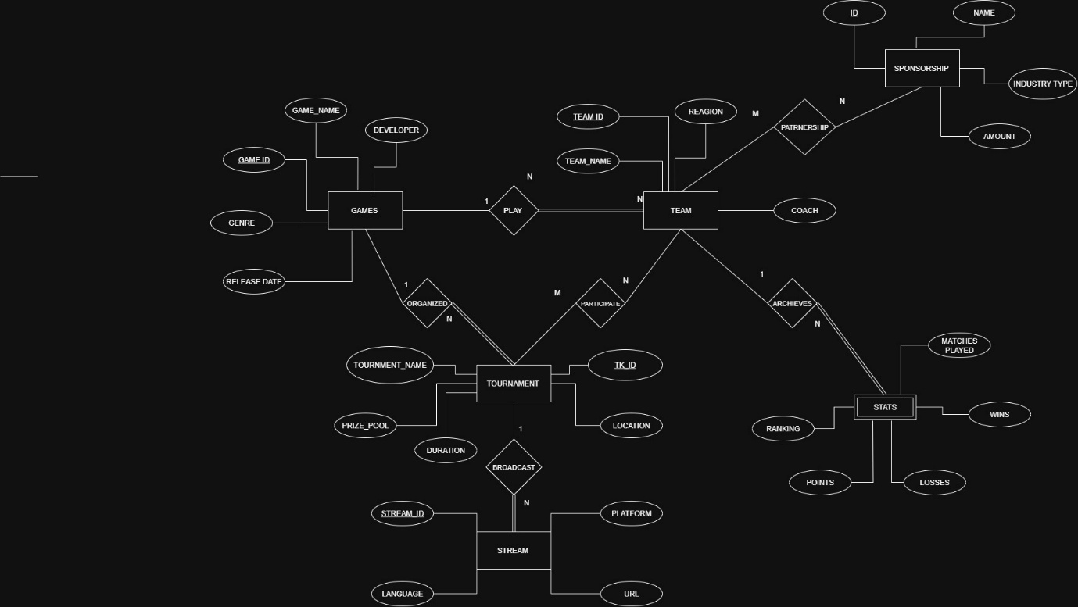
Relational Schema
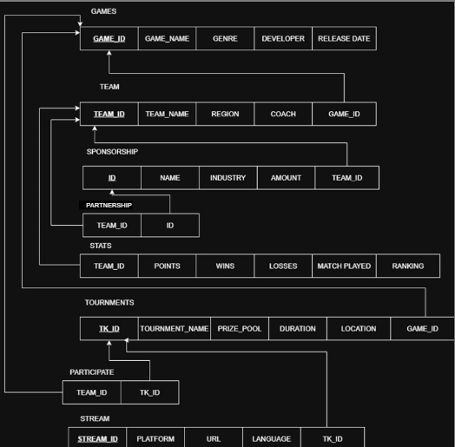

DDL Commands
Refer Create_database.sql file for rest of the sql queries
-- Create the database
CREATE DATABASE IF NOT EXISTS `gaming_tournament_db`;

USE `gaming_tournament_db`;

-- Table: admin_users
CREATE TABLE `admin_users` (
`USER_ID` int NOT NULL AUTO_INCREMENT,
`USERNAME` varchar(50) NOT NULL,
`PASSWORD` varchar(100) NOT NULL,
`CREATED_AT` timestamp NULL DEFAULT CURRENT_TIMESTAMP,
PRIMARY KEY (`USER_ID`),
UNIQUE KEY `USERNAME` (`USERNAME`)
);

-- Table: games
CREATE TABLE `games` (
`GAME_ID` int NOT NULL,
`GAME_NAME` varchar(100) NOT NULL,
`GENRE` varchar(50) NOT NULL,
`DEVELOPER` varchar(100) NOT NULL,
`RELEASE_DATE` date NOT NULL,
PRIMARY KEY (`GAME_ID`),
CONSTRAINT `chk_game_name` CHECK ((`GAME_NAME` <> '')),
CONSTRAINT `chk_genre` CHECK ((`GENRE` <> ''))
);

-- Table: participate
CREATE TABLE `participate` (
`TEAM_ID` int NOT NULL,
`TK_ID` int NOT NULL,
PRIMARY KEY (`TEAM_ID`,`TK_ID`),
KEY `fk_partnership_tournament` (`TK_ID`),
CONSTRAINT `fk_partnership_team` FOREIGN KEY (`TEAM_ID`) REFERENCES `team` (`TEAM_ID`) ON DELETE CASCADE ON UPDATE CASCADE,
CONSTRAINT `fk_partnership_tournament` FOREIGN KEY (`TK_ID`) REFERENCES `tournaments` (`TK_ID`) ON DELETE CASCADE ON UPDATE CASCADE
);

-- Table: partnership
CREATE TABLE `partnership` (
`TEAM_ID` int NOT NULL,
`ID` int NOT NULL,
PRIMARY KEY (`TEAM_ID`,`ID`),
KEY `fk_participates_sponsorship` (`ID`),
CONSTRAINT `fk_participates_sponsorship` FOREIGN KEY (`ID`) REFERENCES `sponsorship` (`ID`) ON DELETE CASCADE ON UPDATE CASCADE,
CONSTRAINT `fk_participates_team` FOREIGN KEY (`TEAM_ID`) REFERENCES `team` (`TEAM_ID`) ON DELETE CASCADE ON UPDATE CASCADE
);

-- Table: sponsorship
CREATE TABLE `sponsorship` (
`ID` int NOT NULL AUTO_INCREMENT,
`NAME` varchar(100) NOT NULL,
`INDUSTRY` varchar(50) NOT NULL,
`AMOUNT` decimal(15,2) NOT NULL,
`TEAM_ID` int NOT NULL,
PRIMARY KEY (`ID`),
KEY `idx_sponsorship_team` (`TEAM_ID`),
CONSTRAINT `fk_sponsorship_team` FOREIGN KEY (`TEAM_ID`) REFERENCES `team` (`TEAM_ID`) ON DELETE CASCADE ON UPDATE CASCADE,
CONSTRAINT `chk_amount` CHECK ((`AMOUNT` > 0)),
CONSTRAINT `chk_sponsor_name` CHECK ((`NAME` <> ''))
);

-- Table: stats
CREATE TABLE `stats` (
`TEAM_ID` int NOT NULL,
`POINTS` int NOT NULL DEFAULT '0',
`WINS` int NOT NULL DEFAULT '0',
`LOSSES` int NOT NULL DEFAULT '0',
`MATCH_PLAYED` int NOT NULL DEFAULT '0',
`RANKING` int NOT NULL,
PRIMARY KEY (`TEAM_ID`),
CONSTRAINT `fk_stats_team` FOREIGN KEY (`TEAM_ID`) REFERENCES `team` (`TEAM_ID`) ON DELETE CASCADE ON UPDATE CASCADE,
CONSTRAINT `chk_losses` CHECK ((`LOSSES` >= 0)),
CONSTRAINT `chk_match_consistency` CHECK ((`MATCH_PLAYED` >= (`WINS` + `LOSSES`))),
CONSTRAINT `chk_matches` CHECK ((`MATCH_PLAYED` >= 0)),
CONSTRAINT `chk_points` CHECK ((`POINTS` >= 0)),
CONSTRAINT `chk_ranking` CHECK ((`RANKING` > 0)),
CONSTRAINT `chk_wins` CHECK ((`WINS` >= 0))
);

-- Table: stream
CREATE TABLE `stream` (
`STREAM_ID` int NOT NULL AUTO_INCREMENT,
`PLATFORM` varchar(50) NOT NULL,
`URL` varchar(255) NOT NULL,
`LANGUAGE` varchar(30) NOT NULL,
`TK_ID` int NOT NULL,
PRIMARY KEY (`STREAM_ID`),
KEY `idx_stream_tournament` (`TK_ID`),
CONSTRAINT `fk_stream_tournament` FOREIGN KEY (`TK_ID`) REFERENCES `tournaments` (`TK_ID`) ON DELETE CASCADE ON UPDATE CASCADE,
CONSTRAINT `chk_language` CHECK ((`LANGUAGE` <> '')),
CONSTRAINT `chk_platform` CHECK ((`PLATFORM` <> '')),
CONSTRAINT `chk_url` CHECK ((`URL` <> ''))
);

-- Table: team
CREATE TABLE `team` (
`TEAM_ID` int NOT NULL AUTO_INCREMENT,
`TEAM_NAME` varchar(100) NOT NULL,
`REGION` varchar(50) NOT NULL,
`COACH` varchar(100) NOT NULL,
`GAME_ID` int NOT NULL,
PRIMARY KEY (`TEAM_ID`),
KEY `idx_team_game` (`GAME_ID`),
KEY `idx_team_name` (`TEAM_NAME`),
CONSTRAINT `fk_team_game` FOREIGN KEY (`GAME_ID`) REFERENCES `games` (`GAME_ID`) ON DELETE CASCADE ON UPDATE CASCADE,
CONSTRAINT `chk_region` CHECK ((`REGION` <> '')),
CONSTRAINT `chk_team_name` CHECK ((`TEAM_NAME` <> ''))
);

-- Table: tournaments
CREATE TABLE `tournaments` (
`TK_ID` int NOT NULL AUTO_INCREMENT,
`TOURNAMENT_NAME` varchar(150) NOT NULL,
`PRIZE_POOL` decimal(15,2) NOT NULL,
`DURATION` varchar(50) NOT NULL,
`LOCATION` varchar(100) NOT NULL,
`GAME_ID` int NOT NULL,
`STATUS` enum('UPCOMING','ONGOING','COMPLETED') DEFAULT 'UPCOMING',
`WINNER_TEAM_ID` int DEFAULT NULL,
PRIMARY KEY (`TK_ID`),
KEY `idx_tournament_game` (`GAME_ID`),
KEY `idx_tournament_name` (`TOURNAMENT_NAME`),
KEY `fk_tournament_winner` (`WINNER_TEAM_ID`),
CONSTRAINT `fk_tournament_game` FOREIGN KEY (`GAME_ID`) REFERENCES `games` (`GAME_ID`) ON DELETE CASCADE ON UPDATE CASCADE,
CONSTRAINT `fk_tournament_winner` FOREIGN KEY (`WINNER_TEAM_ID`) REFERENCES `team` (`TEAM_ID`),
CONSTRAINT `chk_prize_pool` CHECK ((`PRIZE_POOL` > 0)),
CONSTRAINT `chk_tournament_name` CHECK ((`TOURNAMENT_NAME` <> ''))
);

8. Walk through the Web page
(showing all CRUD operations and functions/procedures)

Adding new game
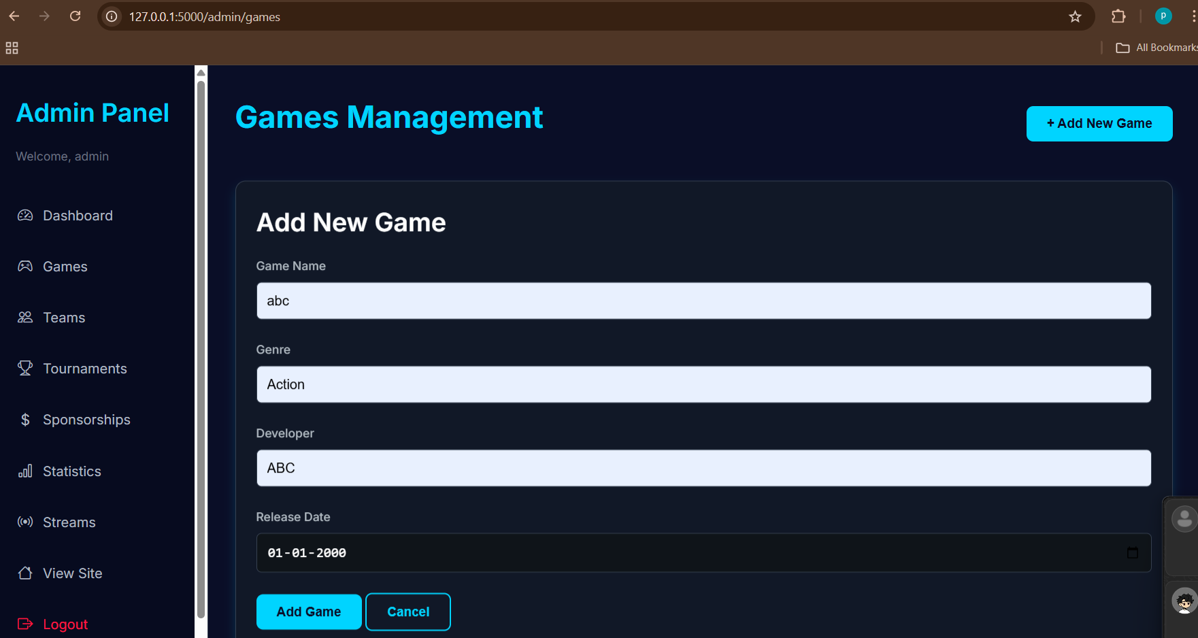
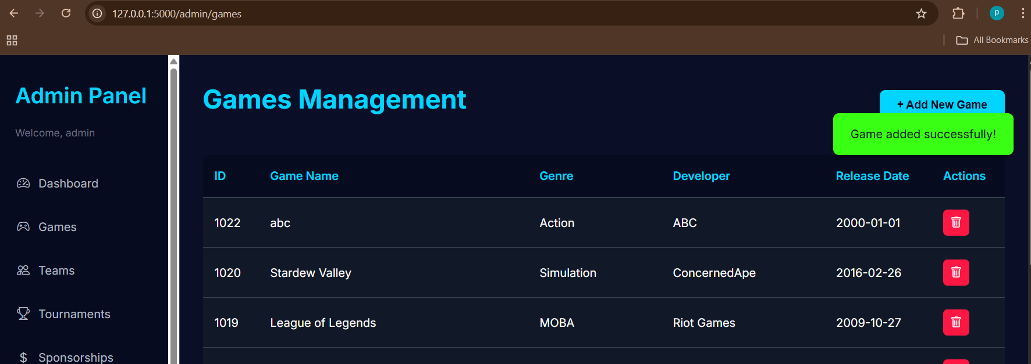
Game abc deleted
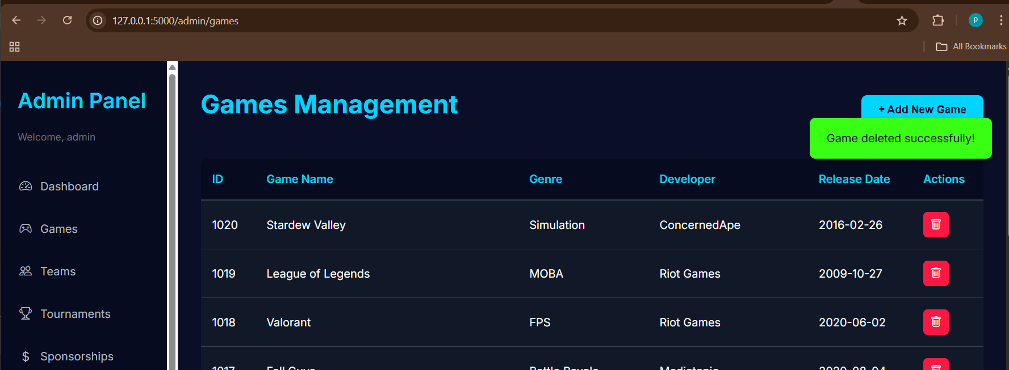

Creating new team
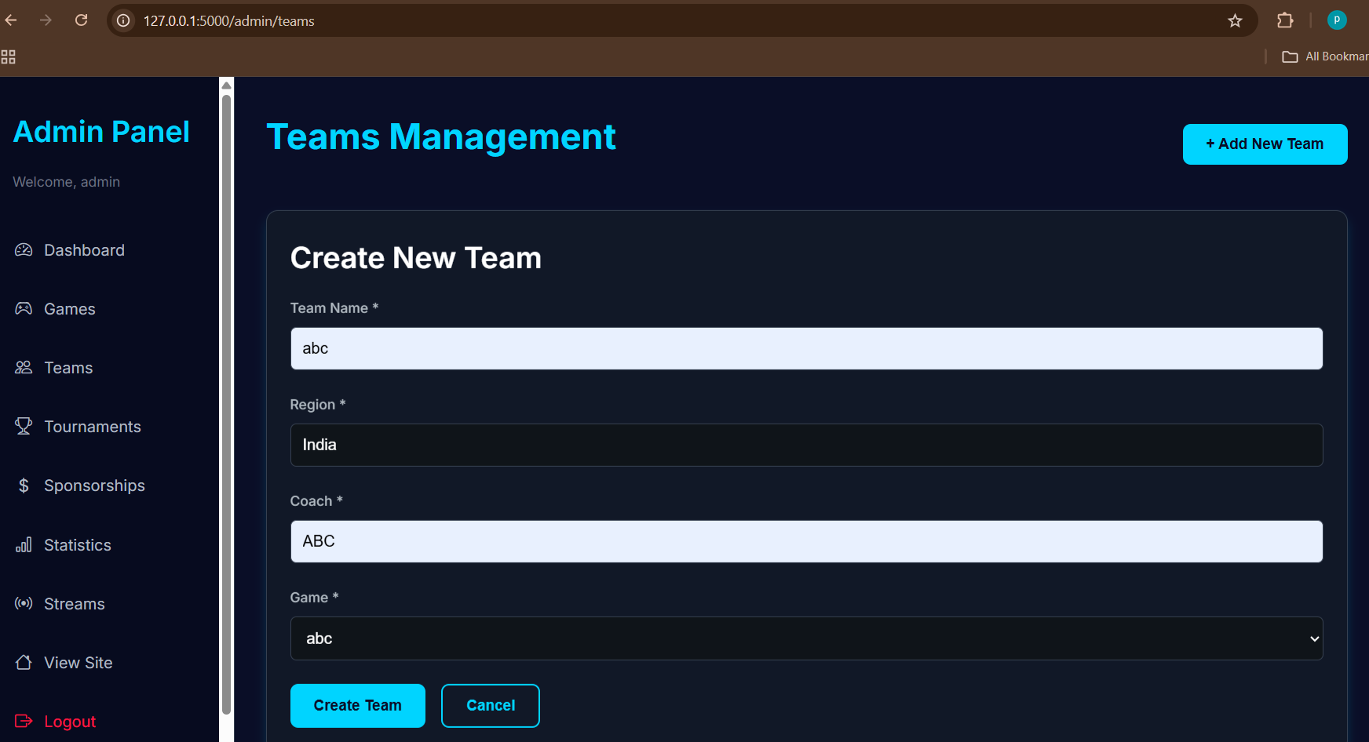
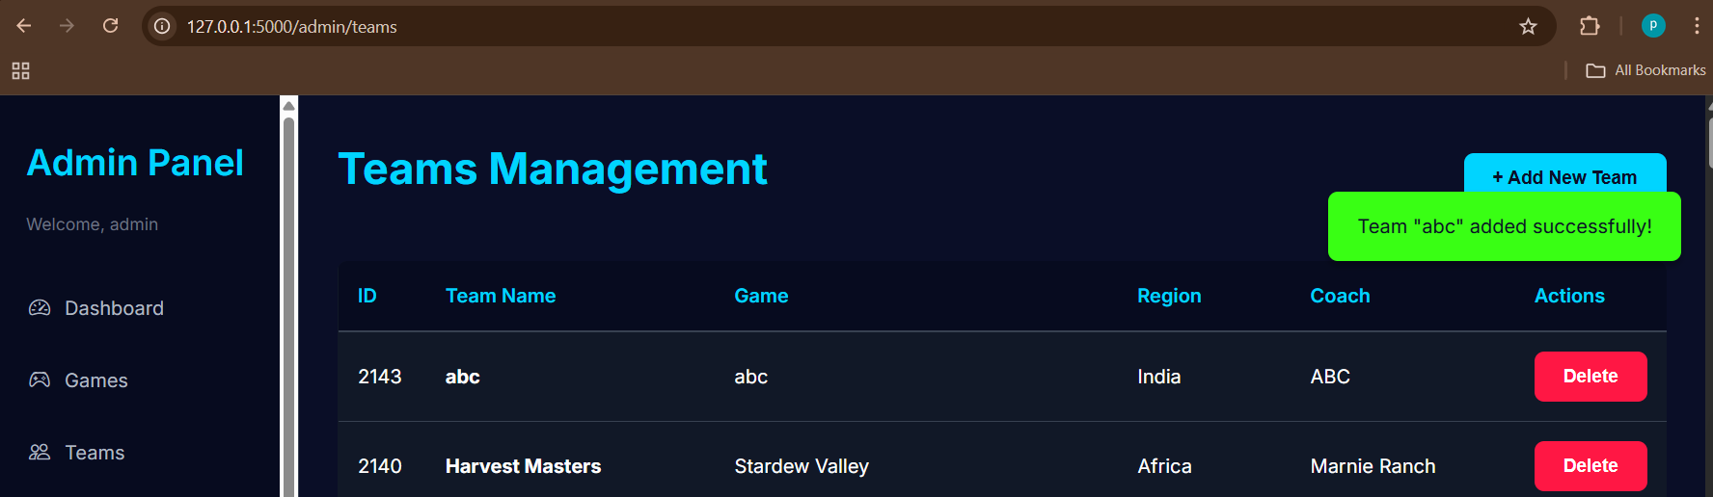

Deleted the abc team
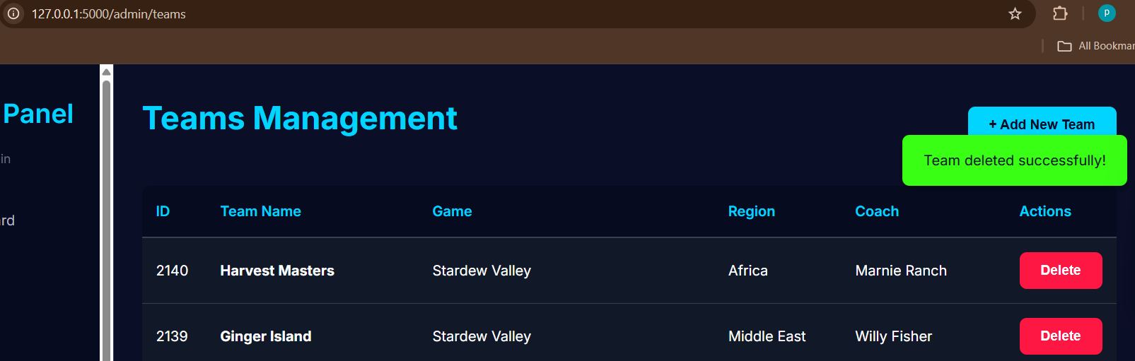

Created 3 new teams for abc game
Will create new tournament for the game abc
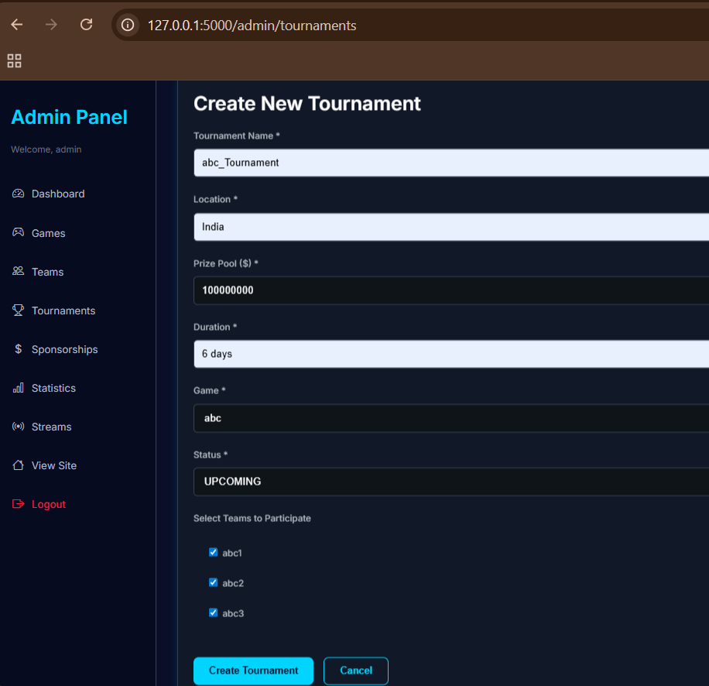
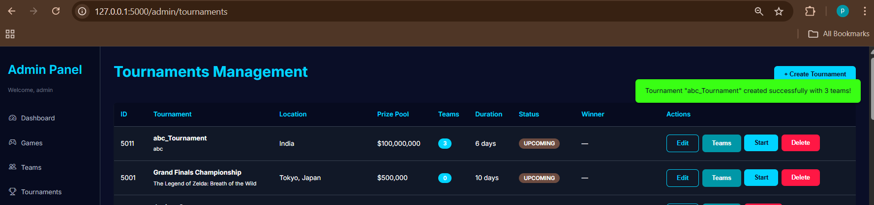
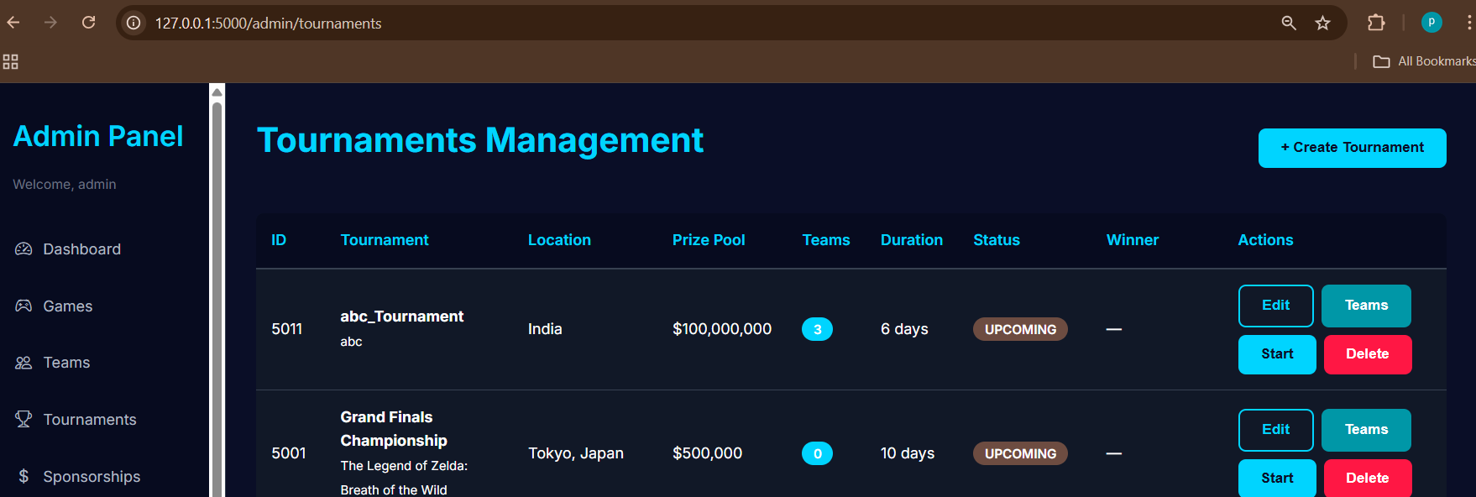

Pressing the Start button changes the status to ongoing
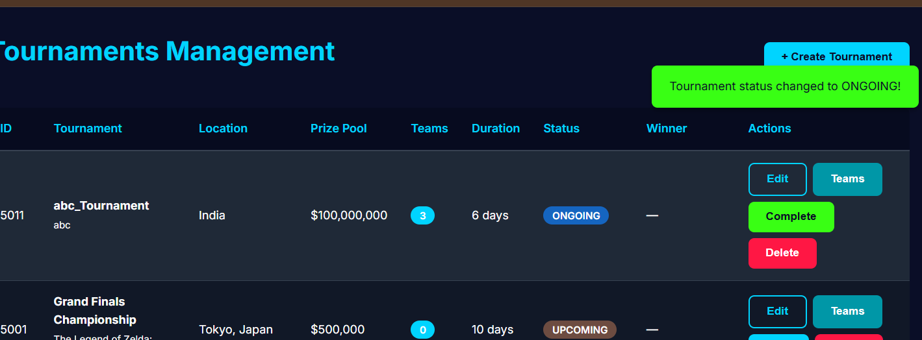

Ongoing tournaments visible in statistic page
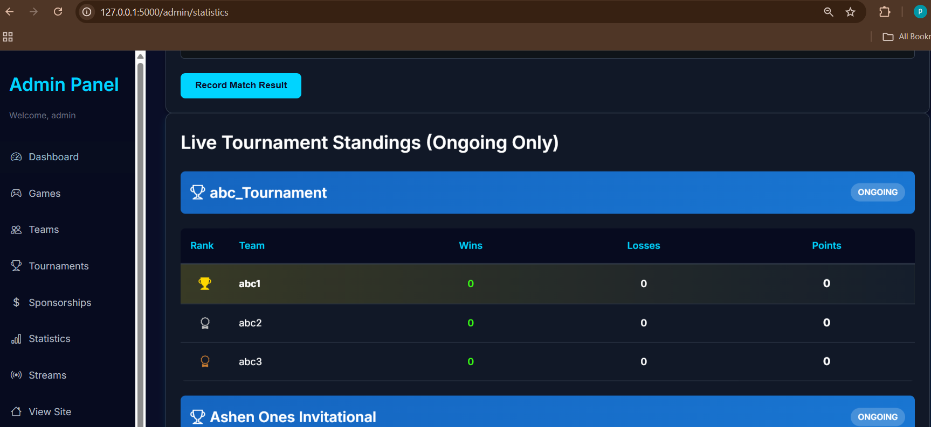
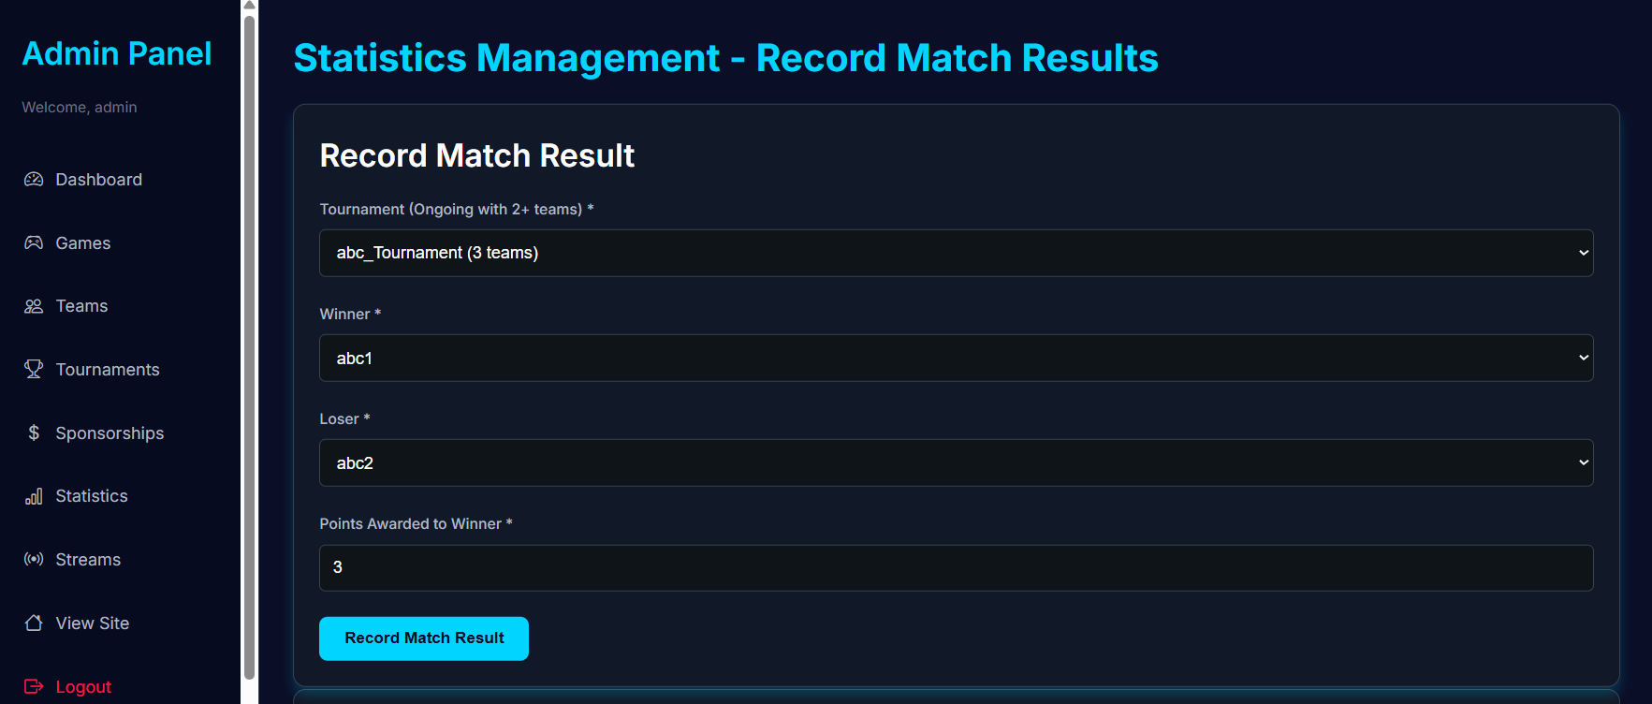
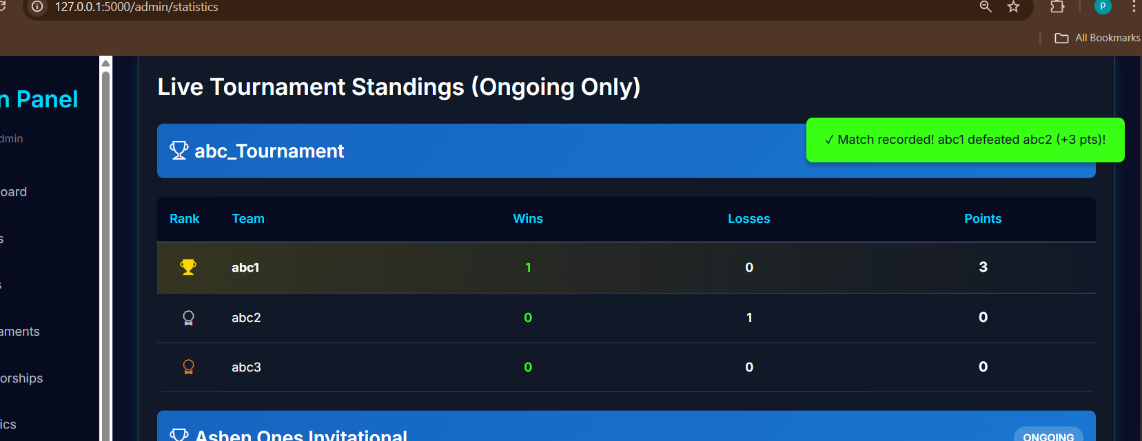
Ranking updated automatically
Given the below standings
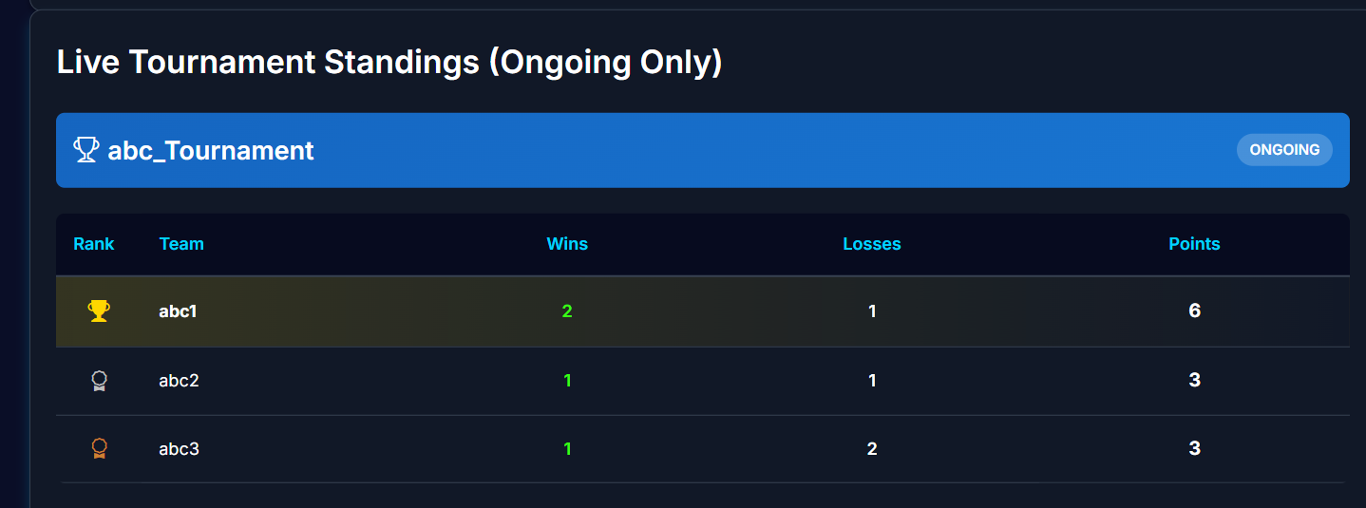
When I press complete option in tournaments
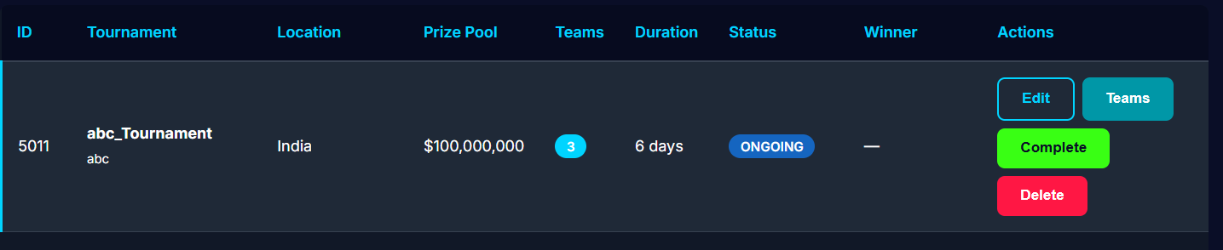
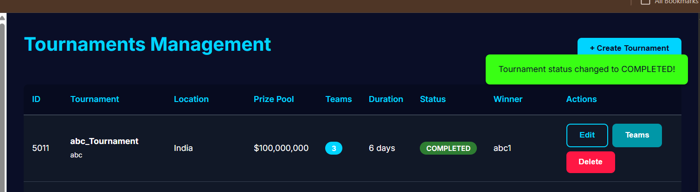
Winner automatically chosen based on ranking

Teams option in tournaments lets you add or remove teams
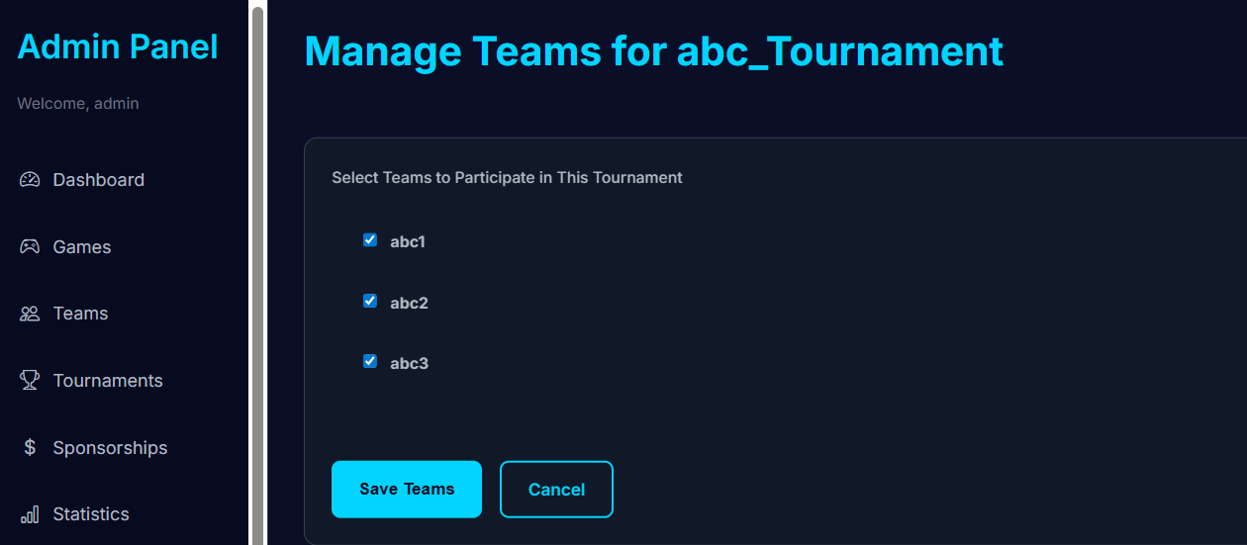

Edit option lets us edit the details of tournament
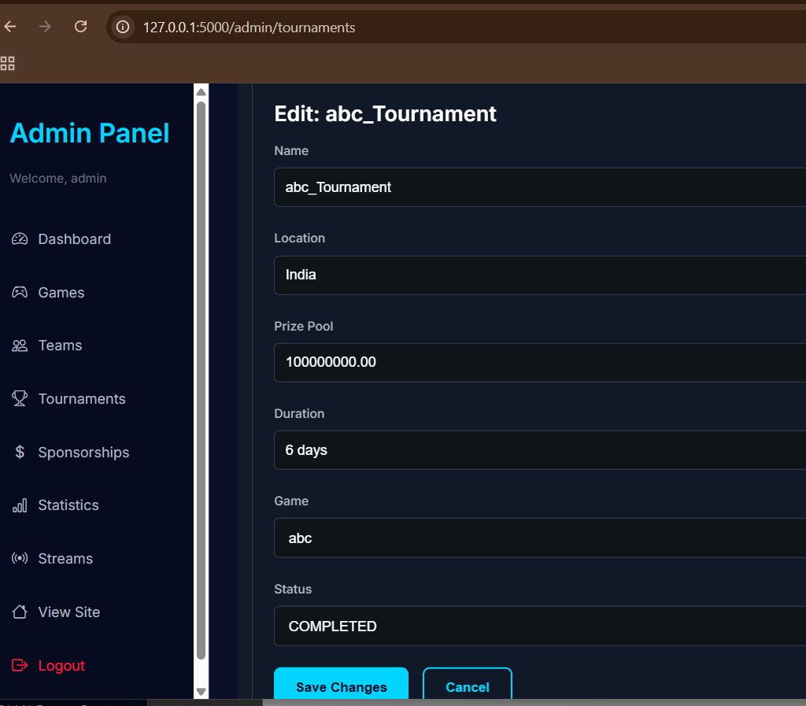
Updated the prize pool using edit option
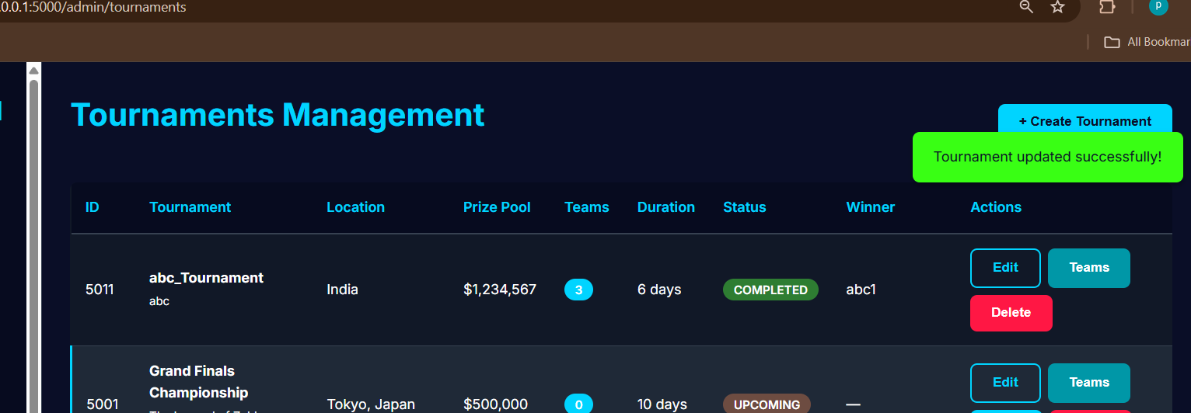

Deleted tournament abc_tournament
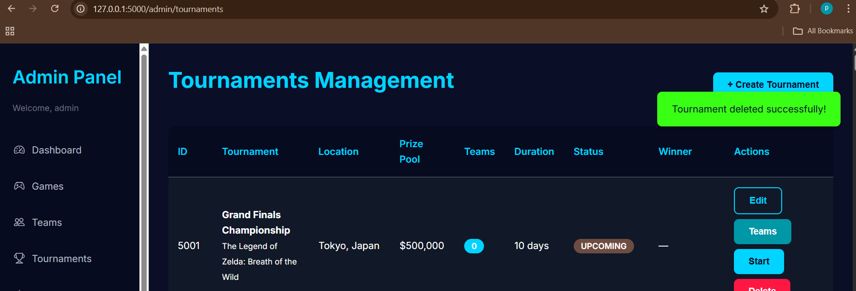

Streams section allows to add stream link to a given tournament
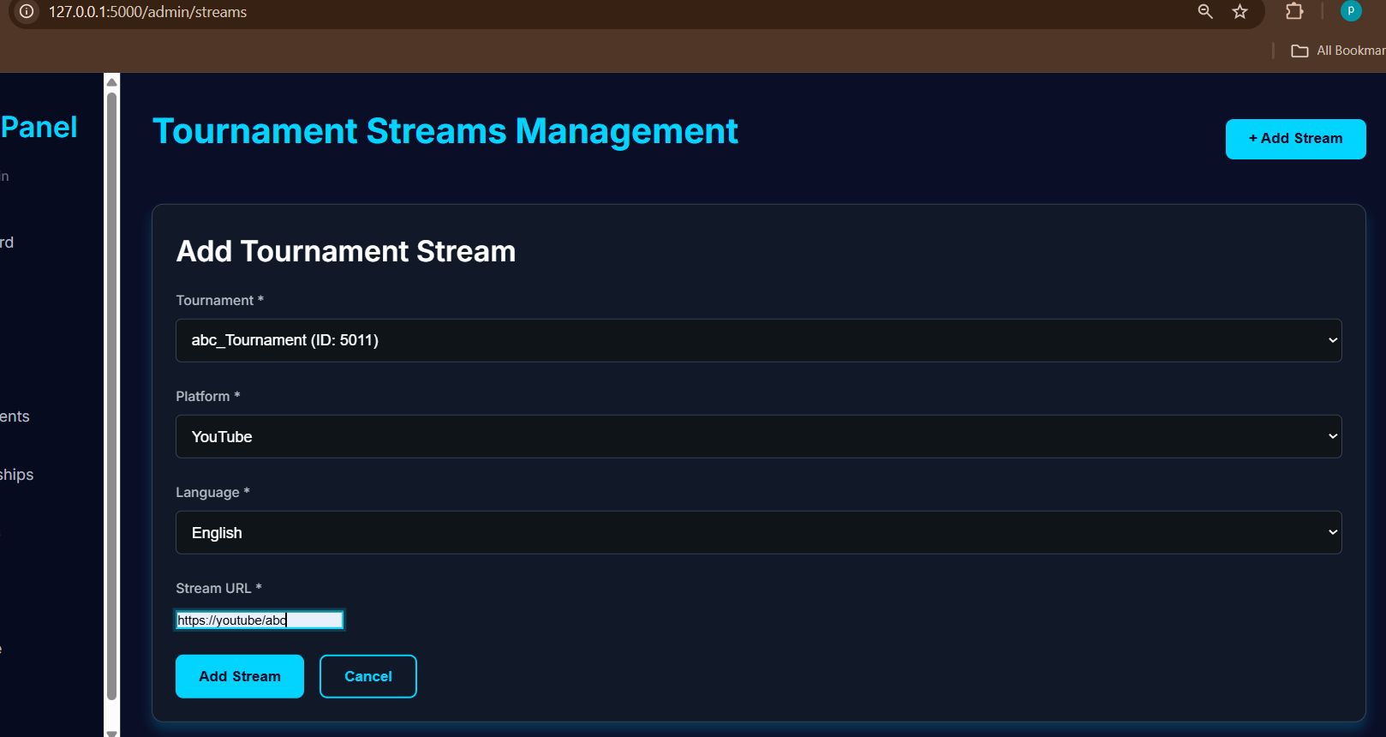

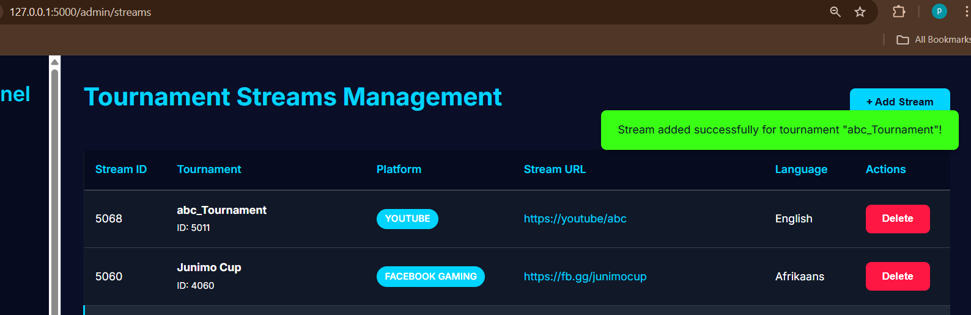

Sponsorship section allows adding sponsors to a give team
Adding sponsor ABC to team abc1(created preciously)
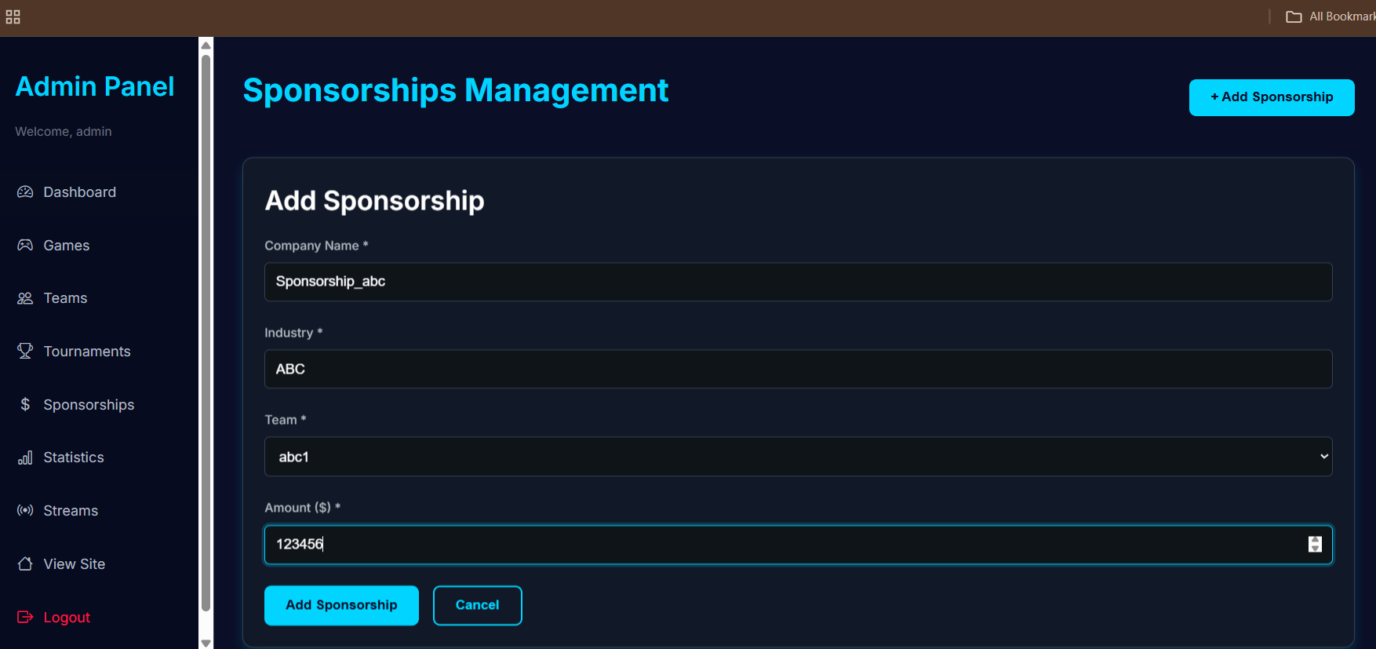
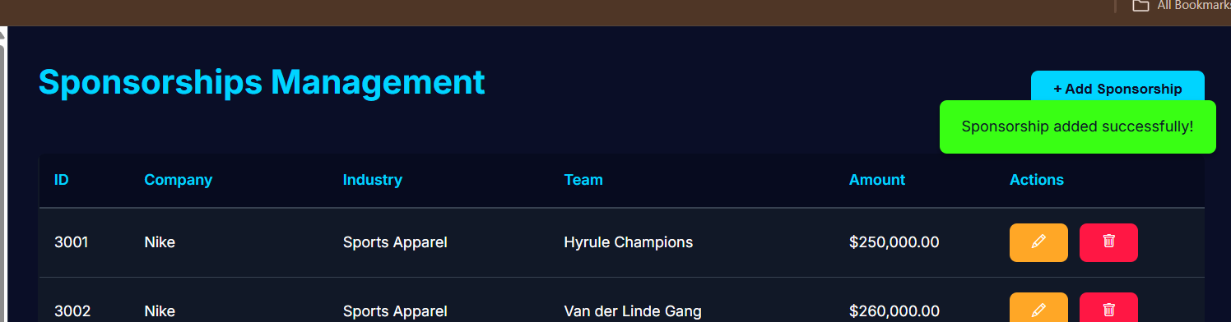
Entry in UI table
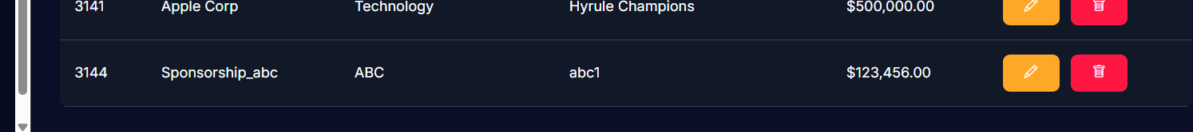

All the updates done are visible from public without admin login
Abc game visible in games section
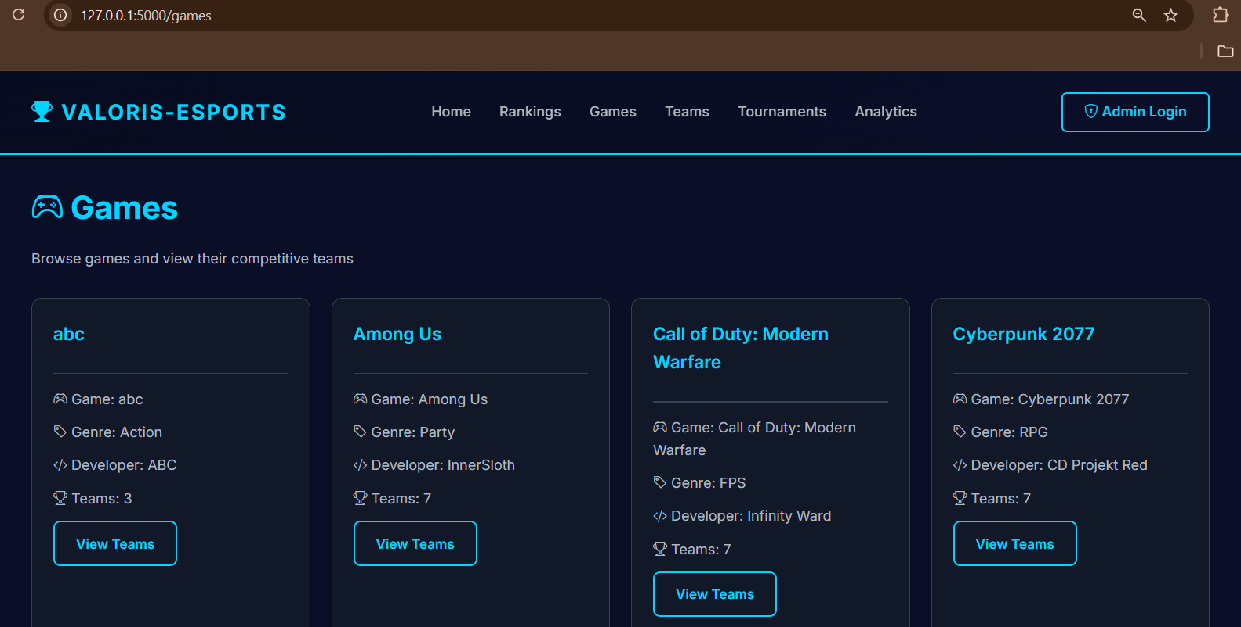
View teams button shows all teams in the respective game
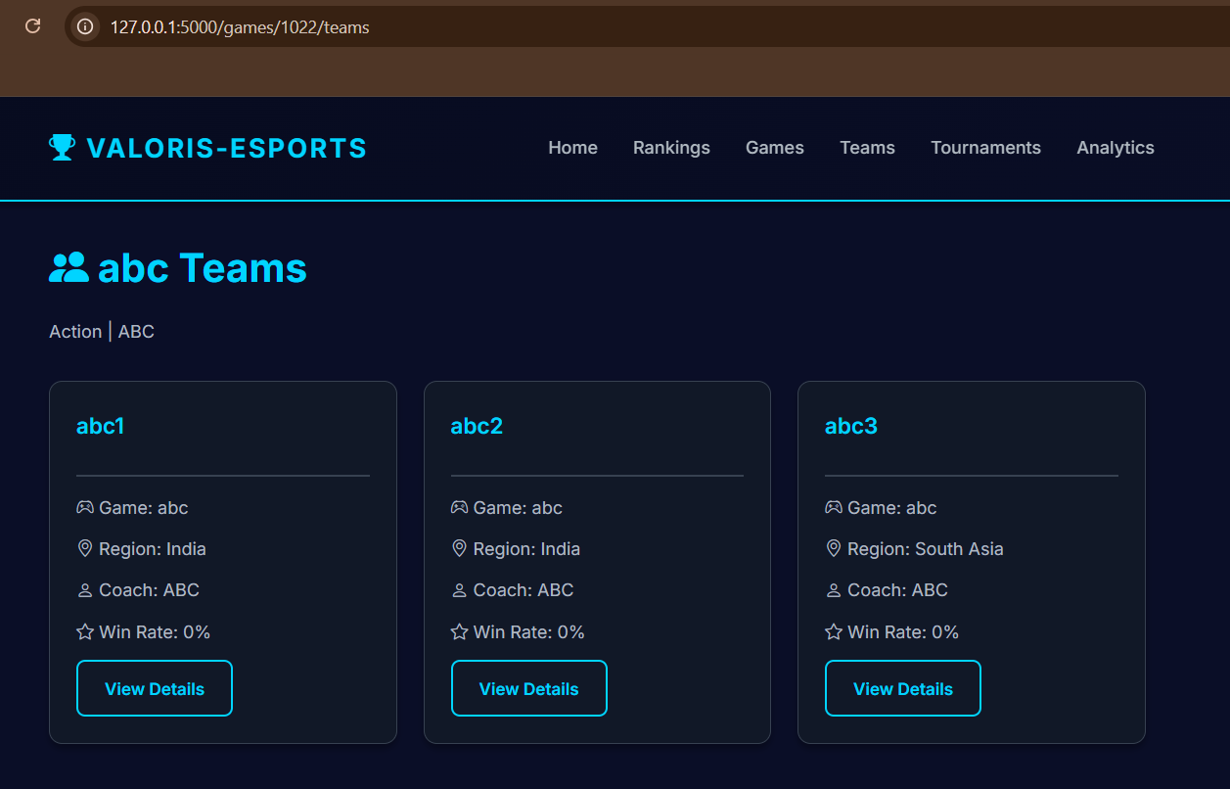
Viewing details of team abc1
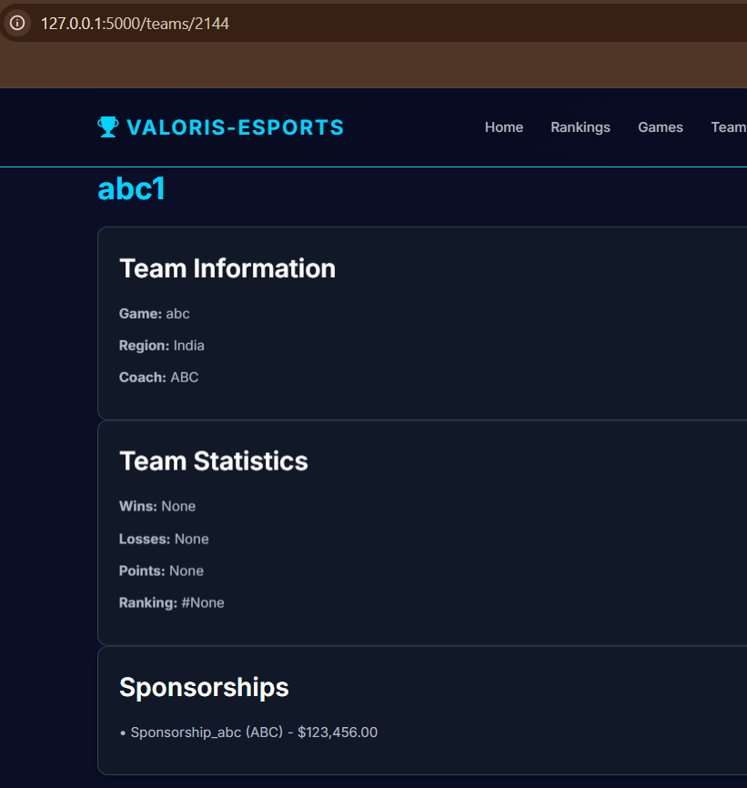
Sponsorships updated here

Public pages
Teams section
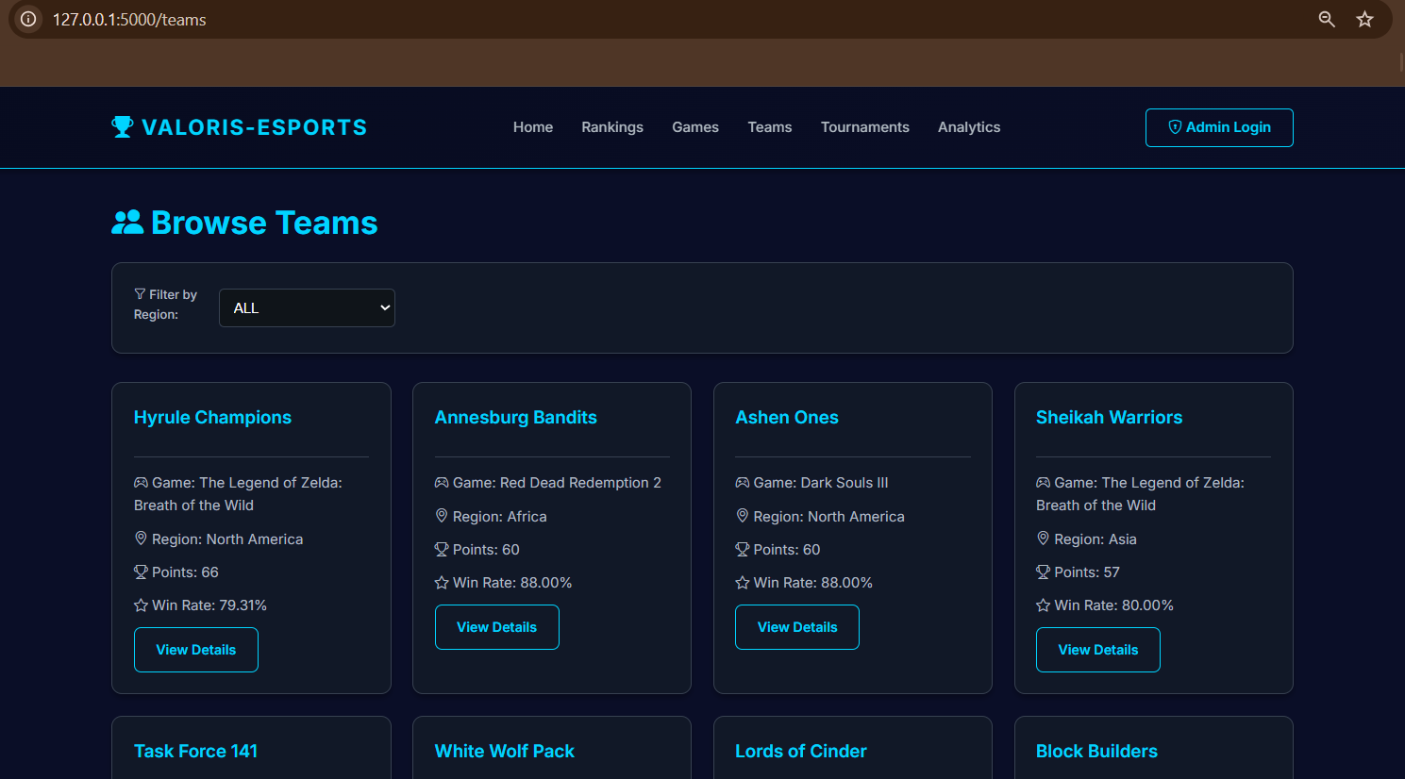
Filter option filters based on region
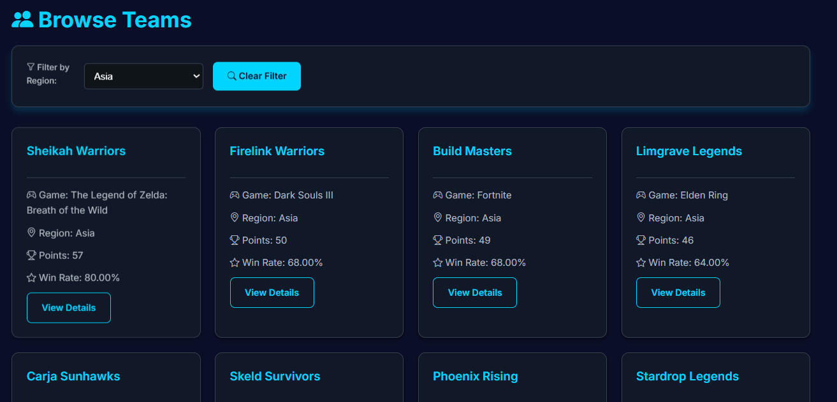

Tournaments section
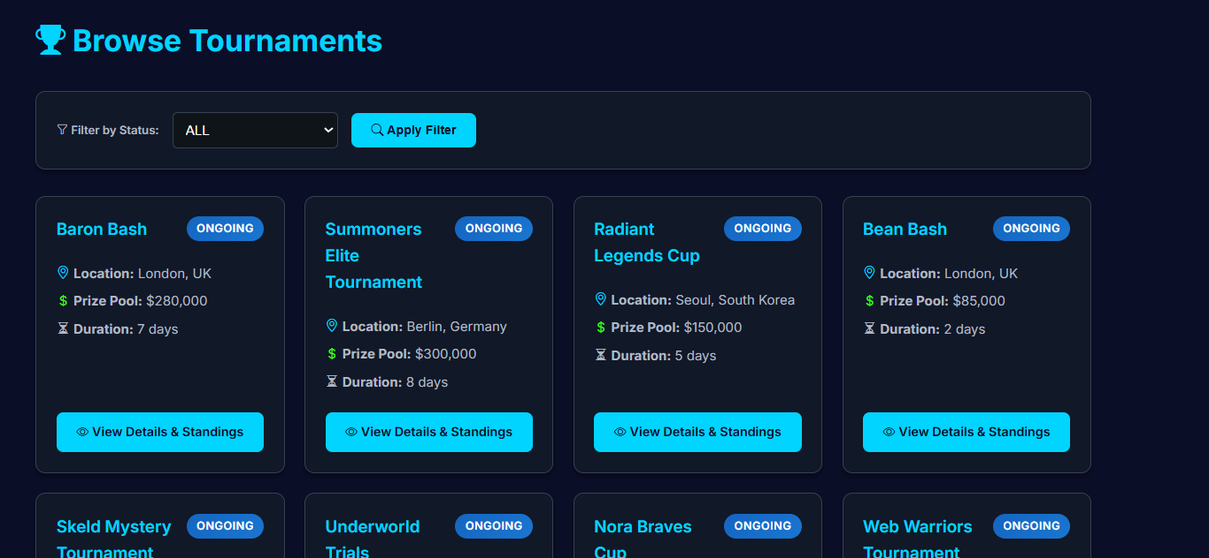
Filter option based on status of tournaments
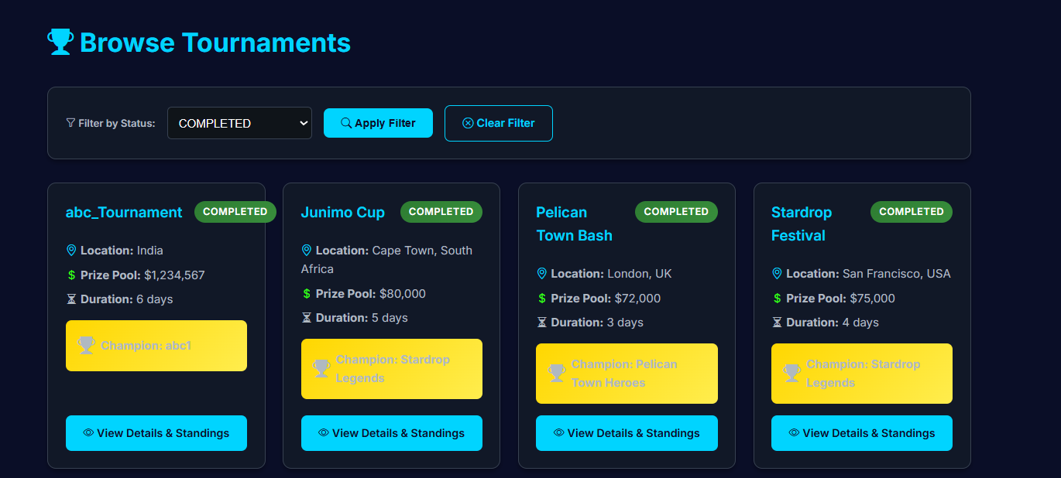

Analytics page
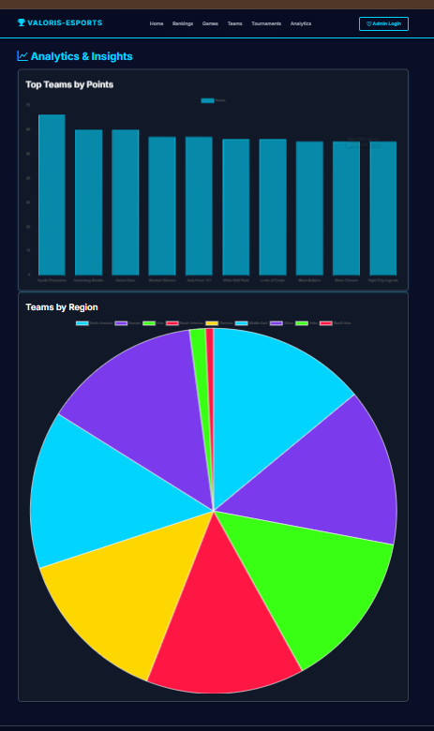

Code snippets for invoking the Procedures/Functions/Trigger
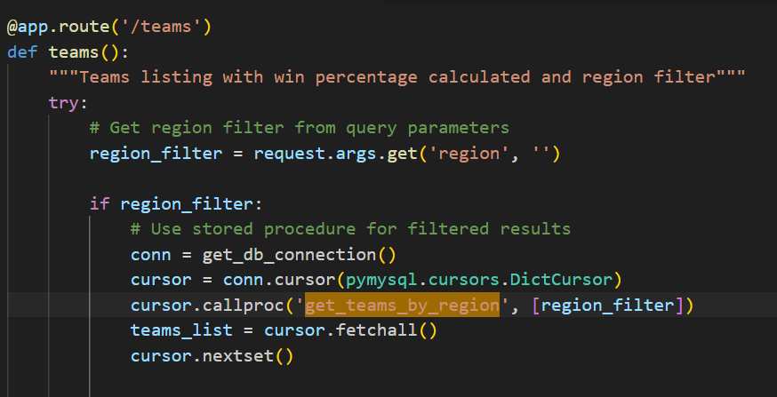
for filter option in the teams section (procedure)

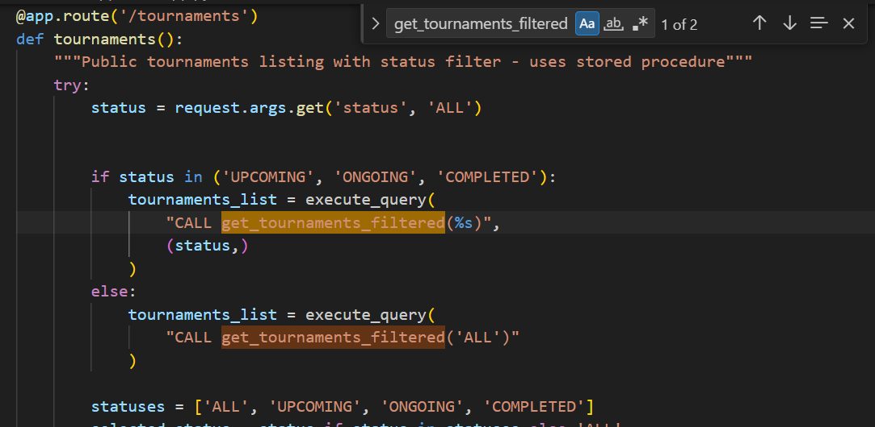
Handles status-based filtering of tournaments via procedure.

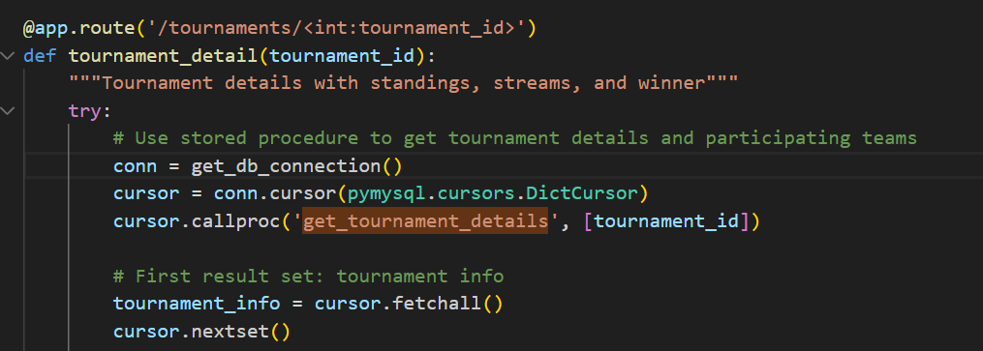

Functions

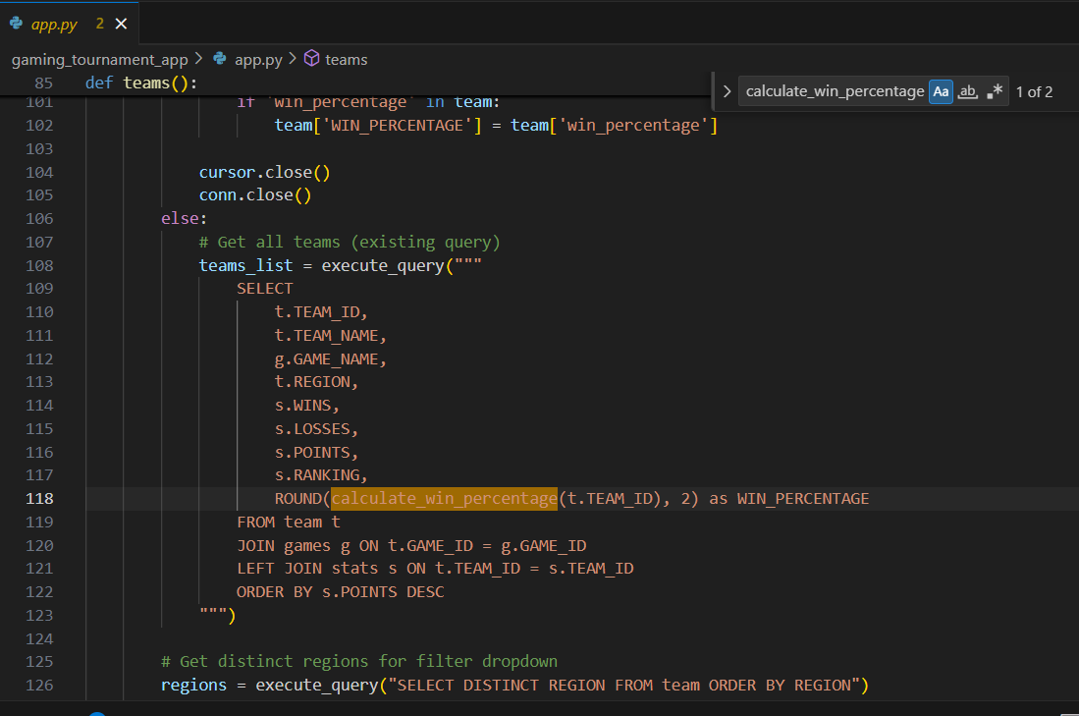
Calculates win percentage for a team based on wins and matches played.

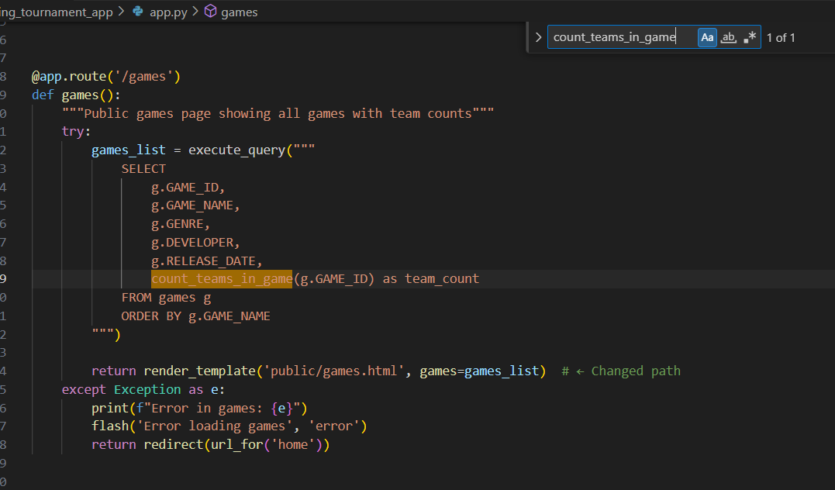
Counts how many teams belong to a specific game.
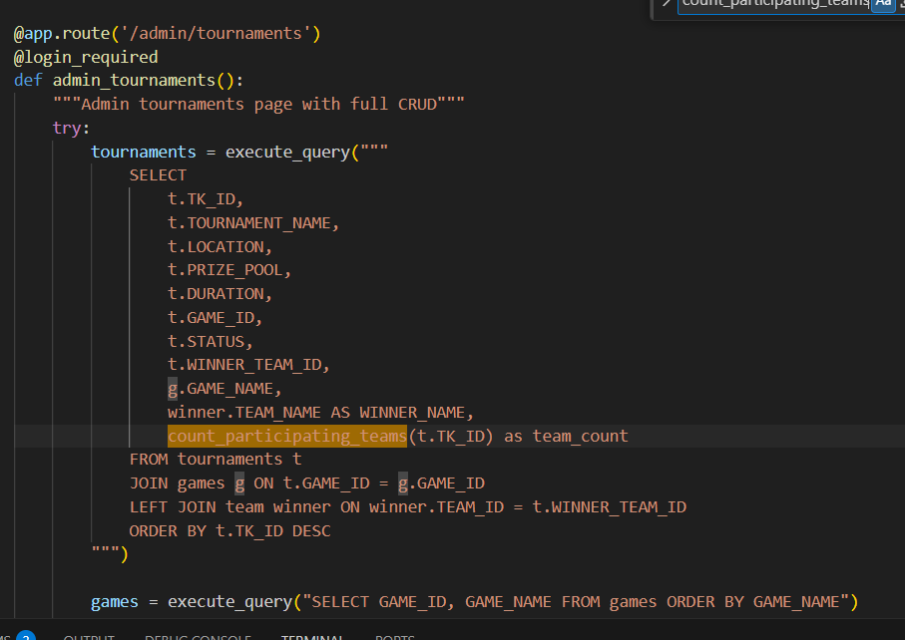
Counts the number of teams participating in a specific tournament

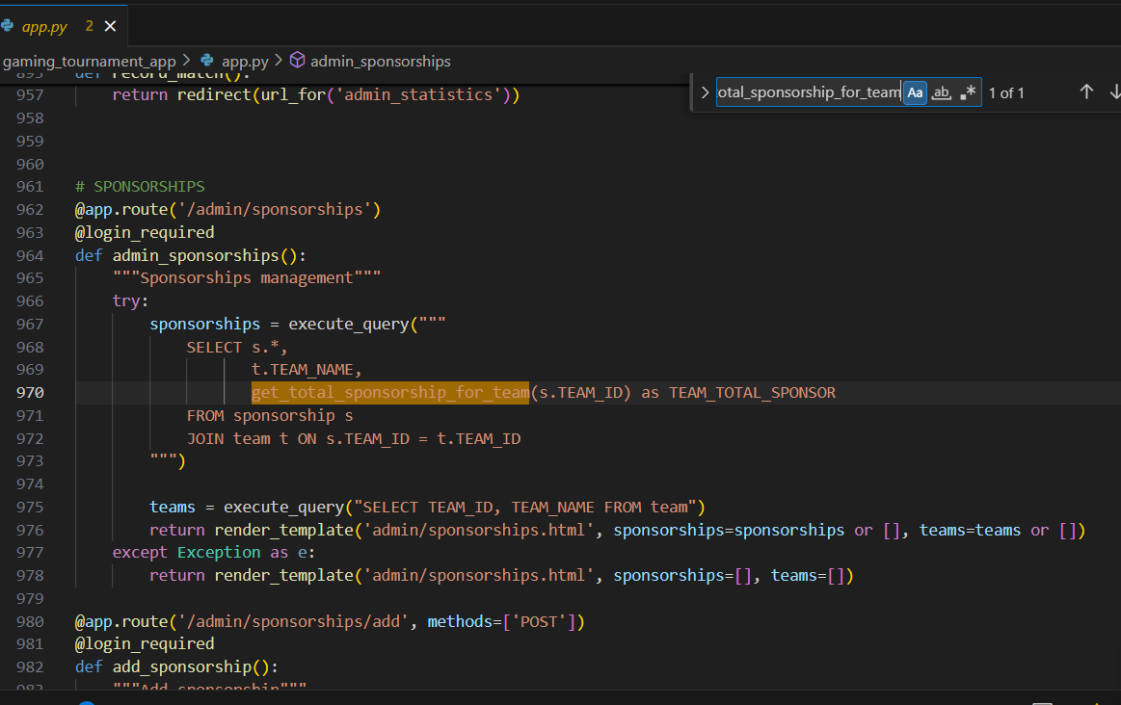
Calculates total sponsorship amount for a team by summing sponsorship amounts.

Triggers
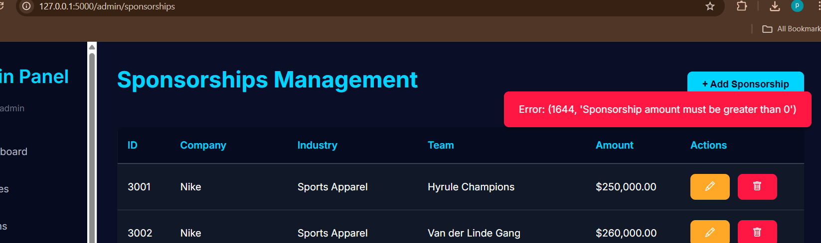
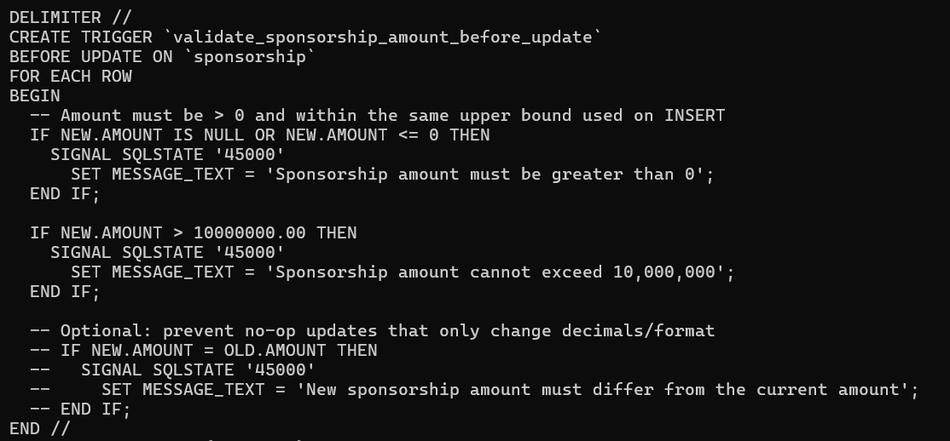

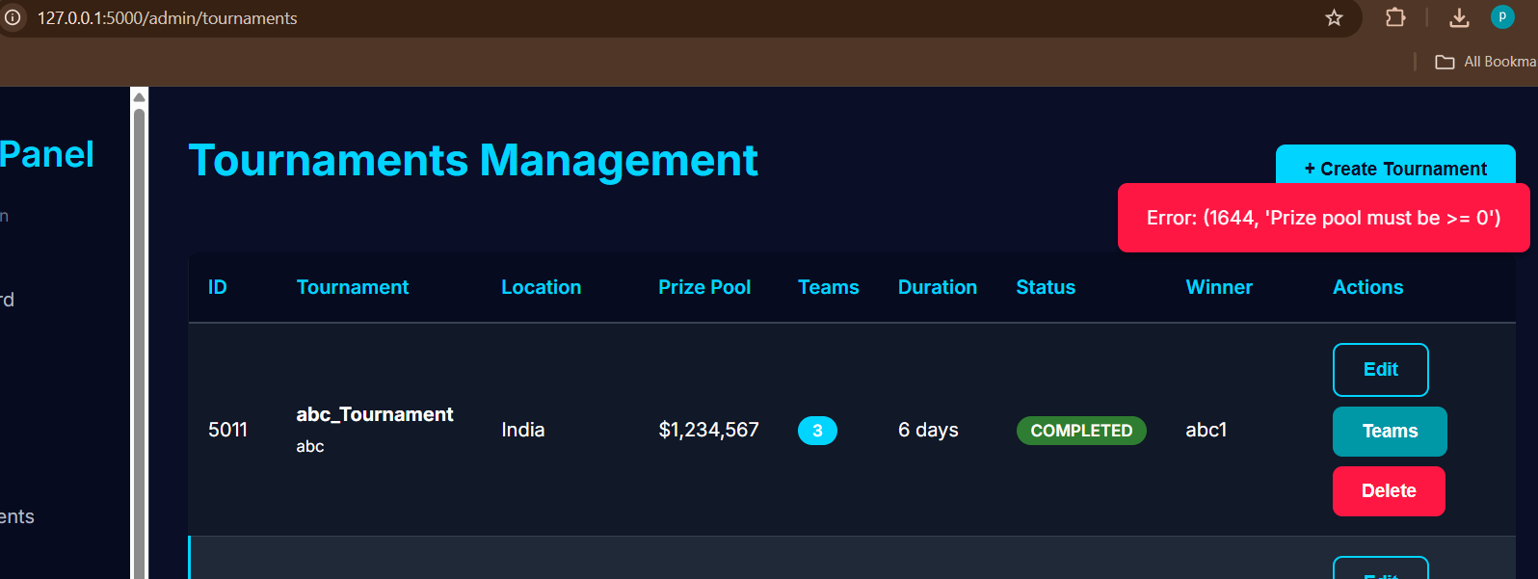
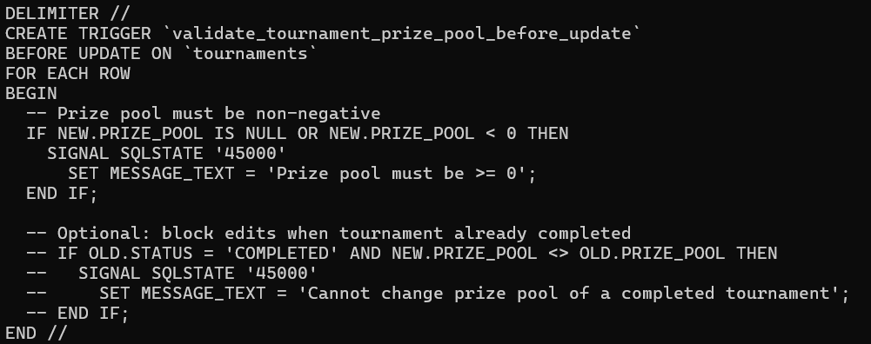

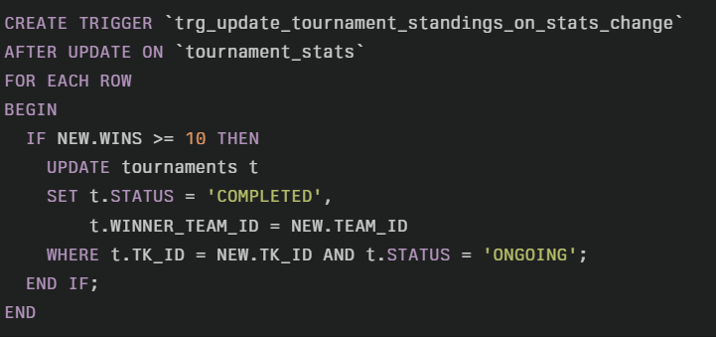
Automatically marks tournament as COMPLETED and sets winner when a team reaches 10 wins
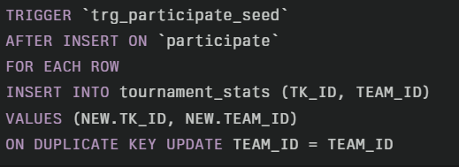
Automatically creates tournament stats entry when a team joins a tournament

