Bio-Signal Processing & FIR Filter Verification
Detailed Mathematical Calculations, Frequency vs. Amplitude Analysis, and ADC Concepts

1. Executive Summary: Frequency vs. Amplitude
A common point of confusion when inspecting bio-signal filter outputs is the apparent contradiction between the filter specification (e.g., 0.5 Hz to 5.0 Hz passband) and the plotted values on the Y-axis reaching magnitudes in the tens of thousands (e.g., -20,000 to +55,000).
Core Principle: Frequency and Amplitude represent two completely orthogonal dimensions of a digital signal. The filter passband (0.5 Hz to 5.0 Hz) governs how fast the signal oscillates over time (horizontal X-axis). The values (-20,000 to +55,000) represent the amplitude or voltage intensity digitized by the ADC into fixed-point integer units (vertical Y-axis).

Parameter | Domain / Physical Meaning | Representation in Plot
Filter Bandwidth  (0.5 Hz - 5.0 Hz) | Frequency domain: Rate of heartbeat/pulse oscillations per second permitted by the bandpass filter. | Horizontal spacing (X-axis):  Determines the distance/samples between consecutive wave peaks.
Signal Amplitude  (-20,000 to +55,000) | Amplitude domain: Digitized sensor voltage level, represented as a 32-bit signed fixed-point integer. | Vertical magnitude (Y-axis):  Height of the waveform corresponding to sensor dynamic range.

2. Waveform Visual Inspection
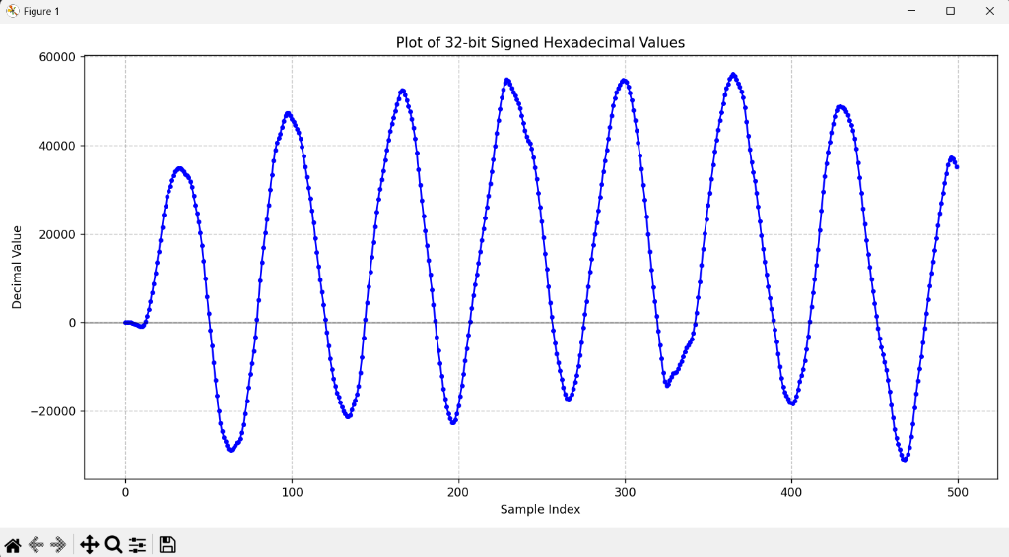
Figure 1: Plot of 32-bit Signed Hexadecimal Filtered Output (500 Samples)

3. Step-by-Step Mathematical Calculations
Step 1: Sampling Interval (Ts) from Sampling Frequency (Fs)
The sampling rate Fs specifies how many discrete measurements are digitized per second.
Given:
• Sampling Frequency (Fs) = 100 Hz (100 samples per second)
Formula for sampling interval (time per sample):
Ts = 1 / Fs = 1 / 100 Hz = 0.01 seconds = 10 milliseconds
Result: Every adjacent sample along the X-axis represents exactly 10 ms of real-world elapsed time.
Step 2: Total Time Duration of the 500 Samples
The X-axis displays indices from sample 0 to sample 500 (N = 500 samples).
Formula for total recorded duration:
Total Time (T_total) = N × Ts = N / Fs
T_total = 500 samples / 100 samples/sec = 5.0 seconds
Result: The entire horizontal width of the plot spans a continuous 5.0-second time window.
Step 3: Cycle Counting and Peak-to-Peak Analysis
A cycle is one complete oscillation of the waveform from one crest (peak) to the subsequent crest.
Identifying peak positions from Figure 1:
• Peak 1: ≈ Sample 35
• Peak 2: ≈ Sample 100 (Interval = 65 samples)
• Peak 3: ≈ Sample 165 (Interval = 65 samples)
• Peak 4: ≈ Sample 230 (Interval = 65 samples)
• Peak 5: ≈ Sample 300 (Interval = 70 samples)
• Peak 6: ≈ Sample 365 (Interval = 65 samples)
• Peak 7: ≈ Sample 430 (Interval = 65 samples)
Average Period per Cycle in Samples:
N_cycle ≈ 68 samples/cycle
Total Complete Cycles in 500 samples:
Cycles = Total Samples / N_cycle = 500 / 68 ≈ 7.3 cycles (≈ 7 full cycles)
Step 4: Calculation of the Signal Frequency (f)
Method A: Overall Ratio (Cycles / Time)
f = Total Cycles / Total Time
f = 7 cycles / 5.0 seconds = 1.40 Hz (cycles per second)
Method B: Single-Cycle Period (T)
T = N_cycle × Ts = 68 samples × 0.01 s = 0.68 seconds
f = 1 / T = 1 / 0.68 s = 1.47 Hz
Result: The observed bio-signal fundamental frequency is approximately 1.4 Hz to 1.47 Hz.
Step 5: Translation to Biomedical Metric (Heart Rate in BPM)
For cardiovascular signals such as Photoplethysmography (PPG) or Electrocardiogram (ECG), frequency in Hertz translates directly to beats per minute:
Heart Rate (BPM) = Frequency (Hz) × 60 seconds/minute
Heart Rate = 1.40 Hz × 60 = 84.0 BPM
Result: This corresponds to a normal, healthy adult resting heart rate (typical clinical range: 60 - 100 BPM).

4. Filter Passband Verification (0.5 Hz - 5.0 Hz)
The FIR bandpass filter implemented in fir_bandpass.v is configured with cutoff frequencies of f_low = 0.5 Hz and f_high = 5.0 Hz. Here is how this specification aligns with the physiological signal:
Filter Boundary | Equivalent Heart Rate | Physiological Purpose & Behavior
High-Pass Cutoff  (0.5 Hz) | 0.5 × 60 = 30 BPM | Rejects slow baseline wander caused by respiration, sweat, sensor motion, and DC voltage offsets.
Signal Frequency  (1.4 Hz) | 1.4 × 60 = 84 BPM | Falls cleanly in the center of the passband [0.5 Hz, 5.0 Hz]. Passed through with minimal attenuation.
Low-Pass Cutoff  (5.0 Hz) | 5.0 × 60 = 300 BPM | Attenuates high-frequency noise, 50 Hz / 60 Hz power-line electromagnetic hum, and EMG muscle tremor artifacts.

5. ADC Mechanics: Conversion Time vs. Sampling Interval
When designing or working with an SoC hardware interface, it is crucial to distinguish between the sampling period and the internal ADC conversion time:
Hardware Clarification: • Sampling Interval (Ts = 0.01 s = 10 ms): The total repetition interval set by a timer or sample trigger. A new sample is delivered to the RISC-V SoC bus once every 10 ms.
• Conversion Time (T_conv ≈ 1 µs - 50 µs): The internal physical time required by the ADC hardware (e.g., Successive Approximation Register / SAR) to quantize the analog voltage into a digital binary code.
• Idle Time: After the ADC finishes conversion in a few microseconds, it holds the result and waits until the remaining duration of the 10 ms interval elapses before initiating the next sample.

6. Why the Y-Axis Values Reach 20,000 to 55,000
The Y-axis range (-20,000 to +55,000) is governed by two factors in the SoC architecture:
1. ADC Bit Resolution:
Bio-signal optical sensors (such as MAX30102 or AFE4404) utilize 16-bit to 18-bit ADCs. A 16-bit signed integer has a numerical span from -32,768 to +32,767 (or 0 to 65,535 for unsigned), naturally producing values in the tens of thousands.
2. Fixed-Point Arithmetic in fir_bandpass.v:
To avoid floating-point units (which consume significant FPGA logic and power), the FIR filter uses integer scaled coefficients (e.g., coeff[13] = 5381). The Multiply-Accumulate (MAC) sum is computed over 64 bits and scaled back using Q13 bit-slicing (data_out <= mac_sum[44:13]). This maintains high precision within 32-bit signed integers.

