

**BE PROJECT SYNOPSIS**

**GROUP NO:**  26

|  |  |  |  |
| --- | --- | --- | --- |
| **Sr. No.** | **Group Members** | **Roll No.** | **Signature** |
| 1 | Prajwal Ravindra Sable | COMPBEA1102 |  |
| 2 | Ashish Balasaheb Dongare | COMPBEA1103 |  |
| 3 | Atharva Prashant Mohite | COMPBEA1104 |  |
| 4 | Mandar Ashok Kulkarni | COMPBEA1109 |  |

**PROJECT TITLE:** Crop yield Prediction.

**GUIDE NAME:** Mrs. Vaishali Kolhe

**CLASS:** B.E. COMPUTER ENGINEERING SEM-I

**TECHNICAL KEYWORDS:**

* Machine Learning
* Support Vector Machine
* Feature extraction
* Forecasting
* APIs

**RELEVANCE OF WORK**

As agriculture being the primary occupation of India, large part of population invests in agriculture activities. But the figures show that despite being into agriculture activities all these years, there is not satisfactory growth in agriculture sector. The major reason behind this is poor productivity due to lesser yield of crops. The lack of knowledge, resources and poor policies deplete the crop yields, subsequently leading farmers to take harsh decisions.

There has been research on crop patterns, soils, and climatic conditions to boost yield of crops, but still results are not up to mark. The reason for this is less research or faults in it, but the research work is not being utilized by farmer as there is not platform or medium through which farmers can use this knowledge.

So the project aims to develop platform which will be providing interface where an farmer as well market persons can get descriptive as well as predictive analysis regarding crop patterns, that will help to increase crop yield as well farmer can get better idea regarding cop patterns and recent market requirements.

**REVIEW OF LITERATURE**

|  |  |  |  |  |
| --- | --- | --- | --- | --- |
| **Sr. No.** | **Title and Authors** | **Conference/Journal Name and Publication Year** | **Topic Reviewed/ Algorithms or methodology used** | **Advantages and disadvantages** |
| 1. | Crop Prediction using Machine Learning.  Authors: Kalimuthu, P. Vaishnavi, M. Kishore | IEEE Xplore (2020 Third International Conference on Smart Systems and Inventive Technology (ICSSIT)),  2020 | In this paper, the authors have proposed machine learning algorithm which suggest crop based on input parameters like soil, temperature, etc. | Advantage: The proper writing, elaboration, and applications of concepts along with results. |
| 2 | Prediction of Crop Yield using Regression Analysis  Authors: Renuka, Sujata Terdal | Indian Journal of Science and Technology, Vol 9(38), October 2016 | In this paper, the authors have deeply elaborated and explained the approach of Regression | Advantage: provides clearer picture of regression algorithm for classification. |
| 3 | Evaluation of Machine Learning Algorithms for Crop  Authors: Kshira Sagar Sahoo, Bata Krishna Tripathy, Bata Krishna Tripathy, Somula Ramasubbareddy | IJEAT, Volume-8 Issue-6, August, 2019 | In this paper, the authors have proposed support vector machine, decision tree and KNN methodology. | Advantage:  Simple and clear explanation |
| 4 | Impact of Machine Learning Techniques in Precision Agriculture  Authors: Rahul Katarya, Ashutosh Raturi, Abhinav Mehndiratta, Abhinav Thapper | 3rd International Conference on Emerging Technologies in Computer Engineering  IEEE Xplore ,14 may 2020 | In this paper, the authors have explained different applications of machine learning for agriculture. | Advantage:  Provides brief description about ml techniques that can help in agriculture sector. |
| 5 | Machine Learning in Agriculture: A Comprehensive Updated Review  Authors: Lefteris Benos, Aristotelis C. Tagarakis, Georgios Dolias, Remigio Berruto, Dimitrios Kateris, and Dionysis Bochtis | Sensors 2021,  Published: 28 May 2021 | This paper presents a role of machine learning in agriculture optimization. | Advantages: Different approaches explained |
| 6 | A Study on Crop Yield Forecasting Using Classification Techniques  Authors: P. Isakki, R. Sujatha | 2016 International Conference on Computing Technologies and Intelligent Data Engineering (ICCTIDE'16) | In this paper, we have demonstrated to estimate the crop yield, choose the most excellent crop, thereby improves the value and gain of the farming area using data mining techniques |  |
| 7 | Agriculture Decision Support System using Data Mining  Authors: Rakesh Shirsath, Neha Khadke, Divya More, Pooja Patil; Harshali Patil | 2017 International Conference on Intelligent Computing and Control (I2C2)  IEEE Xplore: 22 March 2018 | Paper presents the  Process of building prediction model for crop yield briefly. |  |
| 8 | Applications of Machine Learning Techniques in Agricultural Crop Production: A Review Paper  Authors: Subhadra Mishra, Debahuti Mishra1 and Gour Hari Santra | Indian Journal of Science and Technology, Vol 9(38), Oct 2016 | : This paper has been prepared as an effort to reassess the research studies on the relevance of machine learning techniques in the domain of agricultural crop production. | This paper describes how improving agriculture  efficient by prophesying and improves yields by  previous agriculture information |
| 9 | Performance Analysis of Supervised Learning Algorithms based on Classification Approach  Authors: Fazeel Ahmed Khan, Adamu Abubakar Ibrahim, Mohammed Salman Rais, Priyanka Rajpoot, AmbareenKhan,Mohammad , Nishat Akhtar. | 2019 6th IEEE International Conference on Engineering Technologies and Applied Sciences (ICETAS) | In this paper, the authors have explained different ML algorithms, their optimization methodology and different performance evaluation techniques. | Advantage: Evaluation techniques can be utilized to apply the given algorithm in different required use-cases according to the requirements |
| 10 | Performance Evaluation of Best Feature Subsets for Crop Yield Prediction Using Machine Learning Algorithms  Authors: Bhargavi R, Maya Gopal P. S. | Publishes online: 05 Apr 2019 | This research work evaluates the most needed features for accurate crop yield production. |  |

**PROPOSED WORK**

executive summary

Most of the times farmer face huge loss due to improper decision making while choosing the crop to be cultivated in farm. As mentioned earlier the project work aims to solve the problem of farmers by helping them by suggesting the crops to be cultivated that will give better yield and production under certain conditions.

Problem background

In order to solve the problem of determining the crop which will give best results, there are some criteria’s that can be considered, like geographical locations types, climate, irrigation, and crop types plays crucial role in selecting best crop for farmer. So here the problem is to use these features as input and generate some value out of this data.

Proposed solution

The crop-data from past years having attributes like crop-type, region, soil, temperature etc can be used to determine the crop that farmer can cultivate in order to get better results. The data from previous years can be trained to generate machine learning models, thus we can solve the problem.

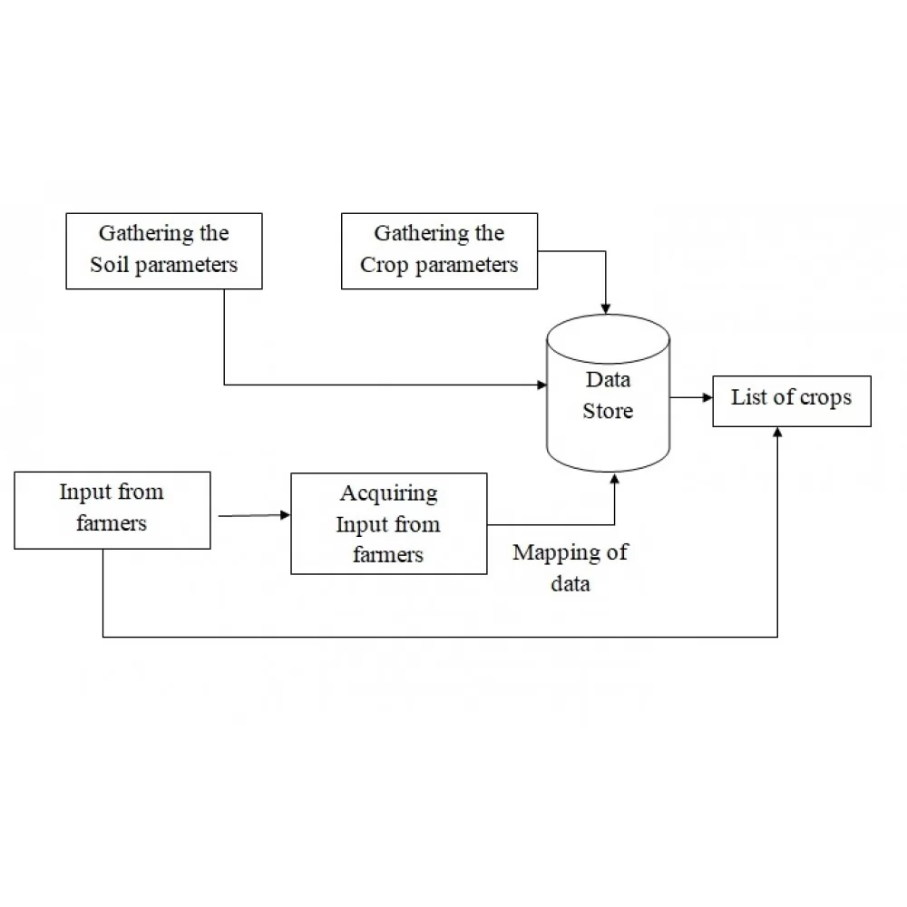

Deliverables/goals

The project promises to deliver interface where user can sign in with details and get recommendations/suggestions regarding crops i.e. What will be the most optimal crop to grow on basis of user provided details.

**RELEVANT MATHEMATICS or ALGORITHM**

**Support vector machine**

Support Vector Machine (SVM) is a supervised machine learning algorithm used for both classification and regression. Though we say regression problems as well its best suited for classification. The objective of SVM algorithm is to find a hyperplane in an N-dimensional space that distinctly classifies the data points. The dimension of the hyperplane depends upon the number of features. If the number of input features is two, then the hyperplane is just a line. If the number of input features is three, then the hyperplane becomes a 2-D plane.

**Decision Tree**

In a decision tree, for predicting the class of the given dataset, the algorithm starts from the root node of the tree. This algorithm compares the values of root attribute with the record (real dataset) attribute and, based on the comparison, follows the branch and jumps to the next node.

For the next node, the algorithm again compares the attribute value with the other sub-nodes and move further. It continues the process until it reaches the leaf node of the tree. The complete process can be better understood using the below algorithm:

* 1: Begin the tree with the root node, says S, which contains the complete dataset.
* 2: Find the best attribute in the dataset using Attribute Selection Measure and feature extraction techniques.
* 3: Divide the S into subsets that contains possible values for the best attributes.
* 4: Generate the decision tree node, which contains the best attribute.
* 5**:** Recursively make new decision trees using the subsets of the dataset created in step -3. Continue this process until a stage is reached where you cannot further classify the nodes and called the final node as a leaf node.

**Random Forest Algorithm**

Random Forest is a classifier that contains a number of decision trees on various subsets of the given dataset and takes the average to improve the predictive accuracy of that dataset." Instead of relying on one decision tree, the random forest takes the prediction from each tree and based on the majority votes of predictions, and it predicts the final output. The greater number of trees in the forest leads to higher accuracy and prevents the problem of overfitting.

**REFERENCES**

1] Kalimuthu, P. Vaishnavi, M. Kishore “Crop Prediction using Machine Learning.” IEEE Xplore Part Number: CFP20P17-ART; ISBN: 978-1-7281-5821-1

[2] V. Sellam, E. Poovammal “Prediction of Crop Yield using Regression Analysis” in 4th Int. Conf. on Reliability, Infocom Technologies and Optimization, Indian Journal of Science and Technology, Vol 9(38), October 2016

[3] Renuka, Sujata Terda “Evaluation of Machine Learning Algorithms for Crop Yield Prediction” International Journal of Engineering and Advanced Technology (IJEAT)ISSN: 2249-8958 (Online), Volume-8 Issue-6, August, 2019

[4] Rahul Katarya, Ashutosh Raturi, Abhinav Mehndiratta, Abhinav Thapper, “Impact of Machine Learning Techniques in Precision Agriculture”, 2020 3rd International Conference on Emerging Technologies in Computer Engineering, IEEE 2020

[5] Lefteris Benos, Aristotelis C. Tagarakis, Georgios Dolias, Remigio Berruto, Dimitrios Kateris, and Dionysis Bochtis, “Machine Learning in Agriculture: A Comprehensive Updated Review.”, Sensors 2021, 21, 3758.

[6] P. Isakki, R. Sujatha, “A Study on Crop Yield Forecasting Using Classification Techniques” 2016 International Conference on Computing Technologies and Intelligent Data Engineering (ICCTIDE'16), IEEE Xplore: 31 October 2016.

[7] Rakesh Shirsath; Neha Khadke; Divya More; Pooja Patil; Harshali Patil, “Agriculture Decision Support System using Data Mining” 2017 International Conference on Intelligent Computing and Control (I2C2)

[8] Subhadra Mishra, Debahuti Mishra and Gour Hari Santra, “Applications of Machine Learning Techniques in Agricultural Crop Production: A Review Paper”, Indian Journal of Science and Technology, Vol 9(38), Oct 2016

[9] Fazeel Ahmed Khan, Adamu Abubakar Ibrahim, Mohammed Salman Rais, Priyanka Rajpoot, AmbareenKhan, Mohammad, Nishat Akhtar, “Performance Analysis of Supervised Learning Algorithms based on Classification Approach”, 2019 6th IEEE International Conference on Engineering Technologies and Applied Sciences (ICETAS)

[10] Bhargavi R, Maya Gopal P. S, “Performance Evaluation of Best Feature Subsets for Crop Yield Prediction Using Machine Learning Algorithms”, 05 Apr 2019