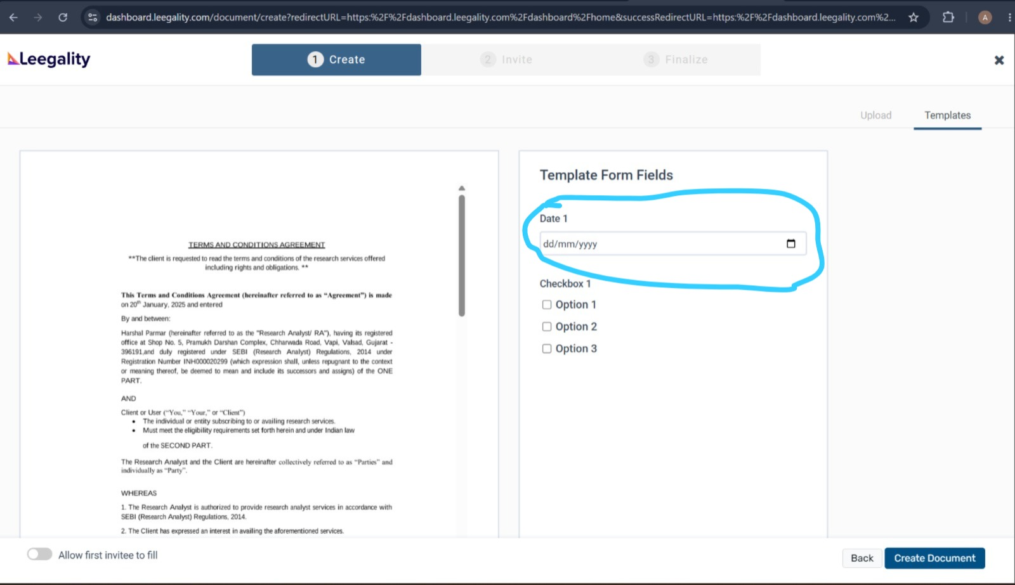
in "Date 1" capture the date when the action is being performed

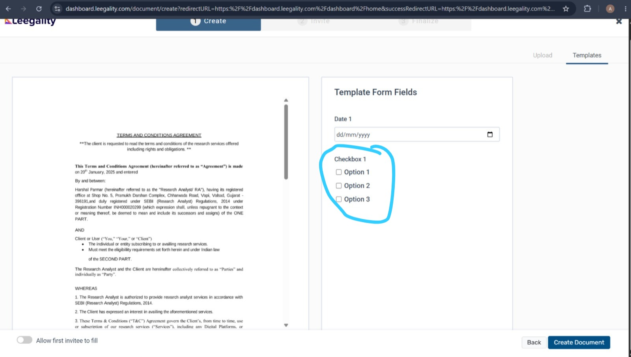

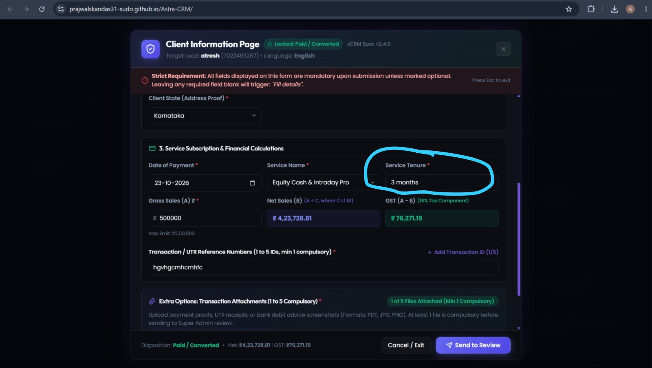

Checkbox 1 is dynamically linked to the Service Tenure field on the Client Information Page. The system must automatically fetch and display whichever Service Tenure option the user selected on that page directly into Checkbox 1.

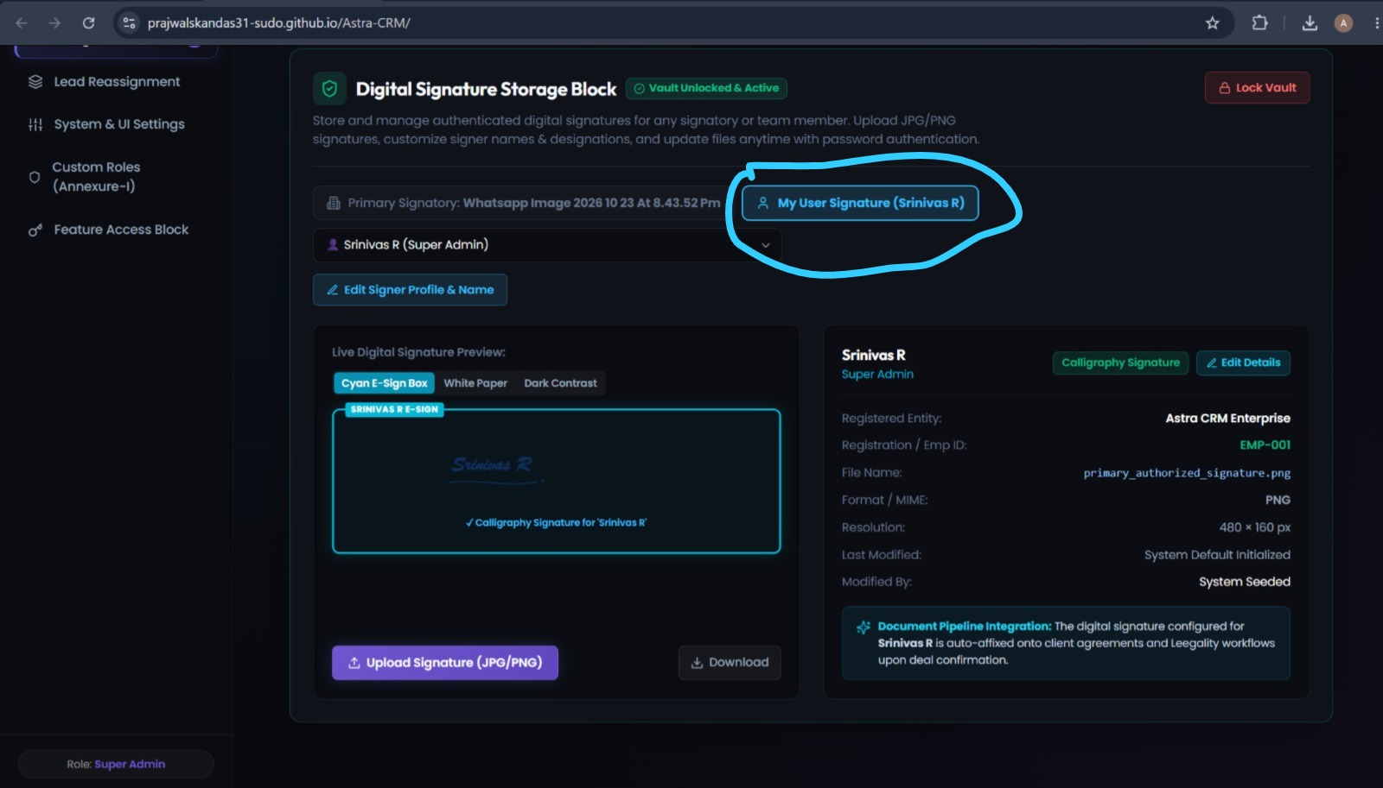
Whatever signature is uploaded in the "My User Signature" block must automatically reflect in the two designated marked locations on the document. Additionally, a timestamp displaying the exact execution time in 24-hour format must be placed directly beneath the signature in both places.
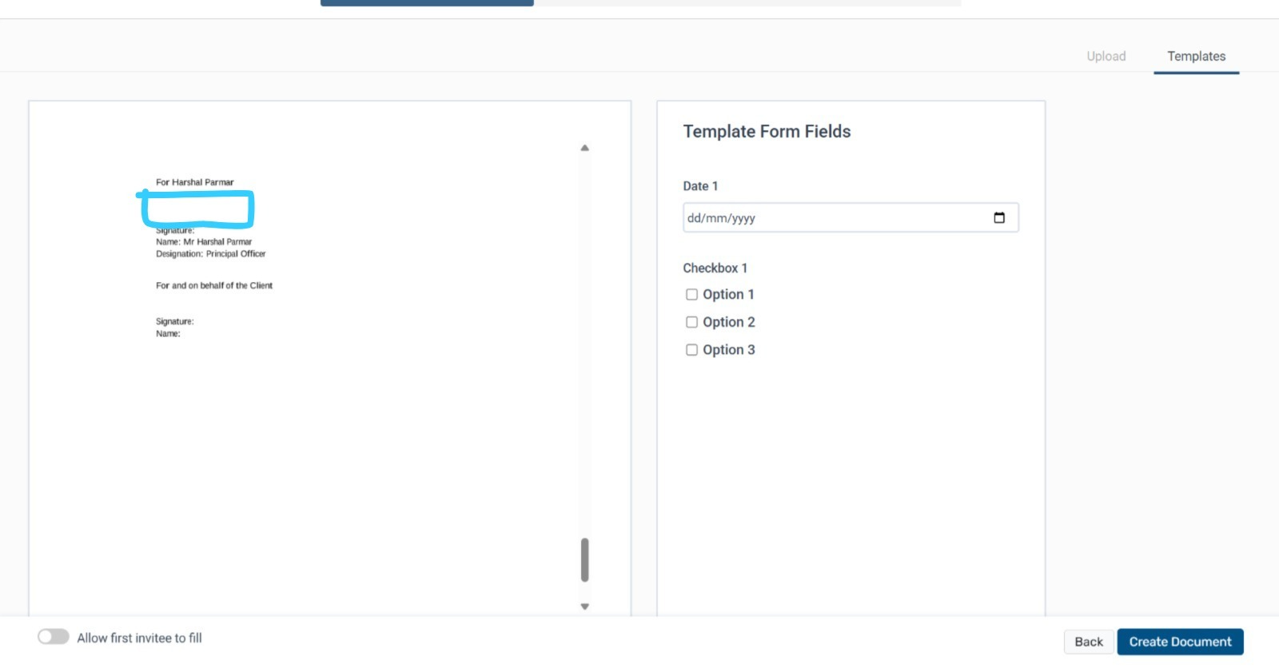

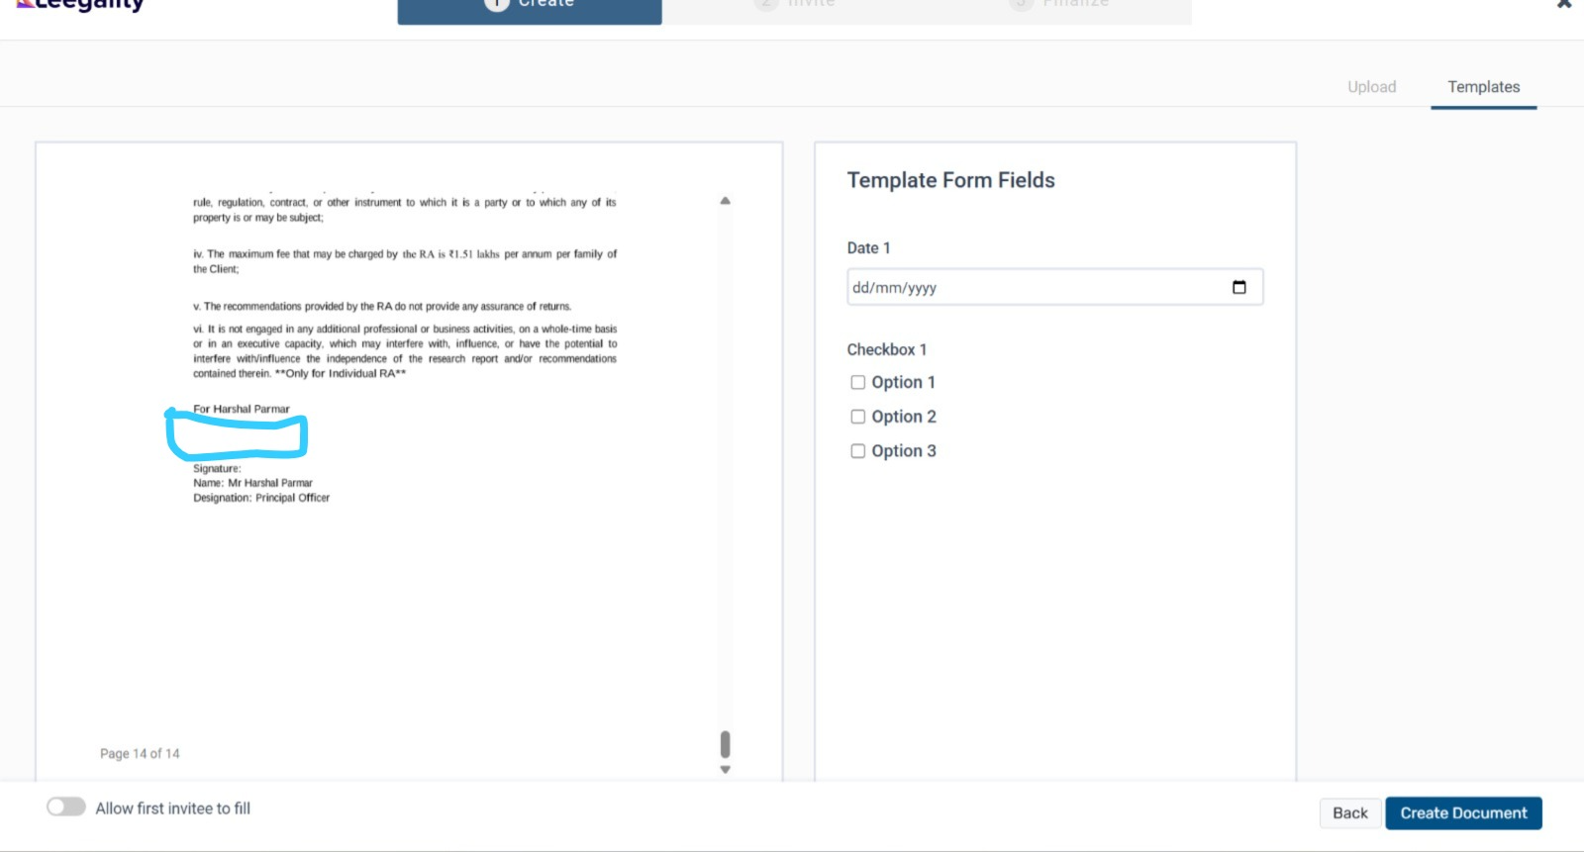

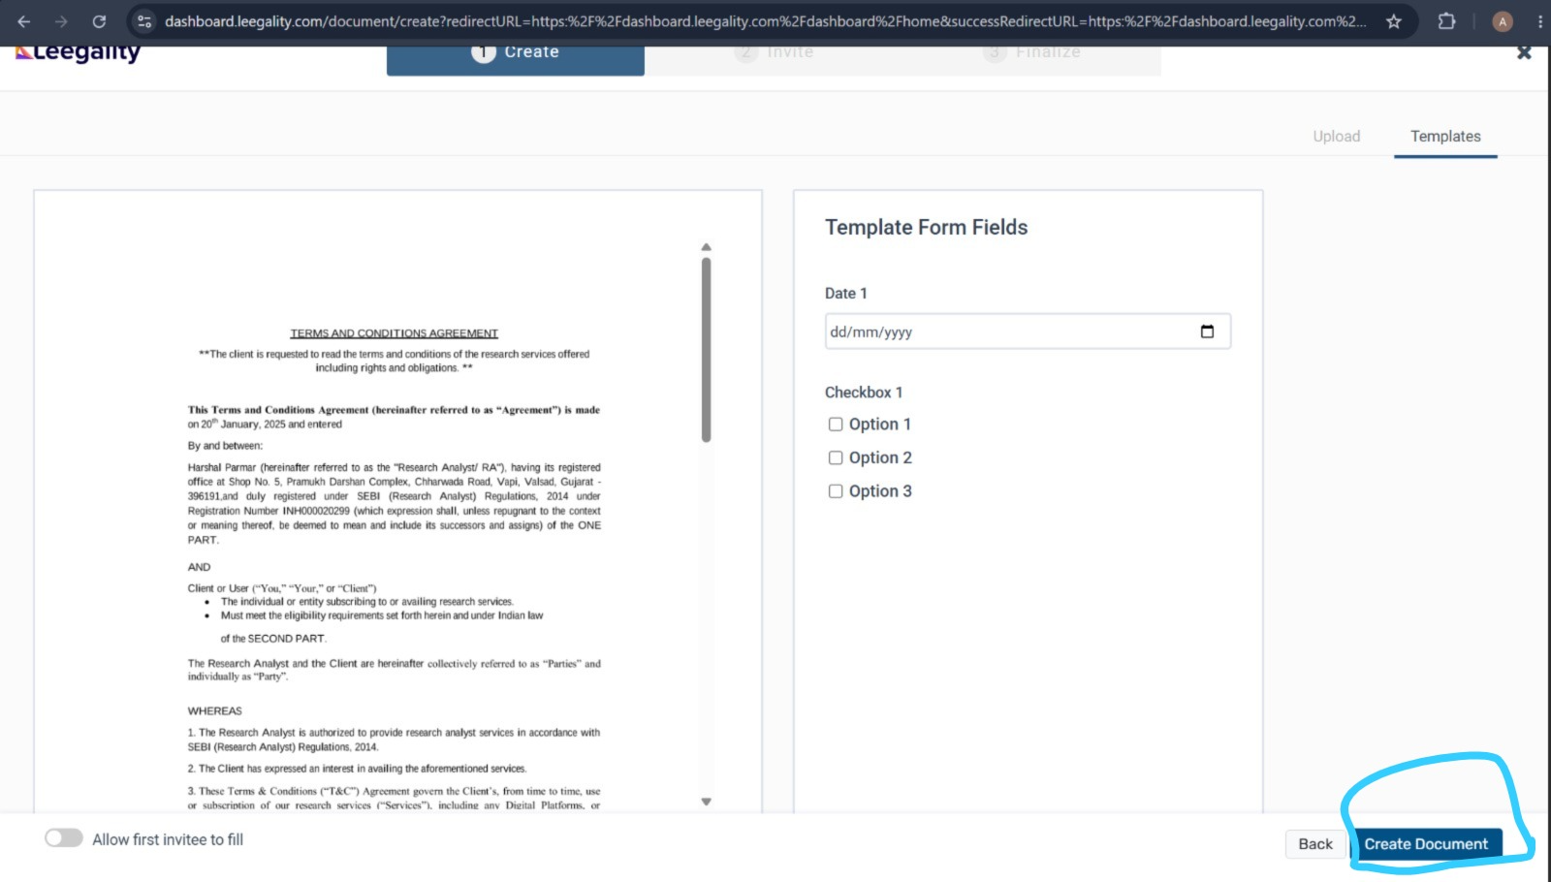
After the above steps are performed , go to “create document”

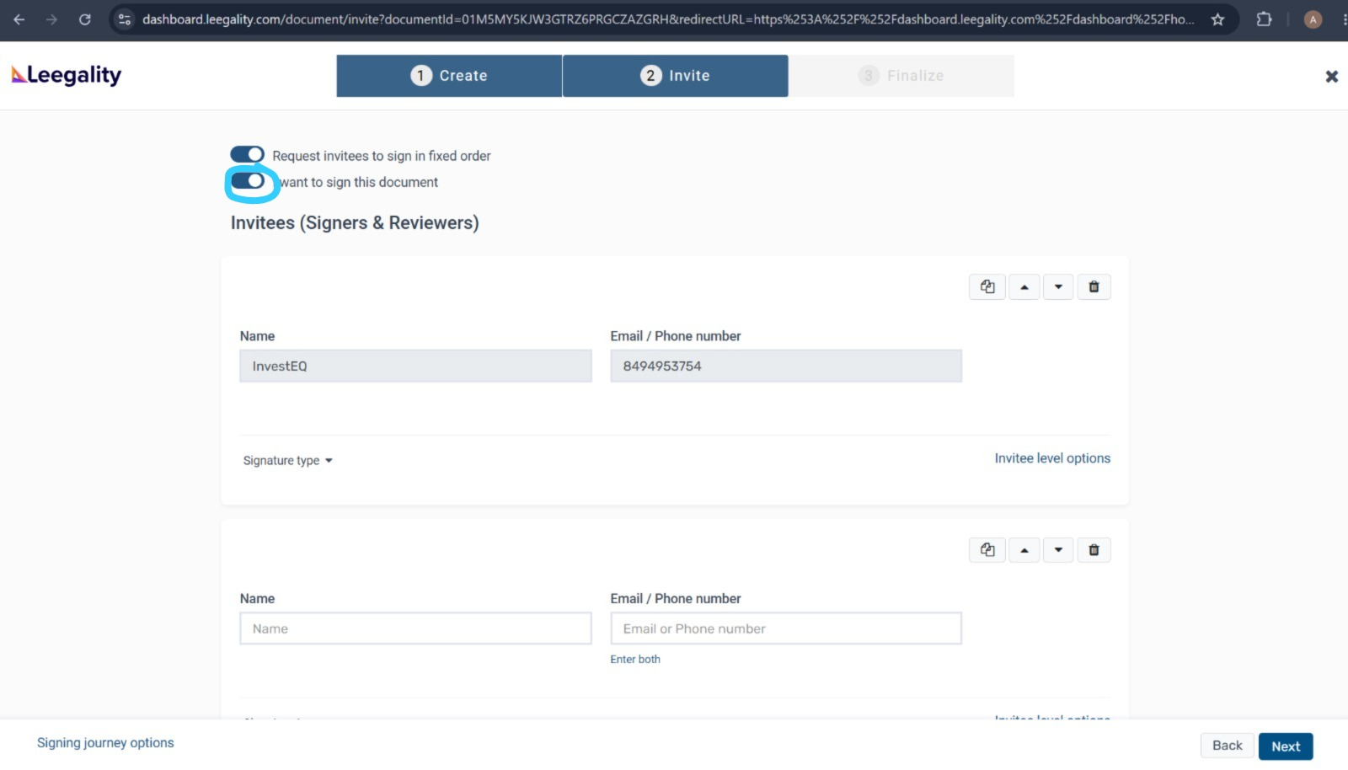
then disable this "i want to sign this document"

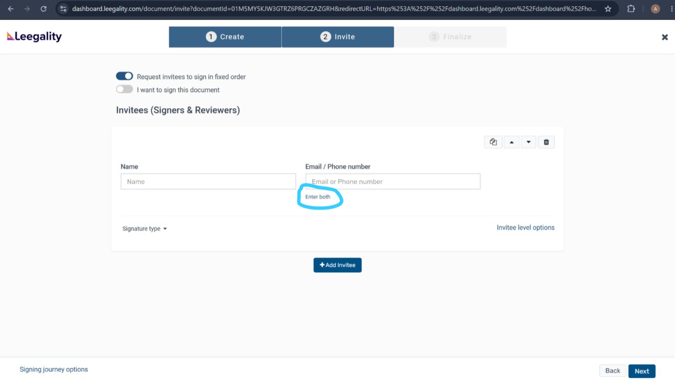
Then select “enter both”

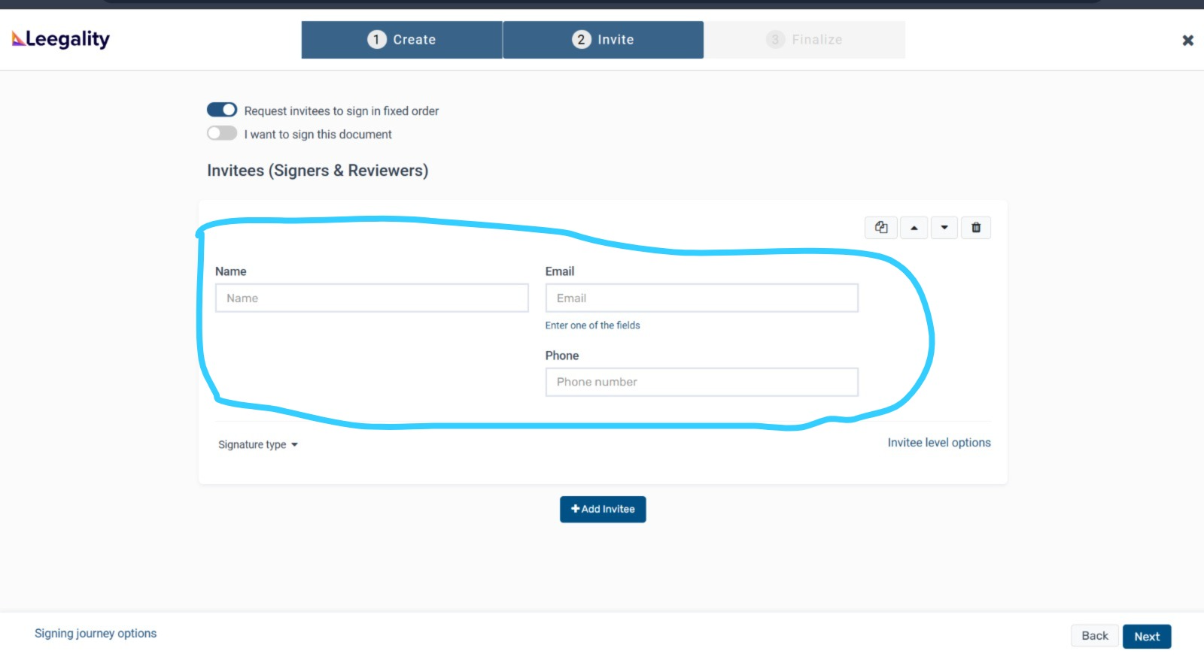

The “name” “email” “phone” must be fetched from the “client information page ” of the crm

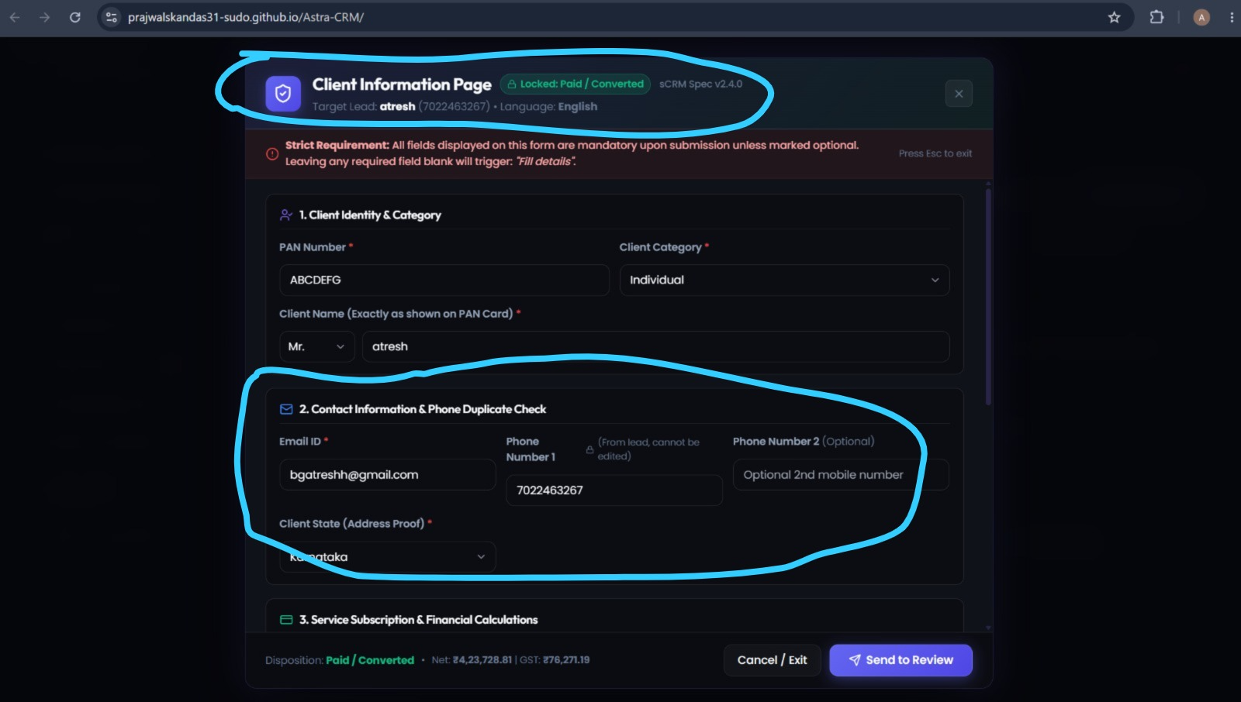

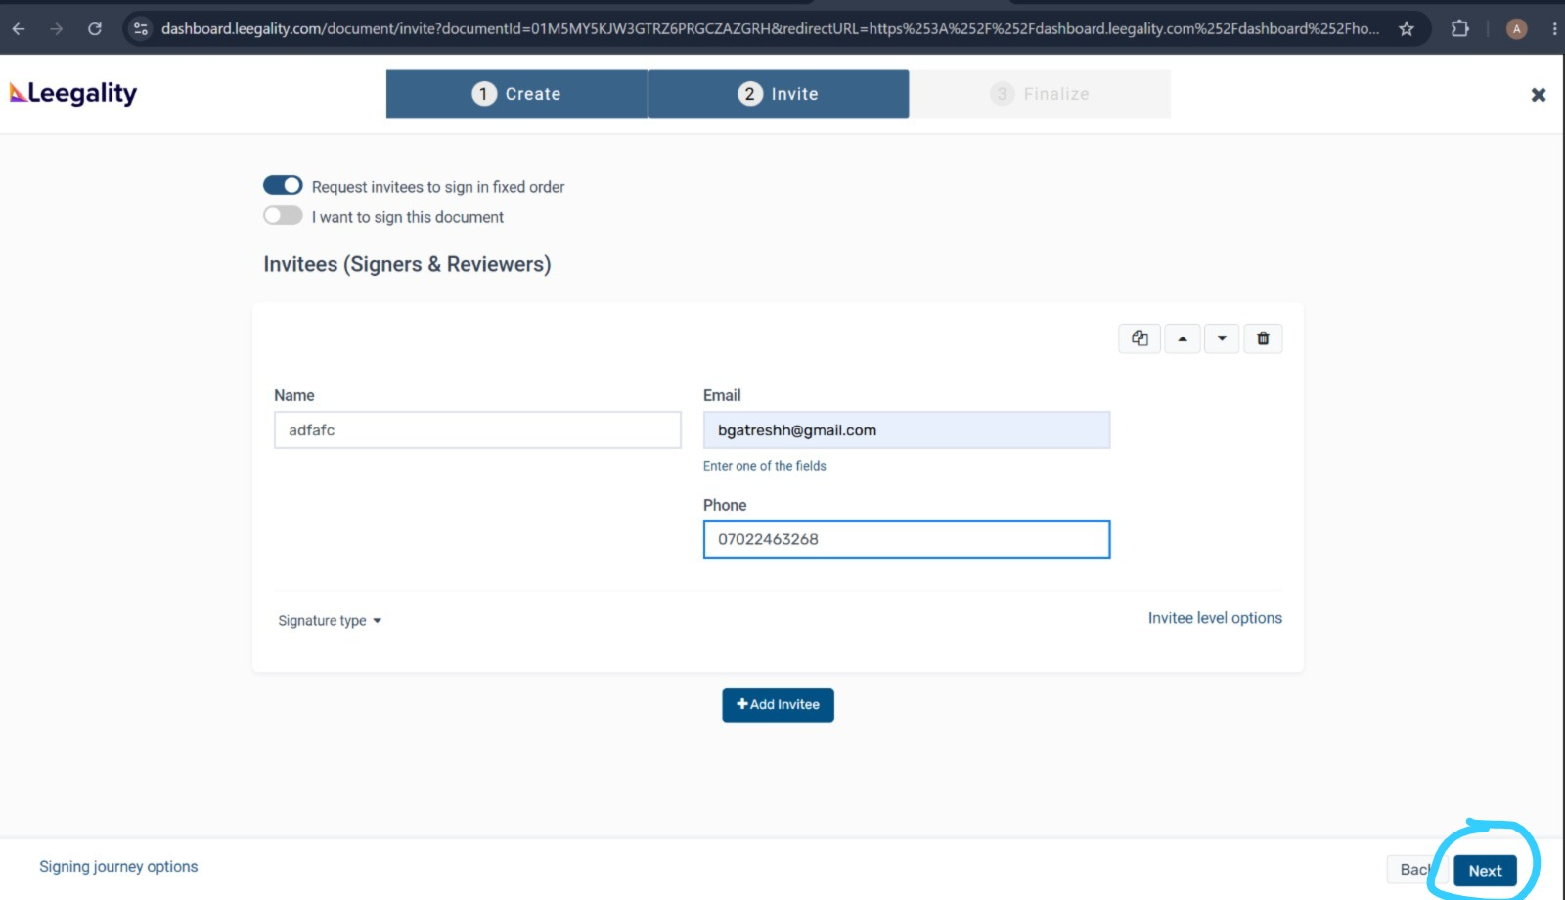
After filling “name” “email” “phone” select “next”

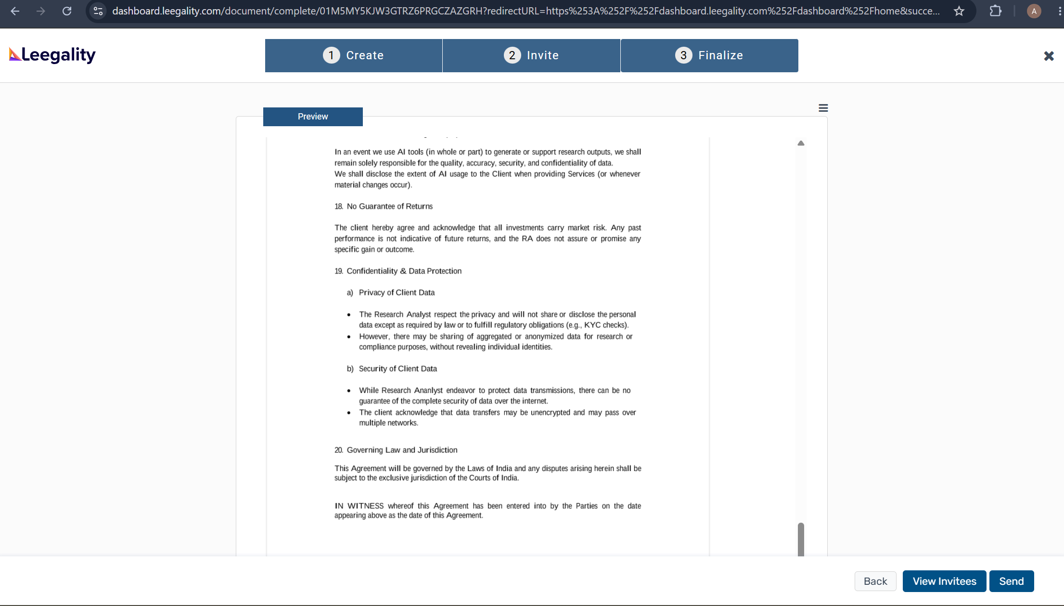then select “send”

