DELIVERABLE 3 — SOFTWARE ARCHITECTURE AND DESIGN SPECIFICATION

1. Introduction

1.1 Purpose
This document describes a proposed logical architecture and design for the Web-Based ML Model Evaluator. It identifies components, their responsibilities, data flow, security boundaries, API contracts, error handling, and traceability to SRS requirements.

1.2 Architectural status
The architecture below is a technology-neutral proposal based on the project title and baseline SRS. It is not a description of verified source code. Replace component names, endpoints, storage choices, and deployment details with the actual implementation before submission.

2. Architecture Overview

2.1 Proposed architectural pattern
Proposed pattern: layered web architecture with separation between presentation, API/application services, evaluation logic, and persistence. This pattern supports independent testing of metric logic and clear responsibility boundaries. A small student project may deploy these layers in one process; the logical separation does not require microservices.

2.2 Component diagram
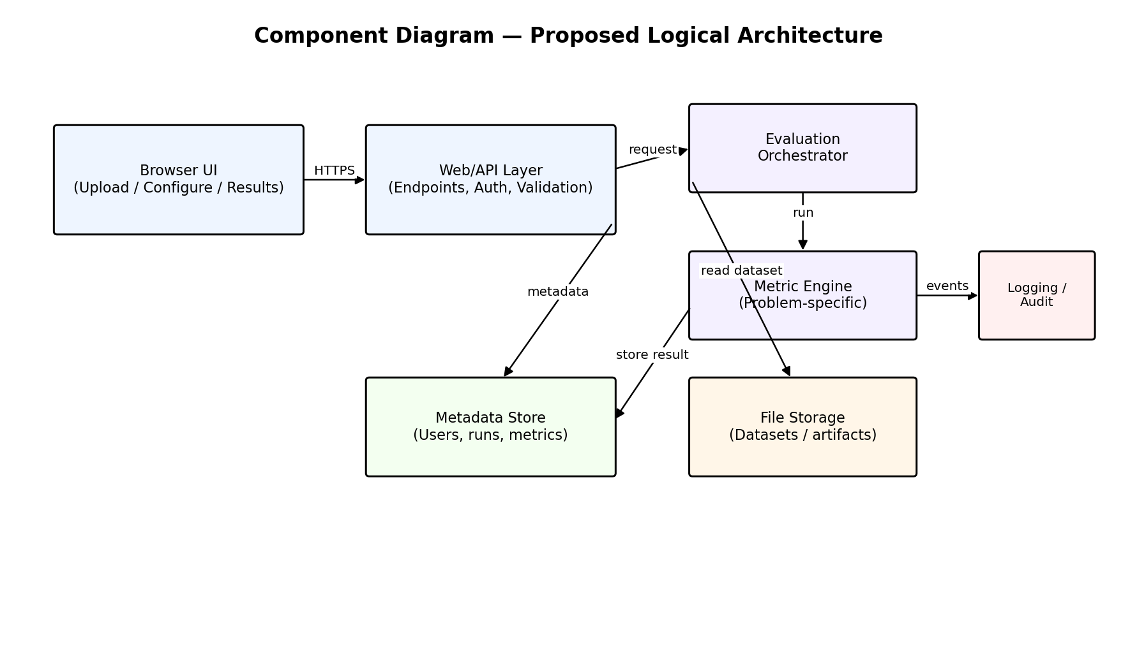
Figure 2. Proposed component diagram; deployment topology and storage technologies remain TBD.

2.3 Component descriptions
Component | Responsibilities | Related requirements
Browser UI | Accept user input, show validation, expose supported configuration, render status and metrics. | FR-01, FR-05, FR-08, NFR-08, NFR-12
Web/API layer | Validate request shape, enforce upload limits, coordinate application use cases, return safe responses. | FR-02–FR-06, FR-09, SEC-01, SEC-02, SEC-06
Evaluation orchestrator | Create a run, call metric logic, track status, associate results with input/configuration. | FR-07, FR-10, FR-14
Metric engine | Implement supported metrics and validate compatible task/metric combinations. | FR-06–FR-08, NFR-03, NFR-09
Metadata store | Persist run metadata, status, configuration, and results if persistence is in scope. | FR-11, FR-14, NFR-07
File storage | Store input files or temporary files under controlled paths, if file persistence is needed. | FR-01, SEC-08
Logging/audit | Record operational events and failure identifiers without sensitive data. | NFR-11, SEC-07

2.4 Data flow
- The browser submits a supported file or prediction input and the selected evaluation configuration.
- The API layer enforces request, file-size, type, and structure checks.
- The orchestrator creates or identifies an evaluation run and invokes the metric engine.
- The metric engine calculates only the selected, compatible metrics.
- The application associates metrics with the run and persists metadata if persistence is implemented.
- The API returns a status/result reference and the UI presents the result or safe error.

2.5 Deployment view
Proposed minimum deployment consists of a browser and one application server. A database and object/file storage are optional depending on whether run history and retained uploads are required. The actual deployment diagram must name the real runtime, database, storage, port, and hosting environment.

2.6 Architectural decisions
Decision | Proposed rationale | Trade-off / confirmation
Layered design | Keeps UI, request handling, metric logic, and persistence responsibilities distinct. | Avoid overengineering; layers may be modules in one application.
Synchronous evaluation initially | Simplifies a small project if input sizes are modest. | Long-running jobs may require background processing and status polling.
Temporary input storage by default | Reduces unnecessary retention of potentially sensitive data. | History/reproducibility may require controlled retention and deletion.
JSON response contract | Easy for browser clients and test automation. | File upload itself may use multipart/form-data.
Allowlist supported metrics | Prevents unsupported combinations and ambiguous behavior. | Metric catalogue must be maintained and documented.

3. Security Architecture

3.1 Trust boundaries
- Boundary A — Browser to server: treat all client input as untrusted; use HTTPS in deployment.
- Boundary B — Uploaded file to parser: validate size, type, schema, and row limits before expensive processing.
- Boundary C — Application to storage: use controlled paths and least-privilege storage permissions.
- Boundary D — User to private resources: enforce ownership checks if accounts and private resources exist.

3.2 Security controls
Threat / risk | Proposed control | Requirement
Oversized upload / resource exhaustion | Enforce byte and, where appropriate, row limits before processing. | SEC-01
Spoofed or malformed file | Allowlist formats; inspect content and parse safely; catch parser errors. | SEC-02
Uploaded code execution | Treat uploads as data; never import/execute uploaded content. | SEC-03
Unauthorized result access | Authenticate and check resource ownership if private accounts are supported. | SEC-04
Network interception | HTTPS in deployed environment. | SEC-05
Information leakage | Safe error mapping; avoid stack traces and secret values in responses. | SEC-06
Sensitive logs | Log identifiers and error codes rather than raw records or credentials. | SEC-07
Retained temporary files | Controlled directory, generated storage names, documented cleanup policy. | SEC-08

3.3 Security assumptions and limitations
This mini-project specification does not claim a formal penetration test, regulatory compliance, or certification. Security checks must be executed against the actual deployed build. If the application has no login system, authentication-related tests should be marked not applicable rather than claiming authorization is implemented.

4. Design Specification

4.1 Module design
Module | Input | Output | Key behavior
Upload handler | Multipart file / input payload | Input reference or validation error | Checks size and allowed format; generates safe storage name.
Schema validator | Parsed header/schema and task configuration | Valid/invalid result with field-level errors | Checks required fields, non-empty rows, compatible values.
Configuration validator | Task type and metric IDs | Validated configuration | Allows only implemented task/metric combinations.
Evaluation service | Validated input and configuration | Metric result object | Calls deterministic metric functions; catches expected failures.
Result presenter | Run/result object | UI view / JSON response | Displays metric names, values, sample count and status.
Run repository (optional) | Run metadata and results | Stored record / run lookup | Persists and retrieves run metadata with access checks.
Error mapper | Internal exception category | Safe error code and message | Avoids exposing stack traces and secrets.

4.2 Metric-engine design
The metric engine should expose a small, testable interface. The following is a conceptual contract, not language-specific code:
evaluate(task_type, reference_values, prediction_values, metric_ids, metric_options) → {metric_name: value, sample_count, metadata}
- Validate that reference and prediction sequences have compatible lengths.
- Validate task-specific value types and metric compatibility.
- Use documented metric definitions and averaging conventions.
- Return structured results; do not mix UI rendering into calculation functions.
- Raise or return typed errors for invalid input and unsupported metrics.

4.3 Sequence diagram — upload and validation
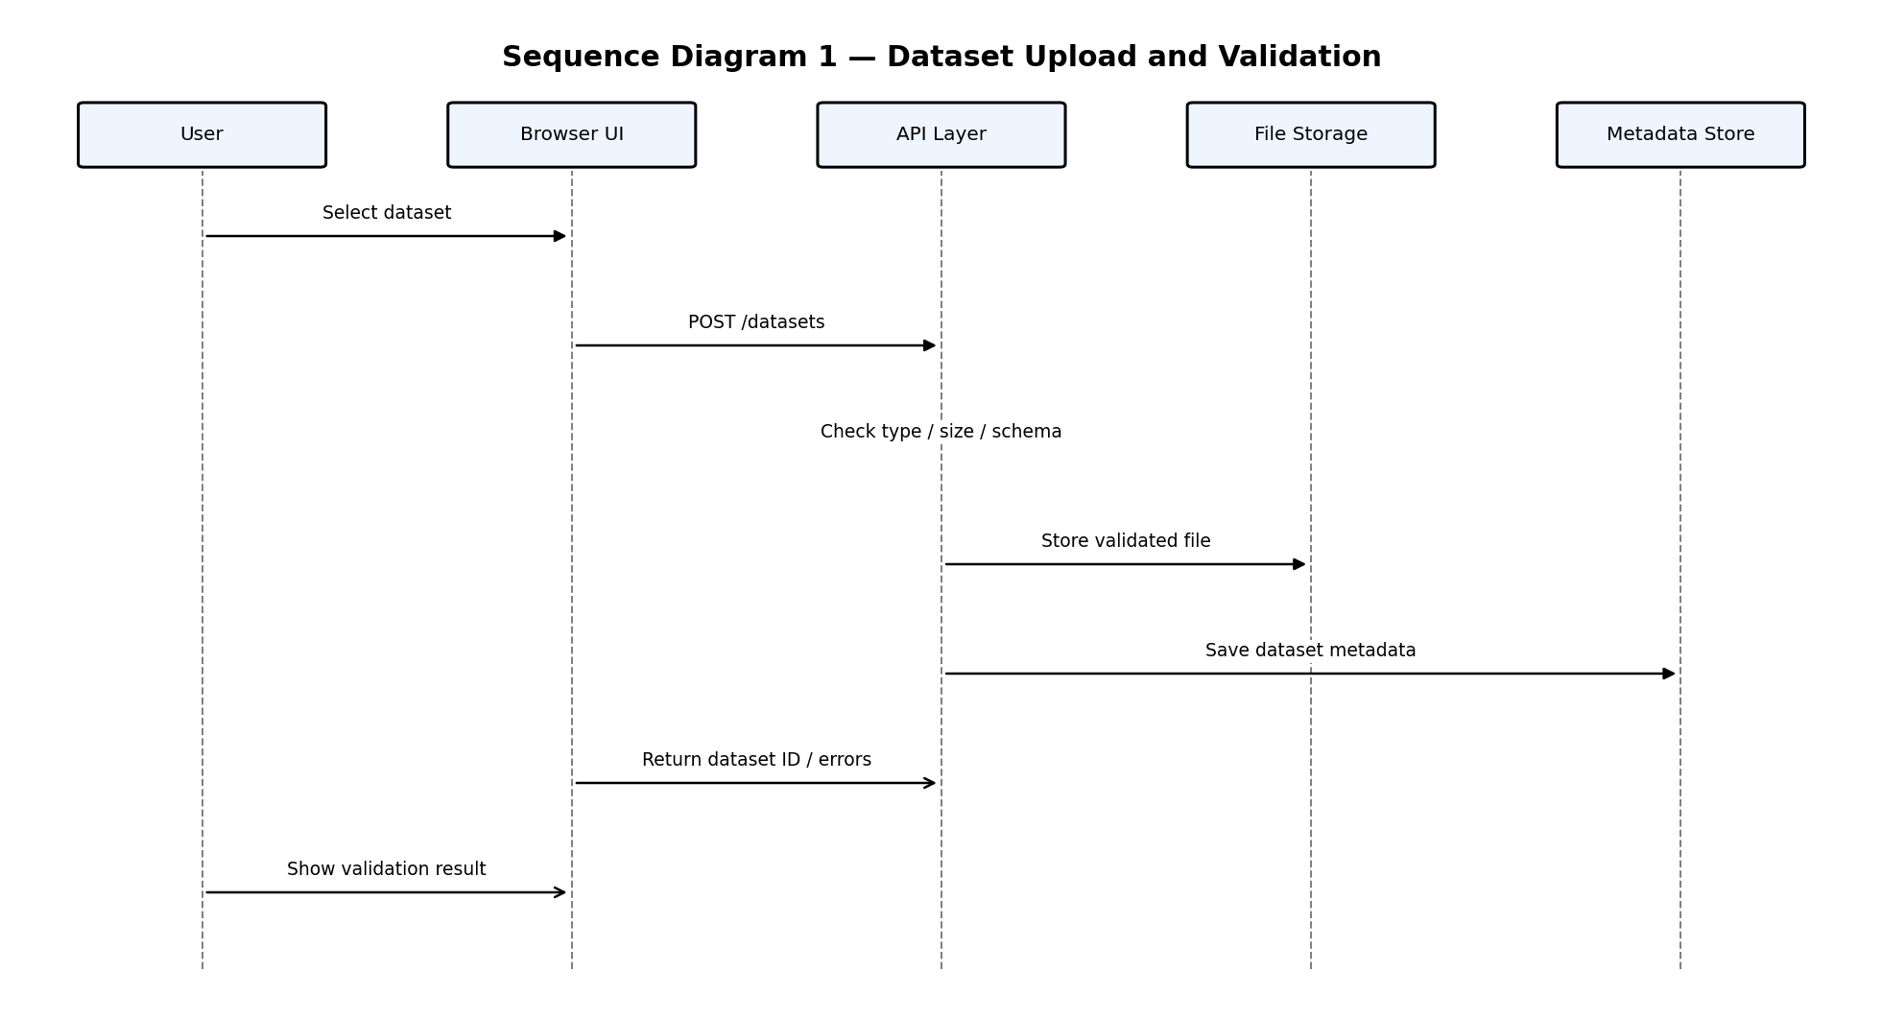
Figure 3. Proposed sequence for upload and validation.

4.4 Sequence diagram — evaluation
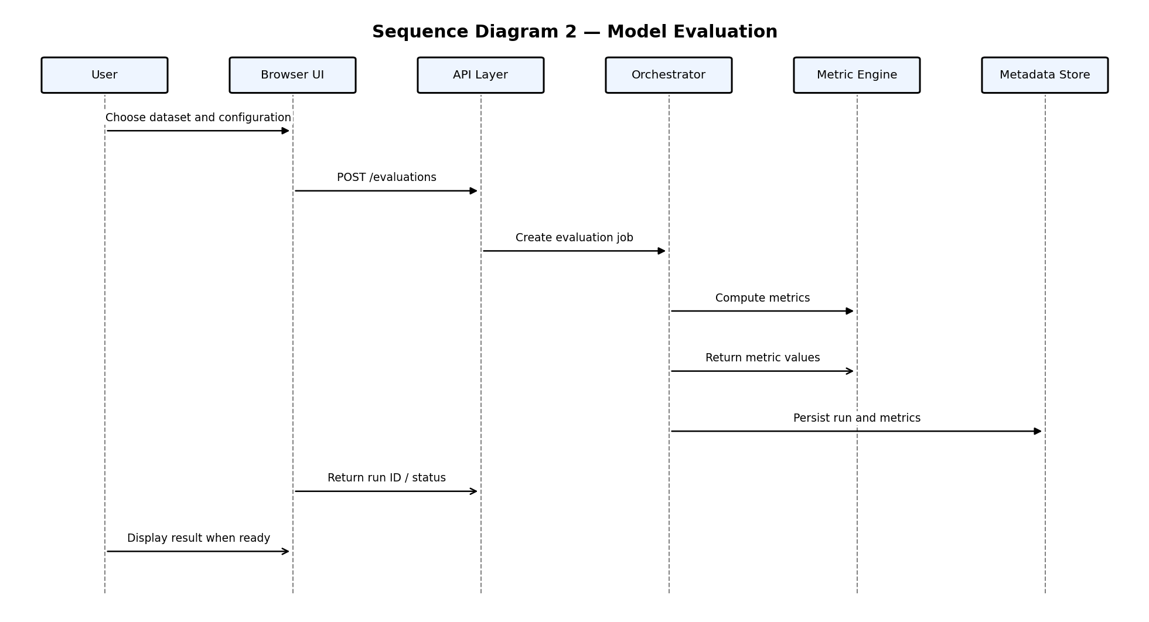
Figure 4. Proposed sequence for evaluation and result persistence.

4.5 API design
The endpoint names below are proposed REST-style contracts. Use them only if they match the actual implementation; otherwise replace them with the real routes.
Method / endpoint | Purpose | Request | Success response | Typical errors
POST /api/datasets | Upload and validate input. | multipart/form-data: file | 201: {input_id, validation_status, schema_summary} | 400 invalid structure; 413 too large; 415 unsupported type
POST /api/evaluations | Start an evaluation. | JSON: {input_id, task_type, metrics, options} | 200/202: {run_id, status} | 400 invalid configuration; 404 unknown input; 422 incompatible data
GET /api/evaluations/{run_id} | Retrieve status and result. | Path run_id | 200: {run_id, status, metrics, sample_count} | 404 unknown run; 403 unauthorized if access control exists
GET /api/evaluations | List run history, if implemented. | Optional paging/filter parameters | 200: {items, page} | 401 unauthenticated; 403 unauthorized
GET /api/evaluations/{run_id}/report | Export a report, if implemented. | Path run_id; optional format | 200: report file or download reference | 404 unknown run; 406 unsupported format

4.6 Example API payloads
Example request for starting an evaluation (field names are illustrative):
{
"input_id": "input_123",
"task_type": "classification",
"metrics": ["accuracy", "f1_macro"],
"options": {}
}
Example successful response:
{
"run_id": "run_456",
"status": "completed",
"sample_count": 100,
"metrics": {
"accuracy": 0.91,
"f1_macro": 0.89
}
}
These examples illustrate a possible contract only. They must be aligned with actual metric support, field names, identifiers, and response codes.

4.7 Error handling design
Error category | Suggested HTTP status | User-facing behavior | Logging
Malformed request / missing field | 400 Bad Request | Name the missing/invalid field. | Record request ID and error code.
Unsupported media/file format | 415 Unsupported Media Type | List accepted formats. | Do not log raw file contents.
File too large | 413 Content Too Large | State configured size limit. | Record size and request ID.
Invalid dataset schema / values | 422 Unprocessable Content | Identify the validation issue. | Record validation category.
Input/run not found | 404 Not Found | State that the requested resource was not found. | Record resource ID, avoiding sensitive payload.
Unauthorized access (if applicable) | 401/403 | Do not disclose whether another user owns a resource beyond policy. | Record access-denial event.
Unexpected evaluation failure | 500 Internal Server Error | Show a generic message and reference ID. | Store stack trace only in protected server logs.

4.8 Logging and monitoring
- Assign a request or run identifier to help correlate events.
- Record start/end time, status, duration, metric identifiers, and error category as appropriate.
- Do not log passwords, tokens, secrets, or full uploaded data rows.
- Keep user-facing errors separate from internal diagnostic details.

4.9 Maintainability and testability
- Keep each metric calculation independently unit-testable.
- Use a central registry or allowlist for supported metrics and task compatibility.
- Keep validation rules in reusable functions rather than duplicating them in UI and API code.
- Document any nondeterministic behavior and numerical tolerance used in repeatability tests.

5. Design Traceability
Design element | SRS requirements supported
Browser UI | FR-01, FR-05, FR-08, NFR-08, NFR-12
Upload handler / schema validator | FR-02, FR-03, FR-04, FR-09, SEC-01, SEC-02
Configuration validator | FR-05, FR-06
Evaluation service / metric engine | FR-07, FR-08, FR-14, NFR-03, NFR-09
Run repository | FR-11, FR-12, FR-14, NFR-07
Error mapper | FR-09, NFR-02, SEC-06
Controlled file storage / cleanup | FR-01, SEC-08
HTTPS deployment configuration | NFR-04, SEC-05
Logging controls | NFR-11, SEC-07
Test plan and RTM | All specified FRs, NFRs, and SEC requirements

