DELIVERABLE 1 — SOFTWARE REQUIREMENTS SPECIFICATION (SRS)

1. Introduction

1.1 Purpose
This Software Requirements Specification defines the proposed functional, non-functional, interface, data, and security requirements for a web-based application that allows a user to submit a dataset, configure an evaluation, run evaluation logic against a machine-learning model or model output, and inspect the resulting metrics. It is intended to guide implementation, testing, and acceptance.

1.2 Scope
The proposed system provides a browser-based workflow for evaluating machine-learning predictions against reference labels. The baseline assumes supervised classification or regression evaluation using prediction data and ground-truth labels. The system validates uploaded inputs, calculates applicable metrics, stores evaluation metadata, and presents a result summary. The project team must confirm whether the actual application evaluates uploaded prediction files, loads serialized models, calls a training/inference pipeline, or uses another mechanism.
- In scope (proposed): dataset/prediction input upload; input validation; evaluation configuration; metric calculation; result display; error feedback; run metadata.
- Out of scope unless explicitly implemented: model training; hyperparameter tuning; model deployment; online inference APIs; automatic bias/fairness certification; production MLOps orchestration; multi-tenant enterprise administration.

1.3 Definitions, acronyms, and abbreviations
Term | Definition
ML | Machine Learning.
Evaluator | Application that computes evaluation metrics for a model’s predictions.
Ground truth | Reference labels or target values used to assess predictions.
Evaluation run | One execution of an evaluation configuration against an input dataset.
FR | Functional requirement.
NFR | Non-functional requirement.
API | Application Programming Interface.
RBAC | Role-Based Access Control.
TBD | To be decided/confirmed by the project team.

1.4 Assumptions and dependencies
ID | Assumption / dependency | Status / action
A-01 | The application is accessed through a modern web browser. | Proposed; confirm supported browsers.
A-02 | The evaluation uses labelled data or a reference target column. | Proposed baseline; confirm task type.
A-03 | The user supplies predictions and reference values, or the application can obtain predictions from a supported model. | Choose one actual workflow.
A-04 | The system can calculate at least one suitable metric for each supported task type. | Select metrics implemented by the team.
A-05 | A server-side component validates requests and performs or coordinates evaluation. | Confirm actual architecture.
A-06 | Persistent storage may be used for run metadata; file persistence is implementation-dependent. | TBD.
A-07 | Authentication is not assumed to exist. If user accounts exist, enforce authorization and ownership. | Confirm login requirement.
A-08 | The system is a student mini-project, not a certified or safety-critical evaluation platform. | Project context; revise if needed.

1.5 Overview
Section 2 describes the product context. Section 3 specifies external interfaces. Section 4 lists functional and non-functional requirements. Section 5 records logical data requirements. Section 6 defines security objectives and requirements. Section 7 provides a use case model. Section 8 lists constraints and acceptance conditions.

2. Overall Description

2.1 Product perspective
The evaluator is a web application with a user interface, a server/API layer, an evaluation component, and storage components where required. These are logical responsibilities, not a claim about the current codebase. The implementation may combine components or use different technologies.

2.2 Product functions
- Accept an evaluation input and identify its structure.
- Validate required columns, target values, file type, file size, and supported task configuration.
- Allow a user to choose a supported evaluation task and metric set.
- Run metric calculations and produce a structured result.
- Display metrics and the status of an evaluation run.
- Provide actionable error messages when input or evaluation fails.
- Optionally retain run history and allow report export, if implemented.

2.3 User classes and characteristics
User class | Needs / privileges
Evaluator user | Submits inputs, configures evaluations, views results for runs they are permitted to access.
Project administrator (optional) | Manages users or system configuration only if such functionality is implemented.
Developer / maintainer | Diagnoses failures through logs and maintains supported metrics and validation rules.

2.4 Operating environment
Proposed environment: a modern browser on a desktop or laptop and a server environment capable of running the chosen application stack. Exact operating systems, browser versions, runtime, database, deployment platform, and resource limits are TBD and must be specified from the implementation.

2.5 Design and implementation constraints
- The application must only claim support for file formats, model types, tasks, and metrics actually implemented.
- Metric names, definitions, input conventions, and averaging strategies must be stated clearly.
- Uploaded data must be validated before evaluation logic consumes it.
- The application must not execute uploaded files as code.
- Evaluation results should be reproducible for the same inputs and configuration, subject to the selected algorithm and numerical environment.

2.6 User documentation
The project should provide concise instructions describing accepted input formats, required columns, supported tasks/metrics, upload limits, how to run an evaluation, how to interpret outputs, and common validation errors.

3. External Interface Requirements

3.1 User interface
- UI-01: The upload screen shall state accepted file formats and the maximum file size.
- UI-02: The configuration screen shall expose only task types and metrics supported by the implementation.
- UI-03: The result screen shall display metric names, values, and relevant context such as sample count and task type.
- UI-04: Validation failures shall identify the problem and, where practical, how to fix it.
- UI-05: Controls shall have understandable labels and visible status feedback.

3.2 Software interfaces
The precise interface depends on the selected stack. The proposed logical API in the Design Specification uses JSON for metadata and multipart/form-data for file uploads. These are design proposals, not verified existing endpoints.

3.3 Hardware interfaces
No specialized hardware interface is required by the baseline. CPU, memory, and storage requirements depend on maximum supported input size and evaluation complexity; these limits are TBD.

3.4 Communications interfaces
If deployed over a network, browser-to-server communication shall use HTTPS in the deployed environment. Local development may use a local HTTP endpoint; this does not satisfy the deployment security requirement.

4. System Features and Requirements

4.1 Requirement conventions
Each requirement uses a unique ID and the word “shall” for a mandatory, testable obligation. Requirements are intentionally measurable where the project team can set a threshold. Where the real deployment limit is unknown, the value is marked TBD and must be fixed before acceptance testing.

4.2 Functional requirements
ID | Name | Requirement
FR-01 | Input upload | The system shall allow the user to submit an evaluation input in at least one documented, supported format.
FR-02 | Upload validation | The system shall reject files with unsupported extensions or content types and display a validation message.
FR-03 | Size limit | The system shall reject inputs exceeding the configured maximum upload size, M_UPLOAD, and state the permitted limit.
FR-04 | Structure validation | The system shall verify that required prediction and reference/target fields are present before starting evaluation.
FR-05 | Configuration | The system shall allow the user to select a supported task type and one or more compatible metrics.
FR-06 | Compatibility | The system shall reject a task/metric combination that is not supported by the evaluator.
FR-07 | Evaluation execution | For valid inputs and configuration, the system shall calculate the selected metrics and associate the results with an evaluation run.
FR-08 | Result presentation | The system shall display each selected metric’s name and computed value for a completed run.
FR-09 | Failure handling | If validation or evaluation fails, the system shall show an actionable error and shall not present the run as successfully completed.
FR-10 | Run status | The system shall expose a status for each submitted evaluation: pending, running, completed, or failed, if asynchronous processing is used.
FR-11 | Run history | If persistence/history is in scope, the system shall list prior runs belonging to the current user or session.
FR-12 | Run detail access | If user accounts are implemented, the system shall prevent a user from viewing another user’s restricted run.
FR-13 | Report export | If report export is implemented, the system shall export the displayed metrics and run context in a documented format.
FR-14 | Input-to-result linkage | The system shall associate each result with the configuration and input identifier used to produce it.

4.3 Non-functional requirements
ID | Quality attribute | Requirement
NFR-01 | Performance | For an input of up to N_ROWS rows and within the configured size limit, 95% of evaluations shall complete within T_EVAL seconds in the documented test environment. N_ROWS and T_EVAL shall be set before acceptance testing.
NFR-02 | Availability / robustness | The application shall handle invalid user input without an unhandled server error or process crash.
NFR-03 | Reliability | For a fixed valid input and configuration, repeated runs shall produce numerically equivalent results within a documented tolerance EPSILON.
NFR-04 | Security — transport | A deployed instance shall use HTTPS for browser-to-server communication.
NFR-05 | Security — file handling | The application shall validate uploaded file type, size, and structure before parsing or processing it.
NFR-06 | Security — secrets | Credentials, API keys, and secret configuration values shall not be committed to source control or returned in API responses.
NFR-07 | Privacy | The application shall not expose uploaded data or run results to unauthorized users; retention and deletion behavior shall be documented.
NFR-08 | Usability | A first-time user following the project instructions shall be able to complete a valid evaluation without developer-only commands.
NFR-09 | Maintainability | Evaluation metric logic shall be separated from request parsing and presentation logic sufficiently to allow a metric to be tested independently.
NFR-10 | Compatibility | The UI shall work in the browser versions explicitly listed in the project’s deployment notes.
NFR-11 | Observability | Unexpected evaluation failures shall be recorded in server logs without logging secrets or unnecessary raw dataset contents.
NFR-12 | Accessibility | Core upload, configuration, and result workflows shall be usable with keyboard navigation and have programmatically associated labels.

4.4 Business rules and metric semantics
- BR-01: Metrics must be compatible with the selected task type.
- BR-02: The system must identify which column/field is the reference target and which is the prediction.
- BR-03: The system must define behavior for missing values, empty input, mismatched lengths, and unsupported labels.
- BR-04: Metric outputs must use documented definitions and averaging choices; for example, classification F1 may be binary, macro, micro, or weighted.
- BR-05: A numeric metric must not be displayed as a valid result if computation failed or returned a non-finite value, unless that value is explicitly defined and explained.

5. Logical Data Requirements
Entity | Proposed fields | Notes
EvaluationRun | run_id, created_at, status, task_type, selected_metrics, input_reference, result_summary, error_code | Logical record; actual persistence TBD.
Dataset/Input | input_id, original_name, stored_reference, size_bytes, schema_summary, created_at | Avoid storing raw data longer than necessary.
MetricResult | run_id, metric_name, metric_value, metric_parameters | May be embedded in run record.
User (optional) | user_id, authentication reference, role | Only if login/account functionality exists.

Data integrity rules: each completed result must refer to one evaluation run; metric values must be linked to the exact configuration; failed runs must preserve an appropriate failure status; and user ownership must be enforced if accounts are supported.

6. Security Requirements

6.1 Security objectives
Objective ID | Objective
SO-01 | Protect the confidentiality of uploaded datasets, prediction values, and evaluation results.
SO-02 | Preserve the integrity of evaluation inputs, configuration, and reported results.
SO-03 | Maintain service availability by rejecting malformed or excessively large inputs safely.
SO-04 | Ensure that users can access only the resources permitted to them, if authentication is implemented.

6.2 Security requirements
ID | Requirement | Verification
SEC-01 | The system shall enforce the configured upload-size limit before fully processing the input. | Boundary-size tests; inspect server configuration.
SEC-02 | The system shall validate file extension, content type, and expected structure; extension alone shall not be treated as sufficient validation. | Malformed-file and spoofed-content tests.
SEC-03 | The system shall not execute uploaded files or evaluate arbitrary code supplied in an upload. | Code review and malicious-input test.
SEC-04 | If accounts exist, each request for a private run or file shall verify ownership or an authorized role. | Cross-user authorization test.
SEC-05 | The deployed application shall use HTTPS and shall not transmit credentials or private dataset contents over plaintext HTTP. | Deployment/configuration inspection.
SEC-06 | Error responses shall not expose stack traces, secrets, filesystem paths, or internal configuration to end users. | Error-path tests.
SEC-07 | Logs shall exclude passwords, access tokens, and raw dataset rows unless explicitly justified and protected. | Log review.
SEC-08 | Temporary uploaded files shall be stored in a controlled location and deleted according to a documented retention policy. | Configuration and lifecycle test.

7. Use Case Model
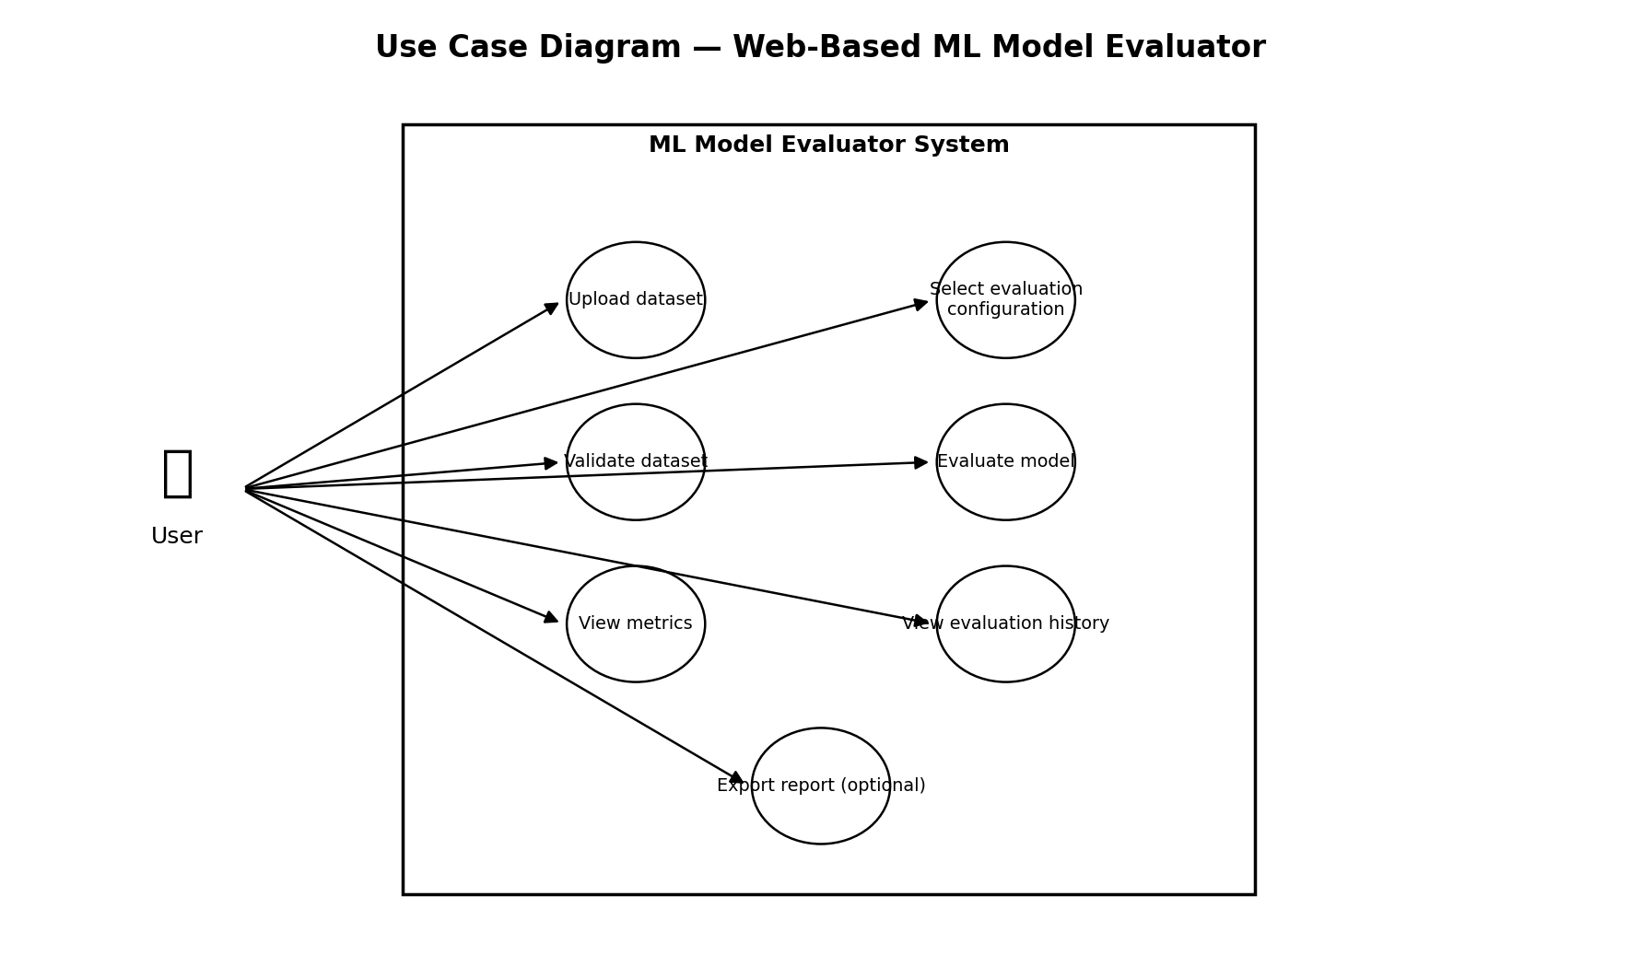
Figure 1. Proposed use case diagram. Optional history/export use cases must be removed if not implemented.

7.1 Use case UC-01: Evaluate a model
Field | Description
Primary actor | Evaluator user
Preconditions | Application is reachable; user has access to the evaluation page; a supported input is available.
Trigger | User starts a new evaluation.
Main flow | 1. User uploads input. 2. System validates file and structure. 3. User selects task and metrics. 4. User submits evaluation. 5. System calculates metrics. 6. System records status and result. 7. UI displays metrics.
Alternative flow A | Input validation fails: system explains the problem and does not start evaluation.
Alternative flow B | Task/metric configuration is incompatible: system requests a valid configuration.
Alternative flow C | Metric calculation fails: system marks the run failed and shows a safe error message.
Postconditions | A valid run has a completed result, or a failed run has a failure status and no false success result.

8. Acceptance Criteria
- A supported valid input can be submitted and validated.
- Missing required fields and unsupported inputs are rejected with understandable messages.
- At least one supported evaluation configuration completes and displays its metric value.
- An invalid configuration cannot be reported as a successful evaluation.
- The implemented security objectives have corresponding tests or inspection evidence.
- At least 7–10 test cases are documented and traceable to SRS requirements.
- All TBD thresholds and supported-format details are resolved before final acceptance.

