**PHARMACY MANAGEMENT SYSTEM**

***Mini Project Report submitted by***

**PRAJWAL H SUVARNA**

(4NM20CS131)

**N GAURAV AJILA**

(4NM20CS112)

***Under the Guidance of***

**Ms.Anusha Anchan**

Assistant Professor

*In partial fulfillment of the requirements for the award of*

*the Degree of*

**Bachelor of Engineering in Computer Science Engineering**

*from*

***Visvesvaraya Technological University, Belagavi***

Department of Computer and Communication Engineering

NMAM Institute of Technology, Nitte-574110

(An Autonomous Institution affiliated to VTU, Belagavi)

# DECEMBER 2022



**ACCREDITED WITH ‘A’ ISO 9001:2015 CERTIFIED**

**DEPARTMENT OF COMPUTER SCIENCE ENGINEERING**

# CERTIFICATE

Certified that the mini project work entitled

“ Pharmacy Management System”

is a bonafide work carried out by

Prajwal H Suvarna(4NM20CS131)

N Gaurav Ajila (4NM20Cs112)

in partial fulfilment of the requirements for the award of

Bachelor of Engineering Degree in Computer and Communication Engineering prescribed by Visvesvaraya Technological University, Belagavi

during the year 2021-2022.

It is certified that all corrections/suggestions indicated for Internal Assessment have been

incorporated in the report deposited in the departmental library.

The project report has been approved as it satisfies the academic requirements in respect of

the mini project work prescribed for the Bachelor of Engineering Degree.

**___________________ ___________________**

***Signature of the Guide Signature of the HOD***

**Semester End Viva Voce Examination**

**Name of the Examiners Signature with Date**

* _______________________  _______________________
* __________________________ __________________________

## ACKNOWLEDGEMENT

We express our deep sense of gratitude to NMAM Institute of Technology that provided us an opportunity in fulfilling our most cherished desire of reaching the

goal.

We are thankful to **Ms. Anusha Anchan**, staff in-charge who inspired us in our work and their support in carrying out this mini project.

We are also thankful to **Dr. Jyothi Shetty**, Professor & HOD, Department of Computer Science Engineering, who inspired us in our work and stood for many of our works.

We whole - heartedly express our gratitude to **Dr. Niranjan N Chiplunkar**, Principal, NMAMIT, Nitte who is responsible for creating such a pleasant environment and appreciating our talents in both academic and extracurricular

activities.

We also thank both teaching and non-teaching staff of Department of Computer and Communication Engineering for their support in carrying out this project.

**PRAJWAL H SUVARNA N GAURAV AJILA**

**4NM20CS131 4NM20CS112**

## CONTENTS

1.ABSTRACT ………………………………………………………… II

2.INTRODUCTION ………………………………………………… 1

2.1 PROJECT OBJECTIVE…………………………………… 1

2.2 PROJECT OVERVIEW…………………………………… 1

2.3 PROJECT SCOPE………………………………………….. 2

3.LITERATURE SURVEY…………………………………………… 3

1. EXISTING SYSTEM………………………………………… 3
2. PROPOSED SYSTEM……………………………………… 4

4.PROBLEM DEFINITION……………............................... 5

5.DETAILS OF THE PROJECT………................................ 6

6.RESULTS AND DISCUSSIONS…………………………………. 9

LOGIN PAGE……………………………………………………. 9

BILLING PAGE………………………………………………….. 9

STOCK INFO…………………………………………………….. 10

SEE CUSTOMER INFO………………………………………. 10

SEE CUSTOMER CART………………………………………. 11

ADD/UPDATE STOCK………………………………………… 11

BRAND INFO…………………………………………………….. 12

DISTRIBUTOR INFO…………………………………………… 12

ADD NEW BRAND/DISTRIBUTOR………………………. 13

7.CONCLUSION…………………………………………………………. 16

8.REFERENCES……………………….......................................17

***1.Abstract :***

Pharmacy Management System is designed to make the existing manual system automatic with the help of computerized equipment and full-edged computer software, fulfilling their requirements, so that their valuable data and information can be secured and stored for a longer period with easy access and manipulation of the same.

The required software is easily available and easy to work with. This database system can maintain and view computerized records without getting redundant entries. The project describes how to manage user data for good performance and provide better services for the client. The goal of this project is to design and develop an Pharmacy management system to fill existing gaps in the electronic management of customer data/item info of the Pharmacy. This system is more accurate, secure and reliable.

||

**INTRODUCTION:**

The proposed project Pharmacy Management System has been developed to overcome the problems faced in the practicing of manual systems. This software is built to eliminate and in some cases reduce the hardships faced by the existing system. Moreover, this system is designed for the particular need of the company to carry out its operations in a smooth and effective manner. This database system is reduced as much as possible to avoid errors while entering data. It also provides an error message while entering invalid data. It is user-friendly as no formal knowledge is required to use the system. Human resource challenges are faced by every organization which have to be overcome by the organization. Every Pharmacy store can have different needs. So changes can be made in the backend to adapt to the changes.

**PROJECT OBJECTIVE:**

The objective of the project is to make a website that is portable on different devices like mobile, laptop, etc., and is capable to manage all pharmacy-related issues like billing, and managing customer/ medicine info accurately. It has to also provide security and must be reliable to use. The user interface must be user-friendly, simple, and fast enough to be interactive. But the main objective is to make the admin/manager’s job easier and make it more accurate.

**PROJECT OVER VIEW:**

The central concept of the website is to allow the admin/manager to manage his store virtually using the Internet and allow employees to generate bill of transactions of the items bought from the store. So before billing customer has to provide his/her information to the cashier who stores that information in the transaction database and after that cashier can then generate the bill . Admin also manages Medicine brand and its stock , Medicine dealer database where he can insert, delete or update information .He can also create normal user who are gonna just use this system for billing. To provide security this website also has a login page so only people with proper admin id and password can access the website. Normal Employee who is registered as user can only generate bills.He can’t interfere in managing medicine brands and medicine dealers or the medicine stocks.The creation and deletion of admin is done by a superuser, the individual who has created the application.

**PROJECT SCOPE:**

This system can be implemented in any shop in the locality or multinational branded shops having retail outlet chains. The system works 24*7 and is accurate every time. The scope is to the admin and normal user. So the admin and normal user with the proper id and password can use this website. This is mainly a billing system and can also be used to perform other operations to manage the store.

**LiteratureSurvey*:***

1. **Existingsystem *:***

The existing Pharmacy management system in the organization still uses the ordinary classical methods which are merely based on pen-paper to record the data of their employee. Large quantities of registers are to be maintained for this purpose which results in downright waste of time in generating reports or searching for stock/customer info and loss of data if any file is lost. It is also an arduous task for organizations as it is an expensive process.

However, somewhere new technologies such as web based systems are used but they also are costly and difficult to implement at some places. The other techniques that are in the market are dependent on facial recognition, biometric scan or card punching. But all of these require an external device to be installed in the working area, which is again a costly process and requires regular maintenance. This project eliminates or reduces as much as possible the difficulties of the existing system and avoids errors while entering data. In comparison to the existing system it is cheaper, easy to implement, easy to use, no maintenance required, on time data and saves

lots of time.

1. **Proposed system:**

The proposed system is based on a database system. This system provides the facilities listed below:

1. Admin should login with valid username and password.
2. Admin manages medicine brands and their stock, medicine dealers, and customer bill information.

1. Admin can add, delete, and update stock and medicines.
2. Admin can enter generate customer bill and store data into the database.
3. Admin can enter medicines that customer wants to buy for the particular customer.
4. Admin can perform billing operations.

## Normal User:

* Normal Employee has to login with his user id and password
* He can view and update his profile
* He can only generate bill and see all the other transactions that is being done

***4. Problem Definition:***

Management of stock/customer info is crucial to any Pharmacy store. Management of Pharmacy is a very broad concept, while here in this paper we would be looking at some important areas which affect database of Pharmacy. Here, we would be working on maintaining the stock/customer details, securing it, maintaining their dependent details, viewing details time saving and genuine. The main aim of this system is to prevent any kind of inaccuracies and help the manager/admin to organize all the information perfectly. As it is seen many times due to paper works, file management there are clashes, which result in damaging relation and effect overall performance of organization which effects organization. So, this database system aims to provide smooth and comfortable managing of Pharmacy details. The database system asks the admin to login and then access the database and operate on that database.

## 5. Details of the project

**Available technologies:**

Languages: HTML, CSS, Javascript, Python.

Frameworks: Django, Bootstrap

RDBMS: PostgreSQL.

Web server: Localhost

Development platform: Visual Studio Code.

**Tools used:**

Editor used: VS Code. .

Operating system: Windows 10.

**Hardware used:**

Processor: AMD Ryzen5.

Ram: 8 GB.

Hard disk: 512 GB.

**Features of Employee Management system:**

* Easy to use.
* It is completely secure.
* It is controlled by super admin, admin, and normal employee users.
* This system is easily compatible with most of web browsers.
* It is very interactive and saves time.

6

* Reduces paper works.
* Calculations are automated so it is highly accurate.
* Admin can view all the records whenever necessary with ease.

***Advantages:***

* It is cost-effective as the user control the web application himself and does not go for professional service.
* Can be used 24*7 and is accurate every time.
* It saves time as it speeds up every aspect of the Pharmacy database management with a range of automated features.
* It is secure as the database process is managed by the admin in house rather than sending private information to a third party.
* Validating procedures and checks restrict user from making mistakes.
* The software is easy to use and is user friendly so no expertise is required.
* The calculations are automated so no chance of error.

**ER diagram:**

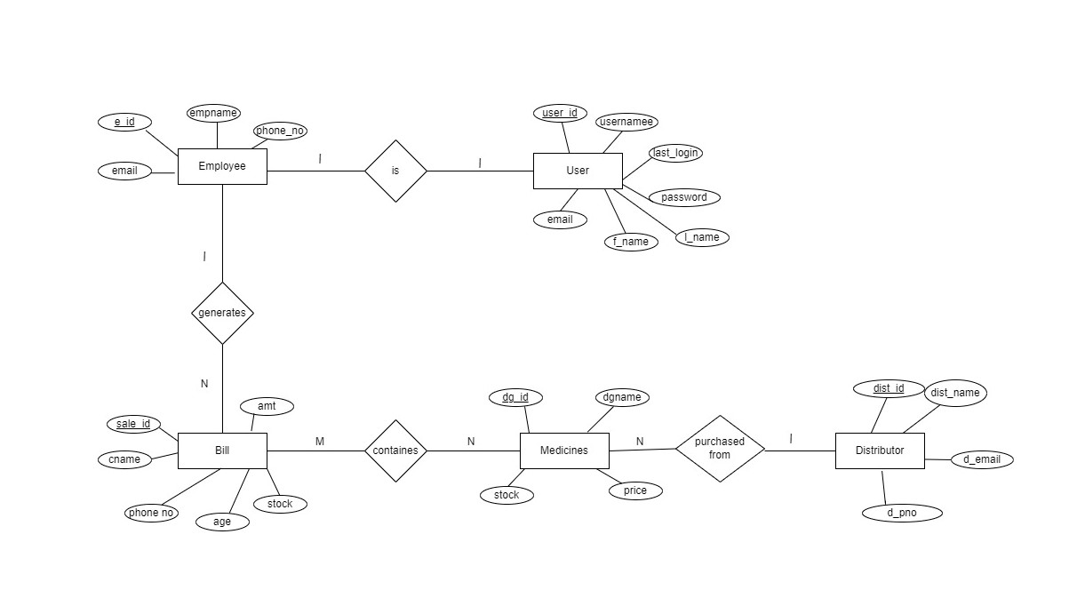

**6. Results and Discussions:**

# Employee Table

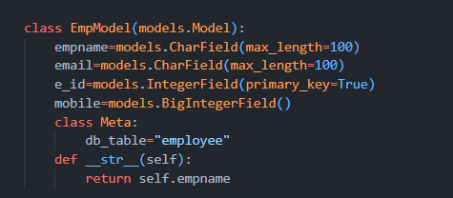

# Users Table

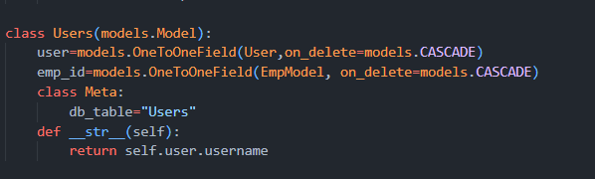

# Medicine Table

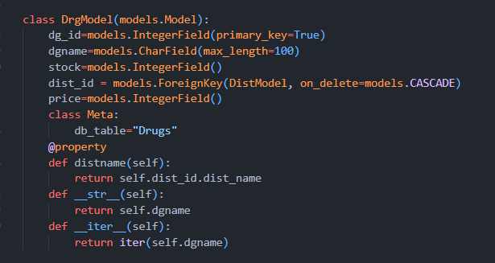

# Distributors Table

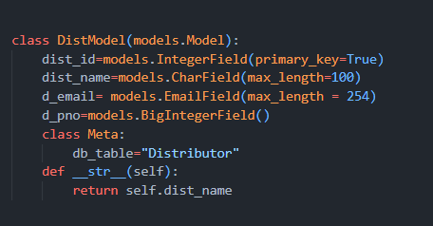

# Bill Table

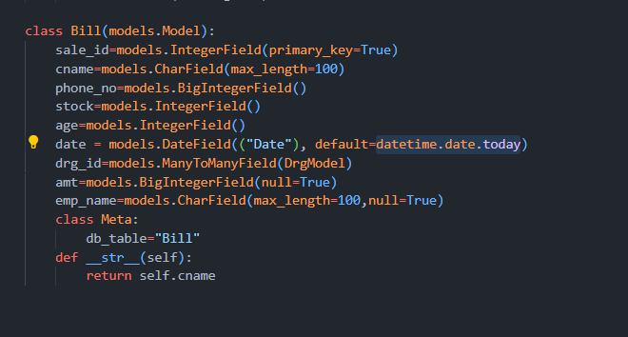

# Here are we sample images of the overview of our application

# Login Page



# 

# ADMIN VIEW-DASHBOARD

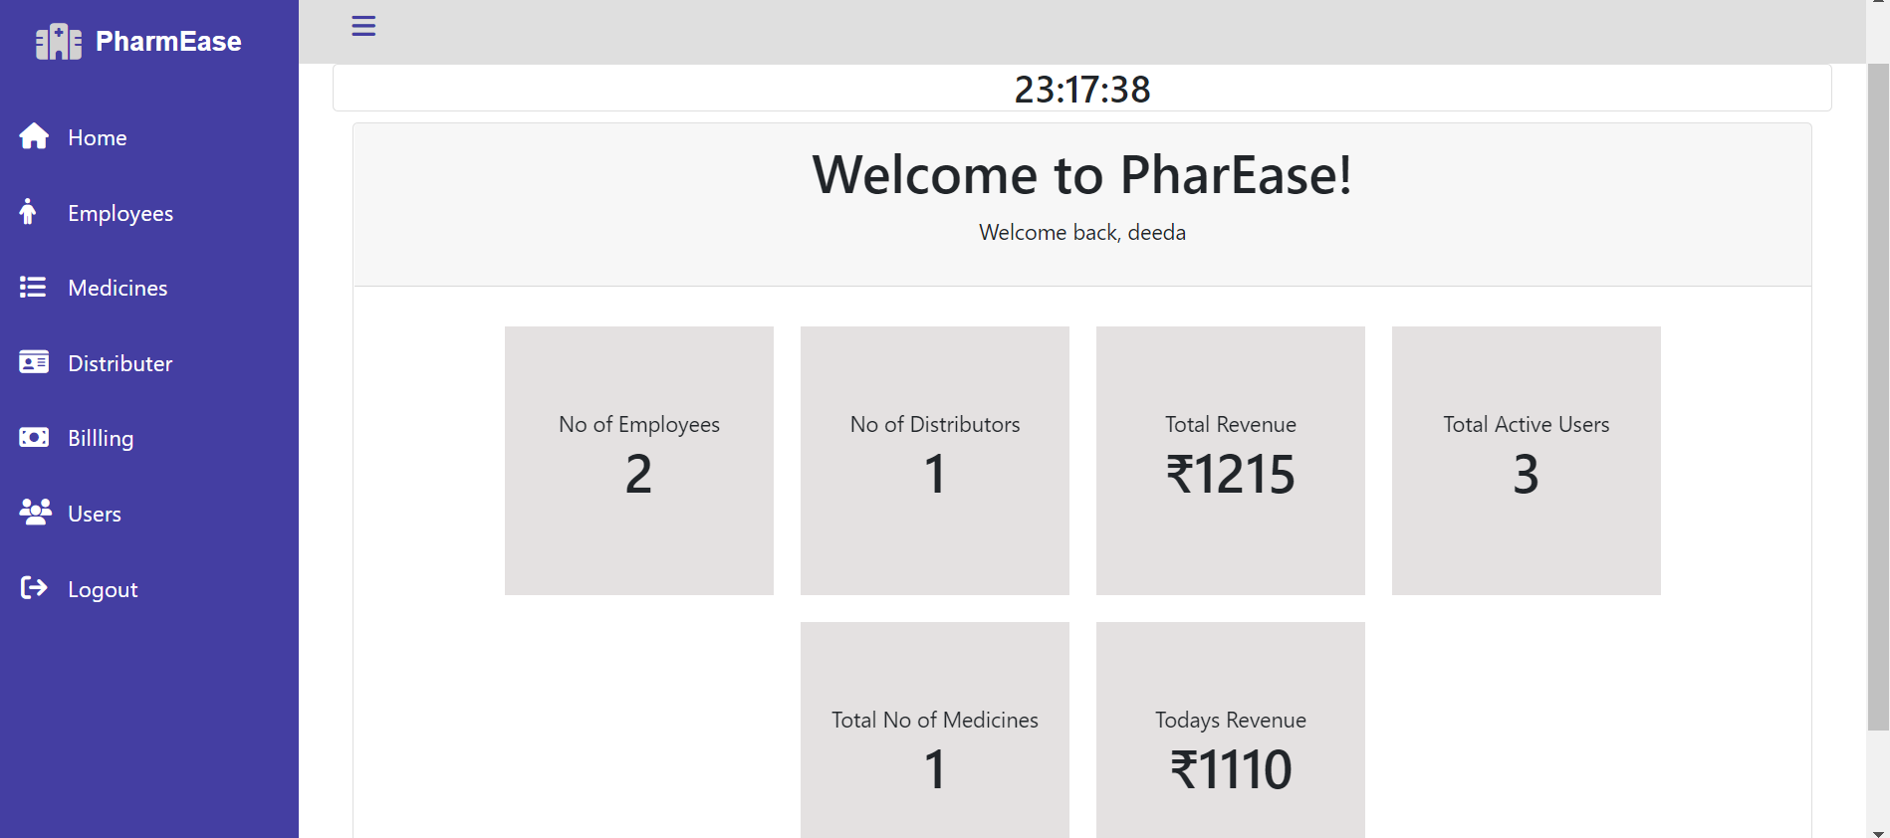

# NORMAL USER-DASHBOARD

# 

# Billing Interface is same for both admin and normal user

# 

# Generating New Bill:

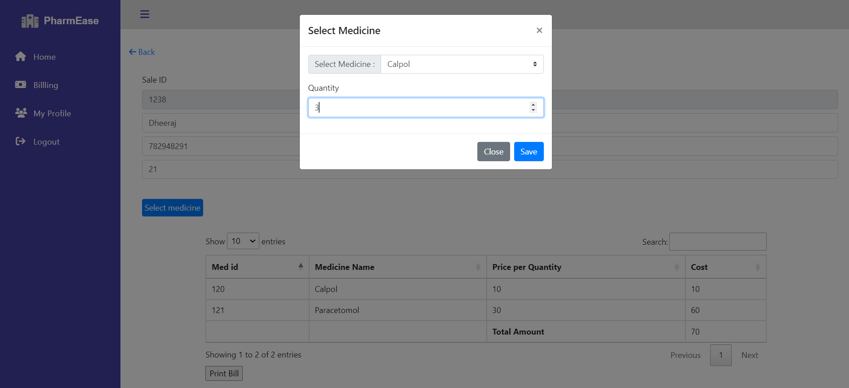

# Only the admin has the privileges to see employee, medicine,user and Distributor table

# Employees Table

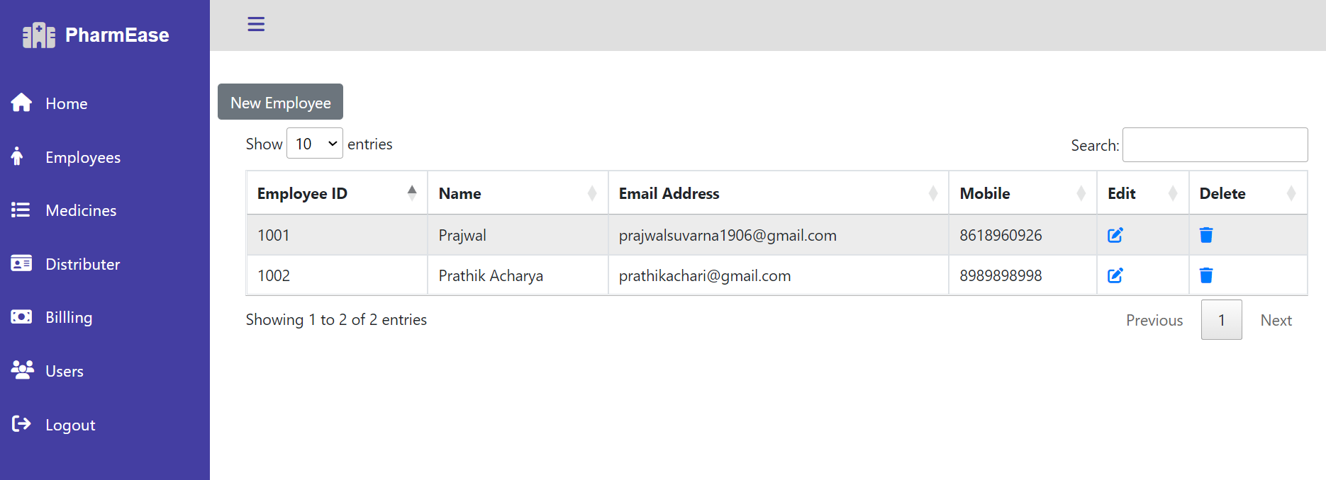

# DISTRIBUTORS TABLE

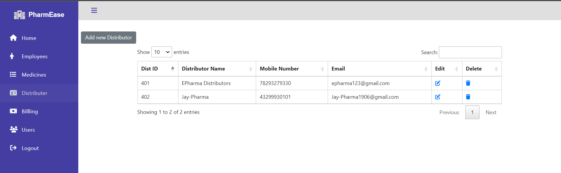

# MEDICINE TABLE

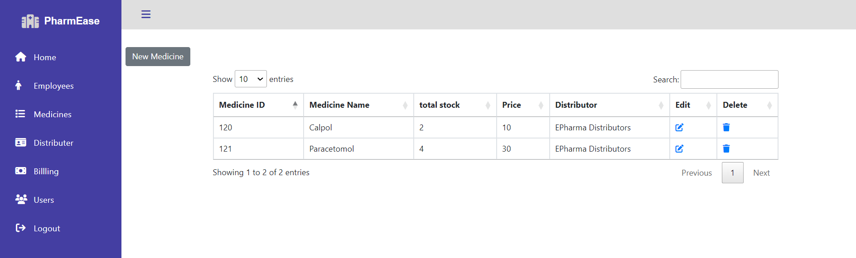

# MEDICINE

Only Admin can update stock, price, and the distributor

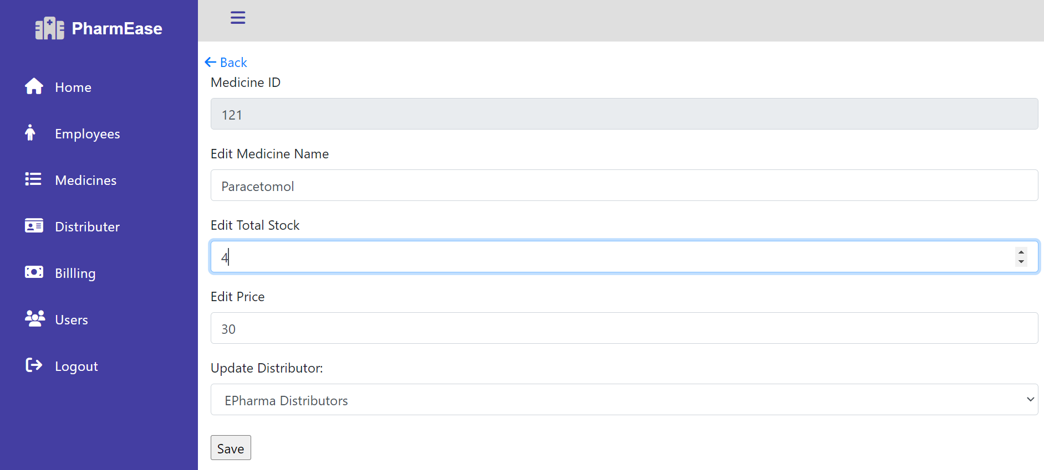

# User Table

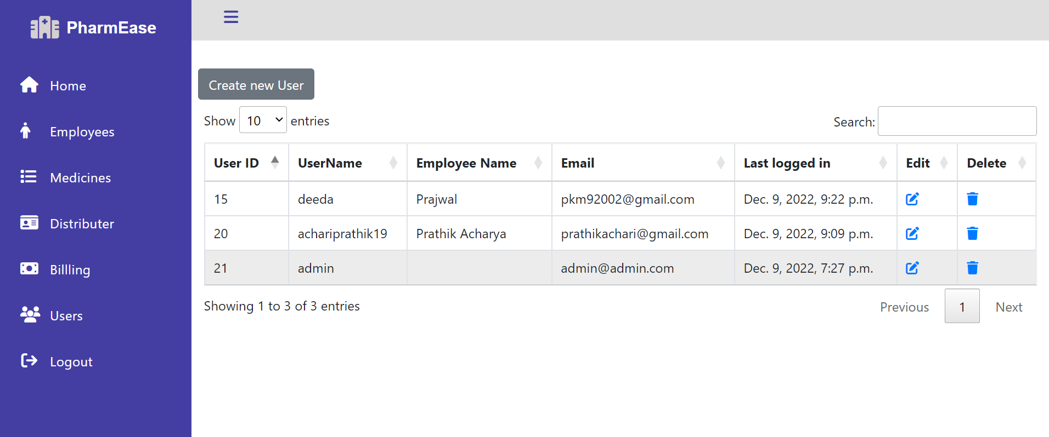

# Admin Can create new Users who are currently employed

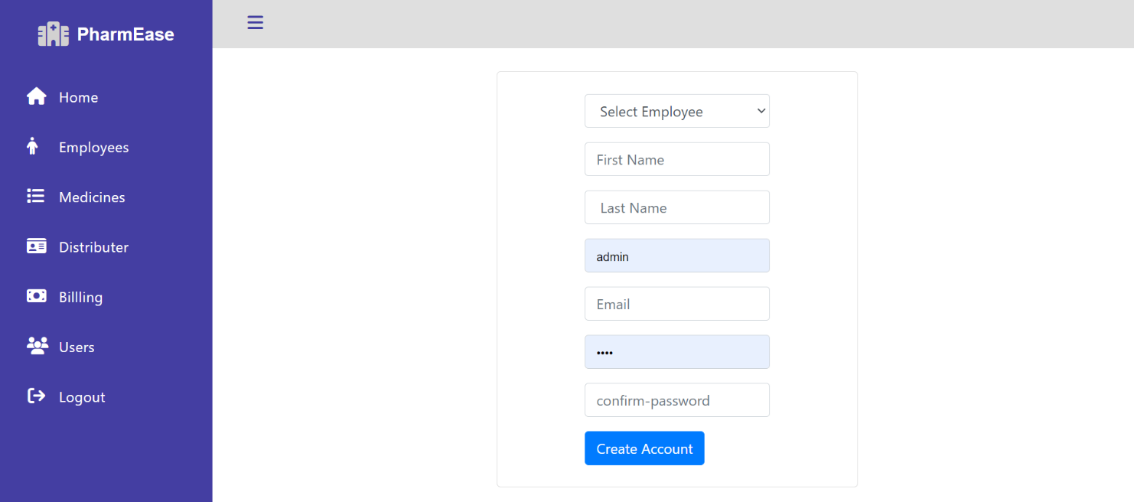

A normal user later logged in can later update his profile and can update his password as well

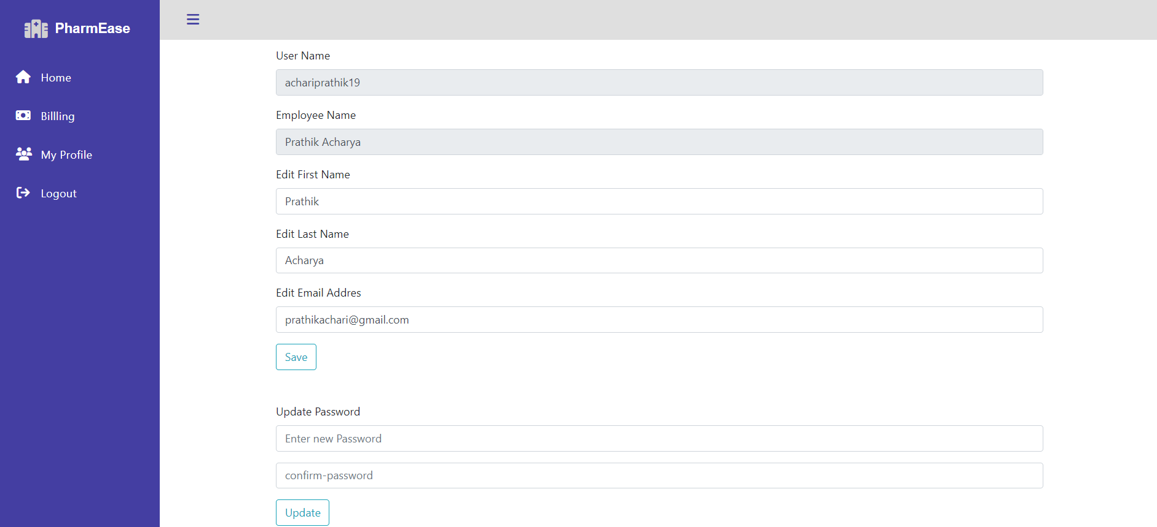

**Conclusion*:***

This project is built keeping in mind that it is to be used only by a admin user and normal employee. It is built for use in small-scale organizations where the scale of the store is limited. According to the requirement, the admin can add, manipulate, update and delete all data in of his store. The admin can perform various operations. The required records can be easily viewed by the admin and normal user anytime he wants in an instant. Numerous validations implemented would enable them to enter accurate data. The main objective of this framework is to save time, make the system cost effective and management records efficiently. The system was developed in line with three tier architecture software model and implemented using web based technologies which include CSS, HTML, Javascript and Python.

***References***:

[*https://youtu.be/Su2SBUPEwxw*](https://youtu.be/Su2SBUPEwxw)

[*https://youtu.be/6mbwJ2xhgzM*](https://youtu.be/6mbwJ2xhgzM)

[*https://youtu.be/rHux0gMZ3Eg*](https://youtu.be/rHux0gMZ3Eg)