DevOps

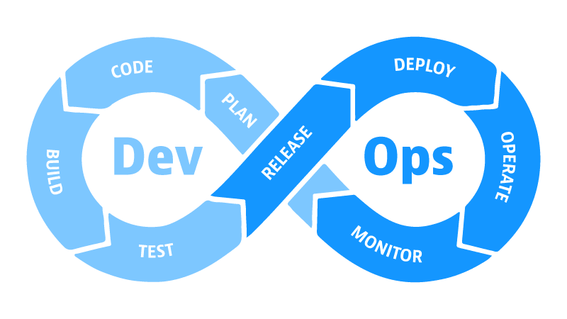

* Automation
* Automation of the process involved in the deployment of an application

Developer

Operations

Administrator

Developer

JDK/JRE 8

MySQL

Tomcat

Deploy

Server

JDK 11

Eclipse

Tomcat

MySQL

Postman

PC/Laptop

Delay in getting the application deployed

Administrator

­­­­­­­JDK 11

Tomcat 9

MySQL 8

­­­­­­­JDK 8

Tomcat 6

MySQL 5

Node.js

Nginx

MySQL 5

.NET

IIS

MS SQL

Server

Virtualization

* The ability to run multiple OS at the same time on a single computer
* This is achieved by using something called as Hypervisor
  + VMware Fusion
  + Oracle Virtualbox
  + Microsoft Hyper-V
* VMs are heavy, cannot be used in every usecase

Containerization

* Another form of virtualization
* VM inside a VM
* Lightweight, they will share resources provided by the Hypervisor

Docker

* Containerization software

Administrator

­­­­­­­JDK 8

Tomcat 6

MySQL 5

Virtual Machine

Virtual Machine

Node.js

Nginx

MySQL 5

Server

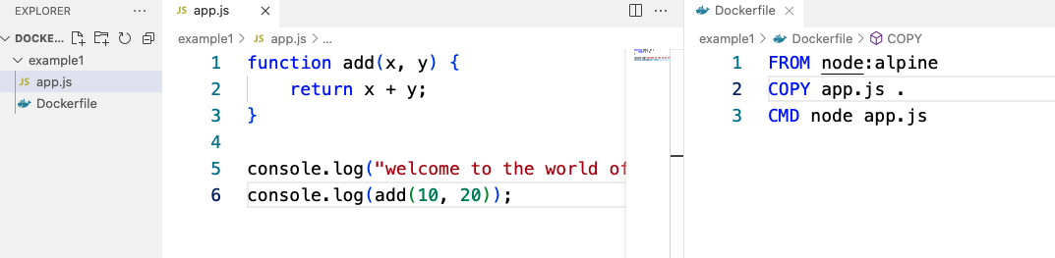

To run this app on some other person's system:

1. Download/Copy and install Node.js

2. Copy our application's code on this person's system somewhere

(for ex: c:\myapp)

3. Open a command prompt (cmd) and then:

cd c:\myapp

node app.js

Instead of asking that person to follow all these steps:

- What we will do is ask him to install Docker

- Next we will create a Docker image which will contain:

- An OS (ex: Linux)

- Required Software (ex: Node.js)

- Application Files (copy ..)

- Command for executing the application (node ..)

- Now that person just needs to obtain this image and run the same

with the help of Docker

