REST API Development

Microservices architecture

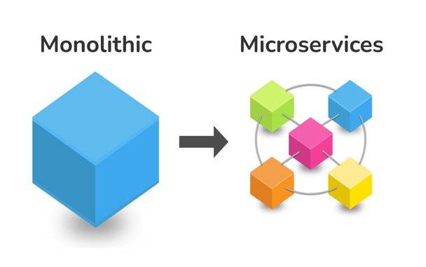

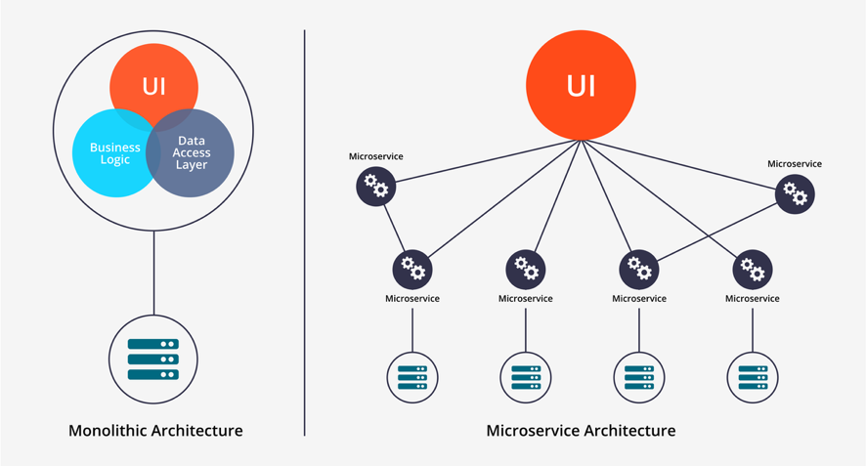

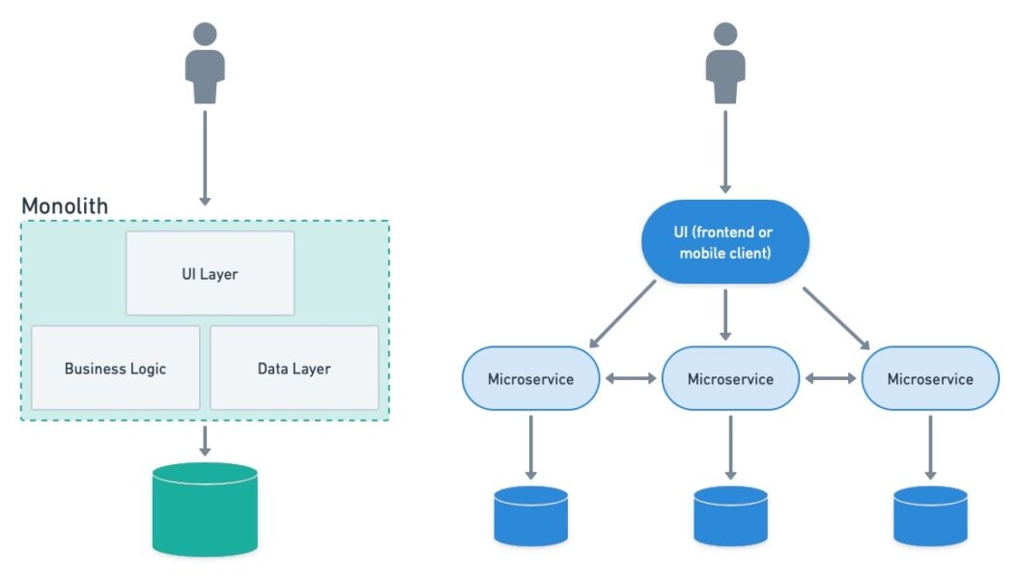

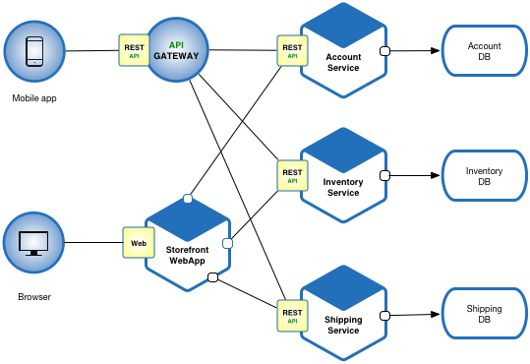

User

Interface

(Controller)

DB

Servlet/JSP

Tomcat Server

Deploy: WAR file

Customer/User

Retailer/Seller

Admin

Shopping Application

Server

Air India

API

MakeMyTrip

JSON

SpiceJet

API

Vistara

API

MicroService

Serverless architecture

Cloud computing

DevOps

