REST API Development

Microservices architecture

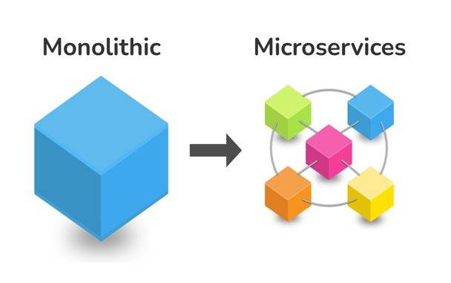

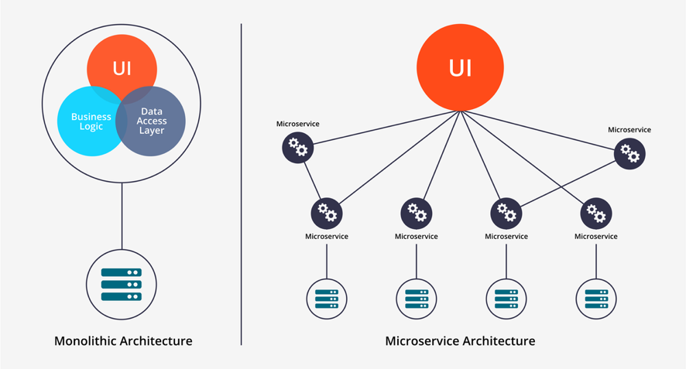

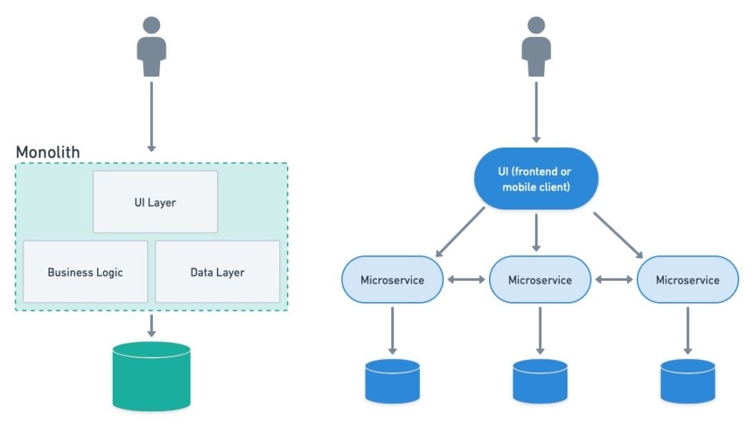

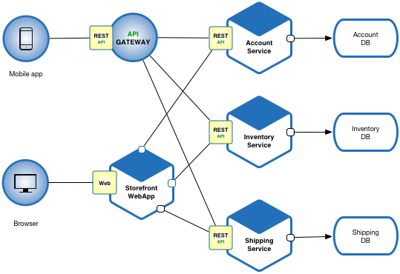

User

Interface

(Controller)

DB

Servlet/JSP

Tomcat Server

Deploy: WAR file

Customer/User

Retailer/Seller

Admin

Shopping Application

Server

Air India

API

MakeMyTrip

JSON

SpiceJet

API

Vistara

API

MicroService

Serverless architecture

Cloud computing

DevOps

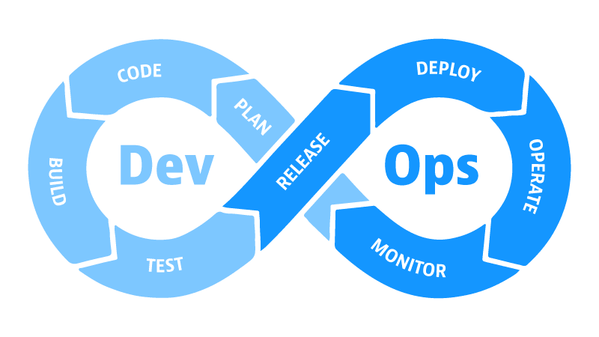

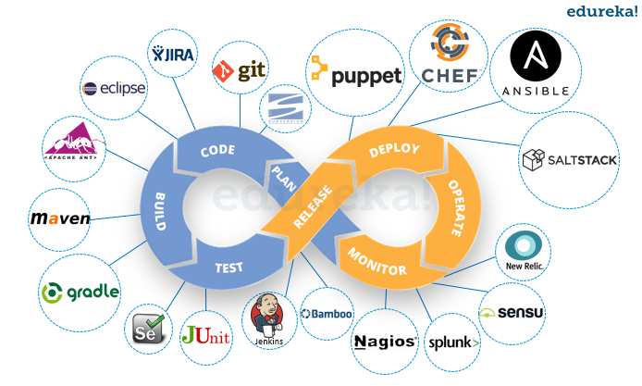

Flight Management Microservice

API of our Flight Management Microservice

------------------------------------------

GET : /flights/{source}/{destination}/{date}

GET : /flights/seats-available?flightNo={flightNo}&travelDate={travelDate}&noOfSeats={noOfSeats}

POST : /flights/block-seats

Flight Booking Microservice

API of our Booking Microservice

POST : /book-flight

API

API