**Simple Query**

1. 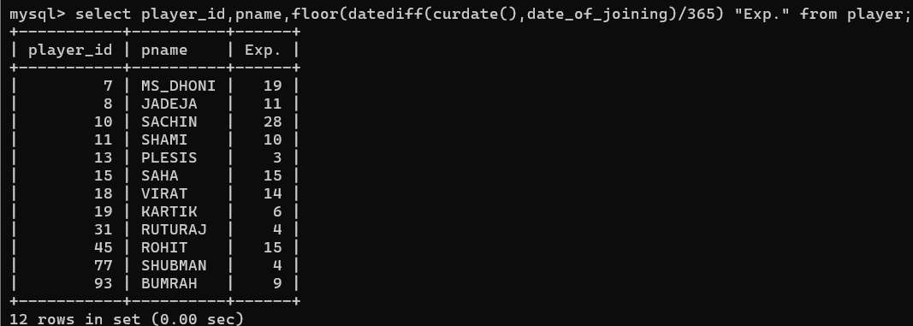display all players playerid, player name and experience
2. 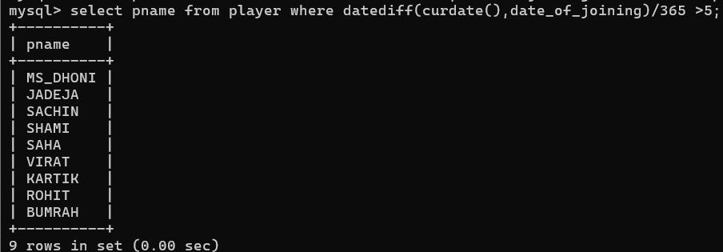display all player with experience > 5 years
3. 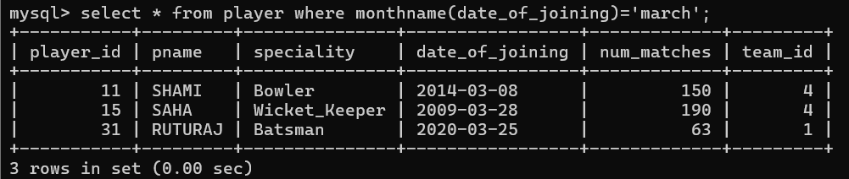display all players joined in march month, any year
4. 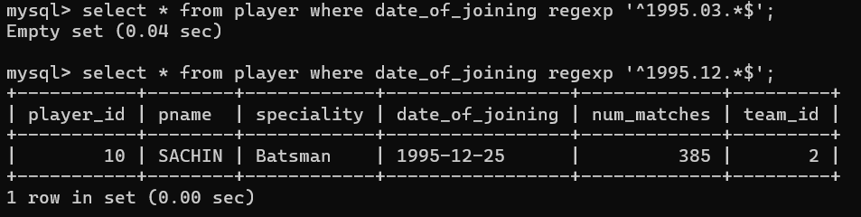display all players joined in march 1995
5. 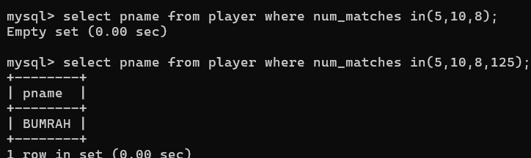display all player with number of matches played are either 5 or 10 or 8
6. 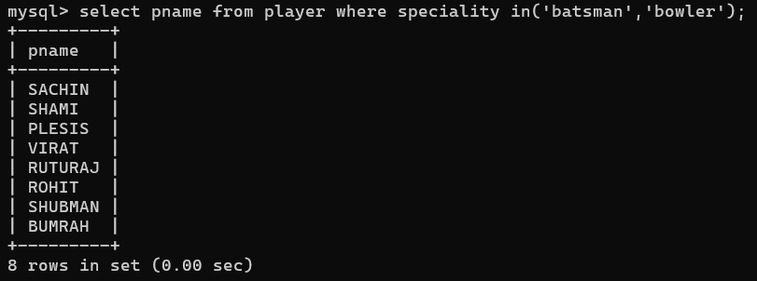display all employees who are either batsman, bowler
7. 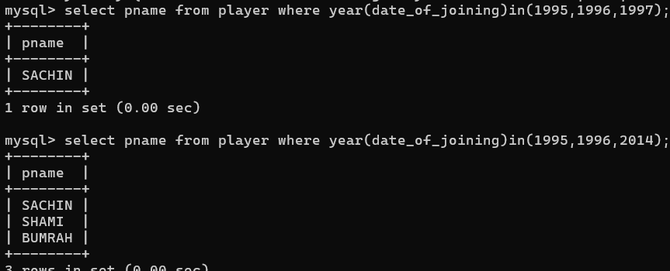display all employees who joined in year 1995 or 1996 or 1997

**Nested query**

1. list all player who plays in virat kohalis team

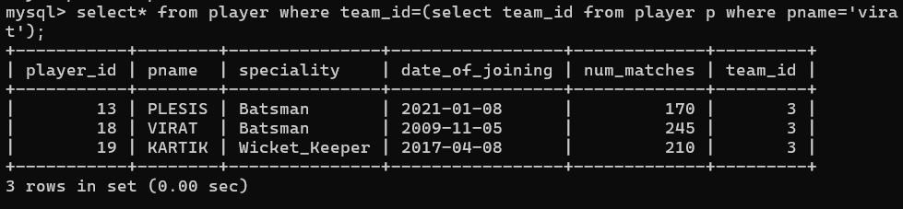

1. list all players who played matches in year 2024

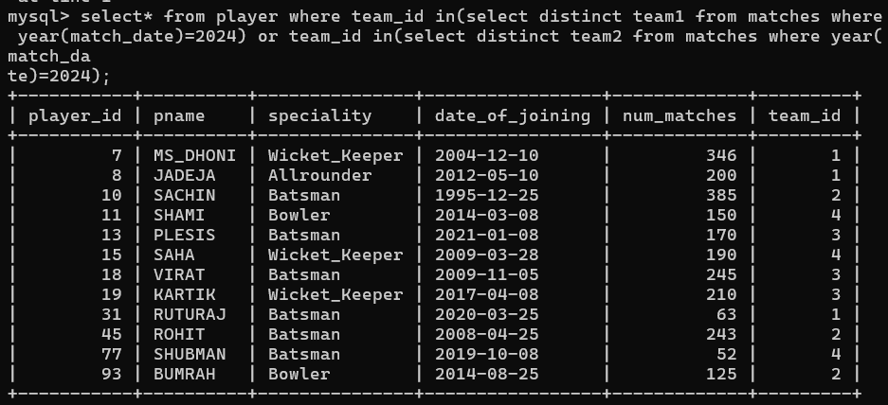

1. list all matches in which man of the match is from team1

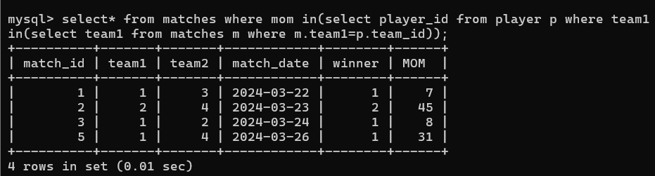

1. list all matches in which man of the match is from team1

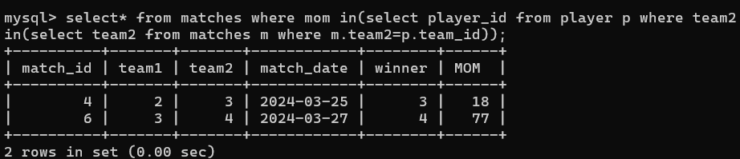

1. list all matches in which csk team win.

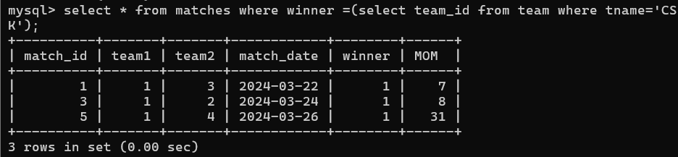

1. list all matches in which either csk or rcb team won the match

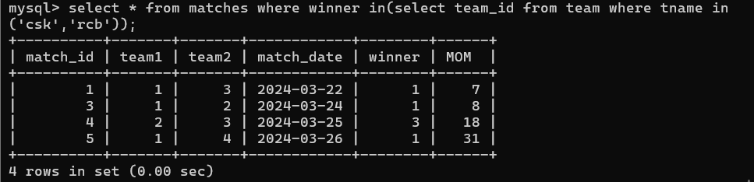

1. list all teams who one atleast one match

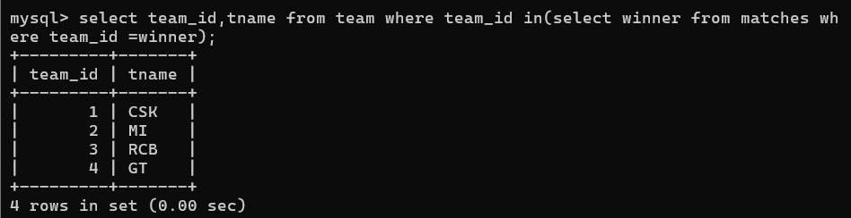

1. list all teams who does not played any match

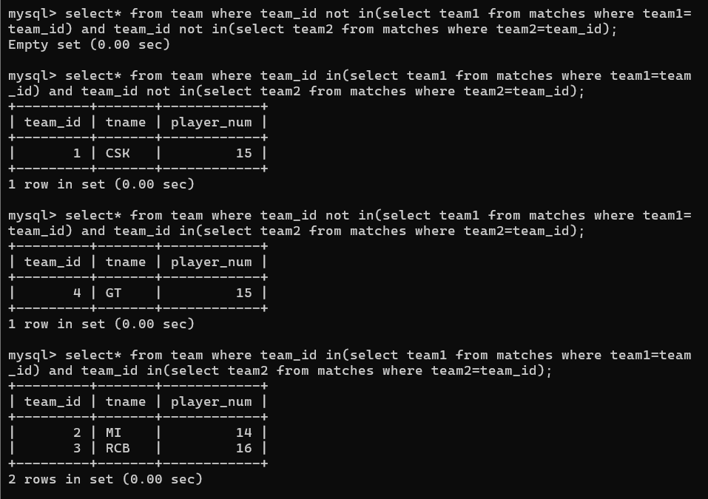

9. list all team name, in which no players are their

10. list all players who are in dhoni’s team

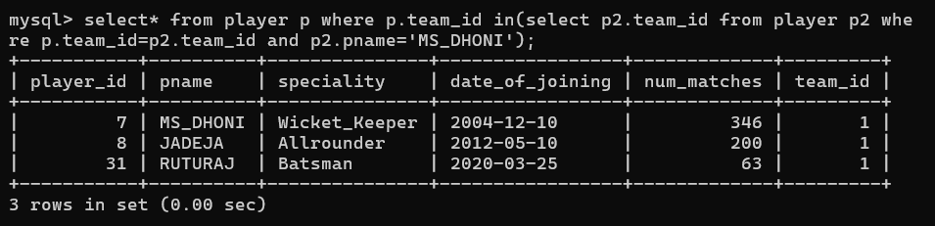

11. list all players who are in either dhoni’s or virat’s team

12. find all team names who one more than 3 matches

