1. **create all given tables**

DONE!!

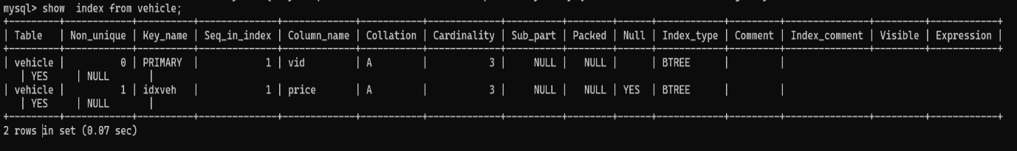**2. create index on vehicle table based on price**

**3. find all customer name,vehicle name, salesman name, discount earn by all customer**

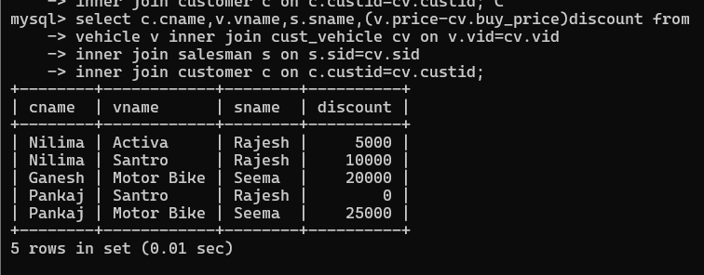

**4. find all customer name,vehicle name,salesman name for all salesman who stays in pune**

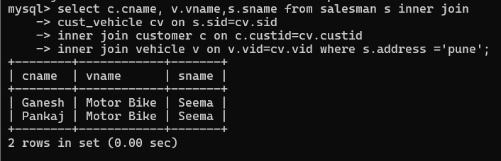

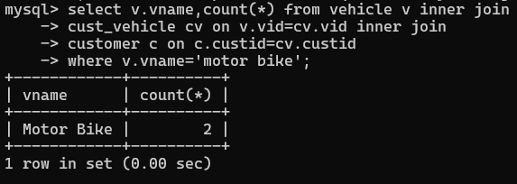**5. find how many customers bought motor bike**

**6. create a view find_discount which displays output**

**-------to create view**

**create view find_discount**

**as**

**select cname,vname,price,buying_price,price-buying_price “discount”**

**from customer c inner join cust_vehicle cv on c.custid=cv.cid inner join vehicle v on**

**v.vid=cv.vid**

**--------to display discount**

**select * from find_discount;**

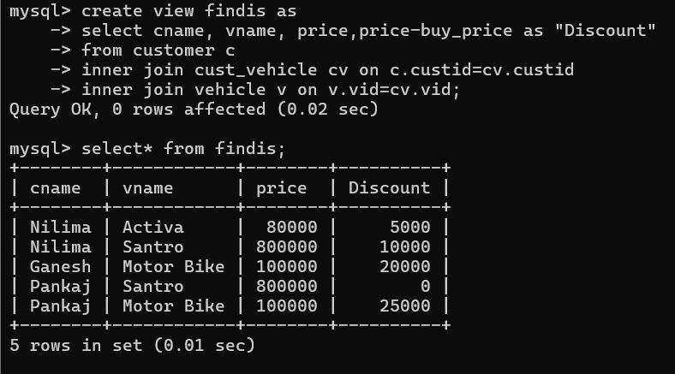

**7. find all customer name, vehicle name, salesman name, discount earn by all customer**

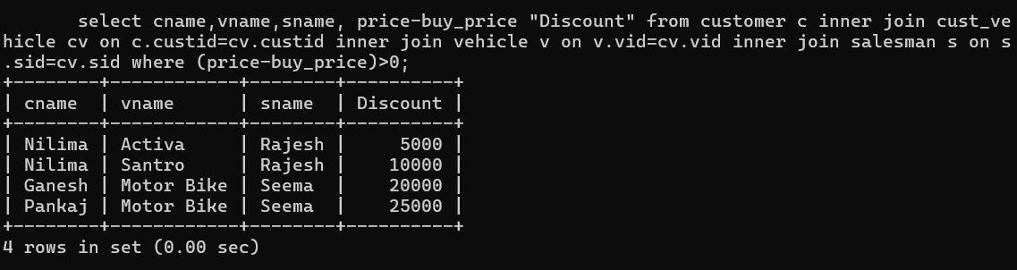

**8. create view my_hr to display empno,ename,job,comm for all employees who earn**

**Commission**

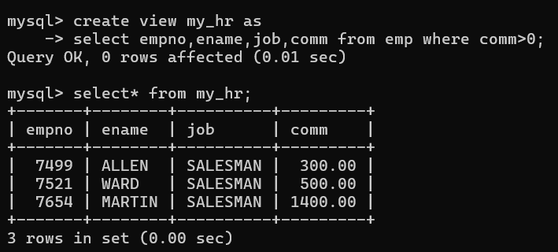

**9. create view mgr30 to display all employees from department 30**

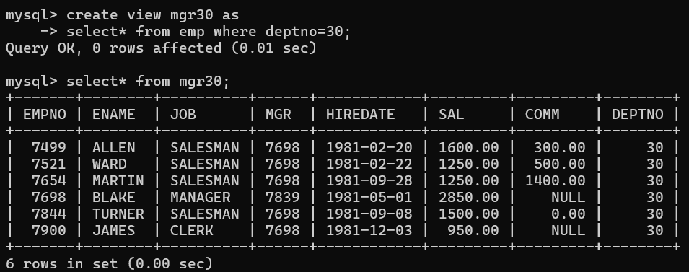

**10. insert 3 employees in view mgr30 check whether insertion is possible**

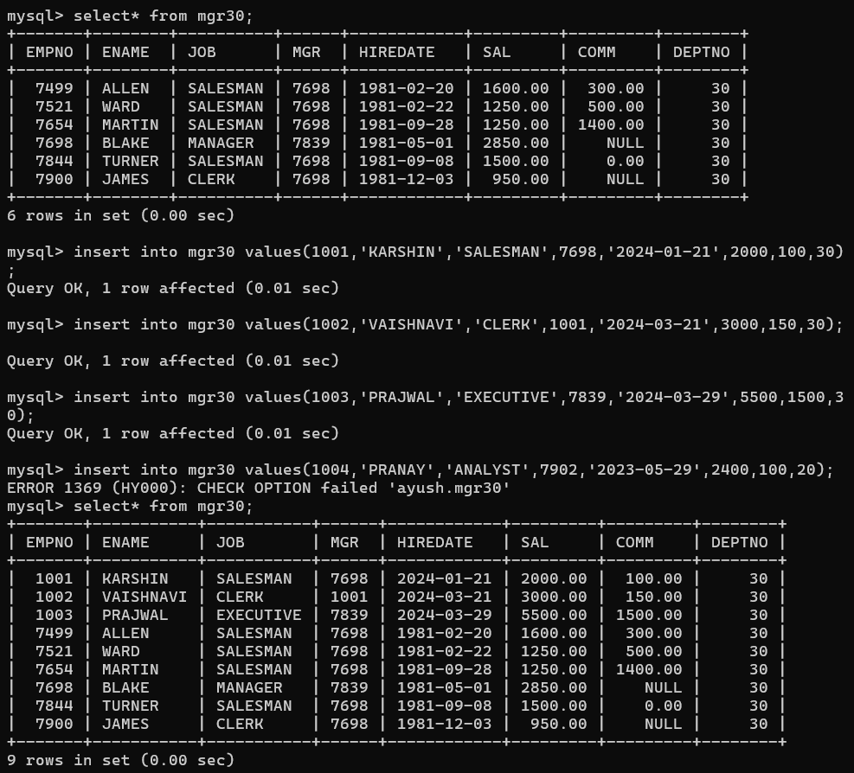

**11. insert 3 records in dept and display all records from dept**

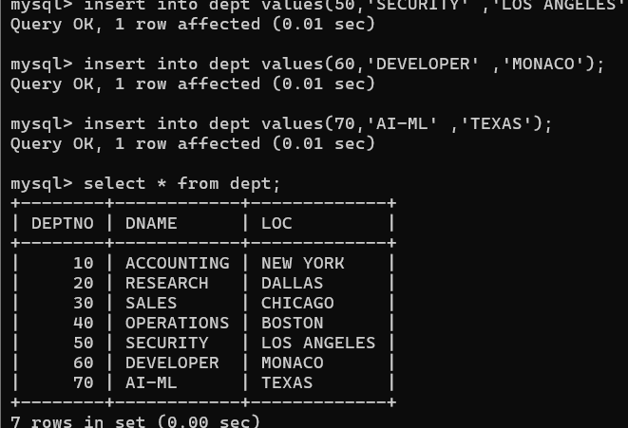

**12. use rollback command check what happens**

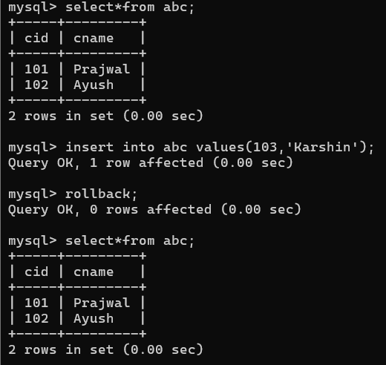

**13. do the following**

**insert row in emp with empno 100**

**insert row in emp with empno 101**

**insert row in emp with empno 102**

**add savepoint A**

**insert row in emp with empno 103**

**insert row in emp with empno 104**

**insert row in emp with empno 105**

**add savepoint B**

**delete emp with empno 100**

**delete emp with emp no 104**

**rollback upto svaepoint B**

**check what all records will appear in employee table**

**rollback upto A**

**check what all records will appear in employee table**

**commit all changes**

**check what all records will appear in employee table**

**check whether you can roll back the contents.**

mysql> insert into emp values(100);

ERROR 1136 (21S01): Column count doesn't match value count at row 1

mysql> insert into emp values(100,'SAI','MANAGER',7902,'2024-02-29',4500,1000,10);

Query OK, 1 row affected (0.00 sec)

mysql> insert into emp values(101,'SAI','MANAGER',7902,'2024-02-29',4500,1000,10);

Query OK, 1 row affected (0.00 sec)

mysql> rollback;

Query OK, 0 rows affected (0.00 sec)

mysql> select * from emp;

+-------+-----------+-----------+------+------------+---------+---------+--------+

| EMPNO | ENAME | JOB | MGR | HIREDATE | SAL | COMM | DEPTNO |

+-------+-----------+-----------+------+------------+---------+---------+--------+

| 1001 | KARSHIN | SALESMAN | 7698 | 2024-01-21 | 2000.00 | 100.00 | 30 |

| 1002 | VAISHNAVI | CLERK | 1001 | 2024-03-21 | 3000.00 | 150.00 | 30 |

| 1003 | PRAJWAL | EXECUTIVE | 7839 | 2024-03-29 | 5500.00 | 1500.00 | 30 |

| 7369 | SMITH | CLERK | 7902 | 1980-12-17 | 800.00 | NULL | 20 |

| 7499 | ALLEN | SALESMAN | 7698 | 1981-02-20 | 1600.00 | 300.00 | 30 |

| 7521 | WARD | SALESMAN | 7698 | 1981-02-22 | 1250.00 | 500.00 | 30 |

| 7566 | JONES | MANAGER | 7839 | 1981-04-02 | 2975.00 | NULL | 20 |

| 7654 | MARTIN | SALESMAN | 7698 | 1981-09-28 | 1250.00 | 1400.00 | 30 |

| 7698 | BLAKE | MANAGER | 7839 | 1981-05-01 | 2850.00 | NULL | 30 |

| 7782 | CLARK | MANAGER | 7839 | 1981-06-09 | 2450.00 | NULL | 10 |

| 7788 | SCOTT | ANALYST | 7566 | 1982-12-09 | 3000.00 | NULL | 20 |

| 7839 | KING | PRESIDENT | NULL | 1981-11-17 | 5000.00 | NULL | 10 |

| 7844 | TURNER | SALESMAN | 7698 | 1981-09-08 | 1500.00 | 0.00 | 30 |

| 7876 | ADAMS | CLERK | 7788 | 1983-01-12 | 1100.00 | NULL | 20 |

| 7900 | JAMES | CLERK | 7698 | 1981-12-03 | 950.00 | NULL | 30 |

| 7902 | FORD | ANALYST | 7566 | 1981-12-03 | 3000.00 | NULL | 20 |

| 7934 | MILLER | CLERK | 7782 | 1982-01-23 | 1300.00 | NULL | 10 |

+-------+-----------+-----------+------+------------+---------+---------+--------+

17 rows in set (0.00 sec)

mysql> insert into emp values(100,'SAI','MANAGER',7902,'2024-02-29',4500,1000,10);

Query OK, 1 row affected (0.00 sec)

mysql> insert into emp values(101,'PRANAY','CLERK',7900,'2022-05-01',3500,850,30);

Query OK, 1 row affected (0.00 sec)

mysql> insert into emp values(102,'AASHU','SALESMAN',7934,'2021-09-16',1500,,30);

ERROR 1064 (42000): You have an error in your SQL syntax; check the manual that corresponds to your MySQL server version for the right syntax to use near ',30)' at line 1

mysql> insert into emp values(102,'AASHU','SALESMAN',7934,'2021-09-16',1500,NULL,30);

Query OK, 1 row affected (0.00 sec)

mysql> savepoint a;

Query OK, 0 rows affected (0.00 sec)

mysql> insert into emp values(103,'NIKHIL','ANALYST',7902,'2019-09-16',1000,NULL,10);

Query OK, 1 row affected (0.00 sec)

mysql> insert into emp values(104,'SHRIYA','CLERK',7839,'2023-09-16',3000,800,30);

Query OK, 1 row affected (0.00 sec)

mysql> insert into emp values(105,'SHIKHA','CLERK',7839,'2023-09-16',3000,800,30);

Query OK, 1 row affected (0.00 sec)

mysql> savepoint b;

Query OK, 0 rows affected (0.00 sec)

mysql> delete from emp where empno=103;

Query OK, 1 row affected (0.00 sec)

mysql> delete from emp where empno=104;

Query OK, 1 row affected (0.00 sec)

mysql> rollback b;

ERROR 1064 (42000): You have an error in your SQL syntax; check the manual that corresponds to your MySQL server version for the right syntax to use near 'b' at line 1

mysql> rollback to b;

Query OK, 0 rows affected (0.00 sec)

mysql> selct* from emp;

ERROR 1064 (42000): You have an error in your SQL syntax; check the manual that corresponds to your MySQL server version for the right syntax to use near 'selct* from emp' at line 1

mysql> select* from emp;

+-------+-----------+-----------+------+------------+---------+---------+--------+

| EMPNO | ENAME | JOB | MGR | HIREDATE | SAL | COMM | DEPTNO |

+-------+-----------+-----------+------+------------+---------+---------+--------+

| 100 | SAI | MANAGER | 7902 | 2024-02-29 | 4500.00 | 1000.00 | 10 |

| 101 | PRANAY | CLERK | 7900 | 2022-05-01 | 3500.00 | 850.00 | 30 |

| 102 | AASHU | SALESMAN | 7934 | 2021-09-16 | 1500.00 | NULL | 30 |

| 103 | NIKHIL | ANALYST | 7902 | 2019-09-16 | 1000.00 | NULL | 10 |

| 104 | SHRIYA | CLERK | 7839 | 2023-09-16 | 3000.00 | 800.00 | 30 |

| 105 | SHIKHA | CLERK | 7839 | 2023-09-16 | 3000.00 | 800.00 | 30 |

| 1001 | KARSHIN | SALESMAN | 7698 | 2024-01-21 | 2000.00 | 100.00 | 30 |

| 1002 | VAISHNAVI | CLERK | 1001 | 2024-03-21 | 3000.00 | 150.00 | 30 |

| 1003 | PRAJWAL | EXECUTIVE | 7839 | 2024-03-29 | 5500.00 | 1500.00 | 30 |

| 7369 | SMITH | CLERK | 7902 | 1980-12-17 | 800.00 | NULL | 20 |

| 7499 | ALLEN | SALESMAN | 7698 | 1981-02-20 | 1600.00 | 300.00 | 30 |

| 7521 | WARD | SALESMAN | 7698 | 1981-02-22 | 1250.00 | 500.00 | 30 |

| 7566 | JONES | MANAGER | 7839 | 1981-04-02 | 2975.00 | NULL | 20 |

| 7654 | MARTIN | SALESMAN | 7698 | 1981-09-28 | 1250.00 | 1400.00 | 30 |

| 7698 | BLAKE | MANAGER | 7839 | 1981-05-01 | 2850.00 | NULL | 30 |

| 7782 | CLARK | MANAGER | 7839 | 1981-06-09 | 2450.00 | NULL | 10 |

| 7788 | SCOTT | ANALYST | 7566 | 1982-12-09 | 3000.00 | NULL | 20 |

| 7839 | KING | PRESIDENT | NULL | 1981-11-17 | 5000.00 | NULL | 10 |

| 7844 | TURNER | SALESMAN | 7698 | 1981-09-08 | 1500.00 | 0.00 | 30 |

| 7876 | ADAMS | CLERK | 7788 | 1983-01-12 | 1100.00 | NULL | 20 |

| 7900 | JAMES | CLERK | 7698 | 1981-12-03 | 950.00 | NULL | 30 |

| 7902 | FORD | ANALYST | 7566 | 1981-12-03 | 3000.00 | NULL | 20 |

| 7934 | MILLER | CLERK | 7782 | 1982-01-23 | 1300.00 | NULL | 10 |

+-------+-----------+-----------+------+------------+---------+---------+--------+

23 rows in set (0.00 sec)

mysql> rollback to a;

Query OK, 0 rows affected (0.00 sec)

mysql> select* from emp;

+-------+-----------+-----------+------+------------+---------+---------+--------+

| EMPNO | ENAME | JOB | MGR | HIREDATE | SAL | COMM | DEPTNO |

+-------+-----------+-----------+------+------------+---------+---------+--------+

| 100 | SAI | MANAGER | 7902 | 2024-02-29 | 4500.00 | 1000.00 | 10 |

| 101 | PRANAY | CLERK | 7900 | 2022-05-01 | 3500.00 | 850.00 | 30 |

| 102 | AASHU | SALESMAN | 7934 | 2021-09-16 | 1500.00 | NULL | 30 |

| 1001 | KARSHIN | SALESMAN | 7698 | 2024-01-21 | 2000.00 | 100.00 | 30 |

| 1002 | VAISHNAVI | CLERK | 1001 | 2024-03-21 | 3000.00 | 150.00 | 30 |

| 1003 | PRAJWAL | EXECUTIVE | 7839 | 2024-03-29 | 5500.00 | 1500.00 | 30 |

| 7369 | SMITH | CLERK | 7902 | 1980-12-17 | 800.00 | NULL | 20 |

| 7499 | ALLEN | SALESMAN | 7698 | 1981-02-20 | 1600.00 | 300.00 | 30 |

| 7521 | WARD | SALESMAN | 7698 | 1981-02-22 | 1250.00 | 500.00 | 30 |

| 7566 | JONES | MANAGER | 7839 | 1981-04-02 | 2975.00 | NULL | 20 |

| 7654 | MARTIN | SALESMAN | 7698 | 1981-09-28 | 1250.00 | 1400.00 | 30 |

| 7698 | BLAKE | MANAGER | 7839 | 1981-05-01 | 2850.00 | NULL | 30 |

| 7782 | CLARK | MANAGER | 7839 | 1981-06-09 | 2450.00 | NULL | 10 |

| 7788 | SCOTT | ANALYST | 7566 | 1982-12-09 | 3000.00 | NULL | 20 |

| 7839 | KING | PRESIDENT | NULL | 1981-11-17 | 5000.00 | NULL | 10 |

| 7844 | TURNER | SALESMAN | 7698 | 1981-09-08 | 1500.00 | 0.00 | 30 |

| 7876 | ADAMS | CLERK | 7788 | 1983-01-12 | 1100.00 | NULL | 20 |

| 7900 | JAMES | CLERK | 7698 | 1981-12-03 | 950.00 | NULL | 30 |

| 7902 | FORD | ANALYST | 7566 | 1981-12-03 | 3000.00 | NULL | 20 |

| 7934 | MILLER | CLERK | 7782 | 1982-01-23 | 1300.00 | NULL | 10 |

+-------+-----------+-----------+------+------------+---------+---------+--------+

20 rows in set (0.00 sec)

mysql> commit;

Query OK, 0 rows affected (0.01 sec)

mysql> select* from emp;

+-------+-----------+-----------+------+------------+---------+---------+--------+

| EMPNO | ENAME | JOB | MGR | HIREDATE | SAL | COMM | DEPTNO |

+-------+-----------+-----------+------+------------+---------+---------+--------+

| 100 | SAI | MANAGER | 7902 | 2024-02-29 | 4500.00 | 1000.00 | 10 |

| 101 | PRANAY | CLERK | 7900 | 2022-05-01 | 3500.00 | 850.00 | 30 |

| 102 | AASHU | SALESMAN | 7934 | 2021-09-16 | 1500.00 | NULL | 30 |

| 1001 | KARSHIN | SALESMAN | 7698 | 2024-01-21 | 2000.00 | 100.00 | 30 |

| 1002 | VAISHNAVI | CLERK | 1001 | 2024-03-21 | 3000.00 | 150.00 | 30 |

| 1003 | PRAJWAL | EXECUTIVE | 7839 | 2024-03-29 | 5500.00 | 1500.00 | 30 |

| 7369 | SMITH | CLERK | 7902 | 1980-12-17 | 800.00 | NULL | 20 |

| 7499 | ALLEN | SALESMAN | 7698 | 1981-02-20 | 1600.00 | 300.00 | 30 |

| 7521 | WARD | SALESMAN | 7698 | 1981-02-22 | 1250.00 | 500.00 | 30 |

| 7566 | JONES | MANAGER | 7839 | 1981-04-02 | 2975.00 | NULL | 20 |

| 7654 | MARTIN | SALESMAN | 7698 | 1981-09-28 | 1250.00 | 1400.00 | 30 |

| 7698 | BLAKE | MANAGER | 7839 | 1981-05-01 | 2850.00 | NULL | 30 |

| 7782 | CLARK | MANAGER | 7839 | 1981-06-09 | 2450.00 | NULL | 10 |

| 7788 | SCOTT | ANALYST | 7566 | 1982-12-09 | 3000.00 | NULL | 20 |

| 7839 | KING | PRESIDENT | NULL | 1981-11-17 | 5000.00 | NULL | 10 |

| 7844 | TURNER | SALESMAN | 7698 | 1981-09-08 | 1500.00 | 0.00 | 30 |

| 7876 | ADAMS | CLERK | 7788 | 1983-01-12 | 1100.00 | NULL | 20 |

| 7900 | JAMES | CLERK | 7698 | 1981-12-03 | 950.00 | NULL | 30 |

| 7902 | FORD | ANALYST | 7566 | 1981-12-03 | 3000.00 | NULL | 20 |

| 7934 | MILLER | CLERK | 7782 | 1982-01-23 | 1300.00 | NULL | 10 |

+-------+-----------+-----------+------+------------+---------+---------+--------+

20 rows in set (0.00 sec)

mysql> rollback;

Query OK, 0 rows affected (0.00 sec)

mysql> select* from emp;

+-------+-----------+-----------+------+------------+---------+---------+--------+

| EMPNO | ENAME | JOB | MGR | HIREDATE | SAL | COMM | DEPTNO |

+-------+-----------+-----------+------+------------+---------+---------+--------+

| 100 | SAI | MANAGER | 7902 | 2024-02-29 | 4500.00 | 1000.00 | 10 |

| 101 | PRANAY | CLERK | 7900 | 2022-05-01 | 3500.00 | 850.00 | 30 |

| 102 | AASHU | SALESMAN | 7934 | 2021-09-16 | 1500.00 | NULL | 30 |

| 1001 | KARSHIN | SALESMAN | 7698 | 2024-01-21 | 2000.00 | 100.00 | 30 |

| 1002 | VAISHNAVI | CLERK | 1001 | 2024-03-21 | 3000.00 | 150.00 | 30 |

| 1003 | PRAJWAL | EXECUTIVE | 7839 | 2024-03-29 | 5500.00 | 1500.00 | 30 |

| 7369 | SMITH | CLERK | 7902 | 1980-12-17 | 800.00 | NULL | 20 |

| 7499 | ALLEN | SALESMAN | 7698 | 1981-02-20 | 1600.00 | 300.00 | 30 |

| 7521 | WARD | SALESMAN | 7698 | 1981-02-22 | 1250.00 | 500.00 | 30 |

| 7566 | JONES | MANAGER | 7839 | 1981-04-02 | 2975.00 | NULL | 20 |

| 7654 | MARTIN | SALESMAN | 7698 | 1981-09-28 | 1250.00 | 1400.00 | 30 |

| 7698 | BLAKE | MANAGER | 7839 | 1981-05-01 | 2850.00 | NULL | 30 |

| 7782 | CLARK | MANAGER | 7839 | 1981-06-09 | 2450.00 | NULL | 10 |

| 7788 | SCOTT | ANALYST | 7566 | 1982-12-09 | 3000.00 | NULL | 20 |

| 7839 | KING | PRESIDENT | NULL | 1981-11-17 | 5000.00 | NULL | 10 |

| 7844 | TURNER | SALESMAN | 7698 | 1981-09-08 | 1500.00 | 0.00 | 30 |

| 7876 | ADAMS | CLERK | 7788 | 1983-01-12 | 1100.00 | NULL | 20 |

| 7900 | JAMES | CLERK | 7698 | 1981-12-03 | 950.00 | NULL | 30 |

| 7902 | FORD | ANALYST | 7566 | 1981-12-03 | 3000.00 | NULL | 20 |

| 7934 | MILLER | CLERK | 7782 | 1982-01-23 | 1300.00 | NULL | 10 |

+-------+-----------+-----------+------+------------+---------+---------+--------+

20 rows in set (0.00 sec)

**14. create a procedure getMin(deptno,minsal) to find minimum salary of given table.**