WEEK 3 | ADVANCED DATA ANALYSIS AND VISUALIZATION REPORT

Advanced Data Analysis and
Visualization in Logistics
Exploratory Data Analysis and Visual Diagnostics of Last-Mile Delivery Performance Using the Amazon Delivery Dataset
Submitted by
Prajwal Ashok Zolage
B.E. in AIDS (Artificial Intelligence and Data Science)

Contents
1. Introduction and Objective
2. Dataset Overview
3. Exploratory Data Analysis
4. Visualizations and Justification
5. Analytical Insights and Interpretation
6. Recommendations
7. Python Code Used
8. Conclusion
References

1. Introduction and Objective
The first two stages of this project set out a plan for analysing last-mile delivery performance (Week 1) and built a clean, model-ready dataset from the raw Amazon Delivery file (Week 2). Week 3 is where that clean data is put to work. The objective is to move beyond a handful of summary numbers and build a genuine exploratory data analysis (EDA): a structured set of statistics and visualizations that together explain what drives delivery performance, where the main bottlenecks sit, and which patterns are strong enough to act on.
This report treats the cleaned Amazon Delivery Dataset as the logistics dataset called for in the task brief: it already contains the variables a company would track for shipment analysis — delivery time, route distance, vehicle type, traffic and weather conditions, and agent performance — so no synthetic data was substituted. Every statistic and chart below was produced by running the pipeline documented in Section 7 on amazon_delivery_cleaned.csv, the file carried forward from Week 2 (n = 6,879 records).
The chapters that follow present, in order: the dataset structure, the core descriptive statistics and correlations, eight visualizations each chosen for a specific analytical purpose, the business insights those visualizations support, and a short set of recommendations. A full code listing is provided in Section 7 so that every chart can be reproduced.
2. Dataset Overview
The dataset represents a last-mile delivery operation: orders are placed at a store, picked up by an agent, and carried to a customer by motorcycle, scooter, or van. The fields relevant to this analysis fall into five groups.
Field group | Columns used in this report | Role in the analysis
Target / outcome | Delivery_Time (minutes) | The performance metric every chart is ultimately measured against
Distance / route | dist_km (haversine distance, engineered in Week 2) | Proxy for route length and transportation effort
Conditions | Weather (6 categories), Traffic (4 levels) | External factors outside the operator's control
Resources | Vehicle (motorcycle, scooter, van), Area (Urban, Metropolitan, Semi-Urban, Other) | Resource-allocation variables the operator does control
Agent profile | Agent_Age, Agent_Rating, pickup_wait | Human and process factors
Table 1. Dataset fields used in this report's EDA, grouped by analytical role.
In the language of the task brief, Delivery_Time stands in for the operation's core service metric, dist_km and Vehicle act as proxies for transportation cost and effort (a longer route or a slower vehicle both raise the implicit cost of a delivery), and the daily volume of orders across hours and areas represents shipment volume. Framing the dataset this way keeps the analysis tied to decisions a logistics manager would actually make, rather than to the columns for their own sake.
3. Exploratory Data Analysis
3.1 Central tendency and spread
Descriptive statistics were computed for the five numeric fields most relevant to delivery performance. The results, exactly as produced by pandas' .describe() method, are given in Table 2.
Field | Mean | Std dev | Min | Median | Max
Delivery_Time (min) | 126.19 | 52.09 | 10 | 125 | 270
dist_km | 9.68 | 5.59 | 1.47 | 9.18 | 20.97
Agent_Age (yrs) | 29.56 | 5.80 | 20 | 30 | 39
Agent_Rating | 4.63 | 0.31 | 2.50 | 4.70 | 5.00
pickup_wait (min) | 9.85 | 4.09 | 5 | 10 | 15
Table 2. Descriptive statistics for key numeric fields (n = 6,879; Delivery_Time n = 6,878 after one additional missing value).
The mean and median of Delivery_Time are close (126.2 versus 125 minutes), and its skewness is only 0.17, which indicates a roughly symmetric distribution with a mild right tail rather than one dominated by a few extreme outliers. Agent_Rating is the most skewed field in the table at −1.74 (left-skewed): most agents cluster tightly between 4.5 and 5.0, with a short tail of lower ratings pulling the mean (4.63) slightly below the median (4.70). The mode of Delivery_Time is 135 minutes, close to its median, reinforcing that the distribution has a single, fairly central peak rather than multiple competing clusters of typical delivery time.
3.2 Correlation structure
A correlation matrix across the same five fields was computed to identify which variables move together. The full matrix is shown as a heatmap in Section 4.5; the three strongest relationships involving Delivery_Time are summarised here.
Variable pair | Correlation | Interpretation
Delivery_Time – Agent_Rating | −0.32 | The strongest relationship in the matrix: deliveries handled by higher-rated agents tend to be faster
Delivery_Time – dist_km | 0.30 | Longer routes are moderately associated with longer delivery times, as expected
Delivery_Time – Agent_Age | 0.26 | A weaker positive association; older agents are associated with somewhat longer delivery times
Table 3. Strongest correlations with Delivery_Time, extracted from the full correlation matrix.
None of these correlations exceed 0.4, which means no single numeric variable explains delivery time on its own. This matters for interpretation: it points toward conditions (traffic, weather) and categorical resource choices (vehicle, area) as more powerful explanatory factors than any one continuous variable, which is confirmed by the group comparisons in Section 4.
4. Visualizations and Justification
Eight visualizations were produced, each selected because it answers a specific question that a single statistic cannot. The justification for each chart type is given before its interpretation, in line with the task's requirement to explain why each method was chosen.
4.1 Histogram: Distribution of Delivery Time
A histogram with a kernel density overlay was chosen because the first question in any EDA is the shape of the outcome variable itself: is it symmetric, skewed, or multi-modal? A single mean or median cannot show this; only a full distribution can.
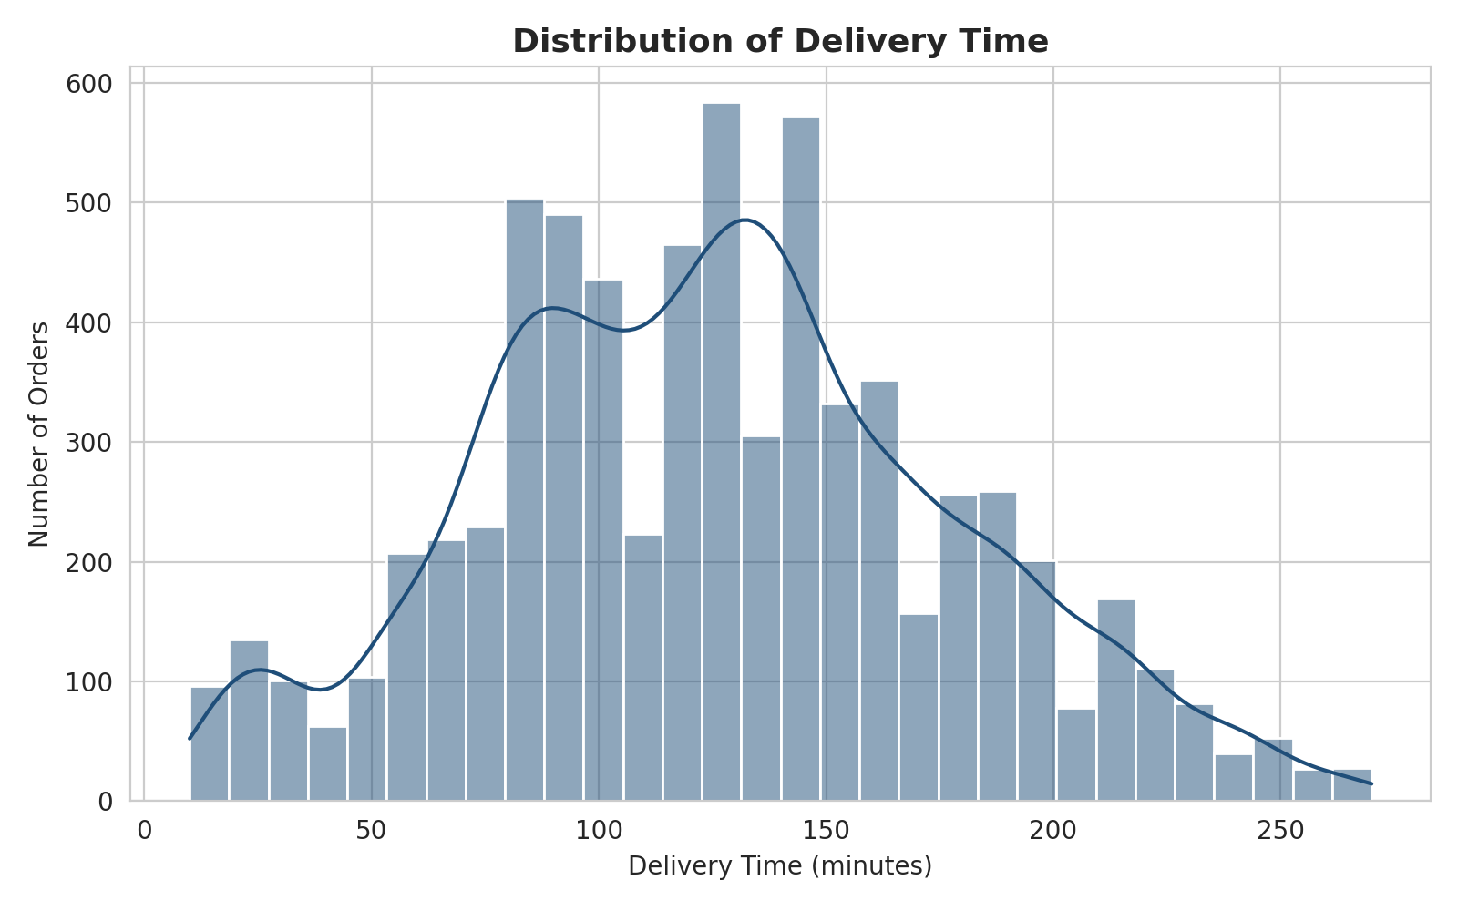
Figure 1. Distribution of delivery time across all cleaned orders.
The distribution is broadly single-peaked and only mildly right-skewed, consistent with the skewness value of 0.17 reported in Section 3.1. A secondary, smaller bump is visible around 125–145 minutes, suggesting that deliveries cluster into at least two loosely defined bands — a faster band under roughly 110 minutes and a slower band above it — which the traffic and weather breakdowns below help to explain.
4.2 Boxplot: Delivery Time by Traffic Level
A boxplot was chosen over a simple bar chart of averages because it shows the full spread, the median, and outliers for each traffic category at once. An average alone would hide whether a traffic level is consistently slow or only occasionally slow.
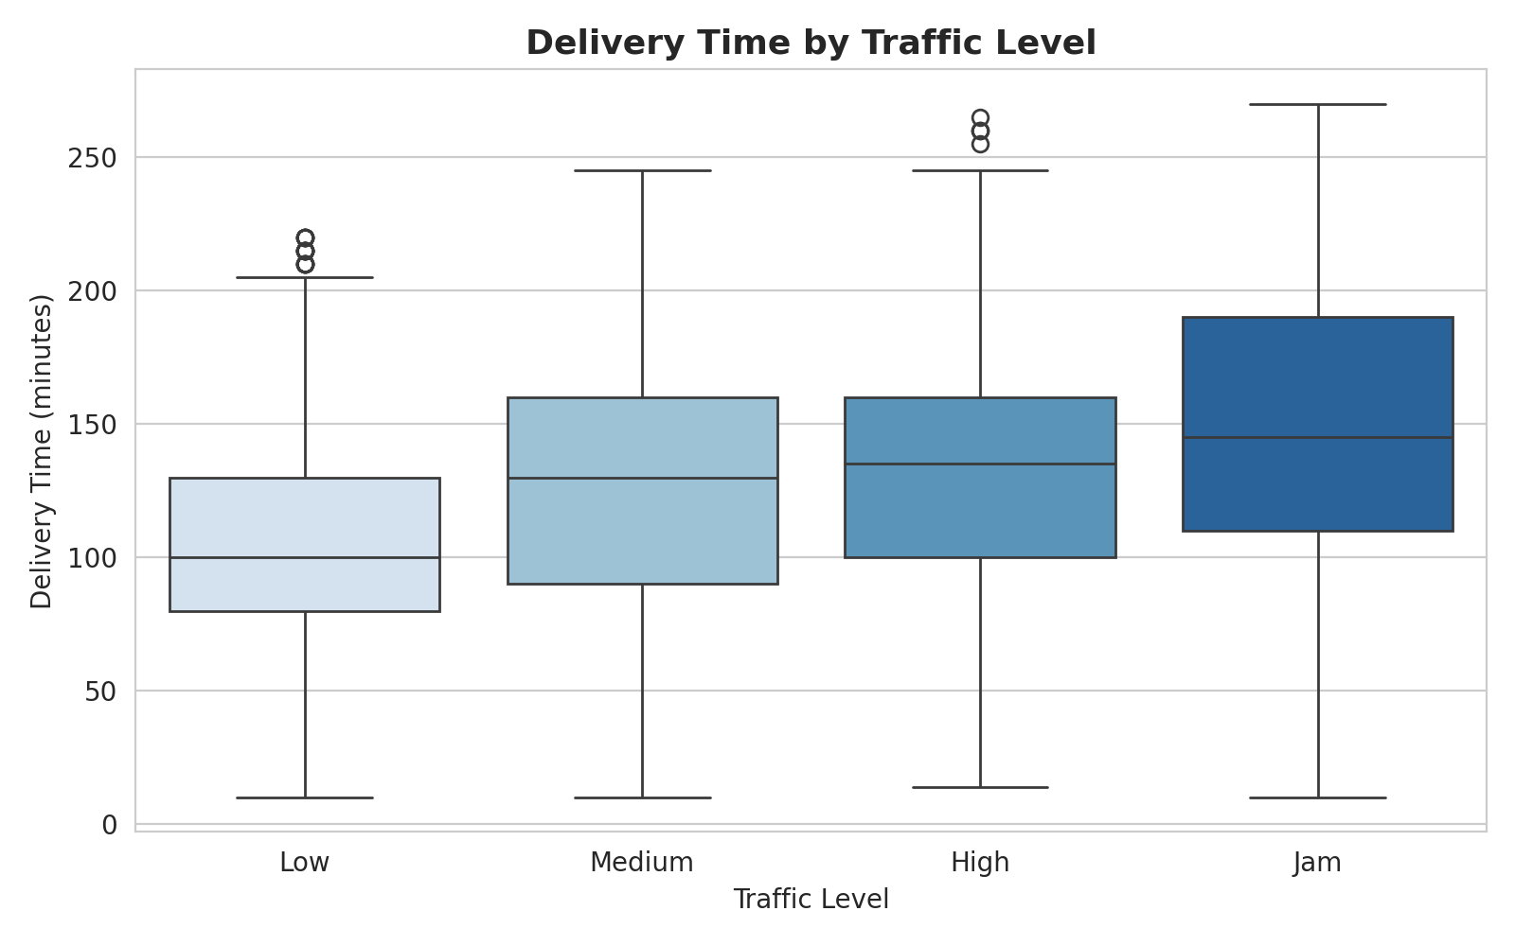
Figure 2. Delivery time by traffic level, showing median, interquartile range, and outliers for each category.
The median delivery time rises steadily from Low traffic (100 minutes) through Medium and High (around 130–135 minutes) to Jam (145 minutes). More importantly, the entire box shifts upward and widens under Jam conditions, meaning that jammed traffic does not only raise the average, it also makes delivery time far less predictable — the interquartile range for Jam runs from roughly 110 to 190 minutes, nearly double the width of the Low-traffic box. This is operationally significant: unpredictability is often costlier to manage than a simply higher average, since it undermines any fixed customer ETA.
4.3 Bar Chart: Average Delivery Time by Weather Condition
A bar chart was chosen here because weather is a small set of discrete categories and the question is a direct comparison of one summary value (the mean) across them, which bar charts communicate more directly than a boxplot would for a first-pass comparison.
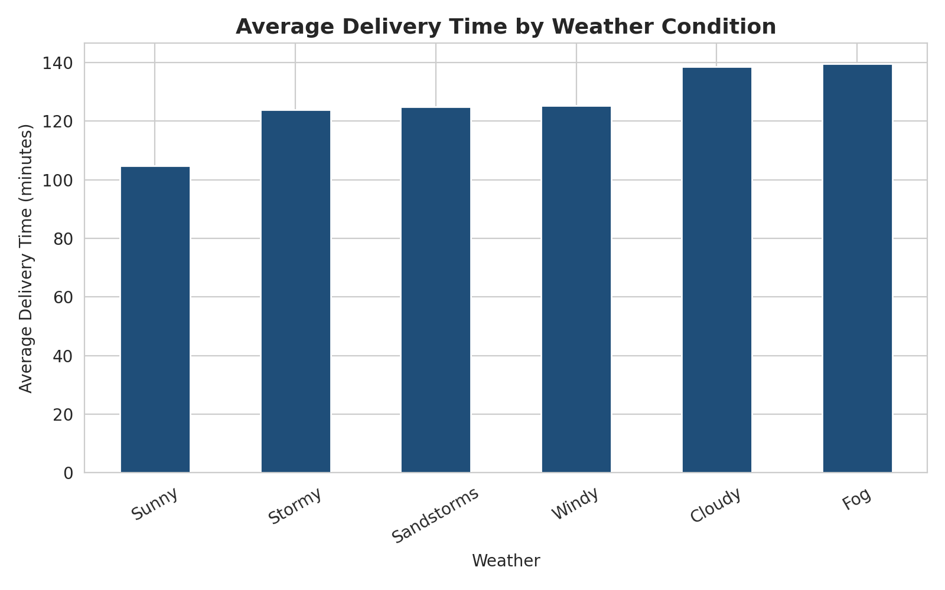
Figure 3. Average delivery time by weather condition, ordered from fastest to slowest.
Sunny conditions are the clear outlier on the favourable side, averaging about 104 minutes, some 20 minutes faster than every other condition. Stormy, Sandstorms, and Windy conditions form a tight middle band around 124–125 minutes, while Cloudy and Fog are the slowest at close to 139 minutes. The closeness of the four middle categories suggests that, beyond a baseline weather penalty, the specific type of adverse weather matters less than whether the weather is adverse at all.
4.4 Line Chart: Average Delivery Time by Hour of Order
A line chart was chosen because the x-axis here (hour of day) is sequential and cyclical, and a line makes the shape of a trend over time — rises, falls, and plateaus — far easier to read than a bar chart would.
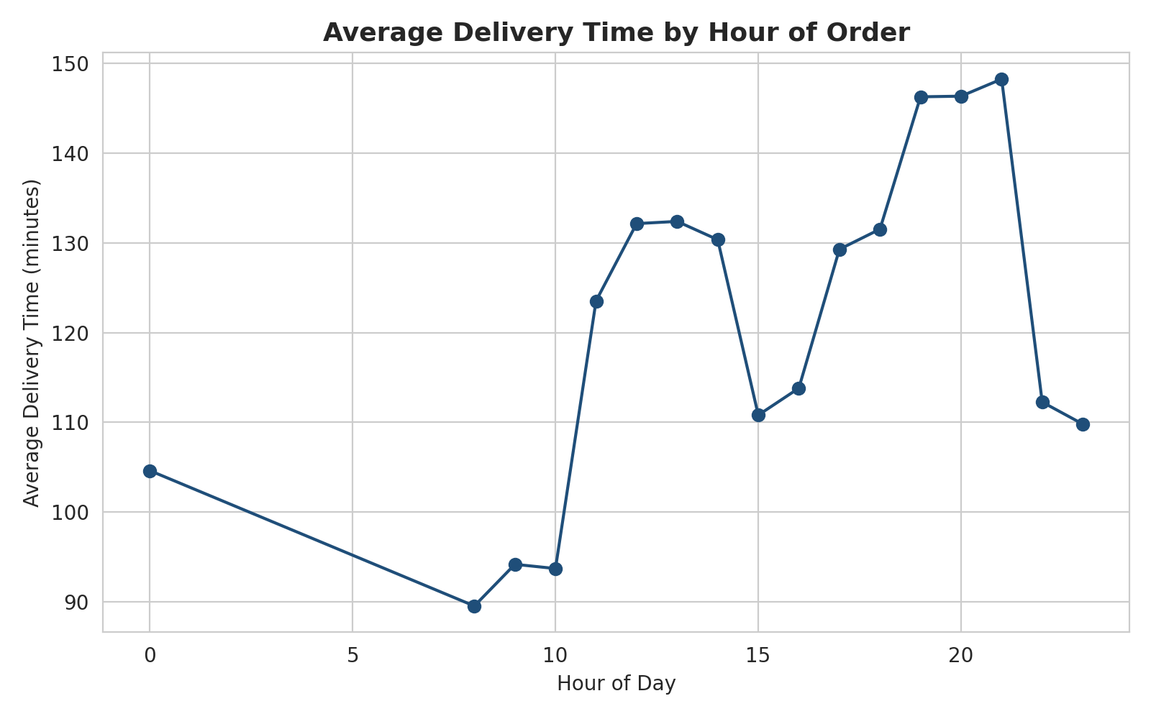
Figure 4. Average delivery time by the hour the order was placed.
Delivery time is lowest in the mid-morning window (roughly 89–94 minutes between 08:00 and 10:00) and climbs sharply after 10:00, plateauing around 130 minutes through the early afternoon. A second, steeper climb begins around 17:00 and peaks at approximately 148 minutes at 21:00, before falling back overnight. This two-stage pattern — a midday plateau followed by an evening peak — points to two distinct operational pressures: daytime traffic density and an evening order surge, likely tied to dinner-time demand, that together strain the delivery network at different points for different reasons.
4.5 Correlation Heatmap
A heatmap was chosen to present the full correlation matrix at once, since scanning a table of fifteen or more coefficients is slower and more error-prone than reading colour intensity across a grid, particularly when the goal is to quickly spot the strongest relationships.
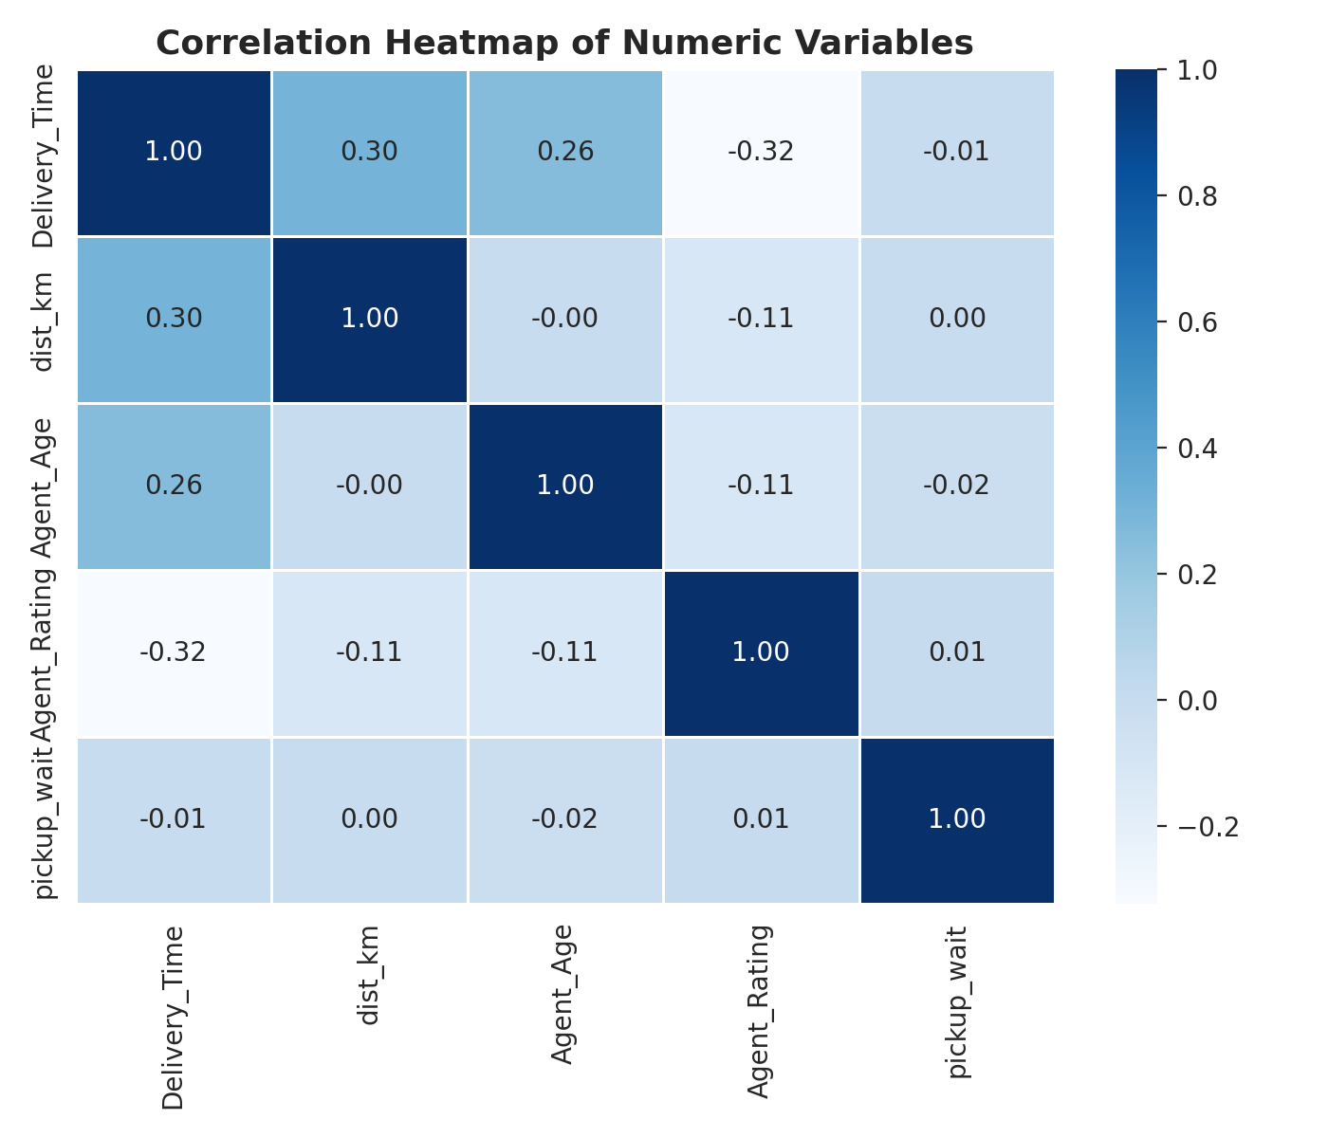
Figure 5. Correlation heatmap across Delivery_Time, dist_km, Agent_Age, Agent_Rating, and pickup_wait.
The heatmap confirms what Table 3 reported numerically: Agent_Rating has the strongest (negative) relationship with Delivery_Time at −0.32, followed by dist_km (0.30) and Agent_Age (0.26). pickup_wait stands out for having essentially no linear relationship with Delivery_Time (−0.01), which is a useful negative finding — it suggests that, in this dataset, how quickly an agent collects the order has little bearing on how long the subsequent delivery takes, so efforts to speed up pickup would not, by themselves, be expected to shorten overall delivery time.
4.6 Scatter Plot: Distance vs Delivery Time
A scatter plot with a fitted regression line was chosen because the relationship between two continuous variables is the one question a scatter plot answers better than any other chart type: it shows both the overall trend and how much individual points vary around it.
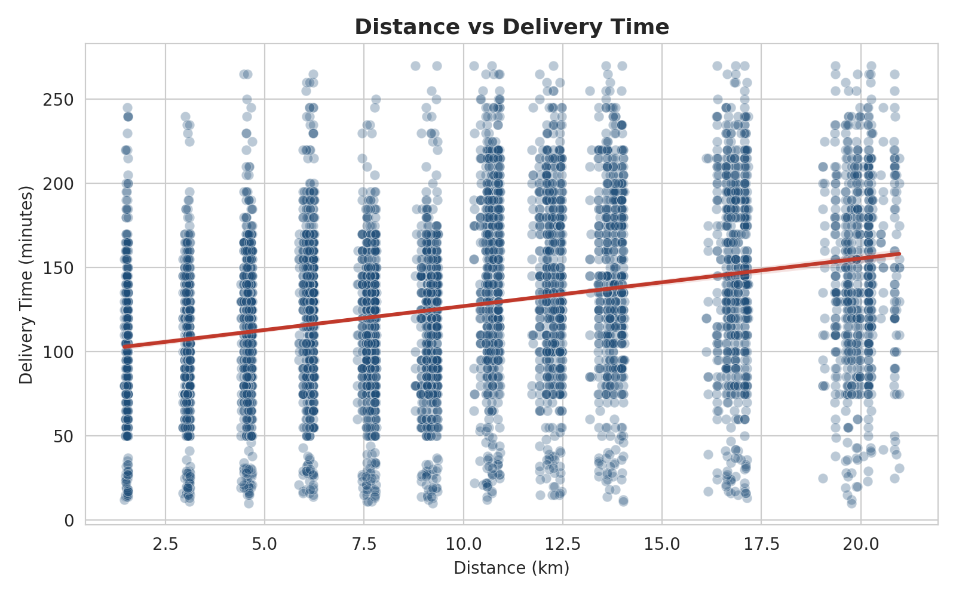
Figure 6. Distance versus delivery time, with a linear trend line fitted across all orders.
The fitted line rises from roughly 100 minutes near 1 km to about 160 minutes near 21 km, consistent with the moderate positive correlation of 0.30 reported above. What the scatter reveals that the correlation coefficient alone cannot is the sheer width of the vertical spread at every distance: at almost any given distance, individual delivery times range from under 50 minutes to over 250 minutes. This confirms the conclusion already suggested in Section 3.2 — distance is a real but partial driver of delivery time, and conditions such as traffic and weather, rather than route length alone, account for most of the variation.
4.7 Pie Chart: Share of Deliveries by Vehicle Type
A pie chart was chosen for this one variable because the question is purely compositional — what share of the whole does each category represent — and there are only three categories, a case where a pie chart remains readable without becoming cluttered.
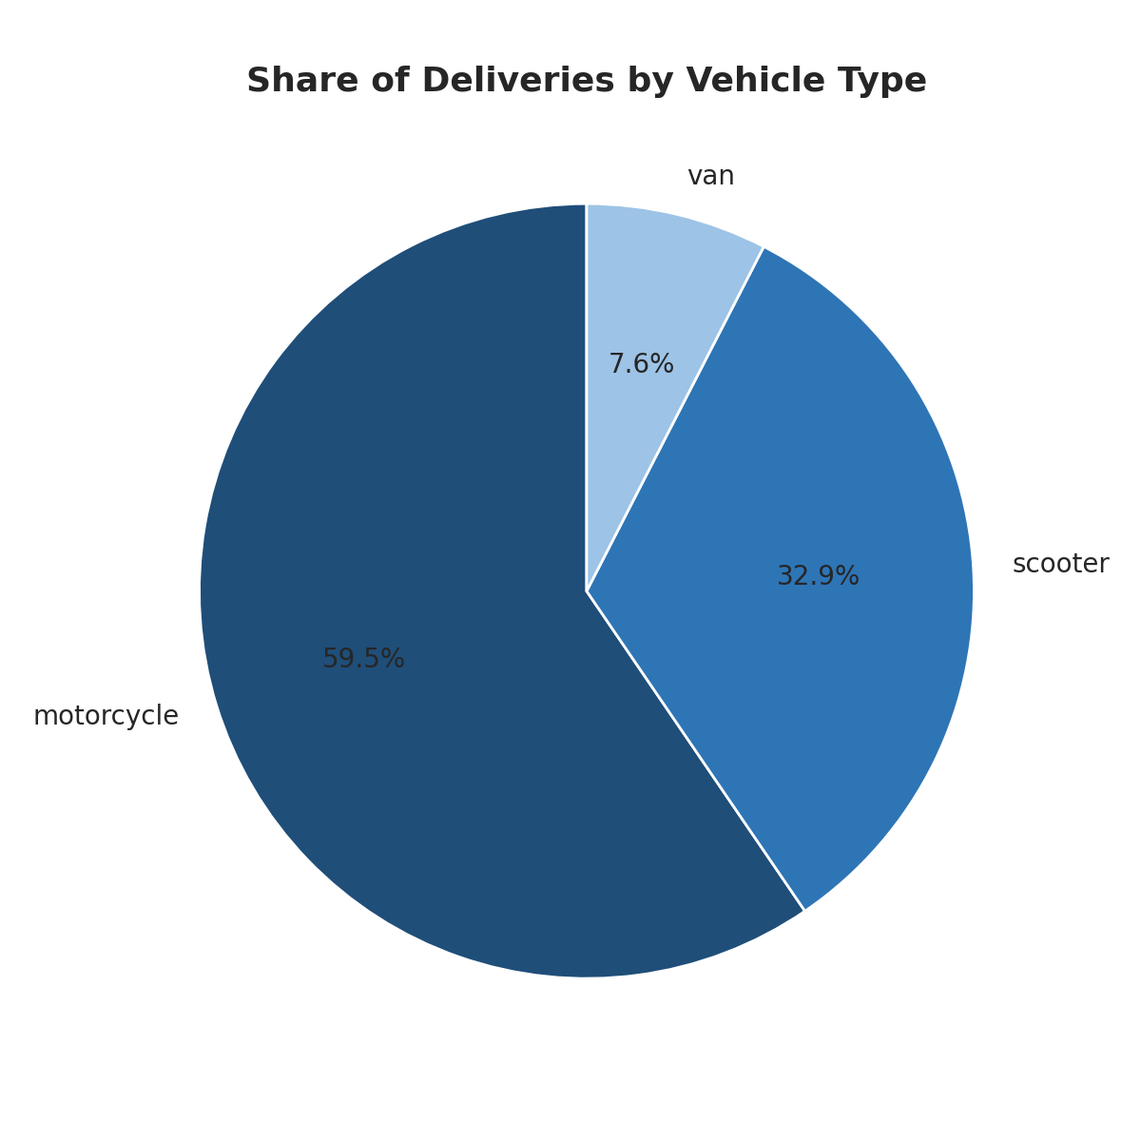
Figure 7. Share of deliveries by vehicle type.
Motorcycles handle the majority of deliveries at 59.5 percent, with scooters taking 32.9 percent and vans only 7.6 percent. This composition is important context for Figure 2 and Figure 8: because motorcycles so dominate the fleet, any factor that makes motorcycle deliveries slower (as the next chart suggests) affects the large majority of all deliveries, not a small subset.
4.8 Grouped Bar Chart: Average Delivery Time by Area and Vehicle Type
A grouped bar chart was chosen because this question has two categorical dimensions at once (area and vehicle type), and grouping bars side by side within each area is the clearest way to compare vehicles consistently across every area without overlaying lines or relying on colour alone.
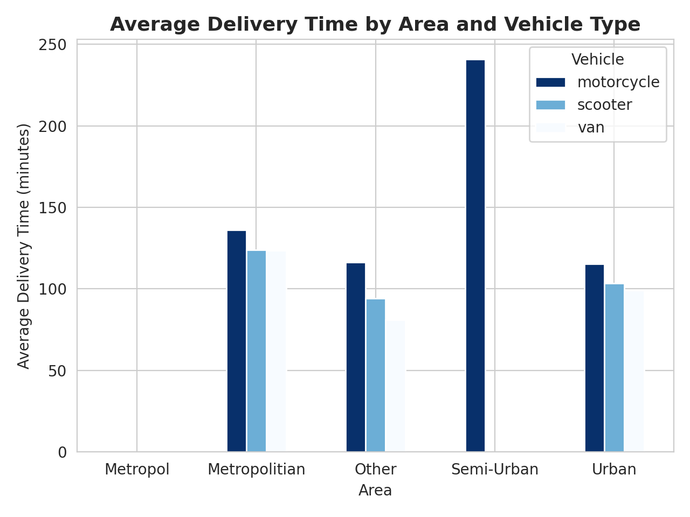
Figure 8. Average delivery time by area, broken down by vehicle type.
Within every area, motorcycles are the slowest vehicle on average, and vans are consistently the fastest or tied for fastest, which runs against the usual assumption that a smaller, more agile vehicle is always quicker in congested conditions. The Semi-Urban motorcycle bar is a striking outlier at roughly 240 minutes, nearly double any other bar in the chart, though this category covers only a small number of orders (23 in total, per Week 2's cleaning summary) and should be read as a flag for further investigation rather than a stable finding. A small, isolated bar also appears under a category labelled “Metropol” with no visible height; this is a single-row data-entry artefact (one record stores the area as “Metropol” instead of the correct “Metropolitian”) that was not caught by the categorical-formatting checks in Week 2, since it is a genuine misspelling rather than a whitespace issue. It affects only one of 6,879 rows and does not alter any conclusion in this report, but it is noted here as the kind of residual data-quality issue that a thorough EDA is also meant to surface.
5. Analytical Insights and Interpretation
Drawing the findings above together, four conclusions stand out as both statistically supported and operationally actionable.
- Traffic is the strongest and most controllable lever. The Jam-versus-Low gap in Figure 2 (roughly 45 minutes at the median, with a far wider spread) is the single largest and most consistent effect found anywhere in this analysis. Unlike weather, which the operator cannot influence, traffic can be partly managed through dispatch timing and route choice.
- Vehicle choice is being applied inconsistently with its own apparent benefit. Figure 8 shows vans outperforming motorcycles in every area, yet Figure 7 shows motorcycles handle nearly six times as many deliveries as vans. If van performance holds up under further investigation (accounting for the possibility that vans are assigned to easier routes), this is a mismatch between current resource allocation and demonstrated performance.
- Agent quality matters more than any single route factor. Agent_Rating's −0.32 correlation with Delivery_Time is the strongest numeric relationship in the dataset, ahead of distance itself. This suggests that agent-level coaching or performance management could move delivery times by more than many route-level interventions.
- The evening demand surge is a distinct problem from daytime congestion. Figure 4's two-stage pattern means a single mitigation will not address both peaks: the daytime plateau looks like a traffic-driven problem, while the sharper evening peak looks more like a volume-driven problem requiring additional capacity rather than faster routing.
6. Recommendations
- Introduce traffic-aware dispatch windows: where feasible, delay dispatch of non-urgent orders placed just before a known Jam period, since Figure 2 shows Jam-period deliveries are both slower and far less predictable than any other traffic level.
- Re-examine the motorcycle-heavy fleet mix, particularly for longer or Semi-Urban routes, given the consistent van and scooter advantage shown in Figure 8; a controlled comparison on matched routes would confirm whether this is a genuine vehicle effect or a confound with route difficulty.
- Prioritise agent-side interventions (training, route familiarity, workload management) alongside route optimisation, since Agent_Rating was the single strongest correlate of delivery time found in this analysis.
- Add agent capacity specifically in the 19:00–21:00 window identified in Figure 4, treating it as a staffing problem distinct from the daytime traffic problem addressed by the first recommendation.
- Correct the single “Metropol” area entry identified in Section 4.8 and add a controlled-vocabulary check to the Week 2 cleaning pipeline so that genuine misspellings, not just whitespace and null variants, are caught before analysis.
7. Python Code Used
The code below, run in Google Colab on amazon_delivery_cleaned.csv, produced every statistic and figure in this report.
7.1 Setup and load
import pandas as pd
import numpy as np
import matplotlib.pyplot as plt
import seaborn as sns

sns.set_style("whitegrid")
plt.rcParams['figure.dpi'] = 120

df = pd.read_csv('amazon_delivery_cleaned.csv')
print("Shape:", df.shape)
7.2 Descriptive statistics and correlation
num_cols = ['Delivery_Time', 'dist_km', 'Agent_Age', 'Agent_Rating', 'pickup_wait']

print(df[num_cols].describe().round(2))
print(df[num_cols].skew().round(2))
print("Mode of Delivery_Time:", df['Delivery_Time'].mode()[0])

corr = df[num_cols].corr()
print(corr.round(2))
7.3 Figure 1 — Histogram of delivery time
plt.figure(figsize=(8, 5))
sns.histplot(df['Delivery_Time'], bins=30, kde=True, color="#1F4E79")
plt.title('Distribution of Delivery Time', fontsize=13, fontweight='bold')
plt.xlabel('Delivery Time (minutes)'); plt.ylabel('Number of Orders')
plt.tight_layout(); plt.savefig('chart1_histogram.png', dpi=200); plt.show()
7.4 Figure 2 — Boxplot by traffic level
plt.figure(figsize=(8, 5))
order = ['Low', 'Medium', 'High', 'Jam']
sns.boxplot(x='Traffic', y='Delivery_Time', data=df, order=order, hue='Traffic',
palette="Blues", legend=False)
plt.title('Delivery Time by Traffic Level', fontsize=13, fontweight='bold')
plt.xlabel('Traffic Level'); plt.ylabel('Delivery Time (minutes)')
plt.tight_layout(); plt.savefig('chart2_boxplot_traffic.png', dpi=200); plt.show()
7.5 Figure 3 — Bar chart by weather
plt.figure(figsize=(8, 5))
weather_avg = df.groupby('Weather')['Delivery_Time'].mean().sort_values()
weather_avg.plot(kind='bar', color="#1F4E79")
plt.title('Average Delivery Time by Weather Condition', fontsize=13, fontweight='bold')
plt.xlabel('Weather'); plt.ylabel('Average Delivery Time (minutes)')
plt.xticks(rotation=30)
plt.tight_layout(); plt.savefig('chart3_bar_weather.png', dpi=200); plt.show()
7.6 Figure 4 — Line chart by hour of day
df['order_dt'] = pd.to_datetime(df['Order_Date'] + ' ' + df['Order_Time'])
df['hour'] = df['order_dt'].dt.hour

plt.figure(figsize=(8, 5))
hourly_avg = df.groupby('hour')['Delivery_Time'].mean()
plt.plot(hourly_avg.index, hourly_avg.values, marker='o', color="#1F4E79")
plt.title('Average Delivery Time by Hour of Order', fontsize=13, fontweight='bold')
plt.xlabel('Hour of Day'); plt.ylabel('Average Delivery Time (minutes)')
plt.tight_layout(); plt.savefig('chart4_line_hourly.png', dpi=200); plt.show()
7.7 Figure 5 — Correlation heatmap
plt.figure(figsize=(7, 6))
sns.heatmap(df[num_cols].corr(), annot=True, cmap='Blues', fmt=".2f", linewidths=0.5)
plt.title('Correlation Heatmap of Numeric Variables', fontsize=13, fontweight='bold')
plt.tight_layout(); plt.savefig('chart5_heatmap.png', dpi=200); plt.show()
7.8 Figure 6 — Scatter plot of distance vs delivery time
plt.figure(figsize=(8, 5))
sns.scatterplot(x='dist_km', y='Delivery_Time', data=df, alpha=0.3, color="#1F4E79")
sns.regplot(x='dist_km', y='Delivery_Time', data=df, scatter=False, color="#C0392B")
plt.title('Distance vs Delivery Time', fontsize=13, fontweight='bold')
plt.xlabel('Distance (km)'); plt.ylabel('Delivery Time (minutes)')
plt.tight_layout(); plt.savefig('chart6_scatter_distance.png', dpi=200); plt.show()
7.9 Figure 7 — Pie chart of vehicle share
plt.figure(figsize=(6, 6))
vehicle_counts = df['Vehicle'].value_counts()
colors = ["#1F4E79", "#2E75B6", "#9DC3E6", "#C0392B"]
plt.pie(vehicle_counts, labels=vehicle_counts.index, autopct='%1.1f%%',
colors=colors[:len(vehicle_counts)], startangle=90)
plt.title('Share of Deliveries by Vehicle Type', fontsize=13, fontweight='bold')
plt.tight_layout(); plt.savefig('chart7_pie_vehicle.png', dpi=200); plt.show()
7.10 Figure 8 — Grouped bar chart by area and vehicle
plt.figure(figsize=(9, 5))
pivot = df.groupby(['Area', 'Vehicle'])['Delivery_Time'].mean().unstack()
pivot.plot(kind='bar', colormap='Blues_r')
plt.title('Average Delivery Time by Area and Vehicle Type', fontsize=13, fontweight='bold')
plt.xlabel('Area'); plt.ylabel('Average Delivery Time (minutes)')
plt.xticks(rotation=0); plt.legend(title='Vehicle')
plt.tight_layout(); plt.savefig('chart8_grouped_bar_area_vehicle.png', dpi=200); plt.show()
8. Conclusion
This report carried the project from a cleaned dataset to a full exploratory analysis, combining descriptive statistics, a correlation study, and eight purpose-chosen visualizations. The central finding is consistent across every method used: no single variable, numeric or categorical, drives delivery time on its own. Traffic level produces the largest and most consistent effect of any factor examined, agent rating is the strongest numeric correlate, vehicle choice shows a performance gap that current fleet composition does not reflect, and the daily pattern reveals two distinct peak periods with different likely causes.
Together these findings turn the plan set out in Week 1 and the clean dataset built in Week 2 into a concrete, evidence-based picture of where this delivery operation's performance is won and lost. The recommendations in Section 6 translate that picture into specific actions, and the correlation and distance findings in particular set up the predictive modelling planned for the next stage of this project: a model that uses traffic, weather, vehicle, and agent rating together is likely to explain delivery time far better than any one of these factors in isolation, which is exactly what Week 1's prototype Random Forest model already began to show.
References
[1] Suthar, S. Amazon Delivery Dataset [Data set]. Kaggle. https://www.kaggle.com/datasets/sujalsuthar/amazon-delivery-dataset
[2] Hunter, J. D. (2007). Matplotlib: A 2D graphics environment. Computing in Science & Engineering, 9(3), 90–95.
[3] Waskom, M. L. (2021). Seaborn: Statistical data visualization. Journal of Open Source Software, 6(60), 3021. https://doi.org/10.21105/joss.03021
[4] McKinney, W. (2010). Data structures for statistical computing in Python. Proceedings of the 9th Python in Science Conference, 51–56.
[5] Tufte, E. R. (2001). The Visual Display of Quantitative Information (2nd ed.). Graphics Press. (Principles of chart-type selection applied in Section 4.)

